Supplementary Material
Figure S1. Scatter plot of caudate nodal strength with age for women and men separately in CN group.
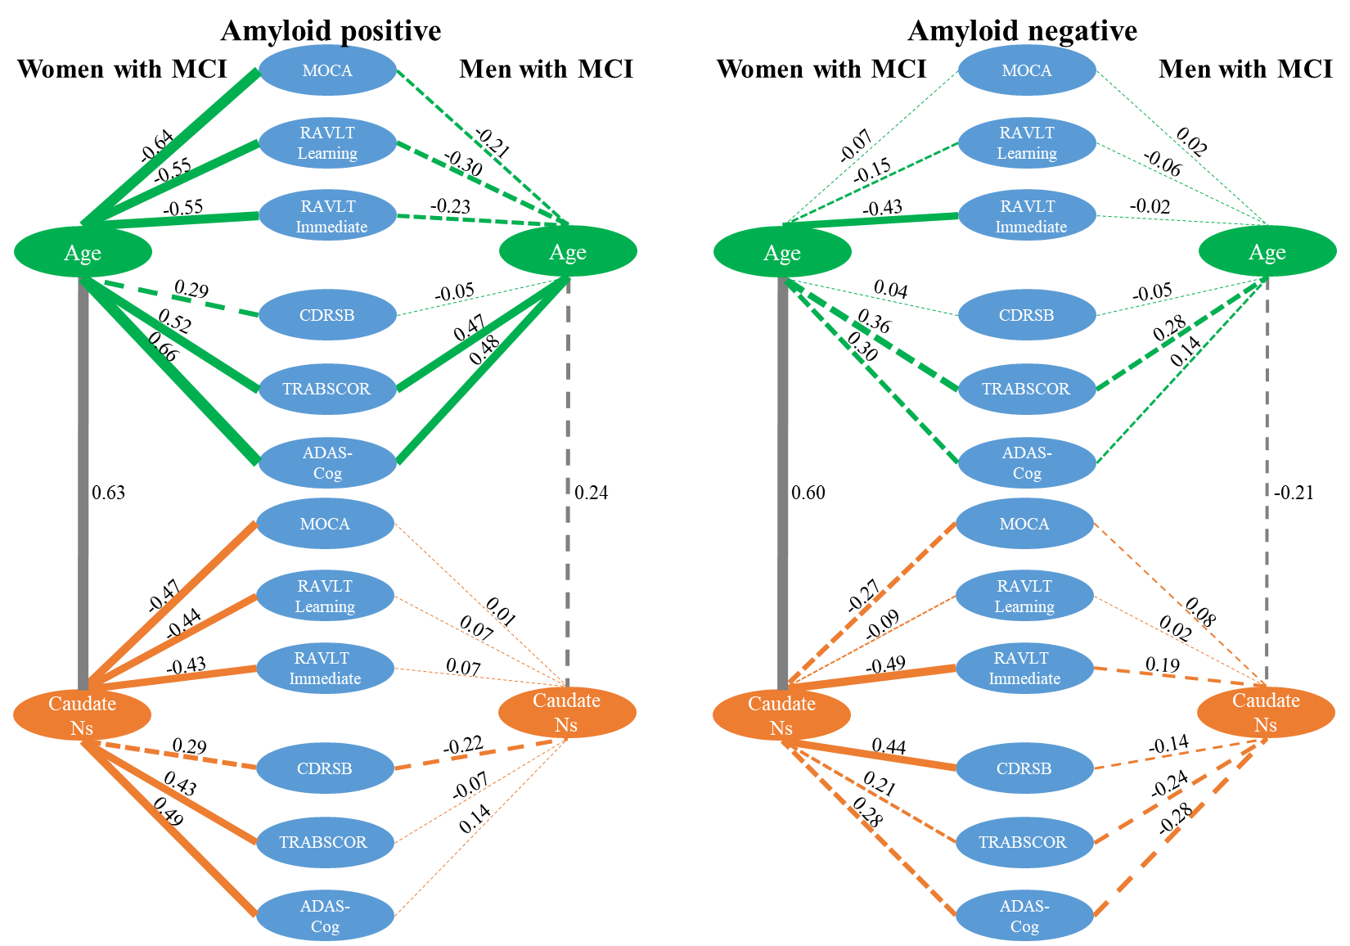
Figure S2. Associations among age, neuropsychological scores and caudate nodal strength (Ns) for amyloid positive (left) and negative (right) participants MCI separately.

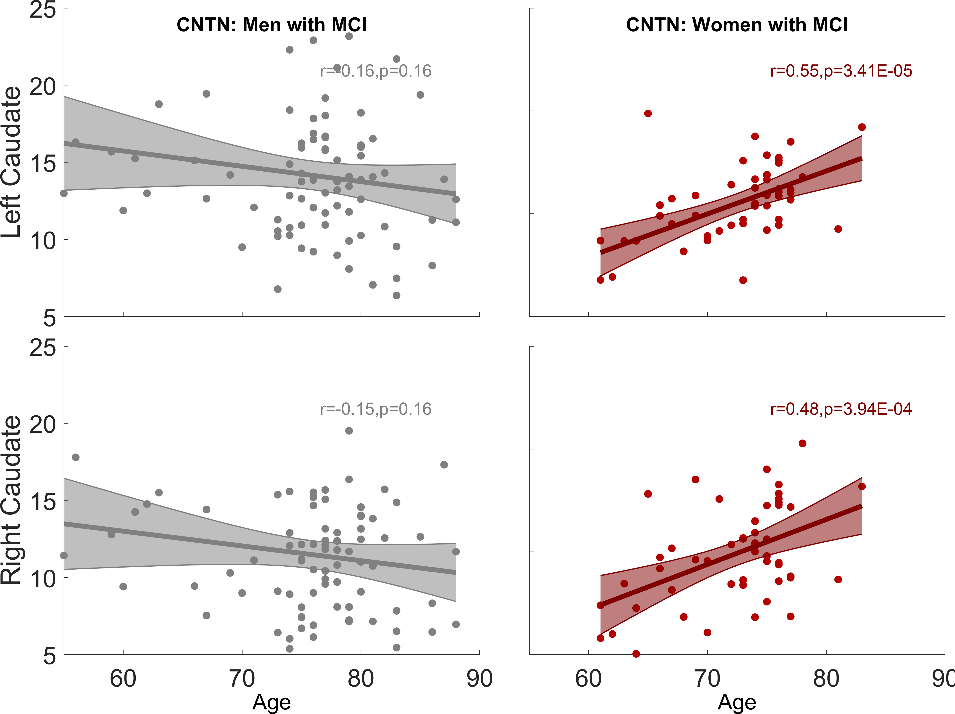
Figure S3. Sex-dependent association between caudate nodal strength and age among MCI group from the independent CNTN cohort. The Pearson’s correlations (r) between age and adjusted left/right caudate nodal strength are 0.55/0.48 for women with MCI and -0.16/-0.15 for men with MCI. The association is only significant in women with MCI (left caudate p=3.4x10-5, right caudate p=3.9x10-4) but not in men with MCI (left caudate p=0.16, right caudate p=0.16).

