Improving implementation of OSA screening: patient-performed neck encirclement within the NoSAS score

Authors: Latreche L¹. Rabec C. ² , Heinzer R³, von Garnier C², Kassir S¹, Hajji S ¹, Ricordeau F¹, Stauffer E¹, Peter Derex L^{1,4,5}, Tankéré P ^{1,4,5}
¹ Center for Sleep Medicine, Croix-Rousse Hospital, Hospices Civils de Lyon, Lyon, France
² Division of Pulmonary Medicine, Lausanne University Hospital (CHUV) and University of Lausanne, Lausanne, Switzerland.
³ Center for Investigation and Research in Sleep, Lausanne University Hospital and University of Lausanne, Lausanne, Switzerland.
⁴ Grenoble Alpes University, HP2 Laboratory (Hypoxia Pathophysiology), INSERM U1300 Grenoble, France
⁵ Lyon Neuroscience Research Center, PAM Team, INSERM U1028 / CNRS UMR 5292 / Lyon 1 University, Lyon, France
Correspondence to
Dr Pierre Tankéré pierre.tankere01@chu-lyon.fr
Pr Peter-Derex, laure.peter-derex@chu-lyon.fr

Supplementary

Supplementary figures:
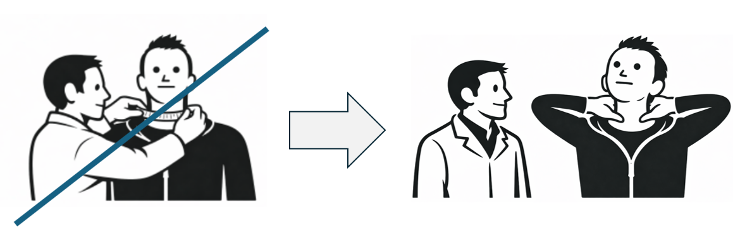
Figure S1: Illustration of patient-performed neck encirclement maneuver used in the modified NoSAS hand score

Supplementary tables

Table S1: Diagnostic performance of neck-related screening criteria for OSA
Criterion | Outcome | N | TP | FP | FN | TN | Se | Sp | PPV | NPV
Measured neck circumference >40 cm | AHI ≥15/h | 319 | 38 | 7 | 180 | 94 | 17.40% | 93.10% | 84.40% | 34.30%
Patient neck encirclement | AHI ≥15/h | 421 | 65 | 14 | 230 | 112 | 22% | 88.90% | 82.30% | 32.70%
Measured neck circumference >40 cm | AHI ≥30/h | 319 | 24 | 21 | 100 | 174 | 19.40% | 89.20% | 53.30% | 63.50%
Patient neck encirclement | AHI ≥30/h | 421 | 51 | 28 | 129 | 213 | 28.30% | 88.40% | 64.60% | 62.30%
Abbreviations: AHI, apnea–hypopnea index; FN, false negatives; FP, false positives; N, number of patients included in the analysis; NPV, negative predictive value; OSA, obstructive sleep apnea; PPV, positive predictive value; Se, sensitivity; Sp, specificity; TN, true negatives; TP, true positives.

Table S2. Diagnostic performance of the standard NoSAS score and the modified NoSAS hand score for OSA detection
Diagnostic performance of NoSAS scores
Score | Outcome | N | TP | FP | FN | TN | Se | Sp | PPV | NPV
NoSAS ≥8 | AHI ≥5/h | 308 | 141 | 5 | 139 | 23 | 50.40% | 82.10% | 96.60% | 14.20%
NoSAS hand ≥8 | AHI ≥5/h | 409 | 188 | 8 | 186 | 27 | 50.30% | 77.10% | 95.90% | 12.70%
NoSAS ≥8 | AHI ≥15/h | 308 | 124 | 22 | 86 | 76 | 59% | 77.60% | 84.90% | 46.90%
NoSAS hand ≥8 | AHI ≥15/h | 409 | 167 | 29 | 119 | 94 | 58.40% | 76.40% | 85.20% | 44.10%
NoSAS ≥8 | AHI ≥30/h | 308 | 85 | 61 | 34 | 128 | 71.40% | 67.70% | 58.20% | 79%
NoSAS hand ≥8 | AHI ≥30/h | 409 | 123 | 73 | 51 | 162 | 70.70% | 68.90% | 62.80% | 76.10%
Abbreviations: AHI, apnea–hypopnea index; FN, false negatives; FP, false positives; N, number of patients included in the analysis; NPV, negative predictive value; OSA, obstructive sleep apnea; PPV, positive predictive value; Se, sensitivity; Sp, specificity; TN, true negatives; TP, true positives.

Table S3. Characteristics of patients according to availability of neck circumference measurement
Characteristic | Neck circumference available (n=320) | Neck circumference missing (n=129) | p-value
Age, years | 48.6 [36.5–61.4] | 51.4 [35.3–60.0] | 0.842
BMI, kg·m⁻² | 26.2 [23.0–31.2] | 27.0 [23.6–34.1] | 0.054
Male sex, n (%) | 156 (48.9) | 60 (46.5) | 0.723
AHI, events·h⁻¹ | 22.0 [12.2–36.8] | 30.8 [15.3–46.2] | 0.006
Moderate-to-severe OSA (AHI ≥15), n (%) | 218 (68.1) | 97 (75.2) | 0.186
Severe OSA (AHI ≥30), n (%) | 124 (38.8) | 69 (53.5) | 0.006

Abbreviations: AHI, apnea–hypopnea index; BMI, body mass index; OSA, obstructive sleep apnea. Continuous variables are presented as median [interquartile range].
Supplementary design information:
We conducted a retrospective analysis of prospectively collected routine clinical data from 449 consecutive patients referred for suspected obstructive sleep apnea (OSA) who underwent sleep studies between September 1 and December 31, 2025. Clinical and anthropometric data, including age, sex, and body mass index (BMI), were prospectively collected in routine practice using a standardized form completed by 4th- to 6th-year medical students involved in patient assessment in the sleep clinic. Medical students were not informed of the specific objective of the present analysis. All assessments were performed under real-life conditions, with a measuring tape available for neck circumference measurement and its use explained to students at the beginning of their clinical rotation.
Neck circumference was measured using a flexible tape at the level of the cricothyroid membrane, corresponding to the anatomical landmark described in the original NoSAS study (mid-anterior neck, just below the laryngeal prominence, at the level of the C5–C6 vertebrae) ⁵. Patient-performed neck encirclement was assessed at the same anatomical level to ensure comparability between methods and was defined as the ability to surround the neck using both hands with thumb-to- middle finger contact.
Sleep studies were performed using polysomnography, and the apnea–hypopnea index (AHI) was calculated according to standard criteria ¹⁵. The following signals were recorded: electroencephalogram (Fp2, C4, O2, T4, Cz, Pz, A1, A2), electro-oculogram, chin and tibialis electromyogram, electrocardiography, nasal airflow (nasal pressure and thermistor), pulse oximetry, and respiratory efforts (thoracic and abdominal belts).OSA severity was defined using conventional thresholds (AHI ≥15 and ≥30 events·h⁻¹).
We evaluated the feasibility and diagnostic performance of two neck-related criteria: measured neck circumference >40 cm and patient-performed neck encirclement. Diagnostic performance was assessed using sensitivity, specificity, positive predictive value (PPV), and negative predictive value (NPV). Paired comparisons between the two approaches were performed using McNemar’s test. Agreement between measured neck circumference and patient-performed neck encirclement was additionally assessed using Cohen’s kappa coefficient in patients with both measurements available. Feasibility improvement was quantified using absolute availability gain and relative reduction in missing data between approaches.
In a secondary analysis, these variables were incorporated into the NoSAS score to compare the standard NoSAS score with a modified version using patient-performed neck encirclement (NoSAS hand), using a predefined threshold of ≥8 points. Feasibility was assessed based on the proportion of missing data.
To explore potential bias related to missing neck circumference measurements, baseline characteristics and OSA severity were compared between patients with available and missing neck circumference data using Wilcoxon rank-sum tests for continuous variables and χ² tests for categorical variables.
All statistical analyses were performed using R software (v4.0.5 and R studio.). Continuous variables are presented as mean ± standard deviation or median [interquartile range], and categorical variables as counts and percentages. A two-sided p-value <0.05 was considered statistically significant.
The study was approved by the Scientific and Ethics Committee of the Hospices Civils de Lyon (CSE-HCL, IRB 00013204; AGORA No. 26-5065). In accordance with French regulations governing retrospective observational studies (MR004), patients were informed and given the opportunity to object to the use of their medical data.

