Questionnaire
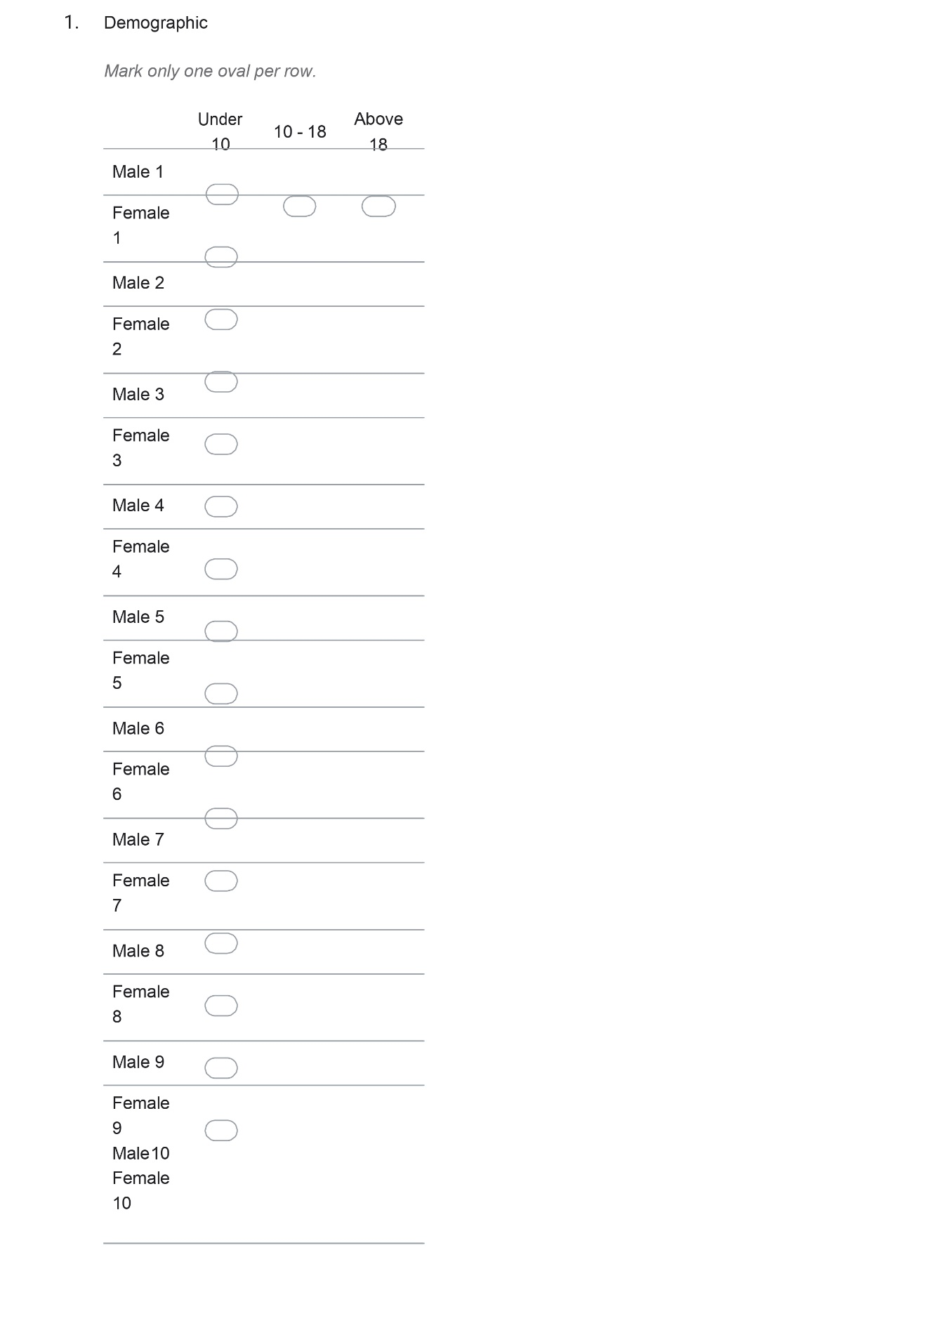
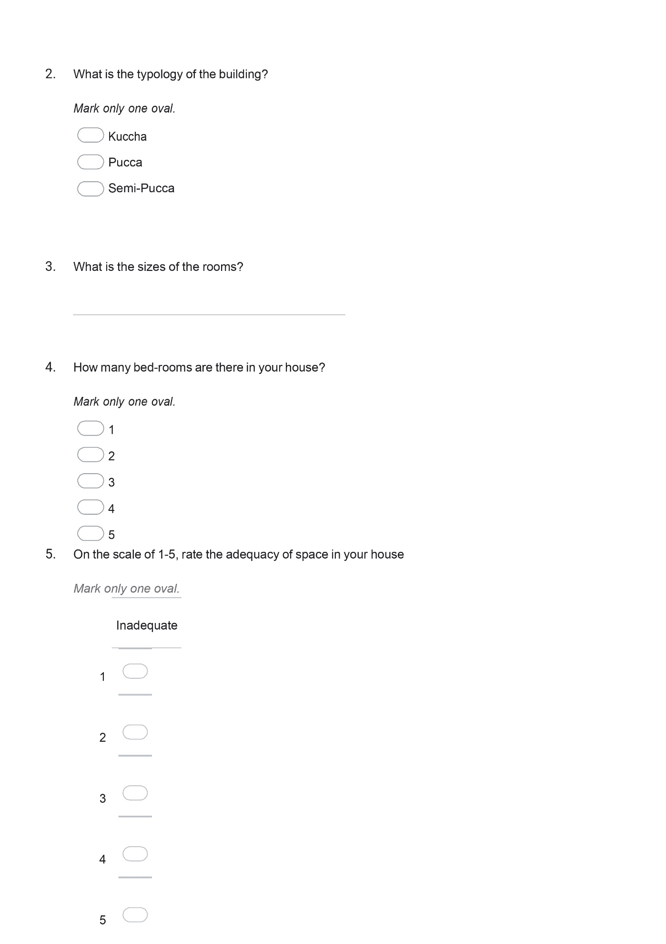
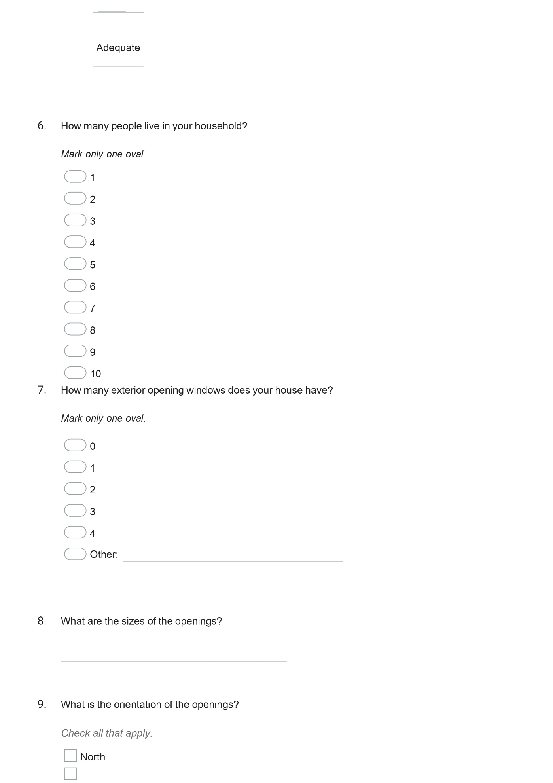
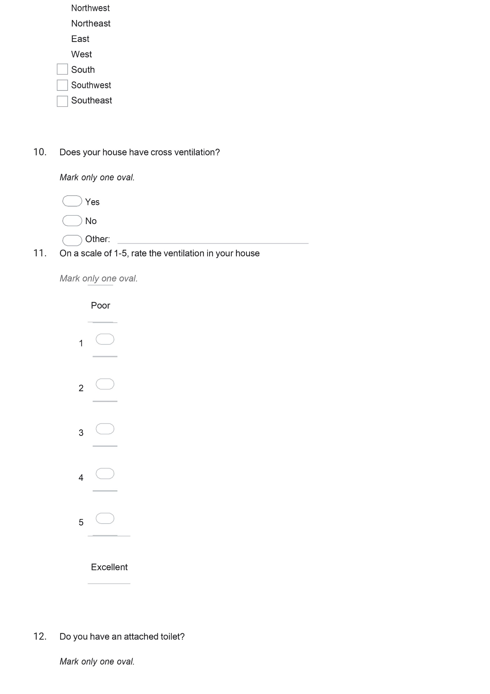
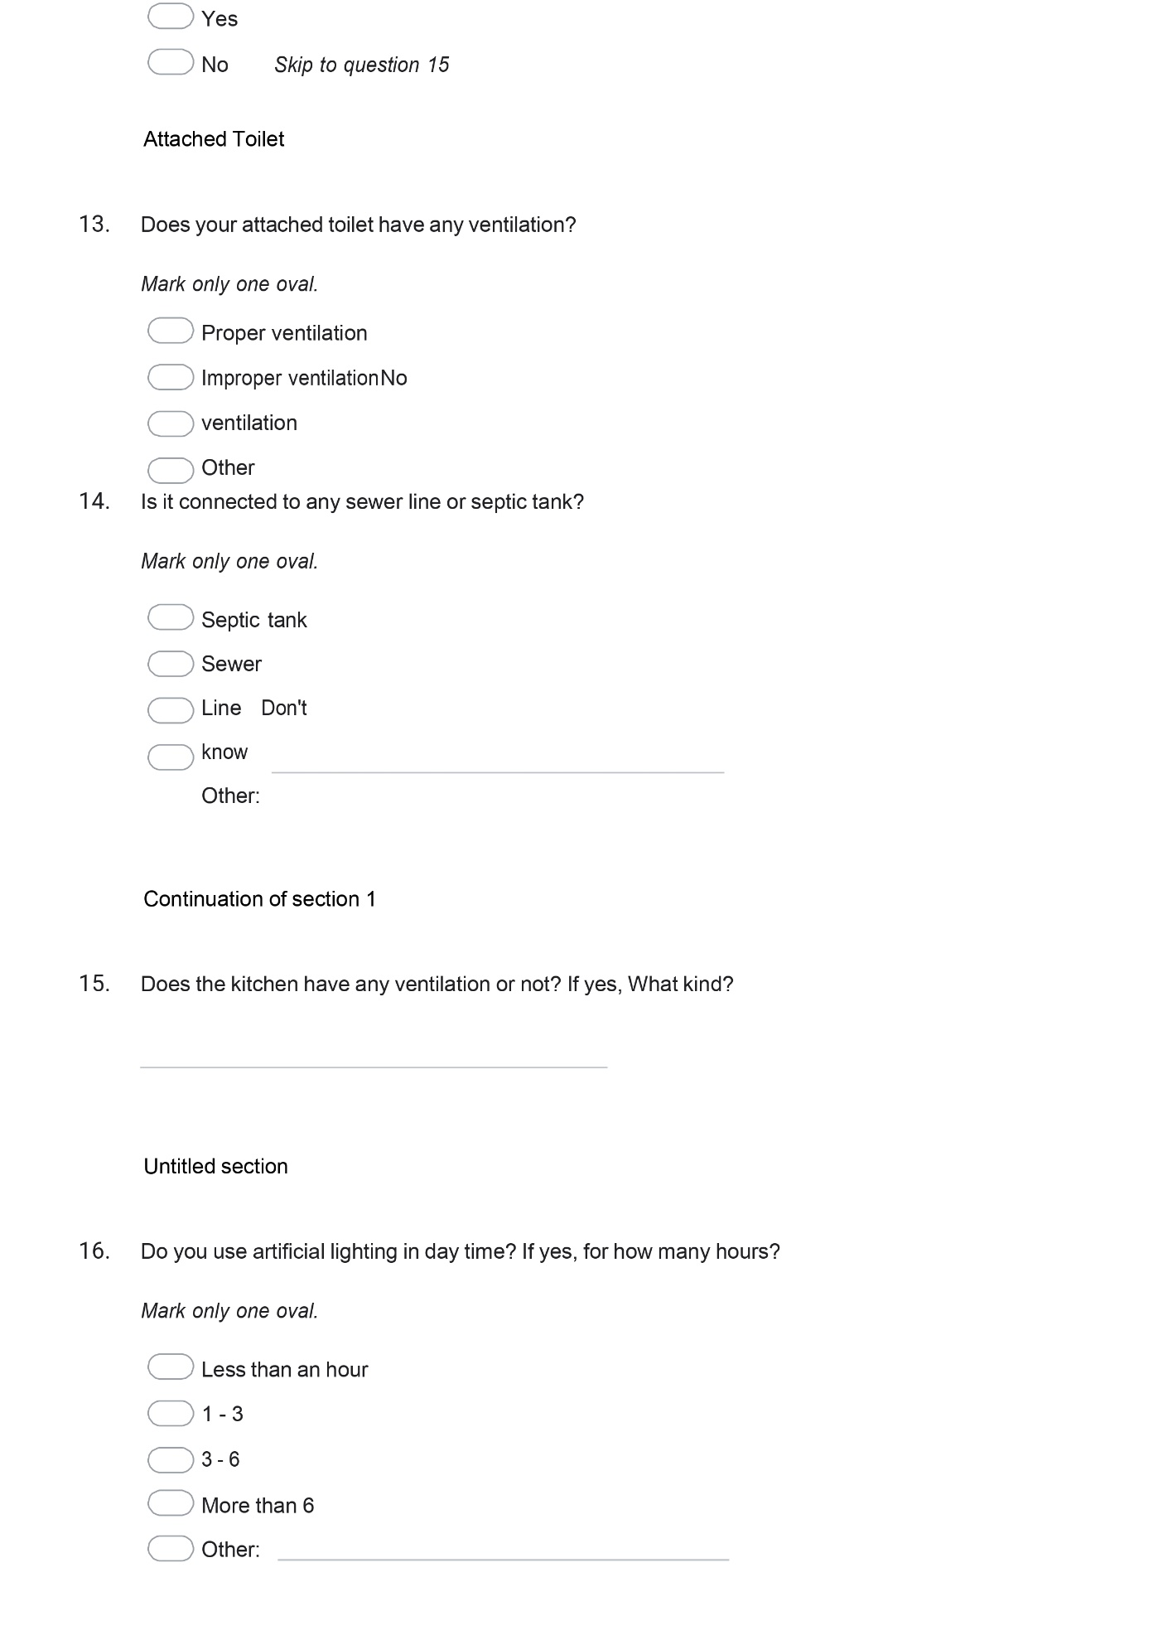
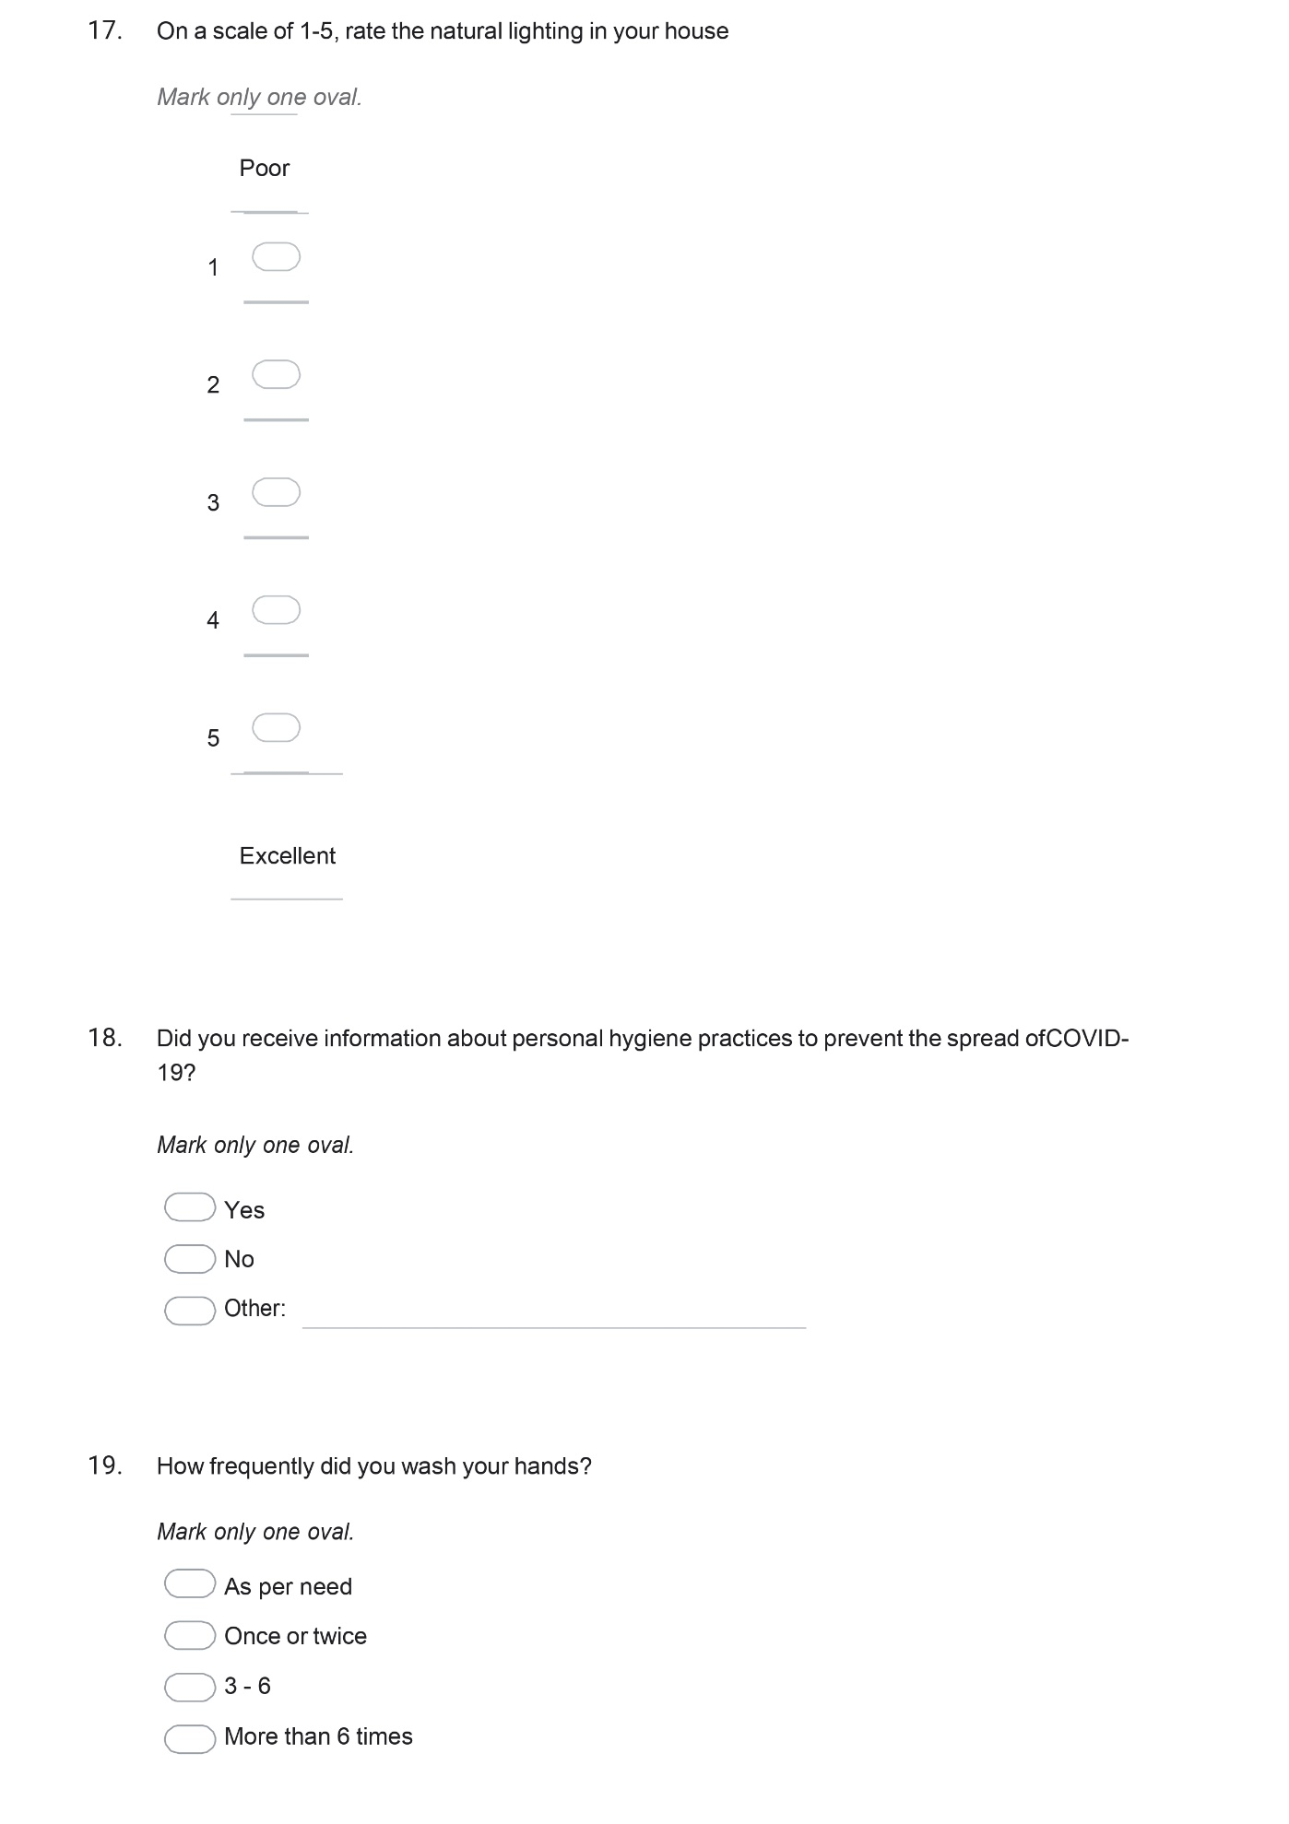
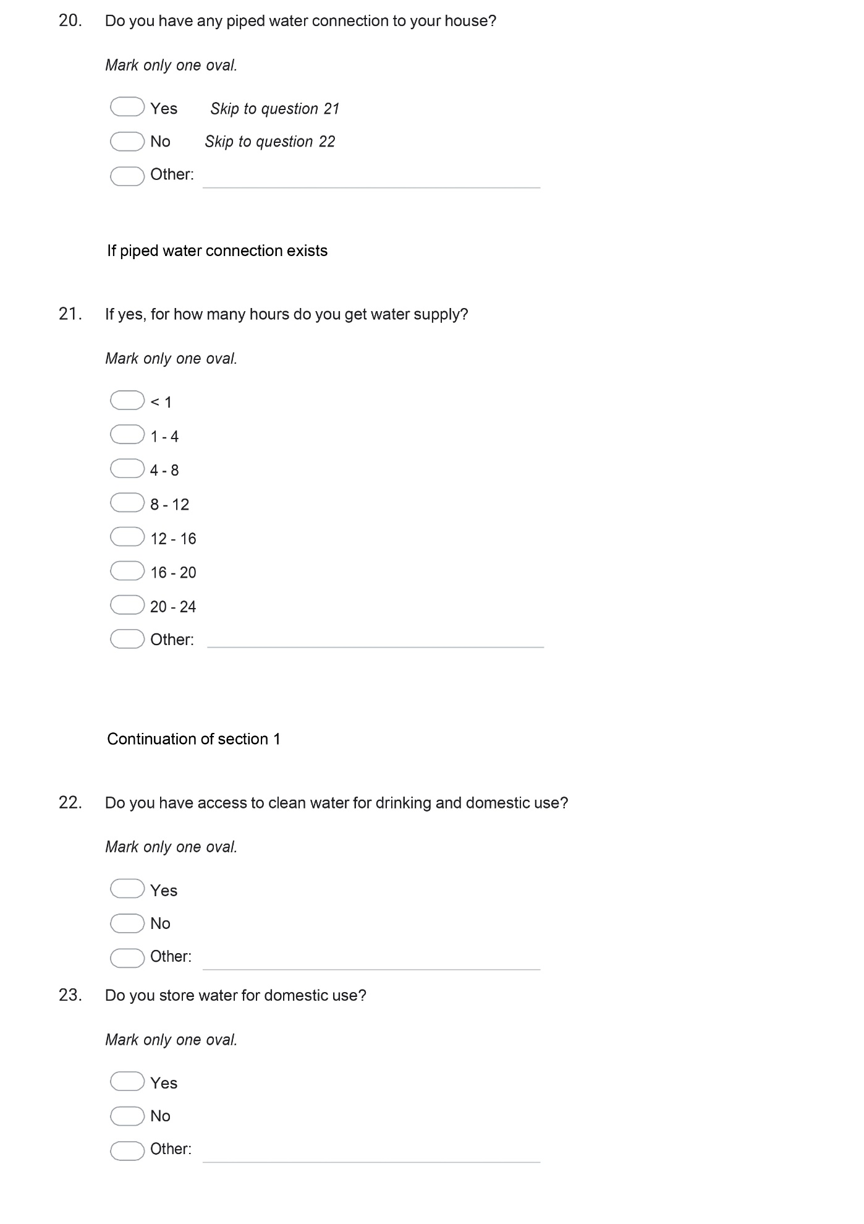
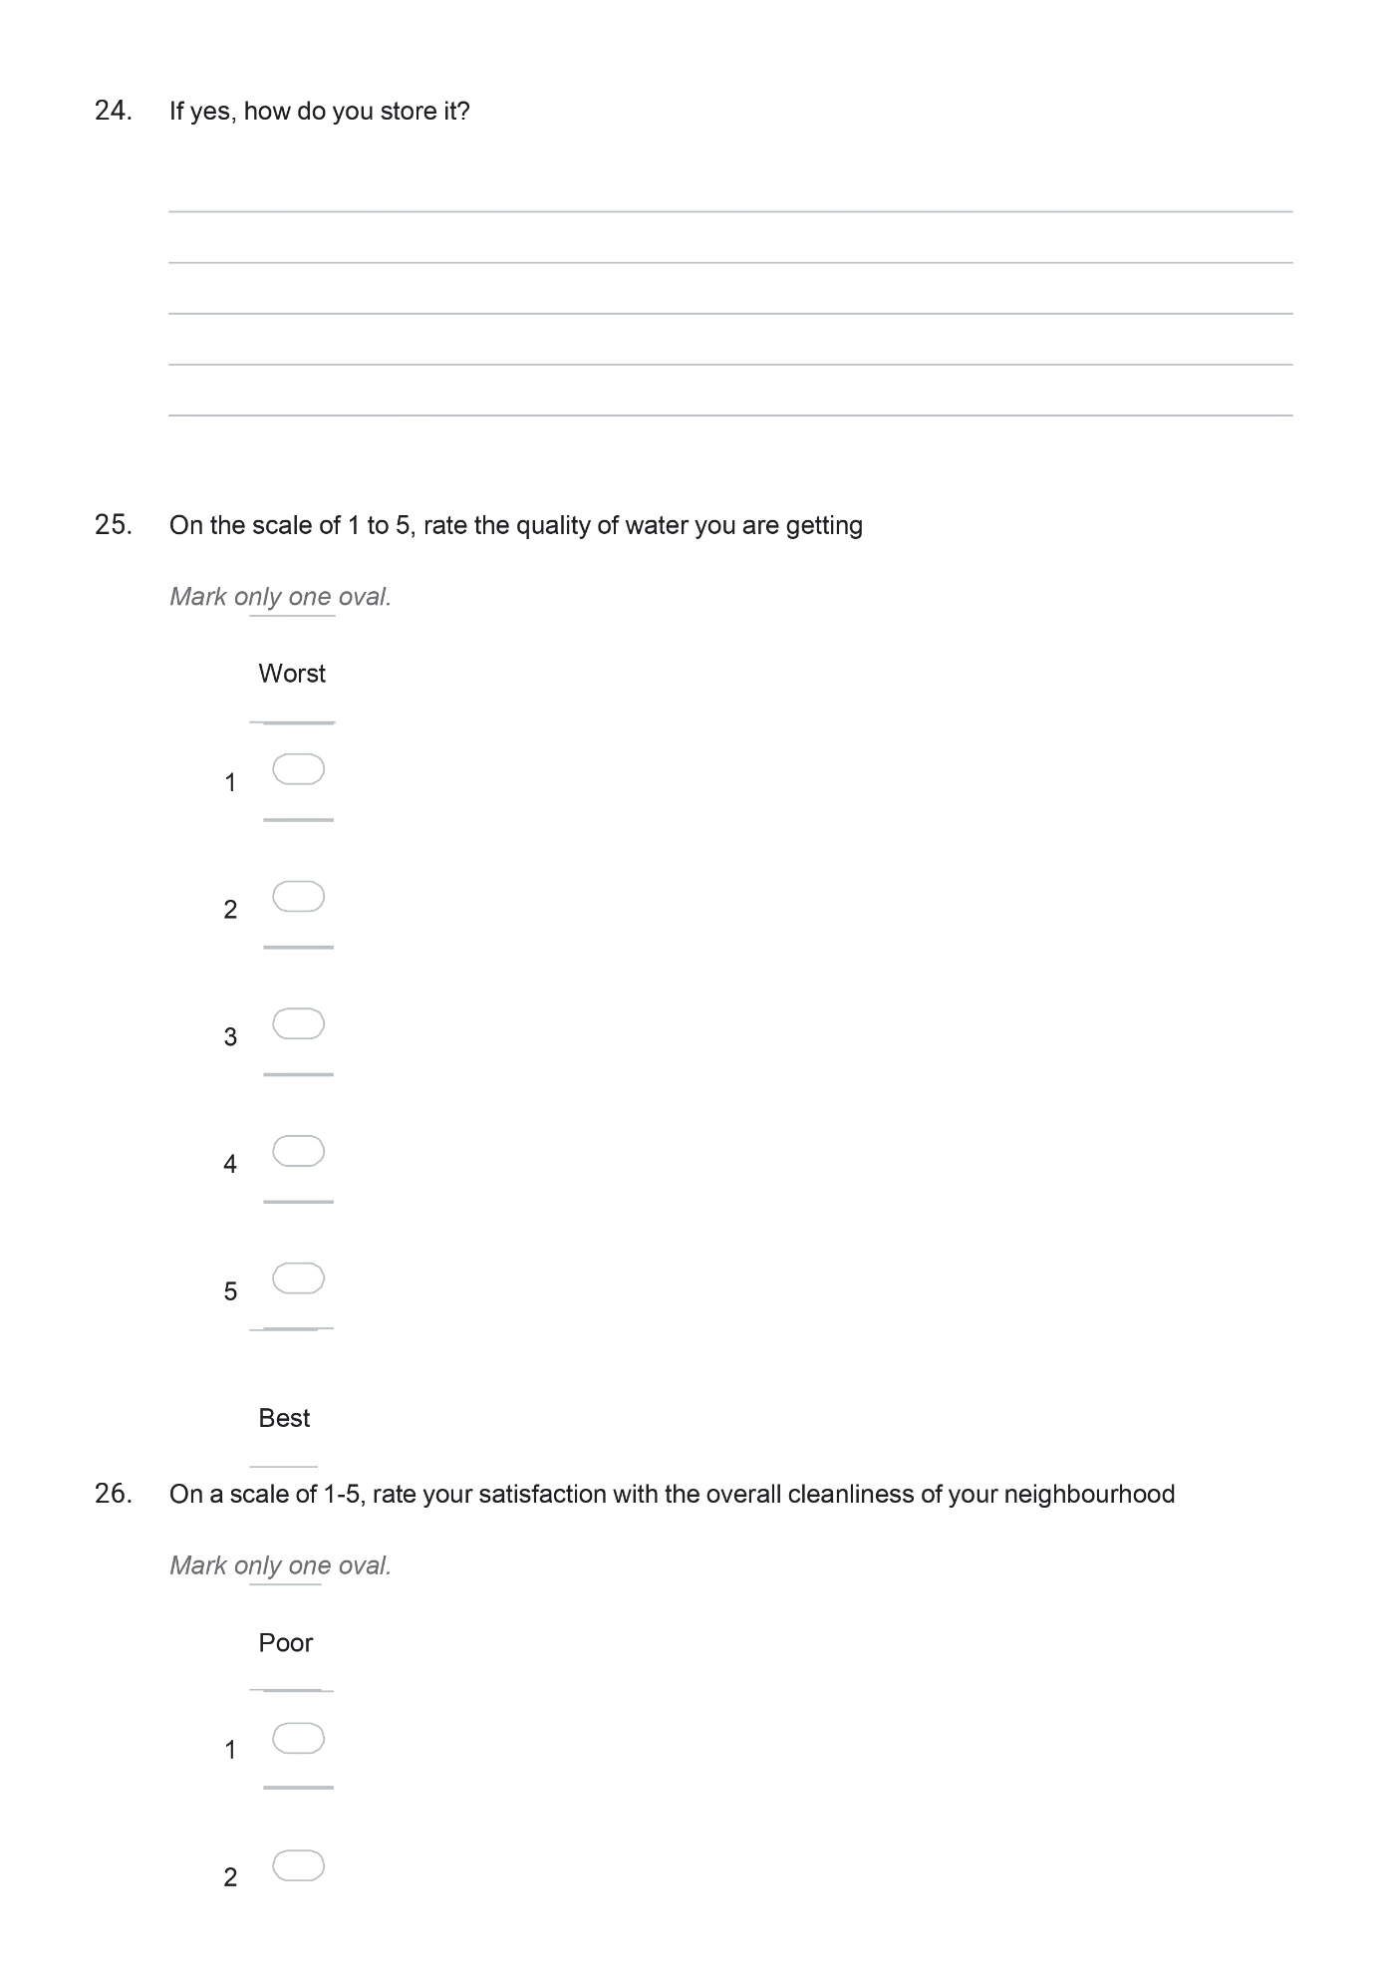
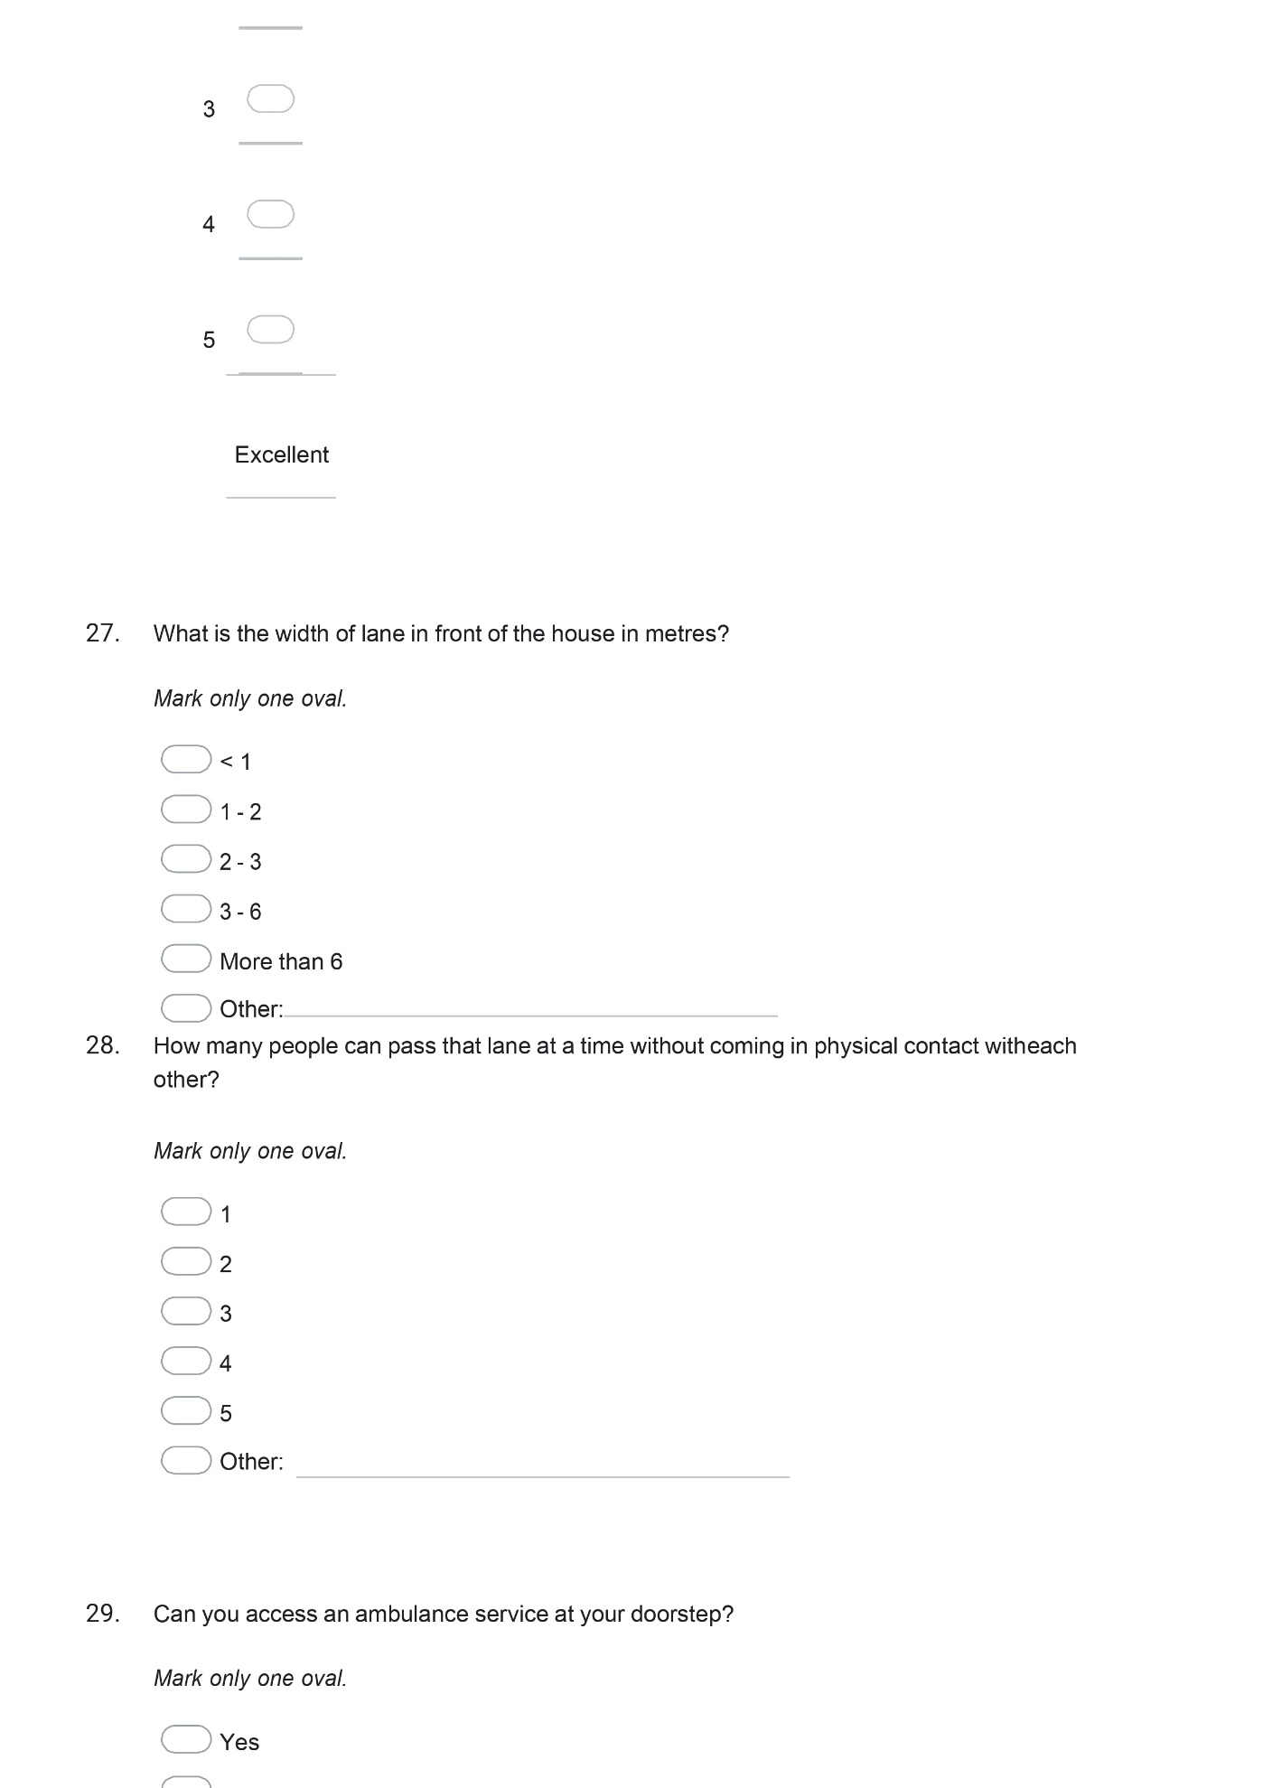
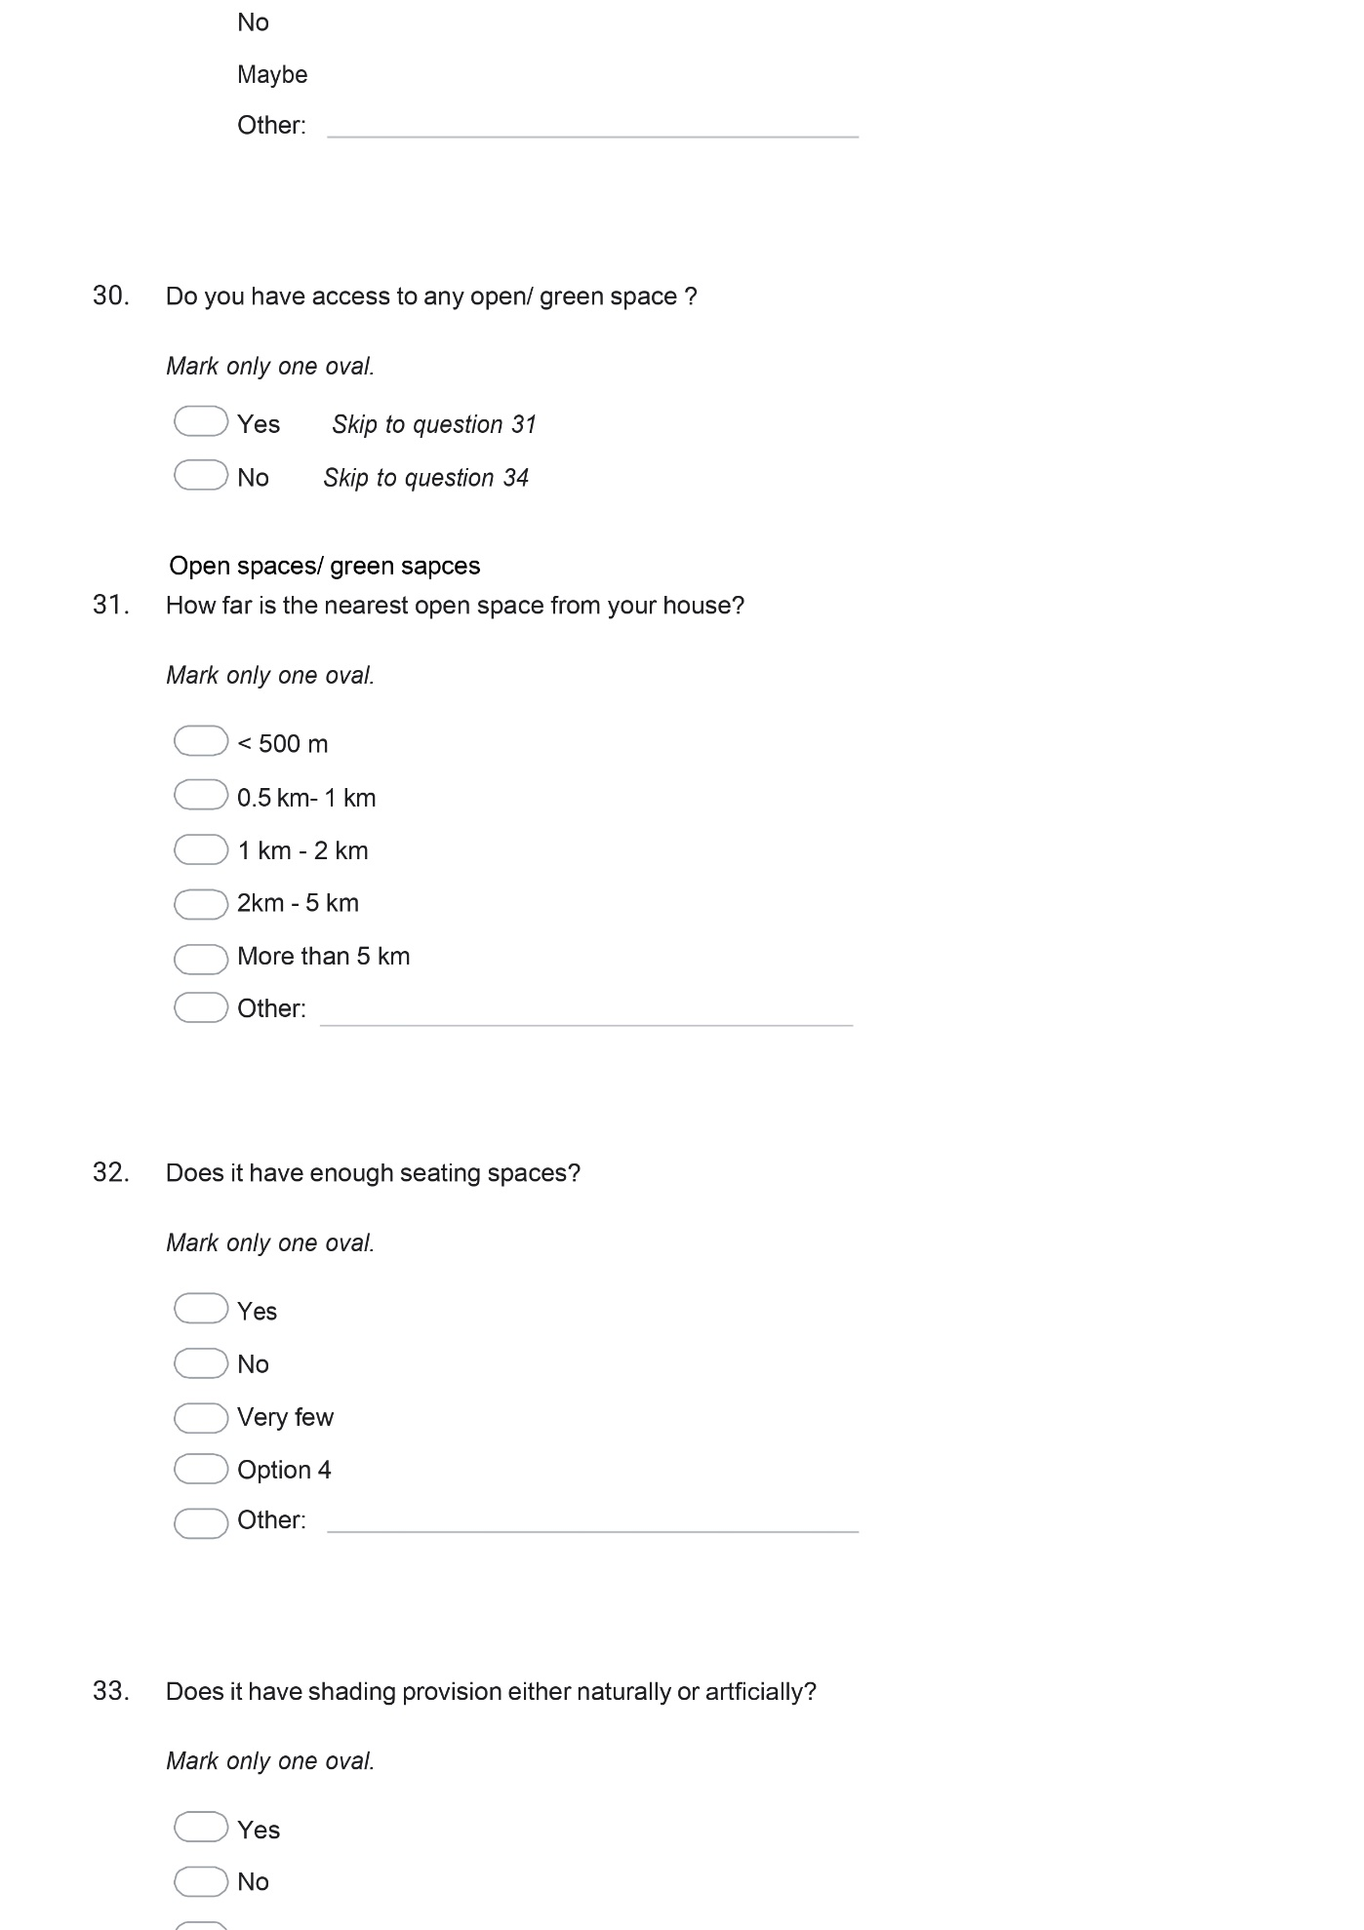
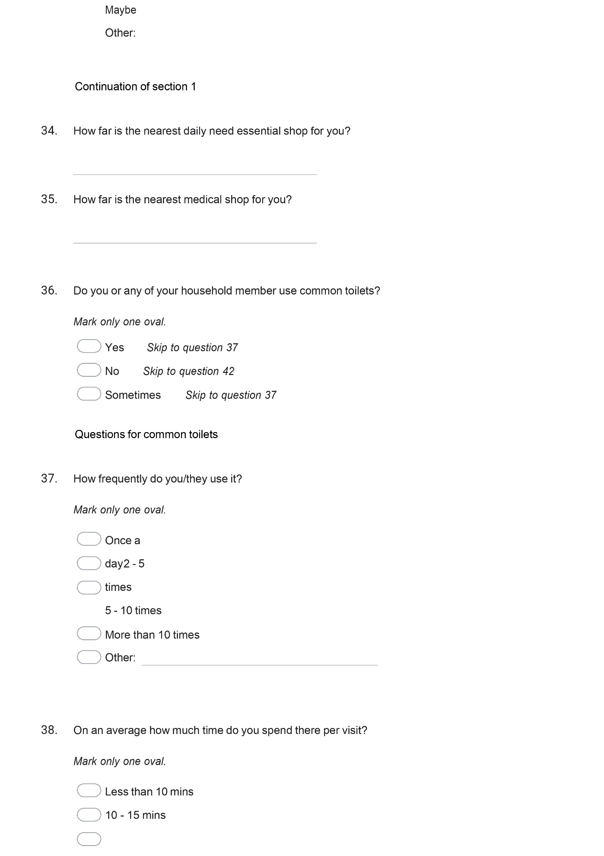
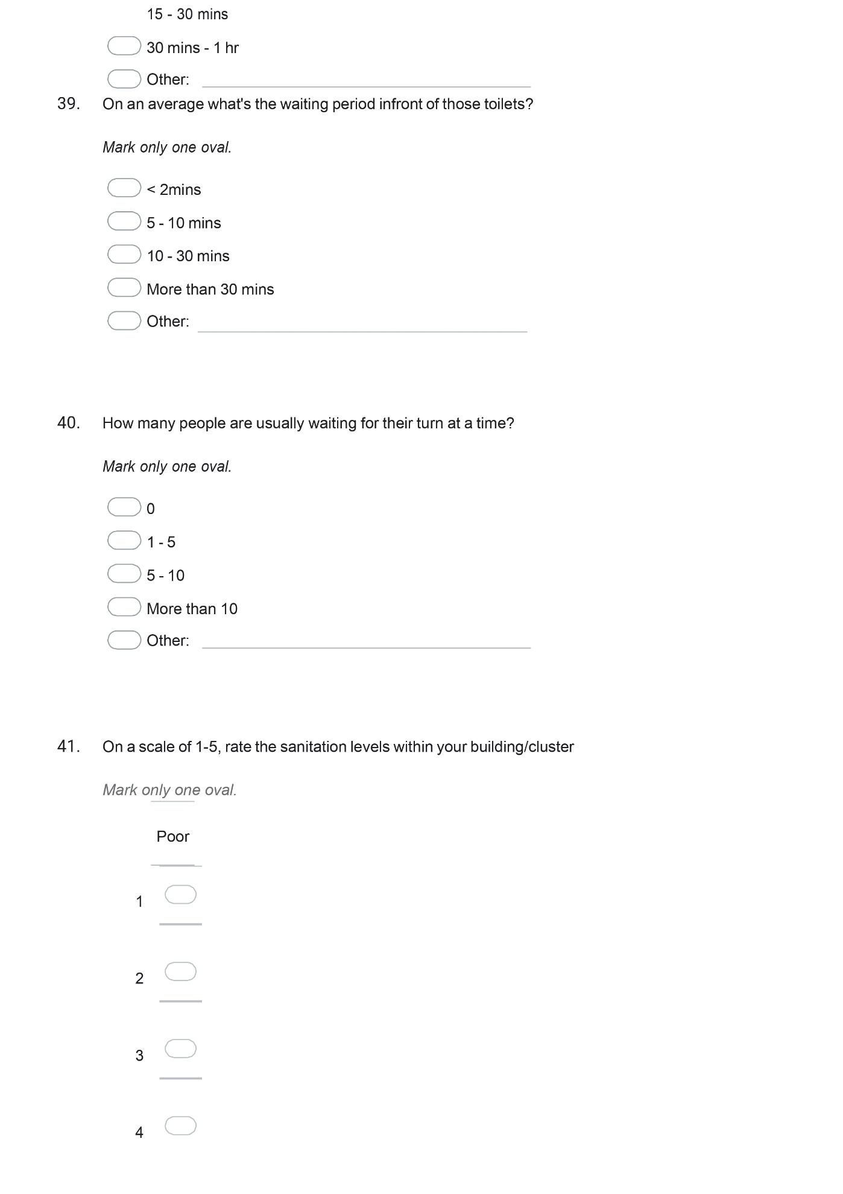
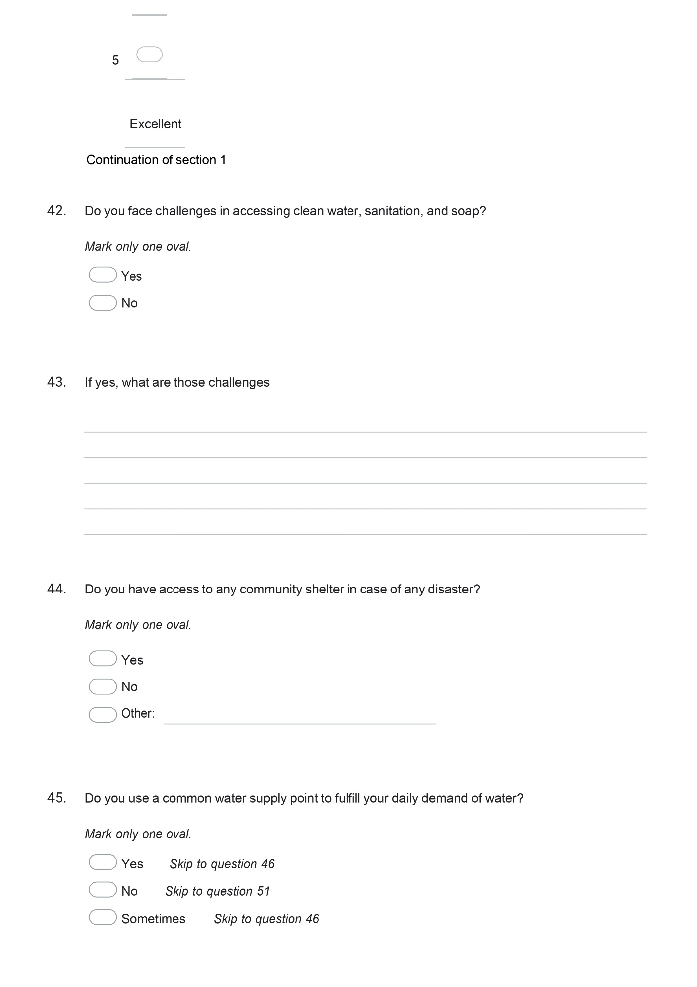
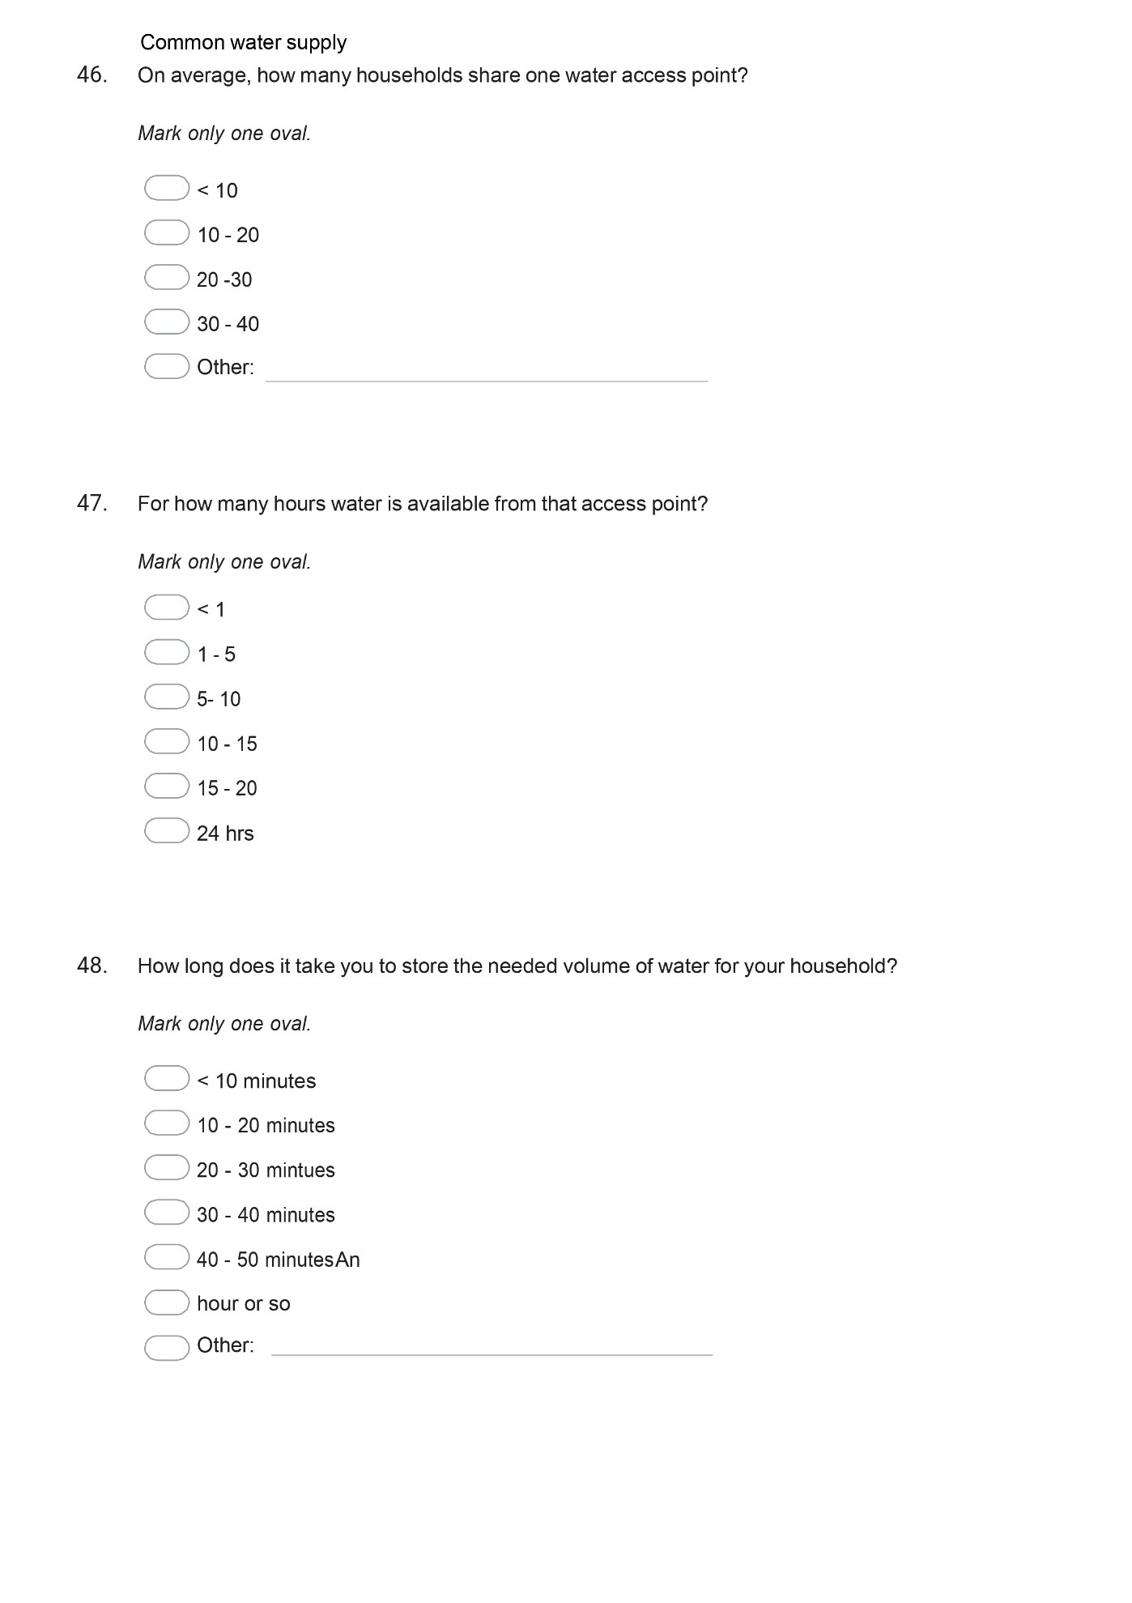
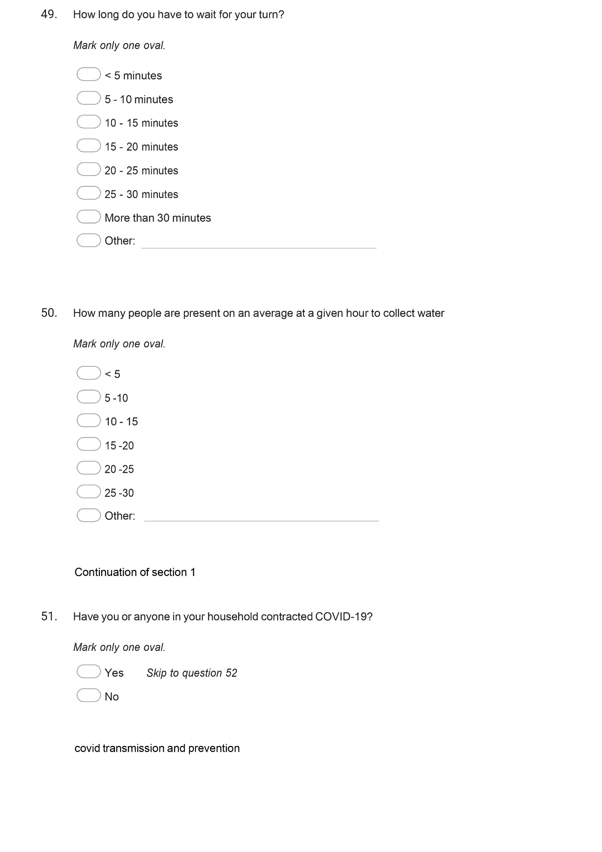
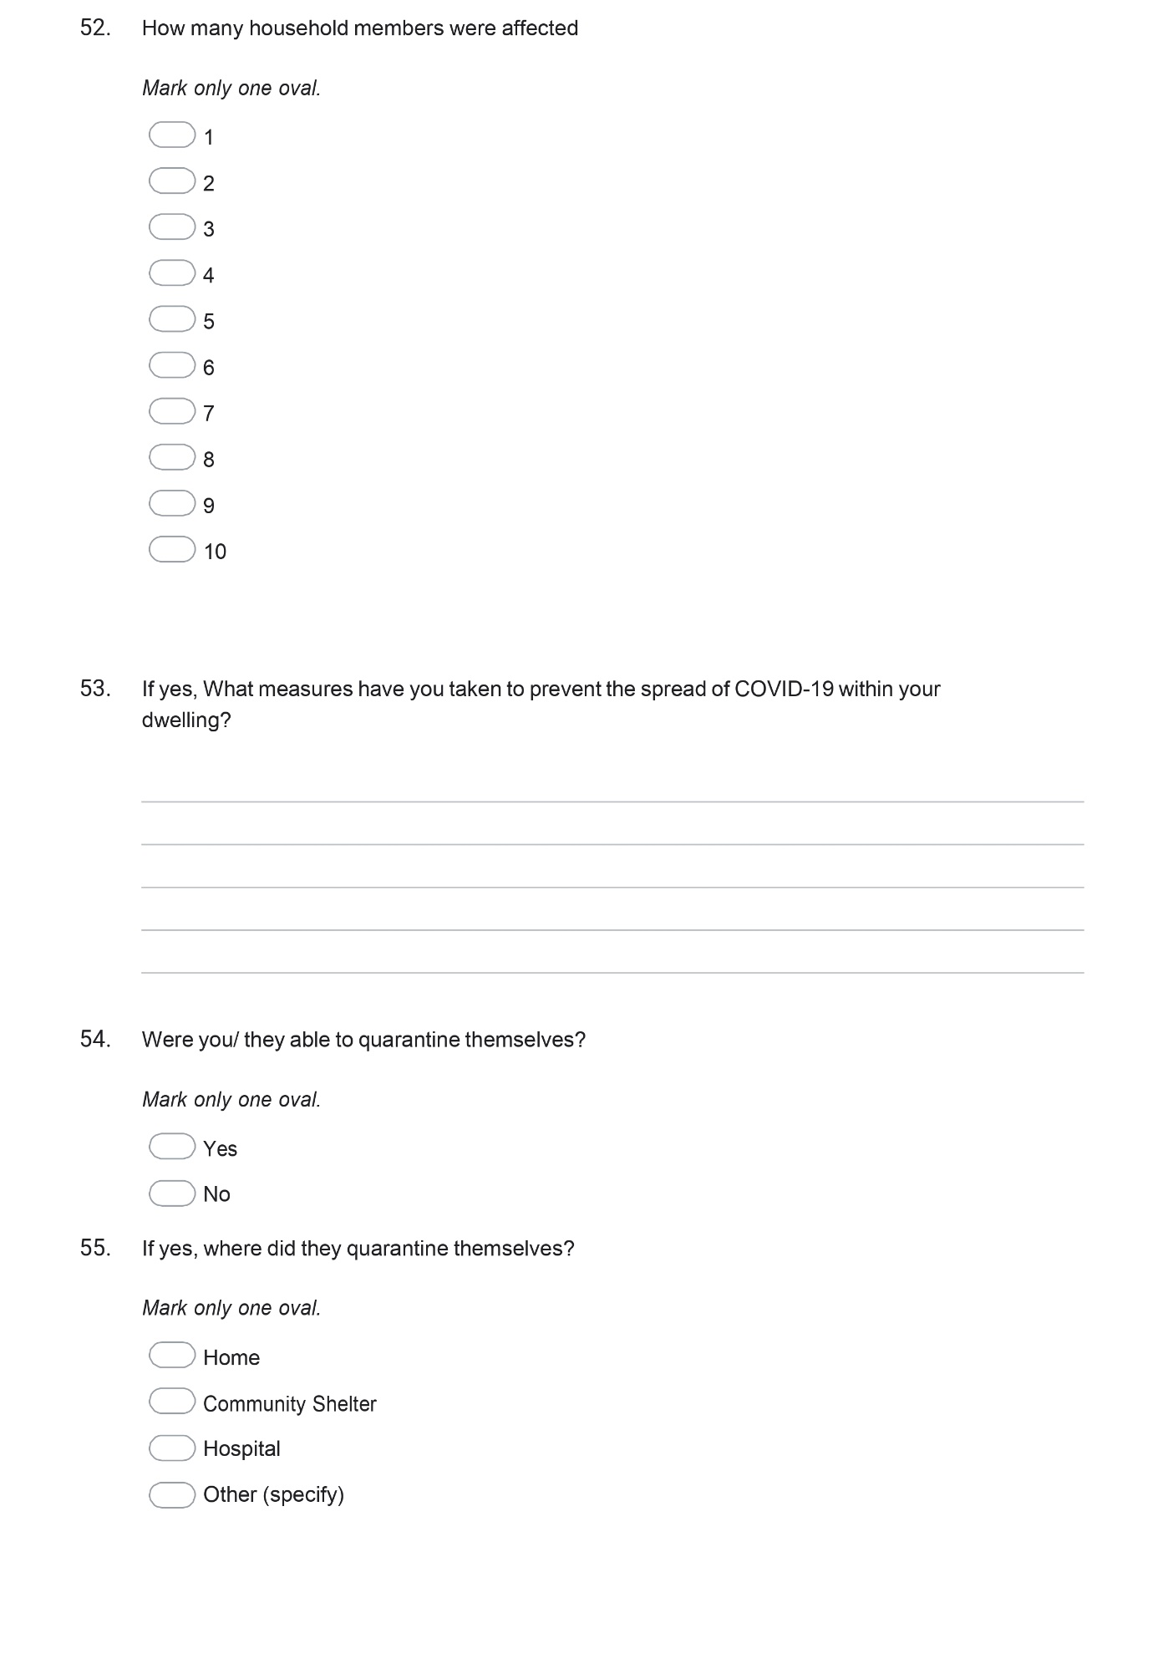
Responses to the questions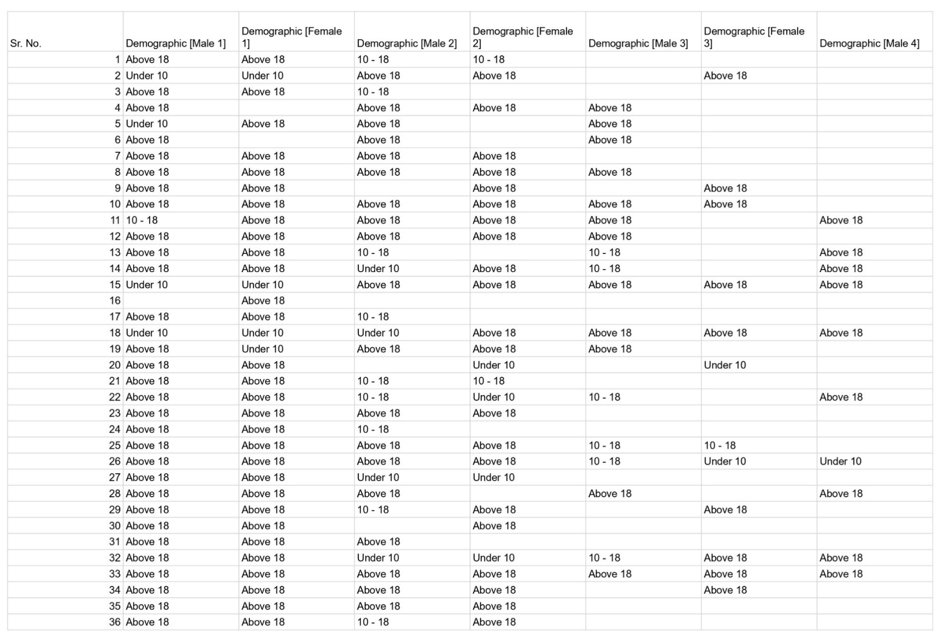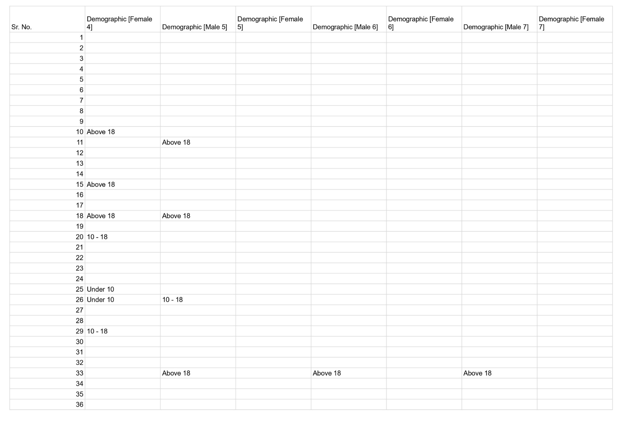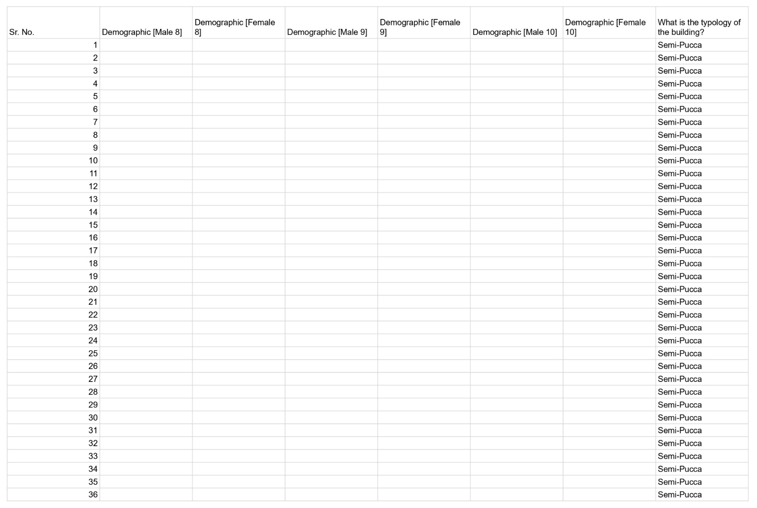
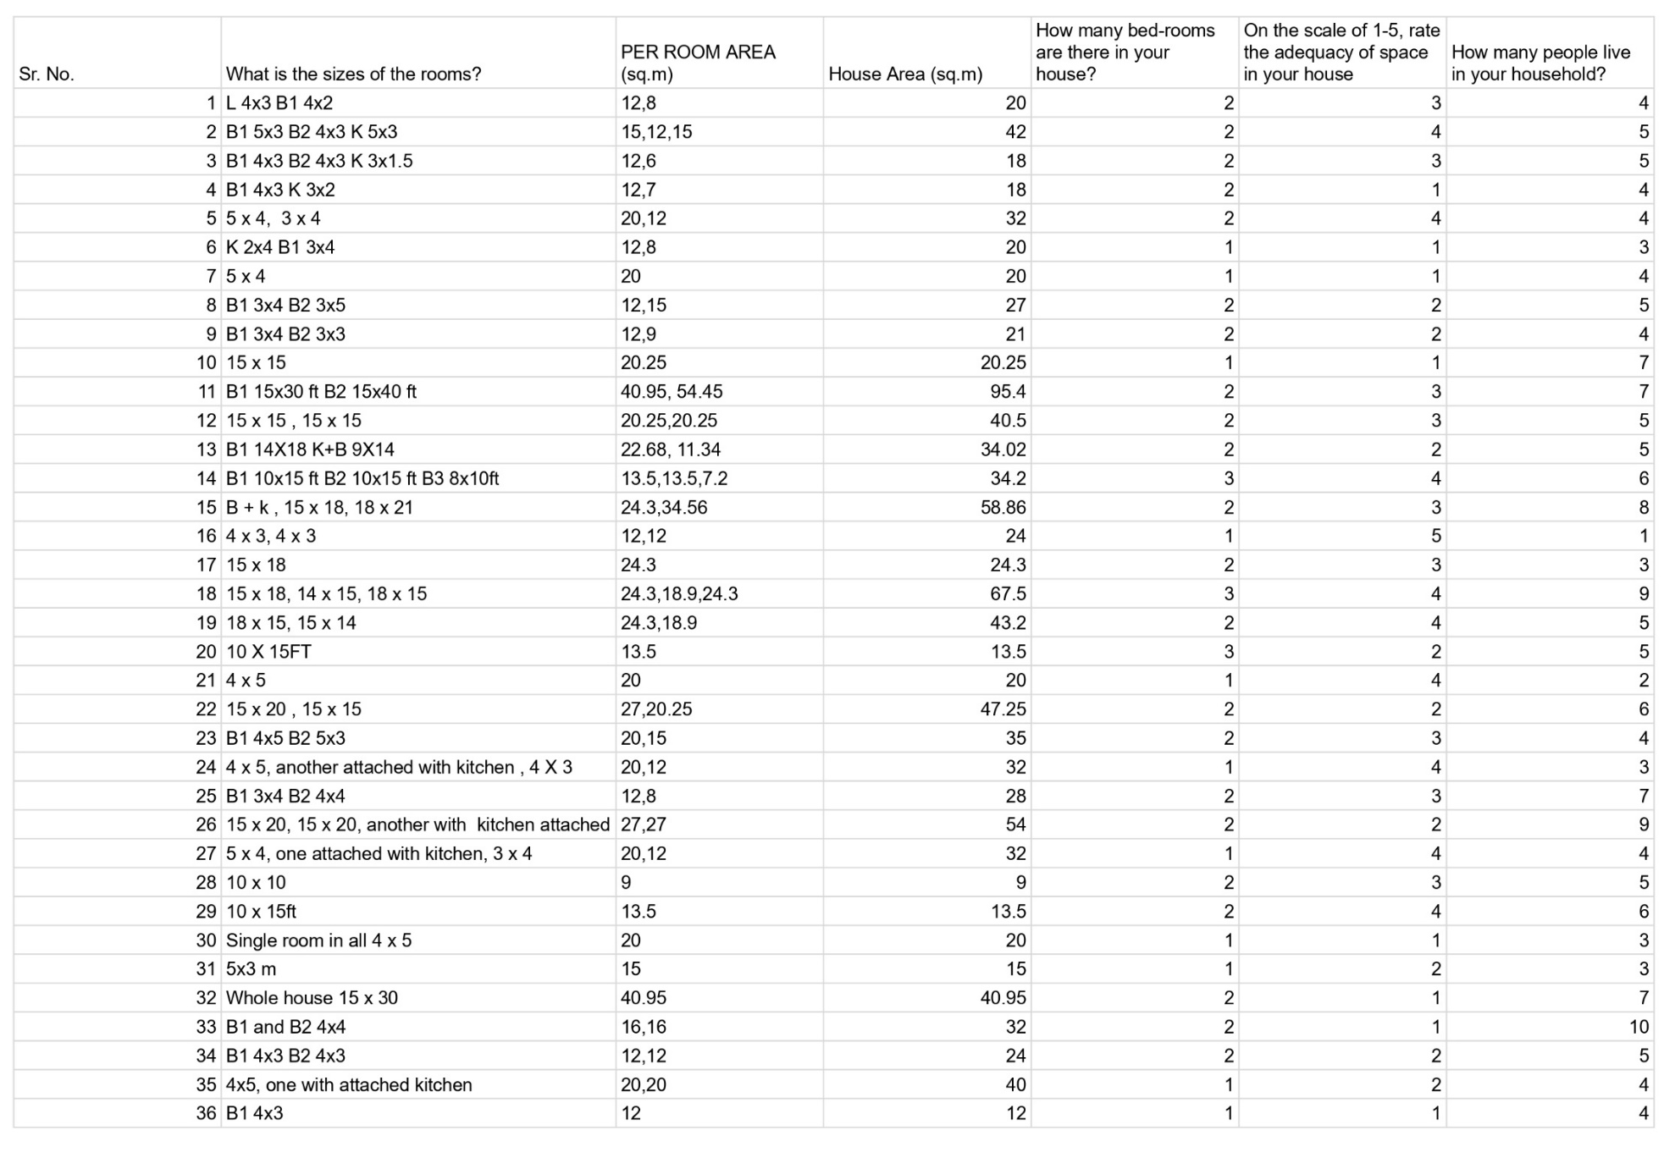
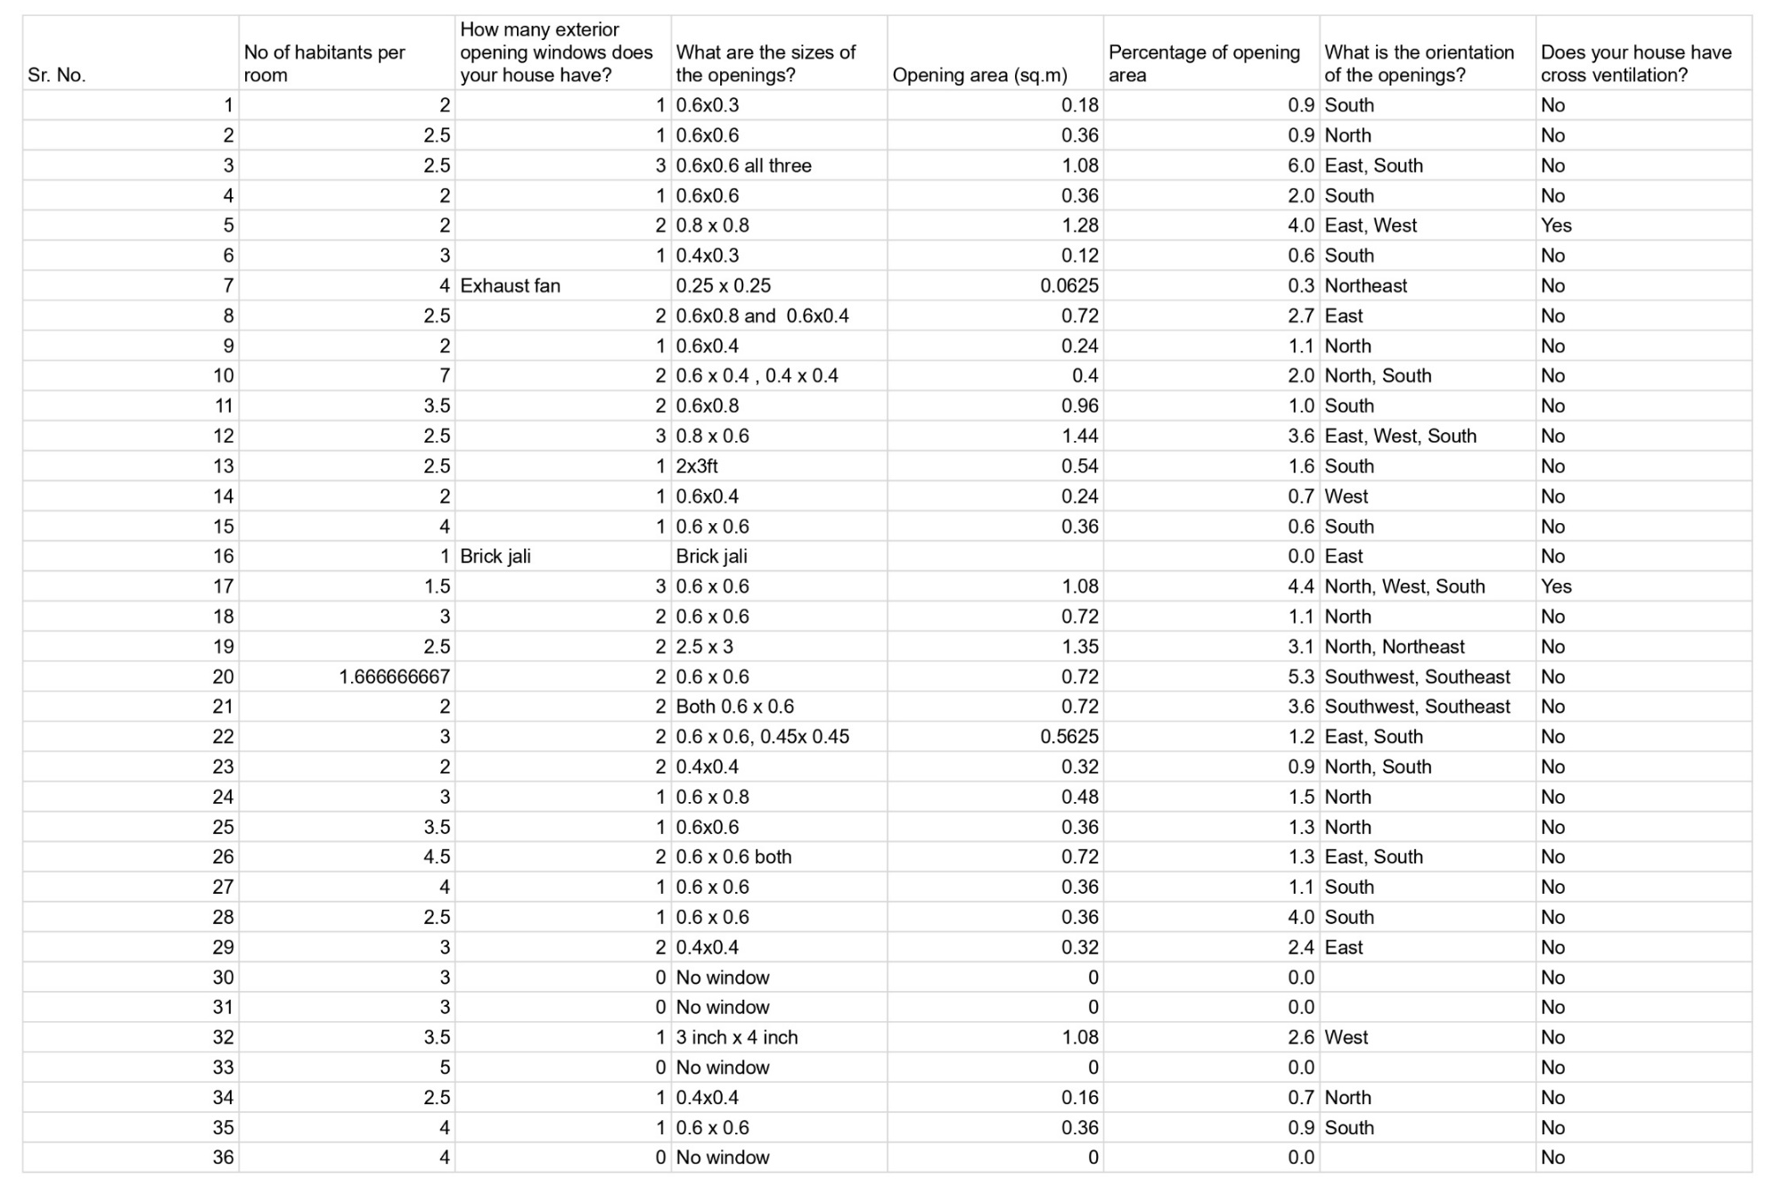
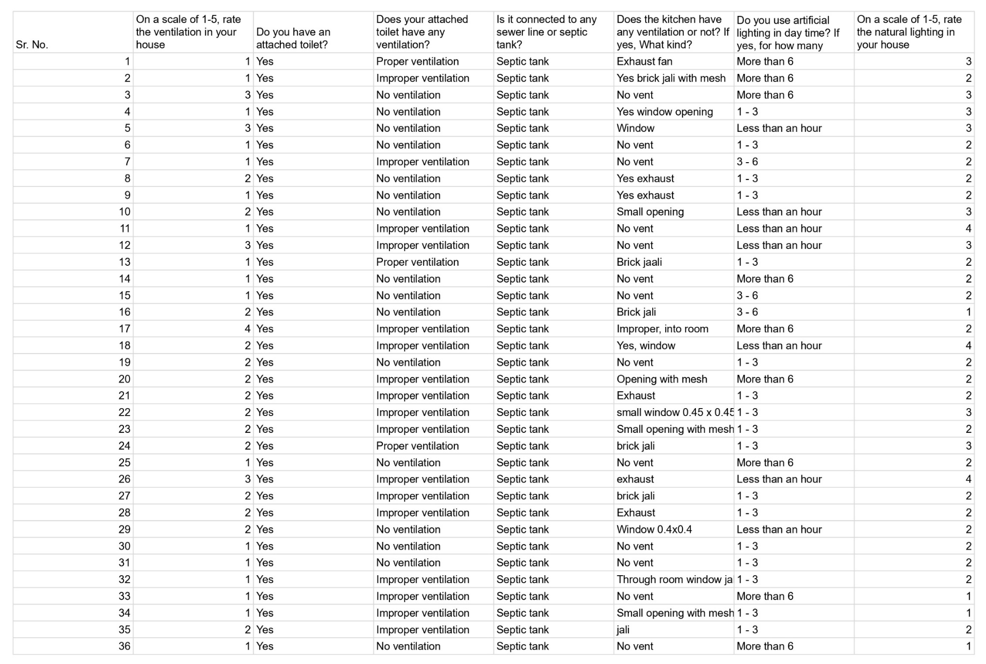
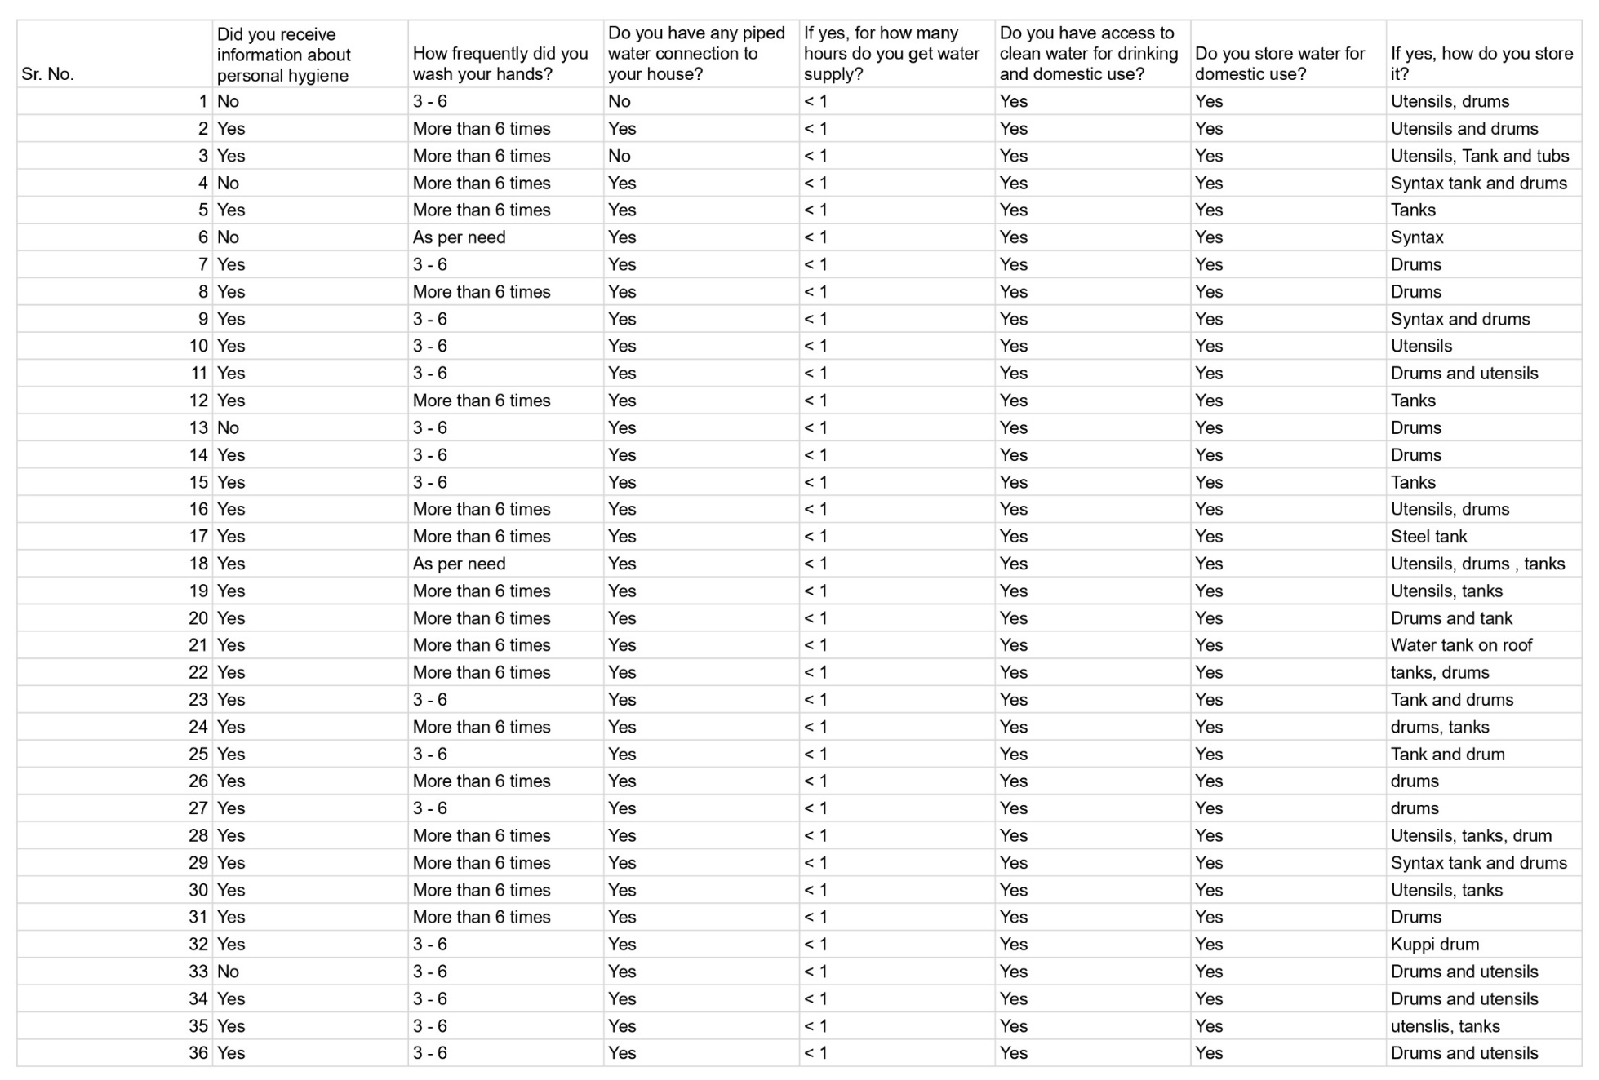
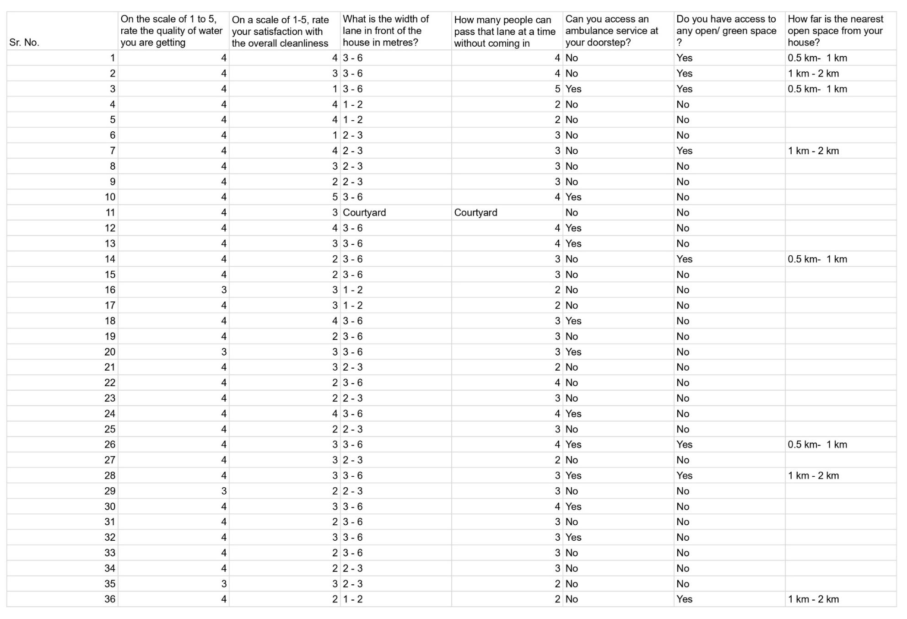
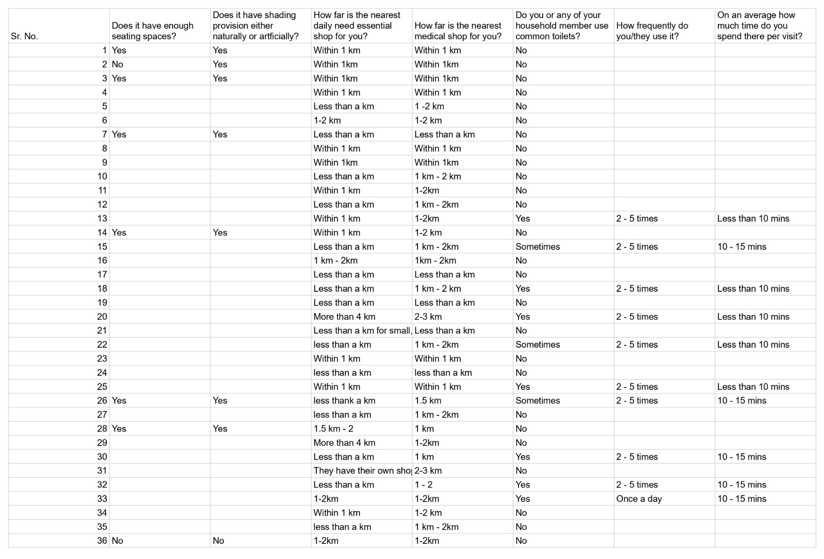
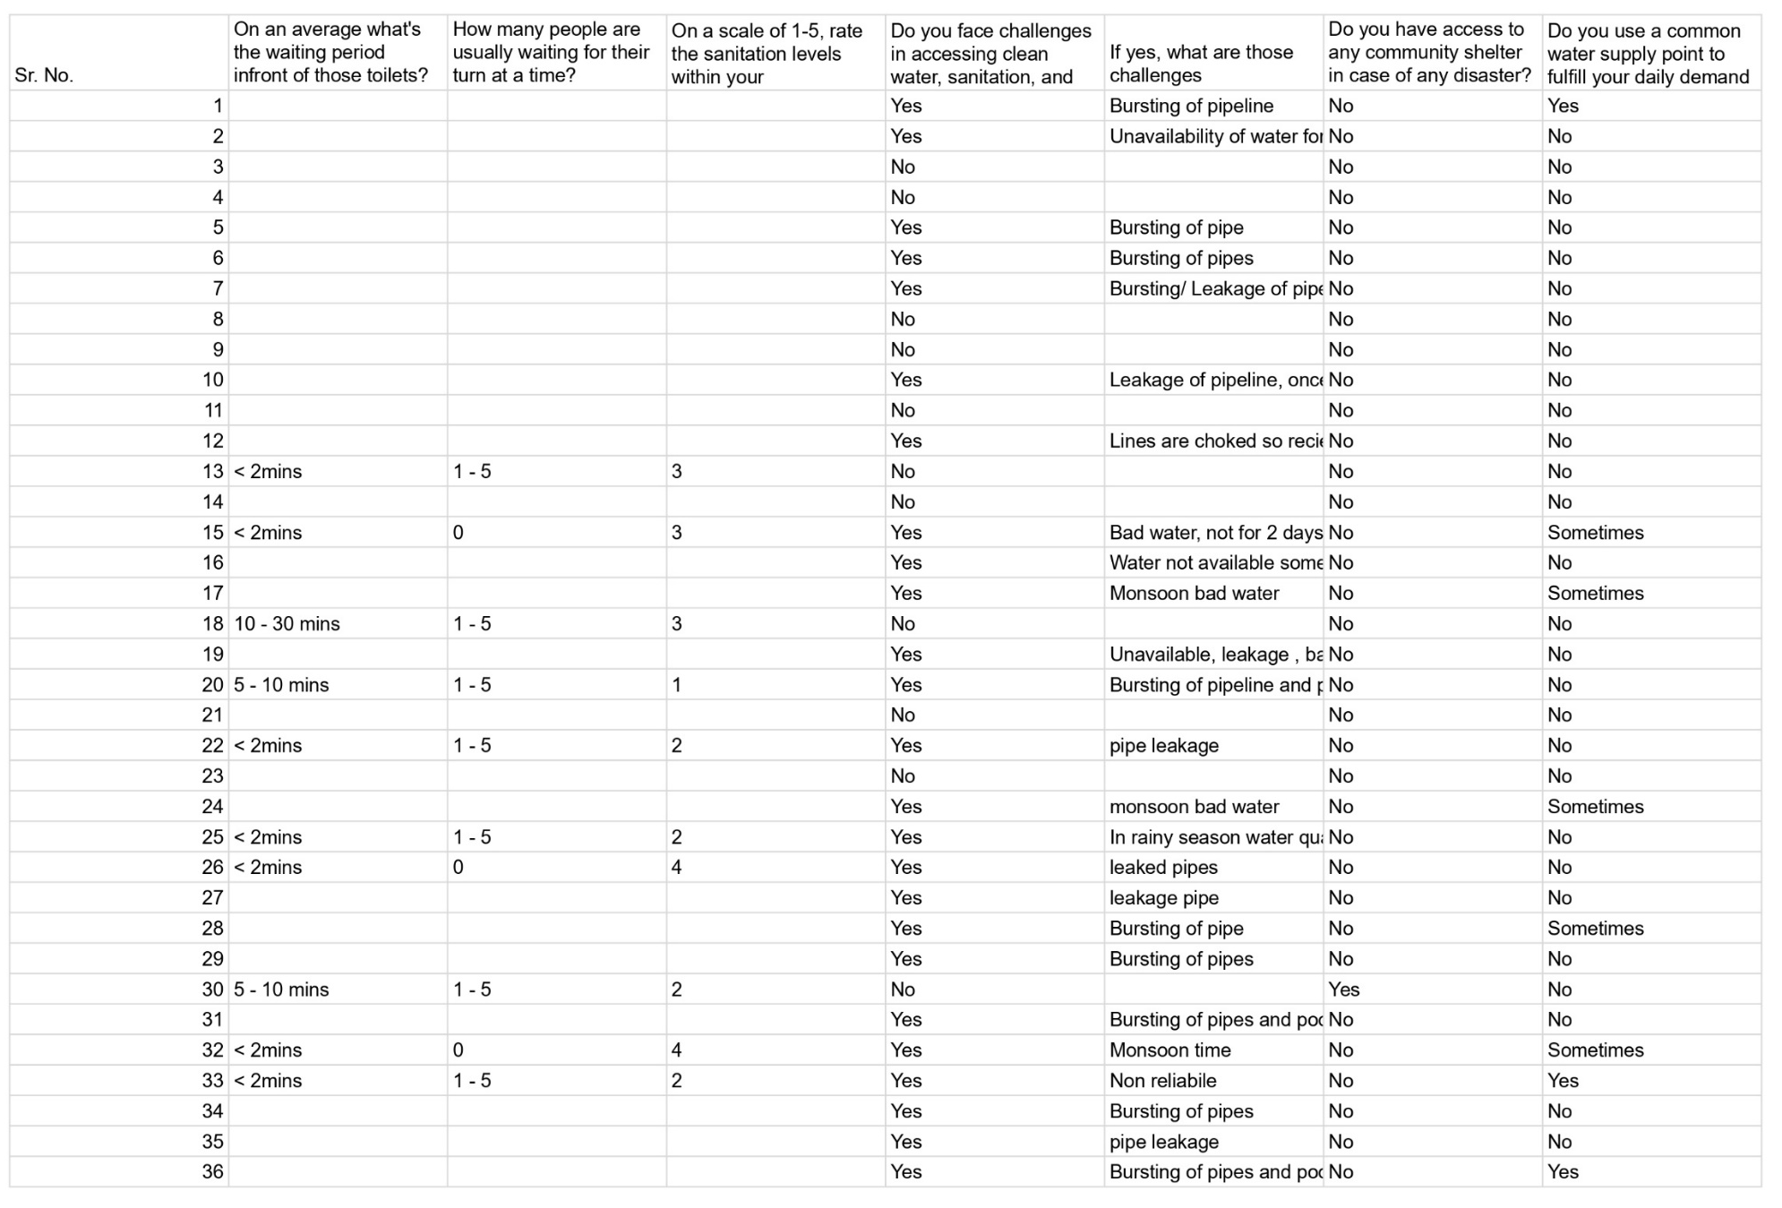
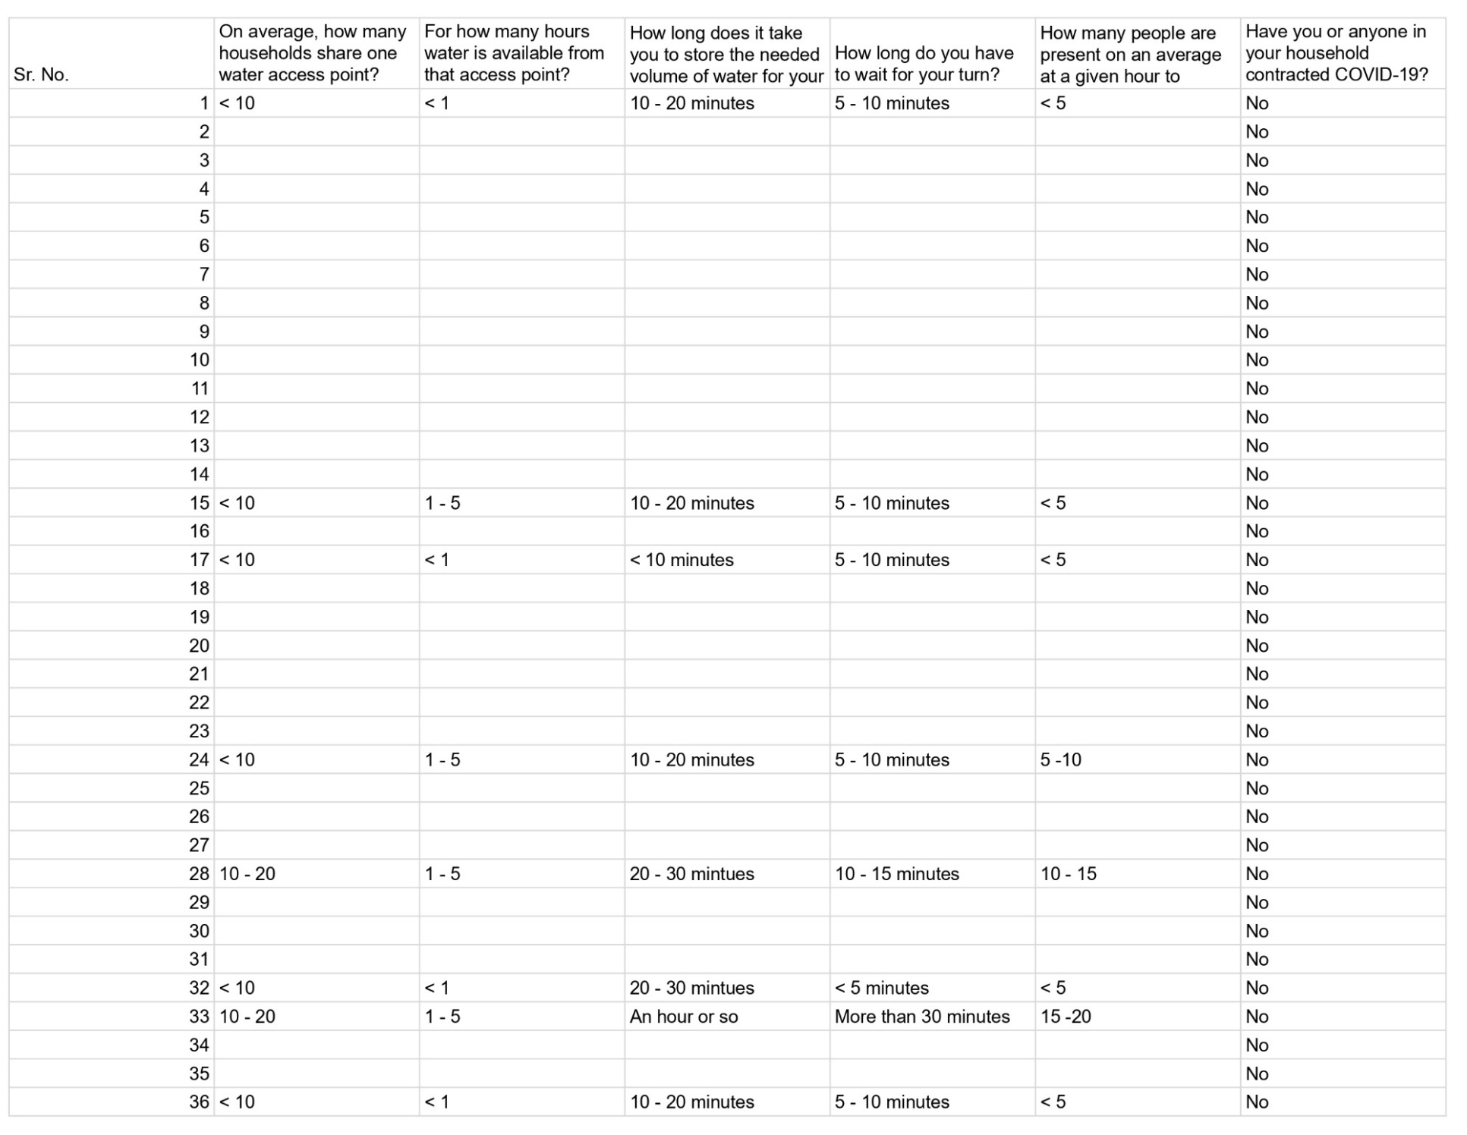
Resilience scoring
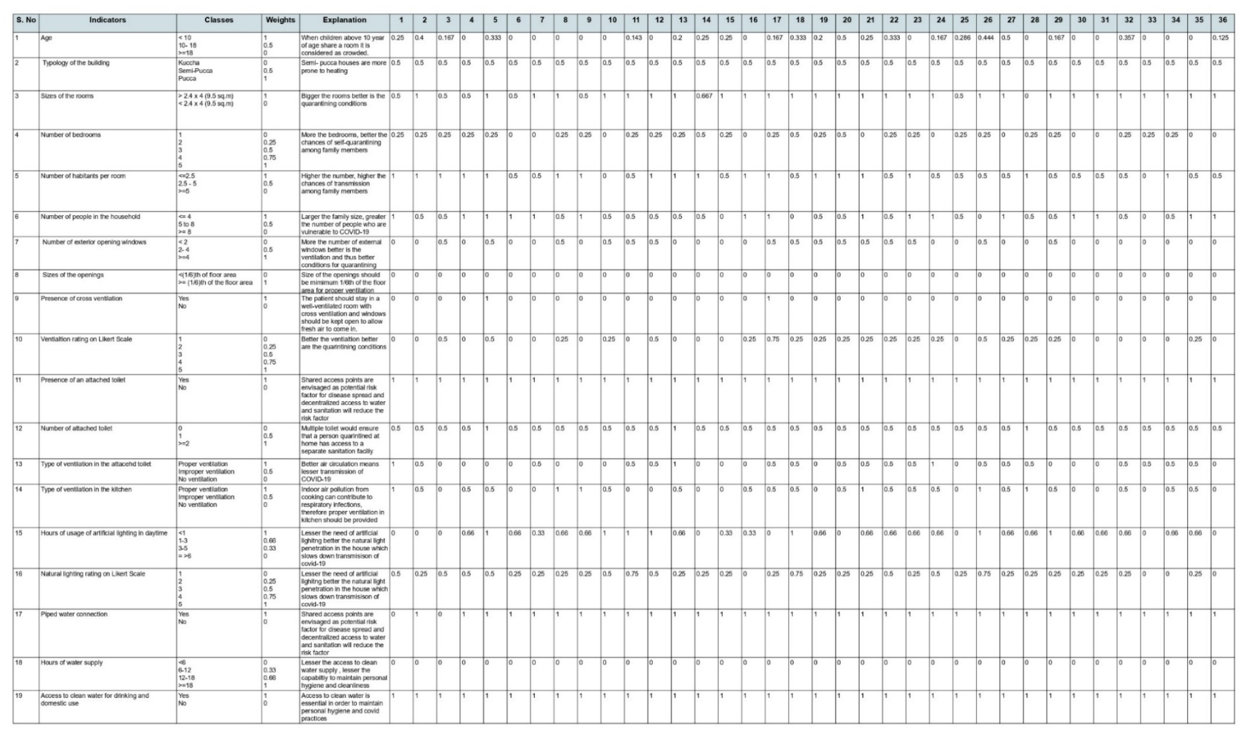
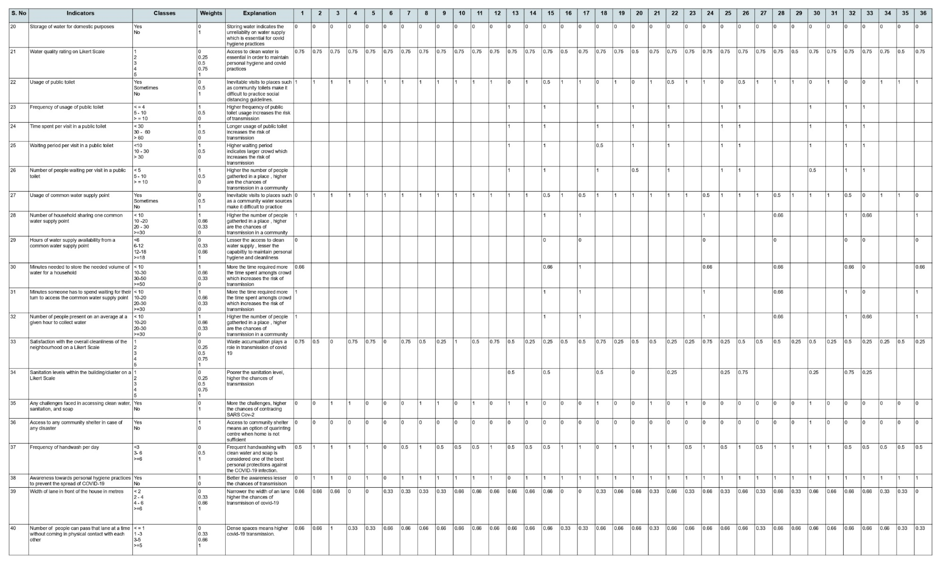
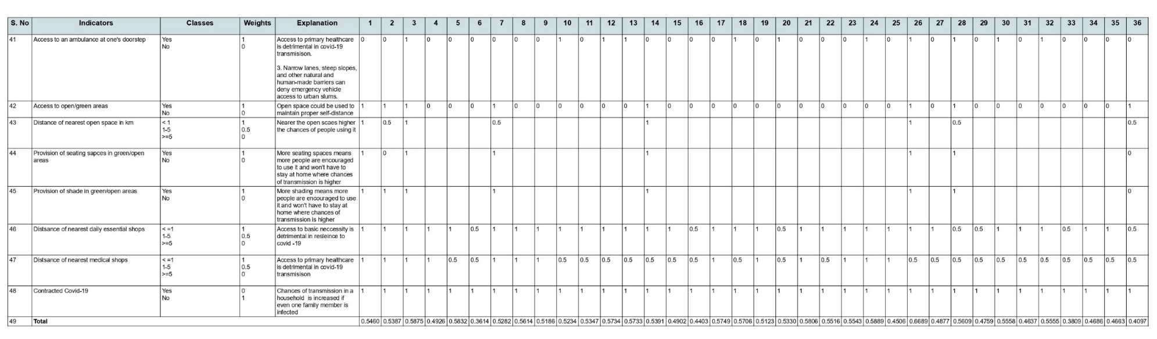

Table 1 Resilience indicator, associated weights, explanation
S. No | Indicator | Classes | Weights | Explanation / Rationale
1 | Age | < 10  10- 18  >=18 | 1  0.5  0 | When children above 10 years of age share a room, it is considered as crowded.
2 | Typology of the building | Kuccha  Semi-Pucca  Pucca | 0  0.5  1 | Semi- pucca houses are more prone to heating
3 | Sizes of the rooms | > 2.4 x 4 (9.5 sq.m)  < 2.4 x 4 (9.5 sq.m) | 1  0 | Bigger the rooms better are the quarantining conditions
4 | Number of bedrooms | 1  2  3  4  5 | 0  0.25  0.5  0.75  1 | More the bedrooms, better the chances of self-quarantining among family members
5 | Number of habitants per room | <= 2.5  2.5 - 5  >=5 | 1  0.5  0 | Higher the number, higher the chances of transmission among family members, children below 10 are considered half person.
6 | Number of people in the household | < = 4  5 to 8  >= 8 | 1  0.5  0 | Larger the family size, greater the number of people who are  vulnerable to COVID-19
7 | Number of exterior opening windows | < 2  2- 4  >=4 | 0  0.5  1 | More the number of external windows better is the ventilation and thus better conditions for quarantining
8 | Sizes of the openings | < (1/6) ^{th} x F.A  >= (1/6) ^{th} x F. A | 0  1 | Size of the openings should be minimum 1/6th of the floor area for proper ventilation
9 | Presence of cross ventilation | Yes  No | 1  0 | The patient should stay in a well-ventilated room with cross ventilation and windows should be kept open to allow fresh air to come in.
10 | Ventilation rating on Likert Scale | 1  2  3  4  5 | 0  0.25  0.5  0.75  1 | Better the ventilation better are the quarantining conditions
11 | Presence of an attached toilet | Yes  No | 1  0 | Shared access points are envisaged as potential risk factor for disease spread and decentralized access to water and sanitation will reduce the risk factor
12 | Number of attached toilets | 0  1  >= 2 | 0  0.5  1 | Multiple toilets would ensure that a person quarantined at home has access to a separate sanitation facility
13 | Type of ventilation in the attached toilet | Proper ventilation  Improper ventilation  No ventilation | 1  0.5  0 | Better air circulation means lesser transmission of COVID-19
14 | Type of ventilation in the kitchen | Proper ventilation  Improper ventilation  No ventilation | 1  0.5  0 | Indoor air pollution from cooking can contribute to respiratory infections, therefore proper ventilation in kitchen should be provided
15 | Hours of usage of artificial lighting in daytime | <1  1-3  3-5  >=6 | 1  0.66  0.33  0 | Lesser the need of artificial lighting better the natural light penetration in the house which slows down transmission of covid-19
16 | Natural lighting rating on Likert Scale | 1  2  3  4  5 | 0  0.25  0.5  0.75  1 | Lesser the need of artificial lighting better the natural light penetration in the house which slows down transmission of covid-19
17 | Piped water connection | Yes  No | 1  0 | Shared access points are envisaged as potential risk factor for disease spread and decentralized access to water and sanitation will reduce the risk factor
18 | Hours of water supply | <6  6-12  12-18  >=18 | 0  0.33  0.66  1 | Lesser the access to clean water supply, lesser the capability to maintain personal hygiene and cleanliness
19 | Access to clean water for drinking and domestic use | Yes  No | 1  0 | Access to clean water is essential in order to maintain personal hygiene and covid practices
20 | Storage of water for domestic purposes | Yes  No | 0 1 | Storing water indicates the unreliability on water supply which is essential for covid hygiene practices
21 | Water quality rating on Likert Scale | 1  2  3  4  5 | 0  0.25  0.5  0.75  1 | Access to clean water is essential in order to maintain personal hygiene and covid practices
22 | Usage of public toilet | Yes  Sometimes  No | 0  0.5  1 | Shared sanitation facilities, could become a vital source of airborne and contact exposures to  SARS-CoV-2
23 | Frequency of usage of public toilet | < = 4  5 - 10  > = 10 | 1  0.5  0 | Higher frequency of public toilet usage increases the risk of transmission
24 | Time spent per visit in a public toilet | < 30  30 - 60  >=60 | 1  0.5  0 | Longer usage of public toilet increases the risk of transmission
25 | Waiting period per visit in a public toilet | <10  10 - 30  >= 30 | 1  0.5  0 | Higher waiting period indicates larger crowd which increases the risk of transmission
26 | Number of people waiting per visit in a public toilet at a time | < 5  5 - 10  >= 10 | 1  0.5  0 | Higher the number of people gathered in a place, higher are the chances of transmission in a community
27 | Usage of common water supply point | Yes  Sometimes  No | 0  0.5  1 | Inevitable visits to places such as a community water sources make it difficult to practice social distancing guidelines.
28 | Number of households sharing one common water supply point at a time | < 10  10 -20  20 - 30  >=30 | 1  0.66  0.33  0 | Higher the number of people gathered in a place, higher are the chances of transmission in a community
29 | Hours of water supply availability from a common water supply point | <6  6-12  12-18  >18 | 0  0.33  0.66  1 | Lesser the access to clean water supply, lesser the capability to maintain personal hygiene and cleanliness
30 | Minutes needed to store the needed volume of water for a household | < 10  10 - 30  30 -50  >=50 | 1  0.66  0.33  0 | More the time required more the time spent amongst crowd which increases the risk of transmission
31 | Minutes someone has to spend waiting for their turn to access the common water supply point | < 10  10 - 20  20 - 30  >=30 | 1  0.66  0.33  0 | More the time required more the time spent amongst crowd which increases the risk of transmission
32 | Number of people present on an average at a given hour to collect water | <10  10 - 20  20 - 30  >=30 | 1  0.66  0.33  0 | Higher the number of people gathered in a place, higher are the chances of transmission in a community
33 | Satisfaction with the overall cleanliness of the neighbourhood on a Likert Scale | 1  2  3  4  5 | 0  0.25  0.5  0.75  1 | Waste accumulation plays a role in transmission of covid 19
34 | Sanitation levels within the building/cluster on a Likert Scale | 1  2  3  4  5 | 0  0.25  0.5  0.75  1 | Poorer the sanitation level, higher the chances of transmission
35 | Any challenges faced in accessing clean water, sanitation, and soap | Yes  No | 0  1 | More the challenges, higher the chances of contracting SARS Cov-2
36 | Access to any community shelter in case of any disaster | Yes  No | 1  0 | Access to community shelter means an option of quarantine centre when home is not sufficient
37 | Frequency of handwash per day | <3  3- 6  >=6 | 0  0.5  1 | Frequent handwashing with clean water and soap is considered one of the best personal protections against the COVID‐19 infection.
38 | Awareness towards personal hygiene practices to prevent the spread of COVID-19 | Yes  No | 1  0 | Better the awareness lesser the chances of transmission
39 | Width of lane in front of the house in metres | <2  2-4  4-6  >=6 | 0  0.33  0.66  1 | Narrower the width of a lane higher the chances of transmission of covid-19
40 | Number of people can pass that lane at a time without coming in physical contact with each other | < = 1  1 -3  3 - 5  >=5 | 0  0.33  0.66  1 | Dense spaces mean higher covid-19 transmission.
41 | Access to an ambulance at one's doorstep | Yes  No | 1  0 | Access to primary healthcare is detrimental in covid-19 transmission.
42 | Access to open/green areas | Yes  No | 1  0 | Plays key role during the  pandemic by providing services relevant to health, recreation, limited public life.
43 | Distance of nearest open space in km | < 1  1 - 5  >=5 | 1  0.5  0 | Nearer the open spaces higher the chances of people using it
44 | Provision of seating spaces in green/open areas | Yes  No | 1  0 | More seating spaces means more people are encouraged to use it
45 | Provision of shade in green/open areas | Yes  No | 1  0 | More shading means more people are encouraged to use it
46 | Distance of nearest daily essential shops | < 1  1 - 5  >=5 | 1  0.5  0 | Access to basic necessity is detrimental in resilience to covid -19
47 | Distance of nearest medical shops | < 1  1 - 5  >=5 | 1  0.5  0 | Access to primary healthcare is detrimental in covid-19 transmission
48 | Contracted Covid-19 | Yes  No | 0  1 | Chances of transmission in a household is increased if even one family member is infected

Table 2: Resilience score interpretation.
S. No. | Score | Category
1 | 1 – 0.75 | Good
2 | 0.75 - 50 | Average
3 | 0.50 - 0.25 | Below Average
4 | 0.0 – 0.25 | Poor

Table 3: Correlation amongst variables
Correlations
 |  | Housing  Design | Housing Infrastructure | Community Infrastructure | Community Design | Resilience score of a house
Housing Design | Pearson Correlation | 1 | .385* | .209 | .103 | .698**
Housing Infrastructure | Pearson Correlation | .385* | 1 | .153 | -.110 | .419*
Community Infrastructure | Pearson Correlation | .209 | .153 | 1 | .286 | .601**
Community Design | Pearson Correlation | .103 | -.110 | .286 | 1 | .661**
Resilience score of a house | Pearson Correlation | .698** | .419* | .601** | .661** | 1

Table 4: Regression Coefficients Table
Coefficientsª
Model |  | Unstandardized Coefficients |  | Standardized Coefficients | t | Sig.
 |  | B | Std. Error | Beta | t | Sig.
1 | (Constant) | .016 | .013 |  | 1.272 | .213
1 | Housing Design | .351 | .016 | .482 | 21.912 | .000
1 | Housing Infrastructure | .216 | .019 | .248 | 11.240 | .000
1 | Community Design | .171 | .012 | .304 | 14.258 | .000
1 | Community Infrastructure | .231 | .009 | .552 | 26.062 | .000
a. Dependent Variable: Resilience score of a house

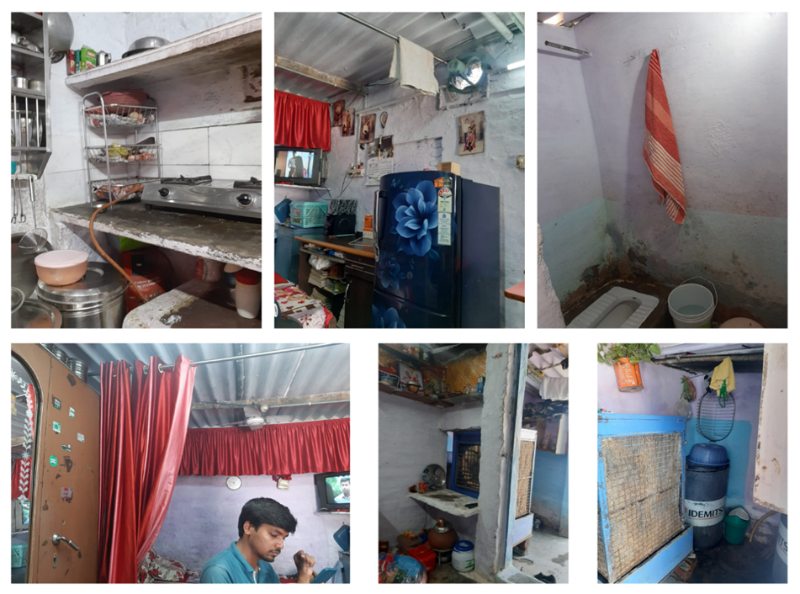
Photo: 1 Typical condition of a house in the slum.i Baba Slu
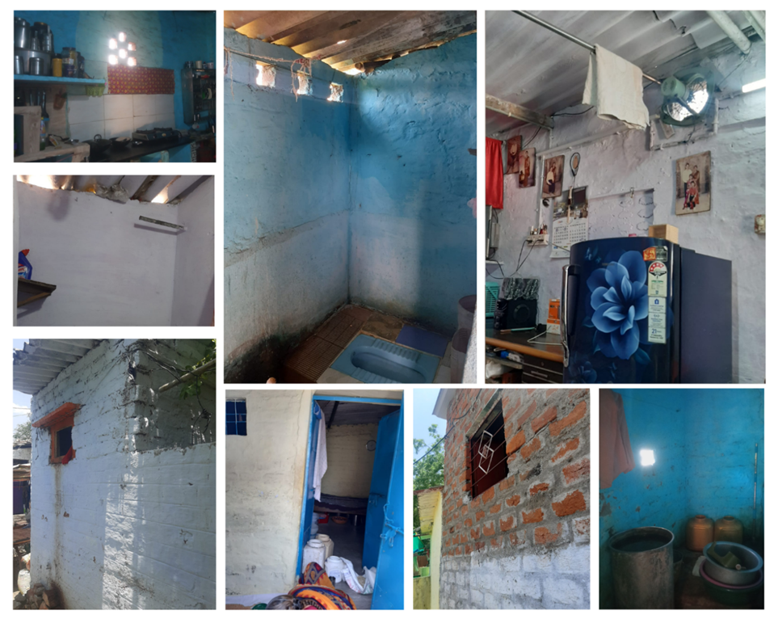
Photo: 2 Typical condition of a house in the slum.

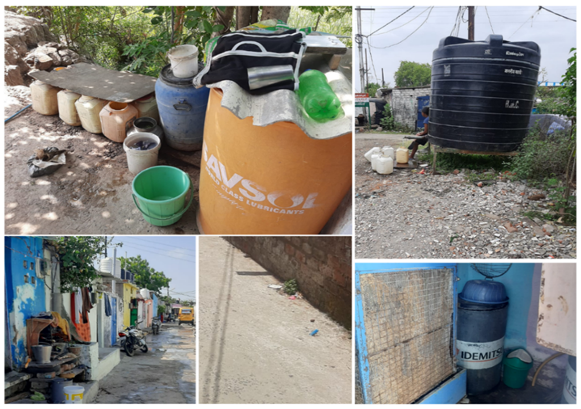
Photo: 3 Water supply and storage facility.

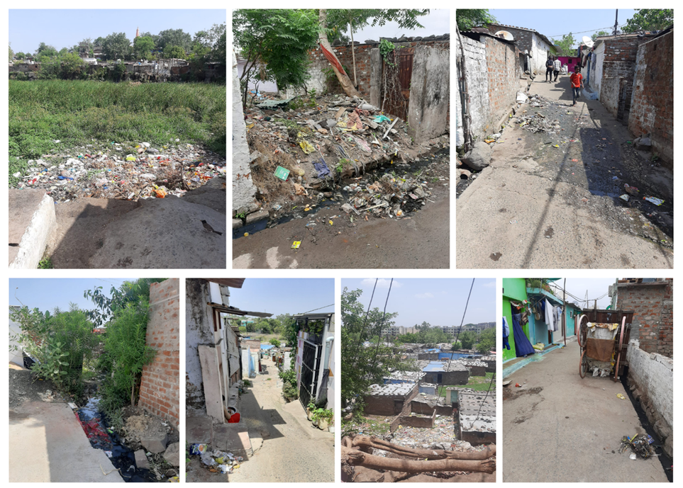
Photo: 4 Picture showcasing garbage spillage in the area.

