A comparative study of ionothermal treatment of rice straw using triflate and acetate-based ionic liquids

K.J. Jisha.,^{1,ǂ} and Sunita Rajamani,^{1,2,ǂ} Dharmendra Singh^{1,3}, Gyanendra Sharma^{1,4}, Ramesh L. Gardas^{1,}*
¹Department of Chemistry, Indian Institute of Technology, Madras, Chennai 600036, India
² Department of Chemistry, St. Joseph's College (Autonomous), Langford Road, Bengaluru 560027, Karnataka, India
³Department of Applied Science & Humanities, Institute of Engineering & Technology, Dr. Ram Manohar Lohia Avadh University, Ayodhya, U. P. - 224001, India
⁴Faculty of Biological Science and Technology, Institute of Science and Engineering, Kanazawa University, Kakuma-machi, Kanazawa, 920-1192, Japan
^{ǂ} These two authors have contributed equally to this work.

*Corresponding author: Tel.: +91 44 2257 4248 fax: +91 44 2257 4202 E-mail: gardas@iitm.ac.in
URL: http://www.iitm.ac.in/info/fac/gardas
-----------------------------------------------------------------------------------------------------------------------

Synthesis of Ionic liquids (ILs)

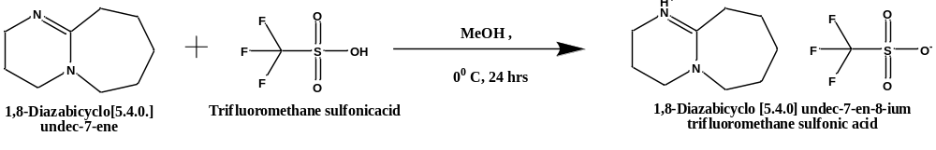
Scheme S1: Synthesis of 1,8-Diazabicyclo [5.4.0] undec-7-en-8-ium trifluoromethane sulfonate [DBUH][OTf]

The IL was synthesized by neutralization method by the equimolar addition of base (DBU) and acid (TFMS) in methanolic solution (Scheme S1). It is mandatory to keep the temperature at 0 °C during the addition, after completing the addition, the reaction mixture was allow to stirred for 24 hrs under inert atmosphere. After completion of the reaction, the excess amount of solvent and the unreacted starting materials can be removed through rotavapor. The light yellow colored liquid, which is obtained as the product was dried under high vacuum at room temperature for 24 hrs and was stored in N₂ atmosphere.

NMR of [DBUH][OTf]: ¹H NMR (500 MHz, CDCl₃) δ1.697 (d, 6H), 2.042 (t, 2H), 2.700 (d, 2H), 3.382 (m, 2H), 3.512 (t, 2H), 3.546 (t, 2H) and 8.692 (s, 1H). ¹³C NMR (125 MHz, CDCl₃) δ19.4, 24.0, 23.6, 28.9, 33.1, 38.4, 48.8, 54.8, 116.7, 119.2, 121.7, 124.3 and 166.5.

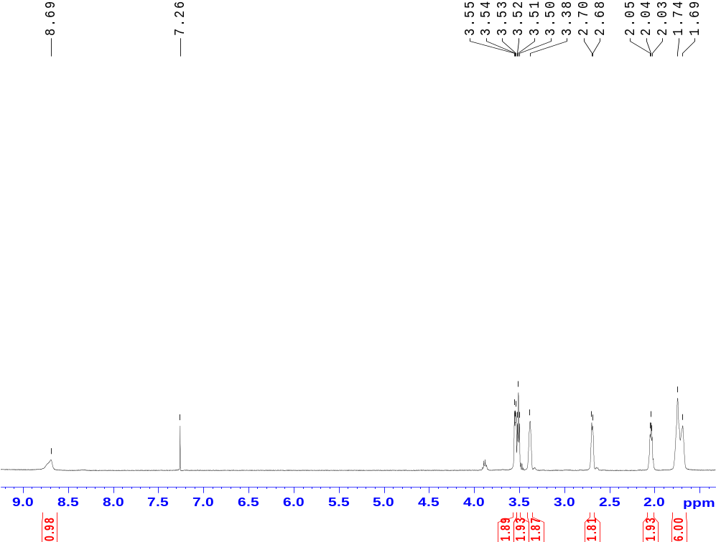

Fig. S1a: ¹H NMR of [DBUH][OTf] IL.

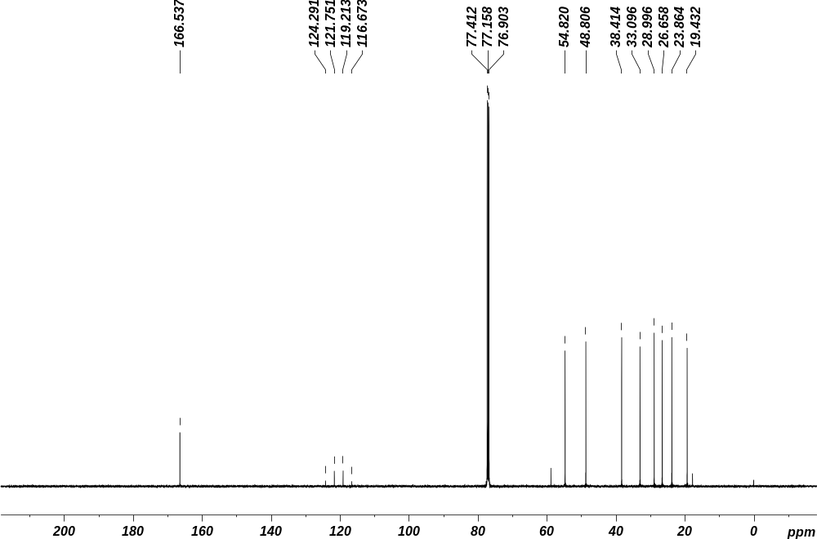
Fig. S1 b: ¹³C NMR of [DBUH][OTf] IL.

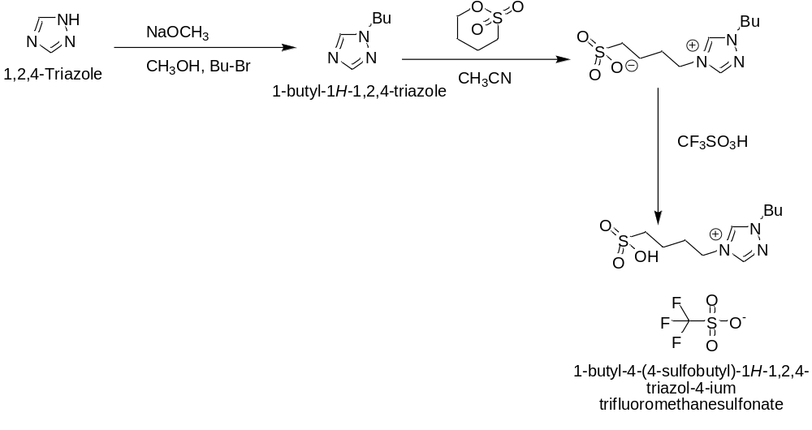
Scheme S2: Synthesis of 1-Butyl-1,2,4-triazolium triflate [BtTzm][OTf]

Preparation of 1-Butyl-1,2,4-triazole :To the solution of 1,2,4-triazole (16.4 mmol) in dry methanol (15 mL), a dry methanolic solution of sodium methoxide (16.5 mmol) was added. The mixture was left to stir for 30 min at room temperature, and then, 16.56 mmol of 1-bromo-butane was added dropwise and left to stir for 4 h followed by reflux overnight at 70 °C. The reaction was monitored through TLC. After completion, the methanol was removed by using a rotary evaporator and halide impurity was removed by washing with a water and ethyl acetate mixture. Moreover, using a rotavapor removed the ethyl acetate and compound was dried through MgSO₄. The crude product was purified through column chromatography in neutral alumina. The resulting solution was then placed into a high vacuum, affording a colorless liquid.

Synthesis of 1-Butyl-1,2,4-triazolium triflate: It was synthesized by a modified Shreeve procedure. In a double necked round-bottom flask, 1−4-butane sultone (14.4 mmol) was added dropwise to the 1-butyl-1,2,4-triazole (14.4 mmol) at 0 °C. The resulting solution was allowed to stir at room temperature until a solid was obtained. In order to remove unreacted starting materials, the reaction mixture was washed with toluene followed by diethyl ether. The crude product was dried under reduced pressure to get the zwitterionic compound. This zwitterionic compound was further allowed to react with trifluoromethanesulfonic acid (14.5 mmol) at 0 °C. The resulting solution was stirred at 60 °C until a thick liquid formed and then washed with diethyl ether to remove the excess trifluoromethanesulfonic acid and placed under a high vacuum as a light yellow color liquid obtained as IL.

NMR Of [BtTzm][OTf]:1 H NMR (500 MHz, CDCl3) δ 9.74 (s, 1H), δ 8.56 (s, 1H), 4.54 (t, J = 5.0 Hz, 2H), 4.42 (t, 7.25 Hz, 2H), 3.15 (t, 6.25 HZ, 2H), 2.24 (m, 2H), 1.96 (m, 2H), 1.84 (m, 2H), 1.38 (m, 2H), 0.97 (t, 7.5 HZ, 3H). 13C NMR (125 MHz, CDCl3) δ 142.7, 140.9, 124.0, 121.5, 119.0, 116.4, 74.1, 52.5, 48.4, 30.8, 23.7, 23.0, 19.4, 13.2. HRMS (ESI +) m/z for [M]+ calcd, 262.1225; found, 262.1223

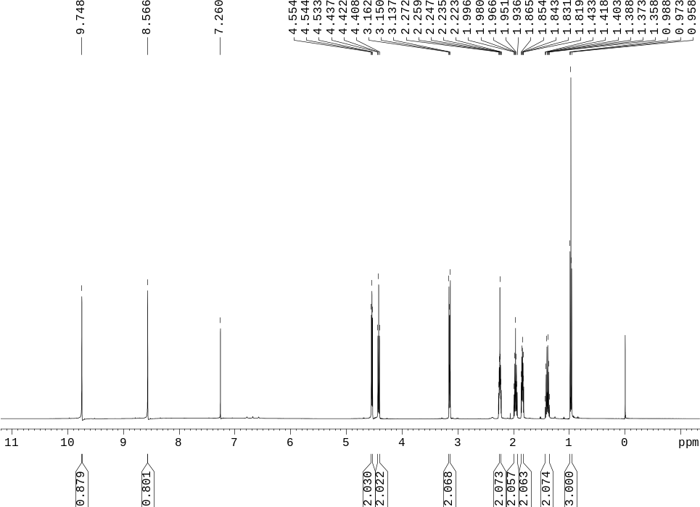
Fig. S2 a: ¹H NMR of [BtTzm][OTf]

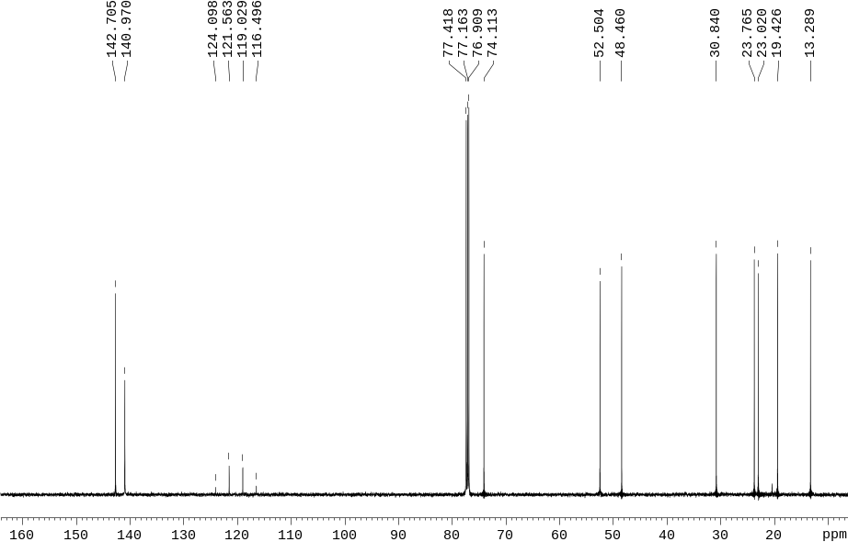
Fig. S2 b: ¹³C NMR Of [BtTzm][CF₃SO₃]
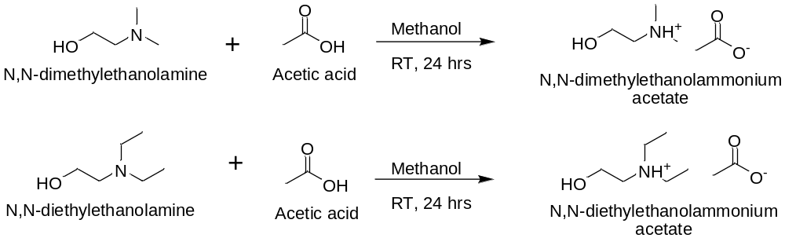
Scheme S3: Synthesis of N,N-dialkylethanolammonium-based PILs

The synthesis of N,N-dialkylethanolammonium-based PILs: It was achieved by Brønsted acid base neutralization method (as shown in Scheme 1). In our previous report, [DMEA] based PILs have been reported.[1] In brief, 0.1 mol of methanolic solutions of N,N-dialkylethanol amine was taken in a double-necked round-bottomed flask equipped with a condenser and a dropping funnel. Carboxylic acids (0.1 mol) was added drop wise with the help of the dropping funnel at ≈283.15 K and addition was continued up to 2 h. After completion of the addition, reaction mixture was stirred for another 24 h at room temperature under nitrogen atmosphere. Moreover, the reaction mixture was dried under high vacuum for 36 h at 323.15 K and was kept under nitrogen atmosphere to avoid the moisture.

NMR of [DMEA][Ace] :1H NMR (500 MHz, CDCl3, figure S1) δ 6.15 (broad, 1H), 3.82 (m, 2H), 2.90 (m, 2H), 2.63 (s, 6H), 2.00 (s, 3H); 13C NMR (125 MHz, CDCl3, figure S2) δ 177.98, 60.90, 57.15, 43.92, 22.69. HRMS (ESI+) m/z for [M]+ calcd 90.0919, found 90.0933.

NMR of [DEEA][Ace] 1H NMR (500 MHz, CDCl3, figure S11) δ 4.64 (broad, 1H), 3.83 (t, 2H), 3.02 (m, 4H), 2.93 (m, 4H), 1.99 (s, 3H), 1.24 (t, 6H); 13C NMR (125 MHz, CDCl3, figure S12) δ 57.03, 60.90, 55.07, 47.39, 23.33, 9.17. HRMS (ESI+) m/z for [M]+ calcd 118.1232, found 118.1211.

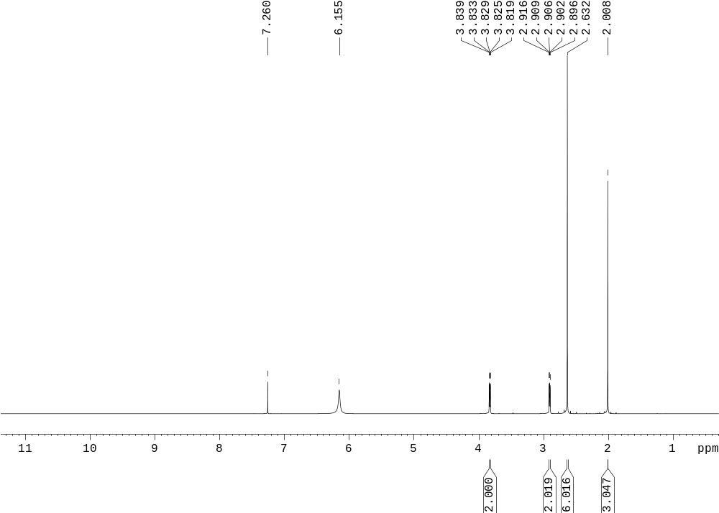
Fig. S3 a: ¹H NMR of [DMEA][Ace]

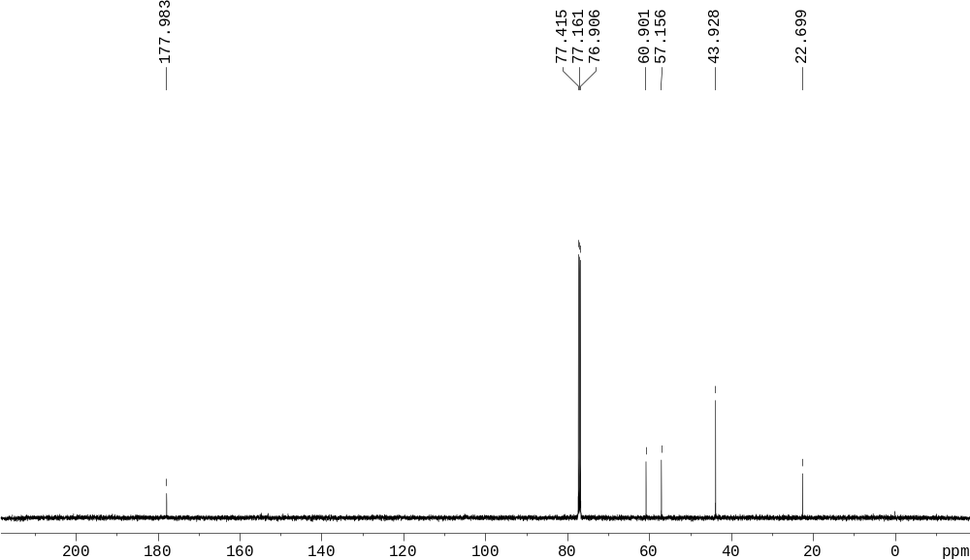
Fig. S3 b : ¹³C NMR of [DMEA][Ace]
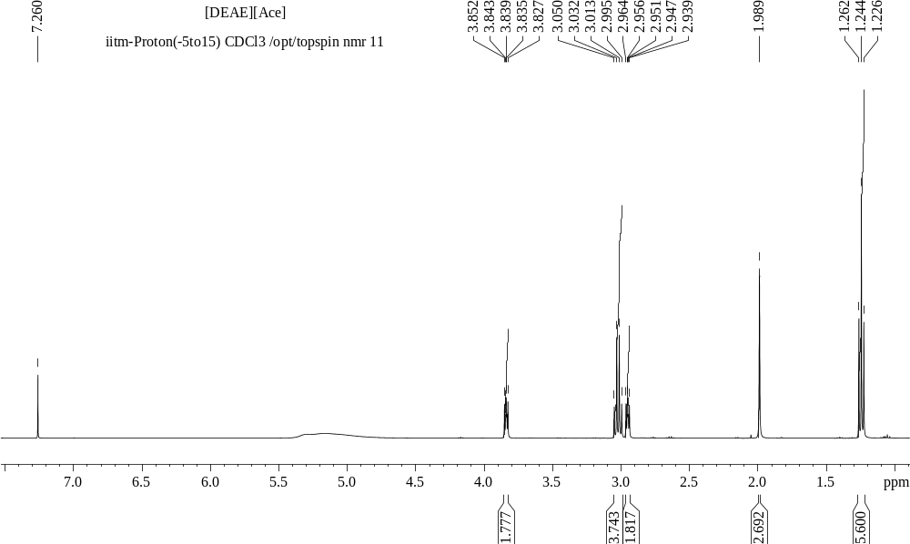
Fig. S4 a : ¹H NMR of [DEEA][Ace]

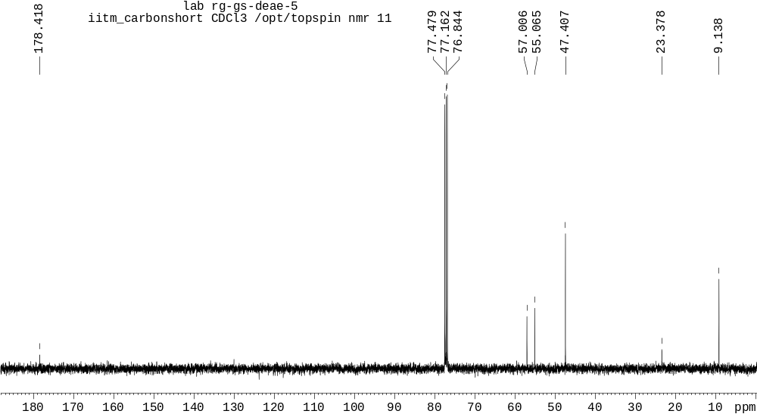
Fig. S4 b : ¹³C NMR of [DEEA][Ace]

Dissolution Experiment

The original rice straw ( S5 a) was added to the DBU-based IL (S5 b). The original rice straw was characterized using SEM and pXRD. A total of 20:1 ratio of IL:rice straw was added and stirred for 6 h at 90 ºC. The anti-solvent was added when the solution was at room temperature and the mixture was filtered. The IL along with water formed the filtrate (S5 c) and the undissolved part formed the residue (S5 d).

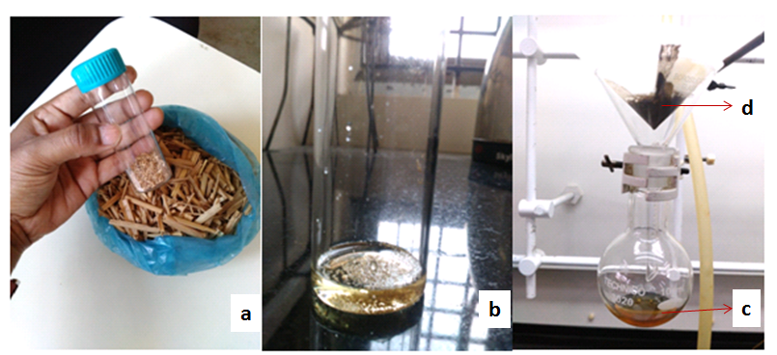
Fig S5: a) Rice straw before treatment; b) Rice straw dissolved in DBU-based IL; c) the IL post-dissolution and d) residue obtained on adding anti-solvent to the solution

Approximately 89% of IL was retained and was recycled for the next dissolution step. 50% of solid residue was obtained indicating that the other 50% was removed as volatile components and the remaining dissolved in IL. The exact percentage of dissolved components in the IL was not investigated in this study. The solid residue obtained post filtration was also characterized using SEM and pXRD.

