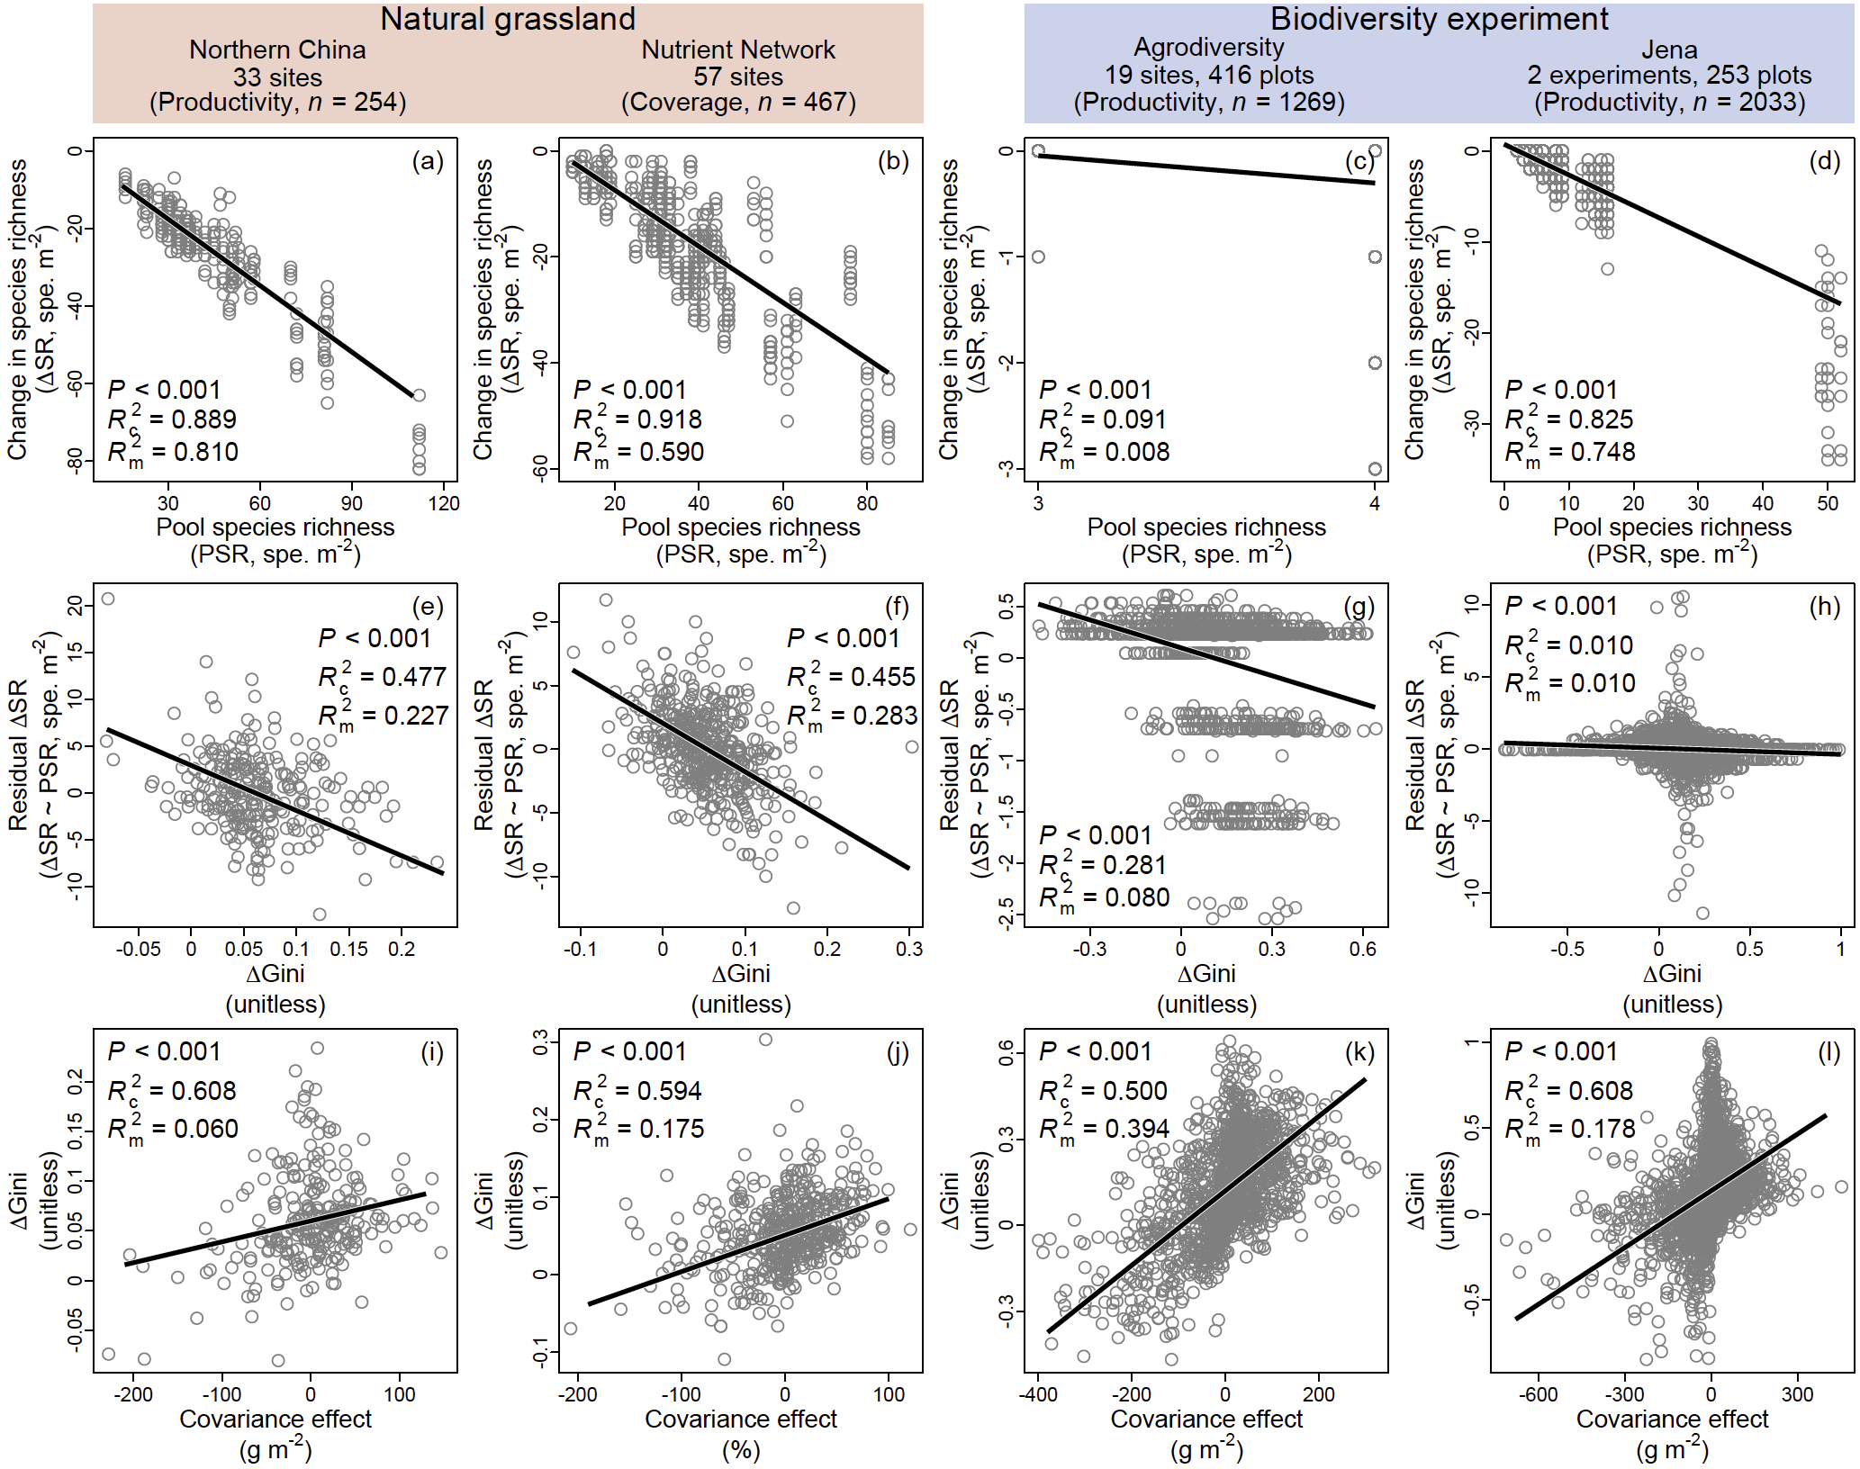
Extended Data Figure 1. Covariance effect and community structure. Relationships between changes in species richness and pool species richness (a–d), between their residuals and changes in species-abundance unevenness (estimated using the Gini index; e–h), and between changes in species-abundance unevenness and the covariance effect (i–l) are shown for both natural grasslands (a–b, e–f and i–j) and biodiversity experiments (c–d, g–h and k–l). Solid black lines represent significant regression lines. Conditional and marginal R² values (i.e., R_{c}² and R_{m}²) are shown in the figures. In biodiversity experiments, sample loss resulted in pool species richness not always matching the originally planted species richness.

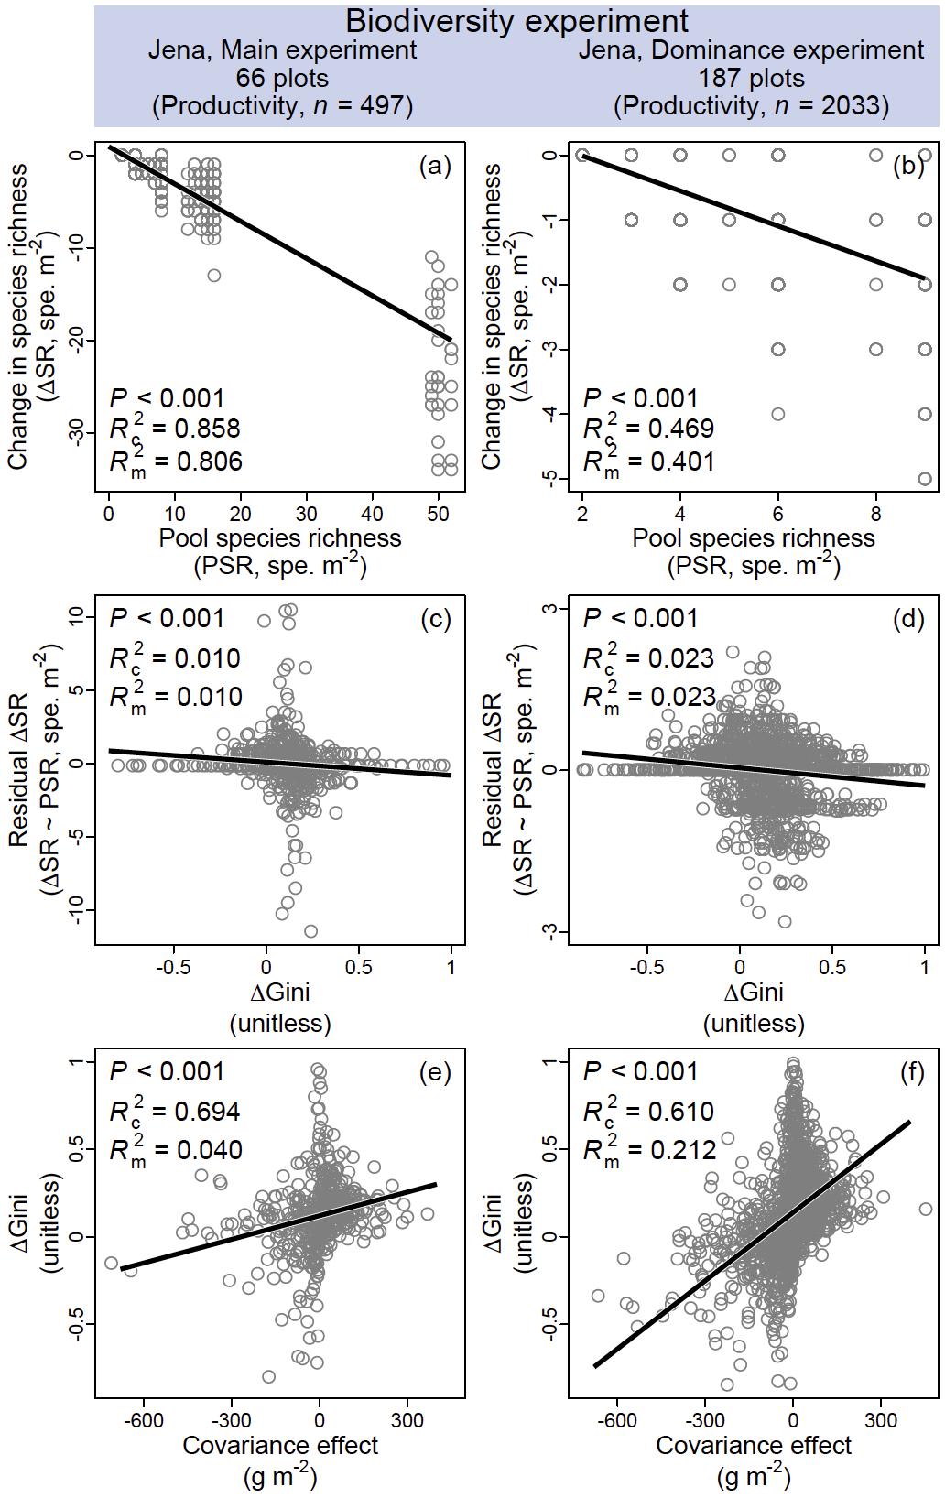
Extended Data Figure 2. Covariance effect and community structure in the Jena biodiversity experiments. Relationships between changes in species richness and pool species richness (a–b), between their residuals and changes in species-abundance unevenness (estimated using the Gini index; c–d), and between changes in species-abundance unevenness and the covariance effect (e–f) are shown for the main (a, c and e) and dominance (b, d and f) experiments in Jena. Solid black lines represent significant regression lines. Conditional and marginal R² values (R_{c}² and R_{m}²) are shown in the figures. Sample loss resulted in pool species richness not always matching the originally planted species richness.

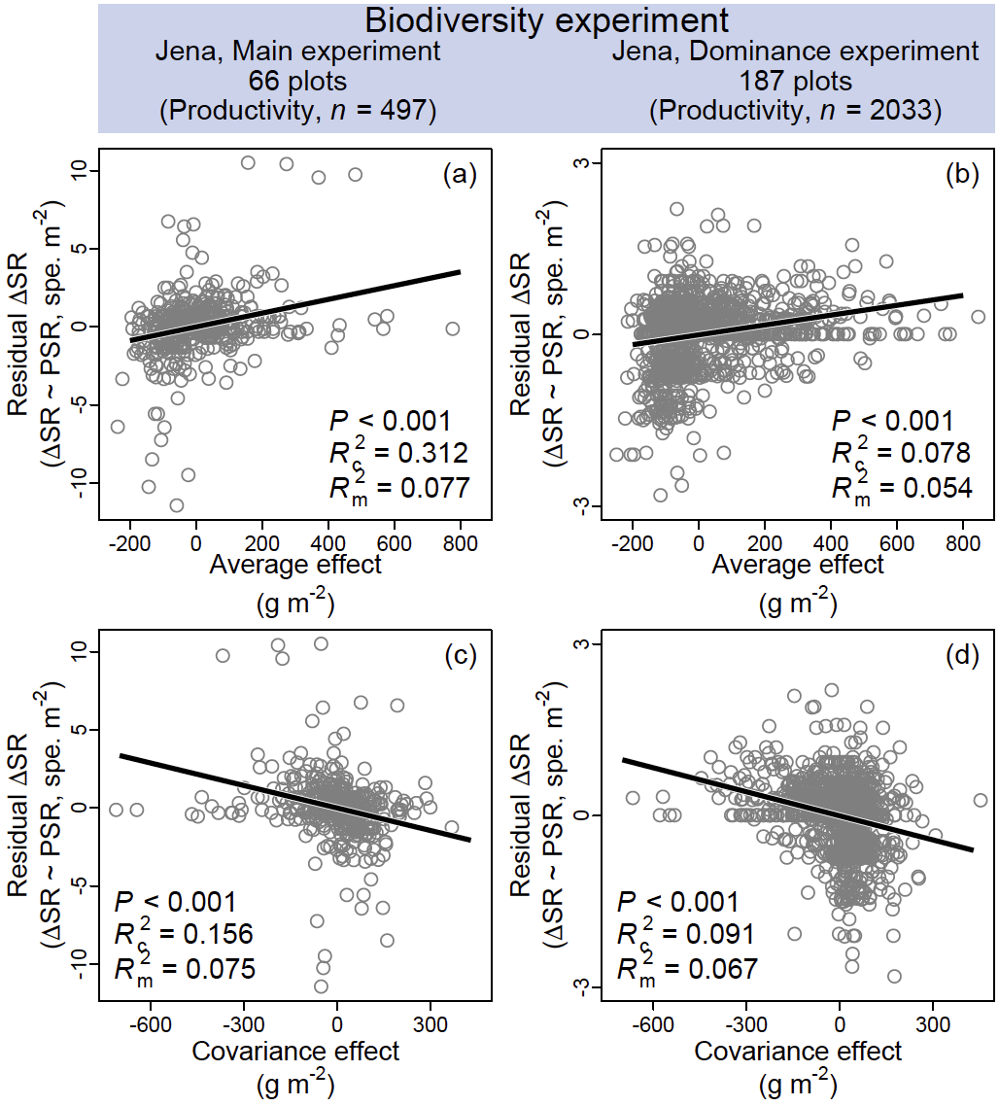
Extended Data Figure 3. Species richness in relation to the average and covariance effects in the Jena biodiversity experiments. Shown are relationships of residual changes in species richness (Extended Data Figure 2a–b) with the average (a–b) and covariance (c–d) effects in the main (a and c) and dominance (b and d) experiments in Jena. Solid black lines represent significant regression lines, with conditional and marginal R² values (R_{c}² and R_{m}²) shown in the figures.

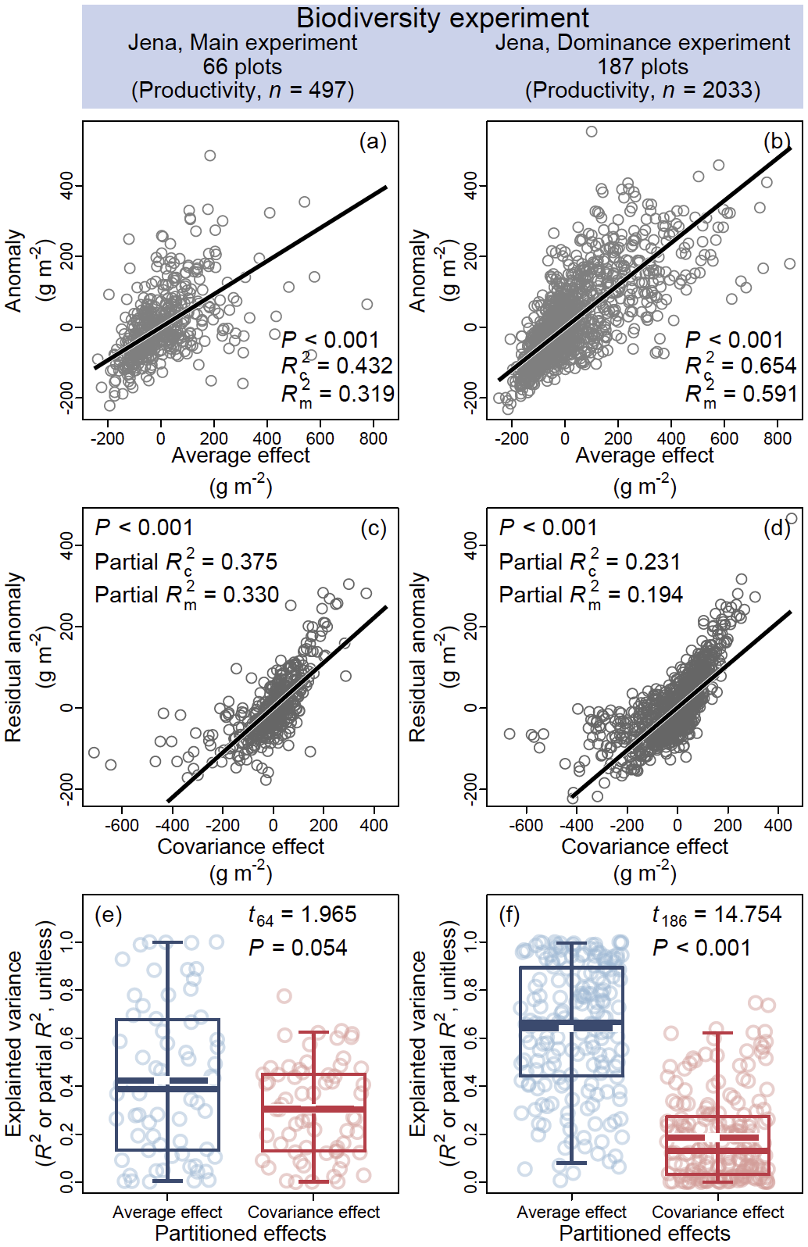
Extended Data Figure 4. Average and covariance effects in driving productivity in the Jena biodiversity experiments. Relationships between temporal deviations in ecosystem functioning (i.e., productivity anomaly) and the average effect (a–b), and between their residuals and the covariance effect (c–d), are shown for the main (a, c, and e) and dominance (b, d and f) experiments in Jena. Conditional and marginal R² (R_{c}² and R_{m}²) from linear regressions, and partial R_{c}² and R_{m}² from residual regressions, are reported for the average and covariance effects, respectively. Solid black lines represent significant relationships. The contributions of the two effects to ecosystem functioning were compared (using paired t-tests). In the main experiment, the two effects showed comparable relative importance (e), and the explanatory power of the covariance effect (partial R²; see Methods) was positively related to species-abundance unevenness (estimated using the Gini index; Extended Data Figure 9a). Boxes (e–f) show medians (solid lines), means (dashed lines), interquartile ranges (boxes) and the 2.5th and 97.5th percentiles (whiskers).

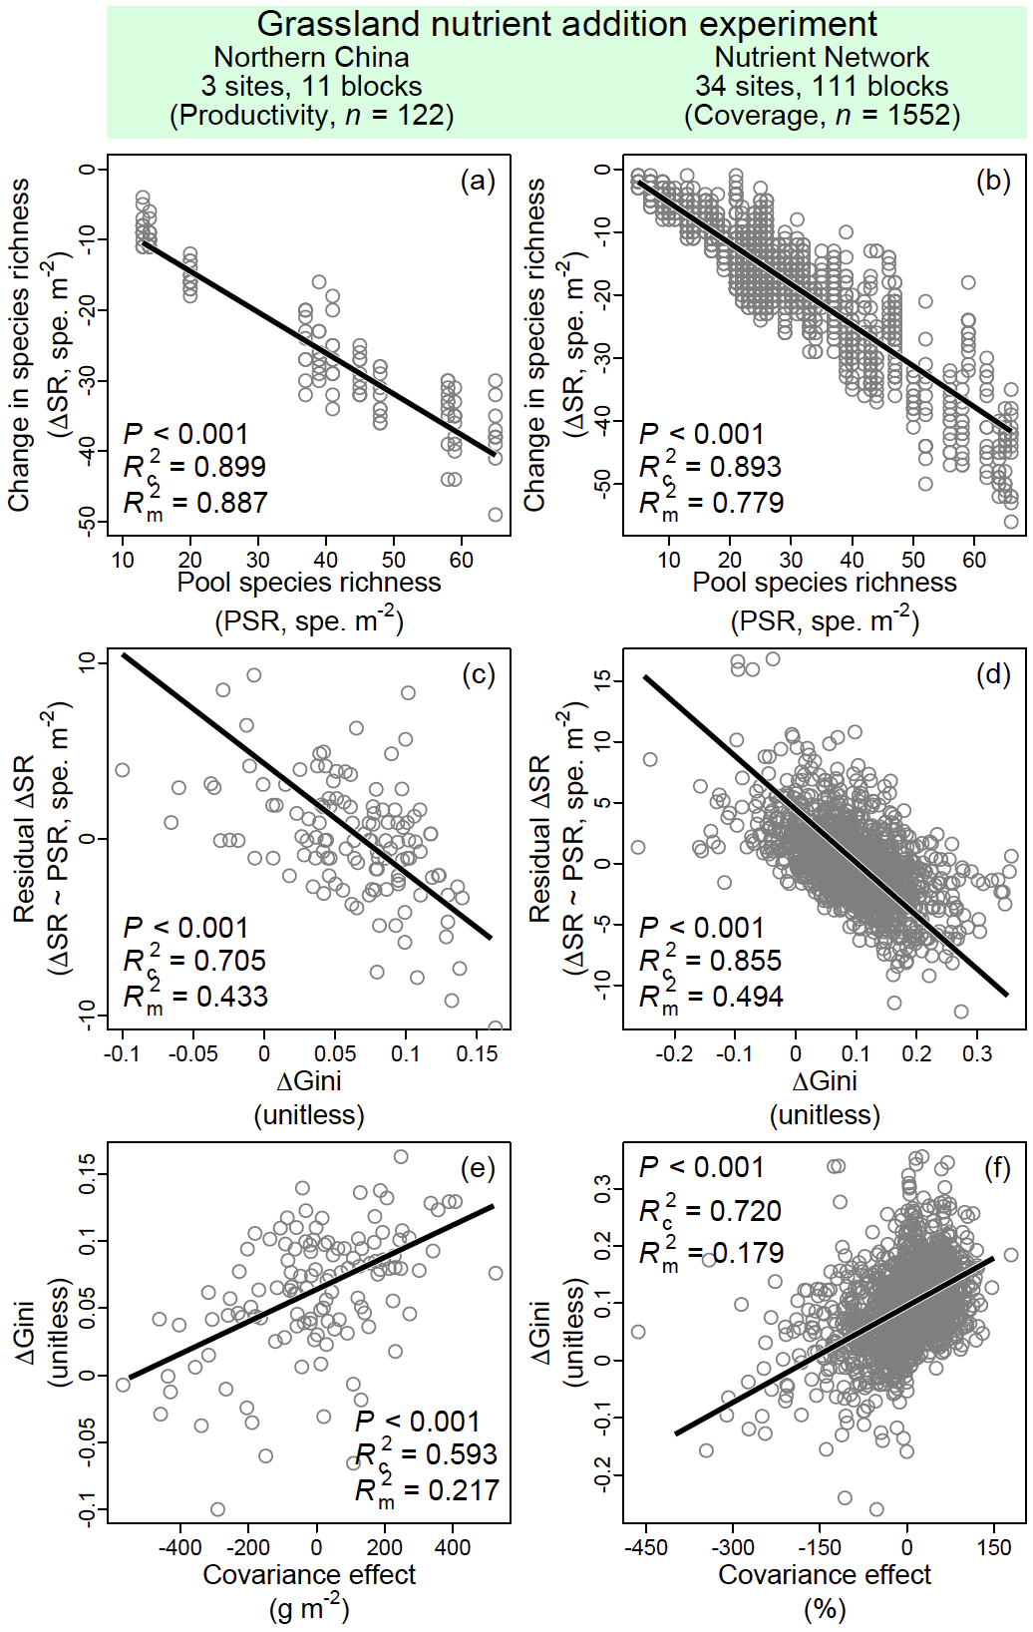
Extended Data Figure 5. Covariance effect and community structure in global grassland nitrogen addition experiments. Relationships between changes in species richness and pool species richness (a–b), between their residuals and changes in species-abundance unevenness (estimated using the Gini index; c–d), and between changes in species-abundance unevenness and the covariance effect (e–f) are shown for nitrogen addition experiments in natural grasslands of northern China (a, c and e) and Nutrient Network (b, d and f). Solid black lines represent significant regression lines. Conditional and marginal R² values (R_{c}² and R_{m}²) are shown in the figures.

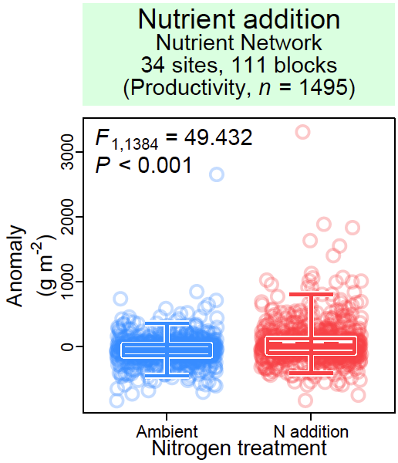
Extended Data Figure 6. Effects of nitrogen addition on plant community productivity in Nutrient Network grasslands. Effects (F-values) of nitrogen addition are shown, with boxes showing medians (solid lines), means (dashed lines), interquartile ranges (boxes) and the 2.5th and 97.5th percentiles (whiskers).

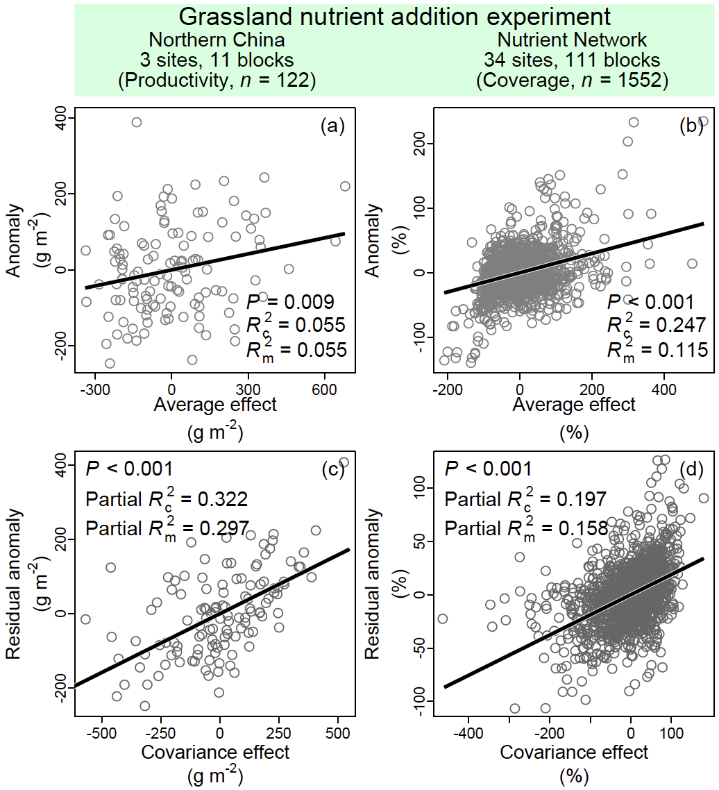
Extended Data Figure 7. Average and covariance effects in driving ecosystem functioning in global grassland nitrogen addition experiments. Relationships between temporal deviations in ecosystem functioning (i.e., anomalies) and the average effect (a–b), and between their residuals and the covariance effect (c–d), are shown for natural grasslands of northern China (a and c) and Nutrient Network (b and d). Conditional and marginal R² (R_{c}² and R_{m}²) from linear regressions, and partial R_{c}² and R_{m}² from residual regressions, are reported for the average and covariance effects, respectively. Solid black lines represent significant relationships.

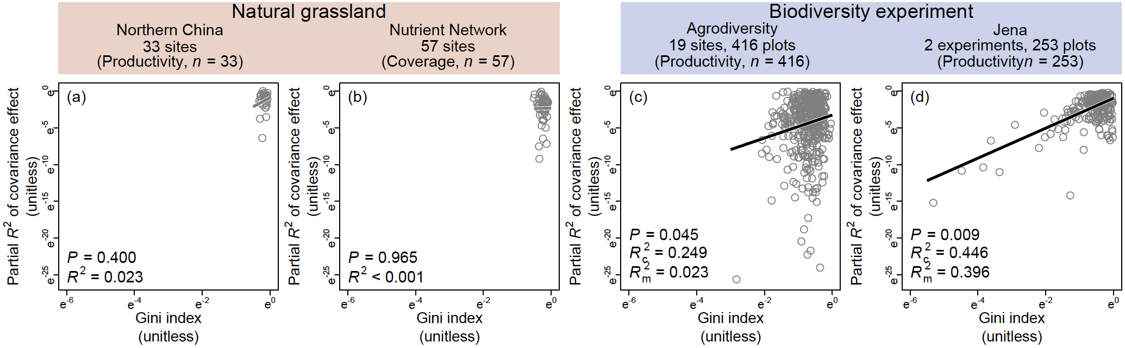
Extended Data Figure 8. Species-abundance unevenness and the relative importance of the covariance effect. Relationships between the partial R² of the covariance effect (see Methods) in explaining temporal deviations in ecosystem functioning (i.e., anomalies) and species-abundance unevenness (estimated using the Gini index) are shown for both natural grasslands (a–b) and biodiversity experiments (c–d). Solid black and dashed grey lines represent significant and non-significant regression lines, respectively. R² values from linear regressions (or conditional and marginal R², i.e., R_{c}² and R_{m}², from linear mixed-effects model) are shown.

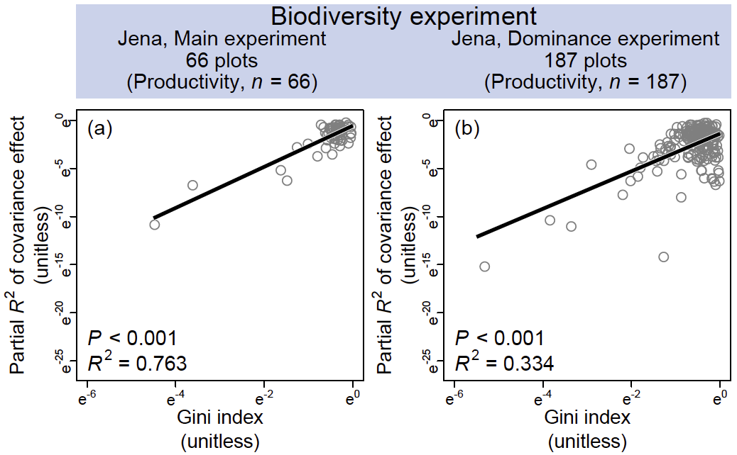
Extended Data Figure 9. Species-abundance unevenness and the relative importance of the covariance effect in the Jena experiments. Relationships between the partial R² of the covariance effect (see Methods) in explaining temporal deviations in ecosystem functioning (i.e., anomalies) and species-abundance unevenness (estimated using the Gini index) are shown for the main (a) and dominance experiments (b). Solid black lines represent significant regression lines. R² values from linear regressions are shown.

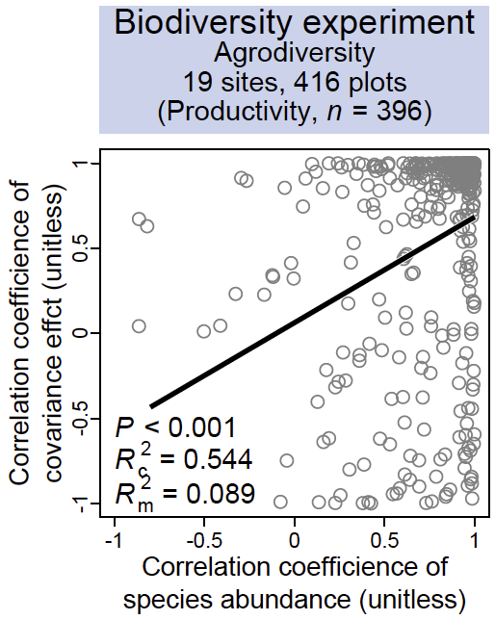
Extended Data Figure 10. Effects of altering species-abundance ranks on the estimation of the covariance effect. Reversing species abundance ranks, as in the design of the Agrodiversity experiment, reversed the sign of the estimated covariance effect (Box 1). Here, we show that when a plot with manipulated species abundances exhibited a negative correlation with abundances in the plot with uniformly high planting proportions, the estimated covariance effect was correspondingly negatively correlated across plots. The solid black line represents a significant regression line, with explanatory power (R²) shown in the figure.

