Supplementary information
for

Reconciling biodiversity–ecosystem functioning relationships across systems

Yonghui Wang^{1,*}, Wenhong Ma¹, Jianguo Wu², Shaopeng Wang³, Bernhard Schmid⁴, Nico Eisenhauer^{5,6}, Yi Tao⁷, Jin-Sheng He^{3,8}, Chao Wang⁹, Zhenhua Zhang¹⁰, Huiying Liu¹¹, Bailing Miao¹, Bin Zhang¹, Huping Yang¹, Xinxin Dai¹, Xinhui Jia¹, Yann Hautier¹²

¹Ministry of Education Key Laboratory of Ecology and Resource Use of the Mongolian Plateau, Inner Mongolia Key Laboratory of Grassland Ecology, Observation and Research Station for the Typical Steppe Ecosystem of the Ministry of Education, and School of Ecology and Environment, Inner Mongolia University, Hohhot, 010021, China
²School of Life Sciences & Global Institute of Sustainability, Arizona State University, Tempe, AZ, 85287-4501, USA
³Institute of Ecology, College of Urban and Environmental Sciences, and Key Laboratory for Earth Surface Processes of the Ministry of Education, Peking University, Beijing, China
⁴Department of Geography, Remote sensing Laboratories, University of Zürich, Zürich, Switzerland
⁵German Centre for Integrative Biodiversity Research (iDiv), Puschstr. 4, Leipzig, 04103, Germany
⁶Institute of Biology, Leipzig University, Puschstr. 4, Leipzig, 04103, Germany
⁷Key Laboratory of Animal Ecology and Conservation Biology, Centre for Computational Biology and Evolution, Chinese Academy of Sciences, Beijing, 100101, China
⁸State Key Laboratory of Herbage Improvement and Grassland Agro-Ecosystems, and College of Pastoral Agriculture Science and Technology, Lanzhou University, Lanzhou, 730000, Gansu, China
⁹National Permanent Scientific Research Base for Warm Temperate Zone Forestry of Jiulong Mountain in Beijing, Experimental Center of Forestry in North China, Chinese Academy of Forestry, Beijing 102300, China
¹⁰National Field Observation and Research Station (Qinghai Haibei) for Alpine Grassland Ecosystems, Northwest Institute of Plateau Biology, Chinese Academy of Sciences, Xining 81000, China
¹¹Tiantong National Station for Forest Ecosystem Research, Center for Global Change and Ecological Forecasting, The Shanghai Key Lab for Urban Ecological Processes and Eco‐Restoration, School of Ecological and Environmental Sciences, East China Normal University, Shanghai, China
¹²Ecology and Biodiversity Group, Department of Biology, Utrecht University, Padualaan 8, 3584 CH Utrecht, The Netherlands

*Authors for correspondence:
Yonghui Wang
Phone: +86 15904819953
E-mail: yhwang@imu.edu.cn
Ministry of Education Key Laboratory of Ecology and Resource Use of the Mongolian Plateau & Inner Mongolia Key Laboratory of Grassland Ecology, School of Ecology and Environment, Inner Mongolia University, Hohhot, 010021, China

Supplementary Table 1. Information for 33 sites in northern China grasslands included in this study.
Site name | Latitude | Longitude | Observation year | Mean annual precipitation | Mean annual temperature | Community biomass | Recorded  species number | Dominant species  (with relative specie biomass, RSB)
 |  |  |  |  |  |  |  | Latin name | RSB (%)
NM0702 | 45.02 | 116.33 | 2007, 2012–2016, 2020–2023 | 270.4 | 2.7 | 64.8 | 28 | Reaumuria soongarica | 56.9
 |  |  | 2007, 2012–2016, 2020–2023 |  |  |  |  | Convolvulus ammannii | 13.1
 |  |  | 2007, 2012–2016, 2020–2023 |  |  |  |  | Allium polyrhizum | 11.7
 |  |  | 2007, 2012–2016, 2020–2023 |  |  |  |  | Neopallasia pectinata | 8.8
NM0703 | 45.73 | 117.59 | 2007, 2012–2016, 2020– 2023 | 304.4 | 2.1 | 122.1 | 51 | Leymus chinensis | 39.9
 |  |  | 2007, 2012–2016, 2020– 2023 |  |  |  |  | Stipa grandis | 18.7
 |  |  | 2007, 2012–2016, 2020– 2023 |  |  |  |  | Cleistogenes squarrosa | 16.6
NM0704 | 47.87 | 118.78 | 2007, 2012–2016, 2020, 2022–2023 | 367.9 | 0.3 | 137.7 | 81 | Cleistogenes squarrosa | 24.4
 |  |  | 2007, 2012–2016, 2020, 2022–2023 |  |  |  |  | Leymus chinensis | 14.2
 |  |  | 2007, 2012–2016, 2020, 2022–2023 |  |  |  |  | Artemisia frigida | 9.3
 |  |  | 2007, 2012–2016, 2020, 2022–2023 |  |  |  |  | Potentilla acaulis | 6.8
 |  |  | 2007, 2012–2016, 2020, 2022–2023 |  |  |  |  | Allium bidentatum | 6.1
 |  |  | 2007, 2012–2016, 2020, 2022–2023 |  |  |  |  | Stipa grandis | 5.3
NM0705 | 48.27 | 118.47 | 2007, 2012–2016, 2020, 2022–2023 | 318.5 | 0.8 | 58.4 | 39 | Agropyron cristatum | 20.9
 |  |  | 2007, 2012–2016, 2020, 2022–2023 |  |  |  |  | Artemisia frigida | 14.4
 |  |  | 2007, 2012–2016, 2020, 2022–2023 |  |  |  |  | Artemisia desertorum | 11.0
 |  |  | 2007, 2012–2016, 2020, 2022–2023 |  |  |  |  | Carex korshinskyi | 8.4
 |  |  | 2007, 2012–2016, 2020, 2022–2023 |  |  |  |  | Astragalus laxmannii | 6.3
 |  |  | 2007, 2012–2016, 2020, 2022–2023 |  |  |  |  | Potentilla tanacetifolia | 5.6
NM0706 | 48.84 | 118.87 | 2007, 2012–2016, 2020, 2022–2023 | 336.4 | 0.1 | 130.6 | 72 | Leymus chinensis | 49.0
 |  |  | 2007, 2012–2016, 2020, 2022–2023 |  |  |  |  | Stipa capillata | 12.7
 |  |  | 2007, 2012–2016, 2020, 2022–2023 |  |  |  |  | Stipa grandis | 6.9
NM0707 | 49.35 | 120.12 | 2007, 2012,  2014–2015,  2020, 2022–2023 | 372.3 | –0.6 | 198.5 | 82 | Leymus chinensis | 28.9
 |  |  | 2007, 2012,  2014–2015,  2020, 2022–2023 |  |  |  |  | Carex pediformis | 12.3
 |  |  | 2007, 2012,  2014–2015,  2020, 2022–2023 |  |  |  |  | Stipa baicalensis | 9.4
 |  |  | 2007, 2012,  2014–2015,  2020, 2022–2023 |  |  |  |  | Artemisia tanacetifolia | 9.1
 |  |  | 2007, 2012,  2014–2015,  2020, 2022–2023 |  |  |  |  | Carex korshinskyi | 6.7
NM0708 | 49.33 | 120.05 | 2020, 2022–2023 | 412.2 | –0.3 | 192.9 | 47 | Leymus chinensis | 30.7
 |  |  | 2020, 2022–2023 |  |  |  |  | Artemisia tanacetifolia | 7.1
 |  |  | 2020, 2022–2023 |  |  |  |  | Achnatherum sibiricum | 6.9
 |  |  | 2020, 2022–2023 |  |  |  |  | Thermopsis lanceolata | 5.5
NM0710 | 49.89 | 119.99 | 2007, 2012–2015, 2020, 2022–2023 | 373.0 | –1.0 | 107.1 | 112 | Stipa baicalensis | 32.6
 |  |  | 2007, 2012–2015, 2020, 2022–2023 |  |  |  |  | Carex pediformis | 29.9
 |  |  | 2007, 2012–2015, 2020, 2022–2023 |  |  |  |  | Carex korshinskyi | 6.2
NM0712 | 49.96 | 119.02 | 2016, 2020,  2022–2023 | 311.4 | –0.6 | 137.1 | 52 | Stipa grandis | 24.5
 |  |  | 2016, 2020,  2022–2023 |  |  |  |  | Artemisia frigida | 9.5
 |  |  | 2016, 2020,  2022–2023 |  |  |  |  | Cleistogenes squarrosa | 7.5
 |  |  | 2016, 2020,  2022–2023 |  |  |  |  | Leymus chinensis | 6.9
 |  |  | 2016, 2020,  2022–2023 |  |  |  |  | Artemisia annua | 6.8
 |  |  | 2016, 2020,  2022–2023 |  |  |  |  | Serratula centauroides | 5.4
 |  |  | 2016, 2020,  2022–2023 |  |  |  |  | Heteropappus altaicus | 5.2
NM0713 | 49.55 | 117.57 | 2007, 2012–2015 | 303.4 | –0.2 | 107.4 | 53 | Cleistogenes squarrosa | 30.2
 |  |  | 2007, 2012–2015 |  |  |  |  | Leymus chinensis | 25.1
 |  |  | 2007, 2012–2015 |  |  |  |  | Stipa grandis | 13.0
 |  |  | 2007, 2012–2015 |  |  |  |  | Artemisia frigida | 5.2
NM0714 | 49.1 | 116.99 | 2007, 2012–2016, 2020, 2022–2023 | 251.6 | 1.1 | 70.6 | 48 | Stipa capillata | 46.4
 |  |  | 2007, 2012–2016, 2020, 2022–2023 |  |  |  |  | Leymus chinensis | 12.3
 |  |  | 2007, 2012–2016, 2020, 2022–2023 |  |  |  |  | Allium polyrhizum | 9.7
 |  |  |  |  |  |  |  | Neopallasia pectinata | 7.9
 |  |  |  |  |  |  |  | Convolvulus ammannii | 6.5
NM0715 | 48.77 | 116.23 | 2007, 2012–2016, 2020, 2022–2023 | 218.4 | 1.7 | 115.2 | 51 | Stipa capillata | 58.1
 |  |  | 2007, 2012–2016, 2020, 2022–2023 |  |  |  |  | Leymus chinensis | 12.4
 |  |  | 2007, 2012–2016, 2020, 2022–2023 |  |  |  |  | Cleistogenes squarrosa | 9.8
NM0716 | 48.58 | 116.95 | 2007, 2012–2015, 2020, 2022–2023 | 248.5 | 1.9 | 72.0 | 34 | Stipa capillata | 49.7
 |  |  | 2007, 2012–2015, 2020, 2022–2023 |  |  |  |  | Allium polyrhizum | 18.1
 |  |  | 2007, 2012–2015, 2020, 2022–2023 |  |  |  |  | Stipa grandis | 10.0
 |  |  | 2007, 2012–2015, 2020, 2022–2023 |  |  |  |  | Carex korshinskyi | 7.2
NM0717 | 48.69 | 117.84 | 2016, 2020, 2023 | 264.3 | 1.0 | 50.4 | 27 | Stipa capillata | 60.5
 |  |  | 2016, 2020, 2023 |  |  |  |  | Carex korshinskyi | 18.3
 |  |  | 2016, 2020, 2023 |  |  |  |  | Cleistogenes squarrosa | 10.9
NM0719 | 49.46 | 118.24 | 2007, 2012–2016, 2020, 2022–2023 | 302.0 | –0.1 | 101.2 | 57 | Cleistogenes squarrosa | 15.2
 |  |  | 2007, 2012–2016, 2020, 2022–2023 |  |  |  |  | Stipa grandis | 14.9
 |  |  | 2007, 2012–2016, 2020, 2022–2023 |  |  |  |  | Koeleria macrantha | 8.7
 |  |  | 2007, 2012–2016, 2020, 2022–2023 |  |  |  |  | Artemisia frigida | 6.7
 |  |  | 2007, 2012–2016, 2020, 2022–2023 |  |  |  |  | Serratula centauroides | 6.3
 |  |  | 2007, 2012–2016, 2020, 2022–2023 |  |  |  |  | Allium chrysanthum | 6.1
 |  |  | 2007, 2012–2016, 2020, 2022–2023 |  |  |  |  | Artemisia pubescens | 6.0
NM0722 | 45.84 | 119.33 | 2016, 2020,  2022–2023 | 419.3 | 1.5 | 104.6 | 82 | Leymus chinensis | 16.8
 |  |  | 2016, 2020,  2022–2023 |  |  |  |  | Carex pediformis | 12.3
 |  |  | 2016, 2020,  2022–2023 |  |  |  |  | Stipa baicalensis | 9.8
 |  |  | 2016, 2020,  2022–2023 |  |  |  |  | Filifolium sibiricum | 6.3
 |  |  | 2016, 2020,  2022–2023 |  |  |  |  | Cleistogenes squarrosa | 6.3
NM0723 | 45.75 | 118.23 | 2007, 2012–2016, 2020–2023 | 346.7 | 1.7 | 104.3 | 42 | Stipa capillata | 38.6
 |  |  | 2007, 2012–2016, 2020–2023 |  |  |  |  | Leymus chinensis | 23.6
 |  |  | 2007, 2012–2016, 2020–2023 |  |  |  |  | Cleistogenes songorica | 9.6
 |  |  | 2007, 2012–2016, 2020–2023 |  |  |  |  | Cleistogenes squarrosa | 7.6
 |  |  | 2007, 2012–2016, 2020–2023 |  |  |  |  | Convolvulus ammannii | 5.9
NM0724 | 45.42 | 116.98 | 2007, 2012–2016, 2020–2023 | 269.6 | 2.7 | 72.5 | 37 | Stipa capillata | 62.1
 |  |  | 2007, 2012–2016, 2020–2023 |  |  |  |  | Allium ramosum | 12.3
 |  |  | 2007, 2012–2016, 2020–2023 |  |  |  |  | Neopallasia pectinata | 6.9
NM0725 | 44.77 | 117.46 | 2007, 2012–2016, 2020–2023 | 325.7 | 2.4 | 100.0 | 37 | Stipa grandis | 38.8
 |  |  | 2007, 2012–2016, 2020–2023 |  |  |  |  | Leymus chinensis | 21.8
 |  |  | 2007, 2012–2016, 2020–2023 |  |  |  |  | Anemarrhena asphodeloides | 18.9
 |  |  | 2007, 2012–2016, 2020–2023 |  |  |  |  | Cleistogenes squarrosa | 6.6
NM0726 | 44.51 | 117.36 | 2007, 2012–2016, 2020–2023 | 330.6 | 2.6 | 109.1 | 30 | Stipa grandis | 34.5
 |  |  | 2007, 2012–2016, 2020–2023 |  |  |  |  | Anemarrhena asphodeloides | 18.2
 |  |  | 2007, 2012–2016, 2020–2023 |  |  |  |  | Leymus chinensis | 16.1
 |  |  | 2007, 2012–2016, 2020–2023 |  |  |  |  | Cleistogenes songorica | 13.7
 |  |  | 2007, 2012–2016, 2020–2023 |  |  |  |  | Cleistogenes squarrosa | 8.1
 |  |  | 2007, 2012–2016, 2020–2023 |  |  |  |  | Agropyron cristatum | 6.0
NM0727 | 44.13 | 116.33 | 2007, 2012–2016, 2020–2021, 2023 | 317.3 | 3.3 | 144.0 | 22 | Stipa grandis | 55.4
 |  |  | 2007, 2012–2016, 2020–2021, 2023 |  |  |  |  | Leymus chinensis | 23.4
 |  |  | 2007, 2012–2016, 2020–2021, 2023 |  |  |  |  | Cleistogenes squarrosa | 7.4
 |  |  | 2007, 2012–2016, 2020–2021, 2023 |  |  |  |  | Cleistogenes songorica | 6.4
NM0729 | 43.99 | 114.85 | 2007, 2012–2016, 2020–2023 | 269.3 | 2.8 | 95.1 | 36 | Artemisia frigida | 29.7
 |  |  | 2007, 2012–2016, 2020–2023 |  |  |  |  | Kochia prostrata | 22.5
 |  |  | 2007, 2012–2016, 2020–2023 |  |  |  |  | Leymus chinensis | 11.3
 |  |  | 2007, 2012–2016, 2020–2023 |  |  |  |  | Convolvulus ammannii | 9.1
 |  |  | 2007, 2012–2016, 2020–2023 |  |  |  |  | Allium bidentatum | 5.2
 |  |  | 2007, 2012–2016, 2020–2023 |  |  |  |  | Heteropappus altaicus | 5.1
NM0730 | 43.83 | 113.86 | 2007, 2012–2016, 2020–2023 | 204.3 | 4.1 | 44.4 | 45 | Stipa capillata | 19.5
 |  |  | 2007, 2012–2016, 2020–2023 |  |  |  |  | Stipa sareptana | 12.2
 |  |  | 2007, 2012–2016, 2020–2023 |  |  |  |  | Salsola collina | 9.2
 |  |  | 2007, 2012–2016, 2020–2023 |  |  |  |  | Heteropappus altaicus | 7.4
 |  |  | 2007, 2012–2016, 2020–2023 |  |  |  |  | Cleistogenes squarrosa | 7.1
 |  |  | 2007, 2012–2016, 2020–2023 |  |  |  |  | Convolvulus ammannii | 7.1
 |  |  | 2007, 2012–2016, 2020–2023 |  |  |  |  | Artemisia frigida | 6.9
 |  |  | 2007, 2012–2016, 2020–2023 |  |  |  |  | Agropyron mongolicum | 5.9
NM0731 | 43.82 | 113.45 | 2007, 2012–2016, 2020–2023 | 180.6 | 4.7 | 35.8 | 31 | Allium polyrhizum | 22.5
 |  |  | 2007, 2012–2016, 2020–2023 |  |  |  |  | Salsola collina | 16.8
 |  |  | 2007, 2012–2016, 2020–2023 |  |  |  |  | Carex korshinskyi | 10.7
 |  |  | 2007, 2012–2016, 2020–2023 |  |  |  |  | Convolvulus ammannii | 10.2
 |  |  | 2007, 2012–2016, 2020–2023 |  |  |  |  | Stipa sareptana | 8.0
NM0732 | 43.63 | 112.18 | 2007, 2012–2016, 2020–2021, 2023 | 144.7 | 5.4 | 20.2 | 23 | Stipa sareptana | 43.6
 |  |  | 2007, 2012–2016, 2020–2021, 2023 |  |  |  |  | Cleistogenes songorica | 12.6
 |  |  | 2007, 2012–2016, 2020–2021, 2023 |  |  |  |  | Allium mongolicum | 9.2
 |  |  | 2007, 2012–2016, 2020–2021, 2023 |  |  |  |  | Convolvulus ammannii | 9.1
 |  |  | 2007, 2012–2016, 2020–2021, 2023 |  |  |  |  | Asparagus cochinchinensis | 8.8
 |  |  | 2007, 2012–2016, 2020–2021, 2023 |  |  |  |  | Salsola collina | 7.0
NM0733 | 42.88 | 112.57 | 2007, 2012–2016, 2020–2023 | 157.2 | 6.0 | 20.0 | 33 | Stipa sareptana | 78.1
 |  |  | 2007, 2012–2016, 2020–2023 |  |  |  |  | Convolvulus ammannii | 5.2
NM0735 | 41.79 | 111.83 | 2007, 2012–2016, 2020–2023 | 265.7 | 4.6 | 54.7 | 36 | Artemisia frigida | 19.0
 |  |  | 2007, 2012–2016, 2020–2023 |  |  |  |  | Stipa breviflora | 14.9
 |  |  | 2007, 2012–2016, 2020–2023 |  |  |  |  | Stipa capillata | 11.0
 |  |  | 2007, 2012–2016, 2020–2023 |  |  |  |  | Kochia prostrata | 10.0
 |  |  | 2007, 2012–2016, 2020–2023 |  |  |  |  | Convolvulus ammannii | 9.7
 |  |  | 2007, 2012–2016, 2020–2023 |  |  |  |  | Allium polyrhizum | 7.0
 |  |  | 2007, 2012–2016, 2020–2023 |  |  |  |  | Neopallasia pectinata | 6.2
NM0736 | 43.89 | 116.29 | 2016, 2020–2023 | 304.8 | 3.5 | 104.6 | 50 | Leymus chinensis | 33.2
 |  |  | 2016, 2020–2023 |  |  |  |  | Stipa grandis | 26.9
 |  |  | 2016, 2020–2023 |  |  |  |  | Stipa capillata | 9.2
 |  |  | 2016, 2020–2023 |  |  |  |  | Cleistogenes squarrosa | 9.2
 |  |  | 2016, 2020–2023 |  |  |  |  | Carex korshinskyi | 7.4
NM0737 | 43.6 | 116.74 | 2020–2023 | 339.7 | 3.5 | 222.8 | 32 | Artemisia annua | 15.7
 |  |  | 2020–2023 |  |  |  |  | Artemisia frigida | 12.8
 |  |  | 2020–2023 |  |  |  |  | Stipa grandis | 12.7
 |  |  | 2020–2023 |  |  |  |  | Kochia prostrata | 11.0
 |  |  | 2020–2023 |  |  |  |  | Achnatherum sibiricum | 9.7
 |  |  | 2020–2023 |  |  |  |  | Caragana microphylla | 8.0
 |  |  | 2020–2023 |  |  |  |  | Sibbaldianthe bifurca | 7.9
 |  |  | 2020–2023 |  |  |  |  | Carex korshinskyi | 7.1
 |  |  | 2020–2023 |  |  |  |  | Agropyron cristatum | 5.6
NM0738 | 43.6 | 116.75 | 2020–2023 | 340.3 | 3.5 | 76.6 | 30 | Stipa capillata | 28.0
 |  |  | 2020–2023 |  |  |  |  | Agropyron cristatum | 18.1
 |  |  | 2020–2023 |  |  |  |  | Cleistogenes squarrosa | 13.1
 |  |  | 2020–2023 |  |  |  |  | Artemisia annua | 13.0
 |  |  | 2020–2023 |  |  |  |  | Carex korshinskyi | 10.3
Hailaer | 49.22 | 119.75 | 2011–2015 | 342.7 | –0.3 | 353.3 | 58 | Leymus chinensis | 28.1
 |  |  |  |  |  |  |  | Carex pediformis | 18.6
 |  |  |  |  |  |  |  | Stipa baicalensis | 6.5
 |  |  |  |  |  |  |  | Artemisia tanacetifolia | 6.3
 |  |  |  |  |  |  |  | Thalictrum squarrosum | 6.3
Maodeng | 44.17 | 116.47 | 2012–2018 | 282.0 | 2.6 | 240.4 | 16 | Leymus chinensis | 56.4
 |  |  |  |  |  |  |  | Stipa capillata | 23.1
 |  |  |  |  |  |  |  | Stipa grandis | 8.5
 |  |  |  |  |  | 240.4 | 16 | Cleistogenes squarrosa | 6.4
Haibei | 37.62 | 101.20 | 2011–2014, 2017 | 484.2 | –1.2 | 330.2 | 70 | Stipa aliena | 32.1
 |  |  |  |  |  |  |  | Elymus nutans | 11.3
 |  |  |  |  |  |  |  | Deyeuxia flavens | 7.7
 |  |  |  |  |  |  |  | Festuca ovina | 5.9

Supplementary Table 2. Information for 57 sites in Nutrient-Network grasslands included in this study.
Site name | Latitude | Longitude | Observation year | Mean annual precipitation | Mean annual temperature | Community biomass | Recorded species number | Dominant species  (with relative species coverage, RSC)
 |  |  |  |  |  |  |  | Latin name | RSC (%)
ahth.is | 65.13 | –19.67 | 2016–2019 | 877.1 | 1.75 | 158.7 | 24 | Betula nana | 48.8
 |  |  |  |  |  |  |  | Empetrum nigrum | 18.2
 |  |  |  |  |  |  |  | Silene acaulis | 12.0
 |  |  |  |  |  |  |  | Vaccinium uliginosum | 5.2
amlr.is | 65.13 | –19.67 | 2016–2019 | 877.1 | 1.75 | 12.1 | 19 | Thymus praecox | 24.6
 |  |  |  |  |  |  |  | Festuca sp | 24.4
 |  |  |  |  |  |  |  | Festuca richardsonii | 23.6
 |  |  |  |  |  |  |  | Silene acaulis | 6.0
 |  |  |  |  |  |  |  | Poa glauca | 5.0
arch.us | 27.17 | –81.22 | 2016–2020 | 1574.8 | 23.95 | 424.2 | 31 | Schizachyrium rhizomatum | 40.2
 |  |  |  |  |  |  |  | Quercus minima | 14.4
 |  |  |  |  |  |  |  | Carphephorus carphephorus | 6.5
 |  |  |  |  |  |  |  | Panicum sp | 5.4
badlau.de | 51.39 | 11.88 | 2016–2020 | 487.7 | 10.45 | 391.8 | 43 | Vulpia myuros | 19.4
 |  |  |  |  |  |  |  | Picris hieracioides | 18.6
 |  |  |  |  |  |  |  | Trifolium dubium | 8.0
 |  |  |  |  |  |  |  | Medicago lupulina | 8.0
 |  |  |  |  |  |  |  | Lolium perenne | 6.2
 |  |  |  |  |  |  |  | Taraxacum campylodes | 6.0
 |  |  |  |  |  |  |  | Bromus hordeaceus | 5.4
bayr.de | 49.92 | 11.58 | 2017–2021 | 621.3 | 9.38 | 145.4 | 41 | Festuca rubra | 39.0
 |  |  |  |  |  |  |  | Luzula campestris | 12.9
 |  |  |  |  |  |  |  | Achillea millefolium | 7.3
 |  |  |  |  |  |  |  | Agrostis capillaris | 6.9
 |  |  |  |  |  |  |  | Plantago lanceolata | 6.0
bldr.us | 39.97 | –105.23 | –– | 431.6 | 7.14 | 98.5 | 18 | Sporobolus airoides | 49.7
 |  |  |  | (2001–2020) | (2001–2020) |  |  | Buchloe dactyloides | 12.9
 |  |  |  |  |  |  |  | Erodium cicutarium | 7.4
 |  |  |  |  |  |  |  | Chondrosum gracile | 6.9
 |  |  |  |  |  |  |  | Bromus tectorum | 5.6
 |  |  |  |  |  |  |  | Bromus arvensis | 5.3
bnch.us | 44.28 | –121.97 | 2008, 2010–2021 | 1207.2 | 6.38 | 273.4 | 32 | Phlox diffusa | 21.0
 |  |  |  |  |  |  |  | Lupinus latifolius | 18.8
 |  |  |  |  |  |  |  | Carex hoodii | 12.5
 |  |  |  |  |  |  |  | Festuca idahoensis | 11.1
 |  |  |  |  |  |  |  | Carex pensylvanica | 10.6
 |  |  |  |  |  |  |  | Bromus carinatus | 6.9
 |  |  |  |  |  |  |  | Penstemon procerus | 5.1
bogong.au | –36.87 | 147.25 | 2010–2021 | 1249.4 | 11.77 | 544.8 | 31 | Poa hiemata | 50.8
 |  |  |  |  |  |  |  | Craspedia jamesii | 14.5
 |  |  |  |  |  |  |  | Trachymene humilis | 13.8
burrawan.au | –27.74 | 151.14 | 2009–2019 | 618.1 | 19.29 | 194.5 | 29 | Eragrostis curvula | 62.5
 |  |  |  |  |  |  |  | Fimbristylis dichotoma | 15.0
 |  |  |  |  |  |  |  | Eragrostis sororia | 5.6
burren.ie | 53.07 | –8.99 | 2016–2020 | 1161.7 | 9.99 | 511.3 | 53 | Centaurea nigra | 15.3
 |  |  |  |  |  |  |  | Carex flacca | 13.6
 |  |  |  |  |  |  |  | Molinia caerulea | 8.8
 |  |  |  |  |  |  |  | Plantago lanceolata | 6.3
 |  |  |  |  |  |  |  | Carex panicea | 6.0
 |  |  |  |  |  |  |  | Festuca rubra | 5.5
 |  |  |  |  |  |  |  | Dactylis glomerata | 5.2
cbgb.us | 41.79 | –93.39 | 2010–2021 | 950.6 | 10.27 | 415.1 | 40 | Schizachyrium scoparium | 42.7
 |  |  |  |  |  |  |  | Andropogon gerardii | 7.8
 |  |  |  |  |  |  |  | Solidago canadensis | 6.7
 |  |  |  |  |  |  |  | Ratibida pinnata | 6.5
 |  |  |  |  |  |  |  | Solidago speciosa | 6.1
cdcr.us | 45.42 | –93.21 | 2008–2021 | 798.6 | 7.21 | 180.0 | 47 | Schizachyrium scoparium | 28.9
 |  |  |  |  |  |  |  | Andropogon gerardii | 23.3
 |  |  |  |  |  |  |  | Poa pratensis | 16.5
 |  |  |  |  |  |  |  | Carex sp | 6.6
 |  |  |  |  |  |  |  | Achillea millefolium | 5.1
cdpt.us | 41.21 | –101.64 | 2008–2021 | 536.6 | 10.28 | 187.7 | 39 | Carex filifolia | 26.0
 |  |  |  |  |  |  |  | Chondrosum gracile | 20.4
 |  |  |  |  |  |  |  | Bromus tectorum | 13.5
 |  |  |  |  |  |  |  | Stipa comata | 11.7
 |  |  |  |  |  |  |  | Artemisia filifolia | 8.1
chilcas.ar | –36.28 | –58.27 | 2014–2020 | 1032.1 | 15.92 | 672.3 | 35 | Festuca arundinacea | 67.9
comp.pt | 38.83 | –8.79 | 2013–2020 | 633.9 | 18.21 | 255.8 | 63 | Tolpis barbata | 17.2
 |  |  |  |  |  |  |  | Tuberaria guttata | 10.0
 |  |  |  |  |  |  |  | Plantago bellardi | 8.3
 |  |  |  |  |  |  |  | Avena barbata | 7.5
 |  |  |  |  |  |  |  | Plantago bellardii | 7.3
 |  |  |  |  |  |  |  | Ornithopus compressus | 6.9
cowi.ca | 48.81 | –123.63 | 2008–2018 | 1747.4 | 9.03 | 516.2 | 10 | Alopecurus pratensis | 83.8
 |  |  |  |  |  |  |  | Vicia sativa | 5.0
elliot.us | 32.88 | –117.05 | 2009–2013, 2015–2019, 2022 | 231.3 | 18.06 | 361.6 | 39 | Erodium botrys | 21.8
 |  |  | 2009–2013, 2015–2019, 2022 |  |  |  |  | Bromus hordeaceus | 21.2
 |  |  | 2009–2013, 2015–2019, 2022 |  |  |  |  | Bromus madritensis | 17.0
 |  |  | 2009–2013, 2015–2019, 2022 |  |  |  |  | Vulpia myuros | 12.6
frue.ch | 47.11 | 8.54 | 2009–2015 | 1179.2 | 9.28 | 794.3 | 33 | Heracleum sphondylium | 21.8
 |  |  |  |  |  |  |  | Alopecurus pratensis | 14.2
 |  |  |  |  |  |  |  | Dactylis glomerata | 12.4
 |  |  |  |  |  |  |  | Phleum pratense | 7.1
 |  |  |  |  |  |  |  | Veronica filiformis | 6.1
 |  |  |  |  |  |  |  | Taraxacum campylodes | 6.0
hall.us | 36.87 | –86.70 | 2008–2014 | 1381.6 | 14.57 | 528.5 | 25 | Andropogon gerardii | 35.9
 |  |  |  |  |  |  |  | Solidago altissima | 24.6
 |  |  |  |  |  |  |  | Sorghastrum nutans | 12.1
 |  |  |  |  |  |  |  | Schizachyrium scoparium | 11.2
 |  |  |  |  |  |  |  | Rubus sp | 8.2
hart.us | 42.72 | –119.50 | 2008–2012 | 240.4 | 8.00 | 74.1 | 27 | Artemisia tridentata | 44.8
 |  |  |  |  |  |  |  | Stipa thurberiana | 11.7
 |  |  |  |  |  |  |  | Poa cusickii | 9.6
 |  |  |  |  |  |  |  | Elymus elymoides | 8.2
 |  |  |  |  |  |  |  | Poa secunda | 7.8
hero.uk | 51.41 | –0.64 | 2008–2012 | 789.1 | 10.45 | 508.9 | 28 | Agrostis capillaris | 38.8
 |  |  |  |  |  |  |  | Lotus corniculatus | 11.4
 |  |  |  |  |  |  |  | Holcus lanatus | 10.2
 |  |  |  |  |  |  |  | Ranunculus repens | 8.2
 |  |  |  |  |  |  |  | Festuca rubra | 7.4
 |  |  |  |  |  |  |  | Holcus mollis | 6.6
hopl.us | 39.01 | –123.06 | 2008–2019 | 1048.5 | 13.01 | 237.6 | 80 | Briza maxima | 20.9
 |  |  |  |  |  |  |  | Avena barbata | 9.4
 |  |  |  |  |  |  |  | Bromus hordeaceus | 8.3
 |  |  |  |  |  |  |  | Elymus glaucus | 7.1
jena.de | 50.94 | 11.53 | 2014–2020 | 601.4 | 9.63 | 356.4 | 44 | Taraxacum campylodes | 22.6
 |  |  |  |  |  |  |  | Poa pratensis | 18.1
 |  |  |  |  |  |  |  | Lolium perenne | 14.3
 |  |  |  |  |  |  |  | Trifolium dubium | 13.3
 |  |  |  |  |  |  |  | Crepis biennis | 8.0
 |  |  |  |  |  |  |  | Geranium pusillum | 5.8
kbs.us | 42.41 | –85.39 | 2014–2019 | 1035.2 | 9.93 | 544.2 | 28 | Bromus inermis | 33.4
 |  |  |  |  |  |  |  | Solidago canadensis | 23.2
 |  |  |  |  |  |  |  | Phleum pratense | 7.3
 |  |  |  |  |  |  |  | Centaurea stoebe | 6.0
 |  |  |  |  |  |  |  | Hieracium sp | 5.5
kibber.in | 32.32 | 78.01 | –– | 352.6 | –1.61 | 37.1 | 12 | Cousinia thomsonii | 36.1
 |  |  |  | (2001–2020) | (2001–2020) |  |  | Heracleum thomsonii | 17.0
 |  |  |  |  |  |  |  | Silene graminifolia | 12.2
 |  |  |  |  |  |  |  | Elymus longiaristatus | 10.1
 |  |  |  |  |  |  |  | Stipa orientalis | 6.5
 |  |  |  |  |  |  |  | Polygonum sp | 6.0
kilp.fi | 69.06 | 20.87 | 2014–2018, 2020–2021 | 620.2 | –2.19 | 168.2 | 38 | Festuca ovina | 30.6
 |  |  |  |  |  |  |  | Harrimanella hypnoides | 8.9
 |  |  |  |  |  |  |  | Anthoxanthum odoratum | 6.4
 |  |  |  |  |  |  |  | Sibbaldia procumbens | 6.4
kiny.au | –36.20 | 143.75 | 2008–2015, 2017–2018 | 409.6 | 16.01 | 164.8 | 46 | Avena barbata | 33.9
 |  |  |  |  |  |  |  | Rytidosperma | 25.5
 |  |  |  |  |  |  |  | Stipa sp | 10.1
 |  |  |  |  |  |  |  | Vulpia bromoides | 6.1
 |  |  |  |  |  |  |  | Maireana humillima | 5.5
koffler.ca | 44.02 | –79.54 | 2011–2019 | 958.7 | 7.63 | 538.2 | 30 | Solidago altissima | 34.6
 |  |  |  |  |  |  |  | Poa sp | 28.7
 |  |  |  |  |  |  |  | Bromus inermis | 9.9
 |  |  |  |  |  |  |  | Monarda fistulosa | 5.3
konz.us | 39.07 | –96.58 | 2008–2012, 2014–2018, 2021 | 904.3 | 13.35 | 463.2 | 45 | Schizachyrium scoparium | 43.8
 |  |  | 2008–2012, 2014–2018, 2021 |  |  |  |  | Andropogon gerardii | 10.0
 |  |  | 2008–2012, 2014–2018, 2021 |  |  |  |  | Sorghastrum nutans | 6.4
 |  |  |  |  |  |  |  | Panicum oligosanthes | 6.0
 |  |  |  |  |  |  |  | Symphyotrichum oblongifolium | 5.3
 |  |  |  |  |  |  |  | Bouteloua curtipendula | 5.1
lancaster.uk | 53.99 | –2.63 | 2009–2011, 2014–2017 | 1127.6 | 9.81 | 104.9 | 19 | Agrostis capillaris | 44.2
 |  |  |  |  |  |  |  | Holcus lanatus | 24.8
 |  |  |  |  |  |  |  | Festuca rubra | 5.3
look.us | 44.21 | –122.13 | 2009–2021 | 1676.8 | 8.40 | 206.9 | 29 | Erigeron aliceae | 25.6
 |  |  |  |  |  |  |  | Carex hoodii | 18.1
 |  |  |  |  |  |  |  | Carex pensylvanica | 14.8
 |  |  |  |  |  |  |  | Elymus glaucus | 8.1
 |  |  |  |  |  |  |  | Rumex acetosella | 7.3
 |  |  |  |  |  |  |  | Bromus carinatus | 6.1
marc.ar | –37.72 | –57.42 | 2012–2021 | 927.4 | 14.85 | 740.2 | 39 | Festuca arundinacea | 49.1
 |  |  |  |  |  |  |  | Bromus catharticus | 15.5
 |  |  |  |  |  |  |  | Spartina densiflora | 10.8
 |  |  |  |  |  |  |  | Veronica peregrina | 6.0
mcla.us | 38.86 | –122.41 | 2008, 2010–2019 | 794.6 | 15.17 | 257.1 | 35 | Bromus hordeaceus | 19.7
 |  |  |  |  |  |  |  | Geranium dissectum | 17.1
 |  |  |  |  |  |  |  | Lolium multiflorum | 13.6
 |  |  |  |  |  |  |  | Taeniatherum caput | 12.7
 |  |  |  |  |  |  |  | Avena fatua | 10.3
msla_2.us | 46.66 | –114 | 2018–2021 | 389.4 | 6.40 | 80.9 | 25 | Elymus spicatus | 26.1
 |  |  |  |  |  |  |  | Poa secunda | 15.2
 |  |  |  |  |  |  |  | Bromus tectorum | 11.5
 |  |  |  |  |  |  |  | Lupinus sericeus | 10.2
 |  |  |  |  |  |  |  | Poa bulbosa | 9.7
 |  |  |  |  |  |  |  | Veronica verna | 6.7
msla_3.us | 46.66 | –114 | 2018–2021 | 389.4 | 6.40 | 87 | 29 | Elymus spicatus | 25.0
 |  |  |  |  |  |  |  | Poa secunda | 21.6
 |  |  |  |  |  |  |  | Veronica verna | 10.8
 |  |  |  |  |  |  |  | Antennaria microphylla | 6.6
 |  |  |  |  |  |  |  | Koeleria macrantha | 6.6
 |  |  |  |  |  |  |  | Bromus tectorum | 5.2
msla.us | 46.66 | –114.00 | 2018–2021 | 389.4 | 6.40 | 115.5 | 31 | Elymus spicatus | 23.6
 |  |  |  |  |  |  |  | Poa bulbosa | 15.4
 |  |  |  |  |  |  |  | Balsamorhiza sagittata | 14.6
 |  |  |  |  |  |  |  | Poa secunda | 7.6
 |  |  |  |  |  |  |  | Veronica verna | 7.0
mtca.au | –31.78 | 117.61 | 2009–2019 | 283.9 | 18.24 | 185.5 | 41 | Stipa nitida_trichophylla | 21.6
 |  |  |  |  |  |  |  | Erodium botrys | 13.7
 |  |  |  |  |  |  |  | Pentaschistis airoides | 11.7
 |  |  |  |  |  |  |  | Erymophyllum tenellum | 9.3
 |  |  |  |  |  |  |  | Waitzia acuminata | 7.6
 |  |  |  |  |  |  |  | Actinobole uliginosum | 7.5
 |  |  |  |  |  |  |  | Brachyscome iberidifolia | 7.4
 |  |  |  |  |  |  |  | Monachather paradoxus | 5.1
nilla.au | –36.90 | 146.01 | 2017–2020 | 826.9 | 14.76 | 152.8 | 17 | Anthoxanthum odoratum | 44.9
 |  |  |  |  |  |  |  | Agrostis capillaris | 17.5
 |  |  |  |  |  |  |  | Ehrharta stipoides | 11.8
 |  |  |  |  |  |  |  | Rytidosperma racemosum | 7.2
 |  |  |  |  |  |  |  | Stenotaphrum secundatum | 6.8
ping.au | –32.50 | 116.97 | 2014–2019 | 464.3 | 17.38 | 234.6 | 13 | Stipa nitida | 25.2
 |  |  |  |  |  |  |  | Avena barbata | 20.4
 |  |  |  |  |  |  |  | Trifolium subterraneum | 18.3
 |  |  |  |  |  |  |  | Erodium botrys | 12.3
 |  |  |  |  |  |  |  | Hypochaeris glabra | 6.7
 |  |  |  |  |  |  |  | Vulpia myuros | 5.2
 |  |  |  |  |  |  |  | Romulea rosea | 5.2
potrok.ar | –51.92 | –70.41 | 2016–2021 | 232.4 | 8.06 | 88.1 | 18 | Poa spiciformis | 35.4
 |  |  |  |  |  |  |  | Stipa speciosa | 19.5
 |  |  |  |  |  |  |  | Carex andina | 11.2
 |  |  |  |  |  |  |  | Festuca pyrogea | 10.0
 |  |  |  |  |  |  |  | Nardophyllum bryoides | 7.8
rook.uk | 51.41 | –0.64 | 2008–2012 | 789.1 | 10.45 | 180.2 | 16 | Galium saxatile | 34.9
 |  |  |  |  |  |  |  | Agrostis capillaris | 28.2
 |  |  |  |  |  |  |  | Rumex acetosella | 18.5
 |  |  |  |  |  |  |  | Luzula campestris | 8.4
saana.fi | 69.04 | 20.84 | 2015–2021 | 637.0 | –2.33 | 109.5 | 56 | Trollius europaeus | 14.9
 |  |  |  |  |  |  |  | Viola biflora | 12.8
 |  |  |  |  |  |  |  | Geranium sylvaticum | 8.2
 |  |  |  |  |  |  |  | Saussurea alpina | 7.2
 |  |  |  |  |  |  |  | Ranunculus acris | 5.1
sage.us | 39.43 | –120.24 | 2008–2013 | 861.3 | 6.89 | 127.4 | 33 | Symphyotrichum spathulatum | 22.3
 |  |  |  |  |  |  |  | Trifolium longipes | 13.5
 |  |  |  |  |  |  |  | Perideridia lemmonii | 10.8
 |  |  |  |  |  |  |  | Poa secunda | 6.9
 |  |  |  |  |  |  |  | Epilobium glaberrimum | 6.5
 |  |  |  |  |  |  |  | Hordeum brachyantherum | 5.1
 |  |  |  |  |  |  |  | Carex nebrascensis | 5.0
saline.us | 39.05 | –99.10 | 2008–2015 | 605.7 | 12.23 | 244.0 | 57 | Andropogon gerardii | 15.3
 |  |  |  |  |  |  |  | Bouteloua curtipendula | 15.3
 |  |  |  |  |  |  |  | Psoralea tenuiflora | 14.6
 |  |  |  |  |  |  |  | Sporobolus compositus | 10.7
 |  |  |  |  |  |  |  | Schizachyrium scoparium | 10.2
 |  |  |  |  |  |  |  | Chondrosum gracile | 7.7
 |  |  |  |  |  |  |  | Sporobolus heterolepis | 5.5
sedg.us | 34.70 | –120.02 | 2008–2017 | 343.9 | 14.80 | 346.5 | 18 | Avena fatua | 59.6
 |  |  |  |  |  |  |  | Bromus diandrus | 29.0
sevi.us | 34.36 | –106.69 | 2008–2018 | 243.2 | 13.81 | 121.3 | 37 | Chondrosum eriopodum | 56.0
 |  |  |  |  |  |  |  | Xanthisma spinulosum | 8.9
 |  |  |  |  |  |  |  | Gutierrezia sarothrae | 6.6
 |  |  |  |  |  |  |  | Salsola kali | 5.3
sgs.us | 40.82 | –104.77 | 2008–2018 | 408.9 | 9.33 | 92.3 | 41 | Chondrosum gracile | 38.5
 |  |  |  |  |  |  |  | Carex duriuscula | 23.2
 |  |  |  |  |  |  |  | Vulpia octoflora | 10.7
 |  |  |  |  |  |  |  | Elymus elymoides | 7.8
 |  |  |  |  |  |  |  | Artemisia frigida | 6.4
shps.us | 44.26 | –112.21 | 2008–2012 | 395.0 | 5.19 | 124.1 | 42 | Artemisia tripartita | 36.7
 |  |  |  |  |  |  |  | Elymus spicatus | 13.6
 |  |  |  |  |  |  |  | Poa secunda | 10.1
 |  |  |  |  |  |  |  | Tetradymia canescens | 8.2
sier.us | 39.24 | –121.28 | 2008–2019 | 994.1 | 15.95 | 287.2 | 57 | Bromus hordeaceus | 19.0
 |  |  |  |  |  |  |  | Taeniatherum caput | 18.6
 |  |  |  |  |  |  |  | Bromus diandrus | 17.0
 |  |  |  |  |  |  |  | Bromus sterilis | 10.8
 |  |  |  |  |  |  |  | Trifolium hirtum | 6.2
smith.us | 48.21 | –122.62 | 2008–2012, 2015–2017, 2019 | 666.8 | 10.59 | 374.9 | 44 | Anthoxanthum odoratum | 20.7
 |  |  | 2008–2012, 2015–2017, 2019 |  |  |  |  | Plantago lanceolata | 15.0
 |  |  | 2008–2012, 2015–2017, 2019 |  |  |  |  | Hypochaeris radicata | 10.1
 |  |  |  |  |  |  |  | Cirsium arvense | 8.8
 |  |  |  |  |  |  |  | Valerianella locusta | 7.5
spin.us | 38.13 | –84.50 | 2008–2020 | 1319.0 | 13.27 | 447.9 | 32 | Poa pratensis | 21.9
 |  |  |  |  |  |  |  | Dactylis glomerata | 13.7
 |  |  |  |  |  |  |  | Vicia grandiflora | 12.1
 |  |  |  |  |  |  |  | Festuca arundinacea | 11.8
 |  |  |  |  |  |  |  | Plantago lanceolata | 10.8
 |  |  |  |  |  |  |  | Viola sp | 9.0
temple.us | 31.04 | –97.35 | 2008–2016, 2020 | 863.5 | 20.12 | 553.0 | 61 | Cocculus carolinus | 18.6
 |  |  |  |  |  |  |  | Schizachyrium scoparium | 14.6
 |  |  |  |  |  |  |  | Symphyotrichum ericoides | 11.1
 |  |  |  |  |  |  |  | Sorghum halepense | 9.8
 |  |  |  |  |  |  |  | Ambrosia trifida | 6.3
 |  |  |  |  |  |  |  | Salvia azurea | 5.3
trel.us | 40.08 | –88.83 | 2009–2015, 2017 | 1071.7 | 11.58 | 1029.2 | 13 | Solidago canadensis | 45.6
 |  |  |  |  |  |  |  | Lespedeza juncea | 22.8
 |  |  |  |  |  |  |  | Juncus sp | 21.4
ukul.za | –29.67 | 30.40 | 2010–2018 | 865.0 | 17.39 | 514.6 | 85 | Tristachya leucothrix | 19.2
 |  |  |  |  |  |  |  | Themeda triandra | 16.8
 |  |  |  |  |  |  |  | Eragrostis curvula | 16.5
 |  |  |  |  |  |  |  | Berkheya umbellata | 7.5
unc.us | 36.01 | –79.02 | 2008–2011 | 1144.6 | 14.95 | 351.0 | 33 | Danthonia spicata | 32.0
 |  |  |  |  |  |  |  | Schedonorus sp | 12.9
 |  |  |  |  |  |  |  | Festuca subverticillata | 12.8
 |  |  |  |  |  |  |  | Tripsacum dactyloides | 8.2
 |  |  |  |  |  |  |  | Poa pratensis | 7.1
 |  |  |  |  |  |  |  | Solidago pinetorum | 6.4
 |  |  |  |  |  |  |  | Panicum sp | 5.1
valm.ch | 46.63 | 10.37 | 2009–2016, 2018–2021 | 1234.7 | 1.83 | 210.7 | 76 | Helianthemum nummularium | 11.3
 |  |  |  |  |  |  |  | Hieracium pilosella | 9.9
 |  |  |  |  |  |  |  | Festuca rubra | 5.3
yarra.au | –33.61 | 150.74 | 2015–2020 | 881.3 | 18.00 | 404.1 | 15 | Cynodon dactylon | 58.6
 |  |  |  |  |  |  |  | Setaria parviflora | 16.0
 |  |  |  |  |  |  |  | Eragrostis curvula | 10.0

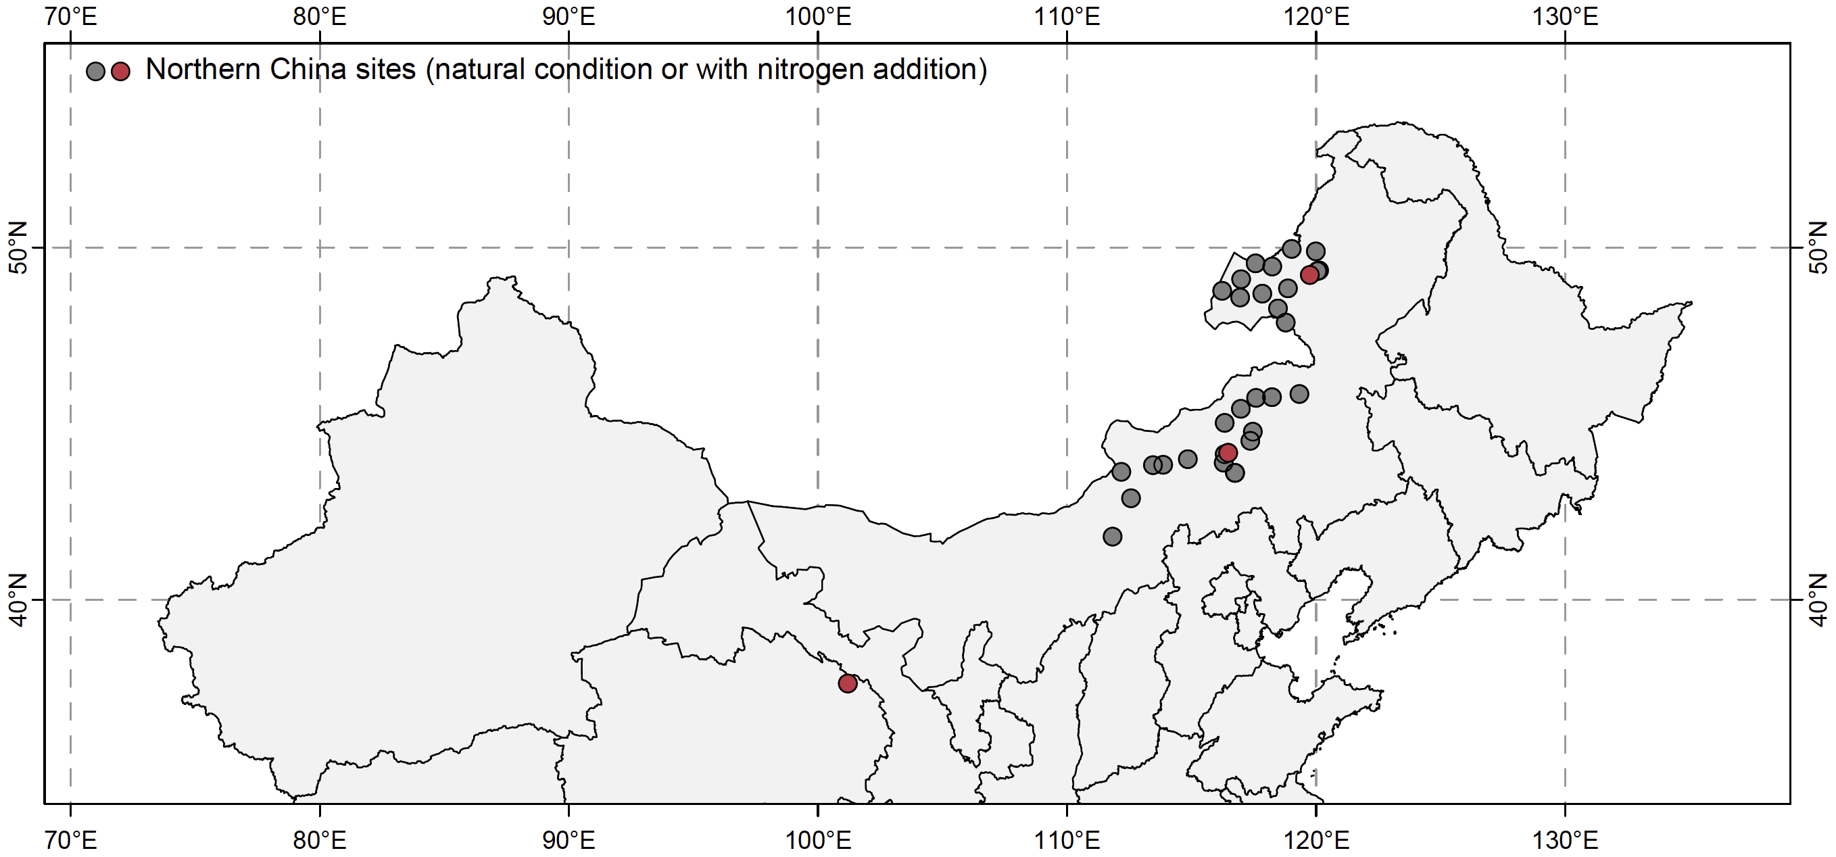
Supplementary Figure 1. Geographical distribution of northern China grassland study sites. The current study includes 30 natural grassland sites and 3 nitrogen-addition experimental sites in northern China. Sites are jittered to reduce overlap.

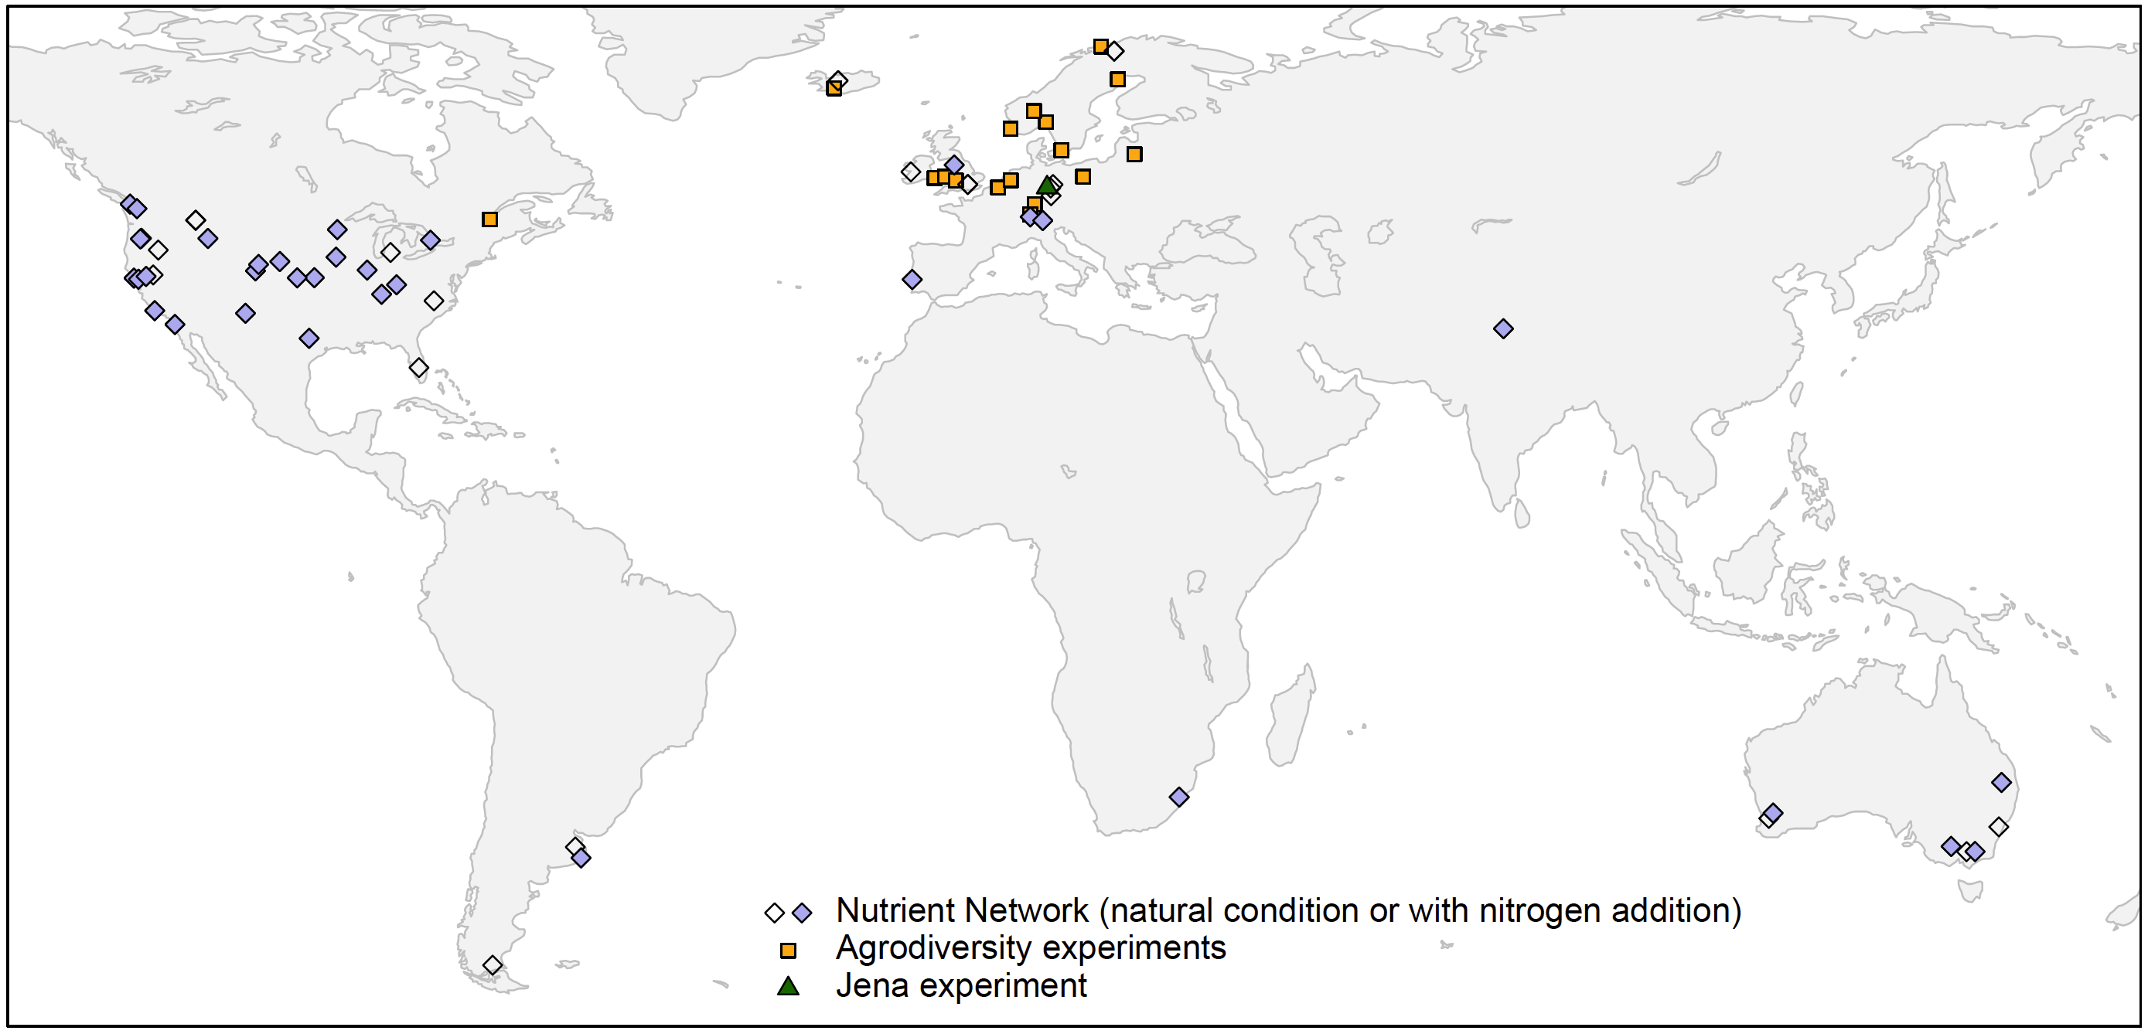
Supplementary Figure 2. Geographical distribution of Nutrient Network study sites and biodiversity experiments. The current study includes 57 natural grassland sites and 34 nitrogen-addition sites from the Nutrient Network, as well as 20 biodiversity experiments (19 Agrodiversity sites and the Jena biodiversity experiment, including both the main and dominance experiments). Sites are jittered to reduce overlap.

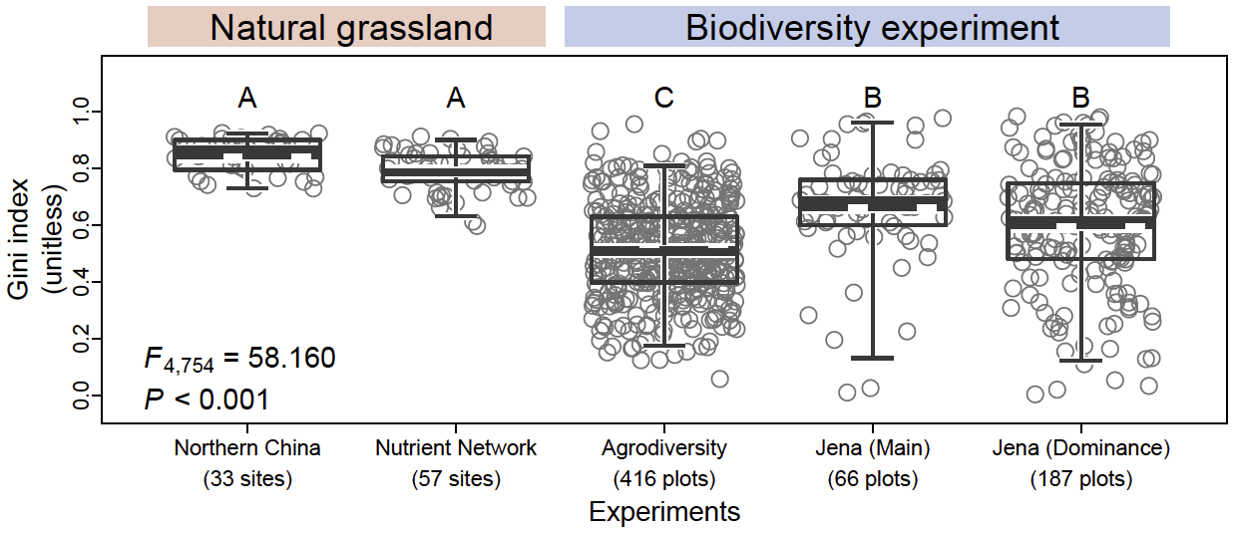
Supplementary Figure 3. Species-abundance unevenness in natural and biodiversity experimental communities. Species-abundance unevenness (estimated using the Gini index) was compared (using F-values) across natural grasslands and biodiversity experiments. Boxes (a–h) show medians (solid lines), means (dashed lines), interquartile ranges (boxes) and the 2.5th and 97.5th percentiles (whiskers). Different uppercase letters represent significant differences in species-abundance unevenness among different systems or experiments.

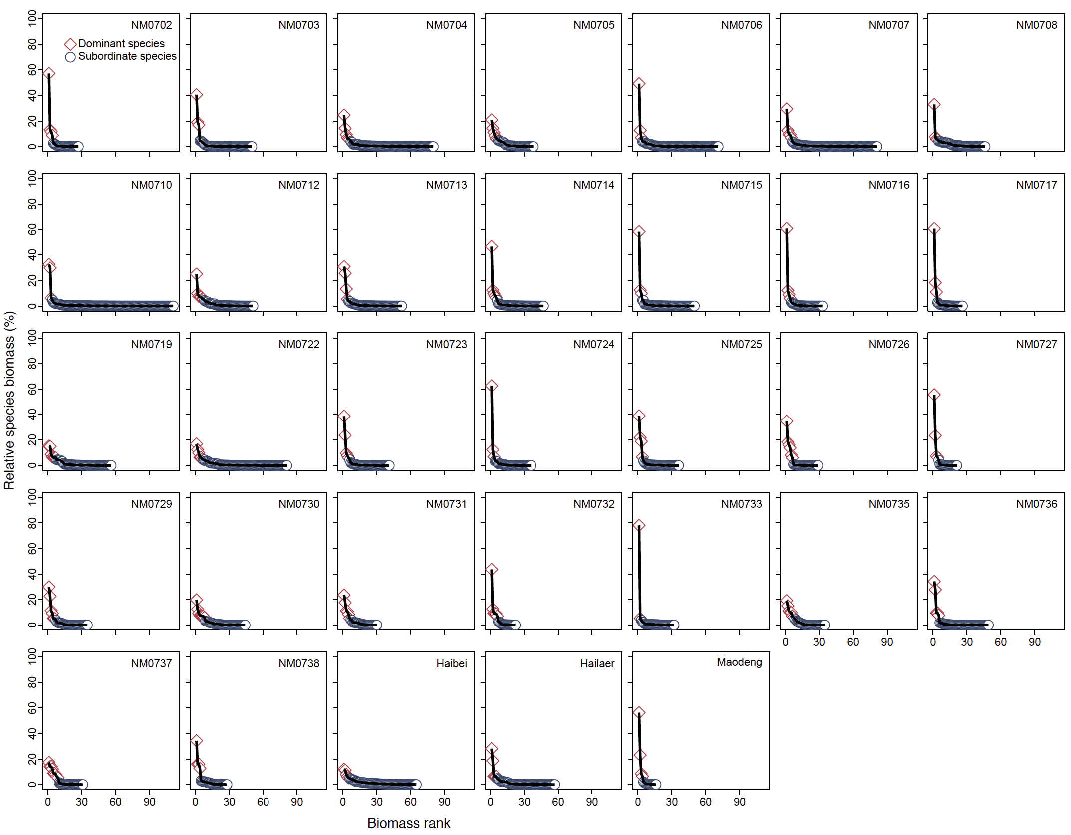
Supplementary Figure 4. Descending order of relative species biomass in northern China grasslands, based on data from all species recorded at each site.

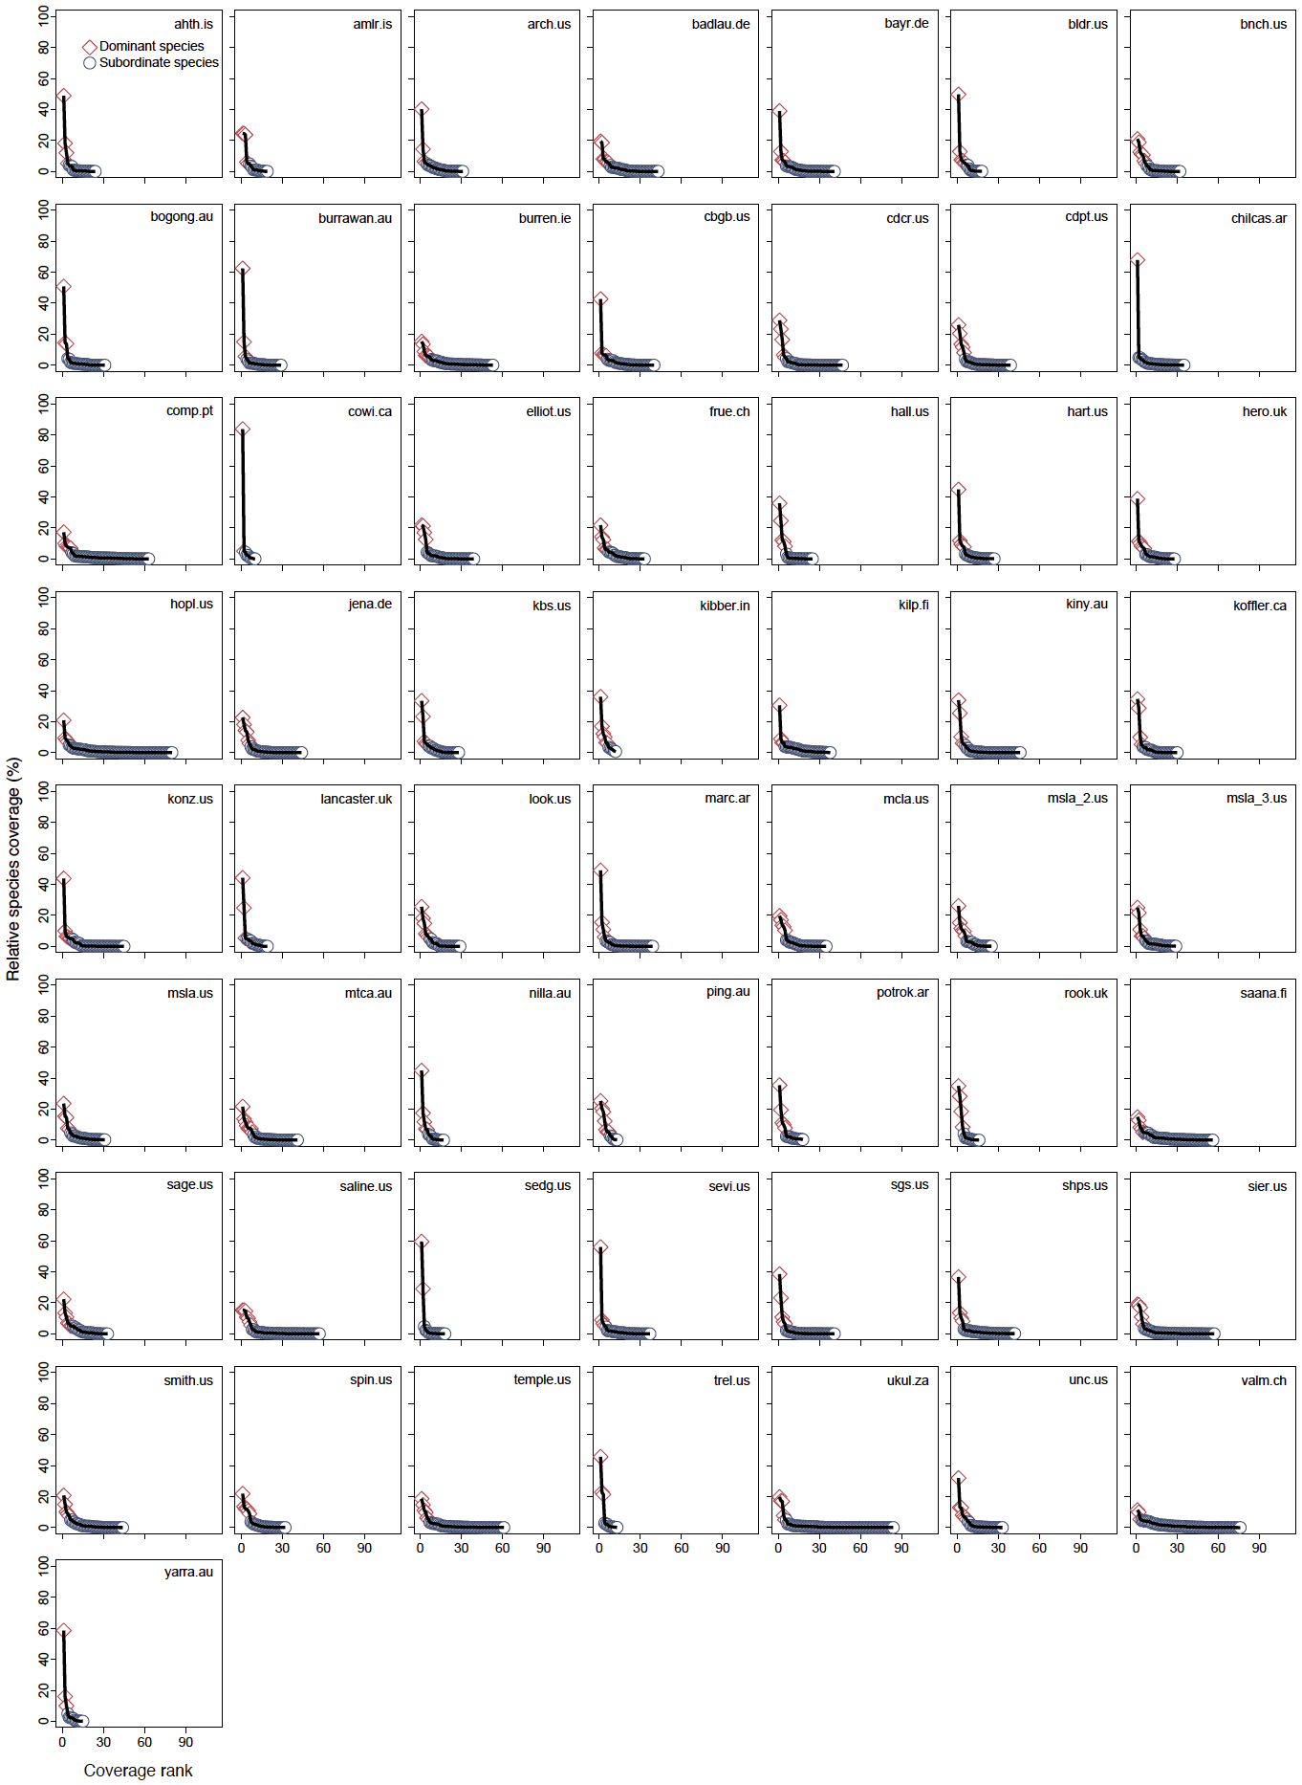
Supplementary Figure 5. Descending order of relative species coverage in Nutrient-Network grasslands, based on data from all species recorded at each site.
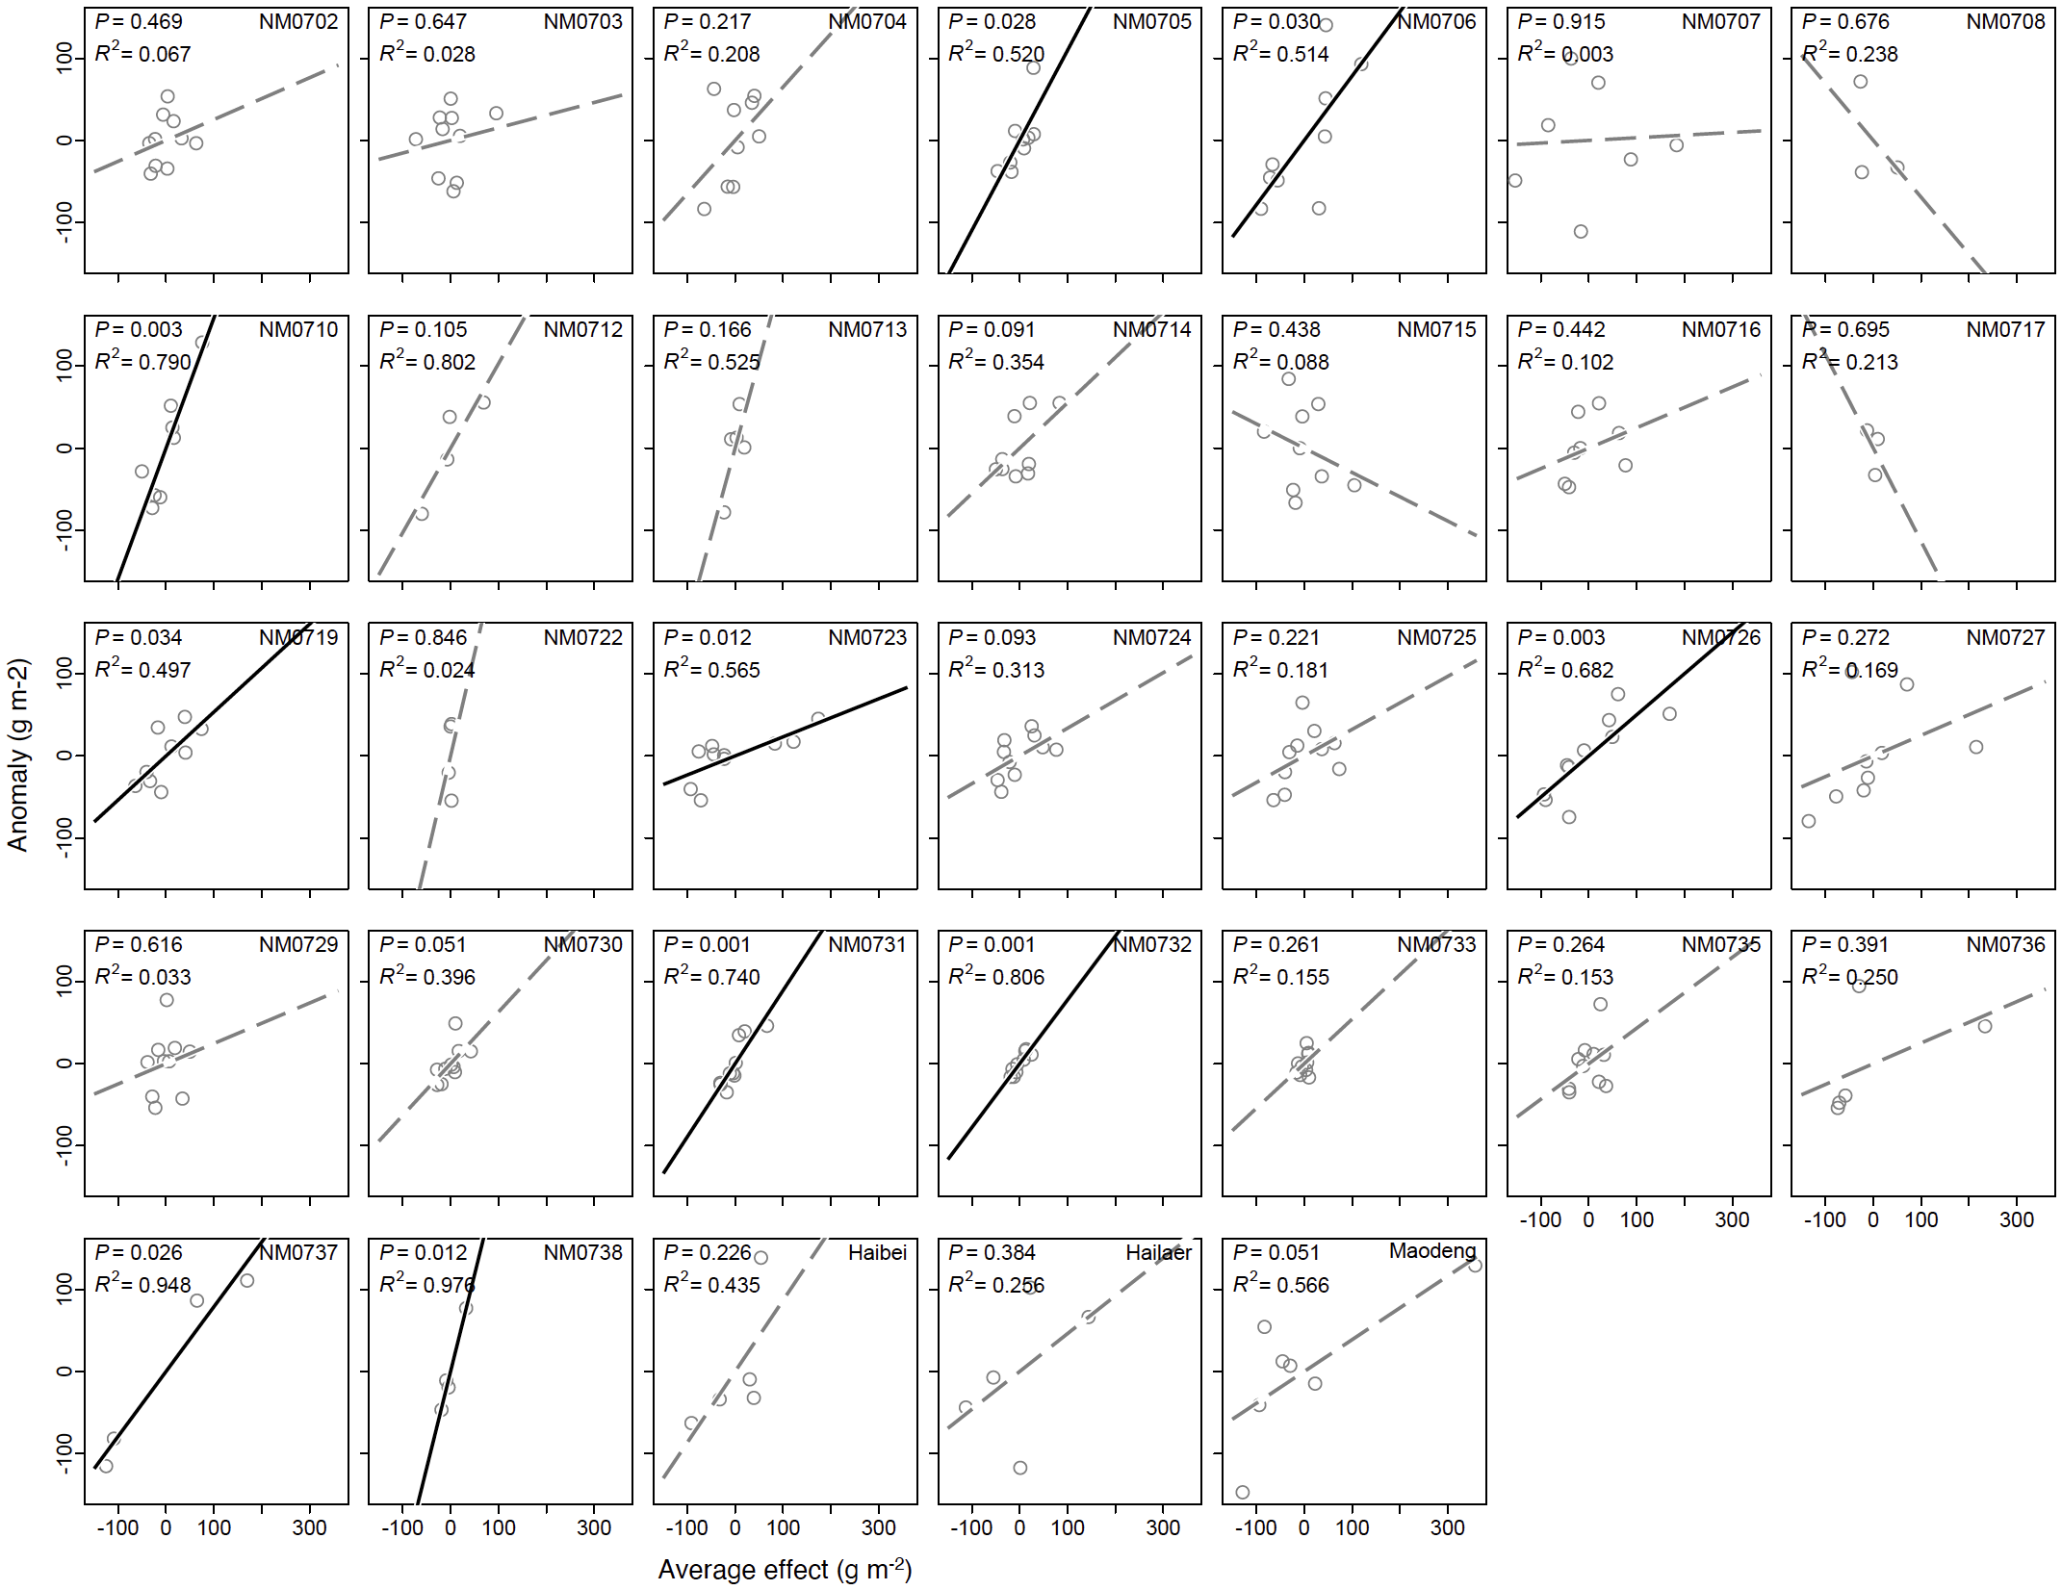
Supplementary Figure 6. Average effect in driving plant community biomass production (productivity) in northern China grasslands. Solid black lines represent significant regression lines; dashed grey lines represent non-significant regression lines. R² values of the regressions are shown.
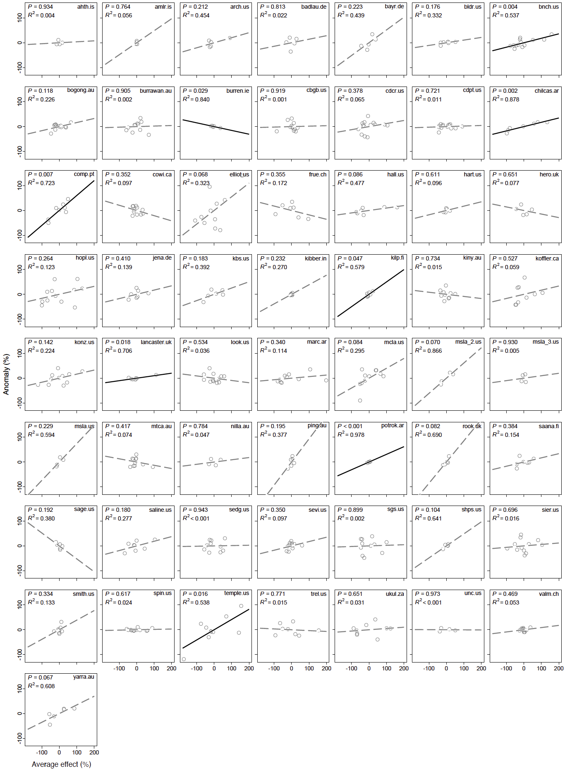
Supplementary Figure 7. Average effect in driving plant community coverage in Nutrient-Network grasslands. Solid black lines represent significant regression lines; dashed grey lines represent non-significant regression lines. R² values of regressions are shown.
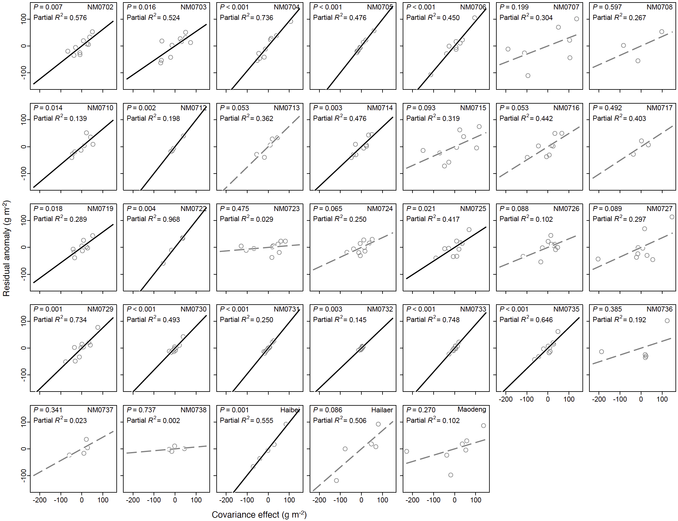
Supplementary Figure 8. Residual regression for the covariance effect in driving plant community biomass production (productivity) in northern China grasslands. Solid black lines represent significant regression lines; dashed grey lines represent non-significant regression lines. Partial R² values, calculated as the product of the R² of residual regressions and the proportion of variance unexplained in linear regressions (Supplementary Figure 6), are also shown.

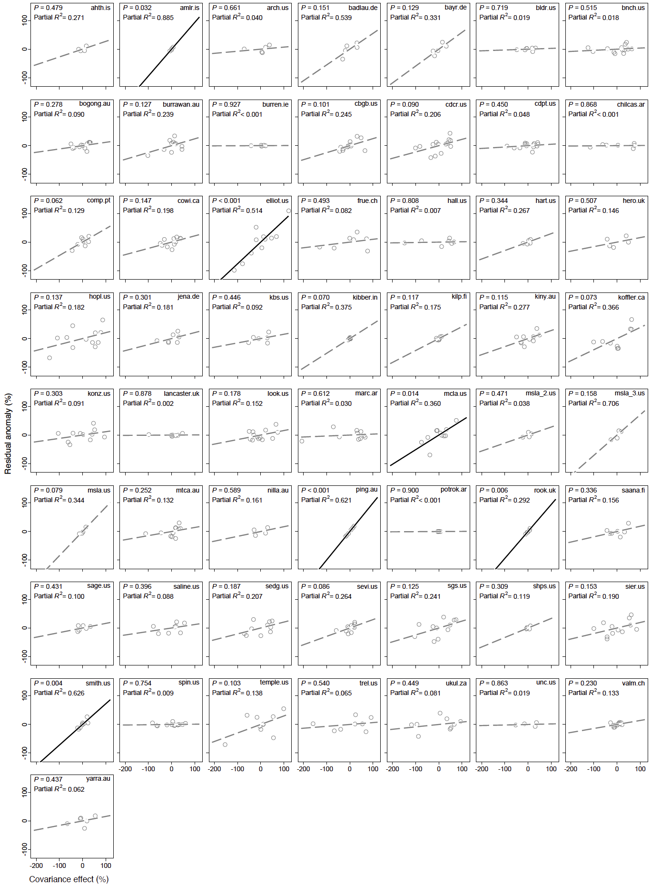
Supplementary Figure 9. Residual regression for the covariance effect in driving plant community coverage in Nutrient-Network grasslands. Solid black lines represent significant regression lines; dashed grey lines represent non-significant regression lines. Partial R² values, calculated as the product of the R² of residual regression and the proportion of variance unexplained in linear regressions (Supplementary Figure 7), are also shown.

