Spatial and single-nucleus transcriptomics reveal the complexity of genomic imprinting in maize
Tao Li¹, Yi Jiang¹, Mingyue Zhang², Kesen Zhu¹, Siqi Jiang¹, Xuerong Yang², Hongjun Liu^{2,3}, Jiechen Wang⁴, Xiaomei Dong⁵ & Junpeng Shi^{1,#}
¹Guangdong Provincial Key Laboratory of Plant Stress Biology, School of Agriculture and Biotechnology, The Shenzhen Campus of Sun Yat-sen University, Sun Yat-sen University, Shenzhen, 518107, China
²State Key Laboratory of Crop Biology, College of Life Sciences, Shandong Agricultural University, Tai'an, Shandong, 271018, China
³Yazhouwan National Laboratory, Sanya, Hainan, 572024, China
⁴National Key Laboratory of Plant Molecular Genetics, CAS Center for Excellence in Molecular Plant Sciences, Shanghai Institute of Plant Physiology & Ecology, Shanghai, 200032, China
⁵College of Bioscience and Biotechnology, Shenyang Agricultural University, Shenyang, Liaoning, 110866, China

#Correspondence: Junpeng Shi (shijp6@mail.sysu.edu.cn)
Keywords: Maize, spatial transcriptomics, genomic imprinting, allele-specific expression, lncRNAs

Supplementary Figures
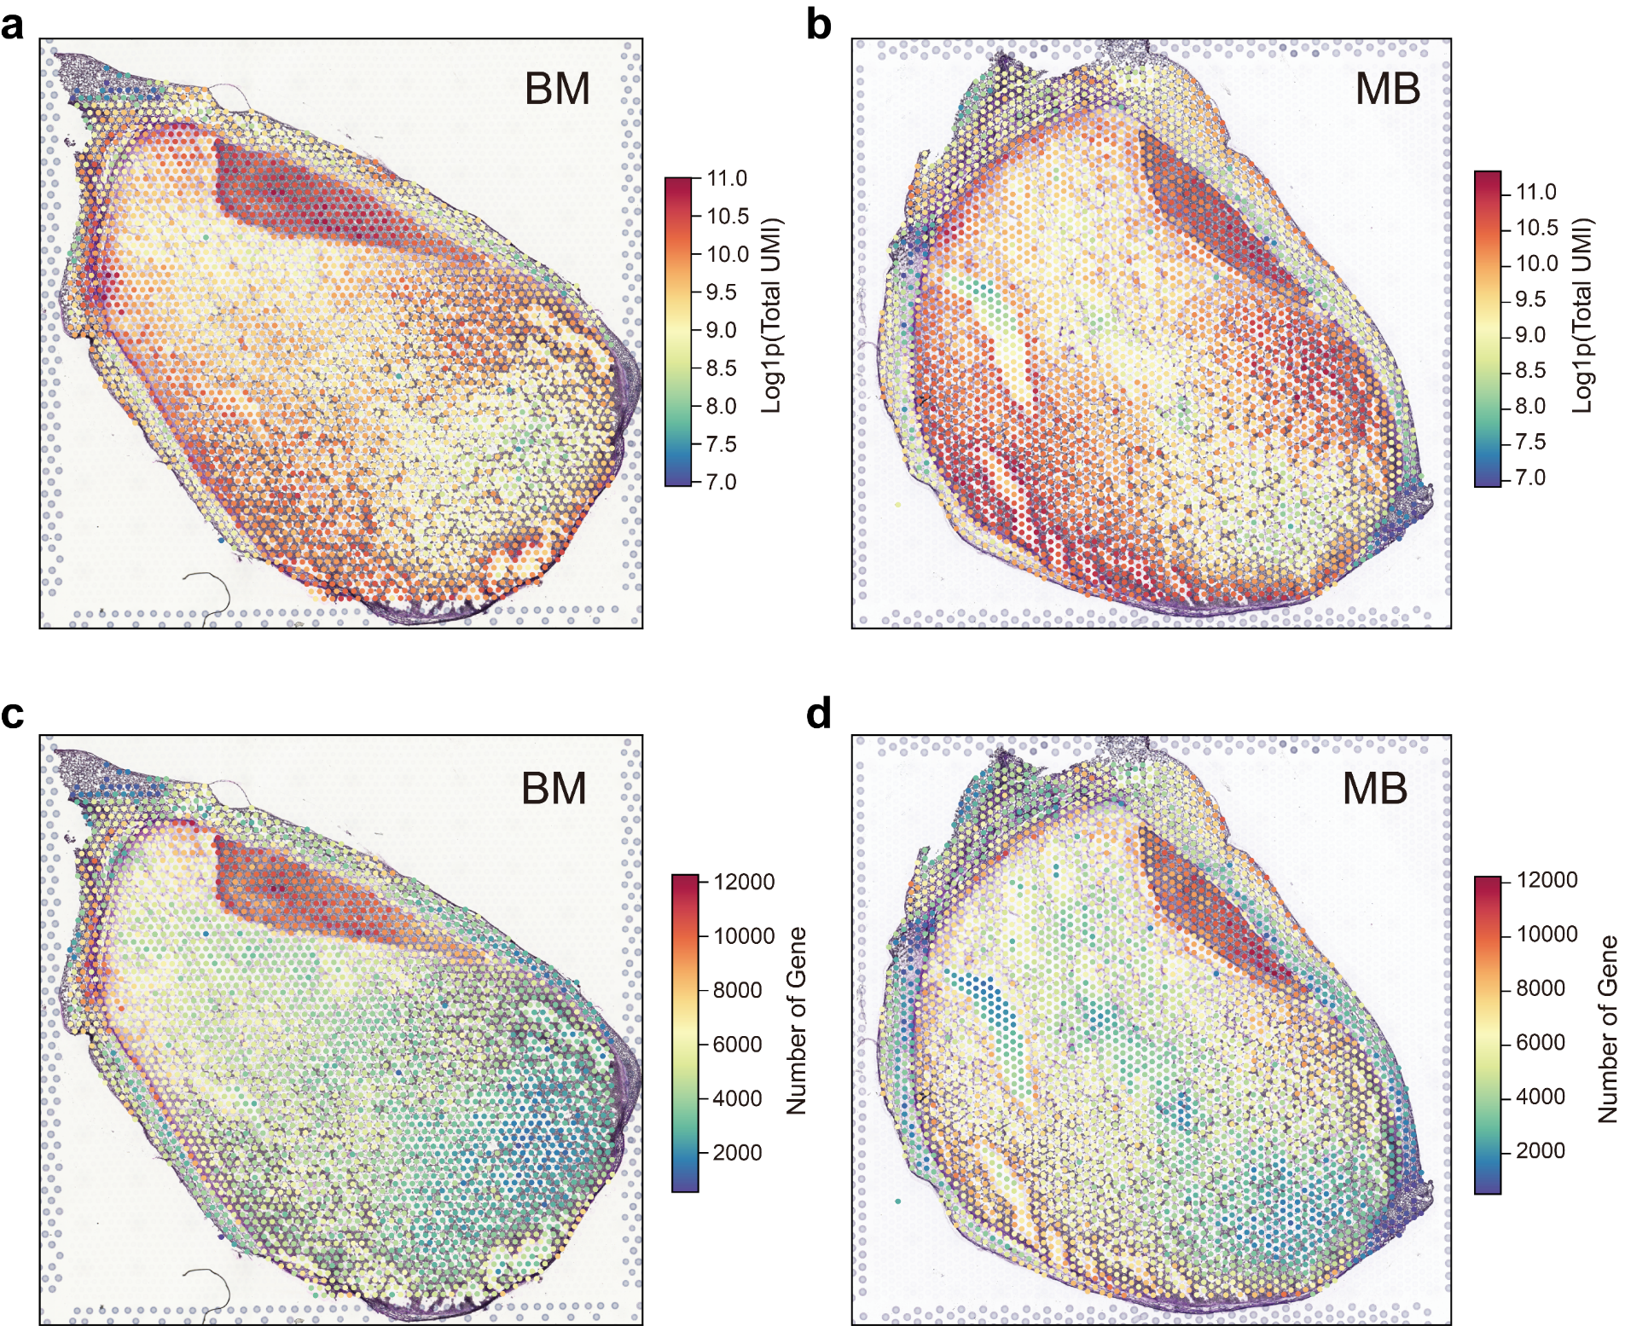
Fig. S1 Spatial overview of sequencing depth and gene detection.
a, b Spatial plot showing total UMI counts per spot in BM (a) and MB (b) samples. c, d Spatial plot showing the number of genes detected per spot in BM (c) and MB (d) samples.

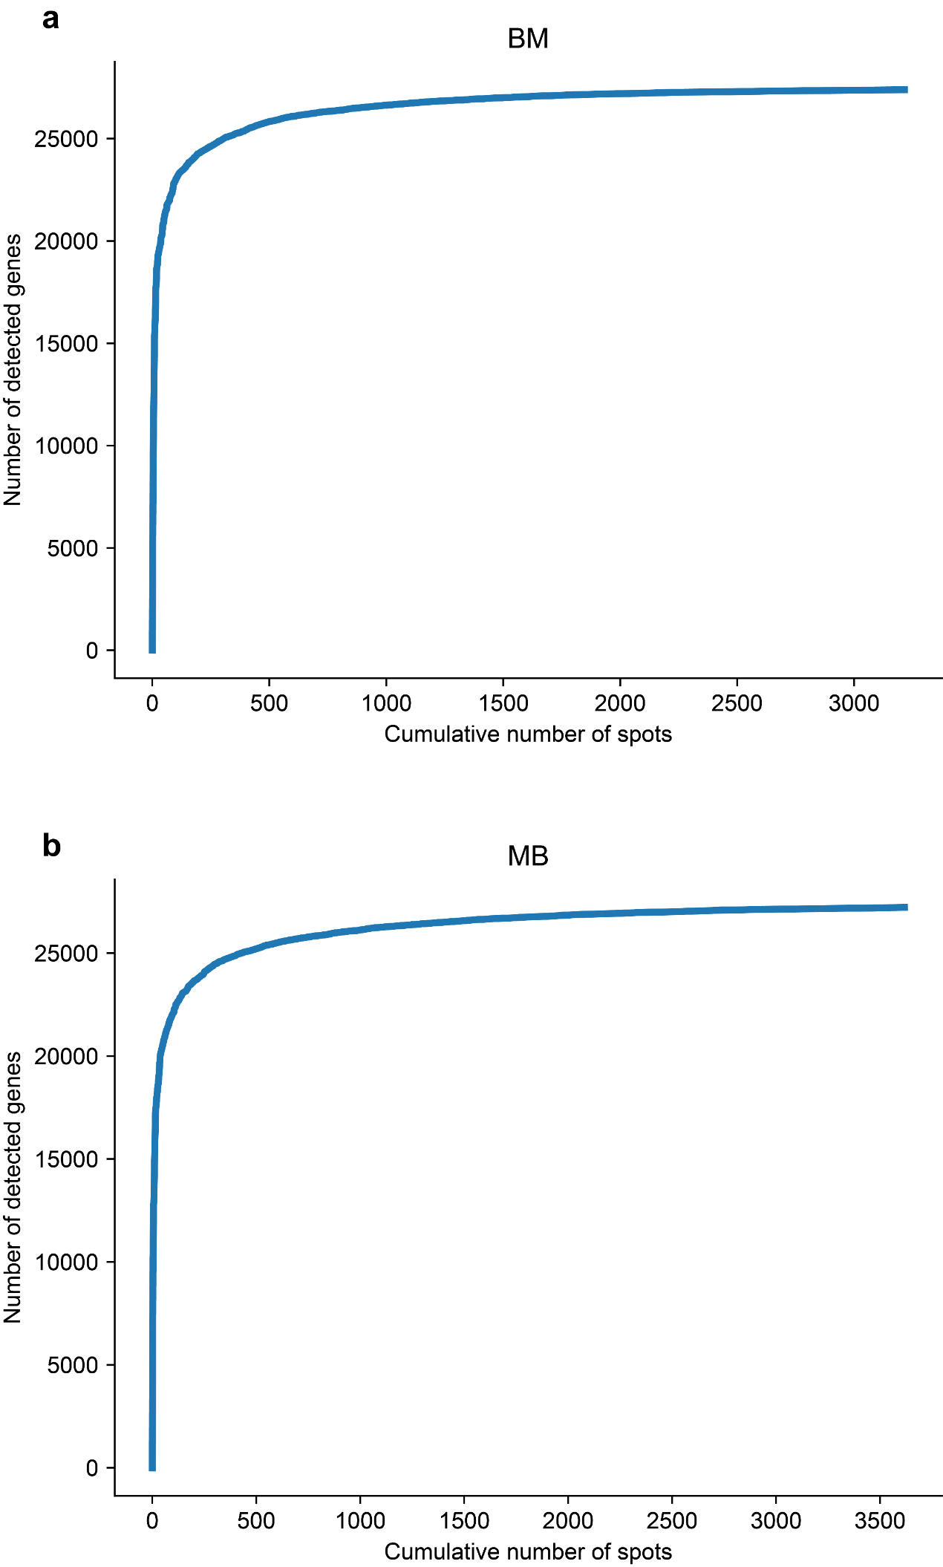
Fig. S2 Line plot showing the number of detected genes as the cumulative number of spots increases in BM (a) and MB (b).

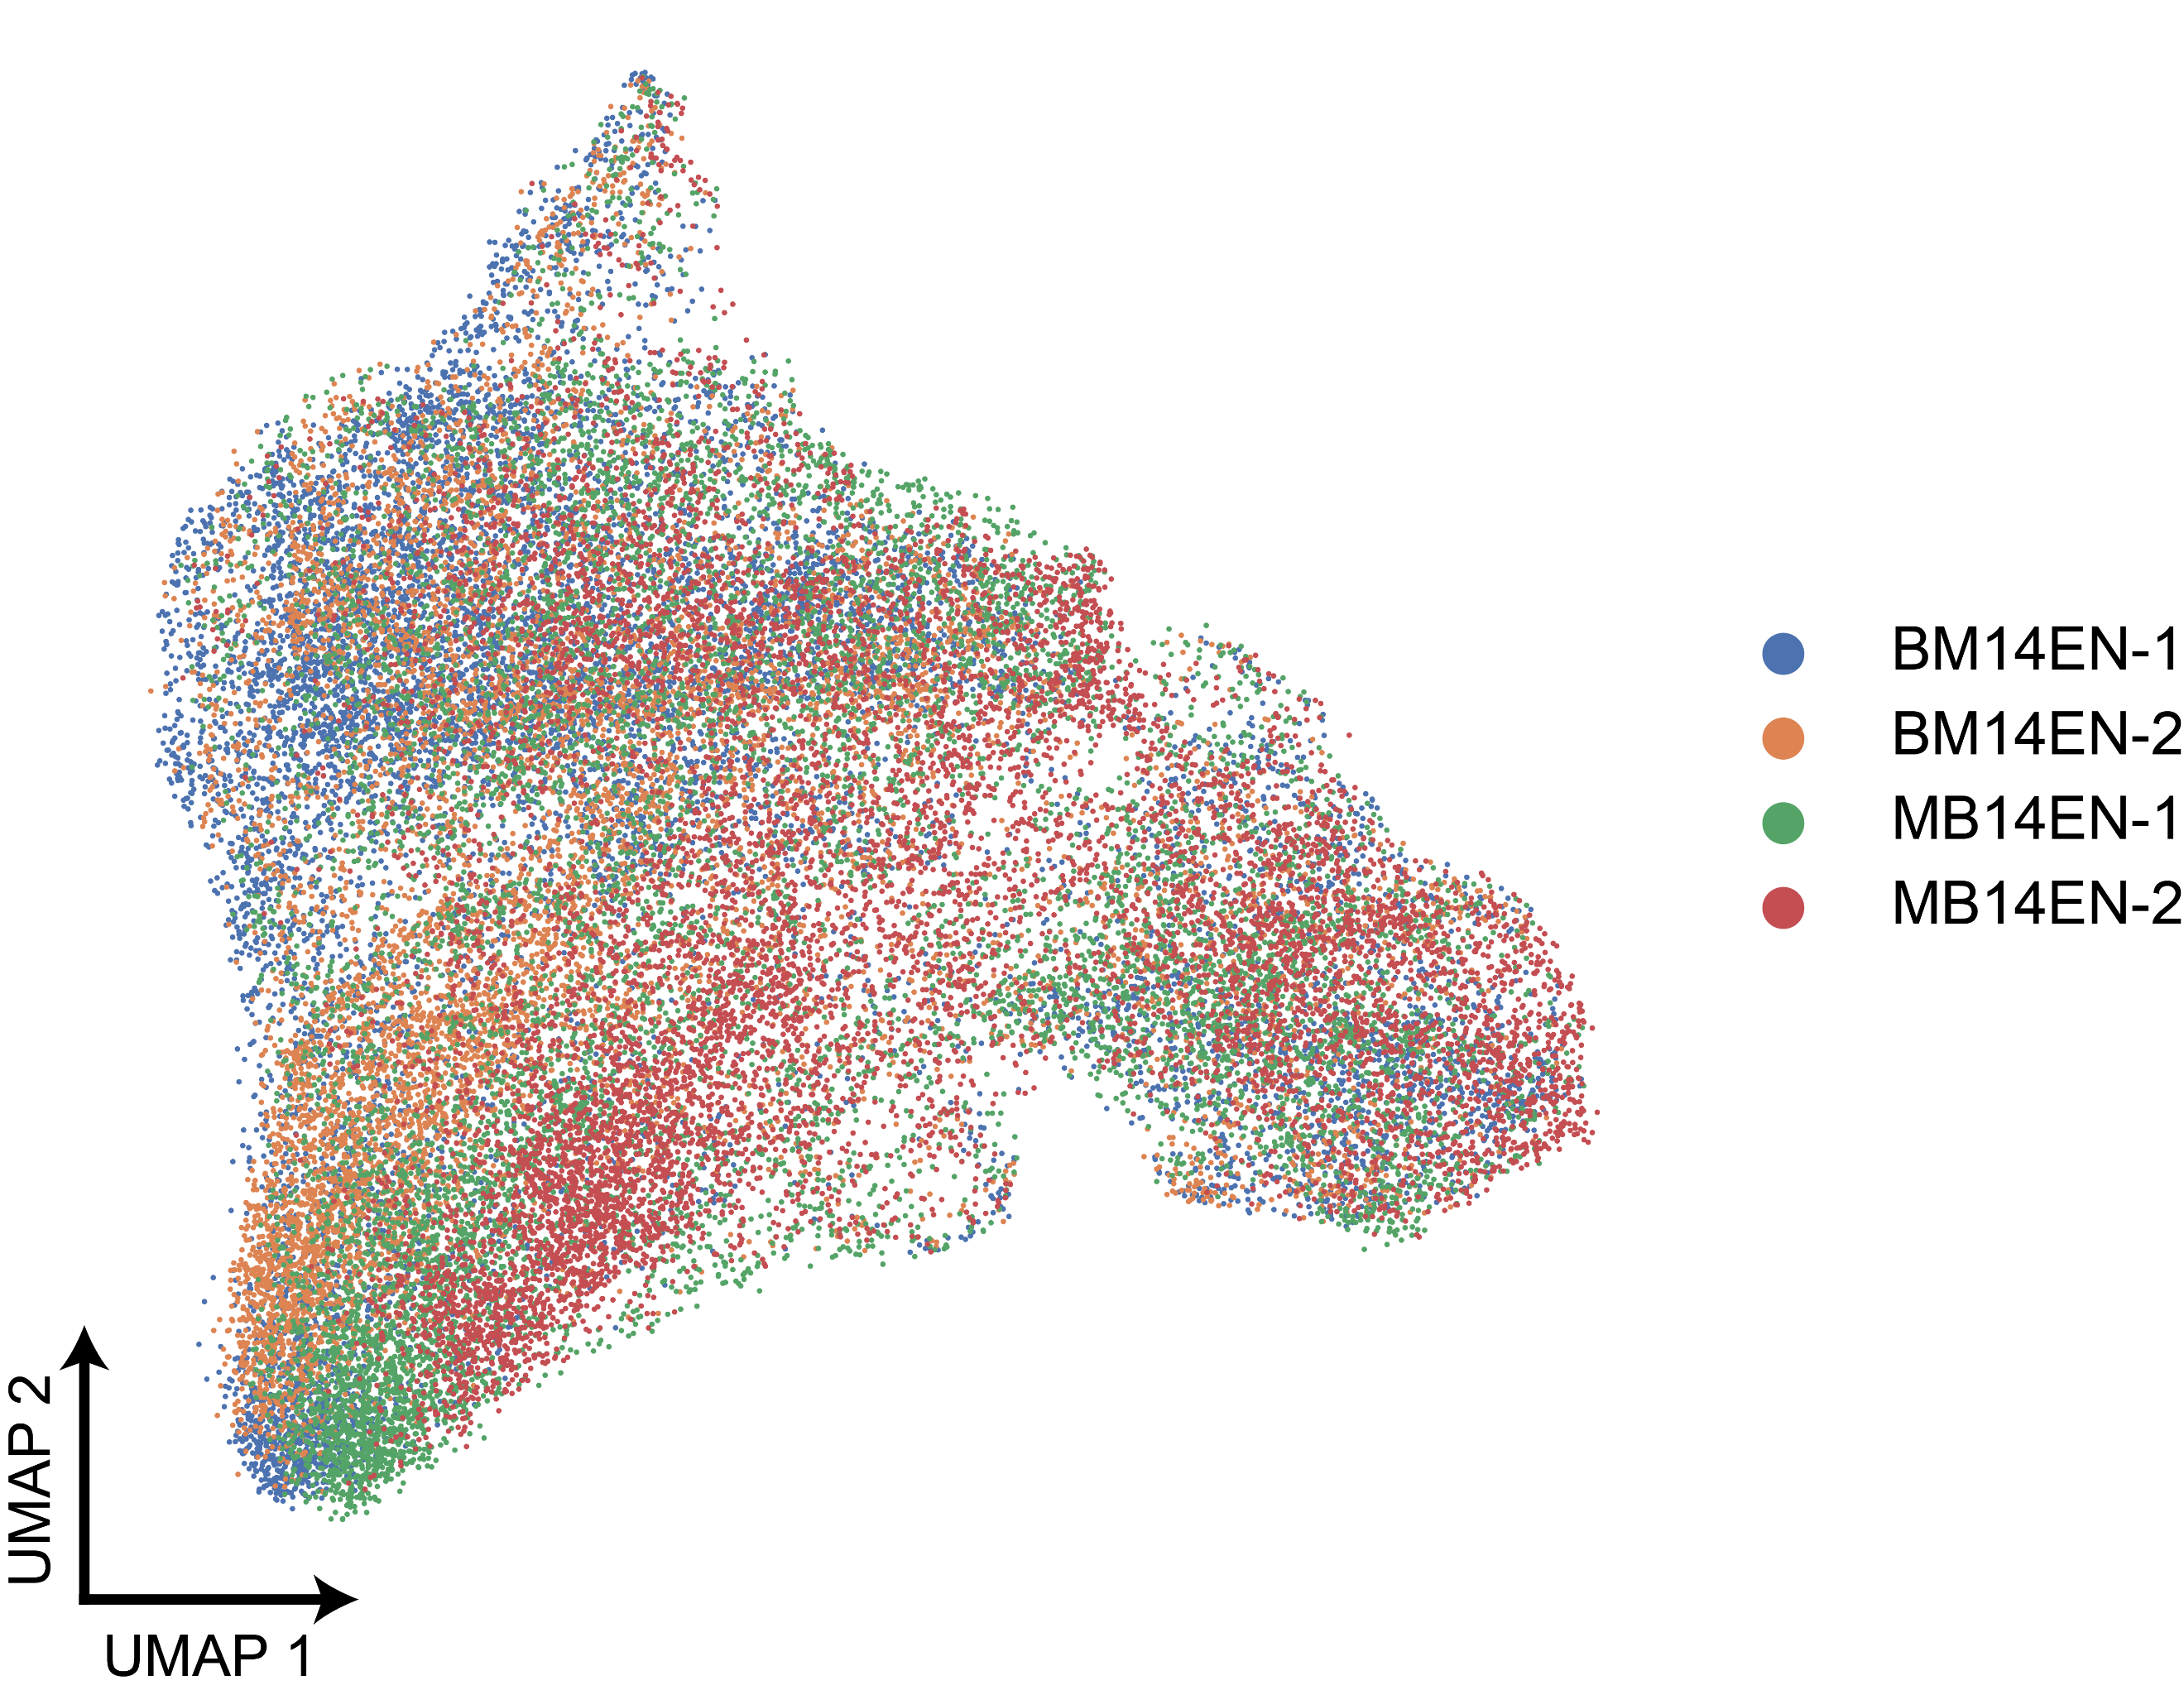
Fig. S3 UMAP of integrated snRNA-seq nuclei colored by sample.

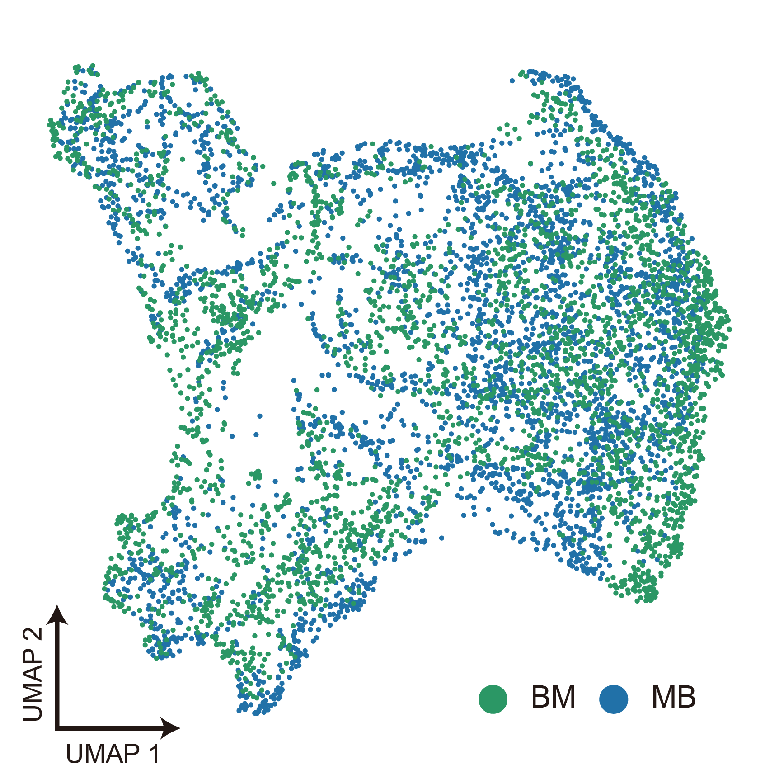
Fig. S4 UMAP of all spatial transcriptomic spots integrating BM and MB, with BM in green and MB in blue.

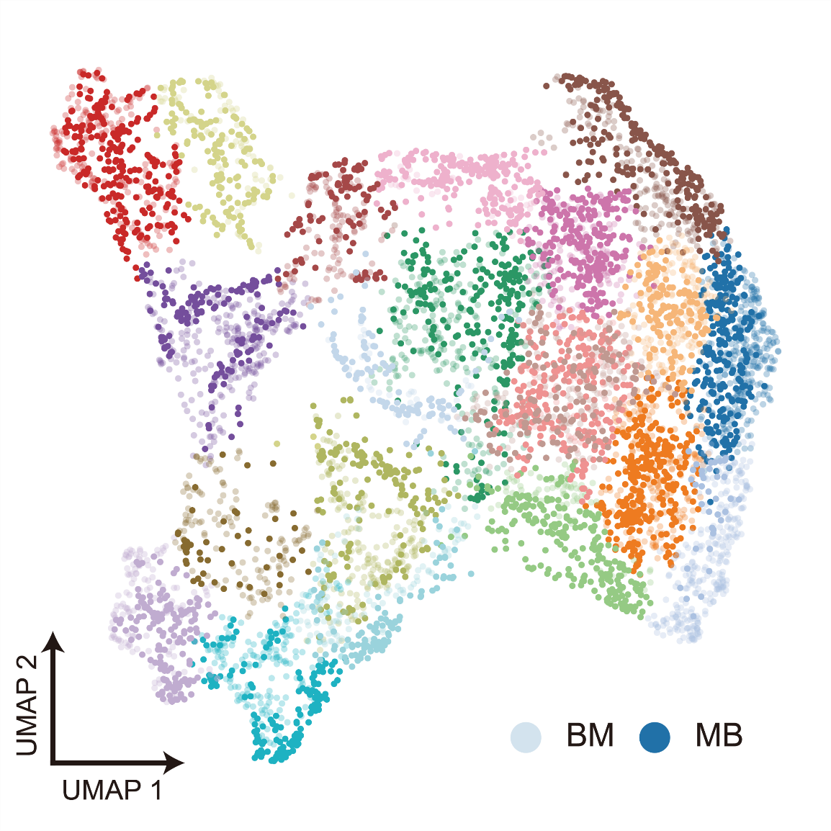
Fig. S5 UMAP of unsupervised clustering; BM shown in transparent, MB in solid color.
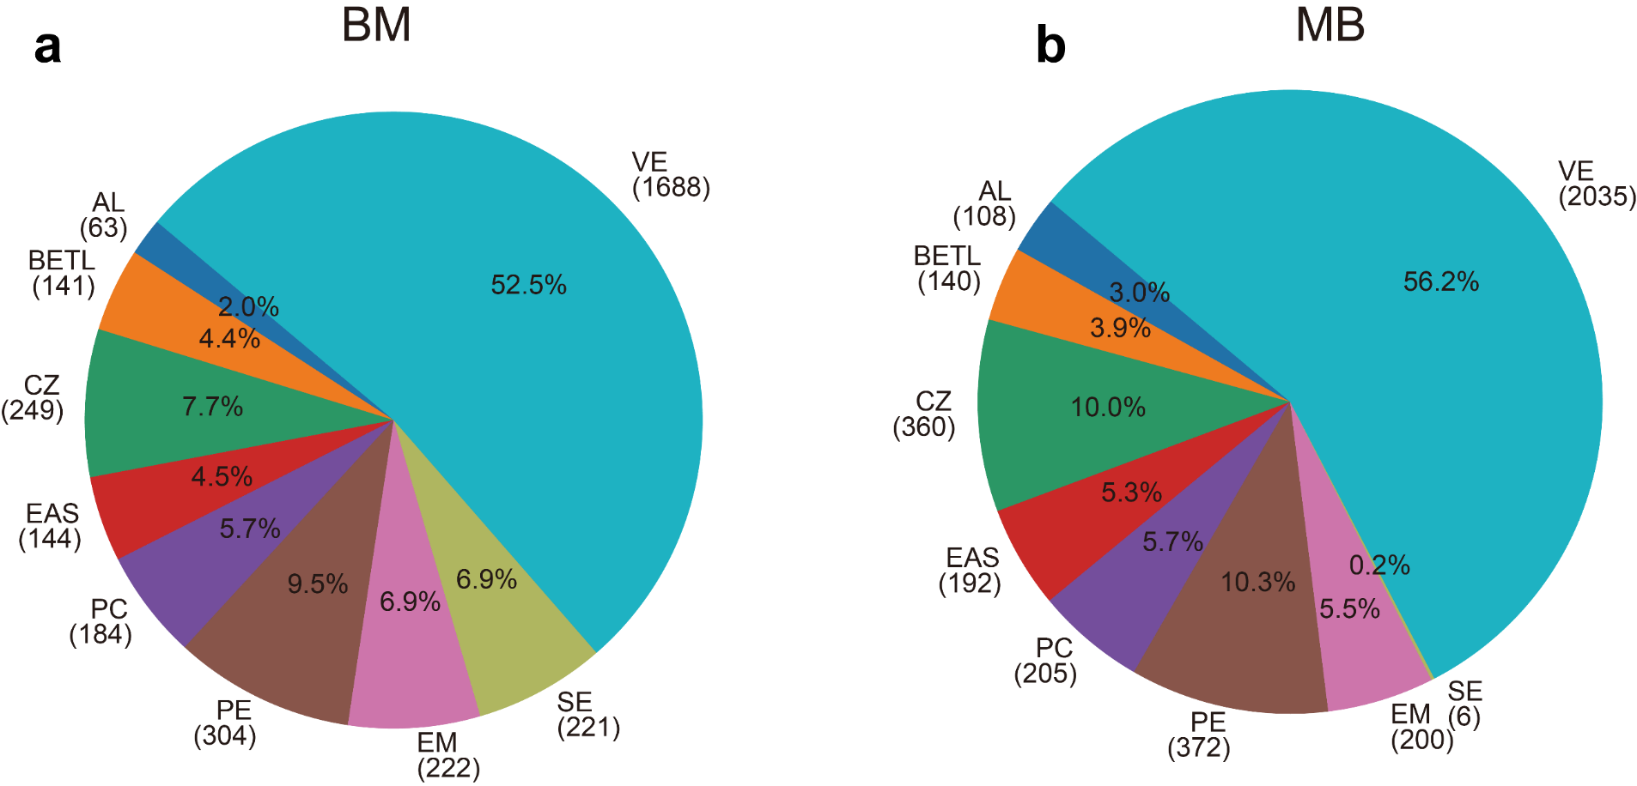
Fig. S6 Pie charts showing the proportion of spots for each cell type in BM (a) and MB (b) samples.

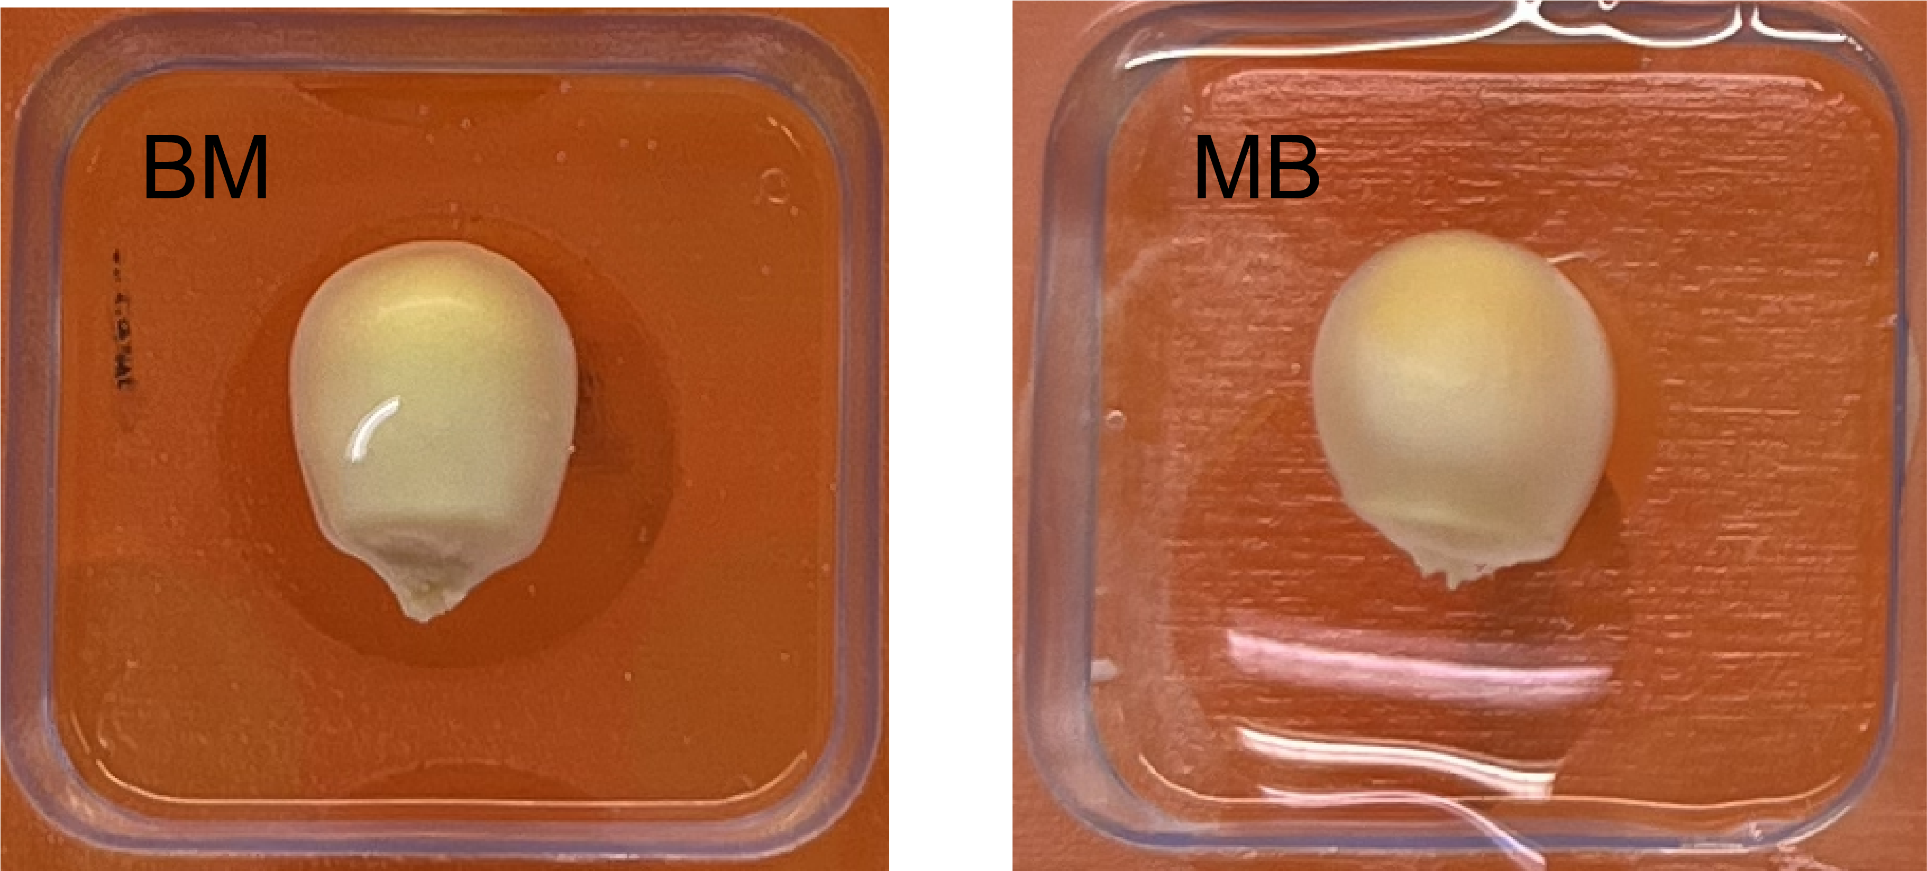
Fig. S7 The 14 DAP kernel phenotypes of BM and MB hybrids that were used for Visium spatial transcriptome sequencing.

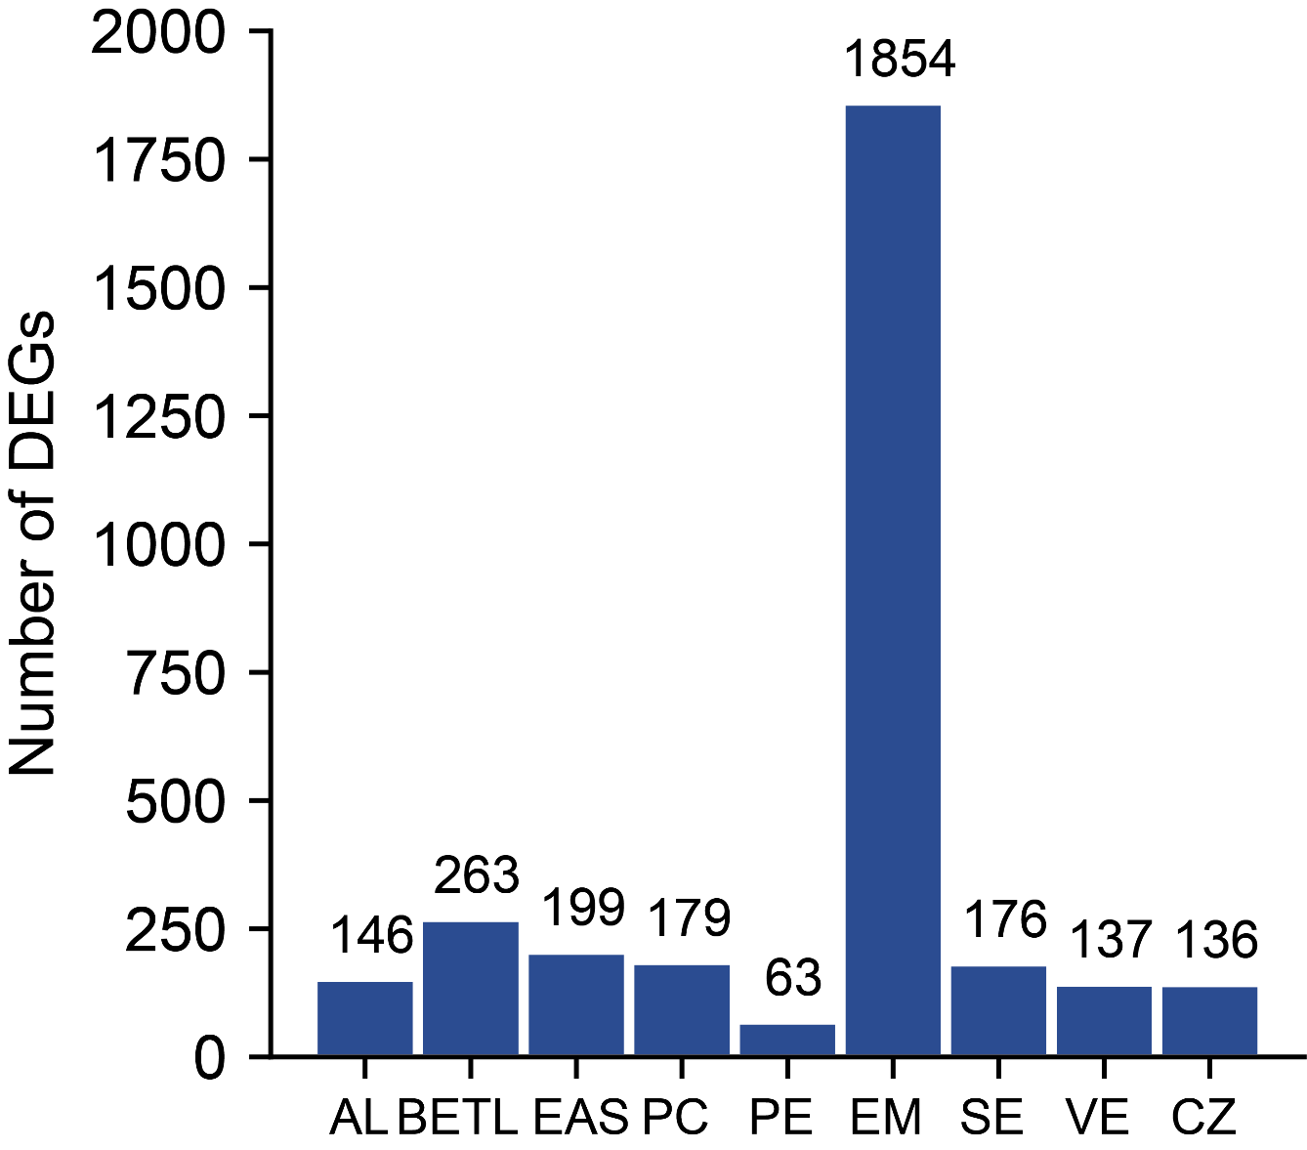
Fig. S8 Bar plot showing the number of DEGs for each cell type compared to other cell types.

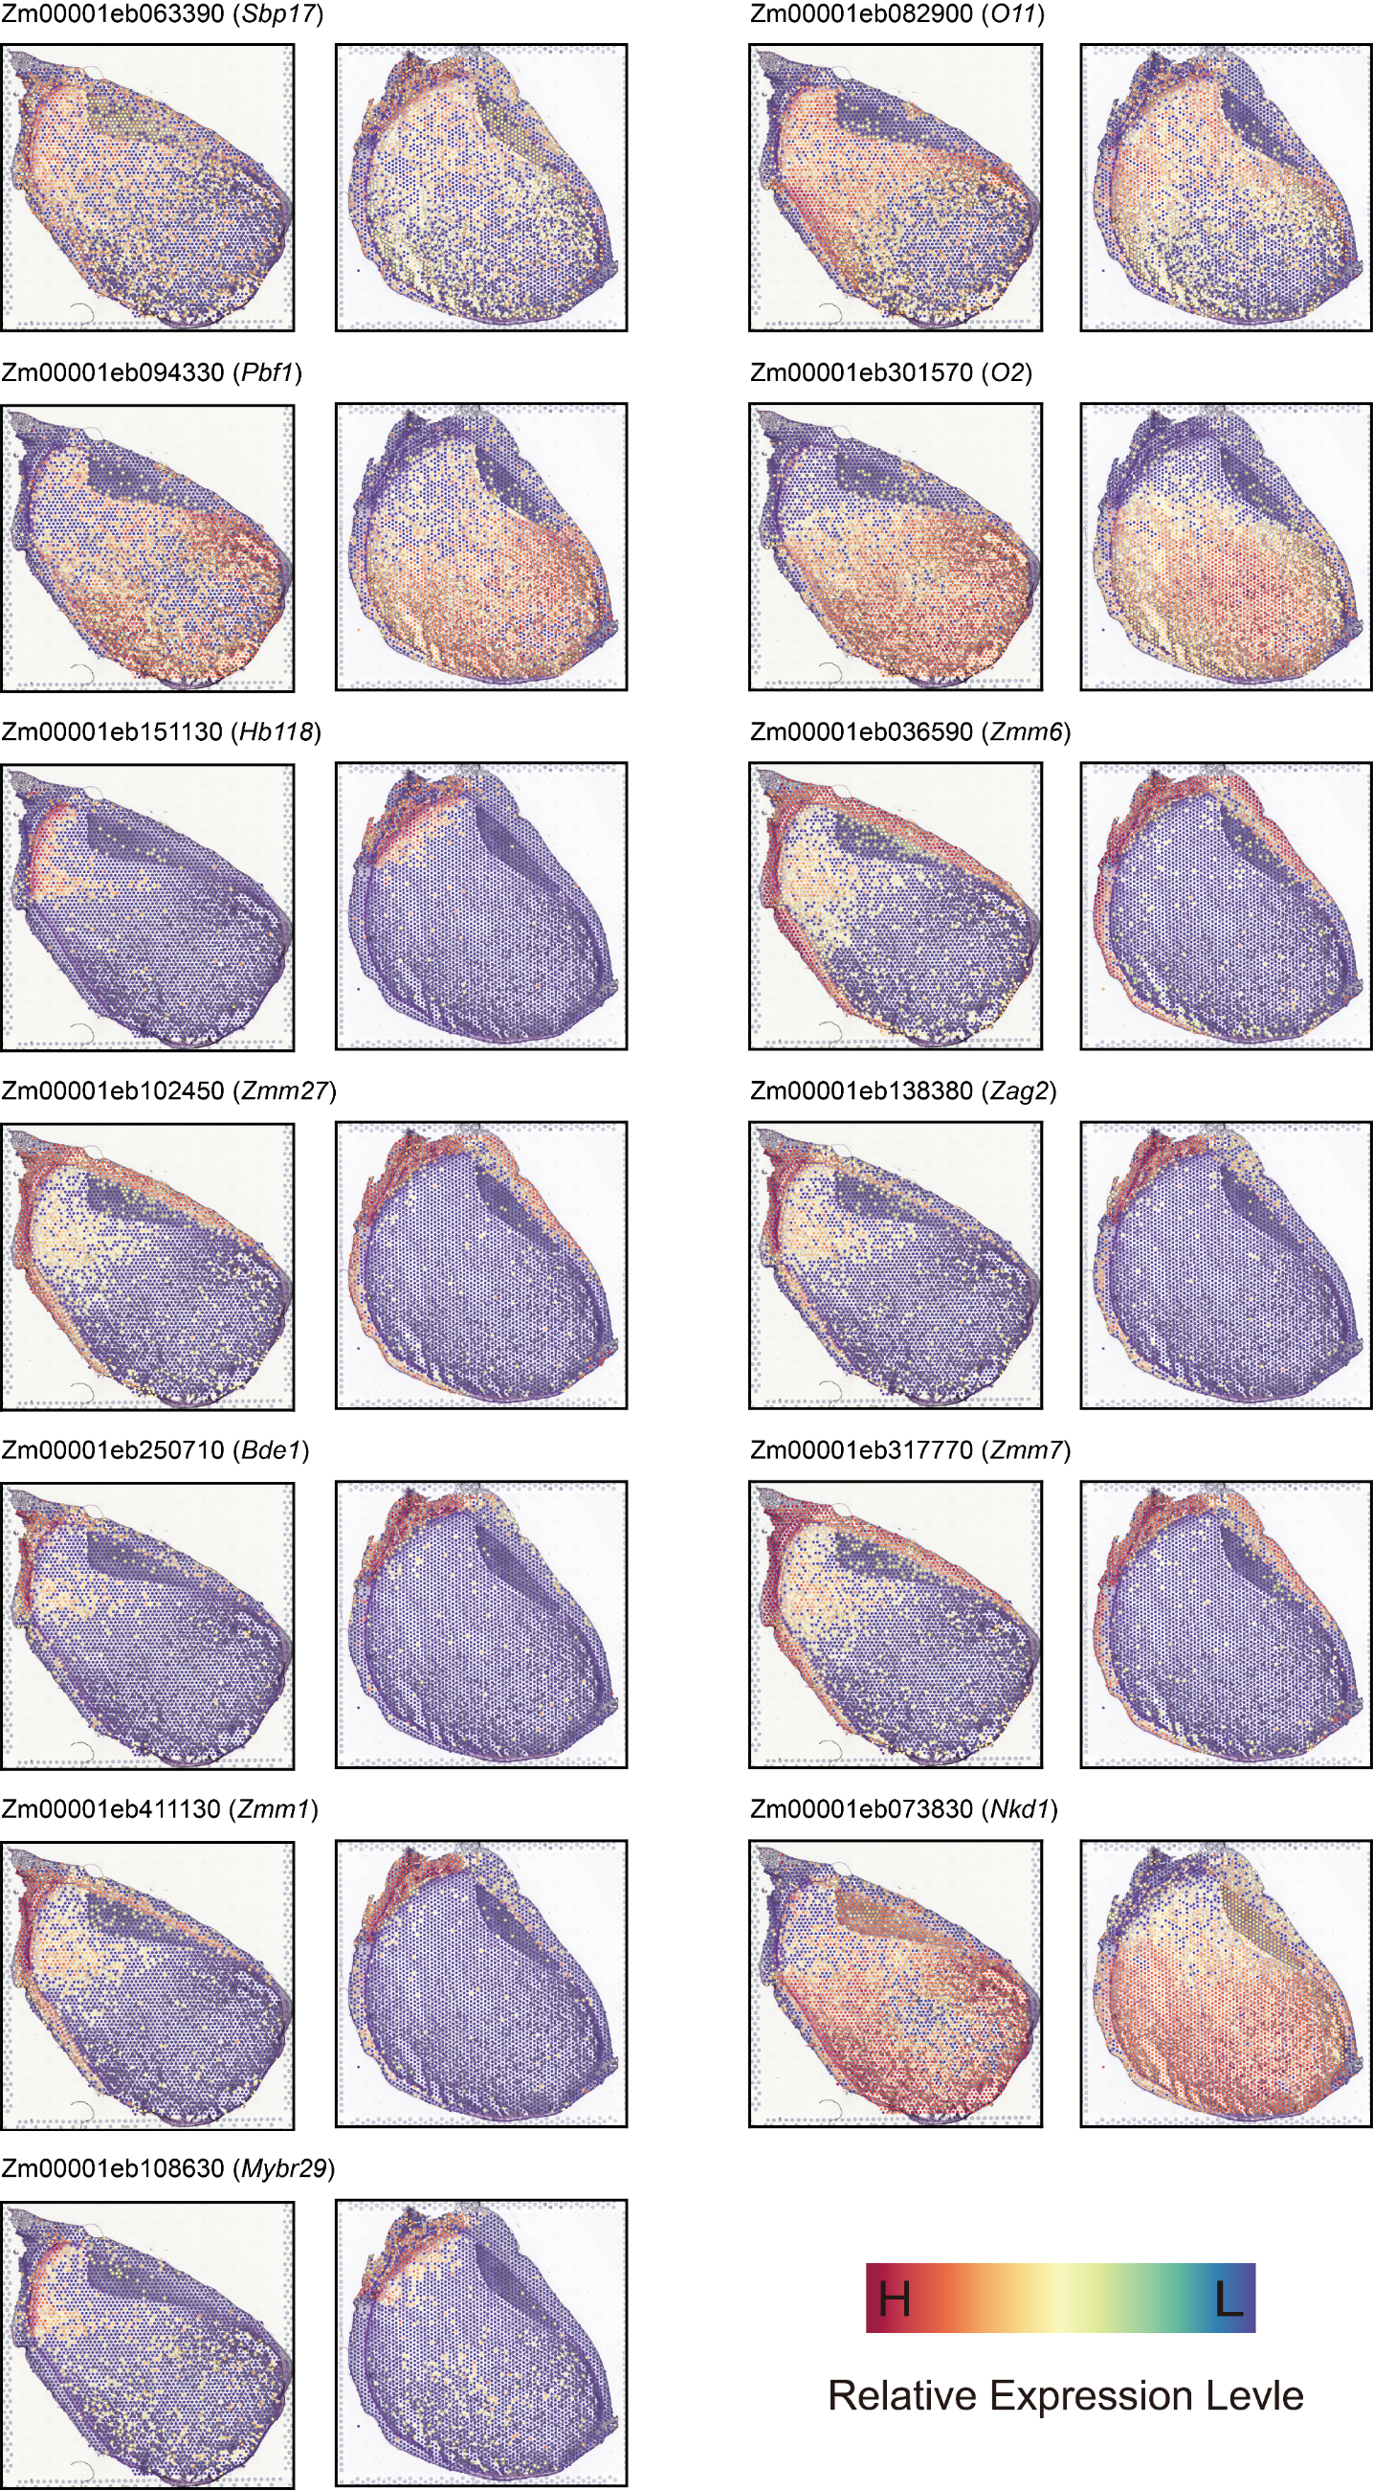
Fig. S9 Spatial expression patterns of transcription factor genes among DEGs.

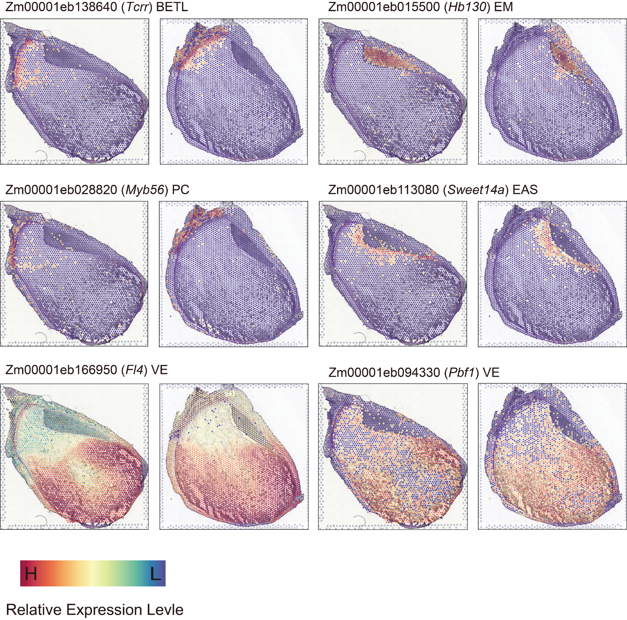Fig. S10 Spatial expression patterns of well-curated marker genes across different cell types.

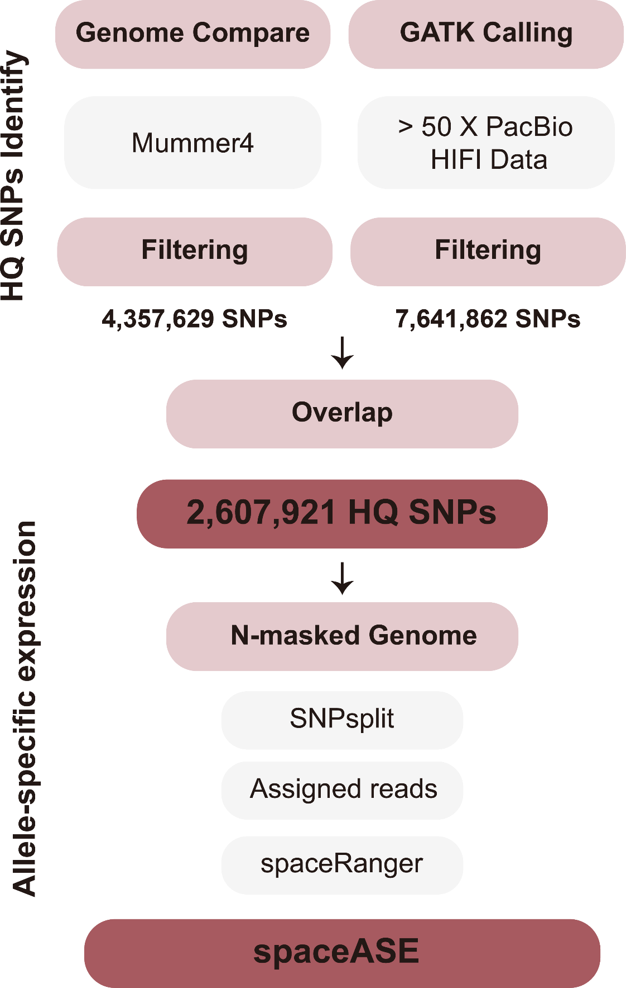
Fig. S11 The workflow of spaceASE to conduct allele-resolved spatial transcriptome analysis in B73 and Mo17 hybrids.

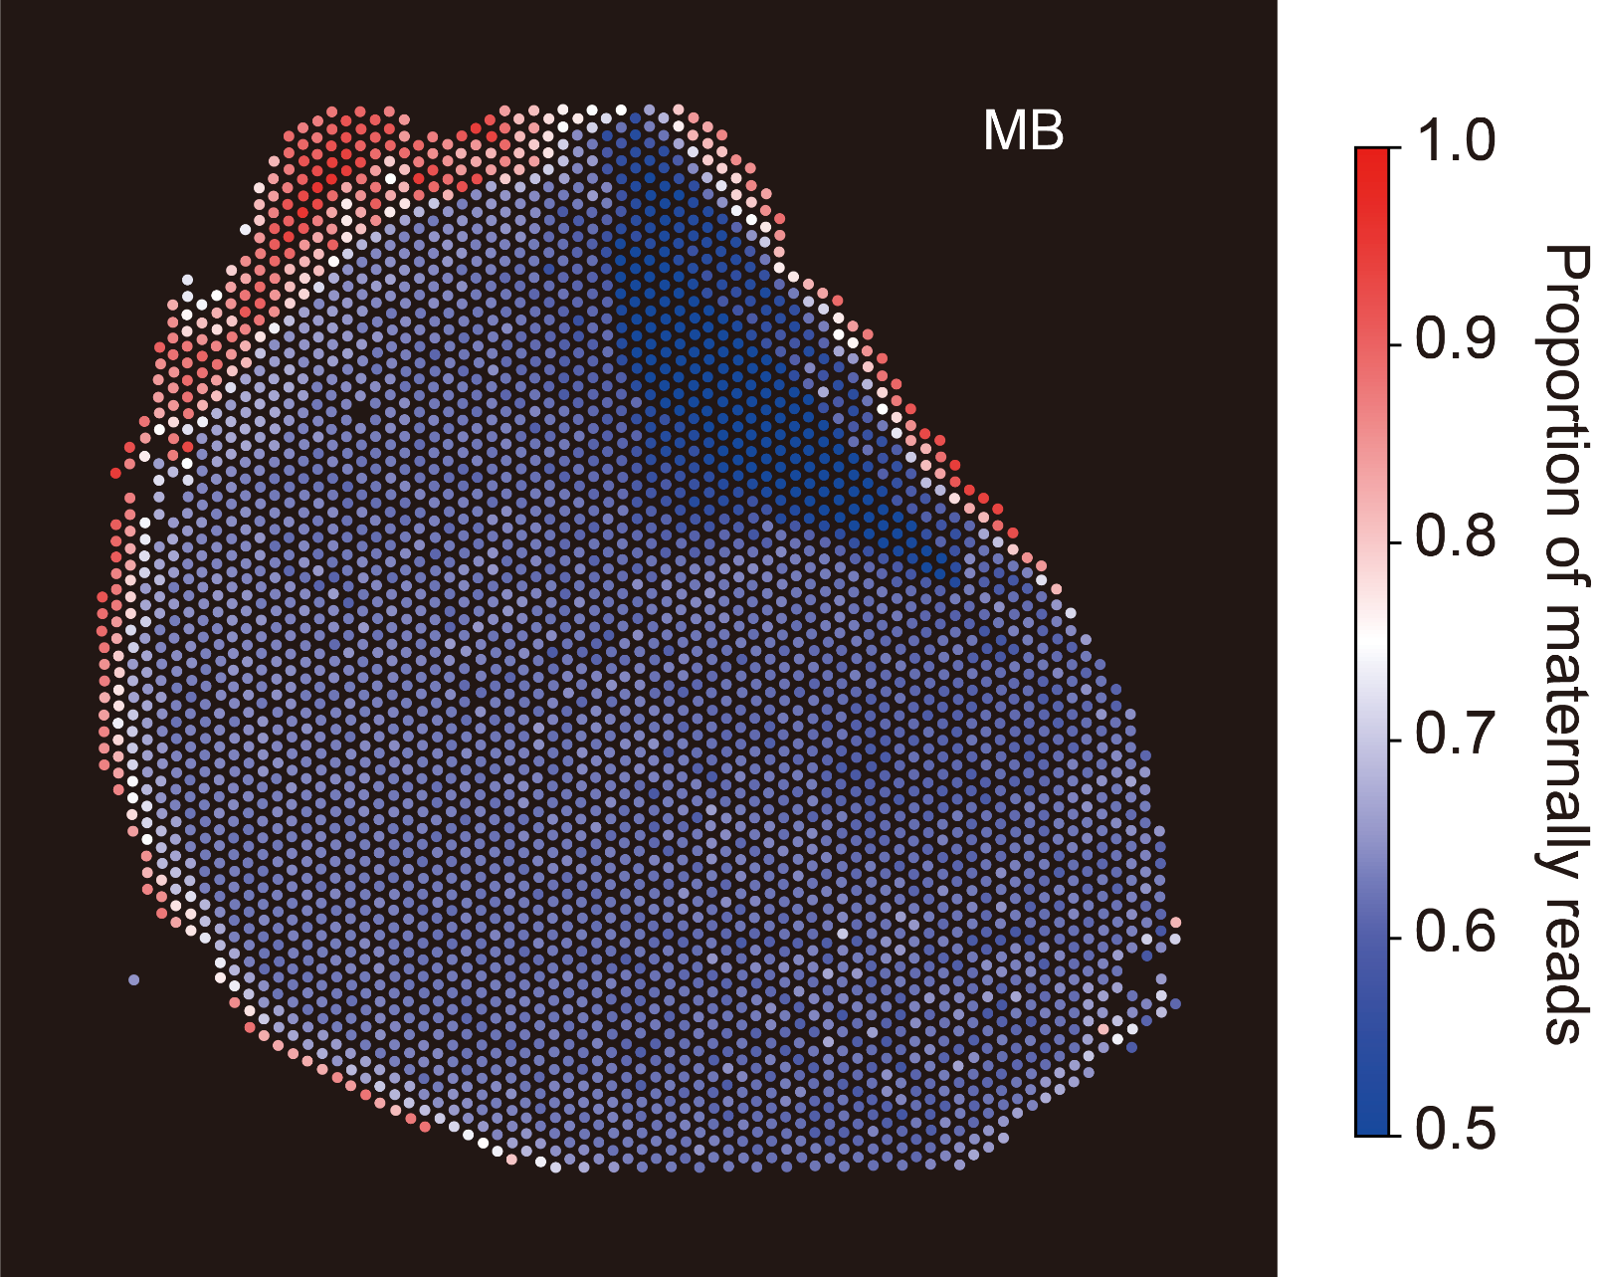
Fig. S12 Spatial plot showing the PMR value of each spot in the MB sample.

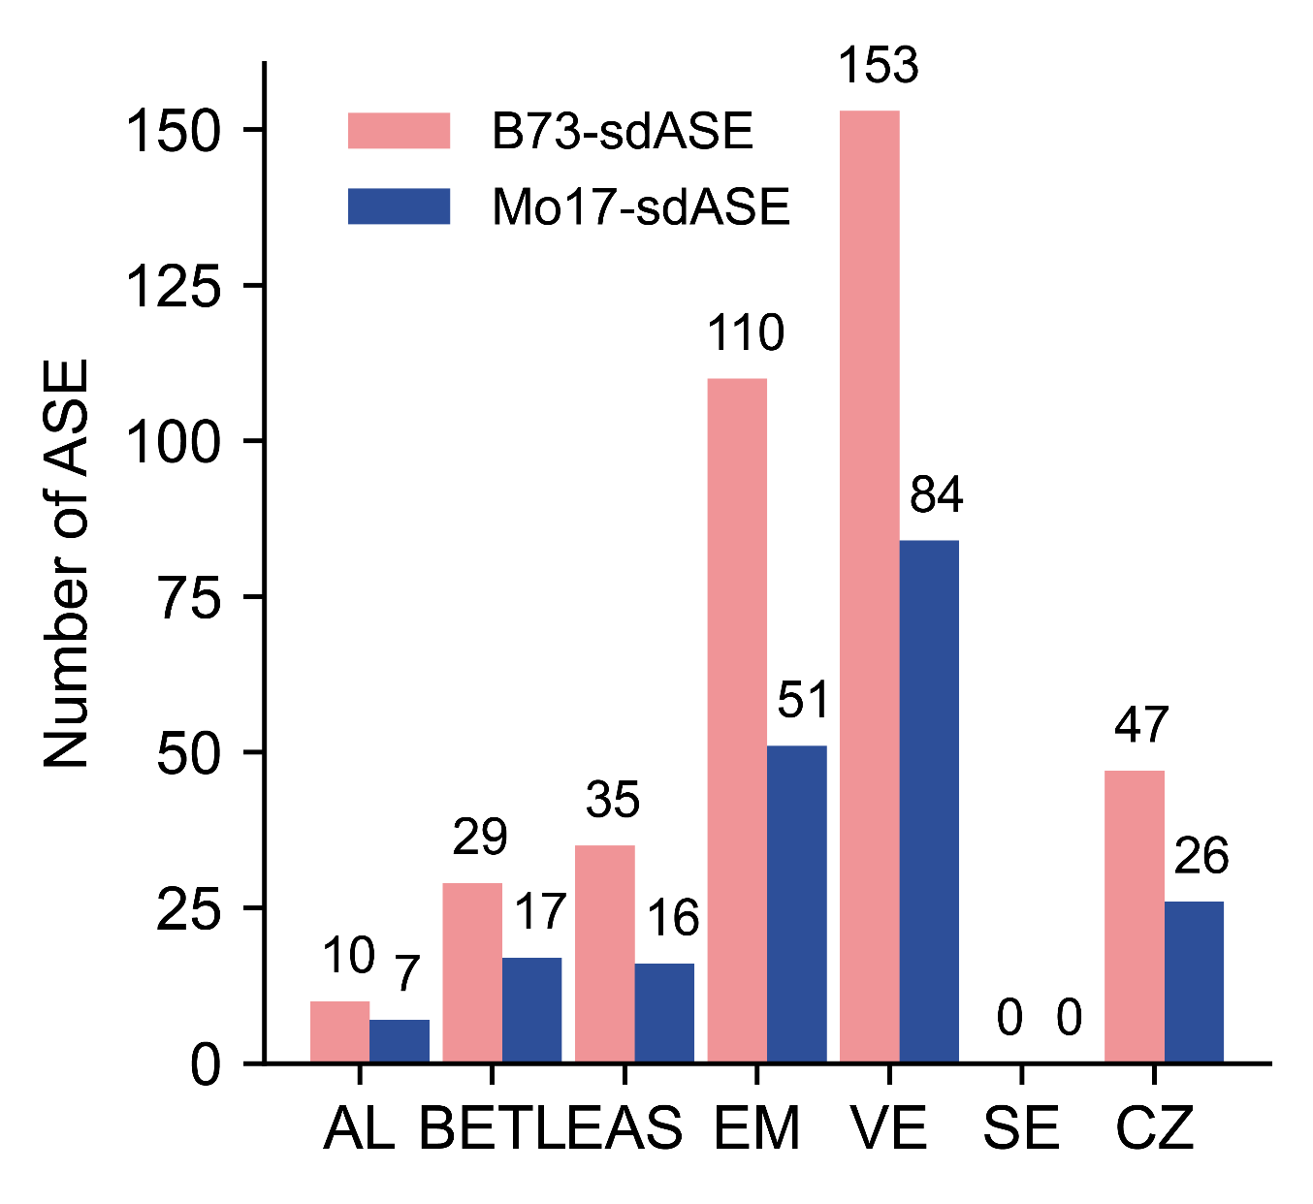
Fig. S13 Bar plot showing the number of B73-sdASE and Mo17-sdASE genes identified across different cell types.

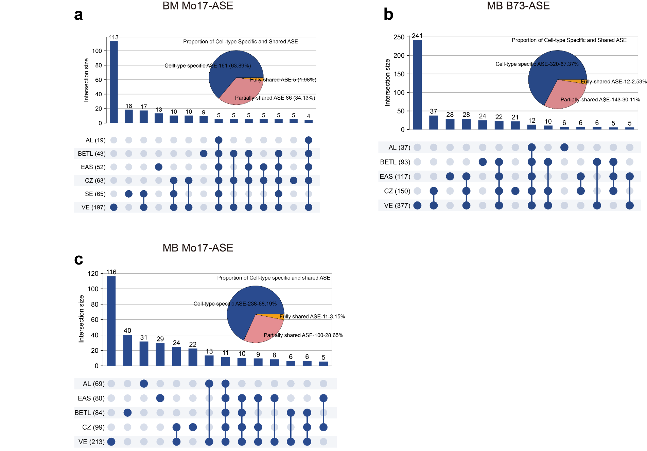
Fig. S14 UpSet plot and pie chart showing the overlap of ASE genes across different cell types.
a UpSet plot and pie chart showing the overlap of Mo17-ASE genes across different cell types in BM. b UpSet plot and pie chart showing the overlap of B73-ASE genes across different cell types in MB. c UpSet plot and pie chart showing the overlap of Mo17-ASE genes across different cell types in MB.

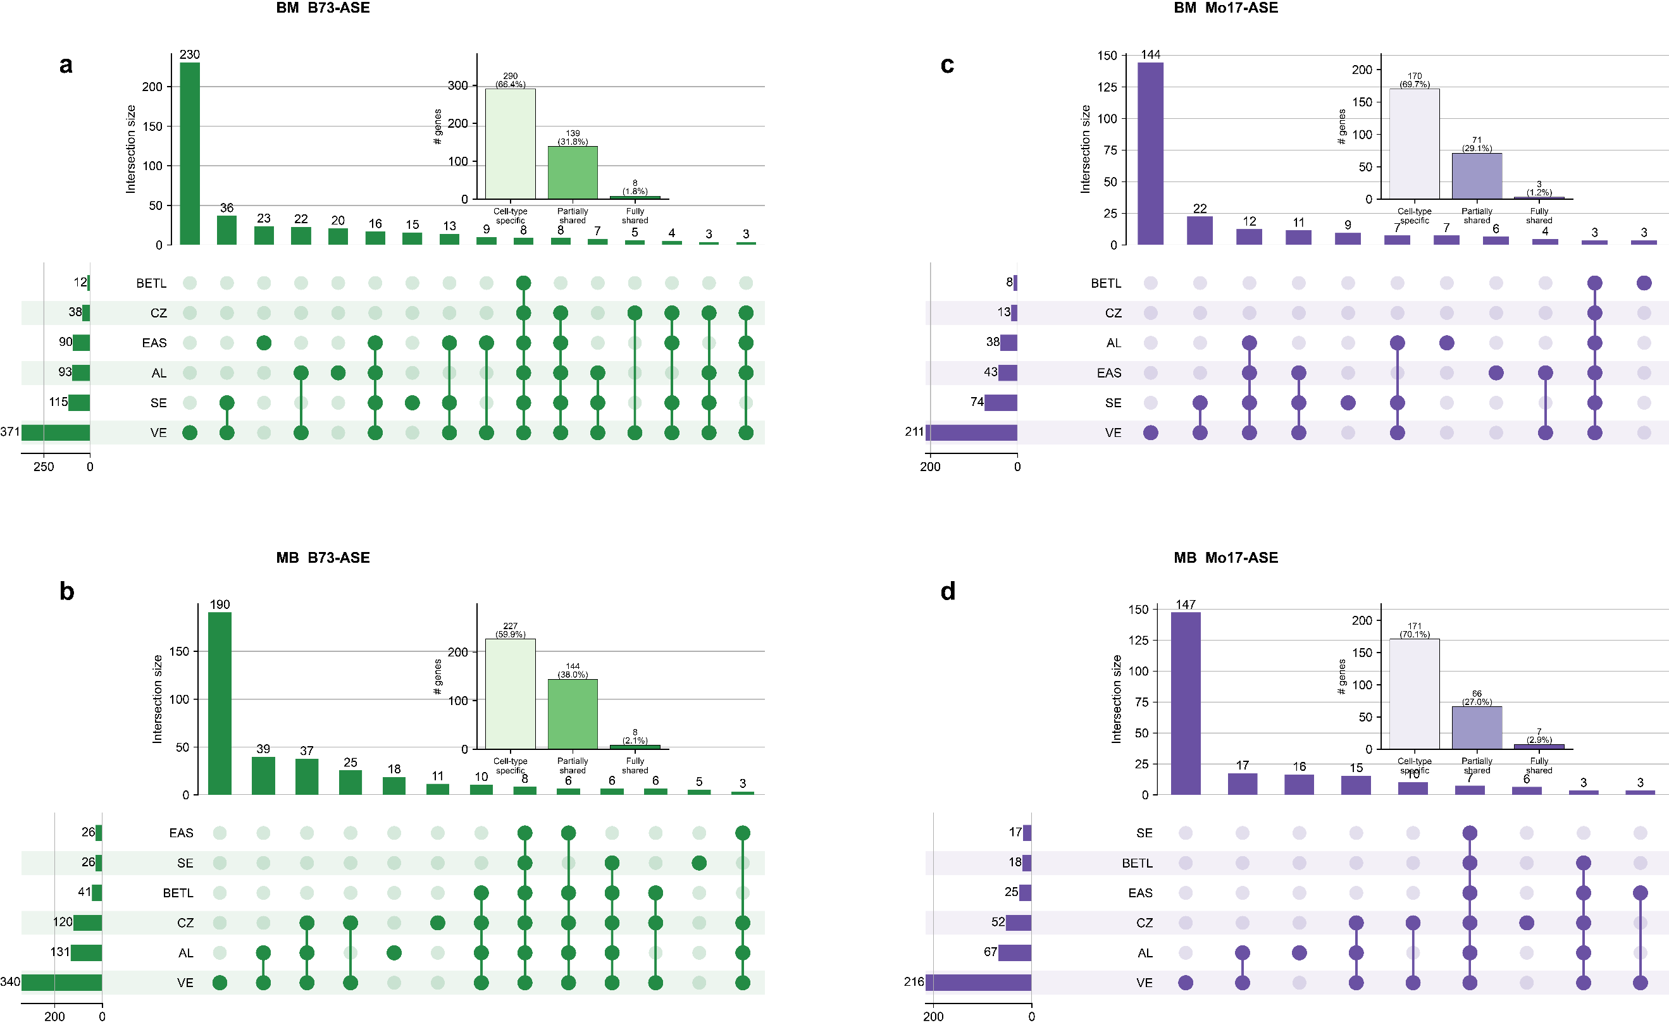Fig. S15 UpSet plots and bar charts showing the overlap of ASE genes across different cell types in the snRNA-seq data. a UpSet plot and bar chart showing the overlap of B73-ASE genes across different cell types in BM. b UpSet plot and bar chart showing the overlap of B73-ASE genes across different cell types in MB. c UpSet plot and bar chart showing the overlap of Mo17-ASE genes across different cell types in BM. d UpSet plot and bar chart showing the overlap of Mo17-ASE genes across different cell types in MB. For each cross direction, ASE genes were called per cell type by intersecting the two replicates.

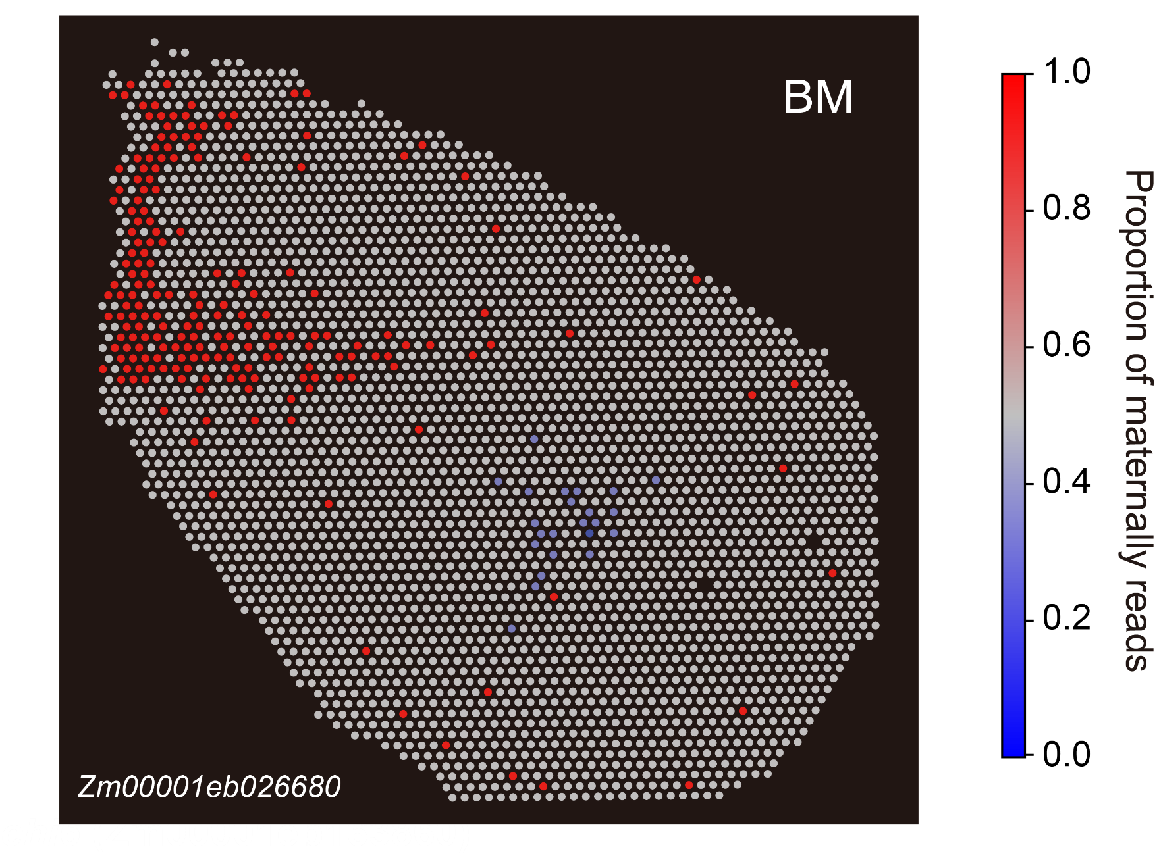
Fig. S16 Spatial PMR map shows antagonistic ASE directions of Zm00001eb026680 in the BETL, CZ and SE of BM.

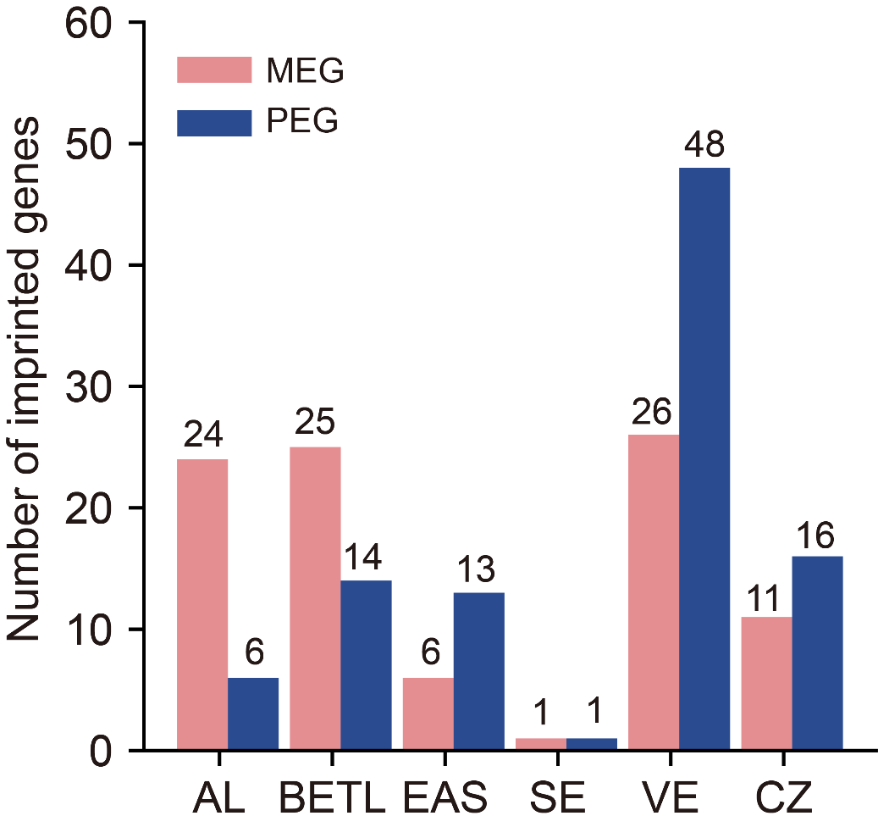
Fig. S17 Bar plot showing the number of unfiltered MEGs and PEGs identified in each cell type.

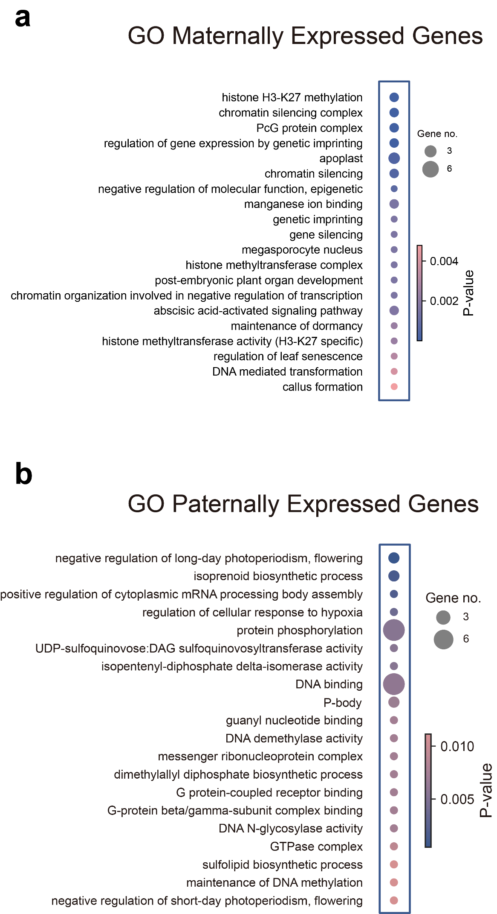
Fig. S18 Heatmap showing the terms of GO enrichment of MEGs (a) and PEGs (b).

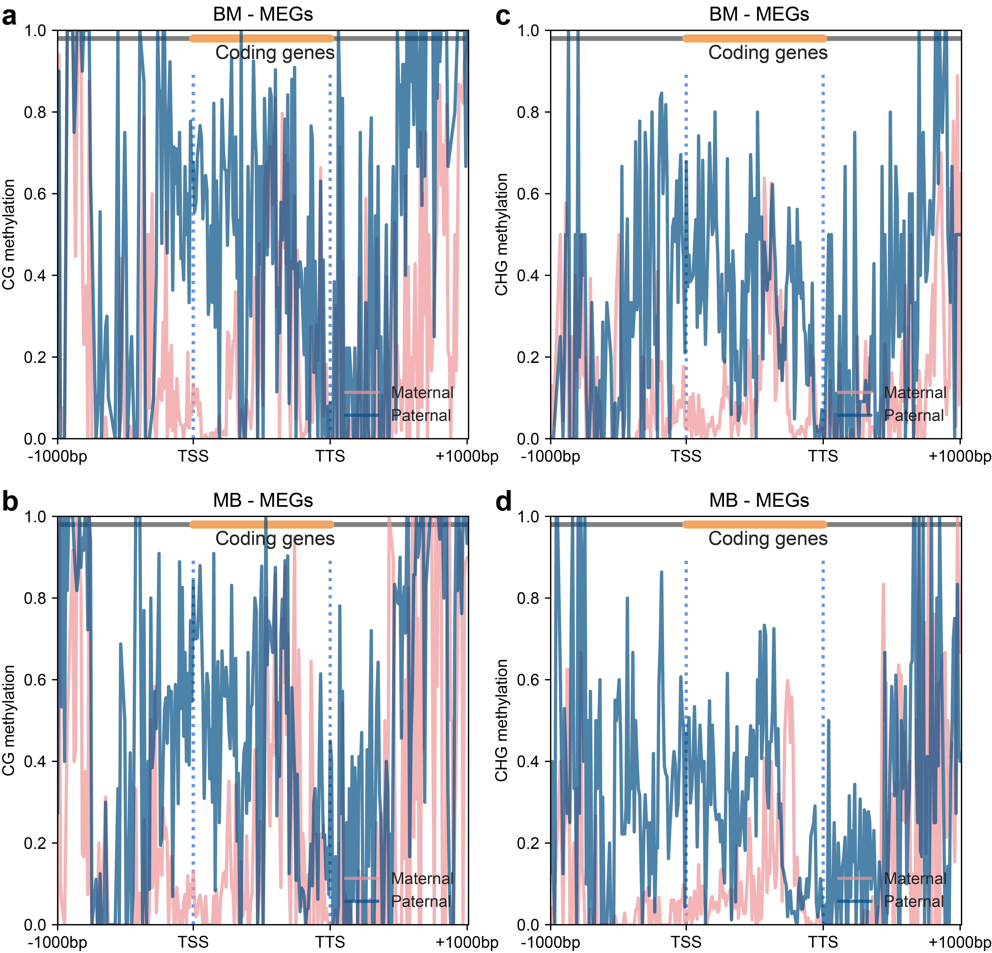
Fig. S19 a, b Metagene plot showing the CG methylation profiles for MEGs in BM and MB. c, d Metagene plot showing the CHG methylation profiles for MEGs in BM and MB.

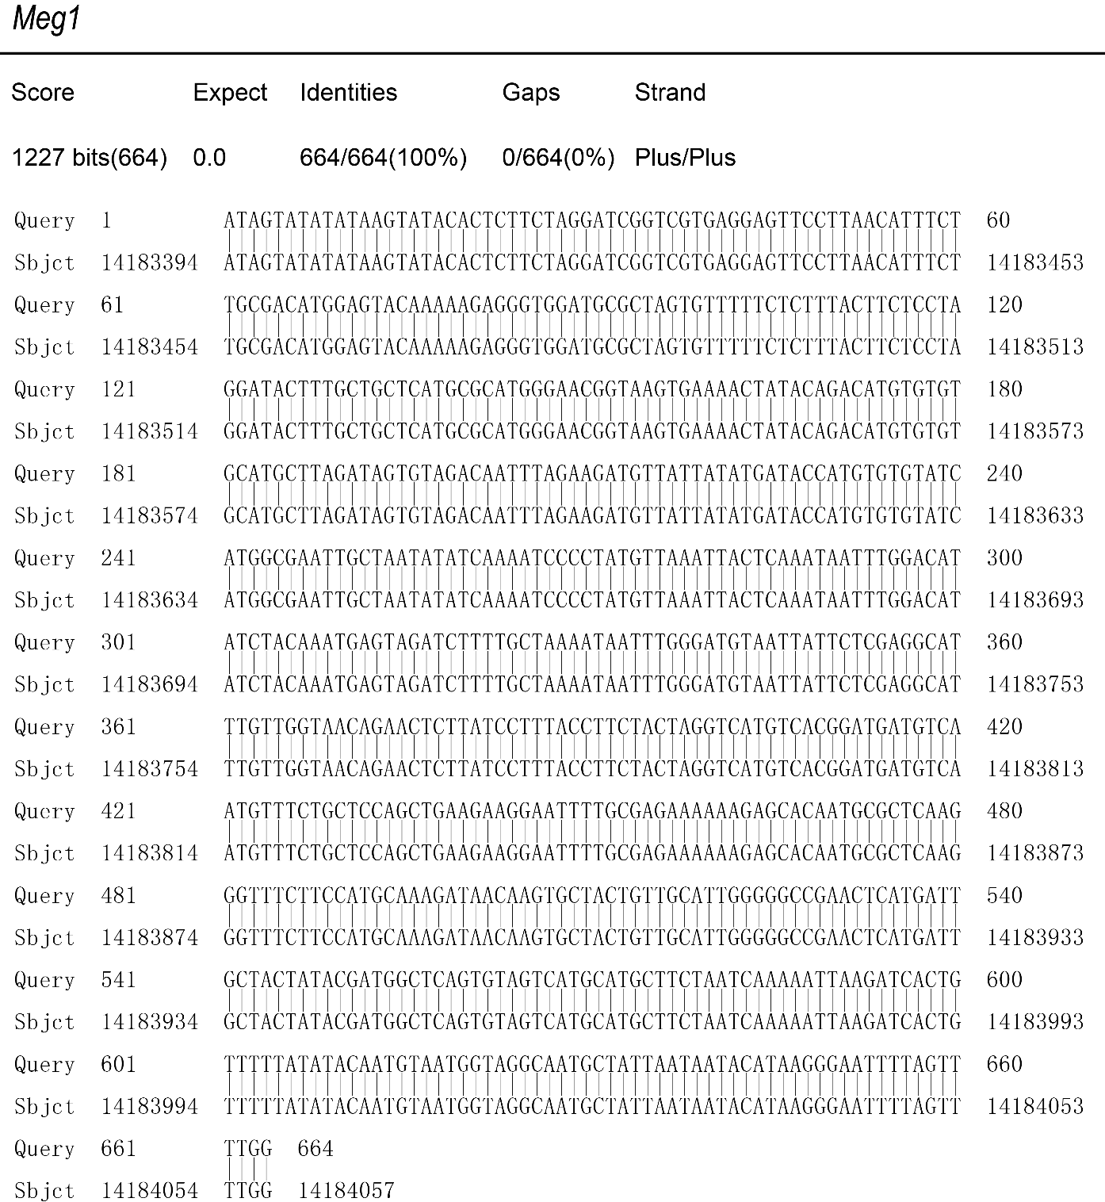
Fig. S20 BLAST alignment of the Meg1 gene to the Mo17 T2T genome sequence.

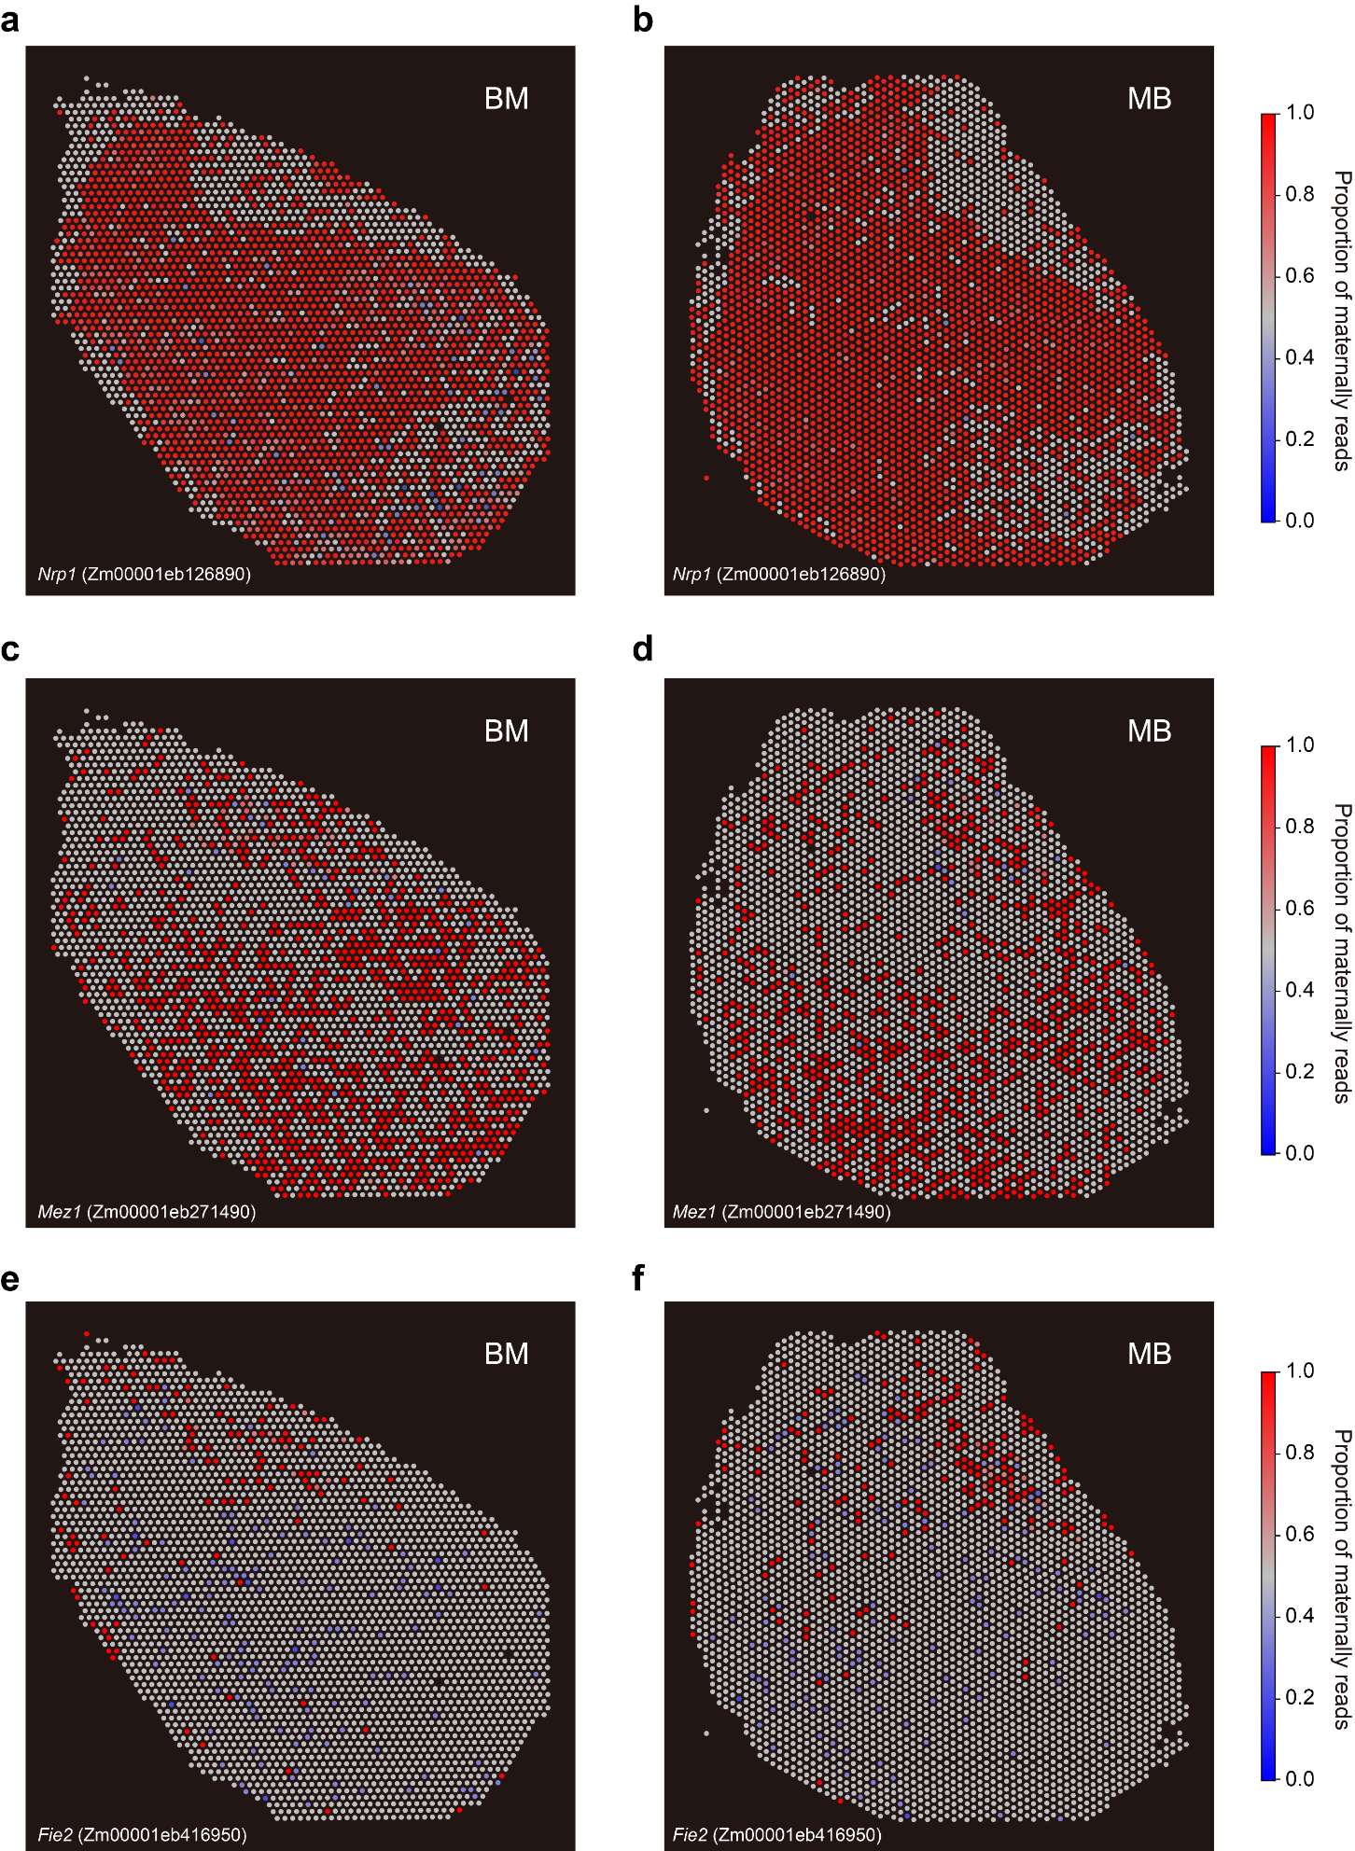
Fig. S21 Spatial PMR maps showing imprinting patterns.
a, b Spatial PMR maps showing imprinting patterns of the maternally expressed Nrp1 (Zm00001eb126890) in BM (a) and MB (b). c, d Spatial PMR maps showing imprinting patterns of the maternally expressed Mez1 (Zm00001eb271490) in BM (c) and MB (d). e, f Spatial PMR maps showing imprinting patterns of the Fie2 (Zm00001eb416950) in BM (e) and MB (f).

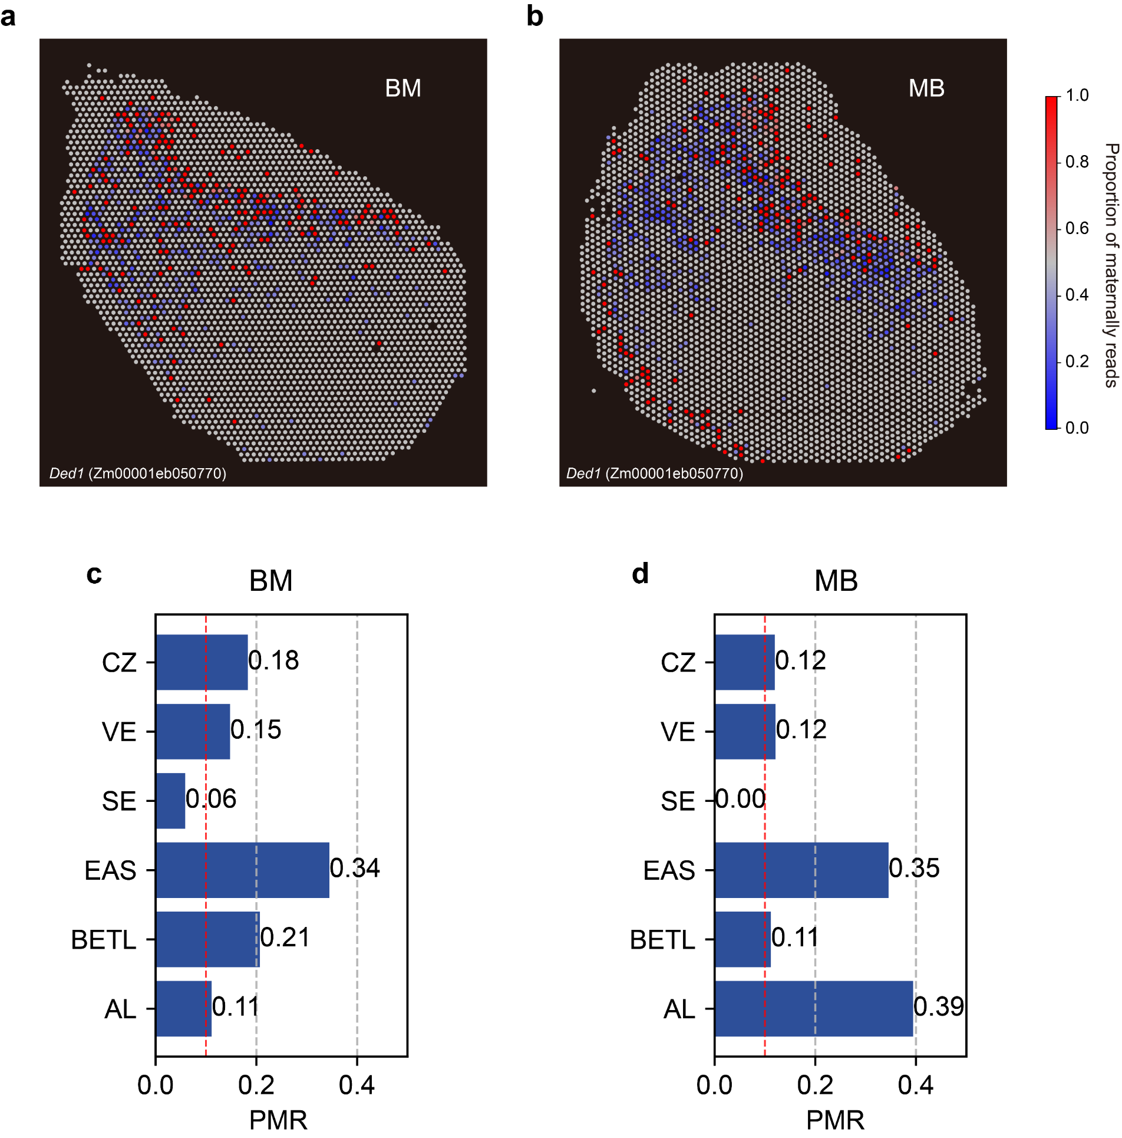Fig. S22 PMR information of Ded1.
a, b Spatial PMR maps showing imprinting patterns of the Ded1 (Zm00001eb050770) in BM (a) and MB (b). c, d PMR values of Ded1 (Zm00001eb050770) across different cell types in BM (c) and MB (d).

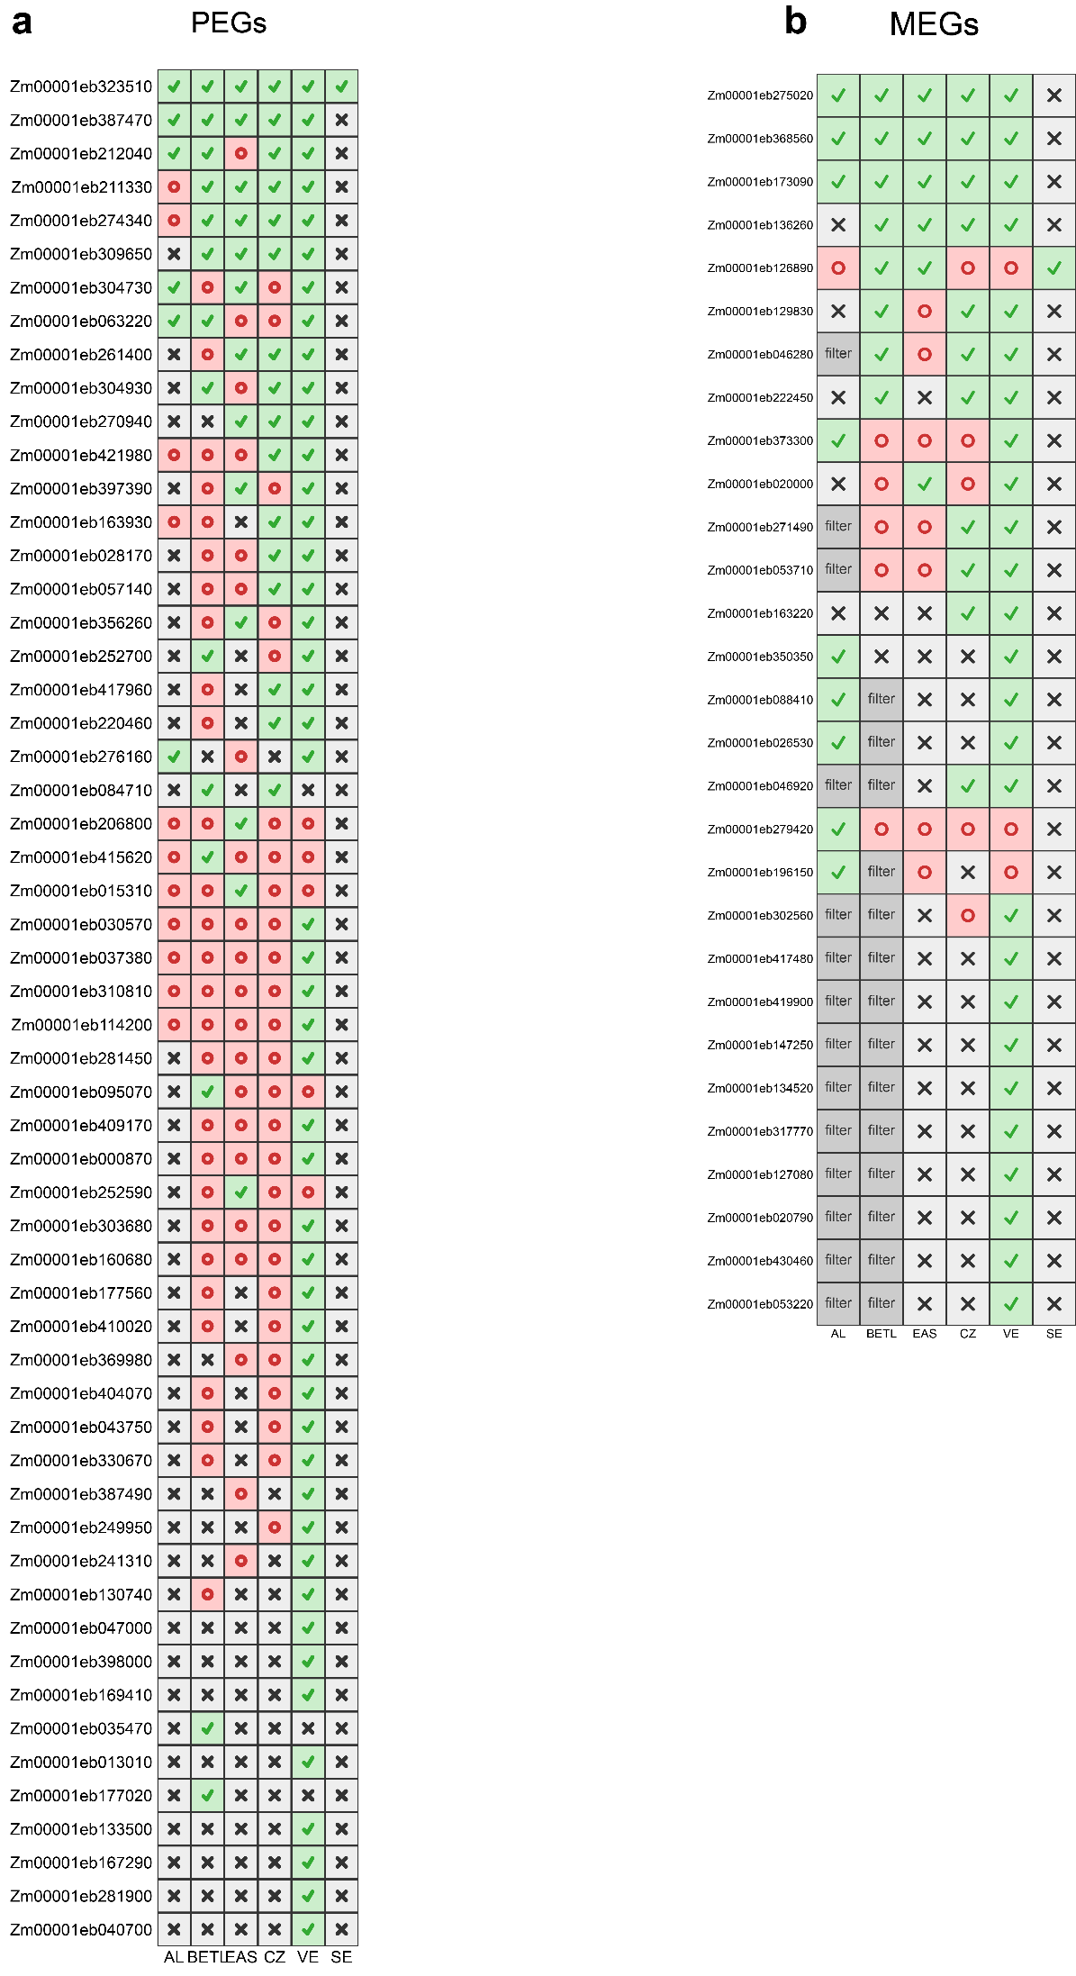
Fig. S23 Heatmap showing the imprinting status of PEGs (a) and MEGs (b) across six endosperm cell types. Green check marks indicate imprinted genes in each cell type, red circles denote non-imprinted genes with sufficient counts, black crosses represent genes with insufficient counts, and “filter” indicates genes excluded by filtering.

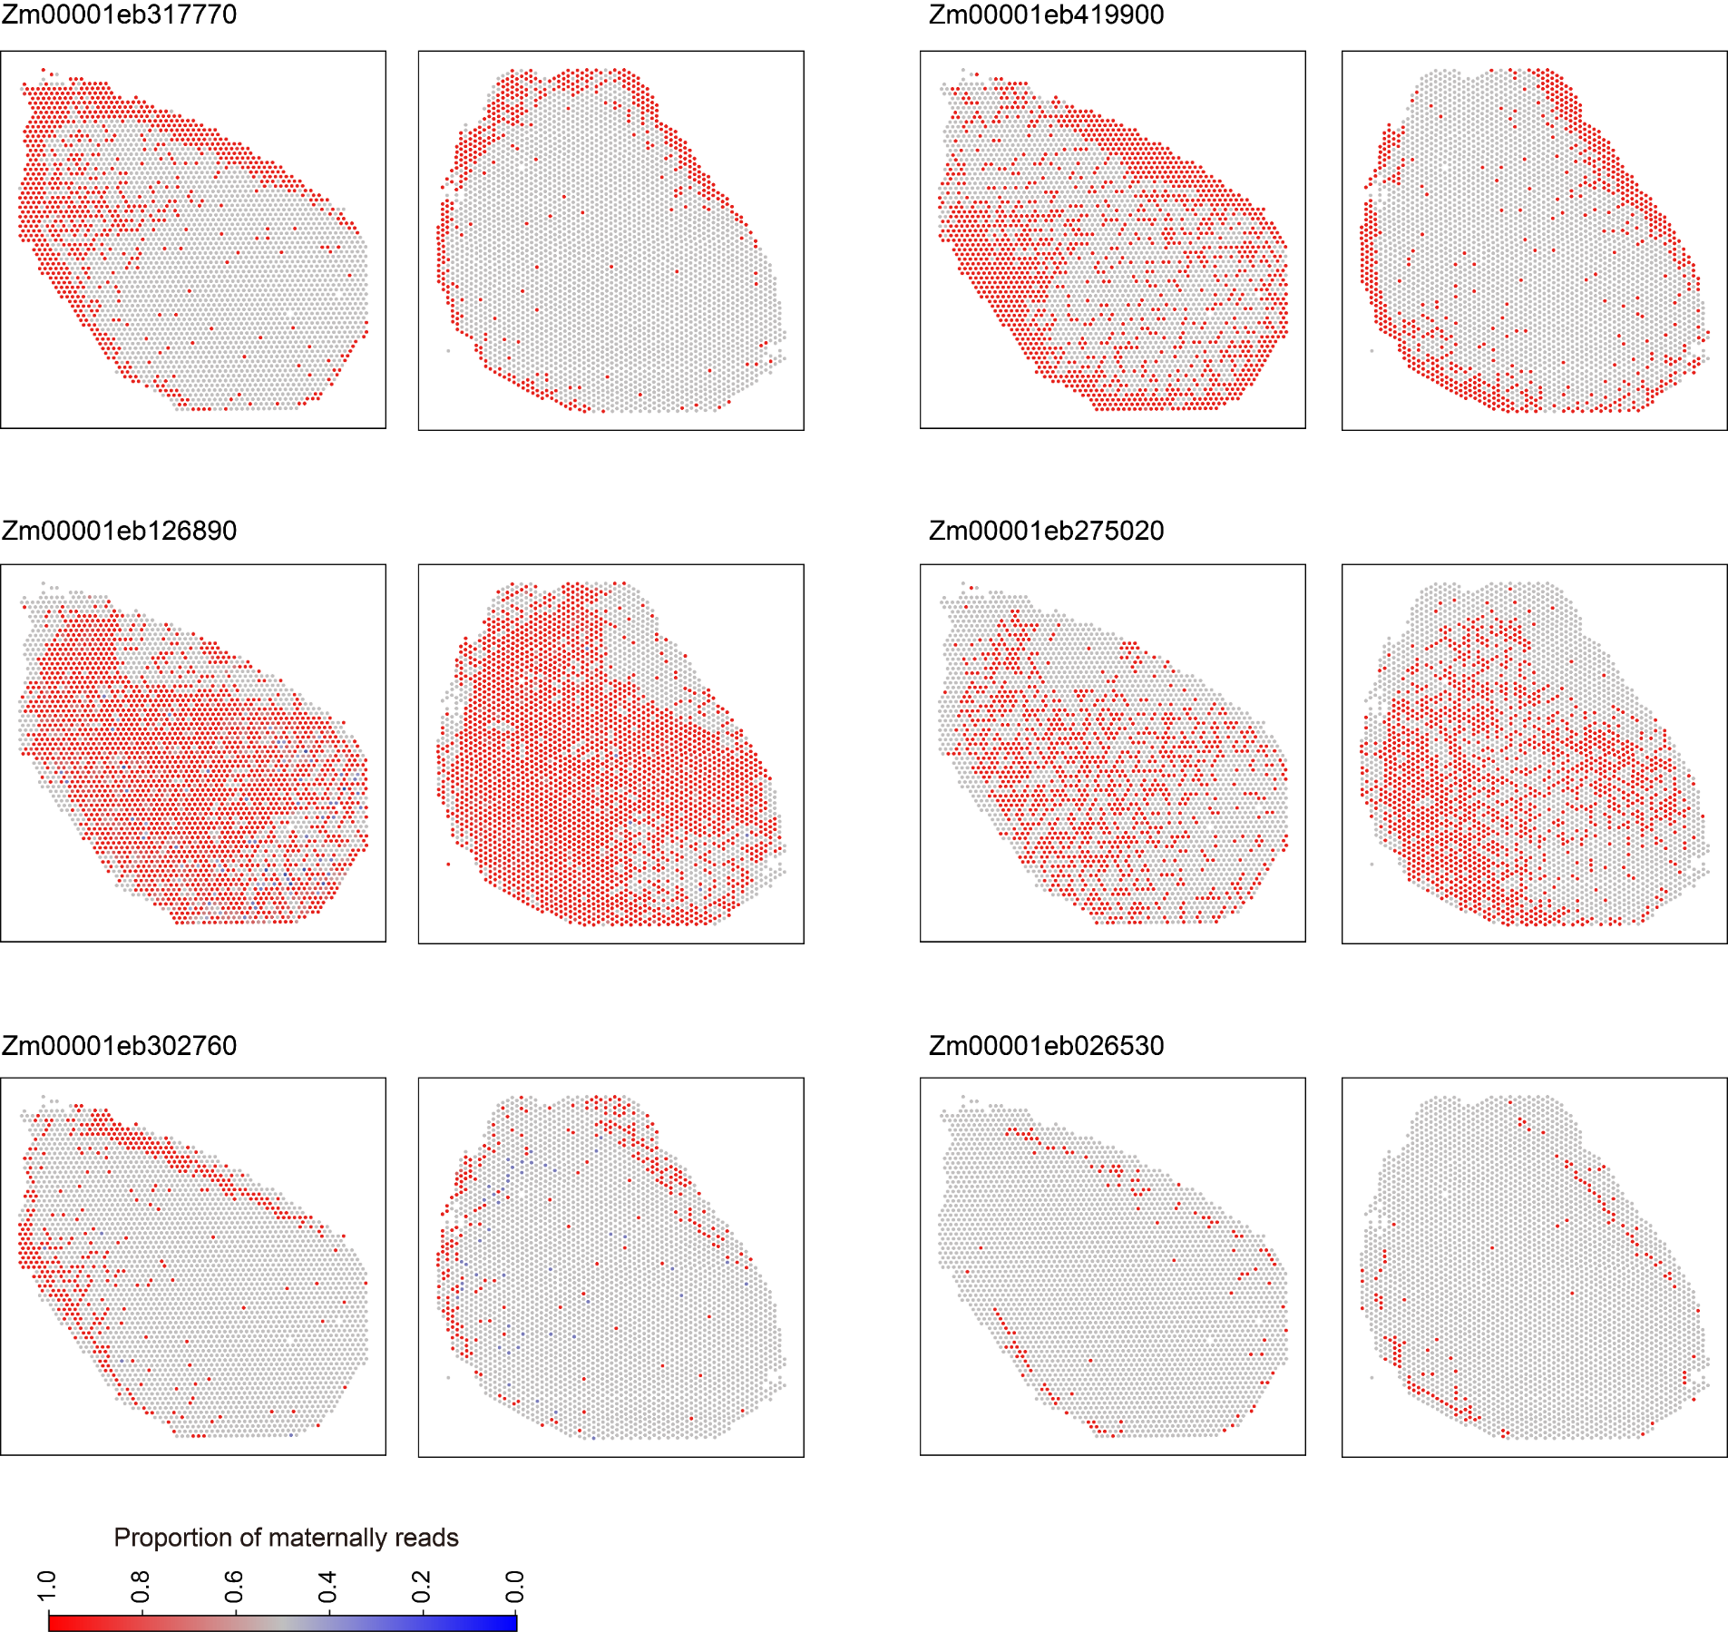Fig. S24 Spatial PMR plots of six imprinted genes in the EM.

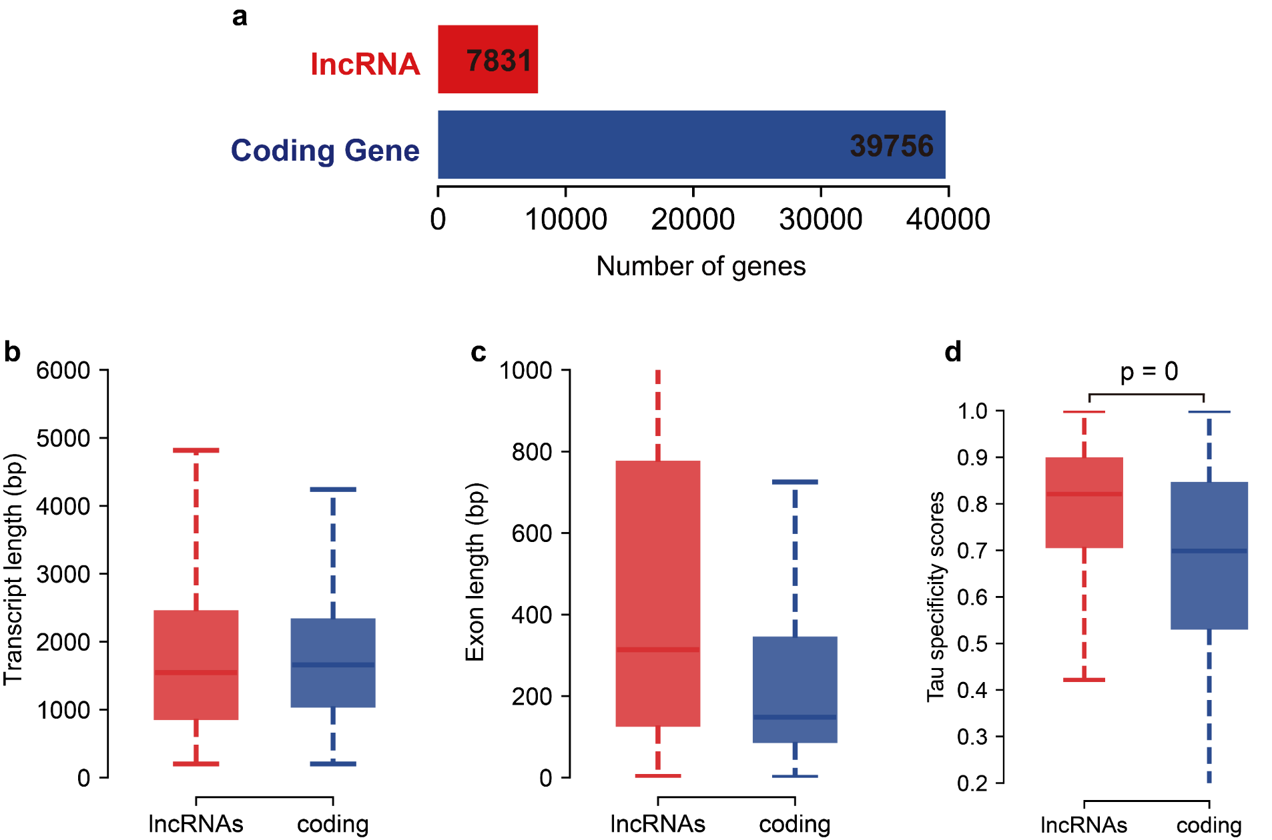Fig. S25 Overview of coding genes and lncRNAs.
a Bar plot showing the numbers of identified lncRNAs and coding genes annotated in the reference genome. b, c Box plots showing transcript length (b) and exon length (c) of lncRNAs and protein-coding genes. d Box plot showing cell-type specificity of lncRNAs and coding genes.

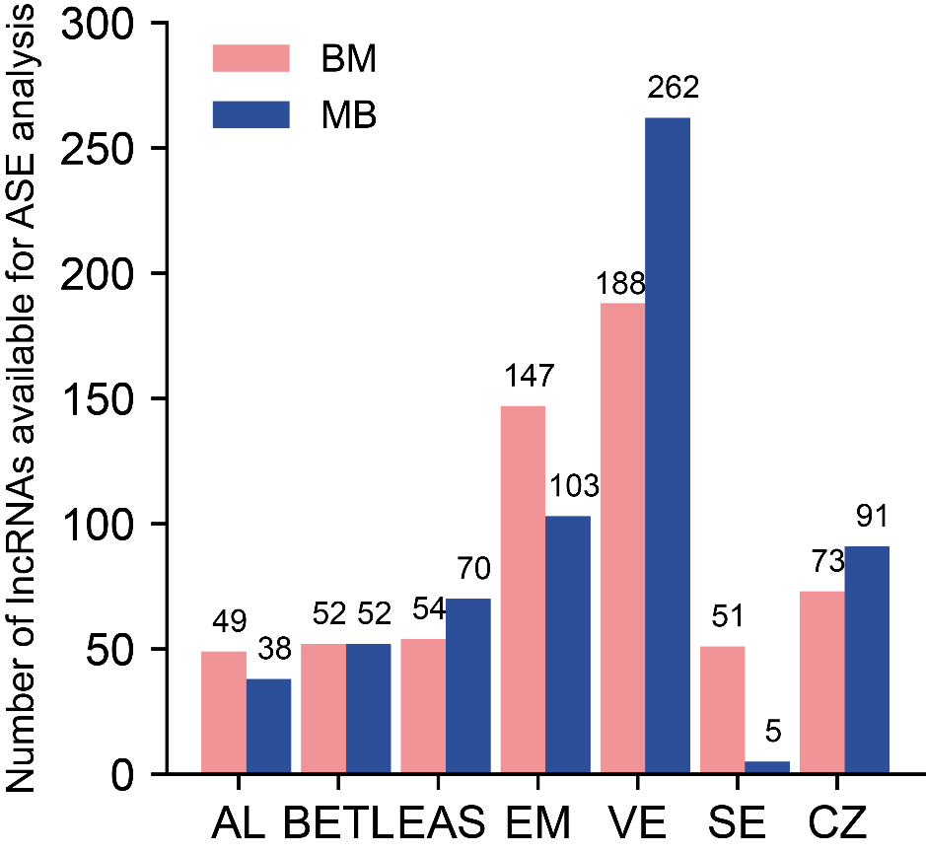
Fig. S26 Bar plot showing the number of lncRNAs available for ASE analysis in each cell type of BM and MB.
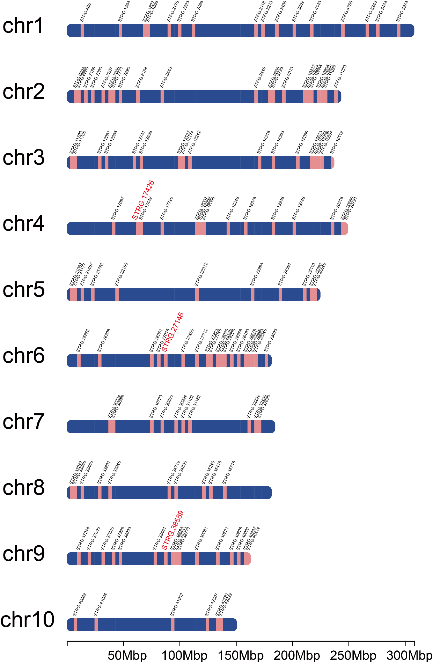
Fig. S27 Chromosomal distribution of ASE lncRNAs, with maternally expressed lncRNAs shown in red.

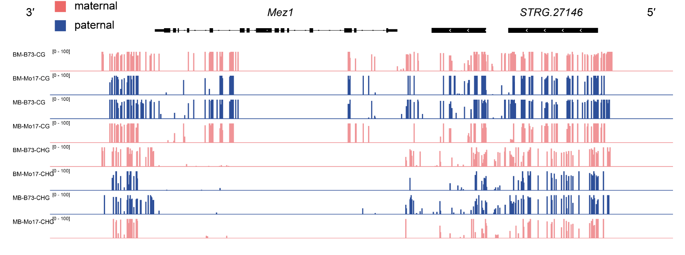
Fig. S28 IGV plot showing allele-resolved CG and CHG methylation levels of the Mez1 and STRG.27146 loci in reciprocal hybrid embryos. Red and blue tracks indicate maternal and paternal alleles, respectively.

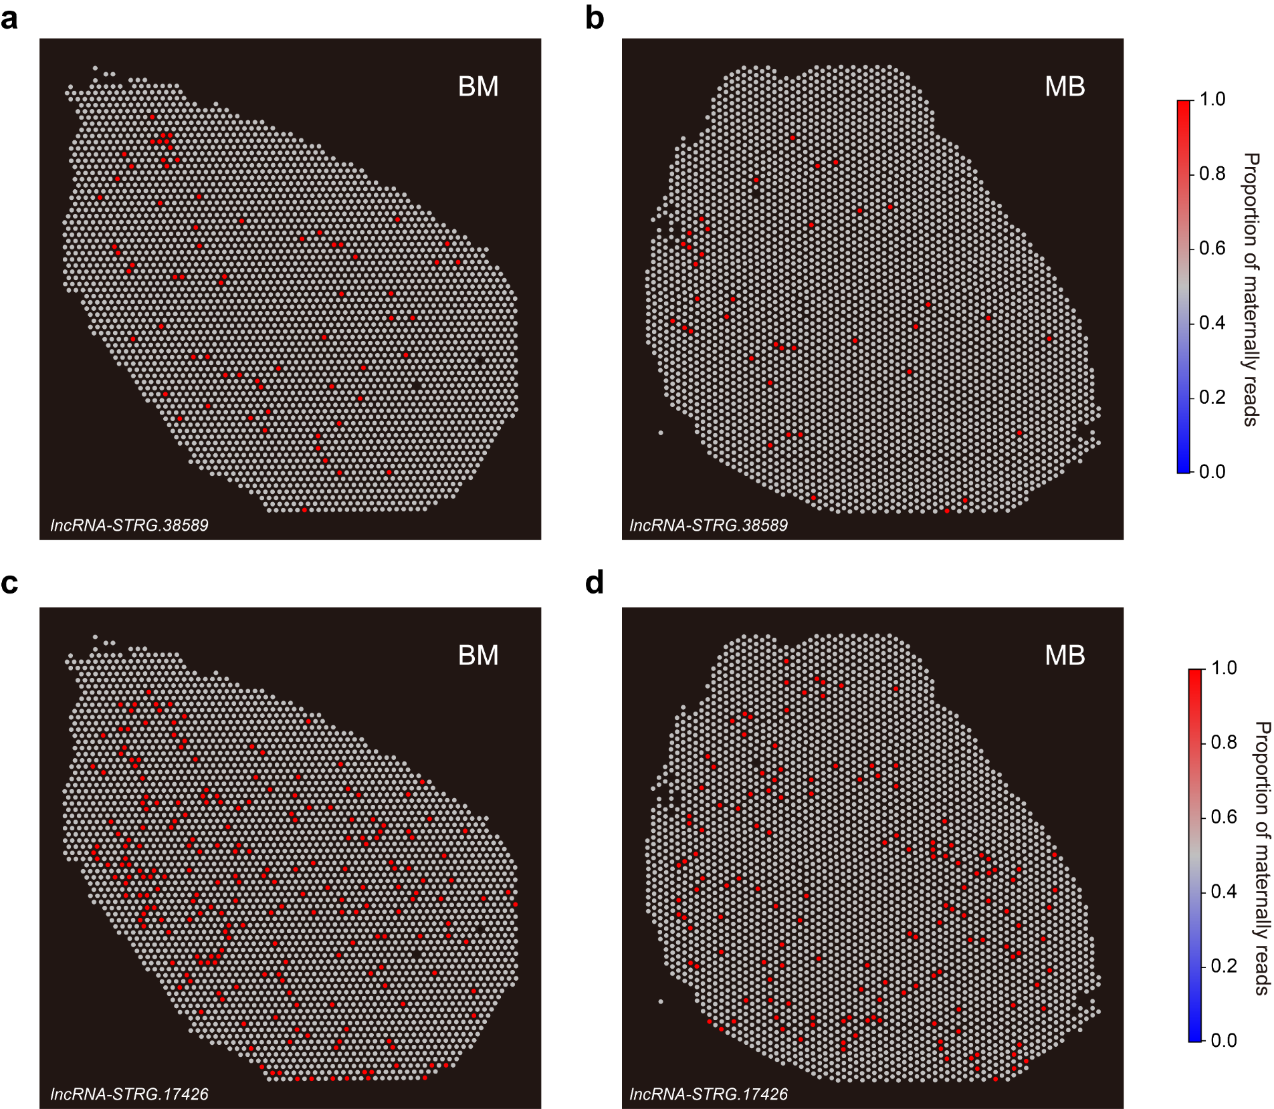Fig. S29 Spatial imprinting status of lncRNAs.
a, b Spatial PMR maps showing imprinting patterns of the maternally expressed lncRNA-STRG.38589 in BM (a) and MB (b). c, d Spatial PMR maps showing imprinting patterns of the maternally expressed lncRNA-STRG.17426 in BM (c) and MB (d).

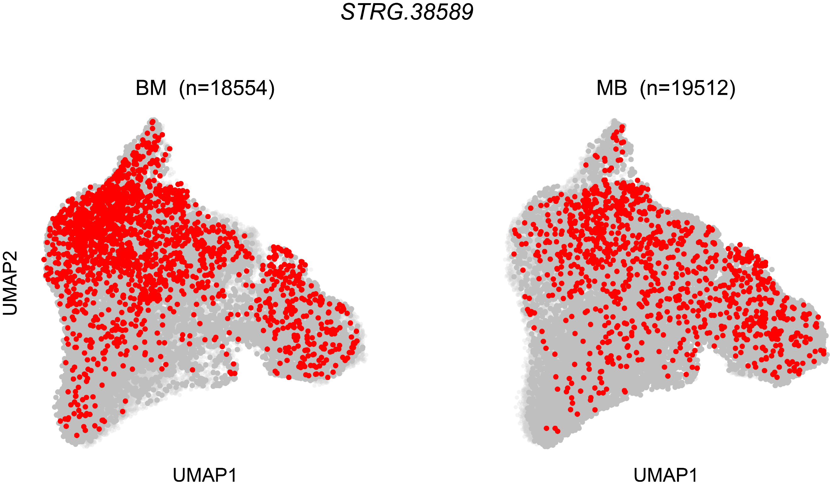
Fig. S30 snRNA-seq UMAP PMR plots showing imprinting status of the maternally expressed STRG.38589 in BM and MB.

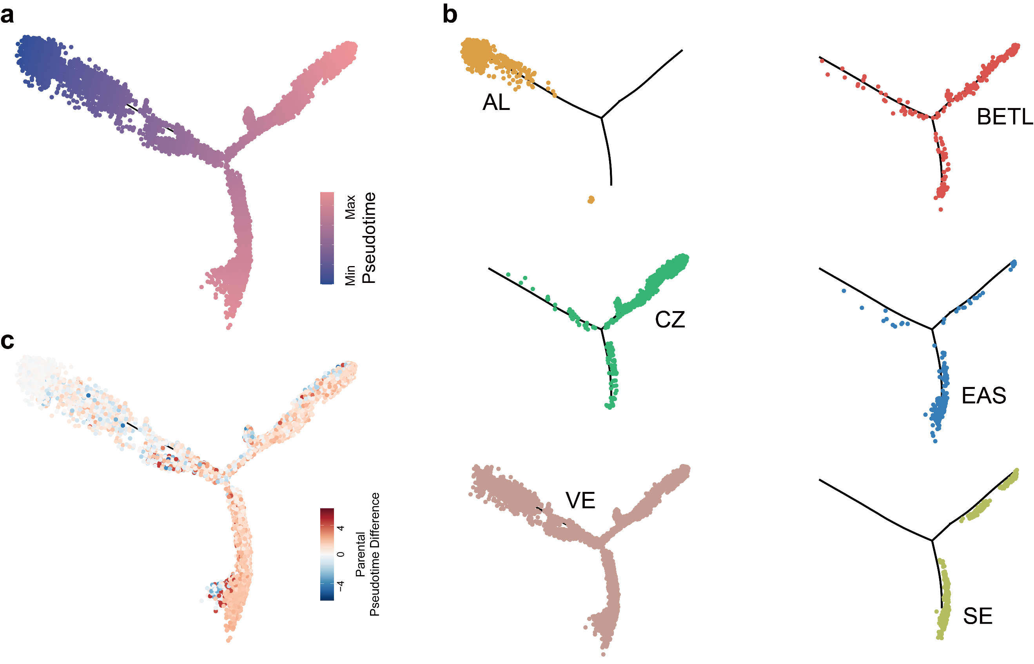Fig. S31 Haplotype-resolved single-nucleus pseudotime analysis and developmental trajectory of maize endosperm in MB.
a Single-nucleus pseudotime analysis of MB endosperm nuclei using Monocle2. b Distribution of the six endosperm cell types (AL, BETL, CZ, EAS, VE and SE) along the snRNA-seq pseudotime trajectory in MB. c Parental pseudotime difference projected onto the MB snRNA-seq developmental trajectory. For each nucleus, the parental pseudotime difference was calculated as the maternal-allele–derived pseudotime minus the paternal-allele–derived pseudotime.

