Online Resource 1 Swimmer plot showing complete timelines for all 49 patients, with time zero (T0) at the time if first local therapy for progressive disease with intent of continuing current TKI course. Three patients received radiotherapy before T0. The reasons are (from top to bottom); 1) Radiotherapy of brain metastases diagnosed at baseline, only shortly after initiation of TKI, and therefore not deemed a progressive event; 2) Consolidative radiotherapy during TKI for oligopersistent disease, and afterwards radiotherapy at TKI change for progression; 3) Radiotherapy for progression at the time of systemic therapy change. * Only TKI systemic therapy courses are shown as colored bars, i.e., a chemotherapy or immunotherapy course (as well as no systemic therapy) will show as grey narrow lines.
Abbreviations: ALK: Anaplastic lymphoma kinase, EGFR: Epidermal growth factor receptor, TKI: Tyrosine kinase inhibitor

Online Resource 2 Distribution of local therapies during TKI treatment. An individual patient can have more TKI courses prolonged with local therapy. Each column represents the fraction of patients or TKI courses with 1, 2, 3, etc., local therapies delivered during a TKI course, stratified per patient (n = 49) or per TKI course (n = 58).
TKI: tyrosine kinase inhibitor.

Online Resource 3 Radiotherapy site, dose, and fractionations, stratified by stereotactic/ablative doses and palliative doses. Fx: fractions; Gy: Gray.
*45 Gy/3 Fx and 67.5/3 Fx are the same fractionation schedules, however 45 Gy/ 3 Fx is prescribed to the planning target volume, while 67.5 Gy /3 Fx is prescribed to the gross tumor volume.
 | Brain | Lung and mediastinum | Vertebral bone | Non-vertebral bone | Soft tissue | Other
Site of radiotherapy | N = 33 | N = 24 | N = 15 | N = 13 | N = 2 | N = 1
Stereotactic/ablative doses
18 Gy/1 Fx | 22 (67%)
27 Gy/3 Fx | 2 (6%)
13 Gy/1 Fx | 1 (3%)
67.5 Gy/3 Fx* |  | 2 (8%)
45 Gy/3 Fx* |  | 1 (4%)
52.5 Gy/15 Fx |  | 1 (4%)
56 Gy/8 Fx |  | 1 (4%)
37.5 Gy/3 Fx |  |  | 2 (13%) |  | 1 (50%)
30 Gy/3 Fx |  |  |  | 2 (15%)
Palliative doses
30 Gy/10 Fx | 7 (21%) | 6 (25%) | 6 (40%) | 2 (15%)
20 Gy/5 Fx | 1 (3%)
25 Gy/5 Fx |  | 13 (54%) | 2 (13%) | 7 (54%) | 1 (50%)
8 Gy/1 Fx |  |  | 5 (33%) | 2 (15%) |  | 1 (100%)

Online Resource 4 PFS2 and TFLS per tyrosine kinase inhibitor course, and OS per patient, stratified by mutation.
Abbreviations: ALK: Anaplastic lymphoma kinase, EGFR: Epidermal growth factor receptor, OS: Overall survival, PFS2: Second progression-free survival, TFLS: Time to failure of local therapy strategy
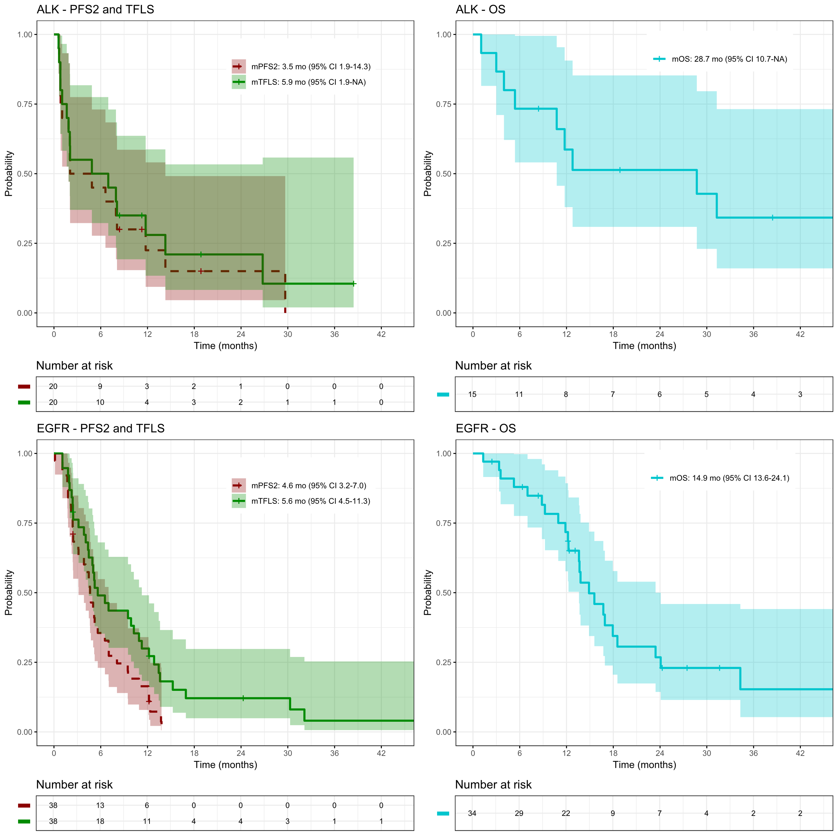
Online Resource 5 Selected studies of local therapy in progressive NSCLC reporting alternative endpoints
Study | Population (mutations, disease setting) | Sites treated | Local therapies | Median time-to-event endpoints | Selected multivariable results for alternative endpoint (TFLS or similar)ª
Yu et al. [26] | Extracranial oligoprogressive EGFR-mutated NSCLC, n = 18 | Lung, LN, adrenal | Surgery, ablative RT, RFA | PFS2: 10 mo (95% CI 2–27)  Systemic therapy change: 22 mo (95% CI 6–30)  OS: 41 mo (95% CI 26-NR)
Weiss et al [28] | Oligoprogressive EGFR-NSCLC on erlotinib, n = 25 | Lung, bone, liver, brain | SRS | PFS2: 6 mo  Erlotinib duration post SRS: 5.7 mo  OS: 29 mo
Friedes et al [22] | Oligoprogressive NSCLC, n = 198 | Intrathoracic (39%), extrathoracic (16%), intracranial (51%) | Definitive RT | PFS2: 7.9 mo (95% CI, 6.5-10.0)  TNT: 8.8 mo (95% CI 7.2-10.9)  OS: 37.7 mo (95% CI 31.5-87.9) | PFS1 interval >6 mo vs ≤6 mo: HR 0.61 (0.41-0.91)  No. of progressive metastases, 2-3 vs 1: HR 1.94 (1.36-2.77)  Intracranial progression vs other: NS
Kroeze et al [23] | Oligo- and poly-progressive NSCLC (ALK or EGFR 60%), n = 108 | Both intracranial (75%) and extracranial | SRT | OPD PFS: 10.4 mo  PPD PFS: 7.4 mo  OPD TTS: 14 mo  PPD TTS: 8 mo  OS (all): 18,1 mo | SRT cranial vs extracranial (univariable): NS  Number of SRT treated metastases (univariable): NS
Hubbeling et al. [24] | Oligoprogressive NSCLC (ALK, ROS1, RET), n = 61 | Mainly brain, bone, lung, thoracic LN (~90%) | RT (n = 76; 61% palliative and 39% definitive), surgery (n=5), PTA (n=5), mixed modality (n=6) | PFS2: 6.8 mo (95% CI 5.1–8.1)  TTNT: 10 mo (95% CI 8.4–15.3)  OS: 34 mo (95% CI 26-NR) | No. of sites progressing: HR 1.07 (1.01-1.14)
Mok et al. [21] | Oligoprogressive EGFR-mutated NSCLC, n = 55 | Lung, bone, brain | Ablative RT | PFS2: not reported  TKI prolongation: 6.9 mo (95% CI 3.1–10.7)  OS: 25.1 mo (95% CI 10-40) | PFS1 ≤20 mo vs ≥21 mo: NS  Number of sites: NS  Intracranial involvement yes vs no: NS
Tsui et al. [12] | Oligoprogressive NSCLC (ALK, EGFR), n= 89 | Mainly brain, bone, lung, LN (~90%) | Hypofractionated RT, SRS, WBRT | PFS2: 4.1 mo (95% CI 3.5–6.3)  extended-PFS: 6.7 mo (95% CI 4.9–8.3)  OS: Not reported | ExtraCNS vs CNS: NS  >1 vs 1 site at 1st LT: NS
Tsur et al [25] | Extracranial oligoprogressive NSCLC, n = 32 | Extracranial, lung and adrenal mostly | SBRT | PFS2: 6.1 mo (95% CI 3.2–8.9)  TTCST: 13.5 mo  OS: 28 mo (from the KM curve) | GTV size: NS
Chen et al  [29] | Oligoprogressive EGFR-mutated NSCLC on Osimertinib, n = 33 | Mainly brain, bone, lung (~90%) | Ablative RT (94%) and palliative RT (6%) | PFS2: 6.9 mo (95% CI 5.8-9.6)  Osimertinib duration post-LT: 9.7 mo (95% CI 7.3-12.4)  OS: 24.4 mo (95% CI 22.1-44.3)
Current study | Progressive NSCLC (ALK, EGFR) n = 49 | Mainly brain, bone, lung | RT (ablative & palliative), surgery | PFS2: 4.6 mo (95% CI 3.1-7.0)  TFLS: 5.6 mo (95% CI 4.5-10.9)  OS: 16.7 mo (95% CI 12.8-24.1) | Intracranial vs extracranial: NS  Size of tumor: NS  TKI duration before LT, <12 months vs ≥12 months: 0.28 (0.13-0.60)
ª Only results that are significant are numbered, all other are shown as not significant (NS).
Abbreviations: ALK: anaplastic lymphoma kinase, CNS: central nervous system, EGFR: epidermal growth factor receptor, GTV: gross tumor volume, HR: hazard ratio, LN: lymph nodes, LT: local therapy; mo: months, NR: not reached, NS: not significant, OPD: oligoprogressive disease, OS: overall survival, PFS2: progression-free survival after local therapy, PPD: polyprogressive disease, PTA: percutaneous thermal ablation, RET: rearranged during transfection, RFA: radiofrequency ablation, ROS1: ROS proto-oncogene 1, RT: radiotherapy, SBRT: stereotactic body radiotherapy, SRS: stereotactic radiosurgery, SRT: stereotactic radiotherapy, TFLS: time to failure of local strategy; TKI, tyrosine kinase inhibitor, TNT: time to new therapy (defined in the study as new systemic therapy, palliative RT, surgical metastasectomy, and hospice enrollment), TTCST: time to change of systemic treatment, TTNT: time to next systemic therapy, TTS: time to therapy switch, WBRT: whole brain radiotherapy

