SUPPLEMENTARY TABLES

Table S1. Monte-Carlo validation of the estimator implementations
Simulated cointegrated panel (N=30, T=30) with a common factor entering both the regressor and the outcome (i.e., cross-sectional dependence) and a known true long-run coefficient of −0.50. Each routine was implemented from primary-source formulae and run on the same simulated data.
Estimator | CSD-robust | Recovered long-run coefficient | Verdict
CCEMG (Pesaran 2006) | Yes | −0.500 | recovers truth
CS-ARDL (Chudik–Pesaran 2015) | Yes | −0.510 (ECT −0.92) | recovers truth
AMG (Eberhardt–Bond) | Yes | −0.500 | recovers truth
Mean Group (Pesaran–Smith 1995) | No | −0.102 | biased
Pooled Mean Group (Pesaran–Shin–Smith 1999) | No | +0.088 | biased
Dynamic fixed effects | No | +0.029 | biased
The diagnostic tests were validated analogously: the CD test returned a non-significant statistic on independent data (CD = −0.73, p = 0.46) and a highly significant one on common-factor data (CD = 93.5, p < 0.001);
CIPS classified a simulated random walk as I(1), a stationary AR process as I(0), and the first difference of a random walk as I(0);
the Pesaran–Yamagata test returned Δ = −1.5 (p = 0.13) for homogeneous slopes and Δ = 241 (p < 0.001) for heterogeneous slopes.

Table S2. Digital health infrastructure index — principal component analysis
Component variable | Loading on PC1
Internet users (% population) | 0.604
Fixed-broadband subscriptions (per 100) | 0.599
Mobile-cellular subscriptions (per 100) | 0.526
Variance explained by PC1 | 81.2%
The index ($DII$) is the standardised first principal component, oriented so higher = greater penetration.

Table S3. Sub-period stability of the fixed-broadband coefficient (CCEMG, outcome = ln rehabilitation-relevant burden)
Period | Broadband coefficient | p | n (country-years)
2000–2021 | −0.00137 | 0.013 | 800
2005–2021 | +0.00064 | 0.360 | 646
2010–2021 | −0.00151 | 0.384 | 456
The nominally significant baseline broadband coefficient reverses sign and loses significance in later windows, indicating it is not a stable association (it is driven by the very low broadband base of the early 2000s).

Table S4. Telehealth-era interaction (CCEMG, outcome = ln rehabilitation-relevant burden)
Term | Coefficient | p
Digital infrastructure index (pre-2015 level) | −0.0005 | 0.93
Digital index × post-2015 | +0.0012 | 0.92
No amplification of any digital association in the post-2015 telehealth-scaling era.

Table S5. COVID-era exclusion — long-run digital-infrastructure (DII) coefficient by estimator and period (outcome = ln rehabilitation-relevant burden)
Estimator | Generation | 2000–2021 (full, N=800) | 2000–2019 (pre-COVID, N=726)
MG | 1st (CSD-naïve) | +0.0353 (p=0.16) | +0.0975 (p=0.23)
PMG | 1st (CSD-naïve) | +0.0440 (p<0.01) | +0.0099 (p<0.01)
DFE (Driscoll–Kraay) | 1st (CSD-naïve) | +0.0404 | +0.0800
CCEMG | 2nd (CSD-robust) | +0.0014 (p=0.81) | −0.0021 (p=0.66)
CS-ARDL | 2nd (CSD-robust) | −0.0273 (p=0.49) | +0.0196 (p=0.65)
AMG | 2nd (CSD-robust) | −0.0050 (p=0.25) | −0.0057 (p=0.23)
Excluding the pandemic years leaves the null unchanged in every CSD-robust estimator. The PMG coefficient, nominally significant in both windows, shifts more than four-fold (0.044 > 0.010), illustrating the instability of first-generation estimates under cross-sectional dependence. (DFE long-run coefficients are derived quantities without mean-group standard errors.)

Figure S1. COVID-era exclusion sensitivity of the long-run digital-infrastructure coefficient
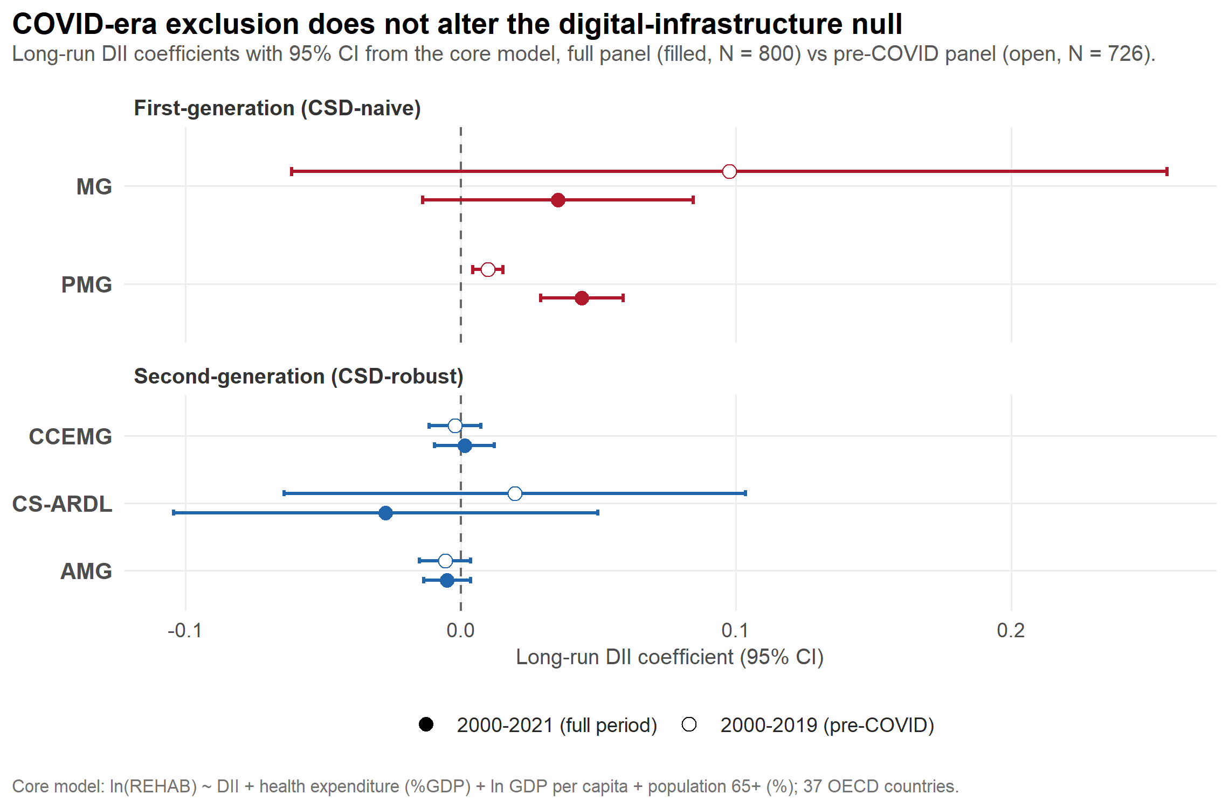
Figure S1. Long-run digital infrastructure index (DII) coefficients with 95% confidence intervals from the core model, estimated on the full panel (2000–2021, filled markers) and the pre-COVID panel (2000–2019, open markers), for first-generation (red) and second-generation, cross-sectional-dependence-robust (blue) estimators. All CSD-robust estimates remain centred on zero in both periods.

