Supplementary information
A Wearable Closed-Loop Insulin Micropump toward a Miniaturized Artificial Pancreas for Diabetes
Ziyu Kuang¹, Xiangbin Kong¹, Tan Cao¹, Rui Lin¹, Zhihe Long¹, Tianyou Jiang¹, Xianchun Jin¹, Xinyu Xue^{1*}, Zhangzhi Zhao^{3*}, Meihua Chen^{2*}
¹School of Physics, University of Electronic Science and Technology of China, Chengdu, 611731, China
²Department of Radiation Oncology, Precision Radiation in Oncology Key Laboratory of Sichuan Province, Sichuan Clinical Research Center for Cancer, Sichuan Cancer Hospital & Institute, Sichuan Cancer Center, University of Electronic Science and Technology of China, Chengdu 610041, China
³Sports Department, University of Electronic Science and Technology of China, Chengdu 611731, China

*Corresponding author Email: xuexinyu@uestc.edu.cn (X. X.); Zhaozz@uestc.edu.cn (Z. Z.); chenmeihua@scszlyy.org.cn (M. C.).

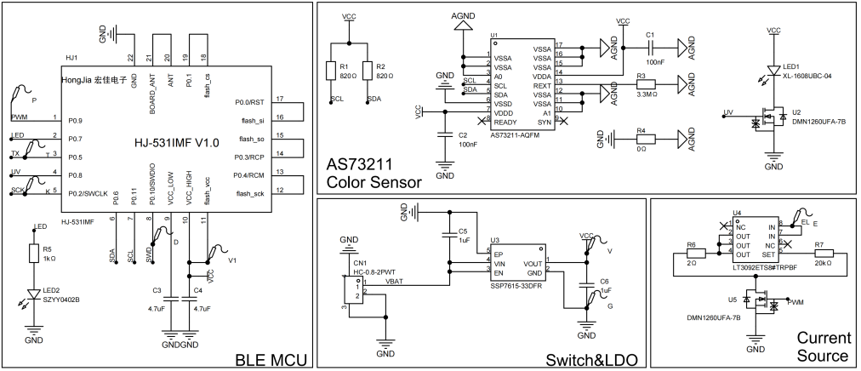
Figure S1. Schematic diagram of the flexible printed circuit (FPC), detailing the BLE microcontroller, XYZ true-color sensor, power management (LDO), and programmable current source modules.

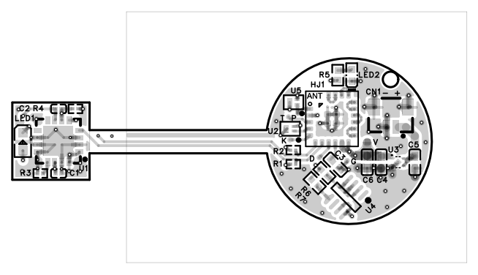
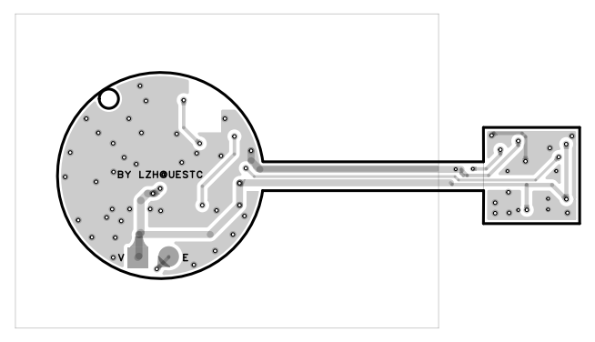
Figure S2. Top and bottom layout designs of the integrated flexible printed circuit (FPC).

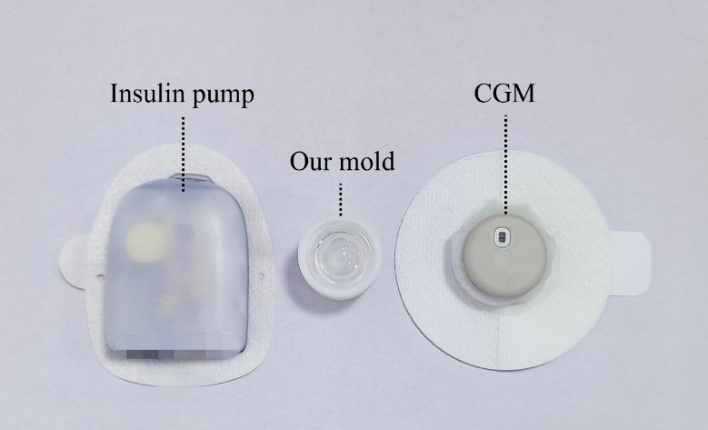
Figure S3. Visual size comparison of the developed closed-loop insulin micropump alongside a commercial insulin pump and a commercial continuous glucose monitoring (CGM) device.

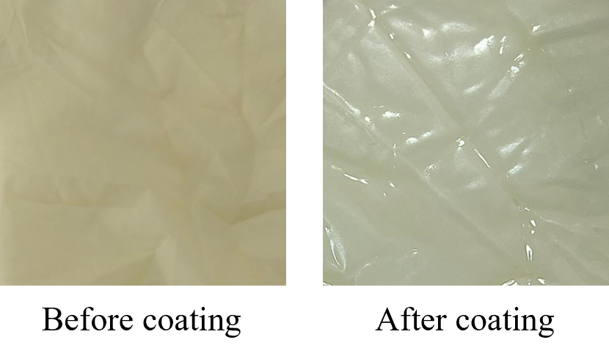
Figure S4. Optical photographs of the highly elastic latex membrane before and after the polyvinylidene chloride (PVDC) coating process.

Figure S5. Cross-sectional microscopic image confirming the uniform deposition of the ultra-thin PVDC coating on the latex membrane.

Supplementary Note 1.
Sample | Item | Parameter/[cm³/(m²·d·Pa)]
1 | Oxygen Transmission Rate | 9.033×10⁻⁵
Testing Conditions and Equipment :
Test Temperature: 23°C ± 2°C
Relative Humidity (RH): 50% ± 2% RH
Test Method: GB/T 1038.1-2022 Plastics — Film and sheeting — Determination of gas transmission rate — Part 1: Differential pressure method.
Instrument: Labthink VAC-V2 Differential Pressure Gas Permeability Tester.

Supplementary Note 2.
Theoretical volume variation of the micro-actuator.
To quantitatively predict the volume variation in the micro-actuator and drug reservoir, a theoretical model is established for the whole micro-actuator system. Ideal gas law of the pump chamber gives
$P(V+V_{0})=nRT$ (Eq S1)
Where$P$is the absolute pressure of the gas inside the micro-actuator,${ V}_{0 }$and$V$are the initial volume and volume change of gas inside the micro-actuator, respectively,$n$is the number of moles of gas,$R$is the ideal gas constant, and$T$is the temperature.
From Faraday's laws of electrolysis, the number of moles of gas generated by water electrolysis is related to the input charge:
$n=\frac{3it}{4F}$ (Eq S2)
Where$i$is the applied constant driving current,$t$is the actuation time, and$F$is the Faraday constant.
From Eq S1, assuming the initial volume${ V }_{0}$is negligible compared to the expansion volume$V$, the pressure$P$can be related by
$P=\frac{3it}{4FV}RT$ (Eq S3)
The volume of a micro-actuator undergoes change when gas pressure is applied. The formula for the Bulk modulus ($k$) can be expressed as
$k=\frac{E}{3(1-2ν)}$ (Eq S4)
$k=V_{0}\frac{P}{V}$ (Eq S5)
where$k$is Bulk modulus,$E$is Young's modulus and$ν$is Poisson ratio.
According to Eq S3, Eq S4, and Eq S5, the functional relationship between the volume variation ($V$) and time$t$can be obtained as
$V^{2}=\frac{9iRTV_{0}(1-2v)}{4EF}t$ (Eq S6)
Therefore, the theoretical volume variation$V$generated by the chamber can be calculated as
$V=\frac{3}{2}\sqrt{\frac{iRTV_{0}(1-2v)}{EF}}\sqrt{t}$ (Eq S7)

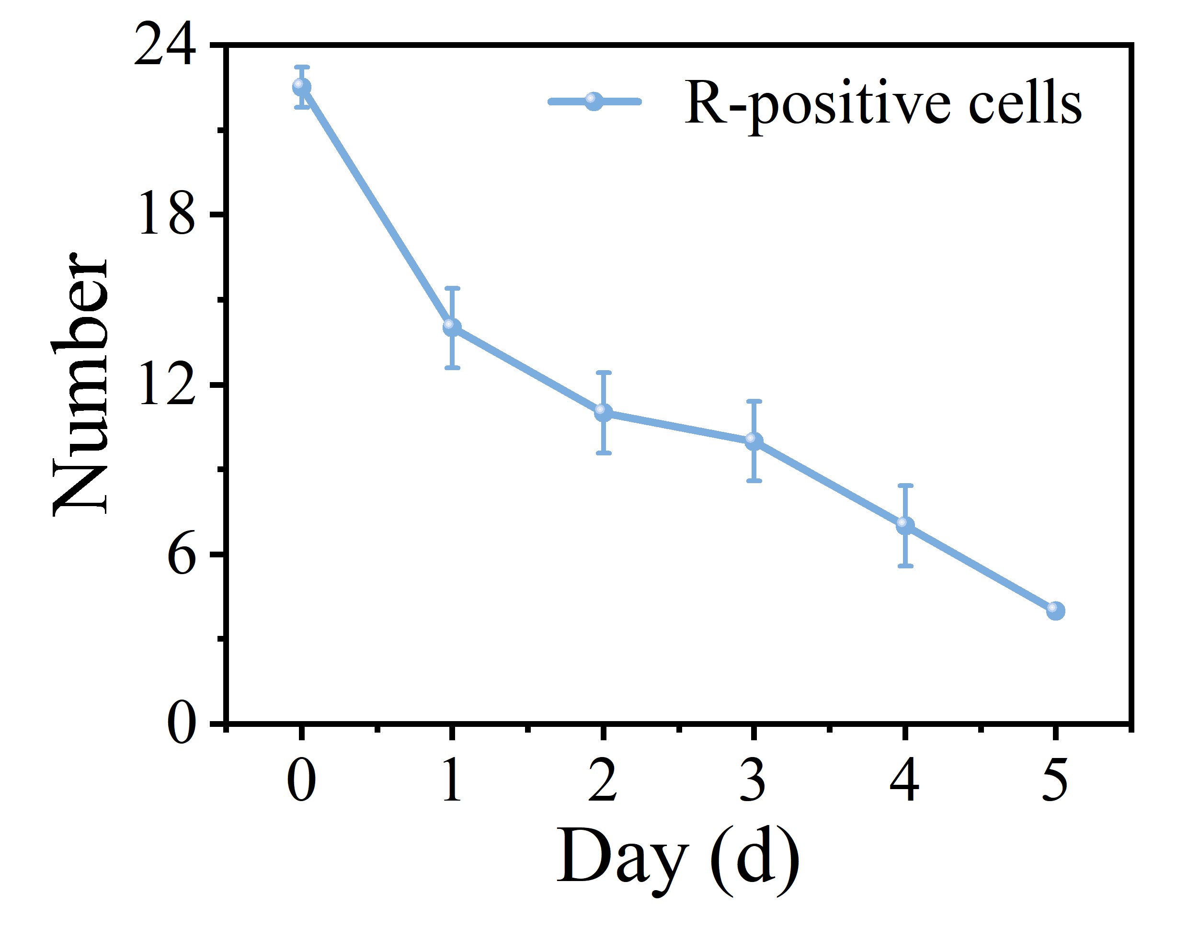
Figure S6. Quantitative analysis of the number of red fluorescence-positive (CD68+) cells in the localized skin tissue over 5 days post-treatment, indicating a declining inflammatory response.

