Appendix S1: Sample item design structure and iterative refinement process (Css4: Steady State Concentration Concept item 4)
Phase | Item Structure | Rational to revise item
Initial version | Stem:  A tablet contains 1000 mg of active pharmaceutical ingredients. Which of the following dosage regimens of the tablet would result in the highest peak steady-state plasma concentration of the active pharmaceutical ingredient?  Options:  - One tablet is given once daily  - One tablet is given twice daily dosing  - One tablet given three times daily  - Two tablets are given once daily (correct answer)  - I am unsure / I cannot answer this confidently | Pilot survey distractor analysis comment  - Option A was selected by <5% of participants (from pilot survey).  Qualitative cognitive interview comment  - The correct option depends on the assumed half-life (despite half-life is not specified). Because the half-life is a critical parameter, both C and D could be answered. To make it unambiguous, specifying half-life or define a total constant dose. Clarify dosing description so that only one option is best fit.
Revised version | Revised stem:  A tablet contains 1000 mg of an active pharmaceutical ingredient, for which the half-life is 6 hours. Which of the following dosage regimens of the tablet would result in the highest peak steady-state plasma concentration of the active pharmaceutical ingredient?  Revised options:  - Half of one tablet four times daily  - One tablet is given twice daily  - One tablet given three times daily  - Two tablets given once daily (correct answer)  - I am unsure / I cannot answer this confidently | Distractors designed to reflect commonly identified misconceptions:  Revised part:  Stem: added section, for which the half-life is 6 hours.  Option: Option A revised to half of one tablet four times daily.  According to sub-concept 19.2, in core concepts of pharmacology (Guilding et al., 2024)“The plasma concentration achieved at steady state is influenced by the dose and dosing interval: higher doses and/or more frequent dosing will result in higher steady-state concentrations.”
Explanation | Correct answer- Option-D  The plasma concentration achieved at steady state is influenced by the dose and dosing interval: higher doses and/or more frequent dosing will result in higher steady-state concentrations. | As shown in the figure below, the correct option depends on the assumed half-life. With a less than 11.55h half-life, D is highest; with a longer one (>11.55h), C is the correct answer. Because the half-life is a critical parameter, both C and D could be answered. To make it unambiguous, we should either specify a half-life or define a total constant dose (Otherwise “A” and “B” are always lower than options C & D).
Uncertainty | - I am unsure / I cannot answer this confidently. | “Unsure” to reduce random guessing.
Final revised survey | Same stem and options (A-D), and uncertainty option (E) | Used in the survey

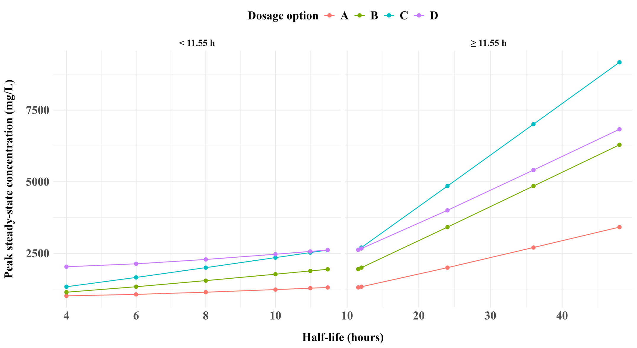

Figure 1: Steady-state peak concentration versus half-life by dosage option
Reference
Guilding, C., White, P. J., Cunningham, M., Kelly‐Laubscher, R., Koenig, J., Babey, A. M., Tucker, S., Kelly, J. P., Gorman, L., Aronsson, P., Hawes, M., Ngo, S. N. T., Mifsud, J., Werners, A. H., Hinton, T., Khan, F., Aljofan, M., & Angelo, T. (2024). Defining and unpacking the core concepts of pharmacology: A global initiative. British journal of pharmacology, 181(3), 375-392. https://doi.org/10.1111/bph.16222

