Supplementary Material
S1. Independent consistency checks
This section provides supporting evidence for the retrospective upper-accumulation consistency framework used in the main manuscript. The evidence includes documentary reports for the seven upper-accumulation events, ERA5-Land hydrological consistency diagnostics, and additional station-based checks for top-ranked H7total events. These materials are intended as independent consistency checks, not as a formal impact-validation database.
S1.1 Documentary consistency evidence for the seven high-accumulation events
Table S1. Documentary evidence for the seven upper-accumulation SESA events.

Date | Dur. | P7 (mm) | Paccum (mm) | H7total  (mm) | Type | Documentary consistency summary
09/01/2019 | 2 | 99.7 | 72.2 | 171.8 | Persistent | Severe flooding across the Litoral, 4 fatalities, >3,500 evacuees, ~3 million affected hectares in Santa Fe, and official emergency/assistance reports for the episode.
06/02/2010 | 1 | 111.7 | 34.6 | 146.3 | 1-day | Santa Fe recorded 72 mm in 12 h, evacuations linked to Paraná River rise, and impacts were documented during the 6–7 February episode..
22/12/2015 | 2 | 61.9 | 64.6 | 126.5 | Persistent | SMN alerts were issued that same evening for Santa Fe and Entre Ríos, monthly rainfall reached 319.7 mm in Santa Fe, and the Paraná later exceeded evacuation level in Puerto Santa Fe.
28/12/2002 | 2 | 63.1 | 46.9 | 110.1 | Persistent | No exact-date press report was found for 28 December, but the event falls within the well-documented 2002–2003 extreme rainy period in Santa Fe/Salado basin, with evacuations and major flooding recorded for the broader episode.
07/01/2019 | 1 | 65.5 | 38.5 | 104.0 | 1-day | This date corresponds to the same January 2019 flooding crisis, with military deployment, severe inundation across Santa Fe, Chaco, Corrientes and Entre Ríos, and strong documentary support from official and media sources.
20/12/2006 | 1 | 62.8 | 32.5 | 95.4 | 1-day | Severe storms affected Santa Fe and Entre Ríos with wind, hail, possible tornadoes, structural damage, outages, and two fatalities documented in Entre Ríos.
04/02/2010 | 1 | 63.3 | 31.4 | 94.7 | 1-day | No exact-date impact report was found for 4 February, but the day sits within a documented high-impact wet episode in early February 2010, with strong regional storm context and impacts reported on 6–7 February.

Source URLs for the table on the seven upper-accumulation events

09/01/2019:

https://www.infobae.com/sociedad/2019/01/09/las-fuertes-lluvias-provocaron-inundaciones-en-casi-todo-el-litoral/ ; https://www.perfil.com/noticias/actualidad/evacuados-hectareas-perdidas-millonarias-las-cifras-de-las-inundaciones.phtml ; https://www.revistachacra.com.ar/nota/24313-inundaciones-en-santa-fe-en-un-mes-llovio-el-promedio-anual/ ; https://reliefweb.int/report/argentina/inundaciones-en-el-litoral-emitieron-un-alerta-por-tormentas-fuertes ; https://www.argentina.gob.ar/noticias/en-nuestro-pais-nos-cuida-el-sistema-nacional-para-la-gestion-integral-del-riesgo-frente

06/02/2010:

https://www.ellitoral.com/index.php/diarios/2010/02/04/politica/POLI-02.html ; https://www.laarena.com.ar/el-pais/2010-2-8-4-11-54-evacuados-en-santa-fe ; https://tn.com.ar/sociedad/el-febrero-mas-lluvioso-en-14-anos_030224/

22/12/2015:
https://tormentasargentinas.com.ar/avisos-y-alertas-vigentes-smn-1930-22122015/ ; https://www.facebook.com/obsesivamente/posts/30-de-diciembre-de-2015a-10-a%C3%B1os-de-la-%C3%BAltima-gran-crecidacon-im%C3%A1genes-de-mi-ami/1477045491088512/

28/12/2002:
https://www.ellitoral.com/index.php/diarios/2002/12/04/regionales/REGI-01.html ; https://cdi.mecon.gob.ar/bases/docelec/fd1259.pdf ; https://agenciatierraviva.com.ar/veinte-anos-de-la-inundacion-de-santa-fe-158-victimas-fatales-desidia-estatal-e-impunidad/

07/01/2019:
https://www.infobae.com/sociedad/2019/01/09/las-fuertes-lluvias-provocaron-inundaciones-en-casi-todo-el-litoral/ ; https://www.perfil.com/noticias/actualidad/evacuados-hectareas-perdidas-millonarias-las-cifras-de-las-inundaciones.phtml ; https://www.revistachacra.com.ar/nota/24313-inundaciones-en-santa-fe-en-un-mes-llovio-el-promedio-anual/ ; https://reliefweb.int/report/argentina/inundaciones-en-el-litoral-emitieron-un-alerta-por-tormentas-fuertes ; https://www.argentina.gob.ar/noticias/en-nuestro-pais-nos-cuida-el-sistema-nacional-para-la-gestion-integral-del-riesgo-frente

20/12/2006:
http://www-atmo.at.fcen.uba.ar/tiempo/situaciones/informe_191206.htm ; https://www.analisisdigital.com.ar/archivo/2006/12/18/el-temporal-dejo-dos-jovenes-muertos-en-la-provincia-y-danos-materiales ; https://www.ladulceseguros.com.ar/boletin/2007febrero.pdf

04/02/2010:
https://www.ellitoral.com/index.php/diarios/2010/02/04/politica/POLI-02.html ; https://www.laarena.com.ar/el-pais/2010-2-8-4-11-54-evacuados-en-santa-fe ; https://tn.com.ar/sociedad/el-febrero-mas-lluvioso-en-14-anos_030224/

S1.2 ERA5-Land hydrological consistency diagnostics

Table S2. ERA5-Land hydrological variables extracted for the seven upper-accumulation events. swvl2_pre: mean volumetric soil water content of layer 2 (7–28 cm) over the 3–7 days prior to event onset (m³/m³ × 10⁻³). swvl1_end_anomaly: anomaly of soil water layer 1 (0–7 cm) at event end relative to DJF climatology. runoff_total_mm: spatially integrated ERA5-Land total runoff (surface + subsurface) over SESA during the event plus one day (mm). Spearman correlations with H7total are shown in the bottom row.
Date | H7total (mm) | Pre-event soil moisture | End-event soil-moisture anomaly | ERA5-Land runoff diagnostic | Evidence type
09/01/2019 | 171.8 | 37.4 | 2.84 | 17.766 | Specific
06/02/2010 | 146.3 | 32.3 | 2.60 | 11.779 | Specific
22/12/2015 | 126.5 | 37.1 | 3.42 | 10.919 | Specific
28/12/2002 | 110.1 | 41.4 | 1.17 | 10.487 | Contextual*
07/01/2019 | 104.0 | 34.1 | 3.89 | 11.644 | Specific
20/12/2006 | 95.4 | 28.4 | 7.55 | 8.724 | Specific
04/02/2010 | 94.7 | 32.1 | 5.99 | 11.359 | Contextual*
Spearman ρ | — | 0.61 | 0.71 | 0.61 | —

Note: ERA5-Land runoff is used as a consistency diagnostic of land-surface hydrological response. Given the small sample size and spatial aggregation over SESA, these values should not be interpreted as formal hydrological validation.

Independent validation for the 28–29 December 2002 event: daily station records at Paraná Aeropuerto (SMN) confirm 63 mm on 23 December and 57.9 mm on 28 December, with four consecutive dry days in between. The observed 7-day antecedent precipitation (P7_obs = 63 mm) is consistent with the IMERG areal estimate (P7 = 63.1 mm), confirming that IMERG correctly captured the immediate antecedent forcing. The elevated swvl2_pre for this event therefore reflects the cumulative hydrological memory of the anomalously wet 2002–2003 season rather than the antecedent week alone (see also Figure S3).

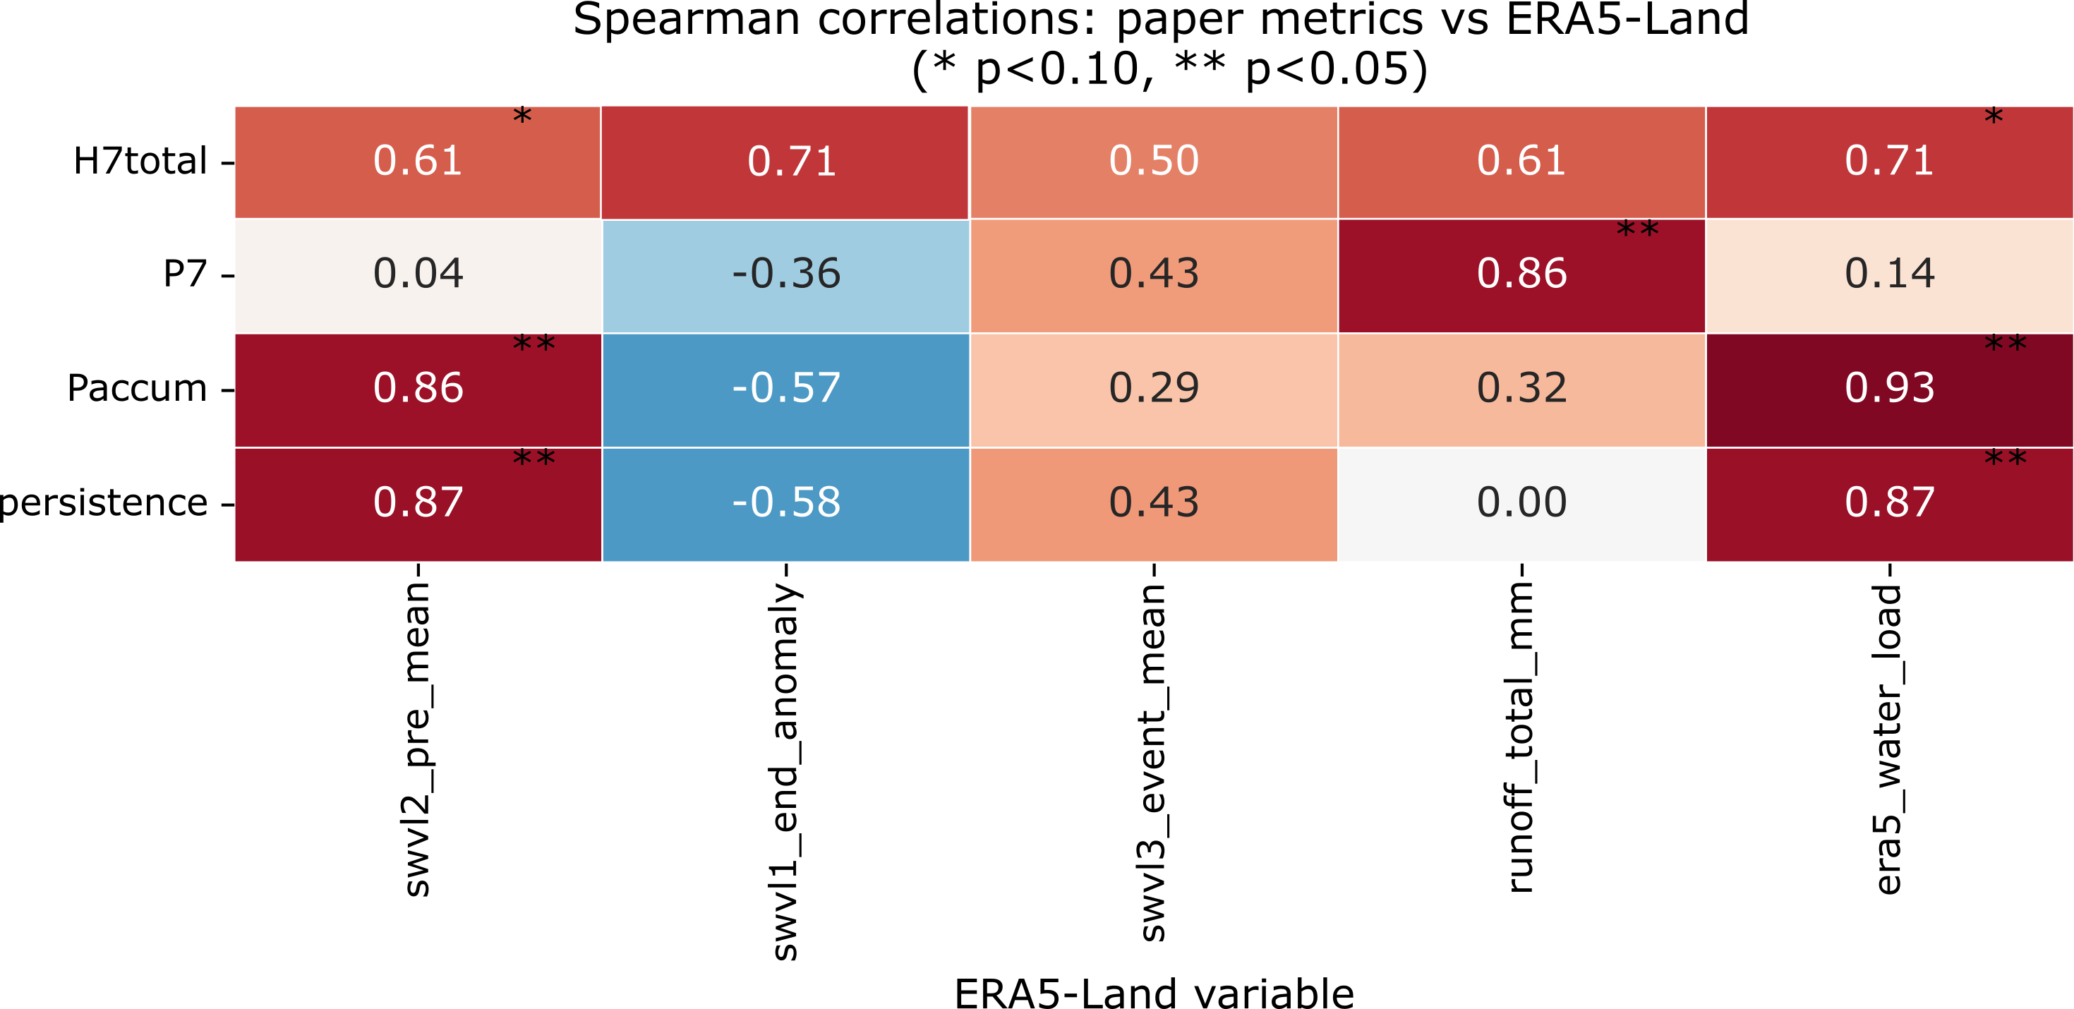
Figure S1. Spearman rank correlations between paper metrics and ERA5-Land hydrological variables for the seven upper-accumulation events. Asterisks denote marginal significance (* p < 0.10, ** p < 0.05).

The full Spearman correlation matrix (Figure S1) reveals a coherent physical signal across most metric-variable pairs. H7total is positively associated with ERA5-Land total runoff (ρ = 0.61) and integrated water load (ρ = 0.71, p = 0.07), indicating that events ranked higher by the compound index also tend to produce larger land-surface hydrological responses in the reanalysis. Persistence and Paccum show the strongest associations with pre-event soil moisture layer 2 (ρ = 0.87 and 0.86 respectively, p < 0.05), suggesting that events with greater accumulated rainfall and longer duration tend to occur under wetter antecedent land-surface conditions. The negative correlation between H7total and the end-of-event soil moisture anomaly (swvl1_end_anom, ρ = −0.71, p = 0.07) is discussed in Section 4.2.

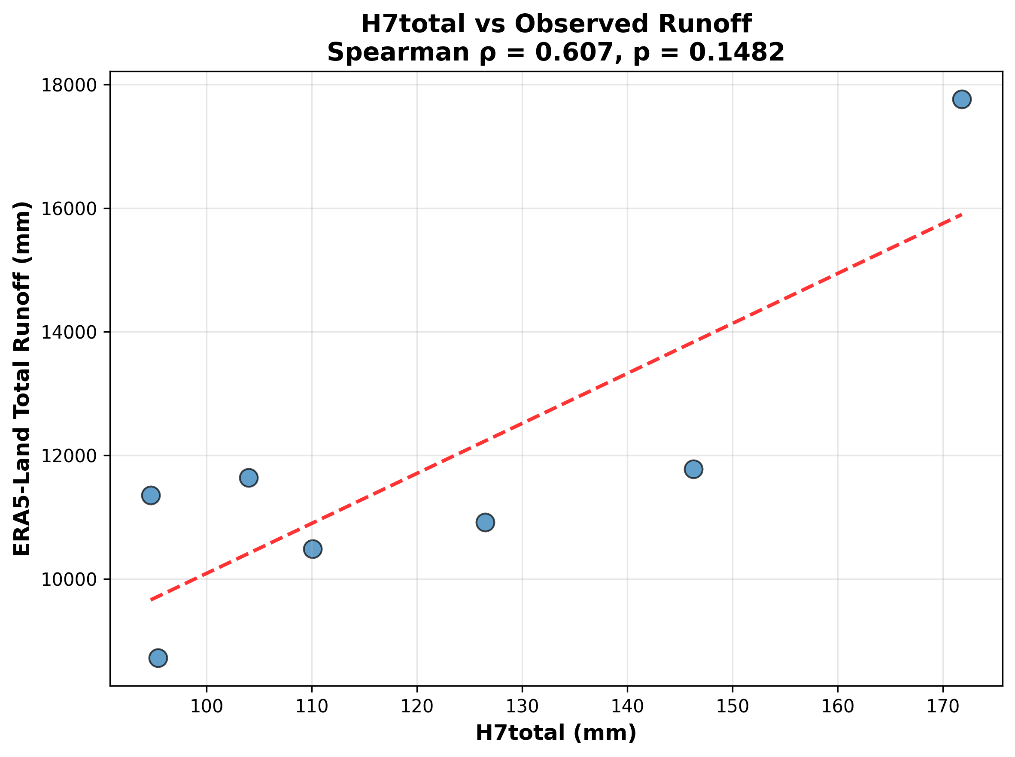
Figure S2. H7total versus ERA5-Land total runoff for the seven upper-accumulation events (Spearman ρ = 0.61, p = 0.15).

Figure S2 shows the relationship between H7total and ERA5-Land total runoff across the seven upper-accumulation events. Despite the small sample size, a positive monotonic tendency is evident, with the January 2019 event anchoring the upper end of both variables. The December 2006 event shows the lowest runoff, consistent with its predominantly convective and short-duration character.
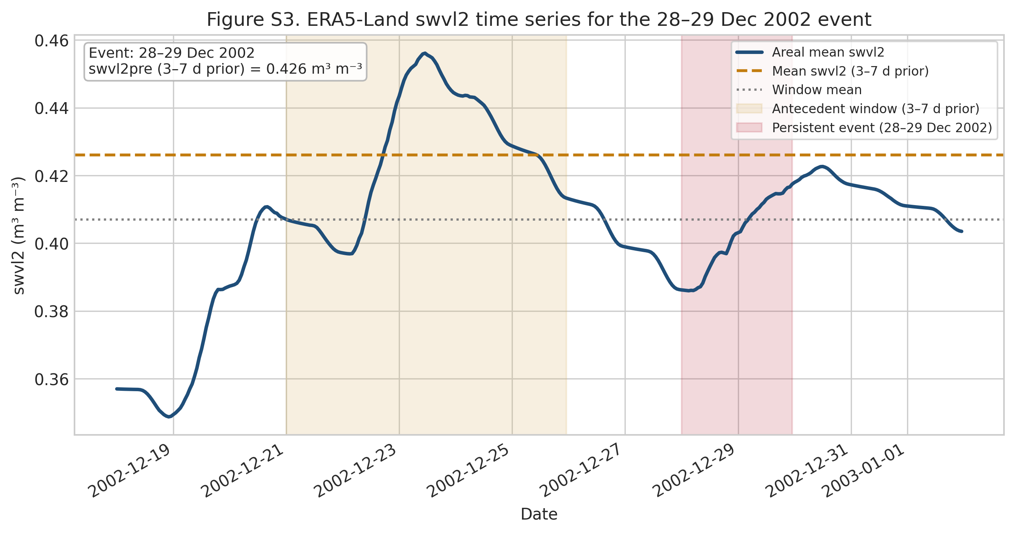
Figure S3. ERA5-Land areal mean soil moisture layer 2 (swvl2) over SESA around the 28–29 December 2002 event. Orange shading: antecedent window (3–7 days prior, mean = 0.426 m³ m⁻³). Red shading: event period.

The December 2002 case warrants specific attention. As shown in Figure S3, ERA5-Land soil moisture layer 2 over SESA was already elevated well before the antecedent window, reflecting the cumulative hydrological loading of the broader 2002–2003 wet season. The peak on 23 December (~0.455 m³/m³), consistent with the 63 mm recorded at Paraná Aeropuerto on that date, was followed by only a partial drainage over four dry days before the onset of the 28–29 December event, leaving the land surface in a persistently wet state (swvl2_pre = 0.426 m³/m³, the highest among all seven upper-accumulation cases) that P7 alone cannot fully represent.

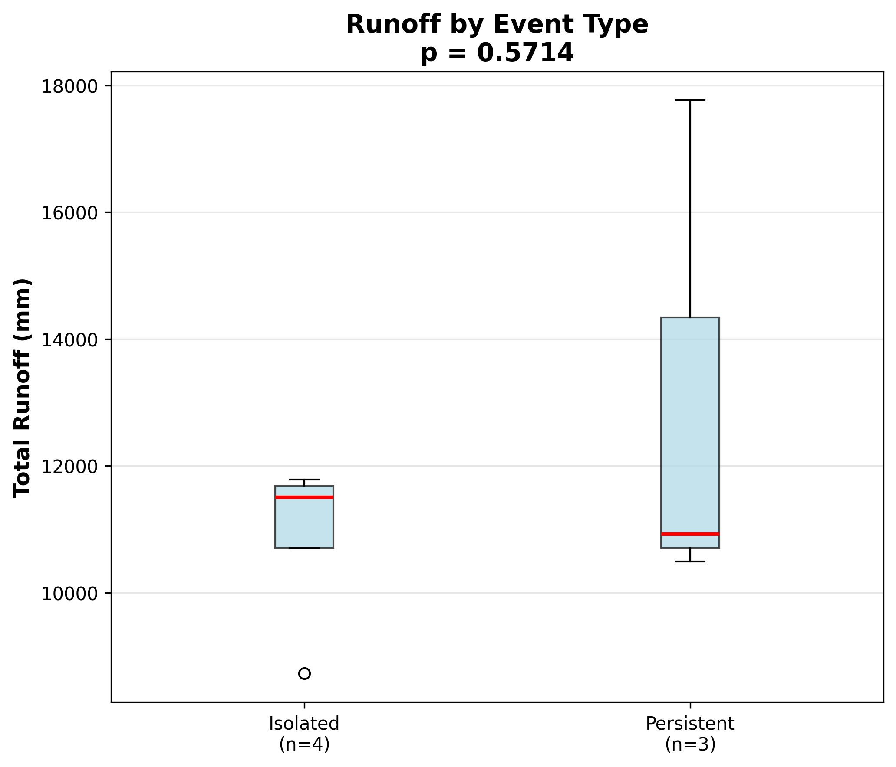
Figure S4. ERA5-Land total runoff distribution for isolated (n=4) and persistent (n=3) upper-accumulation events (Mann-Whitney p = 0.57).

Persistent events tended to produce higher ERA5-Land runoff than isolated events, though the difference was not statistically significant (Mann-Whitney p = 0.57; Figure S4), reflecting the limited power of the comparison at n = 3 vs. n = 4. The January 2019 persistent event drove the upper tail, while the December 2006 isolated event produced the lowest runoff among all seven cases, consistent with its predominantly convective character.

S2. Statistical definitions and diagnostic skill evaluation

The climatological probability of an extreme day was defined as the number of days exceeding the selected threshold divided by the total number of DJF days in the series. The conditional persistence probability was defined as the probability that day t+1 also exceeded the threshold given that day t was extreme. For the upper-accumulation exceedance analysis, 2 × 2 contingency tables were constructed by separating isolated and persistent events according to whether they exceeded the selected H_total percentile threshold. Relative risk, odds ratio, 95% confidence intervals, and Fisher’s exact test were then computed from these tables. P3, P5, P7, and P10 denote antecedent precipitation accumulated over 3, 5, 7, and 10 days before event onset, respectively. H3total, H5total, H7total, and H10total denote the corresponding antecedent-plus-event accumulation metrics, obtained by adding Paccum to each antecedent window.

Table S3. Summary of best-performing metrics under quantile-based and top-k skill evaluation.
Evaluation scheme | Best-performing metric | Performance
Quantile threshold q70 | Paccum | F1 = 0.378, Recall = 1.00
Quantile threshold q75 | Paccum | F1 = 0.438, Recall = 1.00
Quantile threshold q80 | P7 | F1 = 0.519, Recall = 1.00
Quantile threshold q90 | H5total | F1 = 0.588, Precision = 0.50, Recall = 0.714
Top-k ranking Top-3 | H5total | Precision@3 = 1.00, Recall@3 = 0.429
Top-k ranking Top-5 | P10 | Precision@5 = 0.60, Recall@5 = 0.429
Top-k ranking Top-7 | H7total | Precision@7 = 0.571, Recall@7 = 0.571
Top-k ranking Top-10 | H5total | Precision@10 = 0.50, Recall@10 = 0.714

S3. IMERG gauge-based evaluation
S3.1 Grid-scale station evaluation

To evaluate the suitability of IMERG for representing summer precipitation extremes over SESA, a gauge-based validation was performed using daily observations from eight stations distributed across the domain (Santa Fe Aeropuerto, Paraná Aeropuerto, Resistencia Aeropuerto, Concordia, Paso de los Libres, Corrientes, Salto and Uruguaiana). The analysis focuses on the 2002–2024 period and is restricted to the DJF season, consistent with the main event-based framework. For each station, IMERG daily precipitation was extracted from the nearest 0.1° grid cell and compared with the corresponding gauge series, and an additional evaluation was conducted at the area-mean scale by contrasting IMERG-based regional averages with gauge-derived estimates of domain-mean rainfall.

Table S4. Grid-scale evaluation of IMERG daily DJF precipitation against eight gauge stations within SESA during 2002–2024. All statistics are computed on daily values.
Station | Bias  (mm/day) | Correlation | RMSE  (mm/day) | P95 gauge  (mm/day) | P95 IMERG (mm/day) | P95 difference | P99 gauge (mm/day) | P99 IMERG (mm/day) | P99 difference
Santa Fe Aero | 0.16 | 0.706 | 7.68 | 26.66 | 29.68 | 3.02 | 52.14 | 68.16 | 16.02
Parana Aero | 0.31 | 0.725 | 7.47 | 24.28 | 29.87 | 5.59 | 51.11 | 66.64 | 15.53
Resistencia Aero | 0.13 | 0.694 | 9.15 | 27.68 | 31.34 | 3.67 | 52.81 | 68.71 | 15.89
Concordia | 0.05 | 0.741 | 7.89 | 29.19 | 29.03 | -0.16 | 53.92 | 63.52 | 9.60
Paso de los Libres | 0.49 | 0.742 | 8.17 | 25.39 | 29.13 | 3.74 | 52.35 | 61.86 | 9.51
Corrientes | 0.28 | 0.714 | 8.99 | 27.68 | 30.87 | 3.19 | 52.81 | 68.05 | 15.24
INUMET Salto | 0.06 | 0.742 | 7.83 | 29.19 | 29.12 | -0.07 | 53.92 | 63.36 | 9.44
INMET Uruguaiana | 0.57 | 0.735 | 8.25 | 25.03 | 30.23 | 5.20 | 51.93 | 62.61 | 10.68

S3.2 Regional-scale areal-mean evaluation

Table S5. Regional-scale evaluation of the SESA-mean IMERG series against gauge-derived domain-mean precipitation during DJF (2002–2024).
Metric | Gauge (mm/day) | IMERG SESA-mean (mm/day) | Difference (IMERG − gauge) (mm/day)
Bias (daily) | – | – | ~0.25
Correlation | – | – | ~0.59
P95 (DJF) | ~26.9 | 20.35 | ~−6.4
P99 (DJF) | ~52–53 | 28.89 | ~−23.7

At the regional scale (Table S5), the SESA-mean IMERG series exhibits small daily biases (around 0.25 mm/day) and moderate daily correlations (about 0.6) relative to gauge-derived domain-mean estimates. However, the P95 and P99 thresholds of the area-mean series (20.35 and 28.89 mm/day) are substantially lower than the corresponding gauge-based values (around 27 and 53 mm/day), reflecting the smoothing of extremes when precipitation is averaged over the SESA domain.
Table S6. ENSO phase summary for P95 events
ENSO phase | N P95 events | N persistent | % persistent | Median H7total
El Niño | 60 | 9 | 15.00 | 72.98
La Niña | 14 | 2 | 14.29 | 60.55
Neutral | 20 | 2 | 10.00 | 66.54

Table S7. MJO stratification of P95 events over SESA during DJF. Event and persistent-event rates are normalized by the number of DJF days in each MJO category.
MJO category | DJF days | N P95 events | N persistent | Event rate /100 days | Persistent rate /100 days
inactive | 616 | 22 | 4 | 3.57 | 0.65
active phase 1 | 81 | 5 | 0 | 6.17 | 0.00
active phase 2 | 130 | 7 | 1 | 5.38 | 0.77
active phase 3 | 173 | 9 | 1 | 5.20 | 0.58
active phase 4 | 176 | 13 | 4 | 7.39 | 2.27
active phase 5 | 205 | 11 | 2 | 5.37 | 0.98
active phase 6 | 243 | 11 | 0 | 4.53 | 0.00
active phase 7 | 297 | 9 | 0 | 3.03 | 0.00
active phase 8 | 119 | 7 | 1 | 5.88 | 0.84

