Supplementary Materials
Table S1. Patient Data and Treatment Results*
Case # | Tooth # | Sex | Age | Pre-op Pain (VAS) | Spontaneous Pain | STP | Pre-op CVT | Spontaneous Pain Duration | Post-Op Pain Same Evening | Post-Op Pain at 24hr | Post-Op Pain at 48 hr | Post-Op Radiograph | Post-Op CVT | Follow-Up Duration
1 | 26 | M | 17 | 6-7 | Yes | Yes | Painful | <12 hrs | 0 | 0 | 0 | Atypical Apex change | Normal | 25-36 Months
2 | 47 | F | 15 | 7 | Yes | Yes | Painful | Few hrs | 0 | 0 | 0 | No change at Apex | Normal | 25-36 Months
3 | 46 | M | 33 | 0-1 | No | No | Sensitive | NA | 0 | 0 | 0 | No change at Apex | Normal | 25-36 Months
4 | 16 | F | 39 | 2-3 | No | No | Sensitive | NA | 0 | 0 | 0 | Atypical Apex change | Normal | 25-36 Months
5 | 26 | M | 41 | 0-1 | No | No | Sensitive | NA | 0 | 0 | 0 | No change at Apex | Negative | 25-36 Months
6 | 14 | M | 32 | 8 | Yes | Yes | Painful | 12-24 hrs | 0 | 0 | 0 | No change at Apex | Normal | 25-36 Months
7 | 15 | F | 38 | 8 | Yes | Yes | Painful | 1 hour | 0 | 0 | 0 | Apical Lucency | Negative | 13-24 Months
8 | 26 | M | 30 | 7 | Yes | Yes | Painful | 2 hours | 0 | 0 | 0 | No change at Apex | Negative | 13-24 Months
9 | 17 | M | 48 | 6-7 | Yes | Yes | Painful | <12 hrs | 0 | 0 | 0 | No change at Apex | Normal | 13-24 Months
10 | 14 | F | 24 | 2 | No | No | Sensitive | NA | 0 | 0 | 0 | No change at Apex | Normal | 13-24 Months
11 | 24 | M | 40 | 7 | Yes | Yes | Painful | <24 hrs | 4 | 2 | 0 | No change at Apex | Normal | 13-24 Months
12 | 38 | F | 54 | 0 | No | No | Sensitive | NA | 0 | 0 | 0 | No change at Apex | Normal | 13-24 Months
13 | 15 | M | 22 | 8 | Yes | Yes | Painful | 24-36 hrs | 1 | 0 | 0 | No change at Apex | Sensitive | 13-24 Months
14 | 27 | M | 67 | 2 | No | No | Sensitive | NA | 1 | 0 | 0 | No change at Apex | Normal | 13-24 Months
15 | 17 | F | 57 | 8-9 | Yes | Yes | Lingering pain | 24 hrs | 0 | 0 | 0 | No change at Apex | Normal | 13-24 Months
16 | 15 | M | 34 | 9 | Yes | Yes | Pain | 24hrs | 5 | 1 | 0 | No change at Apex | Sensitive | 13-24 Months
17 | 26 | F | 40 | 2 | No | No | Sensitive | NA | 0 | 0 | 0 | No change at Apex | Normal | 13-24 Months
18 | 26 | M | 40 | 4 | Yes | Yes | Lingering pain | Few hrs | 0 | 0 | 0 | No change at Apex | Sensitive | 13-24 Months
19 | 28 | F | 59 | 6 | Yes | Yes | Very Painful | Few hrs | 4 | 0 | 0 | No change at Apex | Normal | 13-24 Months
20 | 15 | M | 23 | 5 | No | Yes | Very Sensitive | NA | 0 | 0 | 0 | No change at Apex | Normal | 13-24 Months
21 | 25 | F | 35 | 7 | Yes | Yes | Painful | <24 hrs | 0 | 0 | 0 | No change at Apex | Normal | 7-12 Months
22 | 48 | M | 48 | 2 | No | No | Painful | NA | 0 | 0 | 0 | No change at Apex | Sensitive | 7-12 Months
23 | 37 | M | 71 | 6 | No | No | Normal | NA | 2 | 0 | 0 | No change at Apex | Normal | 7-12 Months
24 | 34 | M | 47 | 7-8 | Yes | Yes | Painful | 24 hrs | 4 | 0 | 0 | No change at Apex | Normal | 7-12 Months
25 | 46 | M | 17 | 8 | Yes | Yes | Sensitive | 24 hrs | 4 | 0 | 0 | No change at Apex | Normal | 3-6 Months
26 | 27 | M | 34 | 7-8 | Yes | Yes | Painful | 48 hrs | 0 | 0 | 0 | No change at Apex | Normal | 3-6 Months
27 | 17 | F | 52 | 8 | Yes | Yes | Painful | < or =24 hrs | 2 | 0 | 0 | No change at Apex | Sensitive | 3-6 Months
*Tooth# (FDI system, ISO 3950); VAS (Visual Analog Scale); Pre-op (Pre-operative); Post-op(Post-operative); STP (Sensitivity to Percussion); CVT (Cold Vitality Test);

Figure S1. Varying Volumes of Liquid GA on AMicro-applicator for Single-tooth Application *
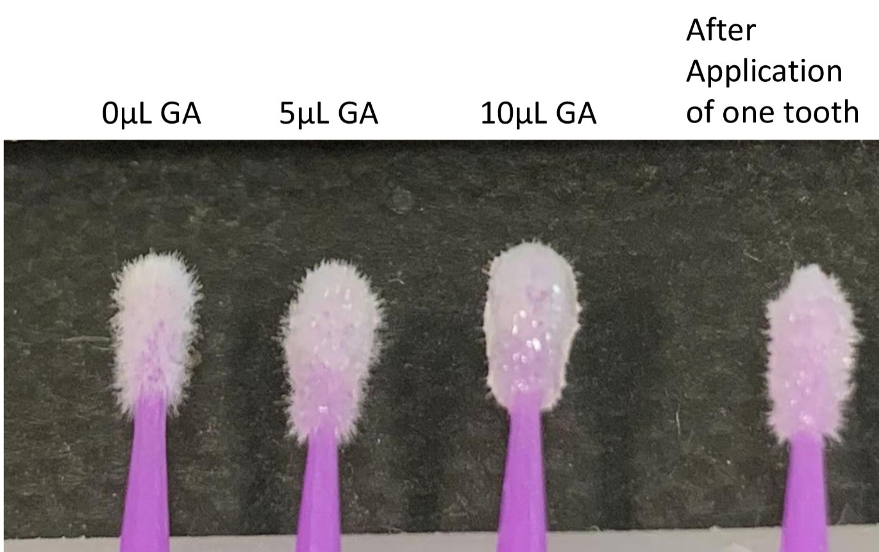
- 2 3 4

*1.Empty Micro-applicator; 2. 5µl liquid GA loaded; 3. 10 µl liguid GA loaded; 4 After application of one cavity with 10 µl liquid GA loaded micro-applicator (about 5 µl GA remains on the microapplicator)

FigureS2. GA–RMGI solid exhibits strong bactericidal activity without direct contact
1.Bacterial Control 2. Paper (pH8.0) only 3. Paper (pH8.0)+Gluma
Placed on top of agar Placed on top of agar
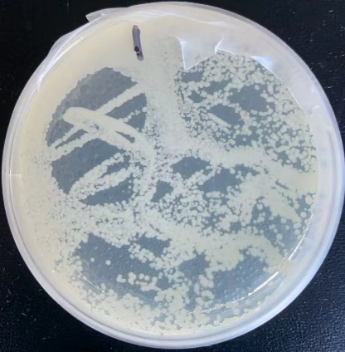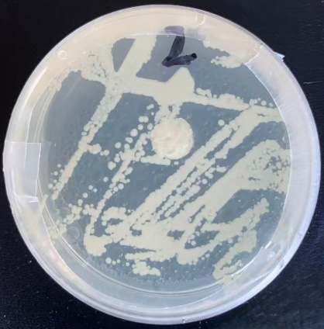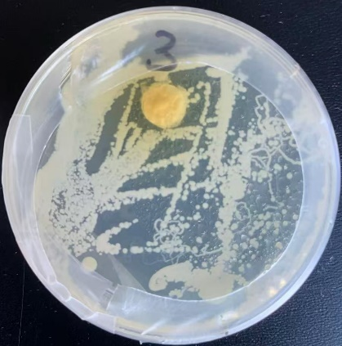

4. Gluma(pH8.0) liquid on 5. GA+HEMA liquid loaded 6. GA+HEMA-Vitrebond Solid
glass dish without agar contact paper (pH8.0) placed on agar (pH8.0) on glass dish no contact
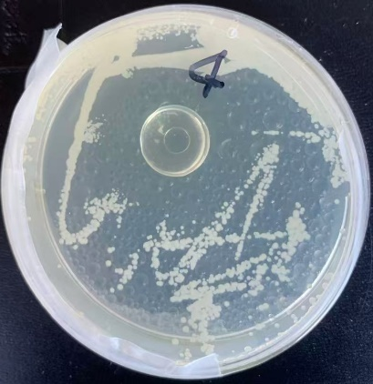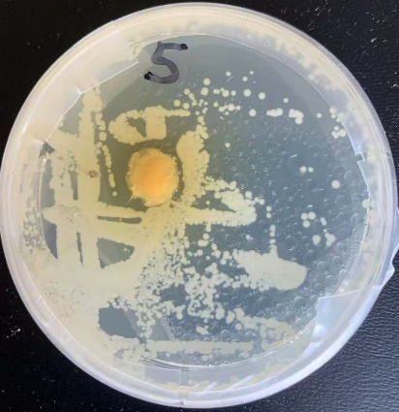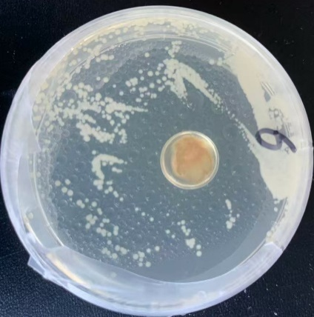
Tryptic soy agar plates were inoculated with oral bacterial culture suspension with a 10 µ -inoculation metal loop. For direct-contact experiments, 10 µL of liquid GA/HEMA or Gluma Desensitizer loaded paper discs were placed directly on the agar surface. For non-contact (vapor-phase) experiments, GA-containing liquids or solids in glass dishes positioned at the bottom of inverted Petri dishes; the agar plates were placed face down above them so that they shared the same enclosed headspace without touching the agar surface.
The Petri dishes were tightly sealed with Parafilm and incubated at 37 °C for 24 h. The presence bacterial growth inhibition halos and radial width (mm) of inhibition zones surrounding the discs were measured, and qualitative changes in colony density across the entire plate were recorded.
The results show that paper only control (Petri dish 2) was same as bacterial control (Petri dish 1) and have no bacterial inhibition effect. Both Gluma solution loaded absorbent paper (Petri dish 3) and GA+HEMA loaded paper (petri dish 5) directly contacting with agar have minimal bactericide effect with less than 1mm inhibition zone. liquid Gluma solution in glass dish (Petri dish 4) without agar contact has a large non-bacterial growth zone 7.5 mm (from the glass disc edge to zone edge). Solid Vitrebond + GA (Petri dish 6) without agar contact also has a large inhibition zone of 6 mm.
These findings indicate that GA, whether in liquid or solid form, can exert potent bactericidal activity via vapor-phase diffusion when not consumed by immediate reaction with proteins in the agar. Conversely, direct contact between GA and the protein-rich agar appeared to quench GA activity rapidly, consistent with extensive crosslinking and depletion of reactive aldehyde groups.

Table S2. Bactericidal activity of solid glutaraldehyde (GA) formedwith different light-cured dental cavity liners/bases
Material combination | Bactericidal activity
Gluma liquid | Positive
GA + HEMA liquid | Positive
Vitrebond Plus-Gluma solid | Positive
Vitrebond Plus-GA + HEMA solid | Positive
Activa-Gluma solid | Positive
Vitrebond Plus solid (no GA) | Negative
Lime-Lite Enhanced solid (no GA) | Negative
Lime-Lite Enhanced-Gluma solid | Negative
Activa solid (no GA) | Negative
TheraCal LC solid (no GA) | Negative
Thera Cal LC-Gluma solid | Negative
No liner/base material alone (without GA) exhibited any bactericidal activity under the tested conditions. Among GA-containing solids, only combinations involving Vitrebond Plus or Activa produced detectable inhibition zones and reduction in colony density. GA-containing solids prepared with Lime-Lite Enhanced or TheraCal LC showed no observable bactericidal effect, suggesting that the physicochemical properties of the liner matrix are critical for GA vapor release.
Material:
-GA +HEMA solution (6.25% Glutaraldehyde solution containing 37.5% HEMA);
- GLUMA Desensitizer; (Kulzer, Hanau, Germany).
-Vitrebond Plus (3M U.S.A.)
-Lime-Lite™ Enhanced, Light Cure Cavity Liner (Pulpdent U.S.A.)
-ACTIVA™ BioACTIVE-BASE/LINER™ (Pulpdent U.S.A.)
-TheraCal LC (BISCO, U.S.A.)

Figure S3. Short, self-limiting bactericidal activity of GA–RMGI solid
0.Bacterial control 1. 1 hr-old GA-Vitrebond Solid 2. 2hr-old GA-Vitrebond solid 3. 4 hr-old GA-Vitrebond
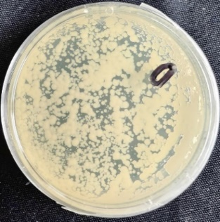
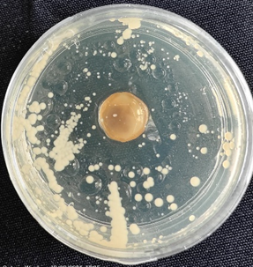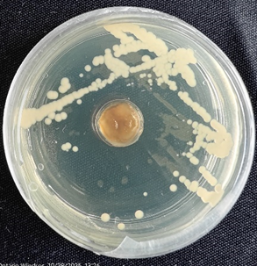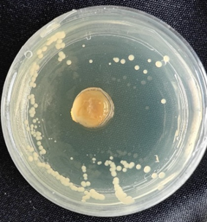
________________________________________________________________________
4. 8 hr-old GA-Vitrebond Solid 5A. 12 hr Bacterial Control 5. 12 hr-old GA-Vitrebond Solid
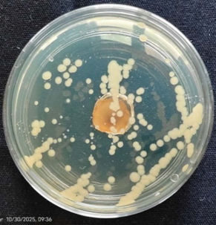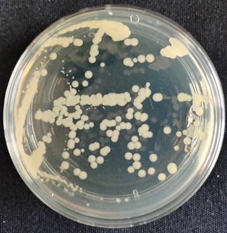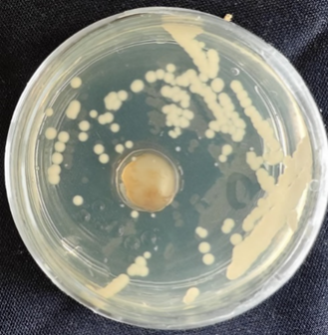
_______________________________________________________________________
6A. 24 hr Bacterial Control 6. 24 hr-old GA-Vitrebond Solid
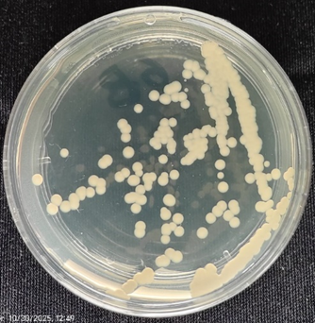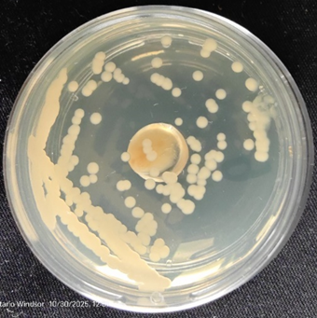
_______________________________________________________________________
To evaluate the time kinetics of GA-RMGI solid bactericidal activity, identical GA–RMGI solid discs were prepared using 10 µL GA and mixed with Vitrobond Plus on each small glass dishes and solidified under curing light. These GA-RMGI solid discs were stored at 37 °C and tested in the bacterial inhibition assay at predetermined time points (1h, 2h, 4 h, 8 h, 12 h, 24 h and a week after formation) in sealed agar Petri dishes under non-contact conditions. Bacterial colonies were counted and compared to the numbers on bacterial control agar dishes and the reductions were expressed as a percentage.. Three same test numbers were combined and average numbers were used

FigureS4. Transient bactericidal activity of GA–RMGI solid

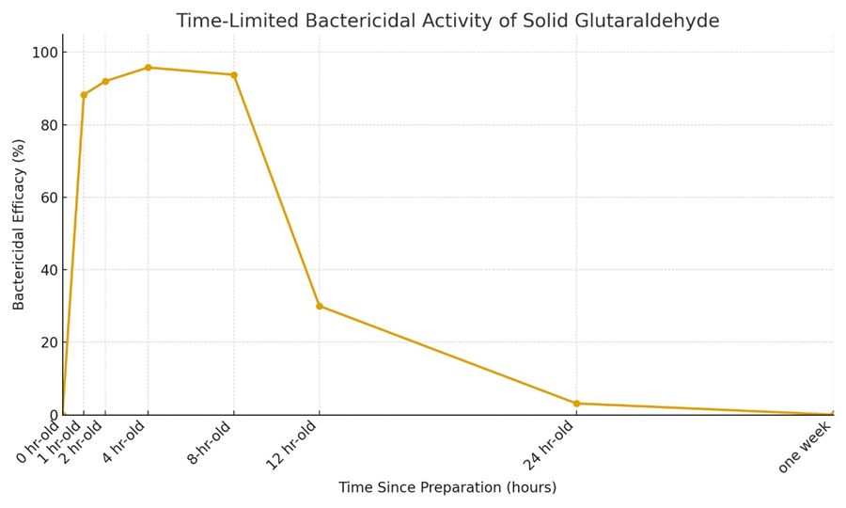
To evaluate the time kinetics of GA-RMGI solid activity, identical GA–RMGI solid discs were prepared using 10 µL GA and mixed with Vitrobond Plus on each small glass dishes and solidified under curing light. These GA-RMGI solid discs were stored at 37 °C and tested in the bacterial inhibition assay at predetermined time points (1h, 2h, 4 h, 8 h, 12 h, 24 h and a week after formation) in sealed agar Petri dishes under non-contact conditions. Bacterial colonies were counted and compared to the numbers on bacterial control agar dishes and the reductions were expressed as a percentage. Three same test numbers were combined and average numbers were used.

