Supplementary Material (online data supplement)
Manuscript: Anticoagulation versus Antiplatelet Therapy After Cancer-Associated Ischemic Stroke: A Net-Benefit Threshold Analysis.
Supplementary Table S1. Detailed model input parameters with evidence status and caveats (including the net-benefit equation). Status vocabulary as in Table 1.
Parameter | Value | Range / distribution | Source | Use | Evidence status | Caveat
Time horizon | 0.5 y | structural assumption | Model design | Base-case horizon | Fixed (structural) | Short horizon reflects competing mortality; longer horizons would require a state-transition (Markov) extension.
Baseline recurrence under AP | 0.08 | varied via RR & horizon | Cancer-stroke literature ⁴ + cohorts | Baseline recurrence probability | Base-case assumption | Not an extracted point estimate; plausibility-anchored only.
AC recurrence RR | n/a (threshold variable) | det. verification value 1.00; PSA priors — legacy broad Uniform(0.40–1.10) (comparison only) + evidence-informed lognormal: ARCADIA-informed neutral (HR 1.00, 95% CI 0.64–1.55) and NAVIGATE-cancer-informed skeptical (HR 1.43, 95% CI 0.71–2.87) | Evidence-informed priors from extracted RCT head-to-head estimates (NAVIGATE-ESUS cancer subgroup ⁶; main ARCADIA trial ¹¹); Pipek 2025 ⁴ = ranking/directional anchor only | Threshold variable | NOT a fixed treatment effect. HRs used as relative-effect priors on the log scale (part of the indirectness of the evidence). Upper bound not truncated (net harm retained). Full extraction in Supplementary Table S2.
Excess major bleeding with AC | 0.02 (base) | Triangular(0.00, 0.02, 0.08) | No clear difference ^{4,7}; observational signals (upper tail) | Bleeding-harm axis | Scenario range; not a fixed point estimate | Arm-level event counts are sparse, so this is not an established point estimate; the ARCADIA cancer post hoc major-hemorrhage values were not adopted as fixed inputs.
ICH fraction among major bleeds | 0.30 (base) | scenario low / intermediate / high | Scenario parameter | Severity weight of bleeds (W) | Scenario range; not a fixed point estimate | Arm-level ICH counts sparse; high-ICH scenario by anticoagulant type / brain involvement.
Weighted bleeding harm W | 0.14 | derived | Computed | Converts bleeding into utility loss | Derived | W = (1 − ICH frac)·d_bleed + ICH frac·d_ICH; changes if components change.
6-month competing mortality | 0.30 (base) | Triangular(0.20, 0.30, 0.45) | Lee et al. 2023 Taipei VGH ¹²; range SCAN ¹³/ASTRAL ¹⁴; high Navi 2014 ³/Oka 2025 ¹⁵ | Competing-risk attenuation of net benefit | Interpolated scenario parameter | 6-month value not directly observed (interpolated between the confirmed 30-day 17.9% and 1-year 51.3% mortality, CAS n=39). Non-differential between strategies in the base case; strategy-specific fatality or differential-mortality assumptions were not modeled as primary inputs. Note: the short-term mortality endpoint is labeled "30-day" in the abstract Results but "discharge mortality" in the abstract Methods, so it was treated conservatively as a scenario anchor; a 1-year recurrence value is not reported in the abstract.
mRS utility anchors (EQ-5D-3L) | 0.90 / 0.82 / 0.70 / 0.54 / 0.24 / −0.14 (mRS 0–5); death = 0 | fixed anchors (PSA varies event disutilities, not the anchors) | Ali et al. 2017 ¹⁶ (PMC6027777), UK EQ-5D-3L value set, Supplement III | mRS health-state utilities | Locked anchor | UK column from Supplement III; endpoint values (mRS 0 = 0.90, mRS 5 = −0.14) consistent with abstract-reported ranges (mRS 0 mean 0.88–0.95; mRS 5 mean −0.48 to 0.22).
Recurrent stroke disutility | 0.20 (base) | Triangular(0.10, 0.20, 0.35) | Pragmatic scenario input informed by the mRS utility anchors reported by Ali et al. ¹⁶; Rivero-Arias ¹⁷ = methodology only | Utility loss of recurrent ischemic event | Pragmatic scenario input | Informed by the mRS utility anchors; NOT a directly extracted value; varied over a wide prespecified range.
Major bleeding disutility | 0.05 (base) | Triangular(0.02, 0.05, 0.10) | Pragmatic scenario input informed by the mRS utility anchors reported by Ali et al. ¹⁶; Rivero-Arias ¹⁷ = methodology only | Utility loss of major bleed | Pragmatic scenario input | Informed by anchors; NOT a directly extracted value; varied over a wide range.
ICH disutility | 0.35 (base) | Triangular(0.20, 0.35, 0.55) | Pragmatic scenario input informed by the mRS utility anchors reported by Ali et al. ¹⁶; Rivero-Arias ¹⁷ = methodology only | Utility loss of intracranial hemorrhage | Pragmatic scenario input | Informed by anchors; NOT a directly extracted value; varied over a wide range.
Net benefit equation | INB | INB = horizon × (1 − mortality) × [ p_recur_AP (1−RR) d_recur − excessBleed × W ] | Model definition | Primary model output (QALY) | Fixed (structural) | Costs excluded; utility-weighted clinical net benefit only.

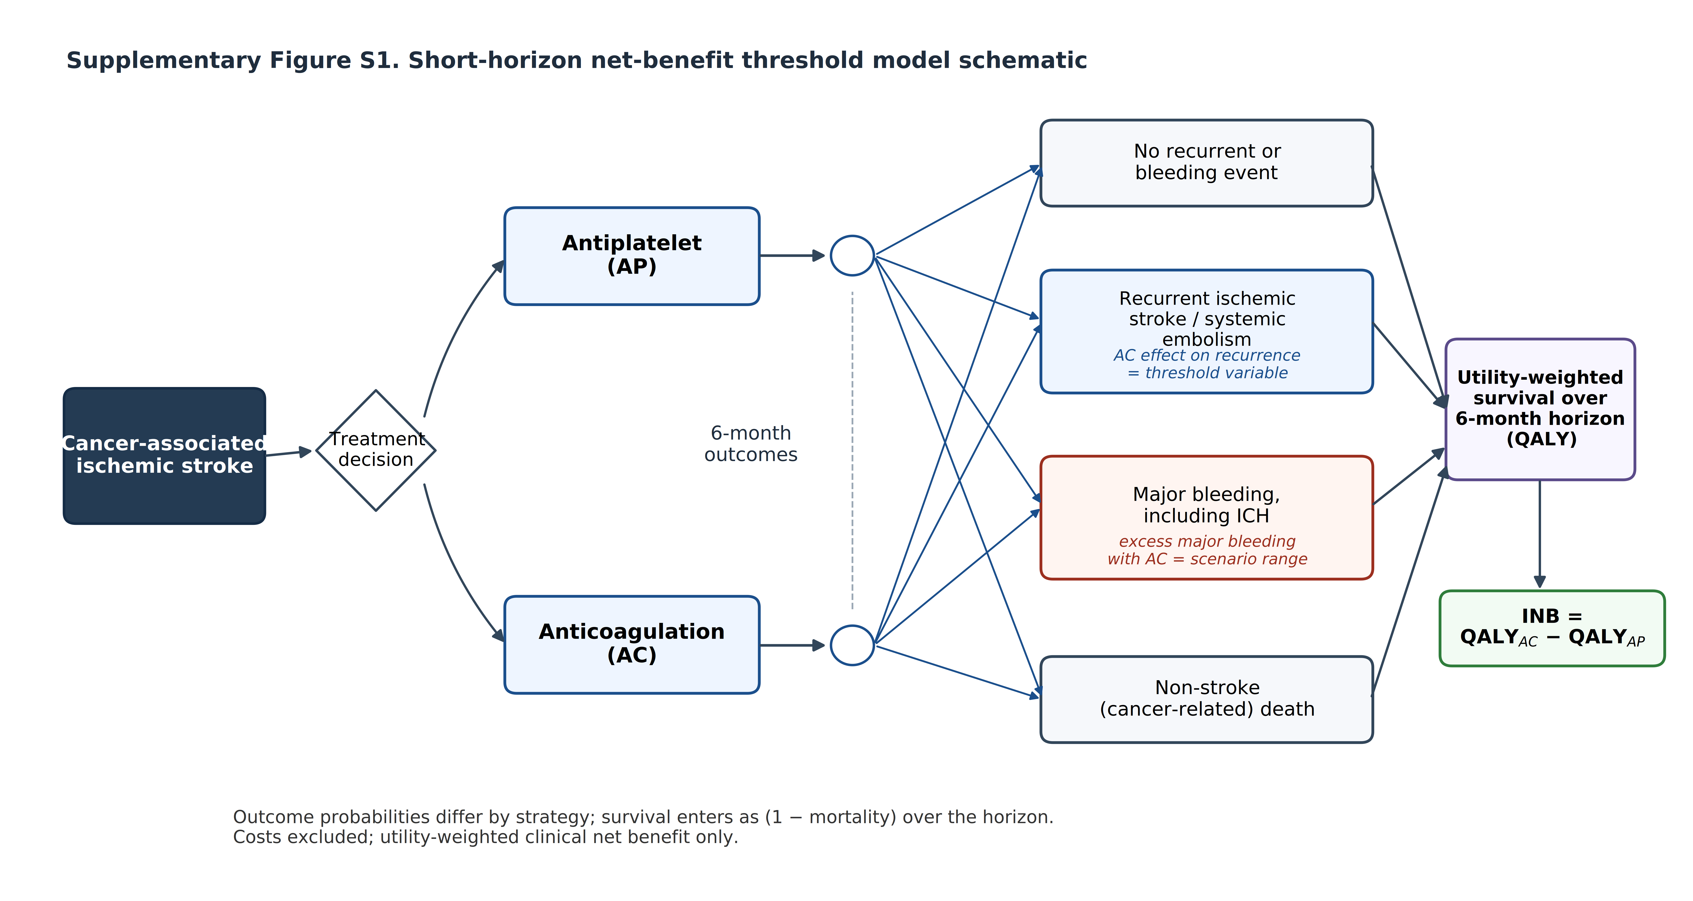
Supplementary Figure S1. Schematic of the short-horizon net-benefit threshold model. The decision is between antiplatelet therapy and anticoagulation in a patient with cancer-associated ischemic stroke. From each strategy, four mutually exclusive 6-month outcomes are modelled — no recurrent or bleeding event, recurrent ischemic stroke or systemic embolism, major bleeding including intracranial hemorrhage, and non-stroke (cancer-related) death — each weighted by modified Rankin Scale–based utilities to yield utility-weighted survival (QALY) over the horizon, from which the incremental net benefit (INB = QALY_AC − QALY_AP) is derived. Outcome probabilities differ by strategy: the anticoagulation effect on recurrence is treated as a threshold variable and the excess major bleeding with anticoagulation as a scenario range. Survival enters as (1 − mortality) over the horizon, and costs are excluded. This is a short-horizon decision structure, not a state-transition (Markov) or cost-effectiveness model.
Supplementary Table S2. Targeted extraction of randomized head-to-head estimates of recurrent stroke (anticoagulation versus antiplatelet) in cancer-relevant populations, with classification for use in the model. All values were verified against the cited source; non-extractable values are flagged rather than imputed, and no hazard ratio or confidence interval was invented.
Source | Design | Population | Comparison | Recurrence estimate (AC vs AP) | Bleeding (as reported) | Use in model
NAVIGATE-ESUS cancer subgroup ⁶ | RCT, pre-specified subgroup | ESUS with cancer (n = 543; mostly cancer history, ~9% active); follow-up ~11 mo | Rivaroxaban 15 mg vs aspirin 100 mg | HR 1.43 (95% CI 0.71–2.87); 7.7% vs 5.4% | Major bleeding nonsignificantly higher with rivaroxaban | Evidence-informed skeptical prior; primary break-even marker
Main ARCADIA trial ¹¹ | RCT | Cryptogenic stroke with atrial cardiopathy (n = 1015; not cancer-specific); follow-up 1.8 y | Apixaban (5/2.5 mg) vs aspirin 81 mg | HR 1.00 (95% CI 0.64–1.55); ~4.4%/y both arms | Symptomatic ICH 0 vs 7; other major hemorrhage HR 1.02 (0.29–3.52) | Evidence-informed neutral prior; context break-even marker
ARCADIA cancer-history subgroup ⁷ | RCT, post hoc subgroup | Cryptogenic + atrial cardiopathy + cancer history (n = 137) | Apixaban vs aspirin | Crude ≈ 0.69 (5 [8.2%] vs 9 [11.8%]); no formal HR; underpowered | Major hemorrhage 1 (1.6%) vs 2 (2.6%) | Exploratory only (no interval); overlay annotation, not a prior
Pipek network meta-analysis ⁴ | Systematic review + network meta-analysis | Cancer-associated stroke (11 studies; n = 1319) | Network vs no treatment | Antiplatelet RR 0.44 (0.20–0.96) and LMWH RR 0.50 (0.26–0.96) vs no treatment; antiplatelet ranked highest (primary analysis); no extractable AC-vs-AP pairwise estimate | No difference in major bleeding or mortality | Ranking/directional anchor only
TEACH pilot ⁵ | Pilot feasibility RCT | Active cancer + ischemic stroke (n = 20) | Enoxaparin vs aspirin | Not usable (feasibility; 60% crossover) | Major bleeding 1 vs 3; no ICH | Not usable for effect; feasibility footnote

Break-even positioning. At the base-case 2% excess major-bleeding assumption the break-even relative risk was 0.825. The two formally estimable contrasts lay at or above this threshold (main ARCADIA 1.00; NAVIGATE-ESUS cancer 1.43); the only estimate below it (ARCADIA cancer-history crude ≈ 0.69) lacked a formal interval and was underpowered, and all estimable intervals crossed both the break-even and the null. The indirect ratio derivable from the Pipek versus-no-treatment estimates (0.50/0.44 ≈ 1.14) has no valid confidence interval and was therefore not used as a prior or plotted as a point estimate. Hazard ratios were used as recurrence relative-effect priors on the log scale, treated as part of the indirectness of the evidence rather than as a direct pooled relative-risk estimate.
Supplementary Table S3. Deterministic break-even recurrence relative risk across bleeding-harm assumptions. Each value is the recurrence relative risk at which incremental net benefit equals zero (the break-even), computed from the locked deterministic formula break-even relative risk = 1 − (excess major bleeding × W) / (baseline recurrence × recurrence disutility), with baseline recurrence 0.08 and recurrence disutility 0.20 held at base case. Anticoagulation is net-beneficial below the tabulated relative risk and antiplatelet therapy at or above it. This table expresses Figure 1 numerically and introduces no new evidence.
Excess major bleeding with AC | Break-even RR (low-harm, W = 0.047) | Break-even RR (base-case, W = 0.140) | Break-even RR (high-harm, W = 0.325)
0% | 1.000 | 1.000 | 1.000
1% | 0.971 | 0.912 | 0.797
2% | 0.941 | 0.825 | 0.594
4% | 0.883 | 0.650 | 0.188
8% | 0.765 | 0.300 | — (AC not net-beneficial at any modelled RR)

W = (1 − ICH fraction) × major-bleeding disutility + ICH fraction × ICH disutility. Low-harm: ICH fraction 0.15, disutilities 0.02/0.20. Base-case: ICH fraction 0.30, disutilities 0.05/0.35 (W = 0.14). High-harm: ICH fraction 0.50, disutilities 0.10/0.55. The base-case column reproduces the manuscript break-even (0.825 at 2% excess bleeding). A dash indicates that anticoagulation cannot reach net benefit within the modelled recurrence range.

Reproducible model code
- cancer_stroke_netbenefit_model.py — net-benefit threshold model (deterministic checks, two-way threshold surface, legacy PSA N = 10,000, seed 20260613).
- cancer_stroke_netbenefit_model_evidence.py — evidence-informed PSA under the three recurrence-effect priors (legacy broad; ARCADIA-informed neutral; NAVIGATE-cancer-informed skeptical), reproducing P(AC favored) = 0.44 / 0.12 / 0.04 (seed 20260613).
- make_evidence_figures.py — generates Figure 2 (three-prior PSA) and Figure 3 (break-even overlay) from the locked model arrays and the verified extracted estimates.
- make_supp_S1_S3.py — computes the Supplementary Table S3 break-even grid from the locked deterministic formula (the Supplementary Figure S1 schematic is provided as a vector SVG with a 600-dpi TIFF export).
All reported figures and probabilistic results are reproducible by running the model scripts with the stated seed (20260613).

