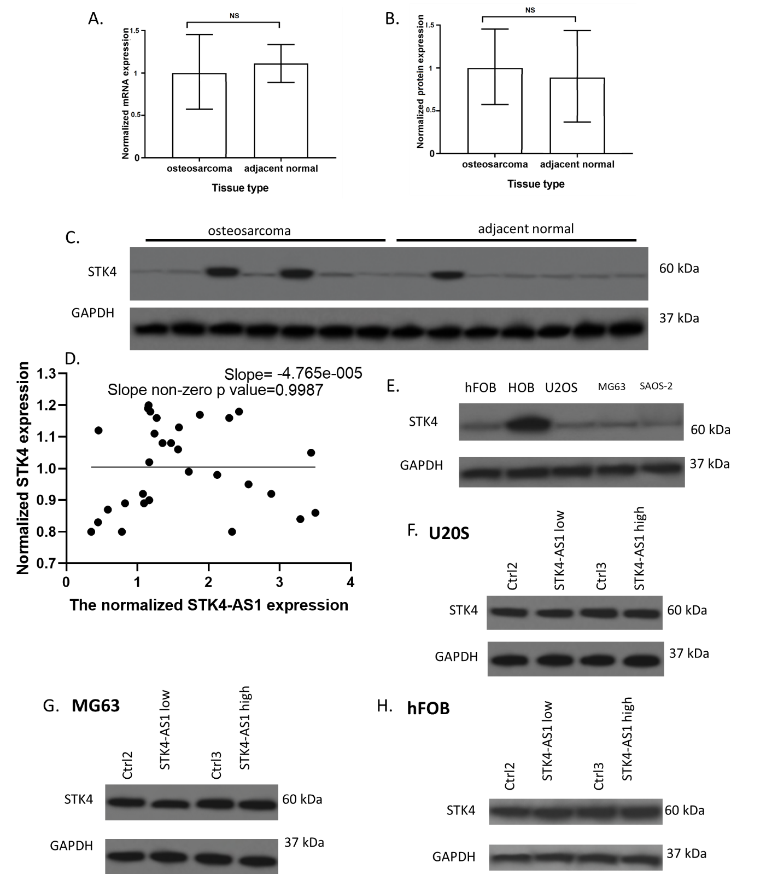
S-Figure 1. levels of STK4. A. mRNA expression of STK4. B. protein expression of STK4. C. Representative images of western blotting assay of tissues. D. Correlation between STK4-AS1 and STK4 expression in osteosarcoma tissues. E. expression of STK4 in human osteosarcoma and osteoblast cells. F-H. Effects of STK4-AS1 overexpression and knockdown on STK4 expression in U2OS, MG63, and hFOB cells.

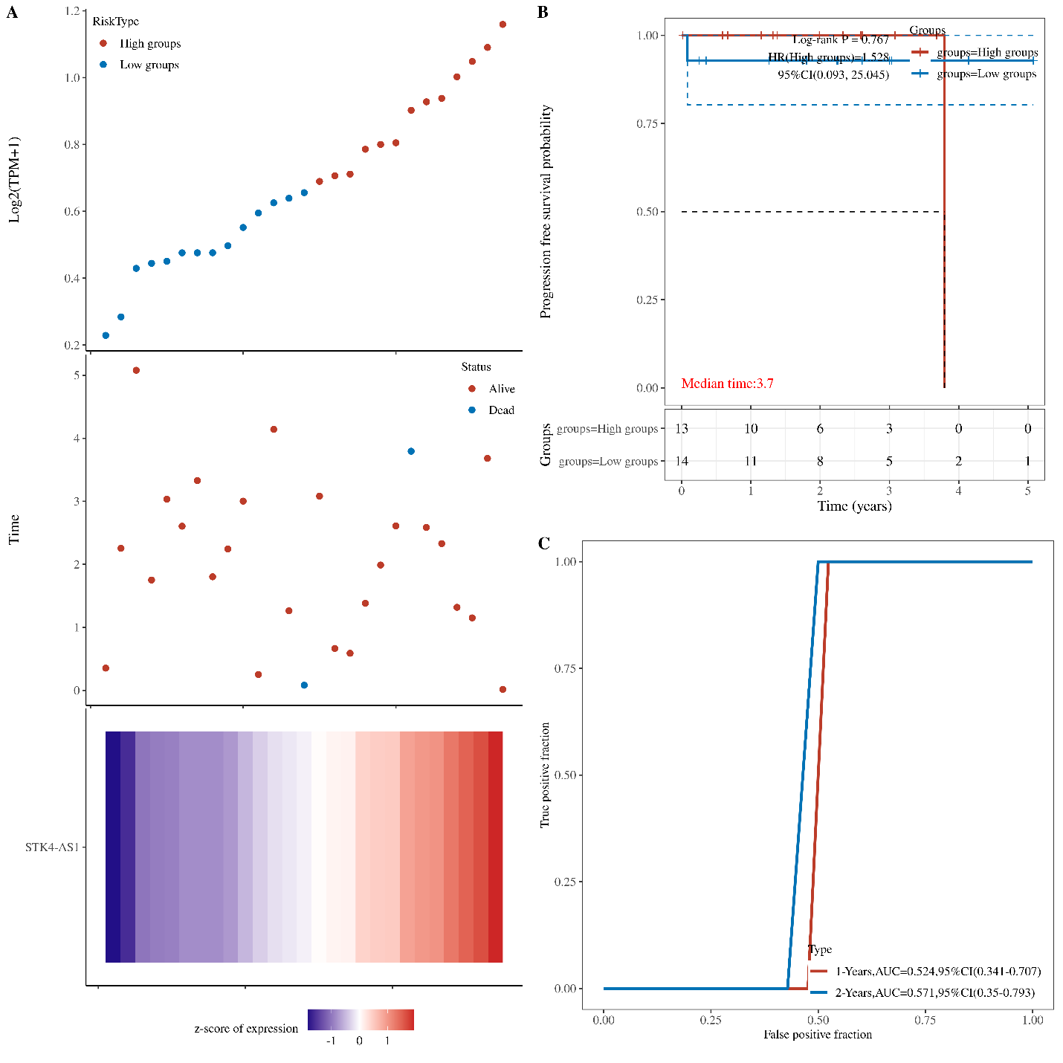
S-Figure 2. The association of STK4-AS1 and patient survival. The dotted line represented the median risk score and divided the patients into low-risk and high-risk group. A. The curve of risk score. Survival status of the patients. More dead patients corresponding to the higher risk score. Heatmap of the expression profiles of the five prognostic genes in low- and high-risk group. B. Kaplan-Meier survival analysis of the five-gene signature. C. Time-dependent ROC (receiver operating characteristic) analysis the of the STK4-AS1.

