Supplementary data
Fig. S1 Diagram (A) showed areas and locations of the control and the treatment groups on the paraspinal region of the dorsum of a pig. The small white dots in the diagram demonstrated the injection sites. Figure (B) demonstrated the gross finding of skin after intradermal injection of BTX-A.
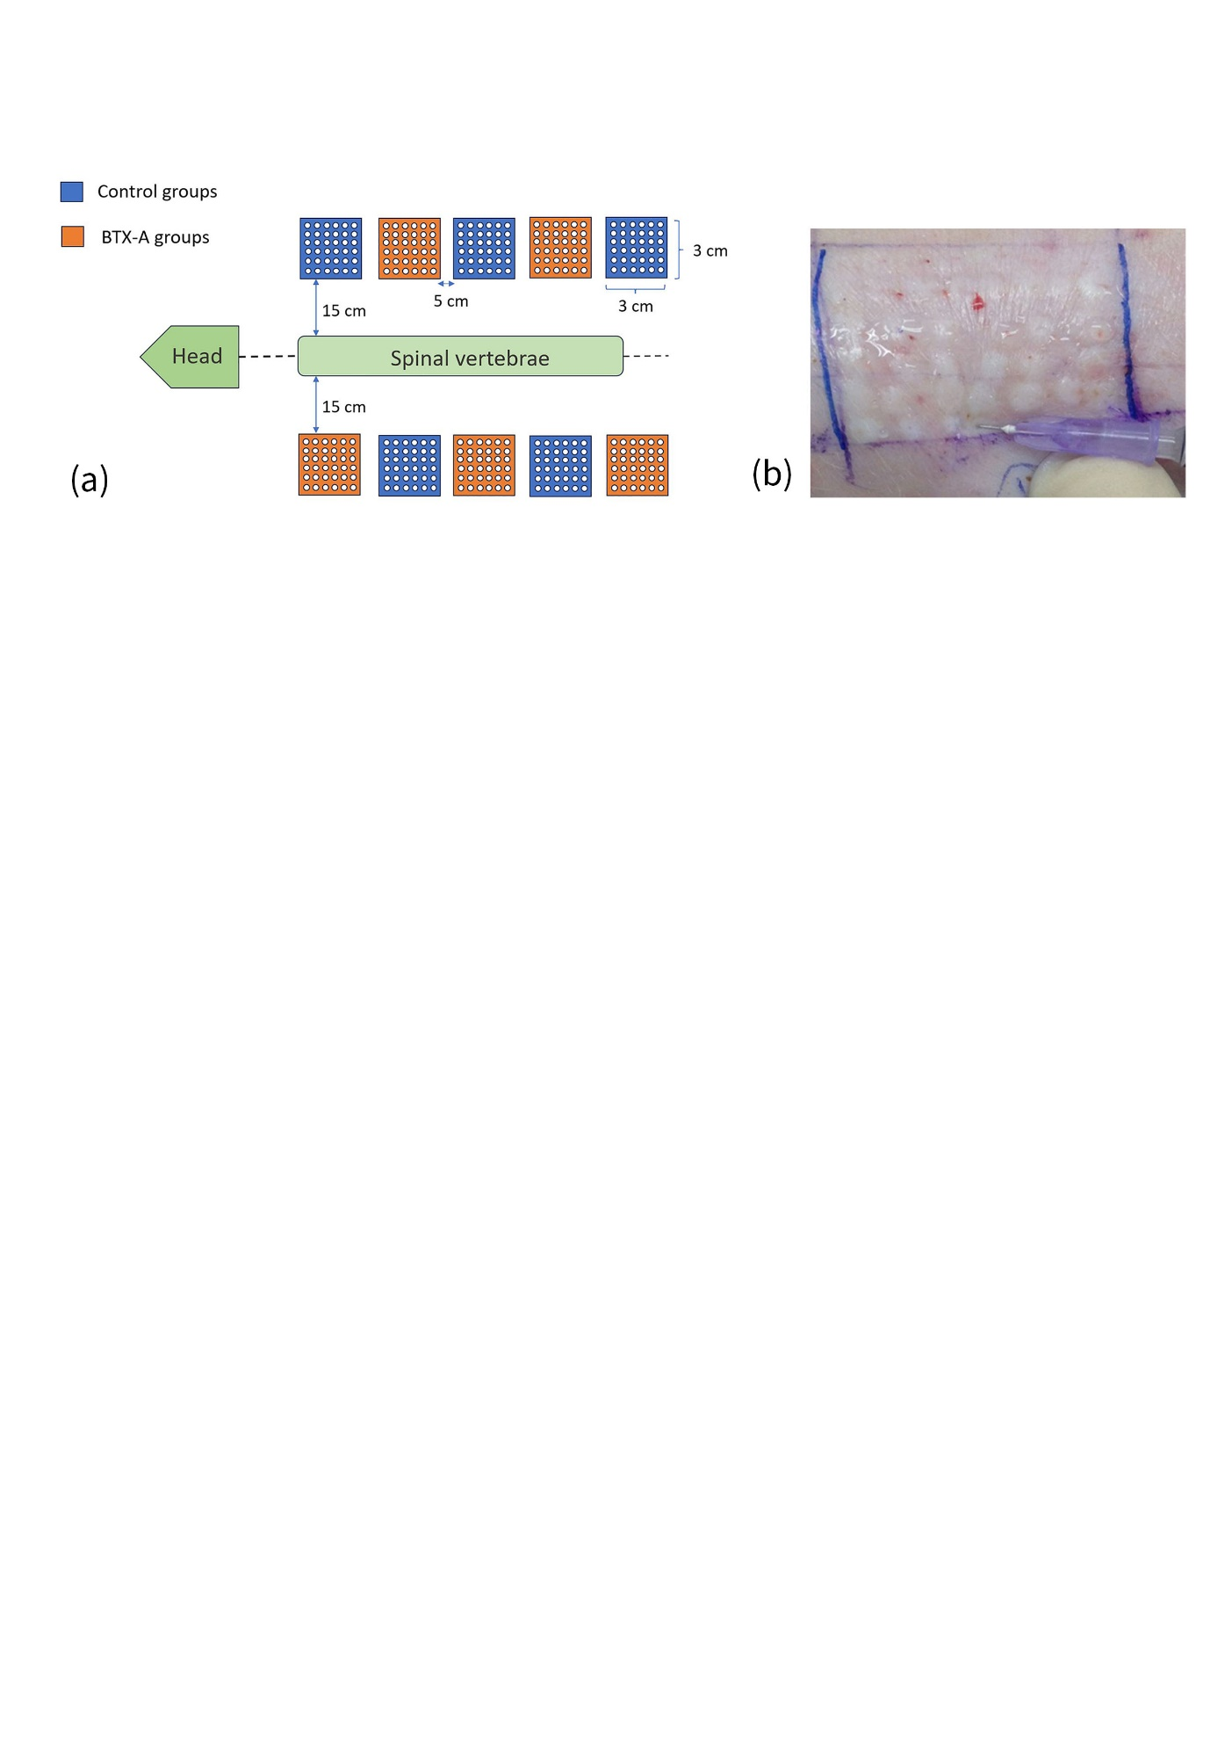
Fig. S 1

