Development and Validation of a Sensitive LC-MS/MS Method for Quantifying N-Nitroso-Ketamine in Ketamine Hydrochloride Injections
Ramamohana Reddy Maddike^{1*}, K. Suresh Babu²
*¹Faculty of Sciences, Lincoln University College, Petaling Jaya 47301, Selangor Darul Ehsan, Malaysia, - 0009-0001-4009-3008
²Faculty of Sciences, Lincoln University College, Petaling Jaya 47301, Selangor Darul Ehsan, Malaysia
* Corresponding Author: phd.ramamohana@lincoln.edu.my

Index of Figures
Figure S1 Molecular structure of Ketamine Hydrochloride and N-Nitroso- Ketamine impurity in the study
Figure S2 Potential Reaction Mechanism for the formation of NDSRI of Ketamine
Figure S3 DNA Alkylation Mechanistic Pathway of Nitrosamine-Induced and Damage
Figure S4 Comparative chromatographic profiles of standard solution across different columns
Figure S5 Certificate of N-Nitroso- Ketamine
Figure S6 Certificate of Ketamine Hydrochloride

Ketamine Hydrochloride  IUPAC name: 2-(2-chlorophenyl)-2-(methylamino)cyclohexan-1-one;hydrochloride  Molecular Mass: 274.18 g/mol  Molecular formula: C₁₃H₁₇Cl₂NO | N-Nitroso- Ketamine (NNK)  IUPAC name: N-[1-(2-chlorophenyl)-2-oxocyclohexyl]-N-methylnitrous amide  Molecular Mass: 266.72 g/mol  Molecular formula: C₁₃H₁₅ClN₂O₂
Figure S1 Molecular structure of Ketamine Hydrochloride and N-Nitroso- Ketamine impurity in the study

Figure S2 | Potential Reaction Mechanism for the formation of NDSRI of Ketamine

Figure S3 | DNA Alkylation Mechanistic Pathway of Nitrosamine-Induced Damage

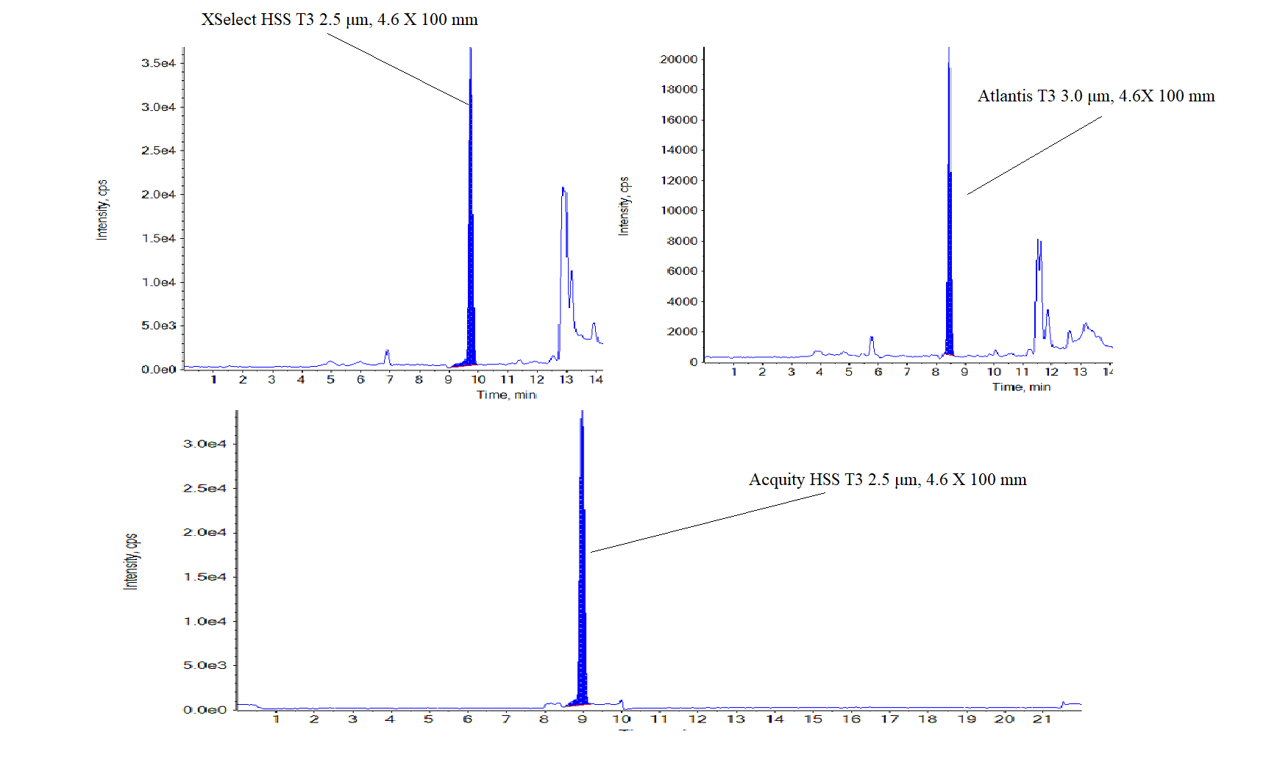Figure S4 | Comparative chromatographic profiles of standard solution across different columns
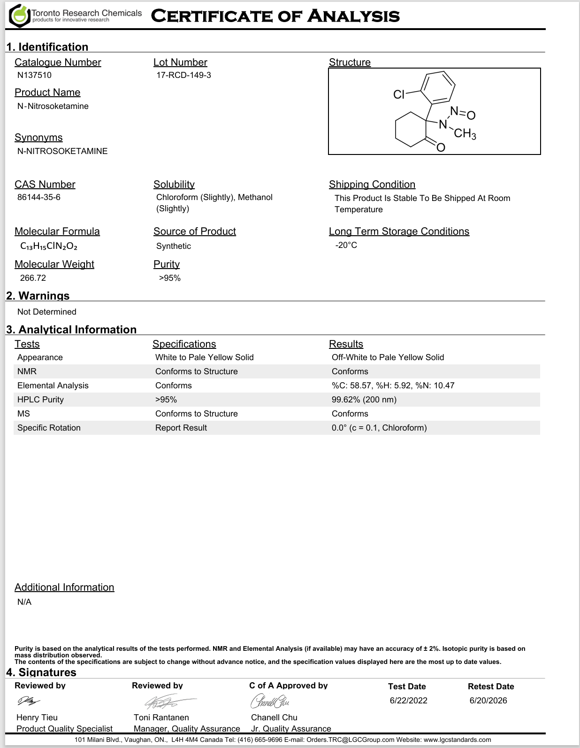

Figure S5 | Certificate of N-Nitroso- Ketamine

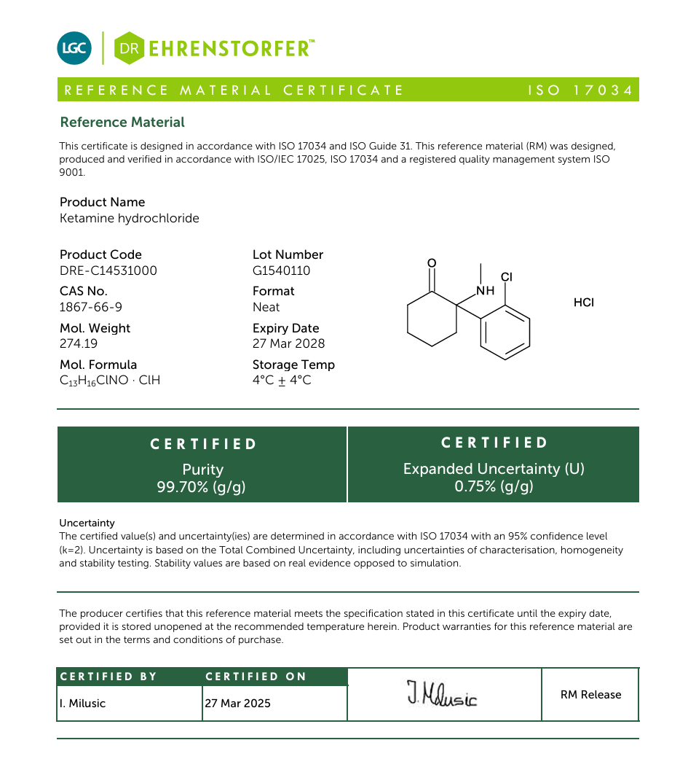
Figure S6 | Certificate of Ketamine Hydrochloride

