Supplementary material

Supplementary Table S1. Profile distribution by ELSA wave.
Wave | Profile-defined person-waves | Unmet need | Active satisfied | Low/no stated demand | Active high demand
2 | 7531 | 31.0% | 26.1% | 21.6% | 21.3%
3 | 7292 | 32.0% | 24.4% | 17.7% | 25.9%
4 | 8716 | 29.8% | 28.2% | 18.8% | 23.2%
5 | 8379 | 28.7% | 30.0% | 20.8% | 20.5%
6 | 8567 | 28.7% | 30.0% | 20.2% | 21.1%
7 | 7442 | 28.3% | 30.5% | 18.2% | 23.1%
8 | 6596 | 26.6% | 32.7% | 17.2% | 23.6%
Percentages are based on profile-defined person-waves.

Supplementary Table S2. Adjusted predictors of unmet cultural need.
Predictor | Adjusted difference, pp (95% CI) | P
Age, per year | -0.27 (-0.34, -0.21) | <.001
Female | 4.54 (3.37, 5.71) | <.001
Education, per year | -1.03 (-1.42, -0.64) | <.001
Middle wealth tertile vs highest | 5.84 (4.60, 7.09) | <.001
Lowest wealth tertile vs highest | 10.70 (9.18, 12.22) | <.001
IADL difficulties, per item | 2.40 (1.59, 3.20) | <.001
ADL difficulties, per item | 3.18 (2.39, 3.96) | <.001
Living alone | -1.25 (-2.70, 0.20) | 0.092
Estimates are adjusted percentage-point differences from modified Poisson regression with participant-clustered robust standard errors; estimates are associational.

Supplementary Table S3. Strict-definition sensitivity analyses.
Definition | Lagged CES-D beta (95% CI) | P
strict A: global_low & want_more | 0.259 (0.211, 0.307) | <.001
strict B: unmet count >= 2 | 0.243 (0.190, 0.295) | <.001
strict C: among low participants, want more vs not | 0.195 (0.158, 0.231) | <.001
Lagged CES-D estimates under alternative unmet-need definitions.

Supplementary Table S4. Secondary fixed-effects outcomes.
Outcome | Profile contrast vs active satisfied | Estimate (95% CI) | P
Life satisfaction | Unmet cultural need | -0.227 (-0.254, -0.200) | <.001
Life satisfaction | Low/no stated demand | -0.088 (-0.119, -0.056) | <.001
Life satisfaction | Active high demand | -0.123 (-0.147, -0.099) | <.001
CASP-19 quality of life | Unmet cultural need | -1.861 (-2.024, -1.698) | <.001
CASP-19 quality of life | Low/no stated demand | -0.966 (-1.171, -0.761) | <.001
CASP-19 quality of life | Active high demand | -1.054 (-1.200, -0.908) | <.001
Negative estimates for life satisfaction and CASP-19 indicate lower wellbeing.

Supplementary Table S5. Inverse-probability response weight diagnostics.
Weight set | N | Mean | SD | Min | P1 | Median | P99 | Max | ESS | Extreme >10
raw (truncated 0.05 floor) | 67,965 | 1.316 | 0.4 | 1.069 | 1.098 | 1.226 | 3.048 | 9.072 | 62206 | 0
stabilized (marg/p) | 67,965 | 1.036 | 0.315 | 0.842 | 0.864 | 0.966 | 2.4 | 7.144 | 62206 | 0
stabilized + 1%/99% truncation | 67,965 | 1.025 | 0.217 | 0.864 | 0.864 | 0.966 | 2.4 | 2.4 | 65056 | 0
ESS = effective sample size. The IPRW model was fitted among person-waves eligible for profile-definition modelling with non-missing covariates used in the response model. The N differs from the profile-defined analytic sample because both profile-defined and non-profile-defined observations contributed to estimating the probability of having a defined preference–participation profile, while observations with missing response-model covariates were excluded.

Supplementary Table S6. IPRW lagged CES-D estimates.
Term | IPRW beta (95% CI) | P
unmet cultural need | 0.285 (0.242, 0.327) | <.001
low no stated demand | 0.105 (0.057, 0.154) | <.001
active high demand | 0.180 (0.139, 0.221) | <.001
Weights use stabilized and 1%/99% truncated weights.

Supplementary Table S7. Global low-participation by desire-for-more decomposition.
Model | Term | Estimate (95% CI) | P
CES-D | Low participation, main effect | 0.075 (0.034, 0.117) | <.001
CES-D | Desire for more participation, main effect | 0.189 (0.137, 0.241) | <.001
CES-D | Low participation × desire for more participation | 0.010 (-0.051, 0.072) | 0.742
incident depression | Low participation, main effect | 0.003 (-0.004, 0.010) | 0.374
incident depression | Desire for more participation, main effect | 0.017 (0.009, 0.026) | <.001
incident depression | Low participation × desire for more participation | 0.008 (-0.003, 0.019) | 0.148
This broader decomposition is not identical to the primary same-domain unmet-need definition.

Supplementary Table S8. Exploratory interaction tests.
Subgroup | Joint F | Joint P
Sex | 0.74 | 0.530
Wealth tertile | 5.31 | <.001
Walking difficulty | 2.91 | 0.033
Living alone | 6.60 | <.001
Age group | 0.74 | 0.618
Interaction analyses are exploratory and interpreted cautiously.

Supplementary Table S9. Profile-defined versus unclassifiable observations.
Group | N | Mean age | Mean CES-D | Median wealth | Female, % | Walking difficulty, % | Living alone, % | CES-D ≥4, %
Profile-defined | 54,523 | 65.7 | 1.35 | 245,000 | 55.8% | 10.5% | 21.9% | 12.9%
Unclassifiable | 14,716 | 68.6 | 1.93 | 177,500 | 55.1% | 22.2% | 30.1% | 21.5%
Values describe pooled person-waves.

Supplementary Table S10. Profile transitions and CES-D change.
Transition model term | CES-D change beta (95% CI) | P
Entering unmet | 0.544 (0.490, 0.598) | <.001
Persistent unmet | 0.617 (0.565, 0.669) | <.001
Exiting unmet | 0.286 (0.231, 0.340) | <.001
Persistent low/no demand | 0.363 (0.308, 0.417) | <.001
Other | 0.206 (0.173, 0.240) | <.001
Reference group: persistent active satisfaction. Transition analyses are supportive and should not be interpreted as causal recovery or deterioration. Positive estimates for exiting unmet need indicate that this transition was still associated with higher CES-D change relative to persistent active satisfaction and should not be interpreted as recovery.

Supplementary figures
Supplementary Fig S1. Conceptual model of preference–participation mismatch. The diagram summarises the conceptual distinction between realised participation, stated desire for more participation, possible constraints, and later-life wellbeing outcomes.
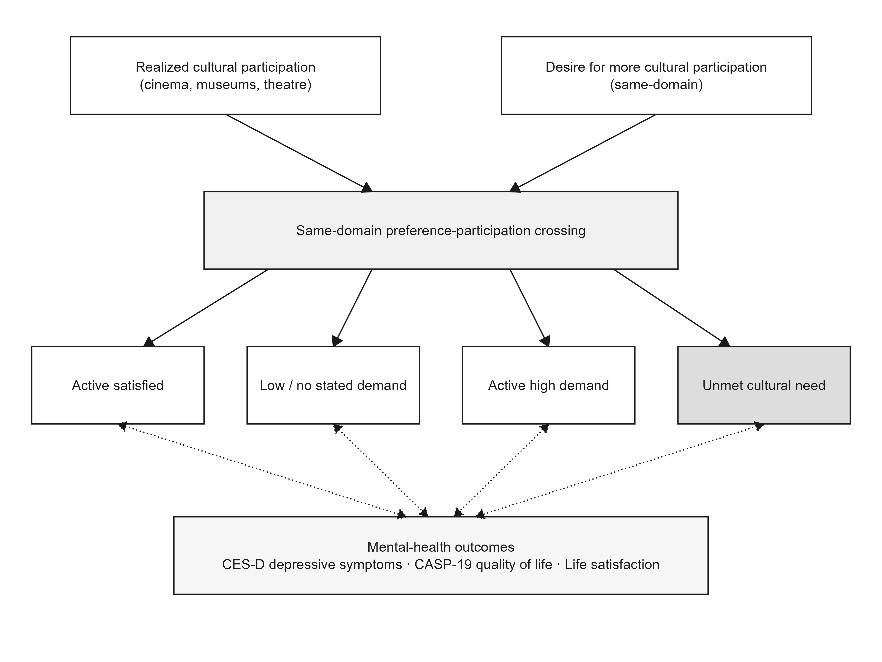
Supplementary Fig S2. Adjusted predictors of unmet cultural need. The figure displays adjusted percentage-point differences for selected demographic, socioeconomic, and functional predictors.
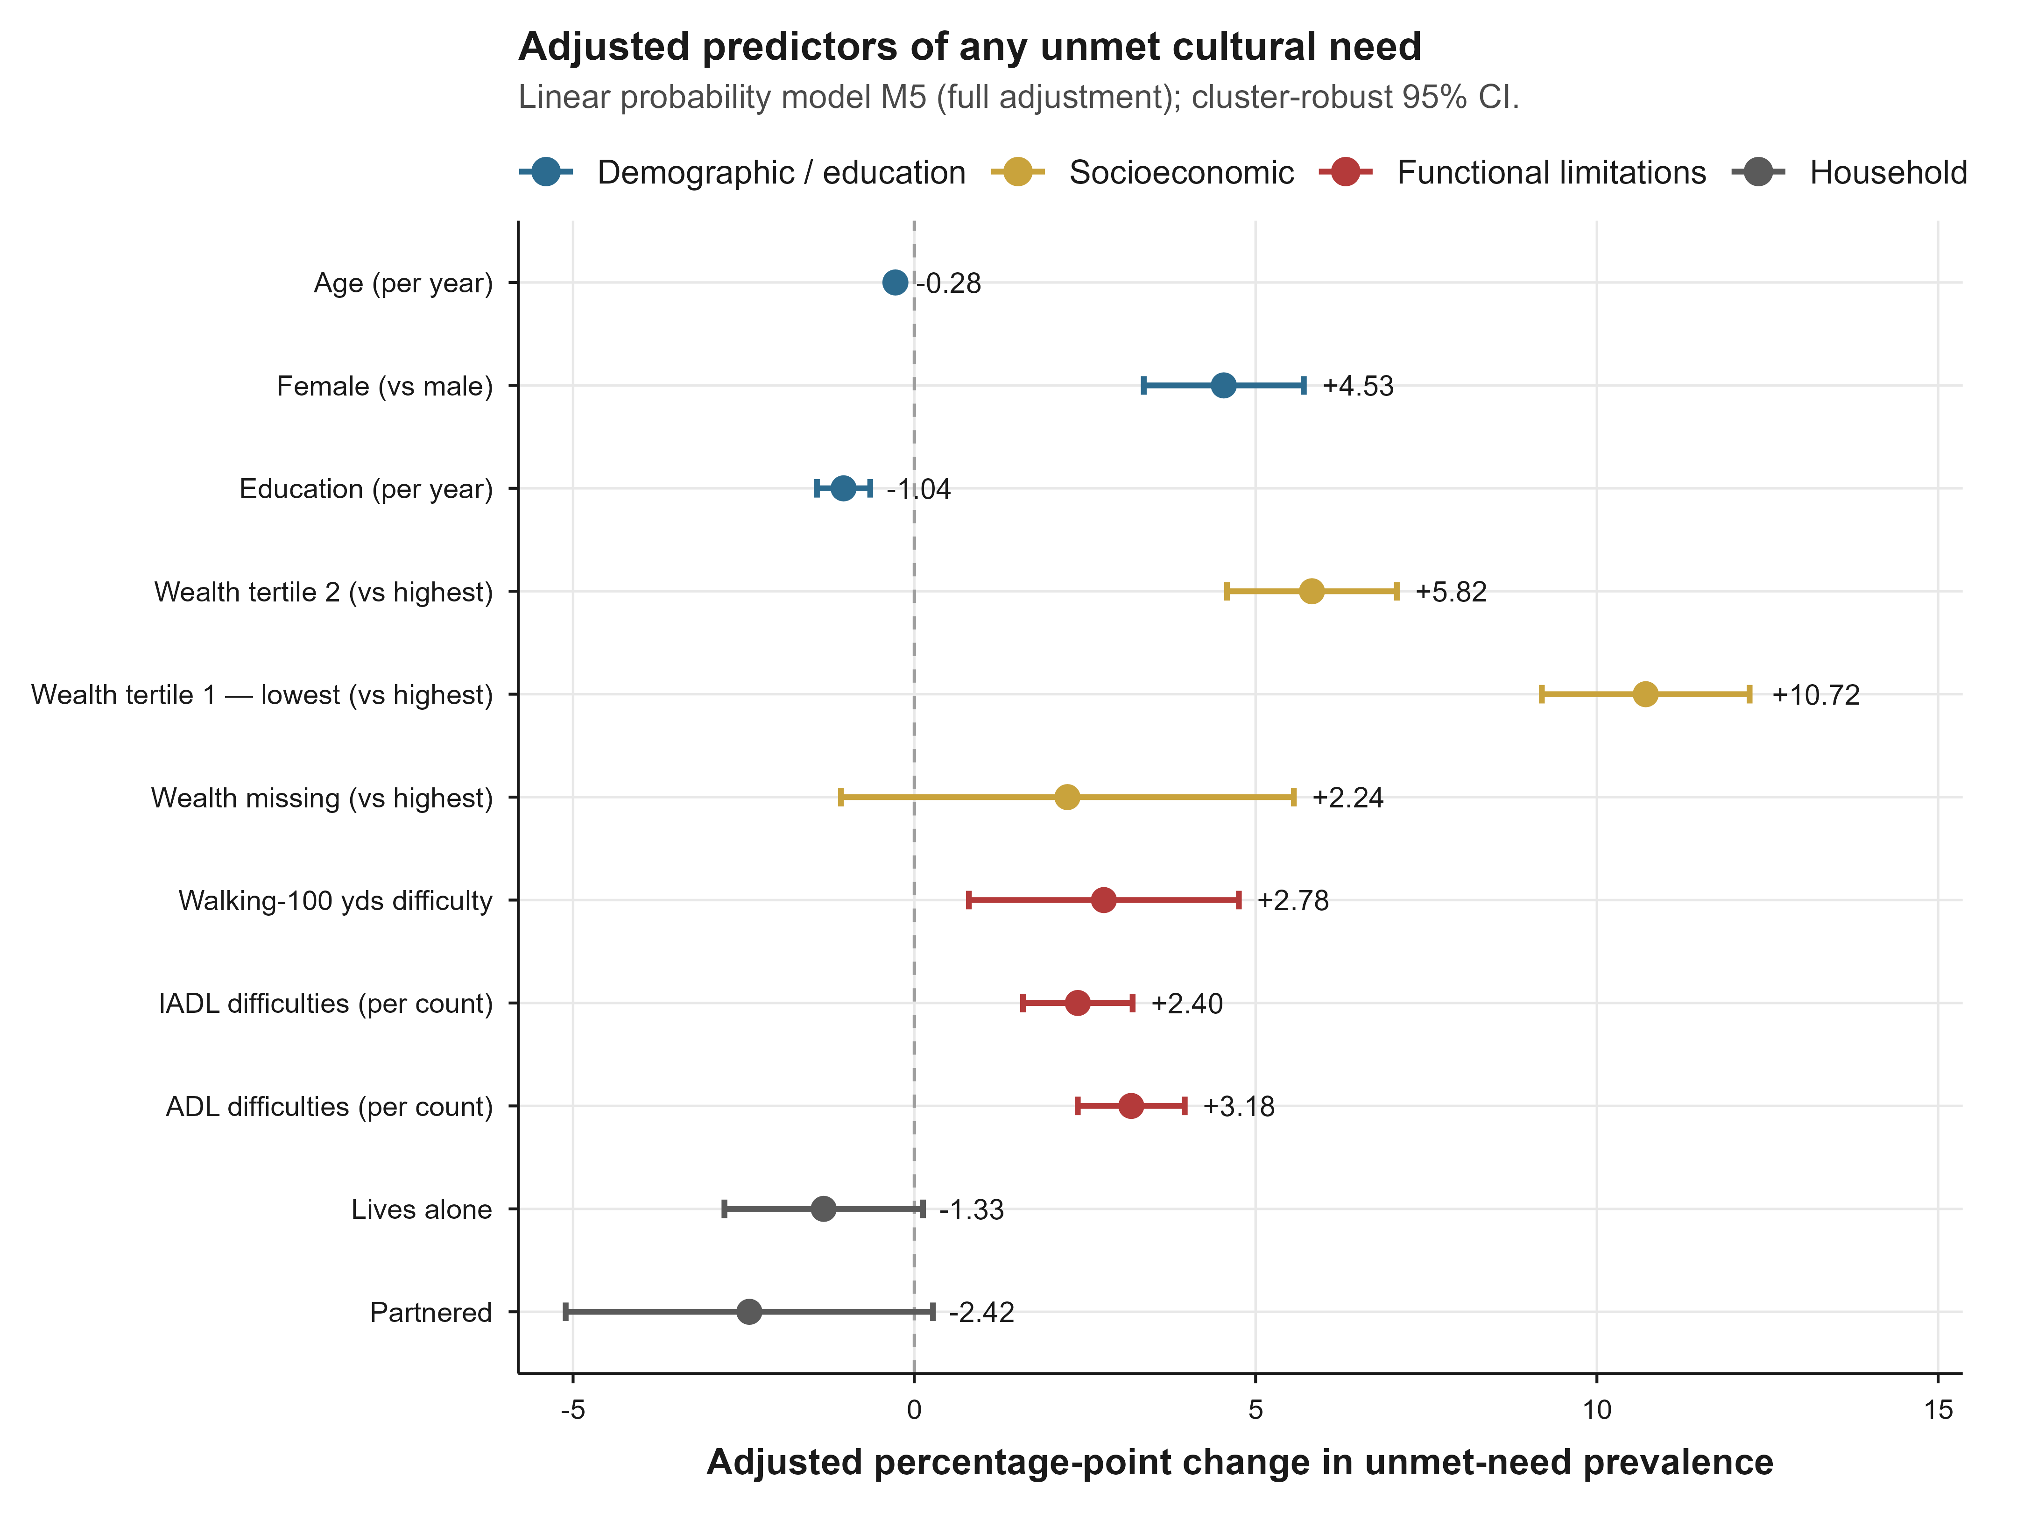
Supplementary Fig S3. Global low-participation by desire-for-more decomposition. The figure shows main effects and interaction terms for broad low participation and desire-for-more indicators in CES-D and incident-depression models.
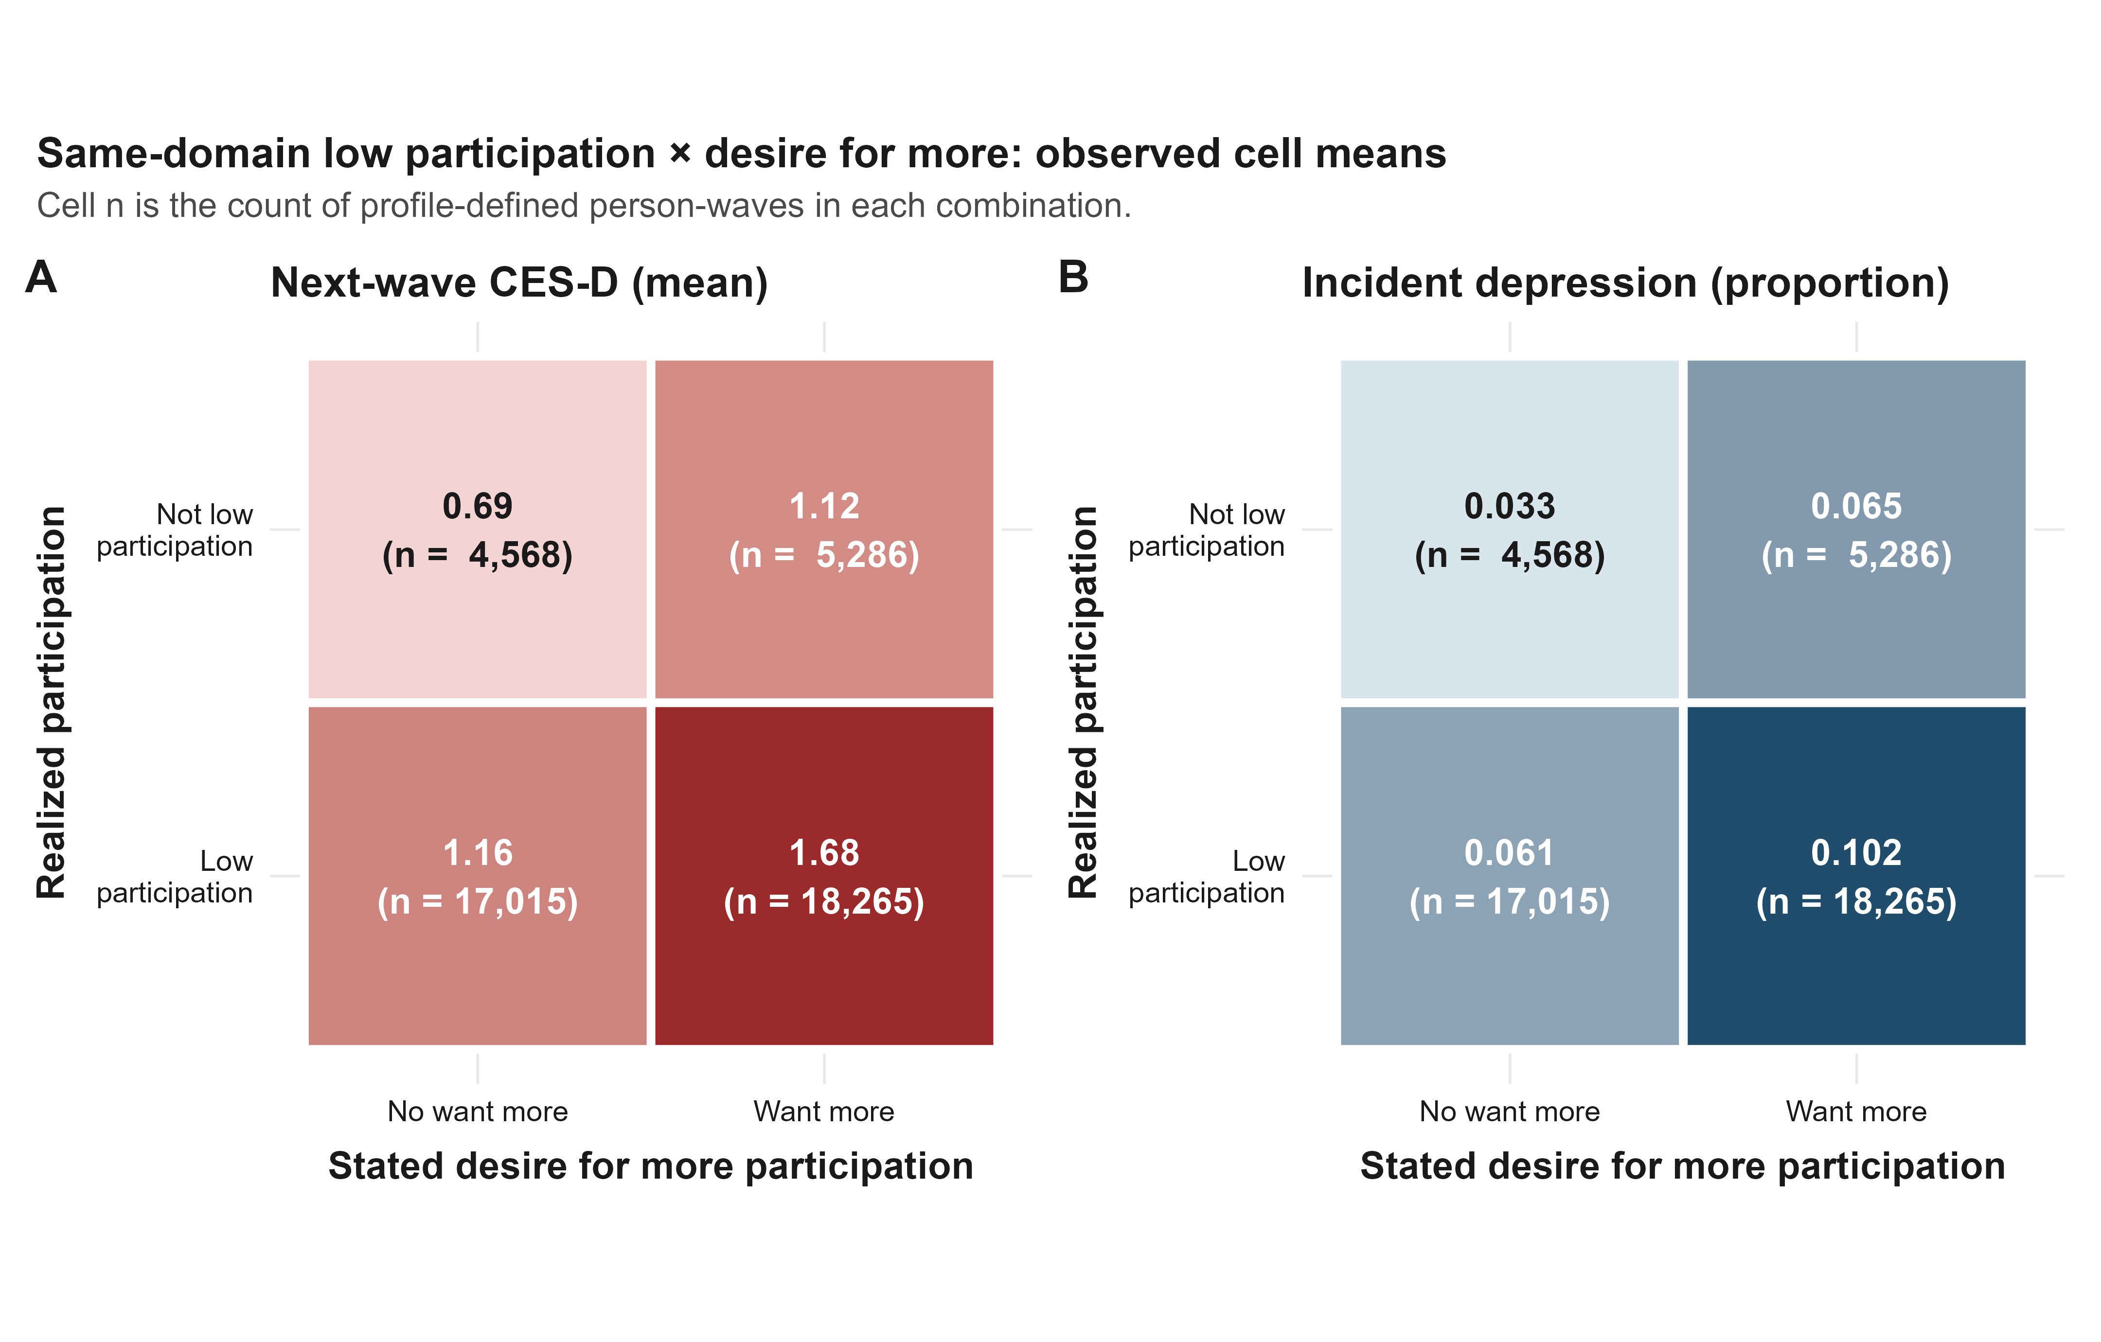
Supplementary Fig S4. Exploratory effect-modification tests. Joint F statistics summarise interaction tests across selected subgroups.
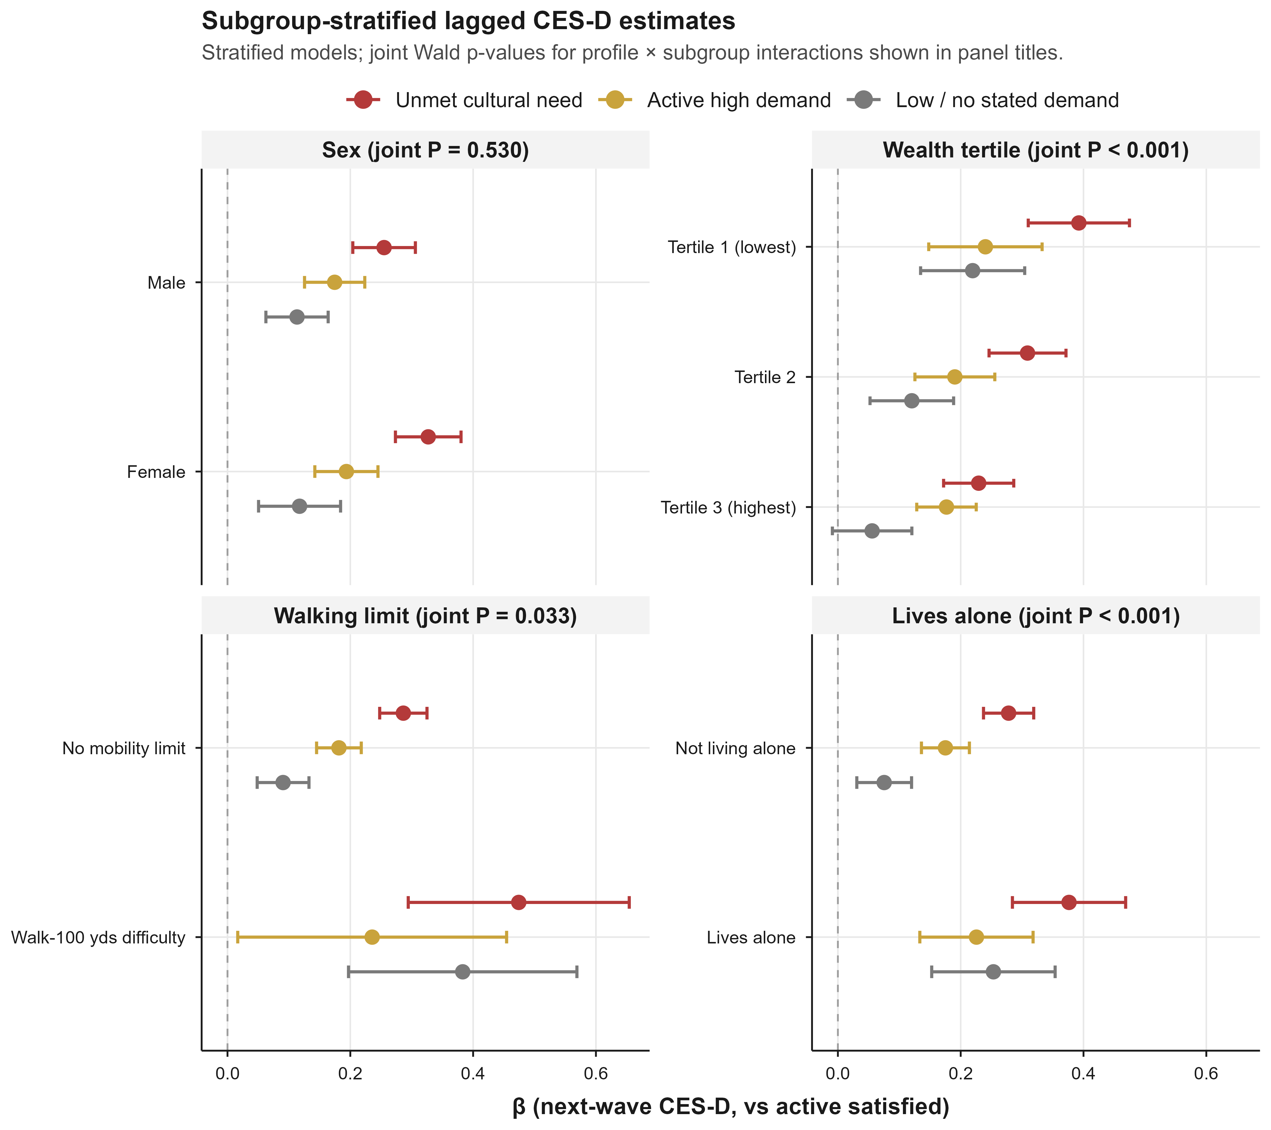

Supplementary Fig S5. Profile transitions and change in depressive symptoms. Estimates represent between-wave changes in CES-D associated with transition patterns, relative to persistent active satisfaction.
