Supplementary Materials
Academic-Media Multitasking During Schoolwork and Digital Performance: Cross-National Evidence on Associations from ICILS 2023
Supplementary Table S1
Weighted Pearson Intercorrelation Matrix of Study Variables
Variable | 1 | 2 | 3 | 4 | 5 | 6 | 7 | 8 | 9 | 10 | 11 | M | SD
1. S_ACMULT | — |  |  |  |  |  |  |  |  |  |  | 50.7 | 10.4
2. CIL | .02*** | — |  |  |  |  |  |  |  |  |  | 481.7 | 101.0
3. CT | -.15*** | .76*** | — |  |  |  |  |  |  |  |  | 477.2 | 118.9
4. Computer experience | .15*** | .20*** | .10*** | — |  |  |  |  |  |  |  | 2.5 | 1.3
5. Safe-ICT instruction | .06*** | .06*** | .03*** | .04*** | — |  |  |  |  |  |  | 50.6 | 10.0
6. A. Text chat | .72*** | .10*** | -.07*** | .12*** | .03*** | — |  |  |  |  |  | 3.9 | 1.2
7. B. Social media use/post | .74*** | -.02*** | -.18*** | .09*** | .02*** | .60*** | — |  |  |  |  | 3.7 | 1.4
8. C. Check social media | .77*** | -.09*** | -.22*** | .07*** | .03*** | .54*** | .68*** | — |  |  |  | 3.3 | 1.4
9. D. Internet for info | .66*** | .03*** | -.05*** | .10*** | .08*** | .42*** | .38*** | .40*** | — |  |  | 3.8 | 1.1
10. E. Watch videos/streams | .67*** | .05*** | -.06*** | .13*** | .04*** | .46*** | .46*** | .42*** | .47*** | — |  | 3.9 | 1.2
11. F. Listen to music/radio | .59*** | .11*** | -.02*** | .12*** | .05*** | .42*** | .37*** | .34*** | .35*** | .42*** | — | 4.1 | 1.2
Note. Entries are weighted Pearson correlations computed at the student level using ICILS 2023 total student weights (TOTWGTS). CIL and CT correlations were averaged across the five plausible values. Means and standard deviations for CIL and CT are reported as plausible-value averaged weighted estimates. Ns vary across variables and variable pairs because estimates were based on available non-missing observations with positive student weights; CT was assessed in 24 systems only. Variables 4 and 6-11 are ordered-response variables, so Pearson correlations should be interpreted as linear approximations. S_ACMULT and S_LRNSAFE are IRT-scaled Warm weighted likelihood estimates. Computer experience is a single ordinal item on years of computer use. Correlations with |r| >= 0.50 are shown in bold. Upper triangle is intentionally blank (matrix is symmetric). *p < .05, **p < .01, ***p < .001.

Supplementary Table S2

Comparison of included and excluded students on key background variables
Characteristic | Included sample | Excluded sample | Std. diff. | P value
CIL outcome (included n = 126,902; excluded n = 4,455)
Socioeconomic background | 0.02 (1.00) | -0.37 (1.03) | 0.297 | <0.001
Computer experience | 2.55 (1.25) | 2.25 (1.40) | 0.255 | <0.001
Safe-ICT instruction | 50.62 (9.96) | 45.98 (11.57) | 0.177 | <0.001
Female | 50.1% | 43.4% | 0.245 | <0.001
CT outcome (included n = 81,516; excluded n = 49,841)
Socioeconomic background | 0.02 (0.99) | -0.06 (1.02) | -0.000 | <0.001
Computer experience | 2.65 (1.20) | 2.15 (1.40) | 0.277 | <0.001
Safe-ICT instruction | 50.48 (9.94) | 50.86 (10.21) | -0.096 | <0.001
Female | 50.3% | 47.2% | 0.030 | <0.001
Note. Included students were those with non-missing S_ACMULT and the relevant outcome indicator, defined as PV1CIL for CIL analyses and PV1CT for CT analyses. Values are weighted mean (SD) for continuous variables and weighted percentage for female. Std. diff. = standardized difference. P values are approximate tests of included versus excluded students. Background variables were cleaned for user-defined missing values and implausible out-of-range codes before comparison.

Supplementary Methods S1. Item Wording, Coding, and Construct Specification
The ICILS 2023 academic-media multitasking items (IS3G21A–F) ask students: “When you do school-related activities outside of school, how often do you also do the following?” Response categories are: never or hardly ever, sometimes, often, always. The six items are:
IS3G21A: Send text messages to chat with others
IS3G21B: Use social media to view or post content
IS3G21C: Check social media for new posts or responses
IS3G21D: Use the internet to find information about things I am interested in
IS3G21E: Watch online videos, live streams, or television
IS3G21F: Listen to music, radio, or podcasts
The IEA-provided scale S_ACMULT is a six-item ordered-response scale calibrated using the Rasch partial credit model and reported as Warm weighted likelihood estimates (WLEs) on the ICILS international metric (M = 50, SD = 10). Cross-country measurement invariance was evaluated using root mean square deviation (RMSD) criteria and found satisfactory across participating systems (Fraillon et al., 2024).
For decomposition analyses, items were grouped as follows. The social multitasking composite was the standardised mean of items A, B, and C. The entertainment multitasking composite was the standardised mean of items E and F. Information-seeking was the standardised single item D. The off-task composite was the standardised mean of items A, B, C, E, and F (excluding the potentially task-relevant item D). All composites were standardized to z-scores for regression analyses with country fixed effects estimated on the pooled student-level data.

Supplementary Methods S2. TIMSS 2023 Measures and Analytic Strategy
TIMSS 2023 does not include any student-reported item directly measuring academic-media multitasking during homework. An exhaustive review of the complete TIMSS 2023 Grade 8 student background questionnaire codebook confirmed that no item captures social media use, entertainment media consumption, or task-switching behaviour during study time. We therefore adopted a three-pronged external corroboration approach.
Prong 1: Learning games frequency (BSBG12F). This item asks “How often do you use the internet to access learning games online?” using a three-point scale (1 = at least once a week; 2 = once or twice a month; 3 = never or almost never). It was reverse-coded so higher values indicate more frequent use and standardised to z-scores. Although the item specifies “learning games,” frequent online game access during study time plausibly indexes distraction-prone study behaviour.
Prong 2: Internet use for schoolwork composite (BSBG12A–F). A mean composite of six items capturing internet use for school purposes (accessing textbooks, assignments, collaborating, asking teachers, finding information, learning games). Items were reverse-coded, and the composite required at least 5/6 non-missing items (Cronbach’s α = .72 in the pooled sample; standardised to z-scores).
Prong 3: Teacher-reported distraction climate. Three teacher-reported items were aggregated to school-level means: BTBG13G (teaching limited by distracted students), BTBM18C (keeping students on task limits digital device use in mathematics), and BTBS21C (same for science). The composite was standardised and used as a cross-level moderator of the Prong 2 association.
All TIMSS models adjusted for digital self-efficacy (BSBGSEC), gender (ITSEX), and home educational resources (BSBGHER). Country-specific regressions used the JK2 paired jackknife variance procedure with five plausible values and Rubin’s rules, mirroring the ICILS strategy.

Supplementary Results S3. Exposure Decomposition Analyses
Table S3 and S4 present regression coefficients from country fixed-effects models estimated on the pooled student-level data. Table S3 reports the single-item models, whereas Table S4 reports the grouped-component and overall-scale models. For CT, most single-item exposures and all grouped-component measures were negatively associated, with checking social media (item C) showing the largest magnitude. For CIL, the pattern was mixed: social media indicators were negative, entertainment indicators were positive, and information-seeking was not significantly associated.
Table S3
Associations of Individual Multitasking Items with CIL and CT in Regression Models with Country Fixed Effects
Single-item model | β CIL | β CT
A. Text chat | 3.43*** | −8.49***
B. Social media use/post | −2.35** | −15.10***
C. Check social media | −8.71*** | −21.74***
D. Internet for information | 1.32 | −7.01***
E. Watch videos/streams | 2.12** | −5.99***
F. Listen to music/radio | 5.40*** | −2.07
Note. Coefficients are from separate regression models with country fixed effects estimated on the pooled student-level data, adjusting for socioeconomic background, computer experience, and gender. Each exposure was standardized to a z-score and entered one at a time. CIL = computer and information literacy. CT = computational thinking. *p < .05, **p < .01, ***p < .001.

Table S4
Associations of Grouped Multitasking Components and the Overall S_ACMULT Scale with CIL and CT in Regression Models with Country Fixed Effects
Grouped-component model | β CIL | β CT
A/B/C. Social | −3.32*** | −20.22***
D. Information-seeking | 1.32 | −7.01***
E/F. Entertainment | 5.28*** | −5.76***
A+B+C+E+F. Off task | −0.03 | −18.97***
Overall S_ACMULT scale | −1.94* | −15.28***
Note. Coefficients are from separate regression models with country fixed effects estimated on the pooled student-level data, adjusting for socioeconomic background, computer experience, and gender. Each exposure was standardized to a z-score and entered one at a time. CIL = computer and information literacy. CT = computational thinking. *p < .05, **p < .01, ***p < .001.

Supplementary Results S4. Non-Linearity Analyses
A generalised additive model (GAM) with a thin-plate regression spline (k = 4) revealed a significant non-linear relationship between S_ACMULT and CIL (edf = 2.96, F = 1939.9, p < .001; R² = .256; Figure S1). The smooth function showed a curvilinear pattern: CIL was relatively stable at low levels of multitasking, declined modestly through the middle range, and then showed steeper declines at the highest multitasking levels. The GAM also controlled for socioeconomic background (β = 28.41, p < .001), computer experience (β = 11.76, p < .001), and gender (β = −15.21, p < .001), with a random intercept for country.
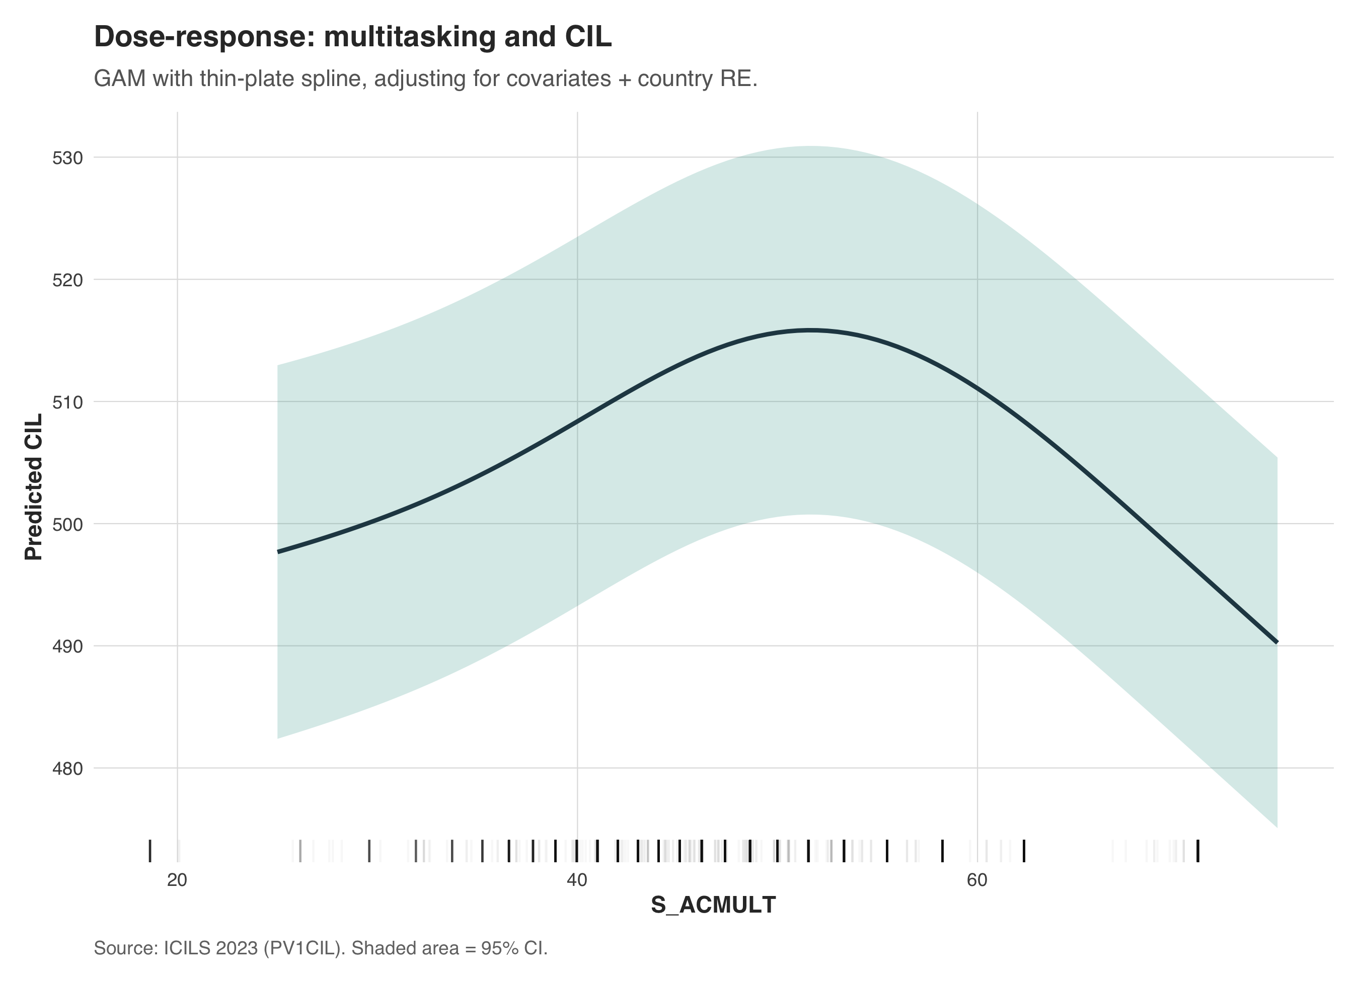
Figure S1. Dose–response relationship between S_ACMULT and CIL, estimated using a generalised additive model with thin-plate regression spline and country random intercept.

Supplementary Results S5. Cross-System Descriptive Patterns
Figure S2 displays the relationship between national averages of S_ACMULT and average CIL across the 35 participating systems. At the country level, average multitasking and average CIL did not align in a simple way, underscoring that the ecological association at the system level does not map directly onto within-system individual-level relationships.
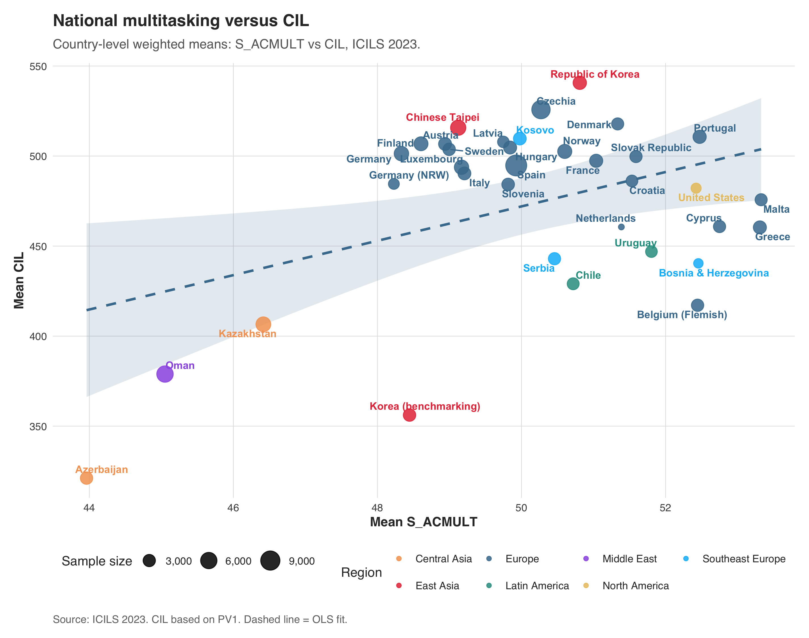
Figure S2. National averages of academic-media multitasking (S_ACMULT) versus average CIL across 35 education systems.

Supplementary Results S6. TIMSS Prong 3: Teacher-Reported Distraction Moderation
Teacher-reported distraction was independently and negatively associated with achievement at the school level (β = −5.87, SE = 1.25, p < .001 for mathematics; β = −4.81, SE = 1.14, p < .001 for science). However, the cross-level interaction between internet use for schoolwork and distraction climate was not statistically significant (mathematics: β = −0.37, 95% CI [−2.26, 1.52]; science: β = −0.61, 95% CI [−2.54, 1.31]). The direction was consistently negative—internet-use penalties were slightly amplified in higher-distraction schools—but the effect was too small to detect reliably. This contrasts with the significant ICILS moderation by S_LRNSAFE, possibly because the TIMSS moderator is a blunt three-item teacher report aggregated to school means, whereas S_LRNSAFE is a detailed student-reported IRT scale with finer measurement granularity (Figure S3).
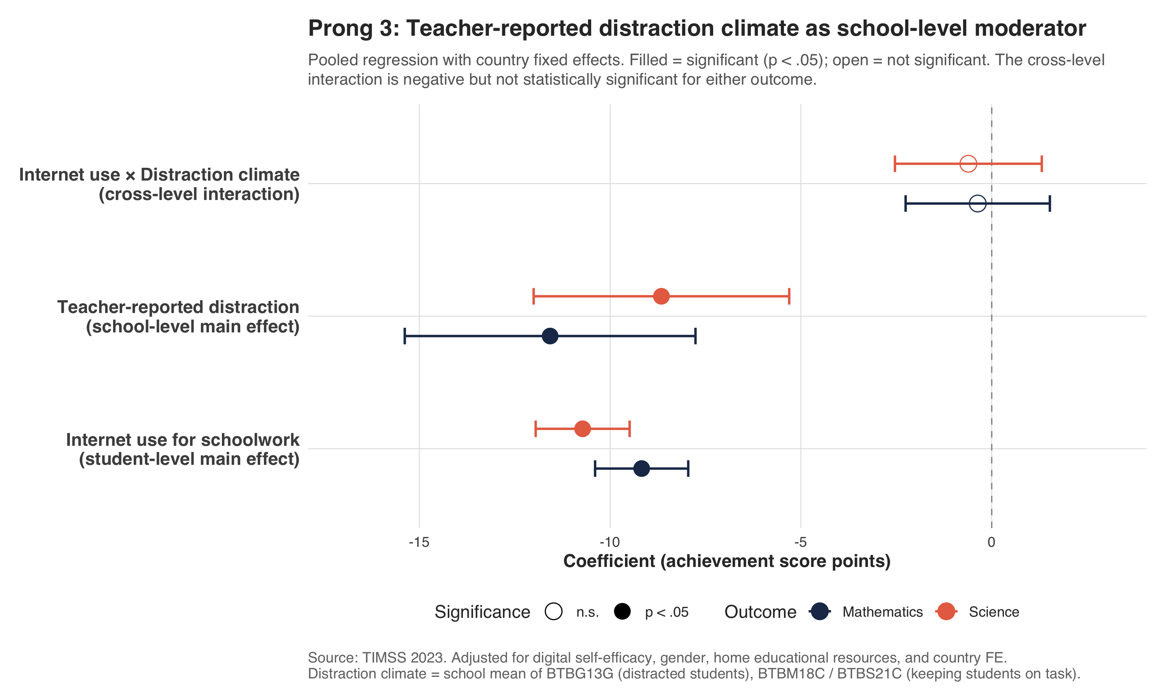
Figure S3. TIMSS Prong 3: Interaction between internet use for schoolwork and teacher-reported distraction climate for mathematics and science achievement.

Supplementary Results S7. Additional Robustness Analyses
Binary exposure specification. In the TIMSS analyses, students in the top tertile of internet use for schoolwork scored 16.54 fewer mathematics points (SE = 0.85, p < .001) compared to those in the lower tertiles. This binary specification corroborates the continuous-exposure findings.
Multilevel models. Two-level linear mixed models (students nested in schools, with country fixed effects) confirmed the primary findings. The random-slope model showed wide between-school dispersion in the multitasking–CIL slope (random slope SD = 1.13; LR χ² = 4011.9, p < .001; intercept–slope r = −0.88), indicating that the multitasking–CIL association varies substantially across schools. Schools with higher average CIL tended to show more negative multitasking slopes.
Binary ICILS exposure. Students who frequently checked social media during homework (“often” or “always” on IS3G21C) scored 17.4 fewer CIL points (SE = 1.56, p < .001) compared to those who checked less frequently, confirming that the continuous-scale findings are robust to alternative exposure specifications.

