Supplementary Information

The toxicity of polyethylene microplastic exposure and its concurrent effect with Aeromonas hydrophila infection to zebrafish

Ning Ding^{1,2,3}, Lin Jiang¹, Xiao Wang¹, Chun Wang^{1,2,3}, Yue Geng¹, Jianxin Zhang¹, Yingxue Sun^{1,2,3*}, Yanping Zhang^{1,2,3}, Quan Yuan^{1,2,3}, Hong Liu⁴

¹School of Ecology and Environment, Beijing Technology and Business University, Beijing, China;
²State Environmental Protection Key Laboratory of Food Chain Pollution Control, Beijing Technology and Business University, Beijing, China;
³Key Laboratory of Cleaner Production and Comprehensive Utilization of Resources, China National Light Industry, Beijing Technology and Business University, Beijing, China;
⁴School of Environmental Science and Engineering, Suzhou University of Science and Technology, Jiangsu Province, China

Corresponding author: Yingxue Sun
Professor
School of Ecology and Environment
Beijing Technology and Business University
Fucheng Road No.11, Haidian District,
Beijing, China 100048
E-mail: sunyx@th.btbu.edu.cn

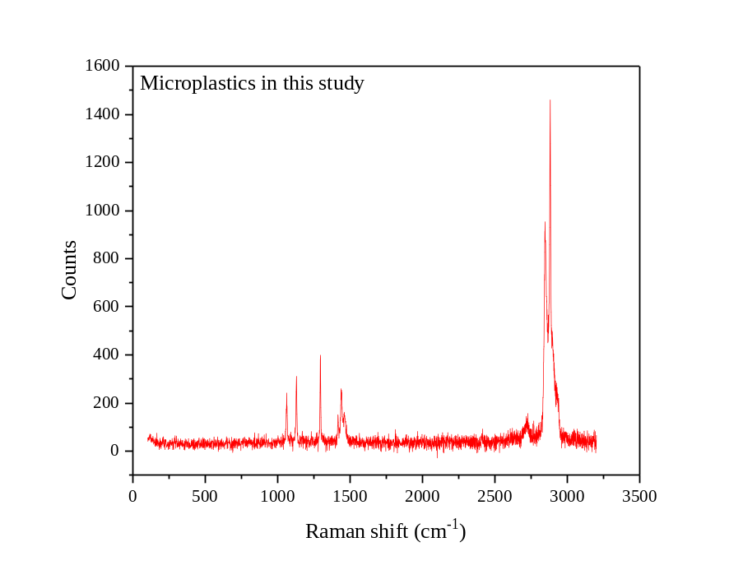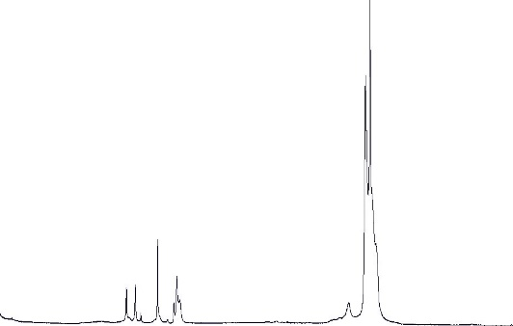
PE
Fig. S1 Raman spectrum of the microplastics

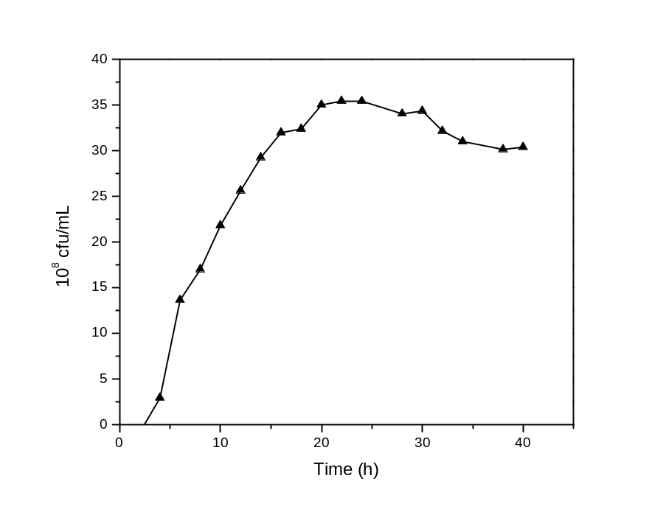
Fig. S2 The growth curve of Aeromonas hydrophila

Healthy zebrafish were cultured by soaking in the water with different concentrations of Aeromonas hydrophila, and the mortality of zebrafish was observed for 7 consecutive days. It was showed that under the condition of high concentration of 3.199×10⁸ cfu/mL, all zebrafish died within 12 h. Under the condition of 3.199×10⁷ cfu/mL, the mortality rate of zebrafish within 7 days was 93.33%. The lethal rate of zebrafish is positively correlated with the environmental concentration of Aeromonas hydrophila. Taking the Log environmental concentration of Aeromonas hydrophila on the x-axis and the lethal rate of zebrafish on the y-axis, the curve is shown in Fig. S3. The relationship between Log concentration and mortality of Aeromonas hydrophila fit the equation y=0.337x-1.783, R²=0.900. According to the curve, the concentration of Aeromonas hydrophila was calculated when the mortality rate was 50%, and the median lethal dose of Aeromonas hydrophila infecting zebrafish was LD₅₀=6.049×10⁶ cfu/mL.
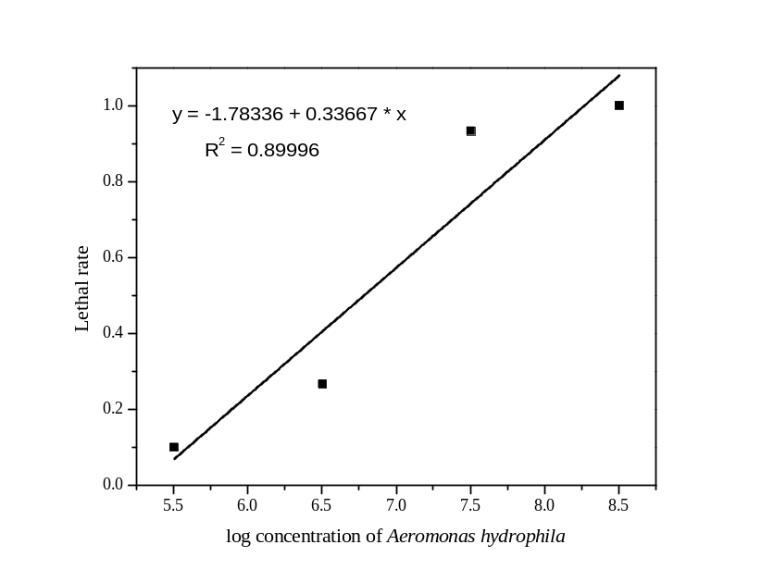
Fig. S3 The curve of log concentration of Aeromonas hydrophila vs. lethal rate of zebrafish.

