Seasonal greenhouse gas flux limits the blue carbon potential of intertidal seagrass (Supplementary material)

Detailed methodology design for greenhouse gas measurements

To quantify greenhouse gas (GHG) fluxes from the sediment-air interface, carbon dioxide (CO₂) and methane (CH₄) were measured in Z. noltii seagrass meadows and adjacent non-vegetated bare sediments, using non-steady state (static) chambers. Three independent replicates of each habitat type (seagrass and bare sediments) were measured. For each replicate, a collar (covering an area of 75.43 cm²) was inserted 5 cm into the sediment to create a tight seal with the sediment. Collars were deployed between 12-24 hours prior to GHG measurements to prevent erroneous data from sediment disturbance and stress responses from physical wounding of the plant (Fiedler et al., 2022; Lenhart et al., 2015; Wang et al., 2011; Wang et al., 2009). For each seagrass replicate, care was also taken to prevent cutting of leaf material during collar deployment. The location of each replicate, or ‘chamber base position’, was independent for every season. To prevent water retention within collars, each had a small hole drilled in the side for water drainage as the tide receded (Figure S2). Drainage holes were fitted with gas-tight bungs upon arrival to the field site, prior to gas measurements being taken. Clear incubation chambers were fitted with lids consisting of three openings: one for the air inlet tubing, one for the air outlet tubing and one to function as a vent. The incubation chamber was inserted into the collar and connected in a ‘closed-path system’ to a cavity ring-down infrared gas analyser (LI-7810, LI-COR Biosciences, Lincoln, NE), sampling both CO₂, water vapour (H₂O) and CH₄ at 1 Hz (prec. CO₂ measurements 3.5ppm at 400 ppm with 1 second averaging; CH₄ measurements 0.60 ppb at 2 ppm with 1 second averaging) (Rey-Sanchez et al., 2022) (Figure S2). To measure ecosystem respiration rates of both habitats, a ‘dark-adapted’ treatment was included, whereby the incubation chamber was covered with opaque black bin bags to prevent UV penetration. Respiration rates were not included in the main manuscript. Spatial replicates of each treatment and habitat were measured sequentially (seagrass, seagrass dark-adapted, bare sediments, bare sediments dark-adapted), since it was not possible to measure replicates at the same time. This will be referred to as a ‘replicate cycle’ throughout. Prior to each respiration measurement, the collar was covered with opaque material to ensure photosystems of the plants or biofilms were open and photosynthetic carbon assimilation had ceased (Beer et al., 2001). Based on pilot experiments to determine the optimum time for each habitat type: for seagrass, collars were covered for 10 minutes; for bare sediments, collars were covered for 5 minutes (Beer et al., 2001). During data analysis, flux plots were visually assessed for indications of active photosynthesis (negative curvature at the start of measurements) and data was trimmed accordingly.
For the first five minutes, or ‘acclimation period’, ambient air was allowed into the chamber through the vent in the incubation chamber lid to prevent effects of disturbance and pressure build up caused by the chamber insertion. After the acclimation period, the vent was closed and concentration of CO₂/CH₄ were measured for 5 minutes (Cowan et al., 2014; Fiedler et al., 2022; Johannesson et al., 2024). Following pilot surveys, a 5-minute measurement duration was deemed appropriate for capturing accurate fluxes, without compromising natural gas diffusion from chamber effects. Between each replicate, the incubation chamber was flushed with ambient air to remove any potential artefacts, and the gas analyser was exposed to ambient air for five minutes, or until a steady state was reached. This was repeated for each treatment and habitat. A desiccator was attached at the air inlet point of the gas analyser to prevent water entry. Within the chamber, a longer tube was attached to the air-inlet opening to ensure gases were sampled directly from the sediment-air interface (~7.2 cm offset from sediment, Figure S2). The continuous flow-through design of the chamber set-up allowed some air movement within the chamber, which prevented gas stratification (Johannesson et al., 2024). Strong movements of air, induced by fans, could cause unnatural diffusion of gases from the sediment surface in chambers of low volume, such as the one used here (~1.6L, depending on collar height) (Fiedler et al., 2022). After all gas flux replicates, the height of each collar was measured due to the uneven terrain and for accurate volume measures.
All parts for the chamber design (incubation chamber and collar) were locally sourced from low-cost materials. Collars were made of rigid polypropylene sourced from a local plumbers’ merchant. Incubation chambers were made of extruded acrylic, with 3 mm wall thickness, a threaded end for screwing on the lid, and a bevelled end for easier insertion to the collar.

Supplementary figures
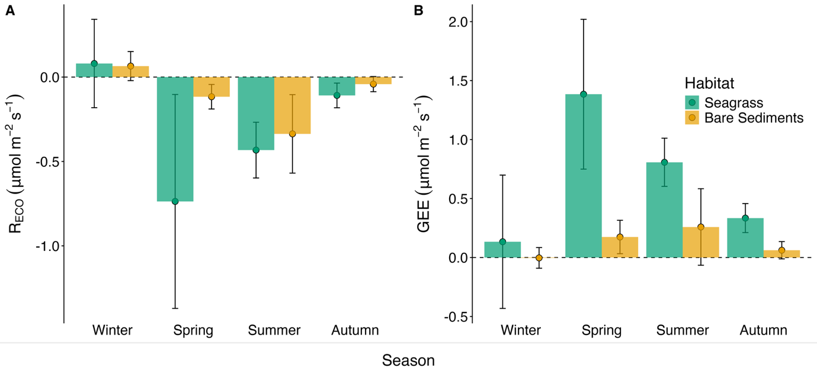
Figure S1. Daytime sediment-air A) ecosystem respiration (R_{ECO}) and B) gross ecosystem exchange (GEE) of emersed Zostera noltii seagrass and adjacent bare sediments, across an annual cycle. Data are presented as means ± two standard errors (n=9). Positive fluxes represent CO₂ uptake, while negative fluxes indicate CO₂ emission. Habitat type is separated by colour: green for seagrass, yellow for bare sediments.

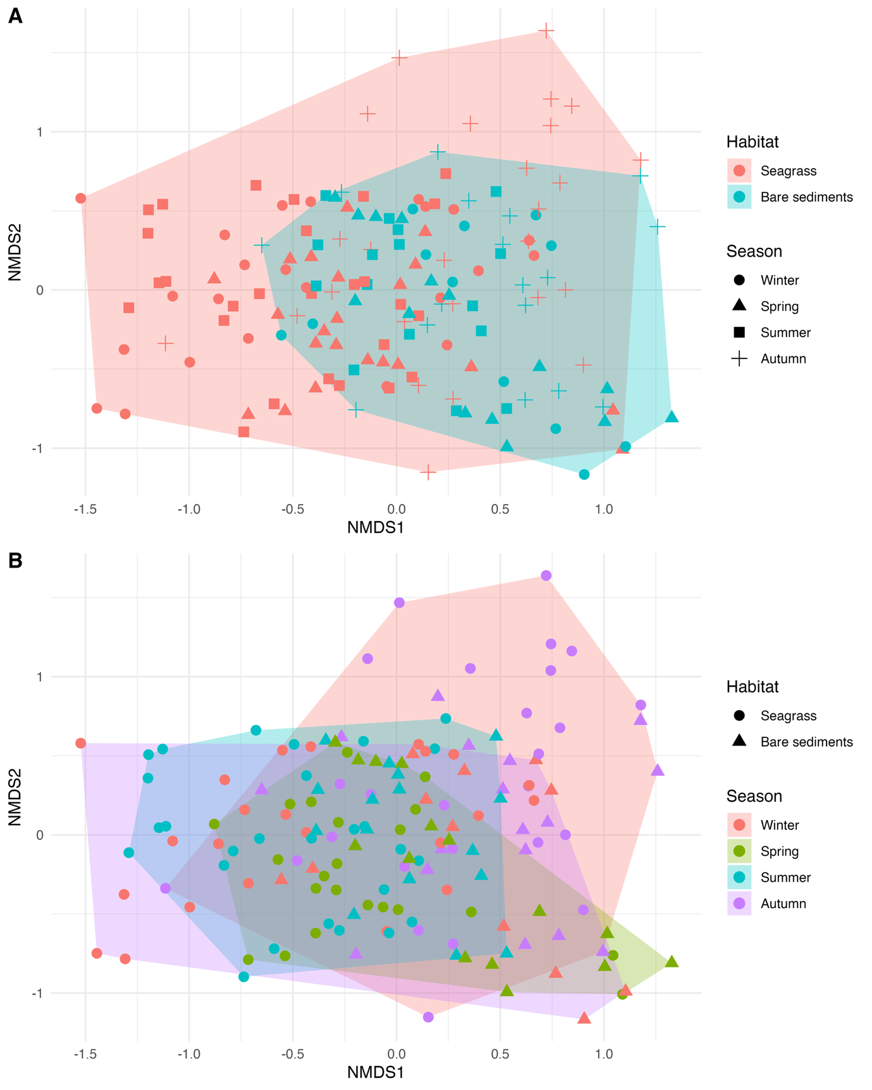
Figure S2. Non-metric multidimensional scaling (nMDS) of methanogen communities in Zostera noltii seagrass and bare sediment, across a seasonal cycle. Community matrix was determined based on relative abundance of methanogen OTUs, using Bray-Curtis distance and 999 permutations, a stress score of 0.157 (k = 3) was calculated. Convex hulls enclose all points for communities across A) season and B) habitat.

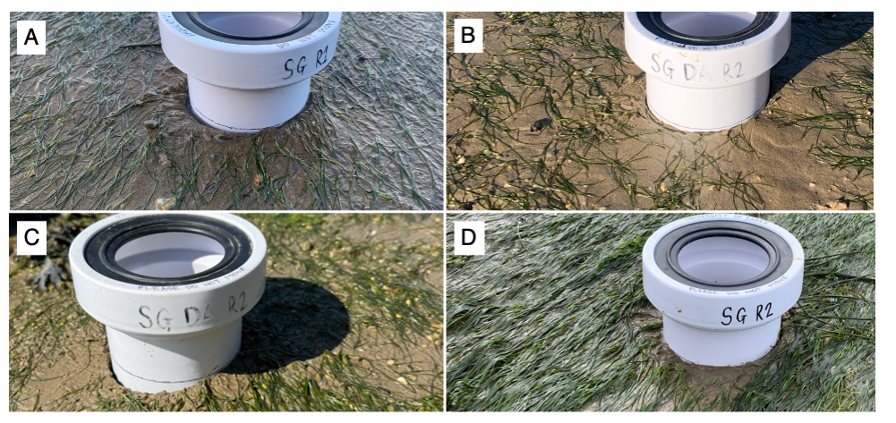
Figure S3. Seasonal biomass changes in Zostera noltii at Nacton Shore, River Orwell. Images taken each season of the sampling period: A) autumn – October 2023, B) winter – January 2024, C) spring – April 2024, D) summer – July 2024. Photo credit to main author.

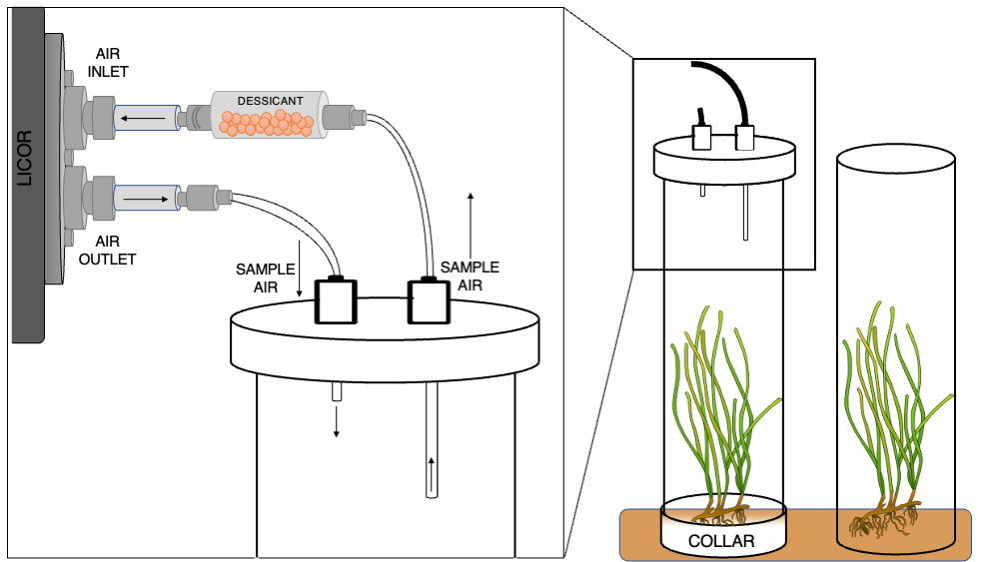
A
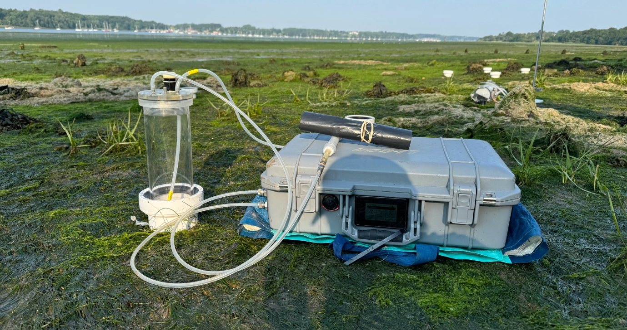
B
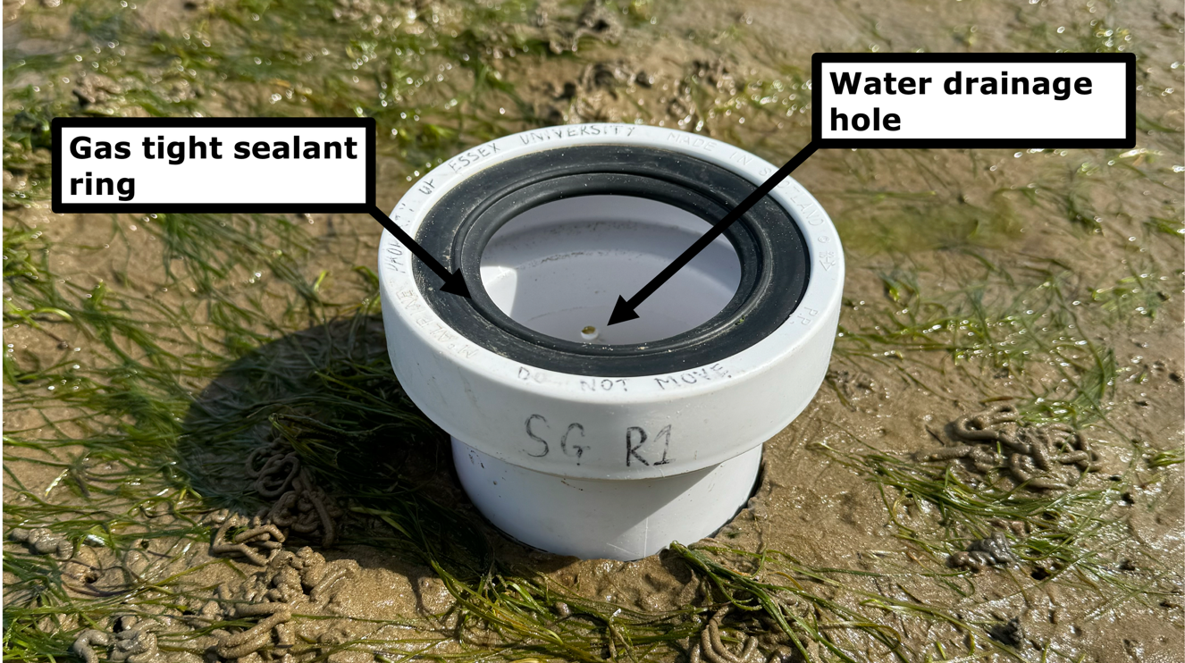
C
Figure S4. A) Graphical representation and B) in-situ set up of the incubation chamber design and closed-loop GHG measurement technique, using a cavity ring-down infrared gas analyser (LI-7810, LiCOR). Note the length of the tubes entering the incubation chamber – inlet air was sampled from the top of the collar (~7.2 cm offset from sediment) to ensure it was not influenced by outlet air entering the chamber. C) Details of collar. Total chamber height was ~26.7 cm depending on sediment surface evenness, and chamber volume was ~1.6L, on average. Photo credit to main author.

Supplementary tables
Table S1. Analysis of deviance for sedimentary nutrient composition. Significant responses shown in bold (df = degrees of freedom).
 | Chisq (χ²) | df | P
Nitrate
Season | 21.1 | 3 | <0.001
Sediment type | 14.0 | 2 | <0.001
Habitat | 2.30 | 1 | 0.13
Habitat x Season | 2.48 | 3 | 0.48
Sediment type x Habitat | 0.35 | 1 | 0.55
Sediment type x Season | 9.24 | 6 | 0.16
Habitat x Sediment type x Season | 2.62 | 3 | 0.45
Nitrite
Season | 84.8 | 3 | <0.001
Sediment type | 30.1 | 2 | <0.001
Habitat | 0.23 | 1 | 0.63
Habitat x Season | 2.82 | 3 | 0.42
Sediment type x Habitat | 0.13 | 1 | 0.72
Sediment type x Season | 6.66 | 6 | 0.35
Habitat x Sediment type x Season | 1.30 | 3 | 0.73
Ammonium
Season | 50.3 | 3 | <0.001
Sediment type | 66.0 | 2 | <0.001
Habitat | 2.81 | 1 | 0.09
Habitat x Season | 0.70 | 3 | 0.87
Sediment type x Habitat | 1.23 | 1 | 0.27
Sediment type x Season | 10.4 | 6 | 0.11
Habitat x Sediment type x Season | 1.49 | 3 | 0.68
Acetate
Season | 23.3 | 3 | <0.001
Sediment type | 21.5 | 2 | <0.001
Habitat | 0.92 | 1 | 0.34
Habitat x Season | 2.76 | 3 | 0.43
Sediment type x Habitat | 0.02 | 1 | 0.90
Sediment type x Season | 6.37 | 6 | 0.38
Habitat x Sediment type x Season | 6.90 | 3 | 0.08
Sulphate
Season | 17.6 | 3 | <0.001
Sediment type | 140 | 2 | <0.001
Habitat | 1.28 | 1 | 0.26
Habitat x Season | 1.56 | 3 | 0.67
Sediment type x Habitat | 0.16 | 1 | 0.69
Sediment type x Season | 26.7 | 6 | <0.001
Habitat x Sediment type x Season | 1.84 | 3 | 0.61
Phosphate
Season | 18.9 | 3 | <0.001
Sediment type | 15.2 | 2 | <0.001
Habitat | 0.80 | 1 | 0.37
Habitat x Season | 1.48 | 3 | 0.69
Sediment type x Habitat | 2.17 | 1 | 0.14
Sediment type x Season | 2.00 | 6 | 0.92
Habitat x Sediment type x Season | 0.59 | 3 | 0.90

Table S2. Analysis of deviance for methanogen OTU community diversity indices. Significant responses shown in bold.
 | Shannon |  |  | Richness |  |  | Evenness
 | Chisq (χ²) | df | P | Chisq (χ²) | df | P | Chisq (χ²) | df | P
Season | 2.35 | 3 | 0.50 | 13.5 | 3 | <0.01 | 3.42 | 3 | 0.33
Sediment type | 4.76 | 2 | 0.09 | 0.85 | 2 | 0.65 | 16.432 | 2 | <0.001
Habitat | 0.39 | 1 | 0.53 | 0.63 | 1 | 0.43 | 7.95 | 1 | <0.01
Habitat x Season | 2.44 | 3 | 0.49 | 1.29 | 3 | 0.73 | 1.88 | 3 | 0.60
Sediment type x Habitat | 0.41 | 1 | 0.52 | 1.77 | 1 | 0.18 | 0.15 | 1 | 0.70
Sediment type x Season | 17.1 | 6 | <0.01 | 36.8 | 6 | <0.001 | 4.31 | 6 | 0.63
Habitat x Sediment type x Season | 4.03 | 3 | 0.26 | 2.16 | 3 | 0.54 | 3.70 | 3 | 0.30

Table S3. Diversity indices of methanogen communities, based on identified genera. Data presented as means (± SD) per season.
 | Shannon | Richness | Evenness
Zostera noltii seagrass
Spring (n=22) | 3.42 (0.78) | 68.2 (23.4) | 0.81 (0.14)
Summer (n=27) | 3.15 (0.54) | 50.7 (26.7) | 0.84 (0.08)
Autumn (n=26) | 2.86 (0.83) | 41.0 (27.3) | 0.83 (0.12)
Winter (n=23) | 3.23 (0.76) | 55.5 (23.9) | 0.83 (0.10)
Mean | 3.16 (0.23) | 53.9 (11.3) | 0.83 (0.01)
Bare sediments
Spring (n=15) | 3.06 (0.84) | 14.9 (5.26) | 0.50 (0.21)
Summer (n=16) | 3.14 (0.58) | 63.4 (25.5) | 0.75 (0.16)
Autumn (n=17) | 3.10 (0.66) | 56.8 (22.0) | 0.78 (0.14)
Winter (n=12) | 3.14 (1.01) | 61.3 (31.1) | 0.80 (0.12)
Mean | 3.11 (0.04) | 57.8 (6.13) | 0.79 (0.03)

Table S4. Sediment-air and sea-air CO₂ fluxes from seagrass. Flux data presented as geometric mean ± SE and range provided in parentheses as lower mean – upper mean, unless specified otherwise
Species | Location | Method | CO2 flux (mmol m⁻² h⁻¹) | Temporal aspect | Flux interface | Reference
Global |  | Median | -0.45 |  |  | This study
Global |  | Geometric mean | -1.99 ± 1.00 |  |  | This study
Global |  | IQR | (-1.57 – 0.03) |  |  | This study
Halophila beccarii | Ronggenshan, Beihai, China | Chamber-based measurements | -0.45 †  (-2.05 – 0.65) | Seasonal (summer/winter) | Sediment-air | Zheng et al (2023)
Halophila stipulacea | Central Red Sea, Saudi Arabia | Mesocosm core incubations | 0.02 ± 0.03 *  (no range provided) | Winter | Sea-air | Burkholz et al (2020)
Mixed seagrasses (Oceana serrulata, Enhalus acoroides, and Thalassia hemprichii) | Fukido estuary (subtropical), Okinawa, Japan | Floating chamber/Eddy covariance | -0.91 ± 0.37 ‡  (no range provided) | Summer | Sea-air | Tokoro et al (2014)
Mixed seagrasses (Halophila and Halodule sp.) | Chilika Lagoon (Southern Sector), India | Bulk formula | 0.41 ± 0.36 *  (0.13 – 1.24) | Seasonal (wet/dry) | Sea-air | Banerjee et al (2018)
Mixed seagrasses (mostly Thalassia testudinum, also Halodule wrighti, and Syringodium filiforme) | Florida Bay, USA | Eddy covariance | 1.04 ± 0.61 ‡§**  (no range provided) | March – June (Daytime only) | Sea-air | Van Dam et al (2021) Limnology & Oceanography
Mixed seagrasses (Zostera tasmanica and Zostera muelleri) | Swan Bay, Victoria, Australia | Bulk formula | -0.03 ± 0.02 *§  (-0.88 – 0.60) | Summer (Daytime only) | Sea-air | Ollivier et al (2022)
Mixed seagrasses (Halodule uninervis and Halophila ovalis) | Liusha Bay, Guangdong Province, China | Chamber-based measurements | 0.07 ± 0.01 *  (0.05 – 0.08) | Seasonal (wet/dry) | Sediment-air | Nie et al (2026)
Mixed seagrasses (Halodule uninervis and Halophila ovalis) | Liusha Bay, Guangdong Province, China | Floating chambers | 0.03 ± 0.02 *  (0.001 – 0.05) | Seasonal (wet/dry) | Sea-air | Nie et al (2026)
Oceana serrulata | Eastern Red Sea, Saudi Arabia | Bulk formula | 0.09 ± 0.02 *  (-0.04 – 0.32) | Seasonal (September – December) | Sea-air | Saderne et al (2023)
Posidonia oceanica | Portlligat Bay (Station S), Spain | Bulk formula | 0.03 ± 0.04 * **  (no range provided) | September | Sea-air | Yau et al (2023)
Thalassia testudinum | Florida Bay, USA | Bulk formula | -0.22 ± 0.13 §  (no range provided) | Spring (Daytime only) | Sea-air | Dobashi and Ho (2023)
Zostera marina | Furen lagoon (boreal), Hokkaido, Japan | Floating chamber/Eddy covariance | -0.70 ± 0.59 ‡  (no range provided) | Seasonal (summer/winter) | Sea-air | Tokoro et al (2014)
Zostera marina | Gullmar Fjord, Sweden | Bulk formula | -0.04 ± 0.03 *  (-0.12 – 0.02) | Seasonal | Sea-air | Henriksson et al (2024)
Zostera muelleri | Kaipara Harbour, New Zealand | Chamber-based measurements | -4.14 ± 0.75 ‡  (-5.18 – -2.69)  Raw data provided by T. Drylie | Summer (Daytime only) | Sediment-air | Drylie et al (pers. comm. 2018)
Zostera noltii | Arcachon Bay, France | Eddy covariance | -4.86 ± 1.94 ‡§  (-9.72 – -1.08) | Seasonal (annual) | Sediment-air | Polsenaere et al (2012)
Zostera noltii | Arcachon Bay, France | Eddy covariance | -1.44 ± 1.63 ‡§  (-6.12 – 1.44) | Seasonal (annual) | Sea-air | Polsenaere et al (2012)
Zostera noltii | Ria Formosa lagoon, Portugal | Chamber-based measurements | -9.1 †§  (no range provided) | Spring (Daytime only) | Sediment-air | Bahlmann et al (2015)
Zostera noltii | Ria Formosa lagoon, Portugal | Chamber-based measurements | -16.4 †§  (no range provided) | Spring (Daytime only) | Sea-air | Bahlmann et al (2015)
Zostera noltii | Arcachon Bay, France | Chamber-based measurements | -1.95 ± 0.73  (-3.64 – 0.41)  Exact values provided by A. Migné | Seasonal (March-September) | Sediment-air | Migné et al (pers. comm. 2016)
Zostera noltii | Essex, UK | Chamber-based measurements | -1.32 ± 0.36  (-2.33 – -0.77) | Seasonal (annual) | Sediment-air | This study

For studies incorporating multiple seasons, fluxes were averaged from seasonal means.
Data from studies incorporating different methods for flux assessments were averaged first by season (where appropriate), then averaged across all method types for the same location.
Data from different flux interfaces (sediment-air, sea-air; i.e. Bahlmann et al. 2015, Nie et al 2026) were kept separate for final global calculations.
Global average calculated as the mean of means across location
†No error values provided by referenced paper
*Original data reported for a 24-hour cycle (day⁻¹). Herein daily fluxes are converted to hourly fluxes by dividing by (24) and data are presented as range of means
**Standard deviation reported
‡Original data reported per second. Herein fluxes are converted to hourly fluxes
§Referenced study includes diel fluxes, only daytime fluxes are reported here, i.e. mean +- standard error and ranges taken from daytime observations only

Table S5. Sediment-air and sea-air CH₄ fluxes from seagrass. Flux data presented as mean ± SE and range provided in parentheses as lower mean – upper mean, unless specified otherwise.
Species | Location | Method | CH₄ flux (µmol m⁻² h⁻¹) | Temporal aspect | Flux interface | Reference
Global |  | Median | 2.46 |  |  | This study
Global |  | Geometric mean | 3.36 ± 0.84 |  |  | This study
Global |  | IQR | (0.33 – 4.75) |  |  | This study
Enhalus acoroides | Li'an Lagoon, Hainan Island, South China Sea | Bulk formula | 5.83 ± 2.75 *  (no range provided) | March | Sea-air | Dai et al (2025)
Halodule wrightii | Gulf of Mexico, Texas, USA | Floating chambers/  Bulk formula | 9.21 ± 7.95 * **  (3.02 – 11.5) | Seasonal | Sea-air | Yu et al (2024)
Halophila beccarii | Ronggenshan, Beihai, China | Chamber-based measurements | -0.94 †  (-2.28 – 2.76) | Seasonal (summer/winter) | Sediment-air | Zheng et al (2023)
Halophila stipulacea | Central Red Sea, Saudi Arabia | Mesocosm core incubations | 2.49 ± 0.66 *  (no range provided) | Winter | Sea-air | Burkholz et al (2020)
Mixed seagrasses (Halophila and Halodule sp.) | Chilika Lagoon (Southern Sector), India | Bulk formula | 4.90 ± 0.73 *  (4.17 – 5.63) | Seasonal (wet/dry) | Sea-air | Banerjee et al (2018)
Mixed seagrasses (Zostera tasmanica and Zostera muelleri) | Swan Bay, Victoria, Australia | Bulk formula | 0.44 *¶ | Summer (Daytime only) | Sea-air | Ollivier et al (2022)
Mixed seagrasses (Halodule uninervis and Halophila ovalis) | Liusha Bay, Guangdong Province, China | Chamber-based measurements | 0.10 ± 0.04 *  (0.06 – 0.30) | Seasonal (wet/dry) | Sediment-air | Nie et al (2026)
Mixed seagrasses (Halodule uninervis and Halophila ovalis) | Liusha Bay, Guangdong Province, China | Floating chambers | 0.89 ± 0.25 *  (0.43 – 1.33) | Seasonal (wet/dry) | Sea-air | Nie et al (2026)
Mixed vegetation | Askö island, Baltic Sea | Bulk formula | 2.46 ± 1.34 *  Median (0.49, IQR: 0.12 – 1.79)  (0.15 – 5.75) | Seasonal | Sea-air | Roth et al (2022)
Mixed vegetation (Zostera japonica and Chaetomorpha linum) | Swan Lake, Rongcheng, Shandong Province, China | Bulk formula | 8.33 ± 0.67 *  (7.67 – 9.00) | Seasonal (June/November) | Sea-air | Dia et al (2026)
Oceana serrulata | Eastern Red Sea, Saudi Arabia | Bulk formula | 0.85 ± 0.11 *  (0.67 – 1.04) | Seasonal (December – September) | Sea-air | Saderne et al (2023)
Posidonia oceanica | Portlligat Bay (Station S), Spain | Bulk formula | 0.005 ± 0.006 * **  (no range provided) | September | Sea-air | Yau et al (2023)
Ruppia megacarpa | Wallagoot Lake, NSW Australia | Bulk formula/Open water??? | 1.35 ± 0.02 *  (0.70 – 2.39) | Summer | Sea-air | Eyre et al (2023)
Thalassia hemprichii | Chwaka Bay, Zanzibar, Tanzania | Chamber-based measurements | 3.15 ± 0.89 §  (no range values reported) | Seasonal (October – March) | Sea-air | Lyimo et al (2018)
Zostera japonica | Swan Lake, Rongcheng, Shandong Province, China | Discrete samples | 0.22 ± 0.23 *  (-0.02 – 0.45) | Seasonal (October-August) | Sea-air | Tan et al (2025)
Zostera marina | Swan Lake, Rongcheng, Shandong Province, China | Discrete samples | 0.14 ± 0.14 *  (0.003 – 0.27) | Seasonal (October-August) | Sea-air | Tan et al (2025)
Zostera marina | Southeastern Massachusetts, USA | Discrete samples | 4.61 ± 0.13  (4.48 – 4.74) | Summer | Sea-air | Al-Haj et al (2022)
Zostera marina | Gullmar Fjord, Sweden | Bulk formula | 0.03 ± 0.02 *  (0.01 – 0.11) *** | Seasonal | Sea-air | Henriksson et al (2024)
Zostera noltii | Arcachon Bay, France | Discrete samples | 4.1 ± 0.39  (no range values reported) | Spring (March) | Sediment-air | Deborde et al (2010)
Zostera noltii | Ria Formosa lagoon, Portugal | Chamber-based measurements | 6.9 †  (no range provided) | Spring (April - daytime only) | Sediment-air | Bahlmann et al (2015)
Zostera noltii | Ria Formosa lagoon, Portugal | Chamber-based measurements | 14.3 †  (9 – 30) | Spring (April - daytime only) | Sea-air | Bahlmann et al (2015)
Zostera noltii | Arcachon Bay, France | Chamber-based measurements | 1.02 ± 0.15  (0.58 – 1.49) | Summer (August) | Sediment-air | Dolivet-Maréchal et al (2026)
Zostera noltii | Essex, UK | Chamber-based measurements | 0.47 ± 0.17  (0.18 – 0.79) | Seasonal (annual) | Sediment-air | This study

Experimental studies that influence natural conditions were not included (George et al., 2020)
*Original data reported for a 24-hour cycle (day⁻¹). Herein daily fluxes are converted to hourly fluxes by dividing by (24) and data are presented as range of means.
**Standard deviation reported
*** Range reported as provided in referenced paper
§Original data reported as µg CH₄ m⁻² h⁻¹, herein converted to µmol m⁻² h⁻¹
¶ Final value reported, other mean values with associated error and ranges available in referenced paper.
†No error values provided by referenced paper
References (supplementary material)

Al‐Haj, A.N., Chidsey, T. and Fulweiler, R.W. (2022) ‘Two temperate seagrass meadows are negligible sources of methane and nitrous oxide’, Limnology and Oceanography, 67(S2). Available at: https://doi.org/10.1002/lno.12250.
Bahlmann, E., Weinberg, I., Lavrič, J.V., Eckhardt, T., Michaelis, W., Santos, R. and Seifert, R. (2015) ‘Tidal controls on trace gas dynamics in a seagrass meadow of the Ria Formosa lagoon (southern Portugal)’, Biogeosciences, 12(6), pp. 1683–1696. Available at: https://doi.org/10.5194/bg-12-1683-2015.
Banerjee, K., Paneerselvam, A., Ramachandran, P., Ganguly, D., Singh, G. and Ramesh, R. (2018) ‘Seagrass and macrophyte mediated CO2 and CH4 dynamics in shallow coastal waters’, PLOS ONE, 13(10), p. e0203922. Available at: https://doi.org/10.1371/journal.pone.0203922.
Burkholz, C., Garcias-Bonet, N. and Duarte, C.M. (2020) ‘Warming enhances carbon dioxide and methane fluxes from Red Sea seagrass (Halophila stipulacea) sediments’, Biogeosciences, 17(7), pp. 1717–1730. Available at: https://doi.org/10.5194/bg-17-1717-2020.
Dai, G., Chen, X., Zhuang, G., Zhang, Y., Zhu, P., Ju, F. and Li, L. (2025) ‘High Methane Production and Emission From Tropical Seagrasses Through Methylotrophic Methanogenesis’, Geophysical Research Letters, 52(5), p. e2024GL113824. Available at: https://doi.org/10.1029/2024GL113824.
Dai, G., Chen, X., Zhuang, G., Zhu, P., Sun, Yafei, Wang, Q., Ju, F., Sun, Yang and Li, L. (2026) ‘Porewater‐Surface Water Interface Mediates Methanogenesis, Oxidation, and Large Methane Emissions in Mixed Seagrass‐Macroalgae Ecosystems’, Journal of Geophysical Research: Oceans, 131(3), p. e2025JC023733. Available at: https://doi.org/10.1029/2025JC023733.
Deborde, J., Anschutz, P., Guérin, F., Poirier, D., Marty, D., Boucher, G., Thouzeau, G., Canton, M. and Abril, G. (2010) ‘Methane sources, sinks and fluxes in a temperate tidal Lagoon: The Arcachon lagoon (SW France)’, Estuarine, Coastal and Shelf Science, 89(4), pp. 256–266. Available at: https://doi.org/10.1016/j.ecss.2010.07.013.
Dobashi, R. and Ho, D.T. (2023) ‘Air–sea gas exchange in a seagrass ecosystem – results from a ³He&thinsp;∕&thinsp;SF₆ tracer release experiment’, Biogeosciences, 20(6), pp. 1075–1087. Available at: https://doi.org/10.5194/bg-20-1075-2023.
Dolivet-Maréchal, M., Schmidt, S., Cognat, M., Schübert, C., Gervaix, J., Creuze Des Chatelliers, C., Labourdette, N., Bertrand, I., Rossi, L.M., Dugue, R., Ahr, M., Richaume, A., Le Roux, X. and Florio, A. (2026) ‘The Dual Climate Role of Seagrass Meadows in Arcachon Bay’, Earth Systems and Environment [Preprint]. Available at: https://doi.org/10.1007/s41748-026-01029-2.
Drylie, T.P., Lohrer, A.M., Needham, H.R., Bulmer, R.H. and Pilditch, C.A. (2018) ‘Benthic primary production in emerged intertidal habitats provides resilience to high water column turbidity’, Journal of Sea Research, 142, pp. 101–112. Available at: https://doi.org/10.1016/j.seares.2018.09.015.
Eyre, B.D., Camillini, N., Glud, R.N. and Rosentreter, J.A. (2023) ‘The climate benefit of seagrass blue carbon is reduced by methane fluxes and enhanced by nitrous oxide fluxes’, Communications Earth & Environment, 4(1), pp. 1–9. Available at: https://doi.org/10.1038/s43247-023-01022-x.
George, R., Gullström, M., Mtolera, M.S.P., Lyimo, T.J. and Björk, M. (2020) ‘Methane emission and sulfide levels increase in tropical seagrass sediments during temperature stress: A mesocosm experiment’, Ecology and Evolution, 10(4), pp. 1917–1928. Available at: https://doi.org/10.1002/ece3.6009.
Henriksson, L., Yau, Y.Y.Y., Majtényi-Hill, C., Ljungberg, W., Tomer, A.S., Zhao, S., Wang, F., Cabral, A., Asplund, M. and Santos, I.R. (2024) ‘Drivers of Seasonal and Diel Methane Emissions From a Seagrass Ecosystem’, Journal of Geophysical Research: Biogeosciences, 129(11), p. e2024JG008079. Available at: https://doi.org/10.1029/2024JG008079.
Lyimo, L.D., Gullström, M., Lyimo, T.J., Deyanova, D., Dahl, M., Hamisi, M.I. and Björk, M. (2018) ‘Shading and simulated grazing increase the sulphide pool and methane emission in a tropical seagrass meadow’, Marine Pollution Bulletin, 134, pp. 89–93. Available at: https://doi.org/10.1016/j.marpolbul.2017.09.005.
Migné, A., Davoult, D., Spilmont, N., Ouisse, V. and Boucher, G. (2016) ‘Spatial and temporal variability of CO 2 fluxes at the sediment–air interface in a tidal flat of a temperate lagoon (Arcachon Bay, France)’, Journal of Sea Research, 109, pp. 13–19. Available at: https://doi.org/10.1016/j.seares.2016.01.003.
Nie, S., Ouyang, X., Lin, J., Guo, F., Maher, D.T., Song, Z. and Yang, Z. (2026) ‘Impact of restoration on reducing carbon emissions from different blue carbon ecosystems’, Ocean & Coastal Management, 271, p. 107962. Available at: https://doi.org/10.1016/j.ocecoaman.2025.107962.
Ollivier, Q.R., Maher, D.T., Pitfield, C. and Macreadie, P.I. (2022) ‘Net Drawdown of Greenhouse Gases (CO2, CH4 and N2O) by a Temperate Australian Seagrass Meadow’, Estuaries and Coasts, 45(7), pp. 2026–2039. Available at: https://doi.org/10.1007/s12237-022-01068-8.
Polsenaere, P., Lamaud, E., Lafon, V., Bonnefond, J.-M., Bretel, P., Delille, B., Deborde, J., Loustau, D. and Abril, G. (2012) ‘Spatial and temporal CO₂ exchanges measured by Eddy Covariance over a temperate intertidal flat and their relationships to net ecosystem production’, Biogeosciences, 9(1), pp. 249–268. Available at: https://doi.org/10.5194/bg-9-249-2012.
Roth, F., Sun, X., Geibel, M.C., Prytherch, J., Brüchert, V., Bonaglia, S., Broman, E., Nascimento, F., Norkko, A. and Humborg, C. (2022) ‘High spatiotemporal variability of methane concentrations challenges estimates of emissions across vegetated coastal ecosystems’, Global Change Biology, 28(14), pp. 4308–4322. Available at: https://doi.org/10.1111/gcb.16177.
Saderne, V., Dunne, A.F., Rich, W.A., Cadiz, R., Carvalho, S., Cúrdia, J. and Kattan, A. (2023) ‘Seasonality of methane and carbon dioxide emissions in tropical seagrass and unvegetated ecosystems’, Communications Earth & Environment, 4(1), pp. 1–10. Available at: https://doi.org/10.1038/s43247-023-00759-9.
Tan, W., Zhong, Z., He, Q., Yun, X., Yang, L., Wang, X., Ji, D., Wang, G., Zhao, J. and Zhang, X. (2025) ‘Methane emission fluxes and associated microbial community characteristics in a temperate seagrass meadow’, Science of The Total Environment, 958, p. 177991. Available at: https://doi.org/10.1016/j.scitotenv.2024.177991.
Tokoro, T., Hosokawa, S., Miyoshi, E., Tada, K., Watanabe, K., Montani, S., Kayanne, H. and Kuwae, T. (2014) ‘Net uptake of atmospheric CO2 by coastal submerged aquatic vegetation’, Global Change Biology, 20(6), pp. 1873–1884. Available at: https://doi.org/10.1111/gcb.12543.
Van Dam, B.R., Lopes, C.C., Polsenaere, P., Price, R.M., Rutgersson, A. and Fourqurean, J.W. (2021) ‘Water temperature control on CO₂ flux and evaporation over a subtropical seagrass meadow revealed by atmospheric eddy covariance’, Limnology and Oceanography, 66(2), pp. 510–527. Available at: https://doi.org/10.1002/lno.11620.
Yau, Y.Y.Y., Reithmaier, G., Majtényi-Hill, C., Serrano, O., Piñeiro-Juncal, N., Dahl, M., Mateo, M.A., Bonaglia, S. and Santos, I.R. (2023) ‘Methane Emissions in Seagrass Meadows as a Small Offset to Carbon Sequestration’, Journal of Geophysical Research: Biogeosciences, 128(6), p. e2022JG007295. Available at: https://doi.org/10.1029/2022JG007295.
Yu, H., Coffin, R. and Organ, H. (2024) ‘Dynamics of methane emissions from northwestern Gulf of Mexico subtropical seagrass meadows’, Biogeochemistry, 167(5), pp. 723–741. Available at: https://doi.org/10.1007/s10533-024-01138-y.
Zheng, P., Chen, G., Lan, W., Li, S., Li, M., Chen, S., An, W., Chen, J., Yu, S. and Chen, B. (2023) ‘Determining effect of seagrass-mediated CO2 flux on the atmospheric cooling potential of a subtropical intertidal seagrass meadow’, Marine Pollution Bulletin, 188, p. 114676. Available at: https://doi.org/10.1016/j.marpolbul.2023.114676.

