Supplementary material

Hybrid G-Quadruplex and i-Motif Formation in G/C-Rich Repeat DNA: Beyond the Competitive Paradigm

L. Trizna, A. Varha, T. Melegová, V. Viglasky
Department of Biochemistry, Institute of Chemistry, Faculty of Science, Pavol Jozef Šafárik University, Košice, Slovakia

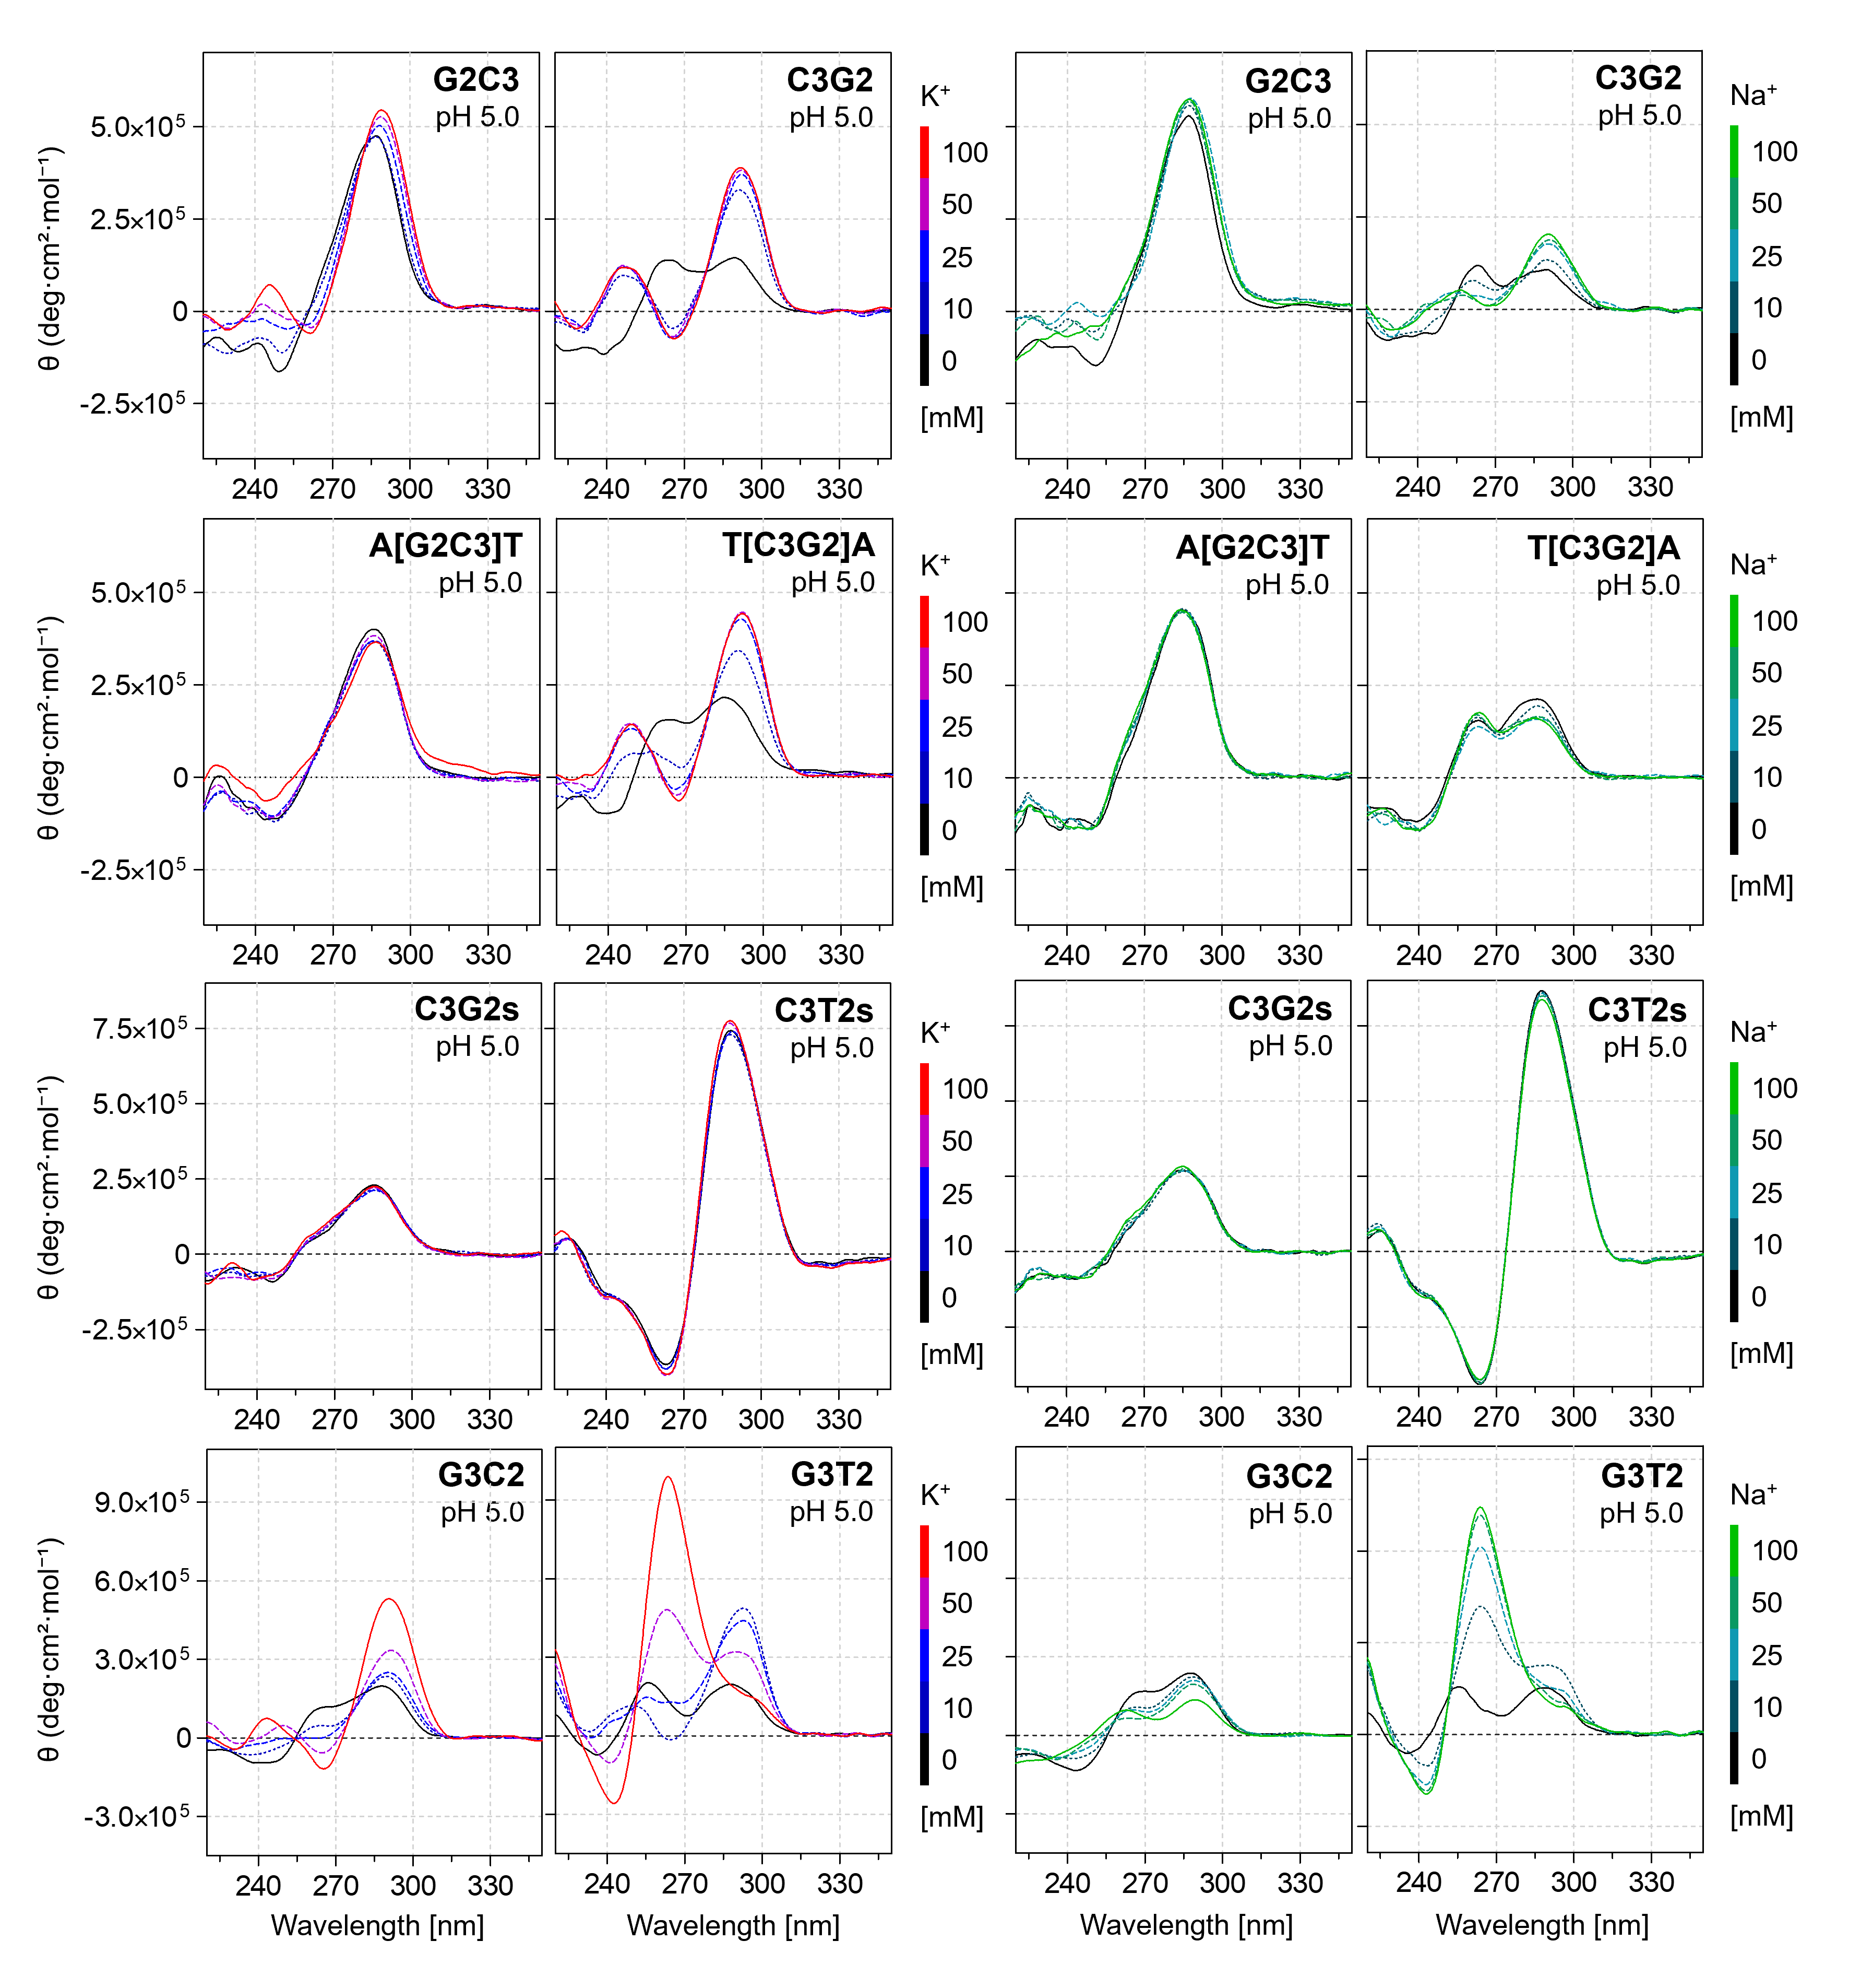
Figure S1: CD spectra of DNA in the presence of K⁺ (0–100 mM) and Na⁺ (0–100 mM), recorded in 25 mM mBR buffer at pH 5.0 (20 °C). Within each row, all spectra are displayed using the same ellipticity scale.

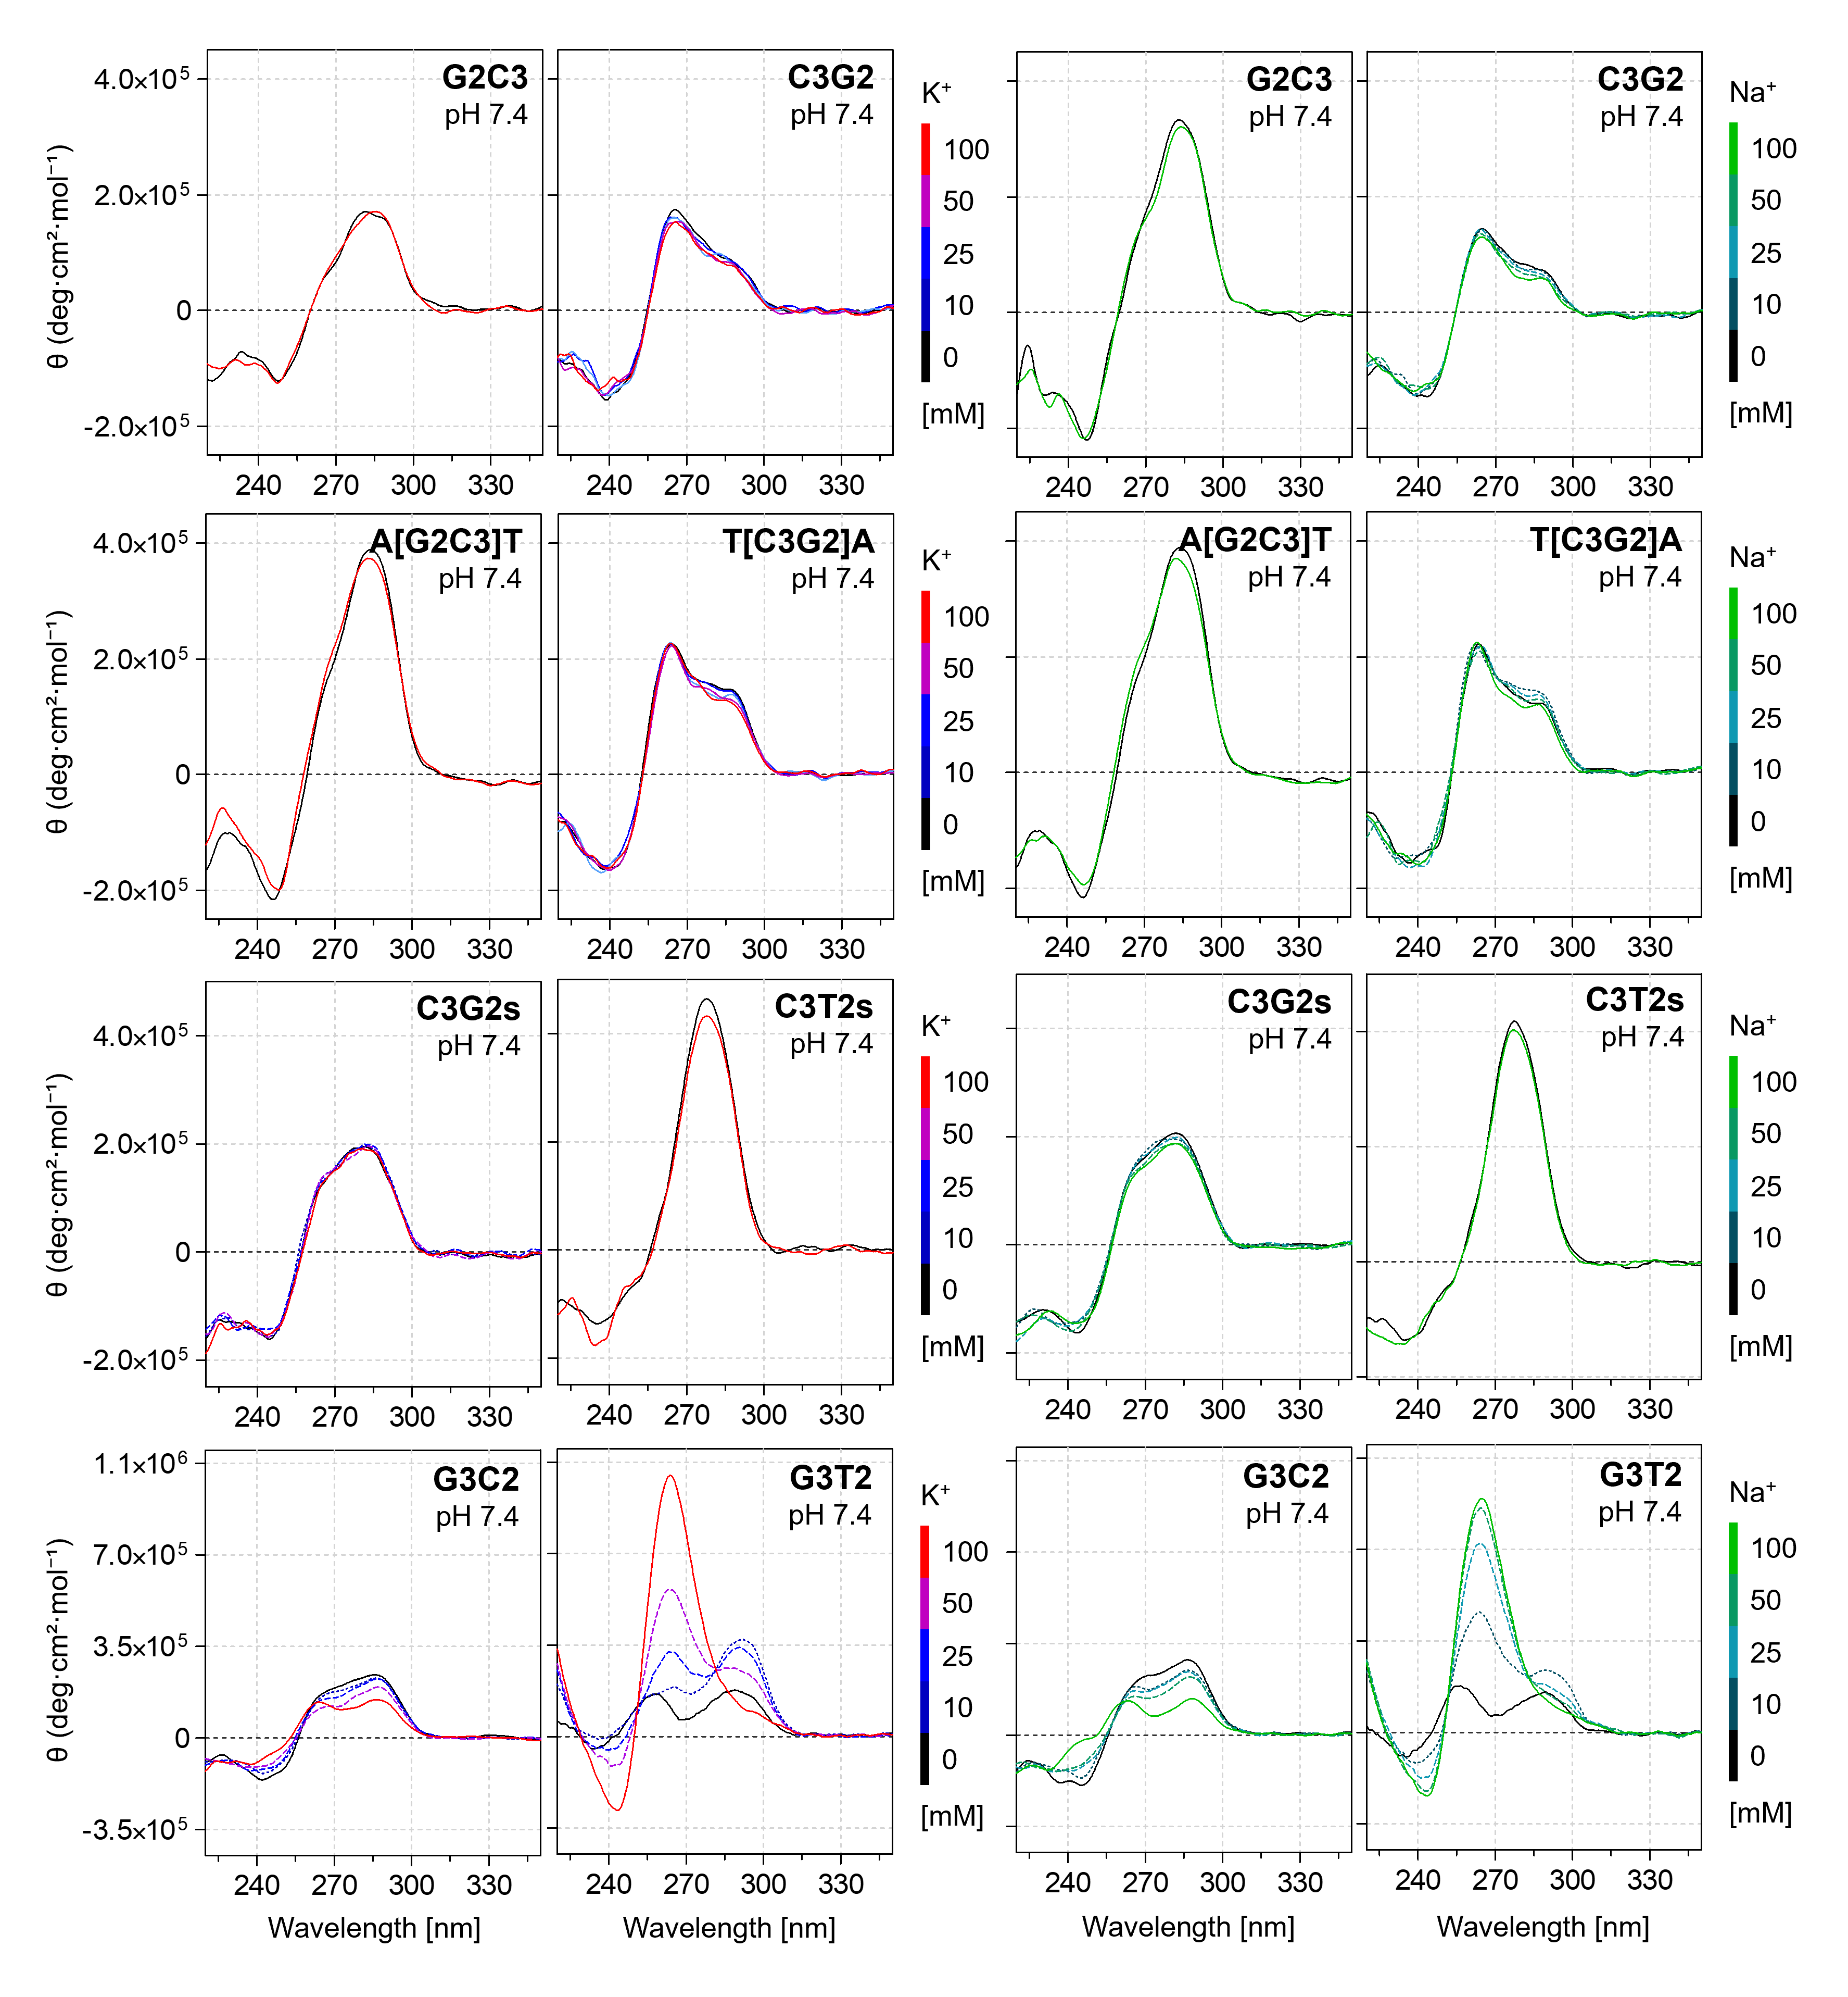
Figure S2: CD spectra of DNA in the presence of K⁺ (0–100 mM) and Na⁺ (0–100 mM), recorded in 25 mM mBR buffer at pH 7.4 (20 °C). Within each row, all spectra are displayed using the same ellipticity scale.

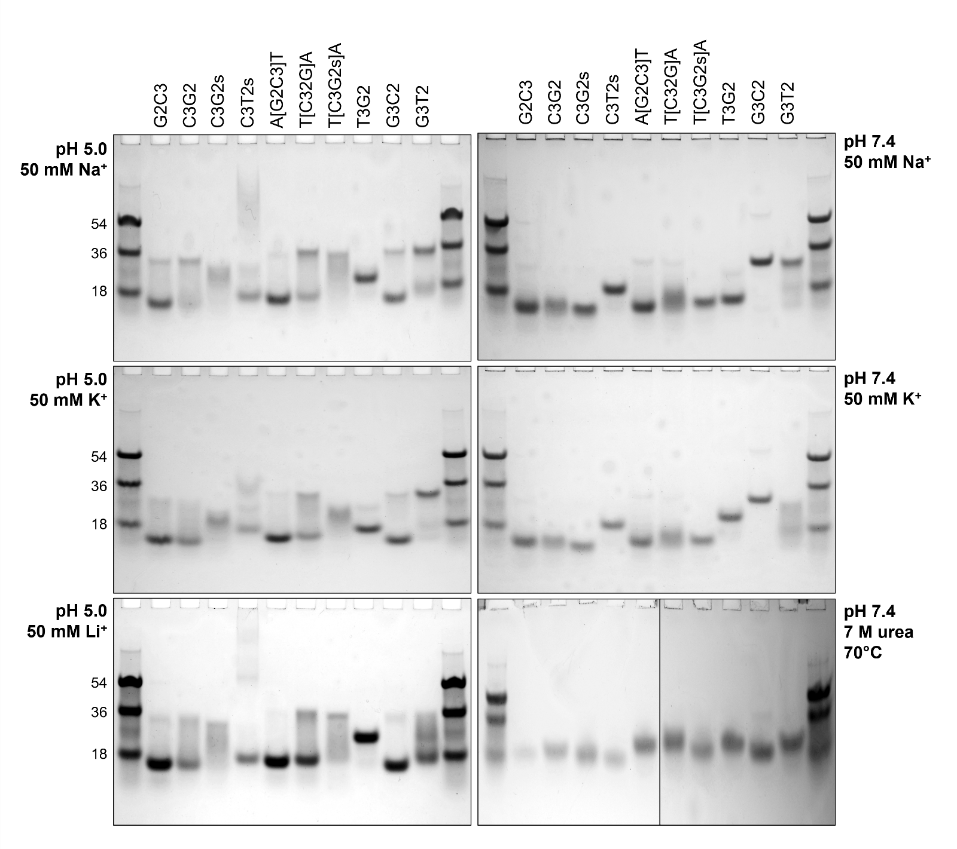
Figure S3: Non-denaturing and denaturing (7 M urea) PAGE electropherograms obtained on 12% polyacrylamide gels at 15 °C or 70 °C and at pH 5.0 or 7.4 in the presence of 50 mM Li⁺, Na⁺, or K⁺. Electrophoresis was carried out at 6 V. cm⁻¹ for 180 min (native PAGE) or 60 min (denaturing PAGE).

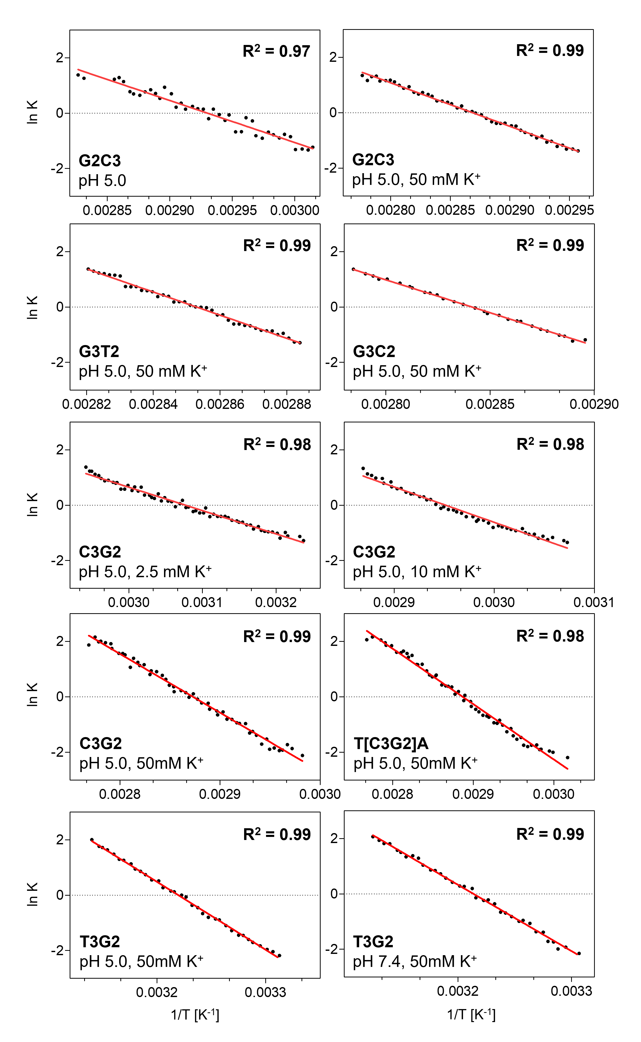
Figure S4: Van’t Hoff plots showing the linear dependence of ln K on 1/T for the analyzed DNA structures. The strong linearity of the fitted trends indicates an approximately two-state unfolding process with high thermodynamic cooperativity.
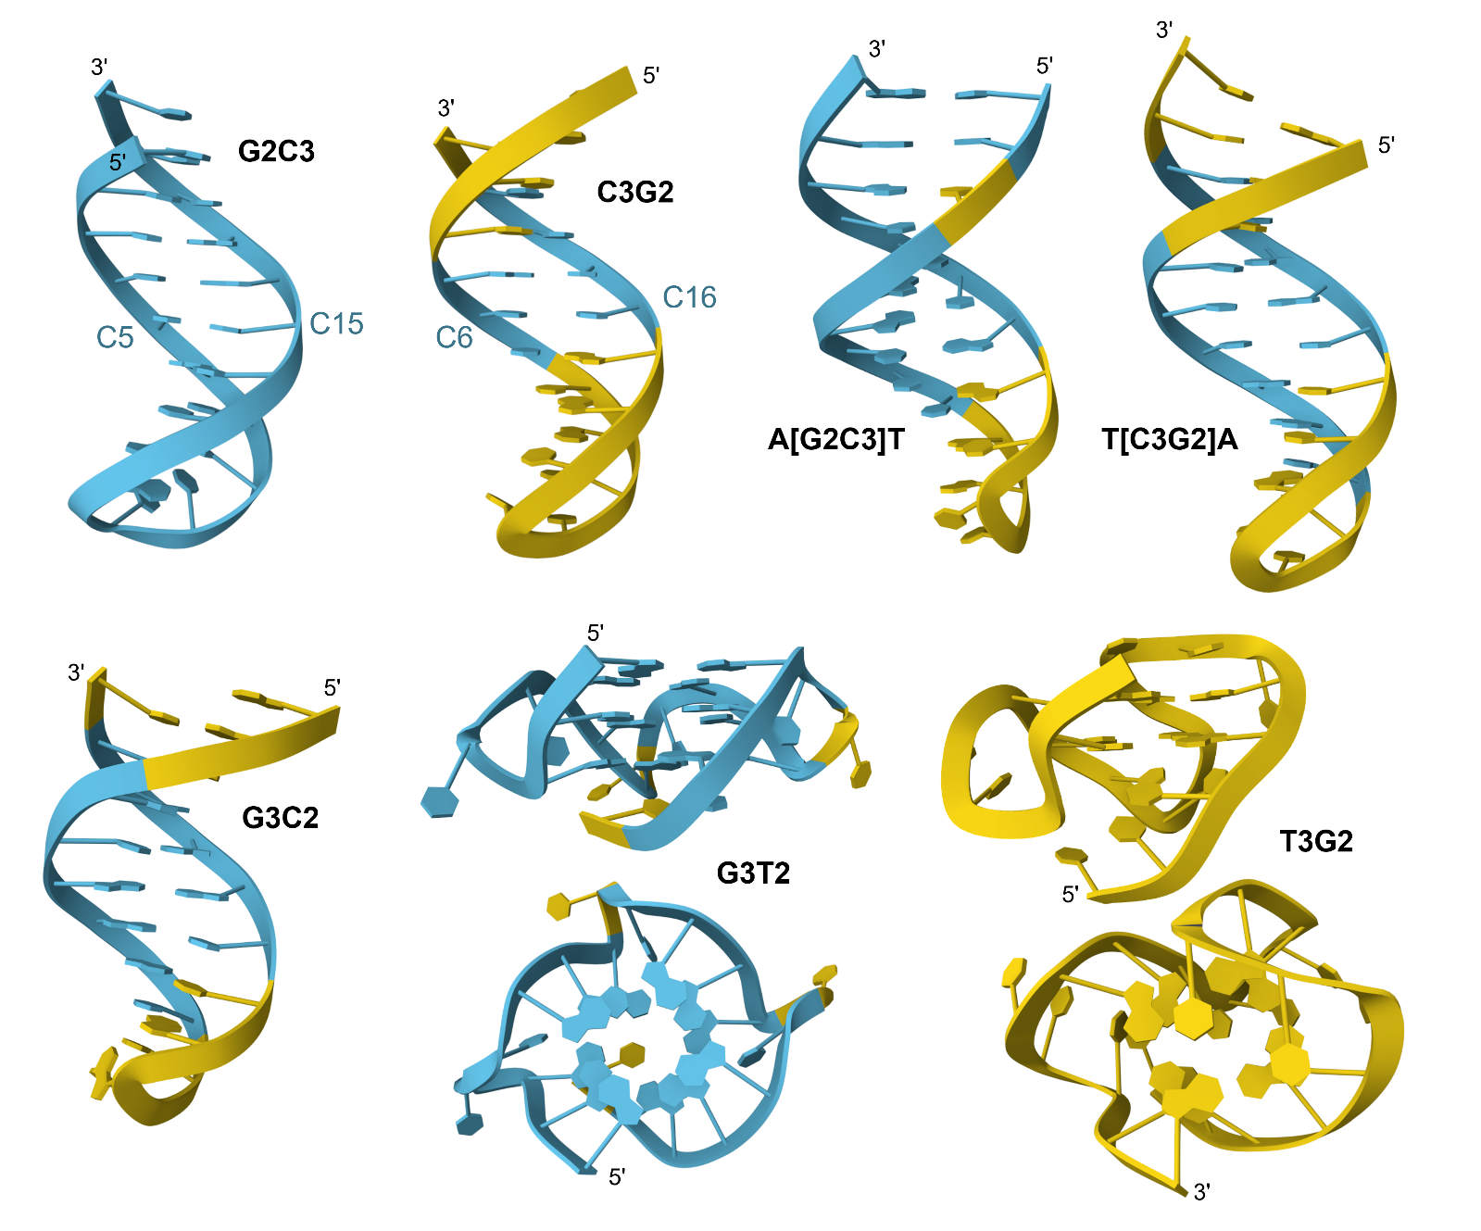
Figure S5: Structural models of the oligonucleotide constructs generated using AlphaFold. Structures are colored according to pLDDT (predicted Local Distance Difference Test) confidence scores, with light blue indicating high‑confidence regions and yellow indicating lower‑confidence regions. The blue coloration corresponds to regions with a high predicted accuracy of the structural model.

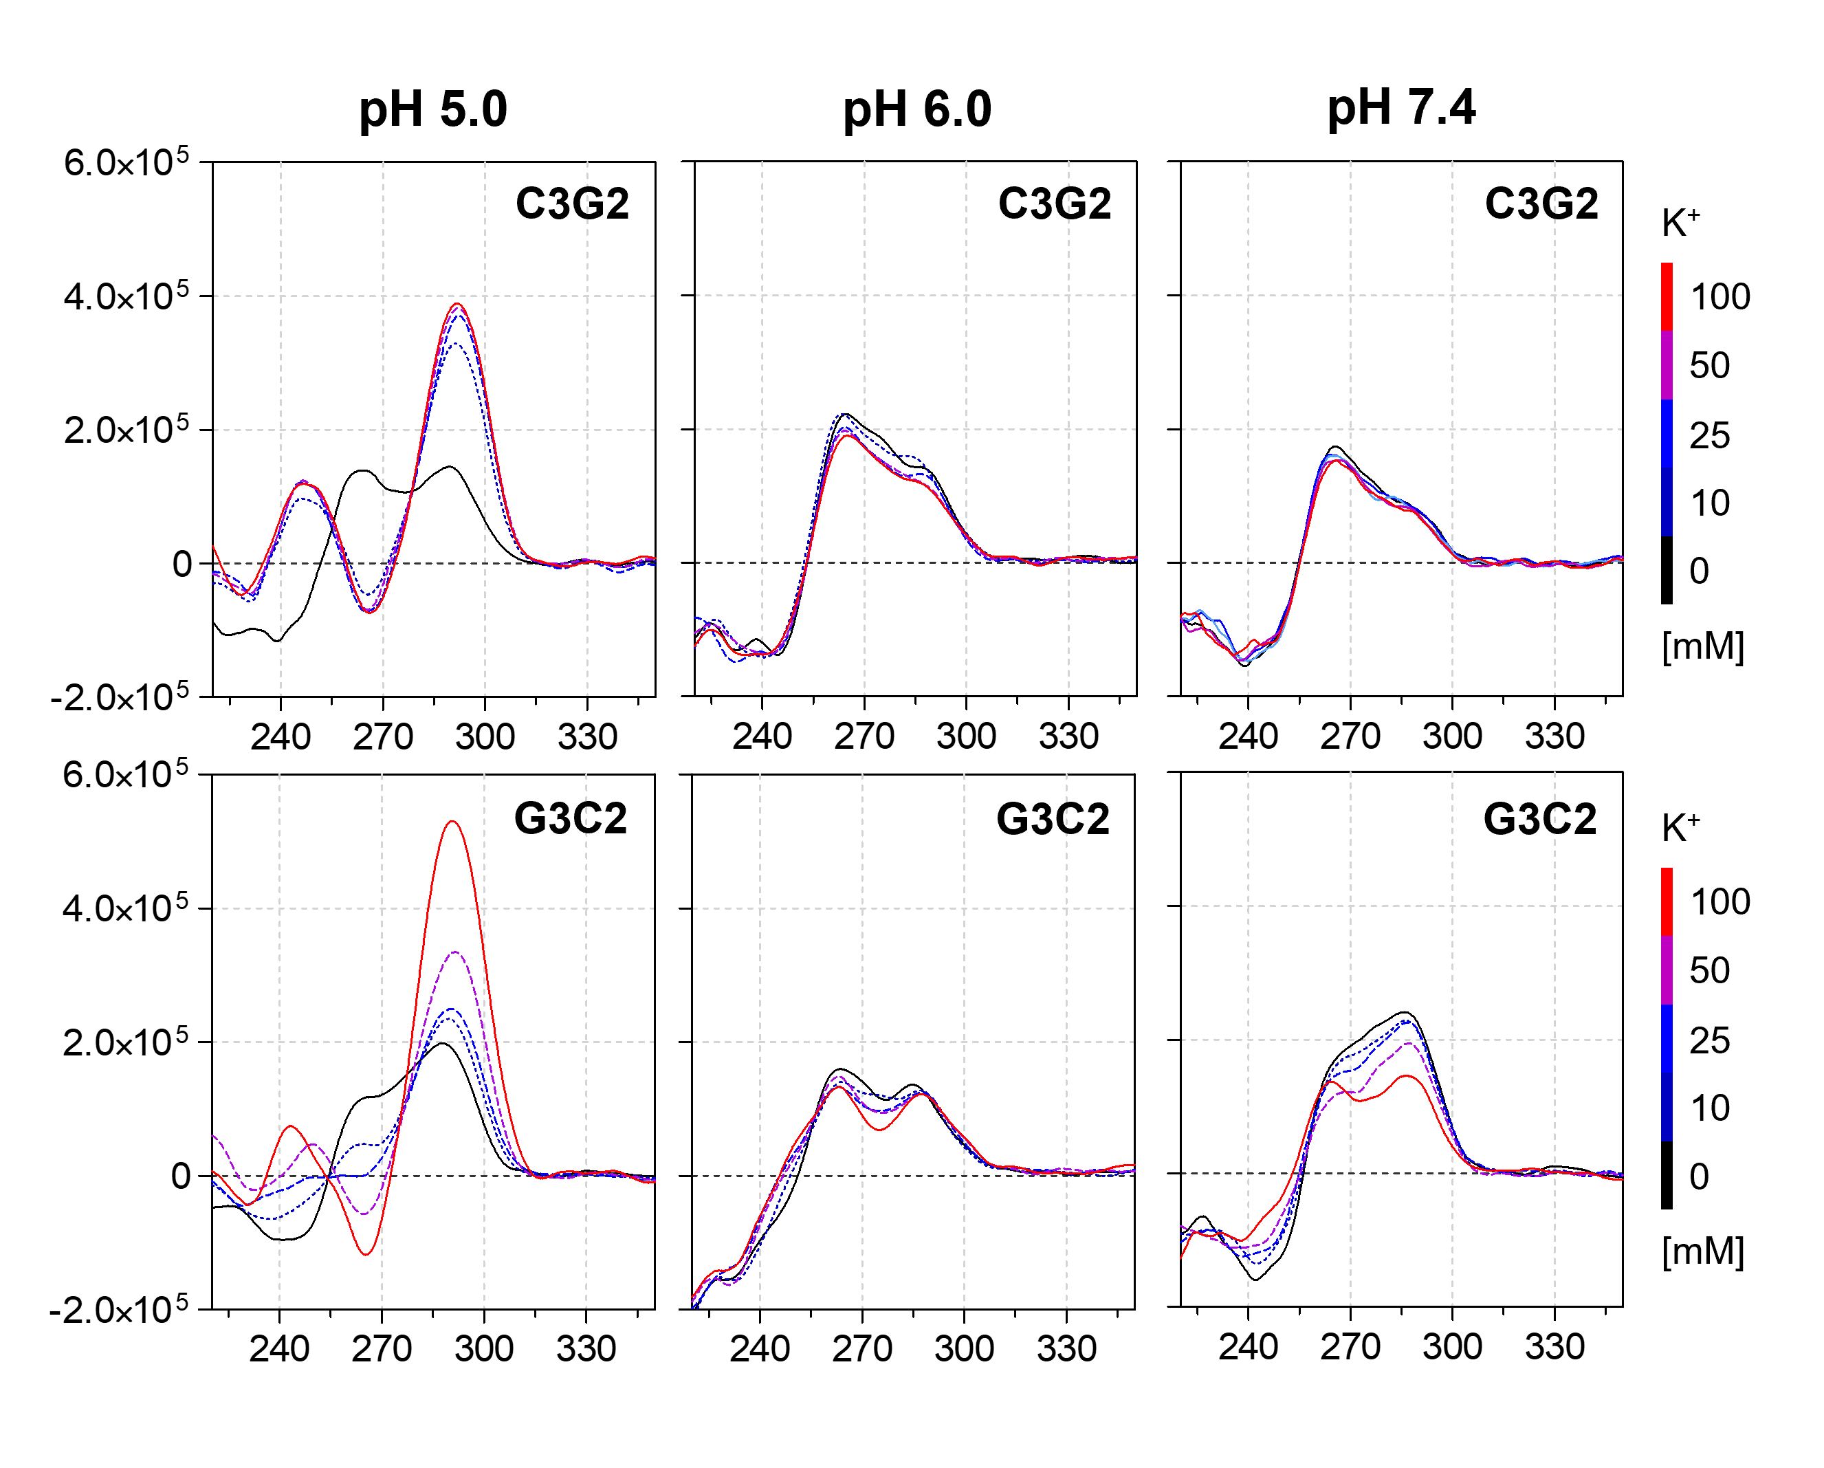
Figure S6 CD spectra of C3G2 and G3C2 titrations with K⁺ (0–100 mM) measured in 25 mM mBR buffer at pH 6.0 (20°C)

