Supporting Information
Engineered ambient-dried dialdehyde cellulose foams with programmable flexible-to-rigid architectures for thermal insulation and protective packaging
Himanshu Modi¹ , Rohit Rai¹ , and Prodyut Dhar^{1*}
¹School of Biochemical Engineering, Indian Institute of Technology (BHU), Varanasi, Uttar Pradesh 221005, India
*Corresponding author email: prodyut.bce@iitbhu.ac.in
Material and Methods
Materials:
Sodium acetate trihydrate (99%, Laboratory Reagent grade), sodium chlorite (99%), and glacial acetic acid were purchased from Molychem Pvt Ltd. Sodium metaperiodate (extra pure, 99.5%), sodium hydroxide (NaOH, 97%) and hydroxylamine hydrochloride (99%) were purchased from Sisco Research Laboratory, India (SRL, India) and were used without any further purification. Millipore water (conductivity 0.66 mΩ cm⁻¹) (Milli-Q®, Millipore, Merck) was used for the preparation of reagents. The rice straw was sourced from agricultural fields of IASc, BHU, Varanasi, Uttar Pradesh, India.
Delignification and Pulping:
20g of rice straw was treated with a 2% delignifying solution (500 mL) containing acetate buffer (pH 4.6) at 80°C for 8 hours [62,63]. The solution was discarded, and a fresh solution was added, subsequently delignified for 8 hours at 80 °C. After delignification, the rice straw was thoroughly rinsed with milipore water to remove excess salts, then dried at 40 °C in a hot-air oven. 20g of delignified and dried rice straw was treated with 1 M NaOH solution (500 mL) at 80 °C for 6 hours. Thereafter, the obtained pulp was thoroughly washed with water until the pH became neutral.
Dialdehyde modification and preparation of Dialdehyde cellulose-based foams:
The solid content of the NaOH-treated pulp was fixed at 10 wt%, followed by dialdehyde modification using sodium metaperiodate. The amount of periodate was varied to prepare dialdehyde cellulose of different charge contents (sodium metaperiodate: cellulose was fixed according to the dry weight of the rice straw pulp at 0.25:1, 0.5:1, 1:1, and 2:1). 20g of pulp (solid content ~10%) was used in each reaction, with different amounts of periodate, in 100 mL of Millipore water. The reaction was carried out in the dark to prevent photodegradation of sodium metaperiodate and was conducted at 50°C for 12 hrs. The reaction was quenched by the addition of isopropyl alcohol, followed by washing the modified cellulose 4-5 times with water. The modified cellulose pulp (solid content~ of 10%) was cast into circular moulds of dimensions (diameter-36mm and height-16mm) and dried at 50 °C for 8-10 hours.
Material Characterisation and analysis:
Apparent density and Porosity:
Density was calculated by measuring the mass of the foams, and volume was measured as the product of the foams' length and cross-sectional area. Porosity was measured according to Equation 1:
$$Porosity=1-\frac{Density of foam}{Density of cellulose} eq.1$$
Aldehyde Content:
To determine the aldehyde content of the modified cellulose, a reaction was set up according to the hydroxylamine hydrochloride method [64]. 0.1g of modified cellulose was mixed with 0.2 M (25ml) of hydroxylamine hydrochloride solution at pH ~ 3 and stirred for 3 hours. Thereafter, the mixture was titrated with 0.01 M NaOH solution until the pH reached~3, as measured with a pH meter (PC 700, EUTECH Instruments, Singapore). A negative control was prepared using non-modified cellulose, and the aldehyde content was determined as per Equation 2:
$$Aldehyde Content= \frac{\left(V_{s}-V_{b}\right) ×C_{NaOH}}{M_{c}} eq.2$$
V_{s} is the volume of NaOH used in the titration of modified cellulose, and V_{b} is the volume of NaOH consumed in the reaction with the blank. C_{NaOH} is the concentration of NaOH used, and M_{c} is the dry mass of the sample.
Attenuated Total Reflection Fourier Transformation Infrared Spectroscopy (ATR-FTIR):
Samples of modified cellulose and non-modified DRS were prepared by grinding and pressing under a hydraulic press to make a fine pellet. The analysis was performed in transmittance mode from wavenumber 4000 to 650 cm⁻¹ on an Agilent Cary 630 FTIR instrument equipped with a Zn-Se crystal, with a resolution of 4 cm⁻¹ and 64 scans, in ATR mode.
X-Ray Diffraction (XRD):
Finely powdered samples were prepared by grinding or milling of DCF foams. The samples were loaded onto a sample holder, which was placed into the XRD (Miniflex600, Rigaku, Japan). The samples were analysed over a 2𝜃 range of ~5-60 ° at a scan rate of 5° per minute and a step size of 0.01°, using CuK_{α} anode (k = 1.54 Å) at an operating voltage of 40kV and 20mA current.
Scanning Electron Microscopy (SEM):
The foams were sliced using a sharp blade and mounted on double-sided carbon tape. A conductive coating of gold and palladium was applied to the sample surface using a DSR1(UK) desk sputter coater at 200 Torr for ~180 sec. The samples were then loaded into the analysis chamber of the JCM-6000 Plus (JEOL, SEM, Japan), and analysis was carried out at an operating voltage of 15 kV.
Thermogravimetric Analysis (TGA):
Foams were powdered, and 5 mg was weighed and loaded onto a platinum holder for analysis in the Perkin Elmer STA6000 (USA). The temperature was set at a range of 25-700 °C at a heating rate of 10℃ under an inert environment, achieved by a continuous flow of nitrogen at a rate of 10 ml/min.
X-Ray Photoelectron Microscopy (XPS):
Samples were cut and pressed into pellets under a hydraulic press. For analysis, the samples were kept in a sample holder and placed inside a vacuum chamber of the K-Alpha (Thermo Fisher Scientific, USA) at 10⁻⁸-10⁻⁹ vacuum for 6-8 hours. Thereafter, it was transferred to an analysis chamber where a monochromatic X-ray source (Al Kα) with a spot size of 400 µm and an energy range of -10 eV to 1350 eV was used to get the survey spectrum, and then a high-resolution scan was performed for each element. The deconvolution was done using CasaXPS software.
Compressive Property:
To analyse the compressive and flexural strength of foams, samples with a diameter of 3.5 cm and length of 1.5 cm (for compression) and thickness of 2mm with gauge length of 10mm (for 3-point bending) were placed on the platform of the texture analyser (EZ-SX, EZ-Test, Shimadzu, Japan), which is equipped with a 500N load cell. The compression rate was set to 0.5 mm/sec, and the samples were compressed in a single-cycle mode to 50% strain to evaluate the compressive strength and modulus.
Impact Resistance:
The impact resistance of DCF foams was analysed using and Izod impact resistance test in an unnotched configuration. Rectangular foam specimens of varying width and thickness were prepared (Table S8) and mounted vertically in the sample holder, with the width of the specimen facing the pendulum. The test was performed under ambient conditions, and the energy absorbed during fracture and impact strength was measured.
$$Impact Strength=\frac{Break Energy (J)}{Width \left(m\right)×Thickness(m)} eq. 3$$
Thermal Insulation Performance:
To determine the thermal insulation property, foams were kept at two different temperatures on a hot plate (50 °C and 100 °C separately), and the change in temperature on the top surface of the foam was observed using a thermal infrared (IR) camera (FLIR C5, USA). The measurements were taken at time intervals of 0, 10, 30, 60, and 120 minutes.
Flame Retardancy:
Foams of different periodate treatments were used to determine the effect of oxidation on flame retardancy. Foam with a diameter of 30mm and a height of 15 mm was used and exposed to a control ethanol flame. The samples, including the PS foam, were put in an ethanol flame for 200 seconds, and a video of the experiment was recorded. Shrinkage percentage was calculated by measuring the change in the volume of foam after the flame test, and weight loss percentage was calculated by using an analytical weighing balance (ATX 244, Shimadzu, Japan)
DCF Box Packaging Performance Evaluation
To evaluate the performance of a DCF-based box for food packaging and for the storage of temperature-sensitive products, an equal amount of butter was placed in a DCF box and a polypropylene box to compare performance. In the DCF box, a thin sheet of paper was placed at the bottom to prevent butter from spilling or absorbing into the box. Both boxes were placed on a hot plate at 50 °C, and a thermal imaging IR camera measured the change in surface temperature of the butter.
Biodegradation of DCF
To evaluate the biodegradability, dialdehyde-modified cellulose foams were placed in garden soil at a depth of approximately ~4 cm below the soil surface. The percentage decrease in weight was measured at regular intervals of 10 days by calculating the difference between the initial and final weights, as follows.
Biodegradation (%) = $\frac{X_{1}-X_{2}}{X_{1}} × 100 \% eq.4$

Life Cycle Analysis (LCA) of the cellulose-based foam, polyurethane foam, and polystyrene foam-based packaging.
A life cycle assessment was conducted to analyse the potential environmental impacts of dialdehyde cellulose-based foam production and compare them with those of polystyrene and polyurethane foam production. In the LCA cradle-to-gate scheme of dialdehyde cellulose-based foams, rice straw generation, delignification, pulping, dialdehyde modification, and drying of foams were considered as major steps. Sodium acetate and sodium chlorite used in delignification were modelled using potassium acetate and sodium hypochlorite, respectively, assuming comparable environmental impacts given their analogous functional roles (Fig. S8). The cradle-to-gate LCA scheme of polyurethane foams includes the fabrication of polyurethane from diphenyl diisocyanate, pentane, and short-chain polyether polyols (Fig. S10). For the analysis of cradle-to-gate LCA of polystyrene foams, styrene and pentane were considered (Fig. S9). The ReCiPe (H) (ReCiPe 2016 v1.1) method was used for LCA studies, and the secondary database for impact calculation was collected from Ecoinvent version 3.8 (GaBi education database 2020). LCA was conducted in GaBi, version 9.2.1.68, and US electricity and thermal energy from hard coal are used to analyse the systems.

Figure S1: FTIR of DCF1 at various incubation time.

D.
C.
B.
A.
Figure S2: (A) XPS survey spectra of RS and DRS, (B) HR-scan of C1s of RS and DRS showing removal of lignin and reduction of peak at 288.1 eV, (C) HR-scan of O1s of RS and DRS, (D) HR-scan of Si2p of RS and DRS.
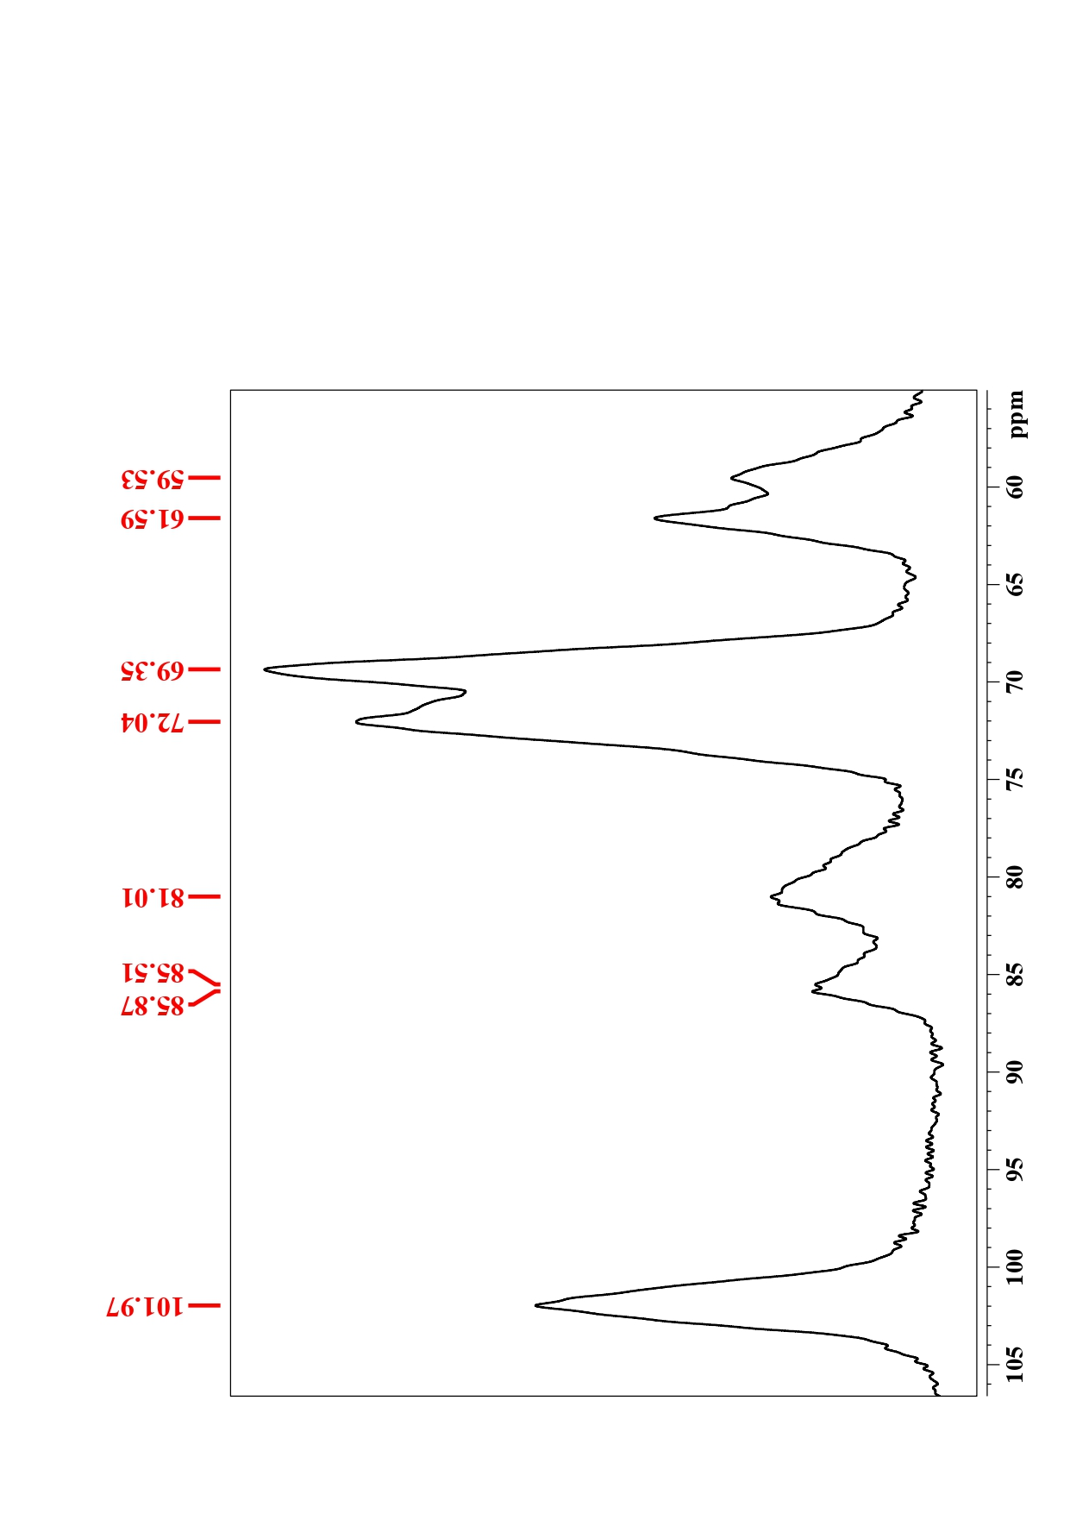
Figure S3: Solid-state NMR spectra of delignified rice straw cellulose.
A.
B.
D.
C.

Figure S4: (A) Pore size distribution in DCF 0.5, (B) pore size distribution in DCF 1, (C) pore size distribution in DCF 2, and (D) pore size distribution in DCF 4.
Figure S5: (A) graph showing volumetric shrinkage % after flame retardancy test in DCF0.5, DCF1, DCF2 and DCF4, (B) graph showing residual weight % after flame retardancy test in DCF0.5, DCF1, DCF2 and DCF4, (C) graph showing TGA analysis of DRS, DCF 0.5, DCF 1, DCF 2, and DCF 4 with two stem degradation profiles, (D) graph showing temperature rate profile for thermal imaging of DCF foams at 100℃.

Figure S6: Thermal imaging comparison of DCF at plate temperature of 50°C
Figure S7: Visual representation of biodegradation of DCF foams in garden soil.

Figure S8: Schematic representation of the cradle-to-gate production of dialdehyde cellulose foams.

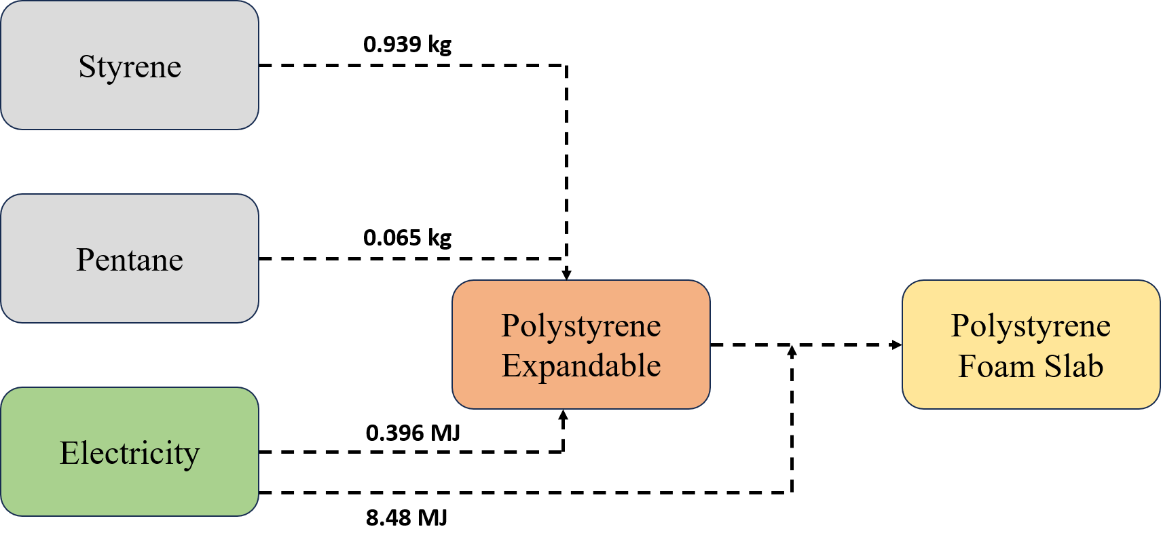
Figure S9: Schematic representation of the cradle-to-gate production of polystyrene foams.

Figure S10: Schematic representation of the cradle-to-gate production of polyurethane foams.

Table S1: XRD analysis of the DCF samples with variation in charge content.
Sample | 2θ (°) | % Crystallinity | Crystallinity Index (CI) | Crystallite Size (Å)
DRS | 16.6, 22.6 | 47.9% | 60.8% | 0.11
DCF0.5 | 16.1, 21.6, | 45.1% | 66.8% | 0.14
DCF1 | 16.1, 21.6 | 42.8% | 62.4% | 0.12
DCF2 | 16.1, 21.6 | 41.5% | 55.9% | 0.08
DCF4 | 16.1, 21.6 | 38.1% | 55.5% | 0.06

Table S2: FTIR analysis of the DCF samples with variation in charge content.
Peaks | RS | DRS | DCF 0.5 | DCF 1 | DCF 2 | DCF 4
3400 cm⁻¹ | Absent | Absent | Absent | Absent | Absent | Present
3300 cm⁻¹ | Present | Present | Present | Present | Present | Absent
2920 cm⁻¹ | Present | Present | Present | Present | Present | Present
2845 cm⁻¹ | Present | Present | Present | Present | Present | Present
1735 cm⁻¹ | Present | Absent | Absent | Absent | Absent | Absent
1640 cm⁻¹ | Present | Present | Present | Present | Present | Present
1505 cm⁻¹ | Present | Absent | Absent | Absent | Absent | Absent
1313 cm⁻¹ | Present | Present | Present | Present | Present | Present
1155 cm⁻¹ | Present | Present | Present | Present | Present | Present
1105 cm⁻¹ | Absent | Absent | Present | Present | Present | Present
1050 cm⁻¹ | Present | Present | Present | Present | Present | Present
896 cm⁻¹ | Present | Present | Present | Present | Present | Absent
880 cm⁻¹ | Absent | Absent | Absent | Absent | Absent | Present

Table S3: XPS analysis of the DCF samples with variation in charge content.
Scan | Binding Energy (eV) | Functional Group | Interpretation
Survey Scan | 102.8 | Si 2p | Silica (Si–O–Si) from rice straw
 | 285.2 | C 1s | Carbon in cellulose (C–C, C–O, C=O)
 | 532.4 | O 1s | Oxygen from cellulose hydroxyl and carbonyl groups
C 1s | ~284.3–285.0 | C–C / C–H | Cellulosic carbon backbone (aliphatic and aromatic carbons)
 | ~286.1 | C–O | Hydroxyl and ether linkages in cellulose and crosslinked DAC
 | ~287.8 | C=O | Aldehyde or carbonyl groups introduced via periodate oxidation
O 1s | 532.4 | C–O / O–C=O | Oxygen in cellulose glycosidic and hemiacetal bonds
Si 2p | 102.8 | Si–O | Silica residues from rice straw’s inherent silica content

Table S4: TGA analysis of the DCF samples with variation in charge content.
Sample | T_{onset} (°C) | T_{max} (°C) | Final Char (%) | Major thermal degradation range (°C) | Weight Loss (%)
DRS | 287.8 | 348.1 | 15.2 | 247.1–356.4 | 39.9
0.5DAC | 247.2 | 348.5 | 2.7 | 209.1–366.4 | 64.3
1DAC | 290.3 | 329.4 | 2.5 | 268.1–360.4 | 65.9
2DAC | 242.2 | 344.1 | 2.9 | 228.1–367.3 | 62.2
4DAC | 292.7 | 350.5 | 4.0 | 280.5–371.3 | 66.61

Table S5: Mechanical analysis of the DCF samples with variation in charge content.
Sample | Density (g/cm³) | Porosity (%) | Compressive Strength (MPa) | Compressive Modulus (MPa) | Flexural Strength (MPa) | Flexural Modulus (MPa)
0.5DAC | 0.13 | ~91 | 0.56 | 1.12 | 0.013 | 0.46
1DAC | 0.16 | ~89 | 0.53 | 1.06 | 0.02 | 1.58
2DAC | 0.18 | ~88 | 0.94 | 1.88 | 0.3 | 6.0
4DAC | 0.19 | ~87 | 3.8 | 7.66 | 1.27 | 15
Polyurethane Foam (PU) | 0.043 | ~96.5 | — | —
Polystyrene Foam (PS) | 0.051 | ~95.8 | — | —

Table S6: Thermal insulation analysis of the DAC samples with variation in charge content.
Sample | Base Temp (°C) | Top Surface Initial Temp (°C) | Top Surface Temp after 120 min (°C) | Temperature Difference from bottom plate (ΔT, °C)
0.5DAC | 50 | 24.3 | 34.3 | 15.7
 | 100 | 39.4 | 48.9 | 51.1
1DAC | 50 | 24.6 | 35.2 | 14.8
 | 100 | 35.1 | 53.3 | 46.7
2DAC | 50 | 25.5 | 32.7 | 17.3
 | 100 | 35.1 | 62.2 | 37.8
4DAC | 50 | 26.2 | 39.0 | 11
 | 100 | 35.9 | 70.2 | 29.8

Table S7: Sensitivity analysis of the dominant impact categories towards the change in key parameters, i.e., electricity, pre-treatment and foam-fabrication.
Categories | Electricity |  | Pre Treatment |  | Foam Fabrication
Categories | 10% Increase | 8% Decrease | 10% Increase | 8% Decrease | 10% Increase | 8% Decrease
Climate change, default, excl biogenic carbon [kg CO2 eq.] | 9.5 | -7.9 | 4.1 | -3.2 | 6.4 | -4.7
Fossil depletion [kg oil eq.] | 13.8 | -4 | 7 | 0 | 9.5 | -1.4
Freshwater Consumption [m3] | 1.41 | -0.7 | 1.41 | 0 | 1.41 | 0
Photochemical Ozone Formation, Ecosystems [kg NOx eq.] | 9.7 | -8 | 4 | -3 | 6.1 | -4.7

Table S8: Impact resistance analysis of DCF foams
Sample | Width (mm) | Thickness (mm) | Break Energy (J) | Impact Strength (KJ/m²)
DCF 0.5 | 34 | 5.70 | 0.0951 | 0.490
DCF 1 | 34 | 6.85 | 0.1295 | 0.556
DCF 2 | 30 | 4.35 | 0.1327 | 1.016
DCF 4 | 24 | 2.61 | 0.1873 | 2.990

