TITLE PAGE
Artificial Hibernation as a Novel Metabolic Therapy for Suppressing Melanoma Growth and Metastasis
Amirhosein Kefayat ^{1∞}, Niyousha Vakilzadehian ^{2,3∞}, Mahshid Bahrami ⁴, Mojtaba Karami ⁵, Fatemeh Ghahremani * ^{6,7}

¹ Institute of Genetics and Cancer, University of Edinburgh, Edinburgh, UK.
² Faculty of Medicine, University of Debrecen, Hungary.
³ Internal Medicine Department, King’s College Hospital NHS Foundation Trust, UK.
⁴ Department of Radiology, University Hospitals Sussex NHS Foundation Trust, UK.
⁵ Department of Dermatology, Tehran University of Medical Sciences, Tehran, Iran
⁶ Department of Medical Physics and Radiotherapy, Arak School of Paramedicine, Arak University of Medical Sciences, Arak, Iran.
⁷ Molecular and Medicine Research Center, Arak University of Medical Sciences, Arak, Iran.

∞ equal participation

*Correspondence: Fatemeh Ghahremani
Email: f.ghahramani@arakmu.ac.ir
Postal code: 38481-76941
Tel: +98-31-37929095
Mobile: +989183162173
Address: Sardasht, Department of Radiotherapy, Arak University of Medical Sciences

Short title: Artificial hibernation a novel therapeutic horizon in cancer

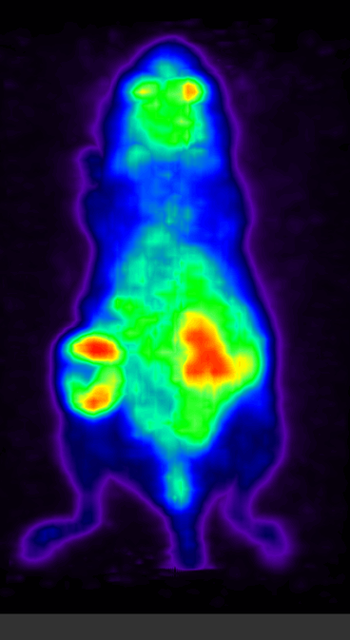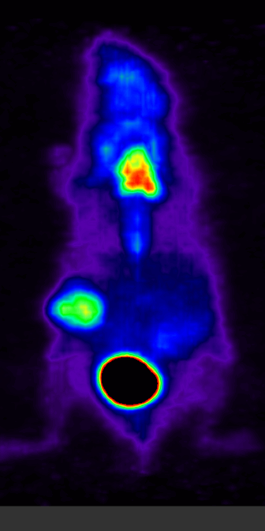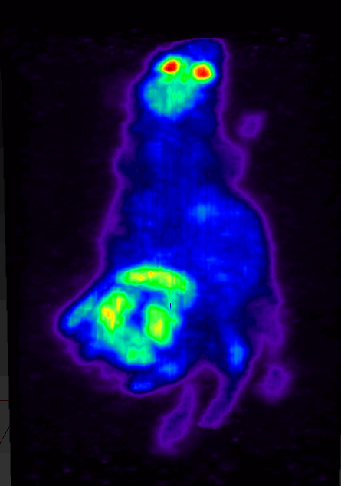
C
B
A
Figure S1. Effect of artificial hibernation on tumor metabolic activity across different tumor sizes. Figures are GIFs please play them. (A) Representative ¹⁸F-FDG PET images of non-hibernated control mice. (B) Hibernated mice bearing moderate-volume tumors (14 days post-tumor implantation). (C) Hibernated mice bearing large tumors (28 days post-implantation). All are shown in GIFs animated pictures

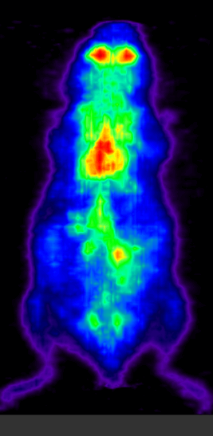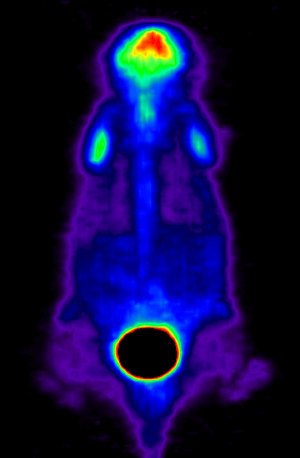
Hibernated
Non-hibernated (control)
Figure S2: Representative ¹⁸F-FDG PET images of lung metastatic nodules-bearing mice under control conditions and during artificial hibernation, shown in GIFs animated pictures. A marked reduction in whole-body metabolic activity is observed during hibernation, including reduced uptake in lung regions with metastatic involvement.

