Supplementary Information

Contrasting genome-size constraints relate to divergent elemental strategies in bryophytes and tracheophytes
Xin Song^{a*}, Helena Vallicrosa^{b,c}, Daijun Liu^{d}, Roger Grau-Andrésª, Joan Garcia-Porta^{e,f}, Alba Martín^{g}, Judith Soléª, Jordi Corbera^{h}, Catherine Preece^{i}, Guille Peguero^{j,k}, Marcos Fernández-Martínez^{a*}
Affiliations:
ª CREAF, Cerdanyola del Vallès, Barcelona, Catalonia, Spain.
^{b} Plant Ecology Research Laboratory PERL, School of Architecture, Civil and Environmental Engineering ENAC, EPFL, CH-1015 Lausanne, Switzerland
^{c} Swiss Federal Institute for Forest, Snow and Landscape Research WSL, Forest & Soil Ecology Unit, CH-8903 Birmensdorf, Switzerland
^{d} LandCRAFT - Department of Agroecology, Aarhus University, Ole Worms Allé 3, DK-8000 Aarhus, Denmark
^{e} Department of Biodiversity Ecology and Evolution, Faculty of Biological Sciences, Complutense University of Madrid, 28040 Madrid, Spain
^{f} Department of Biology, Autonomous University of Madrid, 28049 Madrid, Spain
^{g} Facultat de Farmàcia i Ciències de l’alimentació, Campus Diagonal, Universitat de Barcelona, 08028 Barcelona, Spain
^{h} Delegació de la Serralada Litoral Central, Institució Catalana d’Història Natural (ICHN), 08302 Mataró, Catalonia, Spain
^{i} Institute of Agrifood Research and Technology (IRTA), Sustainability in Biosystems Programme (IRTA), Carretera de Cabrils Km 2, 08348, Cabrils, Catalonia, Spain.
^{j} Department of Evolutionary Biology, Ecology and Environmental Sciences, Universitat de Barcelona, 08028, Barcelona, Spain.
^{k} Institut de Recerca de la Biodiversitat (IRBio), 08028, Barcelona, Spain
* Correspondence to: Xin Song: x.song@creaf.uab.cat
Marcos Fernández-Martínez: m.fernandez@creaf.uab.cat

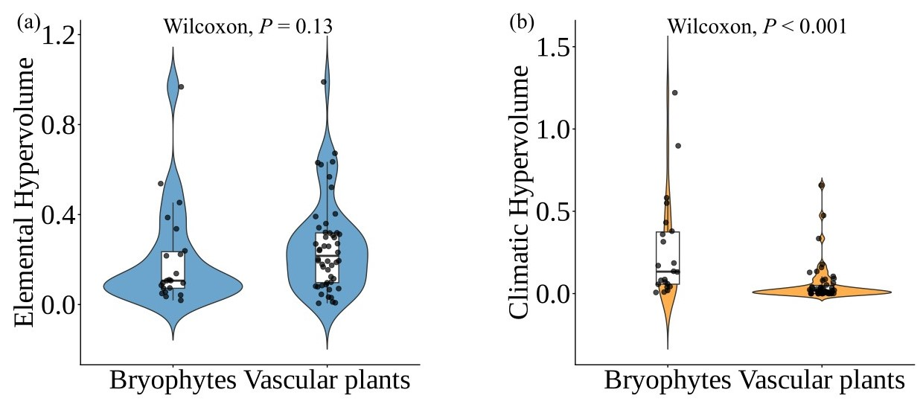
Figure S1 Distribution of elemental hypervolumes and climatic hypervolumes. The elemental hypervolumes of bryophytes are estimated with the same elements as vascular plants (C, N, P, K, Ca, and S). Panel (a) shows the distribution of elemental hypervolumes within bryophytes and vascular plants and their clade-level comparison using a Wilcoxon test. Panel (b) shows the distribution of climatic hypervolumes within bryophytes and vascular plants and their clade-level comparison using a Wilcoxon test. Only species with at least seven sampled individuals were included in this analysis. Points represent species-level estimates, and boxplots summarize the distribution within each clade.
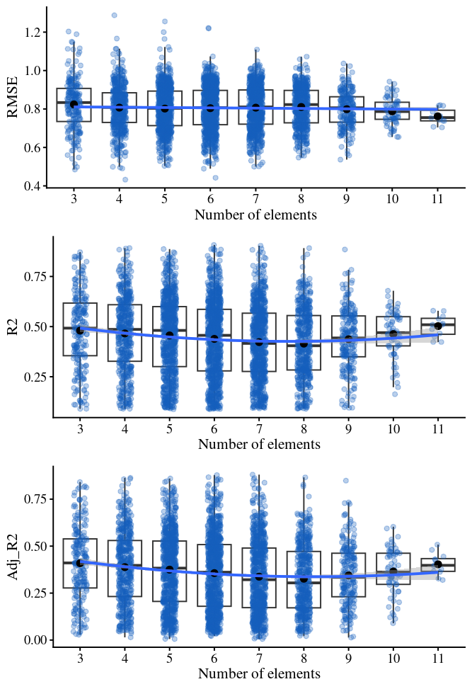
Figure S2 Relationships between element number and model performance. Each point represents an individual model. Boxplots show the median and interquartile range, with whiskers extending to 1.5 × IQR. Black circles indicate mean values for each element-number class. Model performance was evaluated using RMSE, R² and adjusted R².
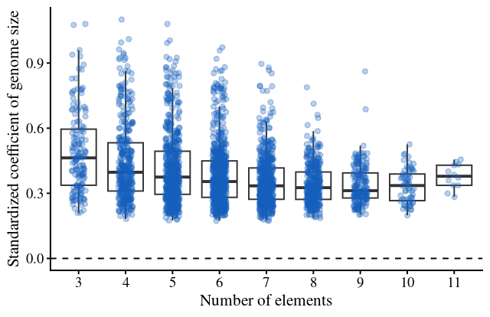
Figure S3 Variation in the standardized regression coefficient of genome size across elemental hypervolumes constructed using different numbers of elements. Each point represents an individual model. Boxplots show the median and interquartile range, and the dashed horizontal line indicates a coefficient of zero.
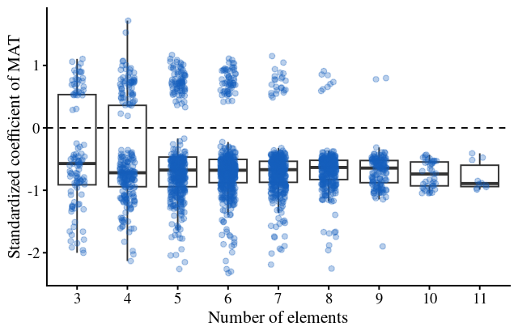
Figure S4 Variation in the standardized regression coefficient of mean annual temperature (MAT) across elemental hypervolumes constructed using different numbers of elements. Each point represents an individual model. Boxplots show the median and interquartile range, and the dashed horizontal line indicates a coefficient of zero.
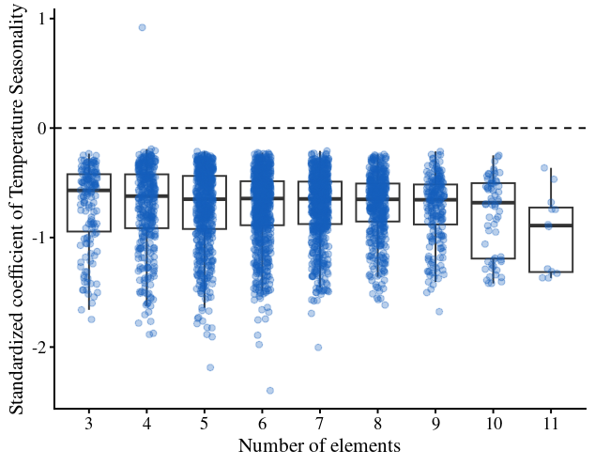
Figure S5 Variation in the standardized regression coefficient of temperature seasonality across elemental hypervolumes constructed using different numbers of elements. Each point represents an individual model. Boxplots show the median and interquartile range, and the dashed horizontal line indicates a coefficient of zero.
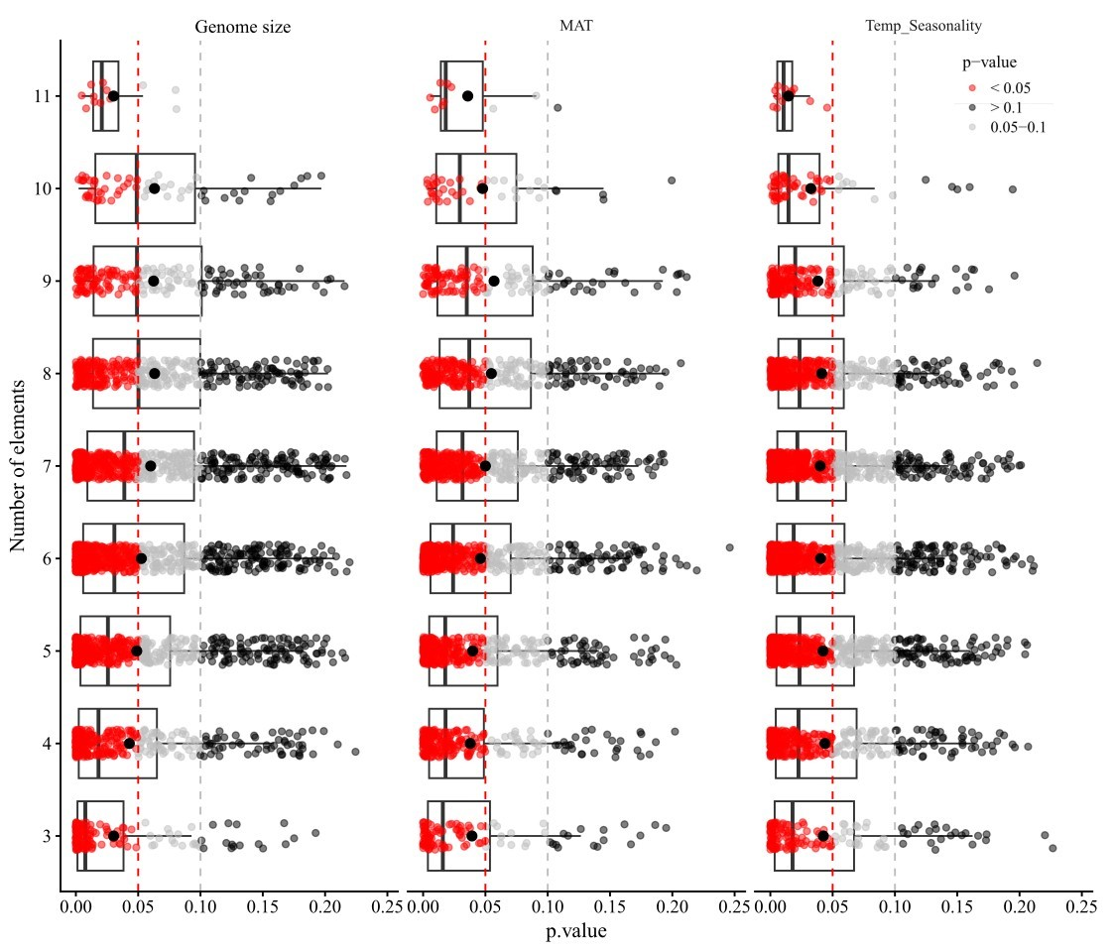
Figure S6 Distribution of p-values for the effects of genome size, mean annual temperature (MAT), and temperature seasonality on elemental hypervolume across different numbers of elements. Each point represents an individual model. Points are colored according to significance level (red: P < 0.05; grey: 0.05 < P < 0.10; black: P >0.10). Vertical dashed red lines denote P = 0.05, and grey dashed lines denote P = 0.10.

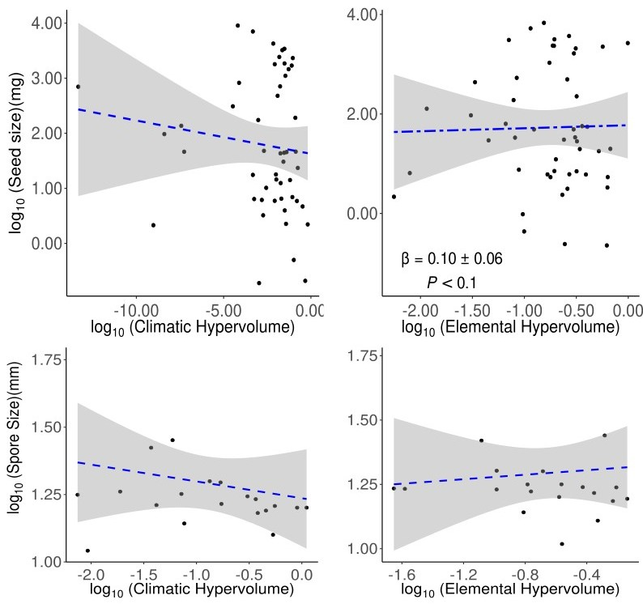
Figure S7 Partial residuals plot showing the relationship between seed size, spore size and elemental and climatic hypervolume sizes. Points represent species-level observations in bryophytes and vascular plants. Parameter estimates shown (β ± standard error of the mean) are standardized parameter estimates. The twodash line indicates a marginally significant relationship, whereas dashed lines indicate non-significant relationships. The shaded area represents the 95% confidence interval of the slopes
FigureS8 The sampling points of bryophytes in our dataset
Table S1. Species list and GenBank accession numbers of the four genes used to construct the phylogenetic tree.
 | species | 5.8S | rbcL | rps4 | trnL
1 | Abietinella abietina | 2169663317 | 4009365 | 2427670374 | 2863068849
2 | Alleniella complanata | 347551634 | NA | 2557505431 | 2557505431
3 | Anomodon viticulosus | 2327860836 | 1729914035 | 407226781 | 1729914293
4 | Anthoceros punctatus | 1632390097 | 2149476 | 751137950 | 39981092
5 | Apopellia endiviifolia | 2502714010 | 2217808967 | 1695978279 | 2566362640
6 | Atrichum undulatum | 39980026 | 1565130006 | 92417450 | 5326682
7 | Bartramia pomiformis | 562814797 | 6329173 | 575396247 | 1940100552
8 | Brachythecium rivulare | 571264635 | 6329631 | 294337081 | 1729914294
9 | Brachythecium rutabulum | 571264640 | 1347830033 | 261279028 | 261279082
10 | Bryum capillare | 12057173 | 27227896 | 23504372 | 23986685
11 | Bryum pseudotriquetrum | 2553988731 | 2217808821 | 323370861 | 23986692
12 | Campylopus introflexus | 2415514847 | 1269216667 | 2512039083 | 1337019346
13 | Campylopus pilifer | 2415514846 | 1269216649 | NA | 259121829
14 | Chiloscyphus polyanthos | 118402665 | 37195334 | 1818990872 | 37195362
15 | Cinclidotus riparius | 1949530582 | 2026603363 | 2209436979 | 307148959
16 | Conocephalum conicum | NA | 184186045 | 59803294 | 5326685
17 | Cratoneuron filicinum | 1772723191 | 30348357 | 67035920 | 1863493929
18 | Cryphaea heteromalla | 443254579 | NA | 92417460 | 33333376
19 | Ctenidium molluscum | 33308564 | 6329409 | 63191658 | 1722502732
20 | Dicranum scoparium | 1563273650 | 156143116 | 2497511671 | 2497511671
21 | Didymodon acutus | 2042164095 | 2026603564 | 751251062 | 2428632154
22 | Didymodon luridus | 41058847 | 831250554 | 28194668 | 387165356
23 | Didymodon tophaceus | 1949530835 | 2026604041 | 1402243825 | 387165351
24 | Encalypta vulgaris | 2245340857 | 2442286395 | 2442286419 | 158991498
25 | Eucladium verticillatum | 61743185 | 1060603177 | 63078572 | 1060603458
26 | Exsertotheca crispa | 2327860927 | 92417430 | 303228130 | 347597402
27 | Fissidens grandifrons | 2777349142 | 1280963458 | 1280963566 | 2174819631
28 | Fissidens taxifolius | 444224607 | 444226262 | 92417454 | 2174819629
29 | Flexitrichum gracile | NA | NA | 2497511679 | 2497511679
30 | Fontinalis antipyretica | 2327860896 | 15383636 | 3098227 | 1900356693
31 | Frullania dilatata | 312191790 | 32263892 | 1695978271 | 2671521634
32 | Grimmia laevigata | 164470624 | 12005066 | 20531112 | 20162008
33 | Grimmia lisae | NA | NA | 77019180 | 1108658276
34 | Grimmia orbicularis | 164470632 | 55785630 | 77019190 | 1108658274
35 | Grimmia pulvinata | 164470638 | 55785634 | 2497511681 | 2497511681
36 | Hedwigia ciliata | 755571319 | 12005054 | 12330545 | 1153219728
37 | Homalothecium lutescens | 33308574 | 155970757 | 407226791 | 1600731905
38 | Homalothecium sericeum | 33308519 | 155970833 | 294337169 | 1600731910
39 | Hylocomium splendens | 695115002 | 6329431 | 695114767 | 33307448
40 | Hypnum cupressiforme | 1774863652 | 9967370 | 294337181 | 1722502766
41 | Leptodictyum riparium | 2157159280 | 1722502677 | 63191684 | 1722502833
42 | Leptodon smithii | 347551631 | 308170729 | 294337191 | 347551762
43 | Leucodon sciuroides | 695115018 | 30578140 | 294337195 | 1729914359
44 | Lewinskya acuminata | 1057485929 | 1433462505 | 1057485976 | 1430919559
45 | Lewinskya affinis | 2798691857 | 2095391295 | 2812427161 | 1430919516
46 | Lewinskya rupestris | 1896454853 | 2095391285 | 2095391532 | 1430919567
47 | Lewinskya striata | 1896454856 | 2095391298 | 2095391570 | 1430919529
48 | Lophocolea bidentata | 1844121824 | 450343175 | 445069976 | 37195351
49 | Lunularia cruciata | 2327860797 | 2149504 | 59803302 | 9588041
50 | Marchantia polymorpha | 222103107 | 2149508 | 486172077 | 222103178
51 | Mnium spinosum | NA | 1226142173 | 323370849 | 323370896
52 | Mnium stellare | NA | 1394503755 | 323370850 | 323370897
53 | Nogopterium gracile | 1772365589 | 1729914251 | 63191690 | 1729914362
54 | Orthotrichum anomalum | 1896454858 | 2095391304 | 12330491 | 1430919511
55 | Orthotrichum diphanum/ Orthotrichum hallii | 1565064535 | 1565064485 | 1565064581 | 1565064618
56 | Oxyrrhynchium speciosum | 2597814349 | 1600731819 | NA | 2802672500
57 | Palustriella commutata | 1772723193 | 1863493908 | 67035906 | 13897902
58 | Palustriella decipiens | 61677633 | 1863493905 | NA | 1863493926
59 | Palustriella falcata | 14279130 | 1863493908 | 67035906 | 1863493927
60 | Philonotis fontana | 755571306 | 2554169965 | 140083428 | 2554169852
61 | Philonotis marchica | 562814819 | 2554169879 | 548954735 | 452107569
62 | Philonotis seriata | 1907691731 | 2554169882 | NA | 2554169822
63 | Plagiochila porelloides | 1143619271 | 56694574 | 48527404 | 671727681
64 | Plagiomnium cuspidatum | 217426440 | 1226142164 | 29422376 | 222103242
65 | Plagiomnium rostratum | 121761473 | 1566526124 | 121761762 | 73746422
66 | Plagiomnium undulatum | 2327860809 | 289541201 | 261279046 | 261279094
67 | Plagiothecium cavifolium | 1907691707 | 610663780 | 610664116 | 356692700
68 | Plasteurhynchium meridionale | 238652978 | 1600731805 | 50235323 | 238654788
69 | Platyhypnidium riparioides | 77386104 | 6230507 | 67036015 | 33307455
70 | Pogonatum urnigerum | 2327860817 | 1565130008 | 293634058 | 293634181
71 | Polytrichum commune | 2327860877 | 156143193 | 293634118 | 20161991
72 | Polytrichum formosum | 39980028 | 218157191 | 261279040 | 261279092
73 | Polytrichum juniperinum | 1242597003 | 156143195 | 222103519 | 222103243
74 | Porella arboris vitae | 379772455 | 379772433 | NA | 379772462
75 | Porella platyphylla | 379772756 | 379772612 | 445070002 | 379772836
76 | Pseudoscleropodium purum | 1774863575 | 11037232 | 7576560 | 33307405
77 | Ptychomitrium polyphyllum | NA | NA | NA | 764155120
78 | Ptychostomum schleicheri | NA | NA | 323370873 | 323370909
79 | Pulvigera lyellii | 1896454865 | 2095391326 | 2095391600 | 1430919504
80 | Radula complanata | 32709083 | 450343222 | 49182786 | 631228060
81 | Rhizomnium punctatum | NA | 20531028 | 323370853 | 323370899
82 | Rhodobryum roseum | 217426453 | NA | 24473825 | 124263549
83 | Rhynchostegium megapolitanum | 238652876 | 1600731855 | NA | 238654806
84 | Rhytidiadelphus triquetrus | 353468604 | 6329558 | 67035977 | 353468786
85 | Rhytidium rugosum | 927239348 | 1729914278 | 2427670427 | 1729914370
86 | Riccardia chamedryfolia | 1315116578 | NA | 2430935627 | 1354636793
87 | Scapania undulata | 2044077425 | 37195312 | 42556497 | 373428192
88 | Schistidium apocarpum | 408476264 | 322719398 | 2330521463 | 261279095
89 | Scleropodium touretii | 314906396 | 50253754 | 50235343 | 33307401
90 | Scorpiurium circinatum | 33308530 | 1729914281 | 50235329 | 1722502845
91 | Sphagnum capillifolium | 49239160 | 1042070352 | 1795742539 | 68164074
92 | Sphagnum rubellum | 49239178 | 1795742532 | 1795742540 | 68144213
93 | Syntrichia fragilis | 2199077206 | 2557703084 | 2557719488 | 638916986
94 | Syntrichia montana | 691194355 | 2557703088 | 2557719706 | 2546778396
95 | Syntrichia papillosa | 2199077217 | 2557703099 | 2557719576 | 2209419168
96 | Syntrichia ruralis | 1949530592 | 2026603390 | 1886438225 | 307148962
97 | Thamnobryum alopecurum | 2327860826 | 2240415772 | 294337272 | 16554882
98 | Thuidium delicatulum | 2327860811 | 695114808 | 695114697 | 695114628
99 | Thuidium tamariscium/ Thuidium thermophilum | 148832185 | NA | 2427670451 | 148832184
100 | Tortella flavovirens | 61743207 | 2208388796 | 63078618 | 63078683
101 | Tortella inclinata | 61743213 | 63078531 | 63078629 | 63078688
102 | Tortella nitida | 61743214 | 1060603285 | 63078631 | 1060603499
103 | Tortella squarrosa | 1060603563 | 1060603251 | 33413240 | 1060603488
104 | Tortella tortuosa | 61743217 | 1060603224 | 2462723638 | 1060603478
105 | Tortula muralis | 1949530590 | 2026603378 | 26421818 | 307148961
106 | Trichostomum crispulum | 2177156429 | 1060603215 | 28194720 | 1060603473
107 | Zygodon rupestris | 2308269518 | 1433462361 | 2430290086 | 1430919508

Table S2 Intraclass correlation coefficients (ICC) evaluating agreement among four thresholds (7, 8, 9, 10) for the hypervolumes estimations. ICC values > 0.90 indicate excellent agreement. Values are reported with 95% confidence intervals.
 | type | ICC | F | df1 | df2 | P | lower bound | upper bound
Single_raters_absolute | ICC1* | 0,87 | 27 | 21 | 66 | <0,001 | 0,77 | 0,93
Single_random_raters | ICC2* | 0,87 | 62 | 21 | 63 | <0,001 | 0,63 | 0,95
Single_fixed_raters | ICC3* | 0,94 | 62 | 21 | 63 | <0,001 | 0,89 | 0,97
Average_raters_absolute | ICC1k* | 0,96 | 27 | 21 | 66 | <0,001 | 0,93 | 0,98
Average_random_raters | ICC2k* | 0,96 | 62 | 21 | 63 | <0,001 | 0,87 | 0,99
Average_fixed_raters | ICC3k* | 0,98 | 62 | 21 | 63 | <0,001 | 0,97 | 0,99
* ICC1 is sensitive to differences in means between raters and is a measure of absolute agreement. ICC2 and ICC3 remove mean differences between judges but are sensitive to interactions of raters by judges. The difference between ICC2 and ICC3 is whether raters are seen as fixed or random effects. ICC1k, ICC2k, ICC3K reflect the means of k raters.

Table S3. Leave-one-out sensitivity analysis for phylogenetic regression models of vascular plants. To assess whether the phylogenetic regression results were driven by any single species, we performed a leave-one-out sensitivity analysis. Each species was sequentially removed from the dataset, the corresponding tip was dropped from the phylogeny, and the phylogenetic linear model was refitted using the same model structure and Pagel’s λ model. We then compared the direction, standardized regression coefficients, standard errors, and statistical significance of predictors with those from the full model.
Species  removed | Beta  full | P  full | Beta  After  removal | Se  After  removal | P  After  removal | Delta  beta | Percent  Change  beta | Direction  changed | Significance  changed
Terminalia glaucescens | 0,50 | 0,00 | 0,38 | 0,14 | 0,01 | -0,12 | 23,53 | FALSE | FALSE
Pinus brutia | 0,50 | 0,00 | 0,54 | 0,12 | 0,00 | 0,04 | 9,07 | FALSE | FALSE
Picea glauca | 0,50 | 0,00 | 0,53 | 0,13 | 0,00 | 0,04 | 7,44 | FALSE | FALSE
Abies balsamea | 0,50 | 0,00 | 0,52 | 0,13 | 0,00 | 0,02 | 4,99 | FALSE | FALSE
Pseudolmedia laevis | 0,50 | 0,00 | 0,52 | 0,13 | 0,00 | 0,02 | 4,86 | FALSE | FALSE
Combretum glutinosum | 0,50 | 0,00 | 0,51 | 0,13 | 0,00 | 0,02 | 3,54 | FALSE | FALSE
Guarea kunthiana | 0,50 | 0,00 | 0,48 | 0,13 | 0,00 | -0,02 | 3,39 | FALSE | FALSE
Betula pendula | 0,50 | 0,00 | 0,51 | 0,13 | 0,00 | 0,01 | 2,78 | FALSE | FALSE
Persicaria amphibia | 0,50 | 0,00 | 0,48 | 0,13 | 0,00 | -0,01 | 2,38 | FALSE | FALSE
Populus alba | 0,50 | 0,00 | 0,51 | 0,13 | 0,00 | 0,01 | 1,88 | FALSE | FALSE
Guatteria amplifolia | 0,50 | 0,00 | 0,50 | 0,13 | 0,00 | 0,01 | 1,70 | FALSE | FALSE
Garcinia madruno | 0,50 | 0,00 | 0,50 | 0,13 | 0,00 | 0,01 | 1,47 | FALSE | FALSE
Pinus pinaster | 0,50 | 0,00 | 0,49 | 0,13 | 0,00 | -0,01 | 1,47 | FALSE | FALSE
Chrysophyllum argenteum | 0,50 | 0,00 | 0,49 | 0,13 | 0,00 | -0,01 | 1,45 | FALSE | FALSE
Pinus taeda | 0,50 | 0,00 | 0,49 | 0,13 | 0,00 | -0,01 | 1,30 | FALSE | FALSE
Picea abies | 0,50 | 0,00 | 0,49 | 0,13 | 0,00 | -0,01 | 1,26 | FALSE | FALSE
Pinus nigra | 0,50 | 0,00 | 0,49 | 0,13 | 0,00 | -0,01 | 1,19 | FALSE | FALSE
Pinus radiata | 0,50 | 0,00 | 0,50 | 0,13 | 0,00 | 0,01 | 1,16 | FALSE | FALSE
Potamogeton natans | 0,50 | 0,00 | 0,49 | 0,13 | 0,00 | -0,01 | 1,11 | FALSE | FALSE
Juniperus thurifera | 0,50 | 0,00 | 0,50 | 0,13 | 0,00 | 0,01 | 1,11 | FALSE | FALSE
Quercus cerris | 0,50 | 0,00 | 0,49 | 0,13 | 0,00 | -0,01 | 1,05 | FALSE | FALSE
Manilkara bidentata | 0,50 | 0,00 | 0,49 | 0,13 | 0,00 | 0,00 | 0,92 | FALSE | FALSE
Nothofagus antarctica | 0,50 | 0,00 | 0,50 | 0,13 | 0,00 | 0,00 | 0,90 | FALSE | FALSE
Abies alba | 0,50 | 0,00 | 0,49 | 0,13 | 0,00 | 0,00 | 0,88 | FALSE | FALSE
Jacaranda copaia | 0,50 | 0,00 | 0,49 | 0,13 | 0,00 | 0,00 | 0,55 | FALSE | FALSE
Fagus sylvatica | 0,50 | 0,00 | 0,49 | 0,13 | 0,00 | 0,00 | 0,52 | FALSE | FALSE
Picea sitchensis | 0,50 | 0,00 | 0,49 | 0,13 | 0,00 | 0,00 | 0,50 | FALSE | FALSE
Sapium glandulosum | 0,50 | 0,00 | 0,49 | 0,13 | 0,00 | 0,00 | 0,48 | FALSE | FALSE
Quercus robur | 0,50 | 0,00 | 0,50 | 0,13 | 0,00 | 0,00 | 0,47 | FALSE | FALSE
Dendropanax arboreus | 0,50 | 0,00 | 0,50 | 0,13 | 0,00 | 0,00 | 0,47 | FALSE | FALSE
Quercus ilex | 0,50 | 0,00 | 0,49 | 0,13 | 0,00 | 0,00 | 0,44 | FALSE | FALSE
Quercus petraea | 0,50 | 0,00 | 0,50 | 0,13 | 0,00 | 0,00 | 0,41 | FALSE | FALSE
Quercus faginea | 0,50 | 0,00 | 0,49 | 0,13 | 0,00 | 0,00 | 0,40 | FALSE | FALSE
Carpinus betulus | 0,50 | 0,00 | 0,49 | 0,13 | 0,00 | 0,00 | 0,39 | FALSE | FALSE
Pinus sylvestris | 0,50 | 0,00 | 0,49 | 0,13 | 0,00 | 0,00 | 0,35 | FALSE | FALSE
Protium decandrum | 0,50 | 0,00 | 0,49 | 0,13 | 0,00 | 0,00 | 0,27 | FALSE | FALSE
Pseudotsuga menziesii | 0,50 | 0,00 | 0,49 | 0,13 | 0,00 | 0,00 | 0,27 | FALSE | FALSE
Quercus suber | 0,50 | 0,00 | 0,49 | 0,13 | 0,00 | 0,00 | 0,26 | FALSE | FALSE
Quercus frainetto | 0,50 | 0,00 | 0,50 | 0,13 | 0,00 | 0,00 | 0,24 | FALSE | FALSE
Pinus mugo | 0,50 | 0,00 | 0,50 | 0,13 | 0,00 | 0,00 | 0,16 | FALSE | FALSE
Arbutus unedo | 0,50 | 0,00 | 0,50 | 0,13 | 0,00 | 0,00 | 0,15 | FALSE | FALSE
Pinus contorta | 0,50 | 0,00 | 0,50 | 0,13 | 0,00 | 0,00 | 0,15 | FALSE | FALSE
Pinus halepensis | 0,50 | 0,00 | 0,50 | 0,13 | 0,00 | 0,00 | 0,14 | FALSE | FALSE
Castanea sativa | 0,50 | 0,00 | 0,50 | 0,13 | 0,00 | 0,00 | 0,11 | FALSE | FALSE
Veronica undulata | 0,50 | 0,00 | 0,50 | 0,13 | 0,00 | 0,00 | 0,10 | FALSE | FALSE
Micropholis venulosa | 0,50 | 0,00 | 0,50 | 0,13 | 0,00 | 0,00 | 0,10 | FALSE | FALSE
Eschweilera coriacea | 0,50 | 0,00 | 0,50 | 0,13 | 0,00 | 0,00 | 0,09 | FALSE | FALSE
Larix decidua | 0,50 | 0,00 | 0,50 | 0,13 | 0,00 | 0,00 | 0,03 | FALSE | FALSE
Robinia pseudoacacia | 0,50 | 0,00 | 0,50 | 0,13 | 0,00 | 0,00 | 0,02 | FALSE | FALSE
Licania alba | 0,50 | 0,00 | 0,50 | 0,13 | 0,00 | 0,00 | 0,01 | FALSE | FALSE
Table S4. Leave-one-out sensitivity analysis for phylogenetic regression models of bryophytes. To assess whether the phylogenetic regression results were driven by any single species, we performed a leave-one-out sensitivity analysis. Each species was sequentially removed from the dataset, the corresponding tip was dropped from the phylogeny, and the phylogenetic linear model was refitted using the same model structure and Pagel’s λ model. We then compared the direction, standardized regression coefficients, standard errors, and statistical significance of predictors with those from the full model.
Species  removed | Beta  full | P  full | Beta  After  removal | Se  After  removal | P  After  removal | Delta  beta | Percent  Change  beta | Direction  changed | Significance  changed
Hedwigia ciliata | 0,02 | 0,92 | -0,15 | 0,22 | 0,51 | -0,17 | 835,06 | TRUE | FALSE
Conocephalum conicum | 0,02 | 0,92 | 0,13 | 0,20 | 0,54 | 0,11 | 527,66 | FALSE | FALSE
Apopellia endiviifolia | 0,02 | 0,92 | -0,07 | 0,18 | 0,71 | -0,09 | 431,82 | TRUE | FALSE
Homalothecium sericeum | 0,02 | 0,92 | 0,11 | 0,22 | 0,63 | 0,09 | 427,87 | FALSE | FALSE
Abietinella abietina | 0,02 | 0,92 | 0,09 | 0,20 | 0,68 | 0,06 | 318,04 | FALSE | FALSE
Porella platyphylla | 0,02 | 0,92 | -0,02 | 0,21 | 0,92 | -0,04 | 209,09 | TRUE | FALSE
Oxyrrhynchium speciosum | 0,02 | 0,92 | 0,06 | 0,20 | 0,77 | 0,04 | 193,69 | FALSE | FALSE
Brachythecium rivulare | 0,02 | 0,92 | -0,02 | 0,20 | 0,93 | -0,04 | 191,76 | TRUE | FALSE
Tortella squarrosa | 0,02 | 0,92 | -0,01 | 0,21 | 0,97 | -0,03 | 133,26 | TRUE | FALSE
Thamnobryum alopecurum | 0,02 | 0,92 | 0,05 | 0,20 | 0,81 | 0,03 | 131,96 | FALSE | FALSE
Hypnum cupressiforme | 0,02 | 0,92 | 0,00 | 0,21 | 0,99 | -0,02 | 113,02 | TRUE | FALSE
Dicranum scoparium | 0,02 | 0,92 | 0,01 | 0,21 | 0,98 | -0,01 | 71,57 | FALSE | FALSE
Plagiomnium undulatum | 0,02 | 0,92 | 0,03 | 0,21 | 0,89 | 0,01 | 43,62 | FALSE | FALSE
Leptodon smithii | 0,02 | 0,92 | 0,01 | 0,21 | 0,96 | -0,01 | 42,95 | FALSE | FALSE
Alleniella complanata | 0,02 | 0,92 | 0,03 | 0,21 | 0,90 | 0,01 | 38,12 | FALSE | FALSE
Anomodon viticulosus | 0,02 | 0,92 | 0,03 | 0,21 | 0,90 | 0,01 | 36,35 | FALSE | FALSE
Homalothecium lutescens | 0,02 | 0,92 | 0,03 | 0,21 | 0,90 | 0,01 | 33,37 | FALSE | FALSE
Fontinalis antipyretica | 0,02 | 0,92 | 0,01 | 0,21 | 0,95 | -0,01 | 31,58 | FALSE | FALSE
Hylocomium splendens | 0,02 | 0,92 | 0,02 | 0,22 | 0,94 | 0,00 | 21,54 | FALSE | FALSE
Lewinskya affinis | 0,02 | 0,92 | 0,02 | 0,21 | 0,94 | 0,00 | 15,51 | FALSE | FALSE
Ctenidium molluscum | 0,02 | 0,92 | 0,02 | 0,21 | 0,93 | 0,00 | 7,79 | FALSE | FALSE
Rhytidiadelphus triquetrus | 0,02 | 0,92 | 0,02 | 0,21 | 0,92 | 0,00 | 1,07 | FALSE | FALSE

