Supplemental Material
Subject Accuracy When Following TS Feedback
Along with determining the changes in gait that occurred when following the feedback, the accuracy of following the feedback was also analyzed. Accuracy was quantified as the percentage of ‘successful’ steps out of the total steps within each TS period. From the tactile feedback trials, the least accurate condition was the RightTS_{Lrg} condition, while the most accurate was the BaselineTS condition (RightTS_{Lrg}: 44.7±31.5%, RightTS_{Med}: 67.7±27.3%, RightTS_{Sml}: 76.5±21.6%, BaselineTS: 89.8±9.2%, LeftTS_{Sml}: 81.0±17.8%, LeftTS_{Med}: 65.4±34.0%, LeftTS_{Lrg}: 56.6±35.2%).
The TS feedback conditions instructing large stance time increases had high variance and lower accuracy than anticipated. We hypothesized that this resulted from the rapid and random transitions between TS conditions. Thus, additional trials were conducted in which subjects following a single TS feedback condition (+20% stance time) continuously for 4 minutes. No TS periods were included at the beginning (30 s) and at the end (1 min), resulting in a total trial duration of 5.5 minutes. These trials were performed once for each limb. Subjects had a total of about 150 steps of TS during each trial. Subjects were more accurate in following this feedback than in the reported trials (Overall: 81.9. ±18.5%, RightTS: 82.8. ±18.2%, LeftTS: 81.0. ±18.8%). This higher accuracy with consistent feedback demonstrates the effectiveness of subjects altering their stance times according to the tactile feedback.
Propulsive Changes in Entire Dataset
In the main text, we analyzed the propulsion data irrespective of left and right sides. This was done to conserve space and target the main effect of propulsion increases. However, we include the propulsion changes for all conditions with sides here for completion.
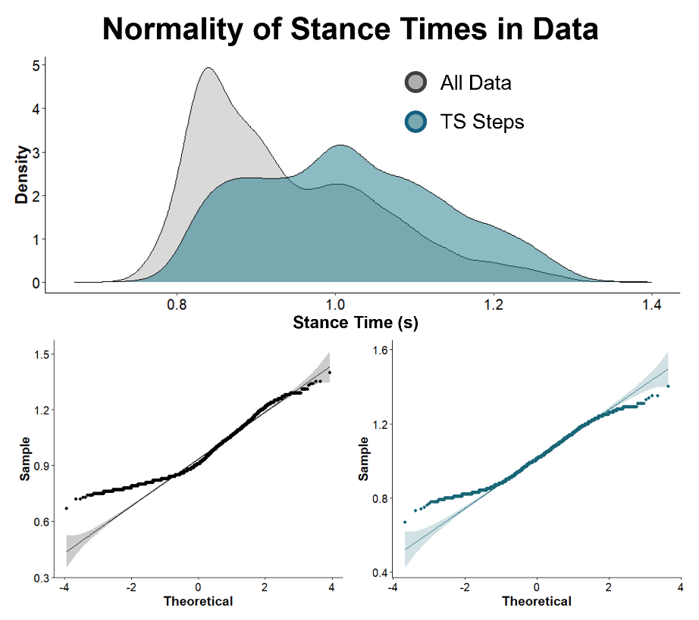
Figure S1: Density and qq plots of the whole data and subset of data used for the linear models.

Condition | NoTS |  | LeftTS_{Lrg} |  | LeftTS_{Med} |  | LeftTS_{Sml} |  | BaselineTS |  | RightTS_{Sml} |  | RightTS_{Med} |  | RightTS_{Lrg}
Limb | Left | Right | Left | Right | Left | Right | Left | Right | Left | Right | Left | Right | Left | Right | Left | Right
Stance Time (s) | 0.87 (0.02) | 0.87 (0.02) | 1.07 (0.02) †Ψ | 0.98 (0.02) †Ψ | 1.04 (0.03) †Ψ | 0.97 (0.03) †Ψ | 1.03 (0.03) †Ψ | 0.96 (0.03) †Ψ | 0.94 (0.03) | 0.94 (0.03) | 0.95 (0.03) † | 1.01 (0.03) †Ψ | 0.98 (0.03) † | 1.06 (0.03) †Ψ | 1.00 (0.03) † | 1.10 (0.03) †Ψ
TLA (deg) | 18.07 (0.59) Ψ | 18.32 (0.59) Ψ | 26.12 (0.83) †Ψ | 21.95 (0.83) † | 24.97 (0.84) †Ψ | 21.52 (0.84) † | 23.78 (0.61) †Ψ | 21.33 (0.61) † | 20.95 (0.58) † | 20.77 (0.58) † | 21.14 (0.61) † | 23.77 (0.61) †Ψ | 21.99 (0.84) † | 25.25 (0.84) †Ψ | 22.92 (0.83) † | 26.42 (0.83) †Ψ
Peak Propulsion (%BW) | 16.79 (0.52) | 15.56 (0.52) | 24.74 (1.07) †Ψ | 18.55 (1.07) | 23.36 (1.16) †Ψ | 18.14 (1.16) | 22.69 (1.09) †Ψ | 17.87 (1.09) | 19.12 (0.69) | 17.09 (0.69) | 19.10 (0.83) | 20.50 (0.83) †Ψ | 19.75 (0.90) | 22.65 (0.90) †Ψ | 21.00 (1.11) † | 23.83 (1.11) †Ψ
Propulsive Impulse (%BW·s) | 3.08 (0.12) | 2.73 (0.12) | 5.96 (0.27) †Ψ | 3.54 (0.27) | 5.46 (0.31) †Ψ | 3.46 (0.31) | 5.15 (0.31) †Ψ | 3.39 (0.31) | 3.89 (0.23) | 3.35 (0.23) | 3.72 (0.27) | 4.49 (0.27) †Ψ | 3.91 (0.26) | 5.14 (0.26) †Ψ | 4.25 (0.30) | 5.60 (0.30) †Ψ
Table S1: Linear mixed effects results across all conditions for all variables, estimated marginal means (standard error). † denotes significant difference from no TS. Ψ denotes significant difference from BaselineTS.
For the relationships between stance time and propulsive features, below are the results for the whole dataset as well, opposed to the subset chosen to improve normality. These relationships are stronger with the whole dataset opposed to our subset chosen. However, we did not include this result in the main text due to the fit being heavily biased towards the baseline walking region.
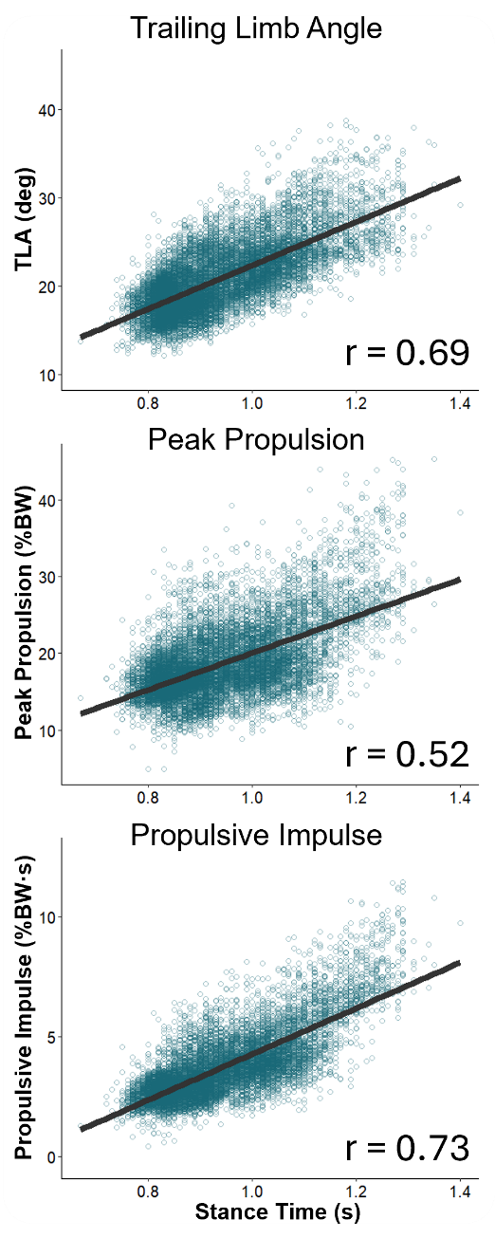
Figure S2: Relationships between stance time and propulsive variables on the whole dataset opposed to the subset chosen in the main text. The relationships are similar but stronger due to the inflated fit from a large amount of data during the no TS condition.

Unstimulated Steps Still Related to Propulsion
Lastly, we wanted to ensure that the type of instruction provided to the subjects, “push off with the vibration onset” was not a strong reason for the relation to propulsive variables. So, we ran the same analysis for the spearman correlations but instead on the opposite side during the TS feedback (right steps during LeftTS; left steps during RightTS; no TS not included). The relations between the non-stimulated steps to the stance times were a little lower than what was reported for the stimulated side. However, this may be due to the reduced overall range of data for the non-stimulated steps being less. Further analysis of a mechanism testing these relations further may aid in this claim.
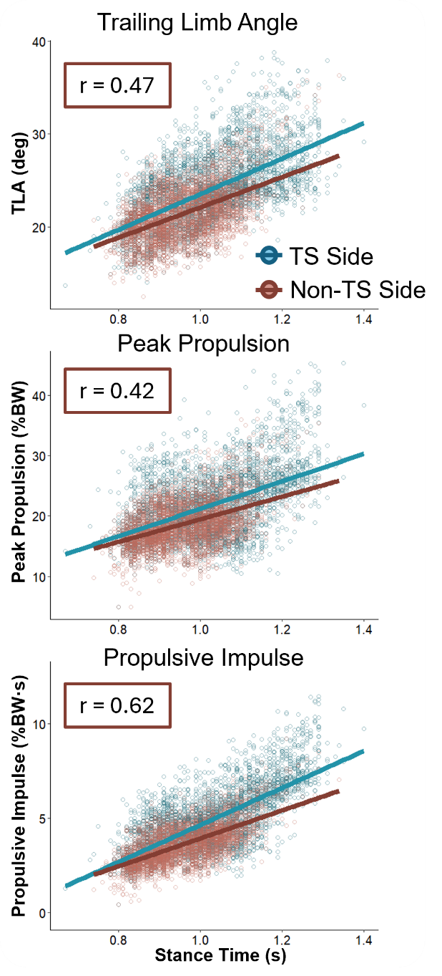
Figure S3: Relationships between stance time and propulsive variables on the reported dataset of the stimulated limb (blue) and the opposite side that did not receive the stimulation (maroon). The relationships are similar but slightly weaker, possibly due to the smaller range of stance times present in the non-stimulated limb.

