Supp Tables
Table S1. Input parameters for the Markov model.
Parameter | high disease activity | moderate disease activity | Low disease activity | Remission
Transition probabilities
MTX monotherapy (Cycle 1) | 0.20 | 0.63 | 0.06 | 0.12
MTX monotherapy (Cycle 2) | 0.06 | 0.25 | 0.13 | 0.56
MTX + LEF (Cycle 1) | 0.26 | 0.47 | 0.11 | 0.17
MTX + LEF (Cycle 2) | 0.09 | 0.27 | 0.18 | 0.45
TNF1 (Cycle 1) | 0.09 | 0.53 | 0.17 | 0.21
TNF1 (Cycle 2) | 0.02 | 0.07 | 0.18 | 0.73
TNF2 (Cycle 1) | 0.19 | 0.50 | 0.15 | 0.17
TNF2 (Cycle 2) | 0.06 | 0.38 | 0.13 | 0.44
Rituximab (Cycle 1) | 0.16 | 0.52 | 0.15 | 0.17
Rituximab (Cycle 2) | 0.14 | 0.21 | 0.14 | 0.50
Usual care | 0.24 | 0.55 | 0.14 | 0.07
Costs
Mean | 92.3 | 68.5 | 45.3 | 23.5
Alpha | 6,391,378 | 6,579,704 | 19,709,018 | 4,730,988
Lambda | 69,283 | 96,054 | 435,558 | 201,319
 | Drug treatment costs per cycle (€)
MTX monotherapy | 13
MTX + LEF | 181
TNF (Adalimumab/Etanercept) | 3067
Rituximab | 5420 (initial) + 1817 (per cycle)
Usual care | 50
This table was adapted from [Schipper et al., 2011]. Values were extracted from the published study and reformatted for presentation. See Reference 42.

Table S2. Missing EQ-5D and/or DAS28 Data by Trial and Study Visit
Trial/ Missingness | n (%)
NCT01721044
Overall
N | 3433
Missingness | 329 (9.6%)
Baseline
N | 527
Missingness | 3 (0.6%)
Week 4
N | 511
Missingness | 21 (4.1%)
Week 8
N | 506
Missingness | 25 (4.9%)
Week 12
N | 489
Missingness | 26 (5.3%)
Week 16
N | 473
Missingness | 22 (4.7%)
Week 20
N | 468
Missingness | 84 (17.9%)
Week 24
N | 459
Missingness | 148 (32.2%)
NCT01721057
Overall
N | 4523
Missingness | 278 (6.1%)
Baseline
N | 684
Missingness | 13 (1.9%)
Week 4
N | 668
Missingness | 21 (3.1%)
Week 8
N | 661
Missingness | 21 (3.2%)
Week 12
N | 648
Missingness | 23 (3.5%)
Week 16
N | 628
Missingness | 20 (3.2%)
Week 20
N | 623
Missingness | 76 (12.2%)
Week 24
N | 611
Missingness | 104 (17.0%)
NCT01711359
Overall
N | 3866
Missingness | 63 (1.6%)
Baseline
N | 584
Missingness | 4 (0.7%)
Week 4
N | 568
Missingness | 13 (2.3%)
Week 8
N | 564
Missingness | 11 (2.0%)
Week 12
N | 551
Missingness | 4 (0.7%)
Week 16
N | 544
Missingness | 12 (2.2%)
Week 20
N | 531
Missingness | 9 (1.7%)
Week 24
N | 524
Missingness | 10 (1.9%)

Table S3. Point Estimates and 95% CI of HSUs by DAS-defined Health State, Trial and Analysis Model
 | Remission | Low Disease Activity | Moderate Disease Activity | High Disease Activity
NCT01721044
LMM | 0.747 (0.727, 0.767) | 0.718 (0.698, 0.738) | 0.678 (0.661, 0.695) | 0.600 (0.582, 0.618)
GEE | 0.749 (0.730, 0.768) | 0.720 (0.702, 0.738) | 0.678 (0.663, 0.693) | 0.598 (0.581, 0.615)
TPMM | 0.728 (0.711, 0.745) | 0.711 (0.694, 0.728) | 0.673 (0.658, 0.688) | 0.598 (0.580, 0.615)
NCT01721057
LMM | 0.806 (0.791, 0.821) | 0.767 (0.752, 0.782) | 0.730 (0.717, 0.743) | 0.657 (0.642, 0.672)
GEE | 0.807 (0.791, 0.823) | 0.768 (0.753, 0.783) | 0.730 (0.716, 0.744) | 0.655 (0.637, 0.673)
TPMM | 0.768 (0.755, 0.779) | 0.747 (0.734, 0.758) | 0.716 (0.705, 0.727) | 0.644 (0.631, 0.660)
NCT01711359
LMM | 0.832 (0.823, 0.842) | 0.797 (0.787, 0.807) | 0.774 (0.764, 0.783) | 0.687 (0.673, 0.701)
GEE | 0.833 (0.823, 0.843) | 0.798 (0.788, 0.807) | 0.773 (0.765, 0.782) | 0.687 (0.667, 0.707)
TPMM | 0.791 (0.658, 0.924) | 0.768 (0.634, 0.903) | 0.752 (0.625, 0.879) | 0.671 (0.515, 0.827)
LMM: Linear mixed-effects model; GEE: Generalized estimating equations; TPMM: Two-parts mixed-effects model

Table S4. Percentage of Patients in Remission State by Treatment Strategy and Treatment Sequence at 5 Years (Base-Case Markov Simulation)
Health State | Strategy 1 |  | Strategy 2
 | Percentage | Sequence | Percentage | Sequence
Remission
MTX | 6.53 | 1 | 4.32 | 5
MTX + LEF | 7.23 | 2 | 7.74 | 1
TNF1 | 13.33 | 3 | 14.27 | 2
TNF2 | 5.32 | 4 | 5.69 | 3
Rituximab | 5.76 | 5 | 6.16 | 4
Usual care | 4.54 | 6 | 4.54 | 6
Total | 42.71 |  | 42.71
Low* | 8.51 |  | 8.51
Moderate* | 34.03 |  | 34.03
Severe* | 14.75 |  | 14.75
*Health states other than remission were in usual care treatment

Supp Figures
Figure S1. Model structure
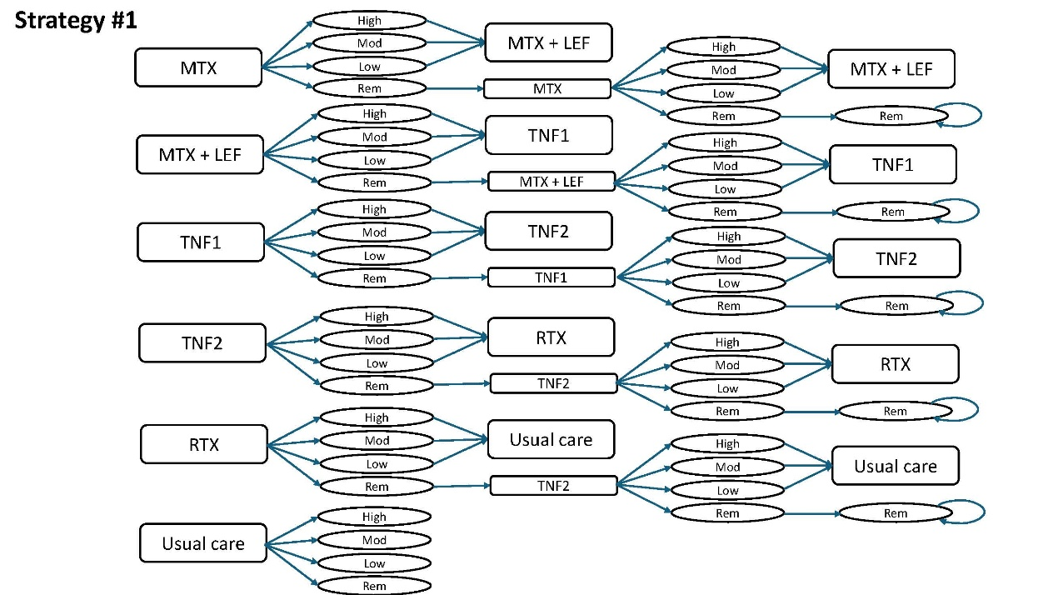
*This figure was adapted from [Schipper et al., 2011]. Values were extracted from the published study and reformatted for presentation. See Reference 42.

Figure S2. Incremental Cost-Effectiveness Planes for Strategy 2 vs Strategy 1 (NCT01721044) Using Health-State Utilities Estimated from (a) LMM, (b) GEE, and (c) TPMM
(a)

(b)

(c)

LMM: Linear mixed-effects model; GEE: Generalized estimating equations; TPMM: Two-parts mixed-effects model
X-axis represents incremental QALYs; Y-axis represents incremental costs.

Figure S3. Cost-Effectiveness Acceptability Curves for Strategy 2 vs Strategy 1 (NCT01721044) Using Health-State Utilities Estimated from (a) LMM, (b) GEE, and (c) TPMM
(a)

(b)

(c)

LMM: Linear mixed-effects model; GEE: Generalized estimating equations; TPMM: Two-parts mixed-effects model
X-axis represents the willingness-to-pay (WTP) threshold per QALY gained; Y-axis represents the probability that Strategy 2 is cost-effective compared with Strategy 1

Figure S4. Incremental Cost-Effectiveness Planes for Strategy 2 vs Strategy 1 (NCT01721057) Using Health-State Utilities Estimated from (a) LMM, (b) GEE, and (c) TPMM
(a)

(b)

(c)

LMM: Linear mixed-effects model; GEE: Generalized estimating equations; TPMM: Two-parts mixed-effects model
X-axis represents incremental QALYs; Y-axis represents incremental costs.

Figure S5. Cost-Effectiveness Acceptability Curves for Strategy 2 vs Strategy 1 (NCT01721057) Using Health-State Utilities Estimated from (a) LMM, (b) GEE, and (c) TPMM
(a)

(b)

(c)

LMM: Linear mixed-effects model; GEE: Generalized estimating equations; TPMM: Two-parts mixed-effects model
X-axis represents the willingness-to-pay (WTP) threshold per QALY gained; Y-axis represents the probability that Strategy 2 is cost-effective compared with Strategy 1

Figure S6. Incremental Cost-Effectiveness Planes for Strategy 2 vs Strategy 1 (NCT01711359) Using Health-State Utilities Estimated from (a) LMM, (b) GEE, and (c) TPMM
(a)

(b)

(c)

LMM: Linear mixed-effects model; GEE: Generalized estimating equations; TPMM: Two-parts mixed-effects model
X-axis represents incremental QALYs; Y-axis represents incremental costs.

Figure S7. Cost-Effectiveness Acceptability Curves for Strategy 2 vs Strategy 1 (NCT01711359) Using Health-State Utilities Estimated from (a) LMM, (b) GEE, and (c) TPMM
(a)

(b)

(c)

LMM: Linear mixed-effects model; GEE: Generalized estimating equations; TPMM: Two-parts mixed-effects model
X-axis represents the willingness-to-pay (WTP) threshold per QALY gained; Y-axis represents the probability that Strategy 2 is cost-effective compared with Strategy 1

