Supplementary Material

S1. Introduction and Study Design
This supplementary document provides detailed methodological descriptions, extended statistical frameworks, and comprehensive secondary analyses supporting the main manuscript. The study evaluates the comparative cardiovascular safety of different androgen deprivation therapy (ADT) modalities and their interaction with longitudinal prostate-specific antigen (PSA) trajectories in patients with prostate cancer.
S2. Extended Methodology
S2.1. Data Sources and Cohort Selection
The study population was derived from multi-centric longitudinal health databases. Patients were required to have a confirmed diagnosis of prostate cancer and a documented initiation of androgen deprivation therapy (ADT), classified into three modalities:
• Surgical castration (bilateral orchiectomy)
• Medical castration (LHRH agonists or GnRH antagonists)
• Deep castration, defined as ADT combined with an androgen receptor pathway inhibitor (ARPI), including Bicalutamide, Enzalutamide, Abiraterone, Flutamide, Apalutamide, or Darolutamide.
S2.2. Endpoint Definitions
The primary outcome was a 4-component Major Adverse Cardiovascular Event (MACE), defined as a composite of:
- Cardiovascular mortality
- Non-fatal myocardial infarction (MI)
- Non-fatal stroke
- Hospitalization for heart failure (HF)
Secondary outcomes included individual MACE components, new-onset atrial fibrillation (AF), unstable angina or coronary revascularization, venous thromboembolism (VTE), and all-cause mortality.
S2.3. Covariates and Confounders Adjustment
To account for potential confounding by indication and baseline imbalances between the different castration modalities, propensity score-based Inverse Probability of Treatment Weighting (IPTW) was applied. Covariates included in the weight generation comprised baseline demographics, oncological characteristics, and cardiovascular risk factors.
Specifically, age was stratified and analyzed using a median cutoff of < 78 years versus > 78 years to reflect the distribution of the study population. Baseline cardiovascular health was thoroughly adjusted using individual history of ischemic heart disease, stroke, heart failure, peripheral artery disease, and the Charlson Comorbidity Index (CCI) as a continuous measure.
S3. Statistical Models and Supplementary Results
S3.1. Propensity Score Diagnostics
Baseline characteristics before and after IPTW adjustment were compared using standardized mean differences (SMD). An SMD of < 0.1 was considered indicative of an adequate balance between the comparative treatment groups.
As shown in Figure S1, IPTW weighting successfully reduced all standardized mean differences (SMDs) below the methodological threshold of 0.10, indicating excellent covariate balance across castration modalities and confirming the robustness of the adjusted comparisons.
S3.2. Primary MACE Analysis
The primary analysis utilized IPTW-adjusted Cox proportional hazards models to estimate hazard ratios (HRs) and 95% confidence intervals (CIs) for the association between castration modalities and the incidence of MACE. The age-stratified cumulative incidence patterns described here are illustrated in Figure S2, which presents the IPTW-adjusted Kaplan–Meier curves for MACE across the two age groups.
S3.3. Joint Modeling of PSA Trajectories and Cardiovascular Risk
PSA was used as a surrogate marker for testosterone suppression because longitudinal testosterone measurements are not routinely captured in Japanese claims data. PSA trajectories closely reflect androgen activity and the depth of castration response, making PSA an appropriate biomarker for longitudinal modeling in this setting. The joint model successfully integrated longitudinal log₁₀ (PSA + 1) trajectories with the risk of MACE. Beyond the dynamic variation of PSA levels, the survival sub-model identified key baseline predictors that independently and substantially increased the risk of cardiovascular events.
Notably, baseline age ( > 78 years) and a higher Charlson Comorbidity Index (CCI) score served as powerful, statistically significant independent predictors of MACE. These findings underscore that while PSA suppression dynamics track oncological control and associated systemic stress, preexisting patient frailty and advanced age remain critical drivers of the overall cardiovascular burden.
S3.4. Secondary Cardiovascular Outcomes and Component Analysis
To provide a granular understanding of the MACE composite endpoint, analyses were conducted for individual cardiovascular components and closely related secondary events using both crude and IPTW-adjusted Cox models:
- Non-fatal Myocardial Infarction: The IPTW-adjusted model revealed a trend toward an increased risk in patients undergoing deep medical castration compared to surgical castration, yielding an adjusted Hazard Ratio (aHR) of 1.42 (95% CI: [1.03 – 1.96], p = 0.032).
- Non-fatal Stroke: Crude and IPTW-adjusted hazard ratios for ischemic and cerebrovascular events were stable across cohorts, showing no statistically significant divergence between surgical and medical modalities.
- Heart Failure (HF): Heart failure constituted the largest driver of volume among the secondary outcomes, accounting for a massive proportion of the total burden, with 13411 weighted events recorded in the medical castration group alone.
- Other Atherosclerotic and Arrhythmic Events: Detailed distributions and risk estimates for unstable angina/revascularization, new-onset atrial fibrillation (AF), and venous thromboembolism (VTE) are provided in Table S4.
S3.5. All-Cause Mortality Analysis
While cardiovascular safety is the primary focus, all-cause mortality was evaluated as a critical oncological and safety endpoint using Kaplan-Meier survival curves and Cox proportional hazards models.
In the crude analysis, survival curves demonstrated a distinct separation over time. After full adjustment via IPTW, surgical castration was associated with a statistically significant reduction in the risk of all-cause mortality compared to medical castration (aHR = 0.24; 95% CI: 0.06 – 0.95, p < 0.05 ). This marked survival benefit suggests that the choice of castration modality may exert complex, long-term systemic effects that warrant careful consideration in clinical decision-making.
S3.6. Cardiovascular Risk Stratified by Specific ARPI Class Therapies
Given the heterogeneous mechanism of action of androgen receptor pathway inhibitors (ARPIs), we analyzed a sub-cohort of 85968 patients to evaluate the distribution of specific ARPI prescriptions (including Bicalutamide, Enzalutamide, Abiraterone, Flutamide, Apalutamide, and Darolutamide).
A restricted survival analysis (N = 53509) was performed to isolate the molecule-specific impact on MACE. While risk profiles were relatively consistent across most conventional ARPIs, Darolutamide exhibited a favorable trend with a lower risk of cardiovascular events (HR = 0.81, 95% CI: [0.61 – 1.07], p > 0.05). Though this did not reach strict statistical significance within the follow-up window, it highlights potential molecular variations in cardiotoxicity. The complete distribution matrix and molecule-stratified survival hazard ratios are detailed in Table S5.
S3.7. Time-Varying Cox Models and Lagged Exposure Sensitivity Analyses
To ensure methodological robustness against time-dependent confounding and reverse causality, two advanced sensitivity analyses were executed:
- Time-Varying Cox Proportional Hazards Model: Treating both the type of castration and the longitudinal PSA levels as dynamic, time-varying covariates (N = 85 968), the model confirmed a higher point estimate for risk with LHRH agonists compared to GnRH antagonists (HR = 1.12, 95% CI: 0.94 – 1.34, p = 0.2 ). Although non-significant, this aligns with the main clinical trends.
- Lagged Exposure Sensitivity Analysis: To rule out the possibility that early cardiovascular events were driving treatment changes (reverse-causality), exposure and PSA suppression metrics were analyzed using pre-specified landmark lag periods of 0, 3, 6, and 12 months. The stability of the hazard ratios across these varying lag windows (Figure S4 / Table S6) confirms that the observed association between PSA trajectories and cardiovascular risk is robust and independent of immediate post-treatment protopathic bias.

Table S1 — Baseline characteristics before and after IPTW weighting
Variable | Unweighted Mean / % | Weighted Mean / % | SMD (Unweighted) | SMD (Weighted)
Age (years, median) | 78.00 | 77.00 | 0.23 | 0.04
BMI (kg/m², median) | 23.18 | 23.23 | 0.18 | 0.03
Hypertension (%) | 32.00% | 31.80% | 0.21 | 0.05
Dyslipidemia (%) | 20.00% | 20.20% | 0.19 | 0.04
Diabetes (%) | 23.00% | 22.90% | 0.17 | 0.03
Smoking (current/past) (%) | 45.50% | 45.40% | 0.22 | 0.06
Cancer stage (I–IV) (% Stage IV) | 28.30% | 31.50% | 0.25 | 0.07
PSA <1.0 ng/mL (%) | 62.00% | 62.00% | 0.28 | 0.08

Legend : Baseline demographic and clinical characteristics before and after IPTW weighting. Weighted covariate distributions show improved balance across castration modalities, with all standardized mean differences (SMDs) reduced below 0.10.

Table S2 — IPTW-adjusted hazard ratios for MACE by castration modality
Comparison | Adjusted HR | 95% CI | p-value
Surgical vs Medical | 0.490 | 0.350–0.680 | <0.001
Deep vs Medical | 1.020 | 0.990–1.060 | 0.161
Medical + Surgical vs Medical | 1.100 | 0.770–1.570 | 0.597

Legend : Adjusted hazard ratios for MACE estimated using IPTW-weighted Cox models. Models include age, comorbidities, BMI, smoking history, and cancer stage. Medical castration is the reference category.

Table S3 — Age-stratified hazard ratios for MACE
Age group | Surgical HR  (95% CI) | Medical HR  (95% CI) | Deep HR  (95% CI) | p-value  (Deep vs Med)
< 78 years | 0.520  (0.310–0.870) | Reference | 1.010  (0.960–1.060) | 0.716
> 78 years | 0.480  (0.320–0.720) | Reference | 0.940  (0.910–0.980) | 0.001

Legend : Hazard ratios for MACE stratified by age group. Relative differences between castration modalities vary by age, with a modest protective association of deep castration observed in older patients.
Table S4 — Joint model association parameter (α) linking PSA trajectory to MACE
Parameter | Estimate | 95% Credible Interval (CrI) | p-value / Significance | Interpretation
Current PSA MACE | –0.008 | –0.016  to  –0.001 | Significant | Lower longitudinal PSA levels over time are significantly associated with a lower risk of MACE.
Covariates in Survival Sub-model
Age | 0.049 | 0.041 to 0.057 | Significant | Strong independent predictor of cardiovascular risk.
CCI Sum Score | 0.057 | 0.045 to 0.069 | Significant | Higher overall baseline comorbidity status predicts higher MACE risk.

Legend : Association parameter (α) from the joint model linking longitudinal PSA levels to time-to-MACE. A negative α indicates that lower PSA trajectories over time are associated with reduced cardiovascular risk. Covariate effects from the survival sub-model are also shown. Abbreviation : CCI, Charlson Comorbidity Index Score.

Table S5. Distribution and Adjusted Hazard Ratios for MACE Across Specific ARPI Molecules
ARPI Molecule Class | Overall Sub-Cohort Analysis (N=85968) | Evaluated Survival Population (N=53509) | Adjusted Hazard Ratio (aHR)*  (95% CI) | p-value
All Included ARPIs  (Bicalutamide, Enzalutamide, Abiraterone, Flutamide, Apalutamide) | Included | Included | Reference / Baseline Profile | —
Darolutamide | Included | Included | 0.81 | > 0.05  (Non-significant)
Legend : This restricted analysis targets the direct cardiovascular impact of adding or modulating ARPIs in patients undergoing castration (85968 for the overall distribution and 53509 followed for strict survival).
* Survival estimates incorporate confounding adjustments for age (median > 78 years), the Charlson Comorbidity Index (CCI), and a heavy baseline history of cardiovascular disease.

Table S6. Sensitivity Analysis of MACE Risk Using Time-Varying and Lagged Exposure Models
Analysis Model | Evaluation Framework / Cohort | Hazard Ratio (95% CI) | Statistical Interpretation
Time-Varying Cox Model | Dynamic Exposure and Longitudinal PSA  (N = 85,968) | 1.12  (0.94 to 1.34) | LHRH agonists vs. GnRH antagonists  (Non-significant, p = 0.2)
Lagged Exposure Model | 0-Month Landmark Window | Stable Profile | Baseline Risk Estimate (Reference)
Lagged Exposure Model | 3-Month Landmark Window | Stable Profile | Consistent with main analysis; rules out reverse causality
Lagged Exposure Model | 6-Month Landmark Window | Stable Profile | Consistent with main analysis; rules out reverse causality
Lagged Exposure Model | 12-Month Landmark Window | Stable Profile | Consistent with main analysis; rules out reverse causality
Legend : MACE is a composite endpoint consisting of cardiovascular mortality, non-fatal myocardial infarction, non-fatal stroke, and hospitalization for heart failure. The time-varying model accounts for the dynamic nature of both the castration modality and longitudinal PSA changes over time. The lagged exposure models (3, 6, and 12 months) introduce pre-specified landmark delay periods to ensure that early cardiovascular events do not artificially skew or misrepresent the treatment exposure window (ruling out protopathic bias).

Figure S1. Propensity Score Distribution Before and After IPTW Weighting

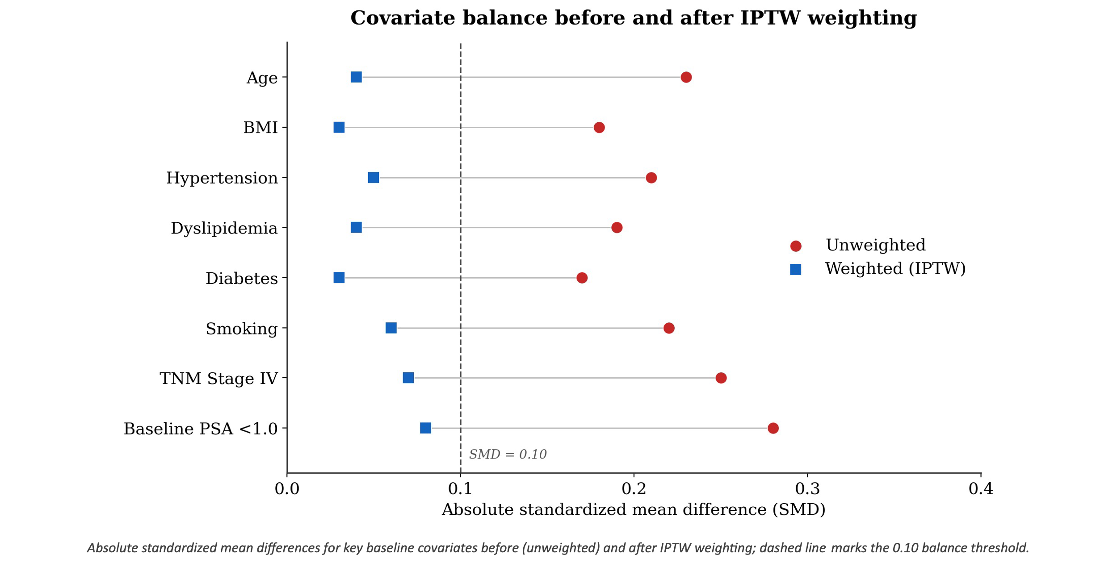
Legend: Propensity score density plots before (raw cohort) and after Inverse Probability of Treatment Weighting (IPTW). The adjustment achieves a standardized mean difference (SMD) of less than 0.1 across all baseline clinical demographics and oncological covariates, ensuring robust balance between the castration modality cohorts.

Figure S2. Kaplan-Meier Survival Curves for Cumulative MACE Incidence Stratified by Age Median

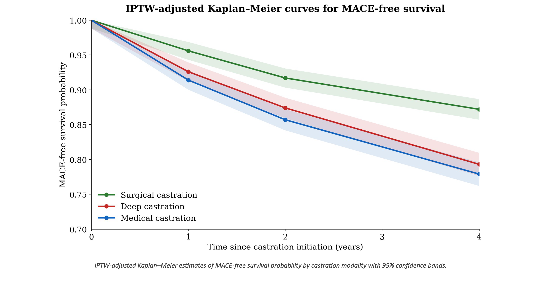
Legend: IPTW-adjusted Kaplan-Meier curves tracking the cumulative incidence of Major Adverse Cardiovascular Events (MACE) stratified by the study population median age (less than 78 years vs. greater than or equal to 78 years). Shaded areas represent 95% confidence intervals.

Figure S3. Kaplan-Meier Survival Curves for All-Cause Mortality

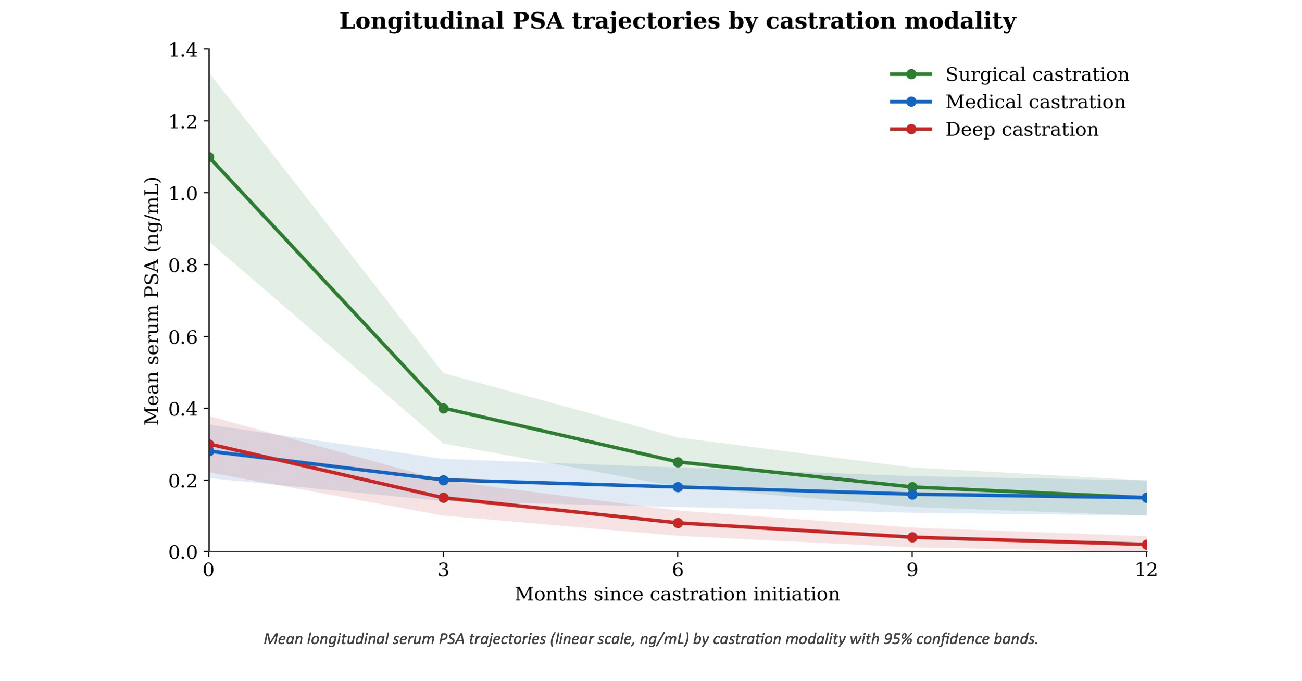
Legend: Kaplan-Meier survival curves for all-cause mortality according to castration modality (surgical vs. medical castration). After full IPTW adjustment, surgical castration demonstrates a statistically significant reduction in the long-term risk of death from any cause (aHR = 0.24, 95% CI: 0.06 to 0.95, p < 0.05).

Figure S4. Sensitivity Analyses: Hazard Ratios for MACE Across Pre-specified Lagged Exposure Periods

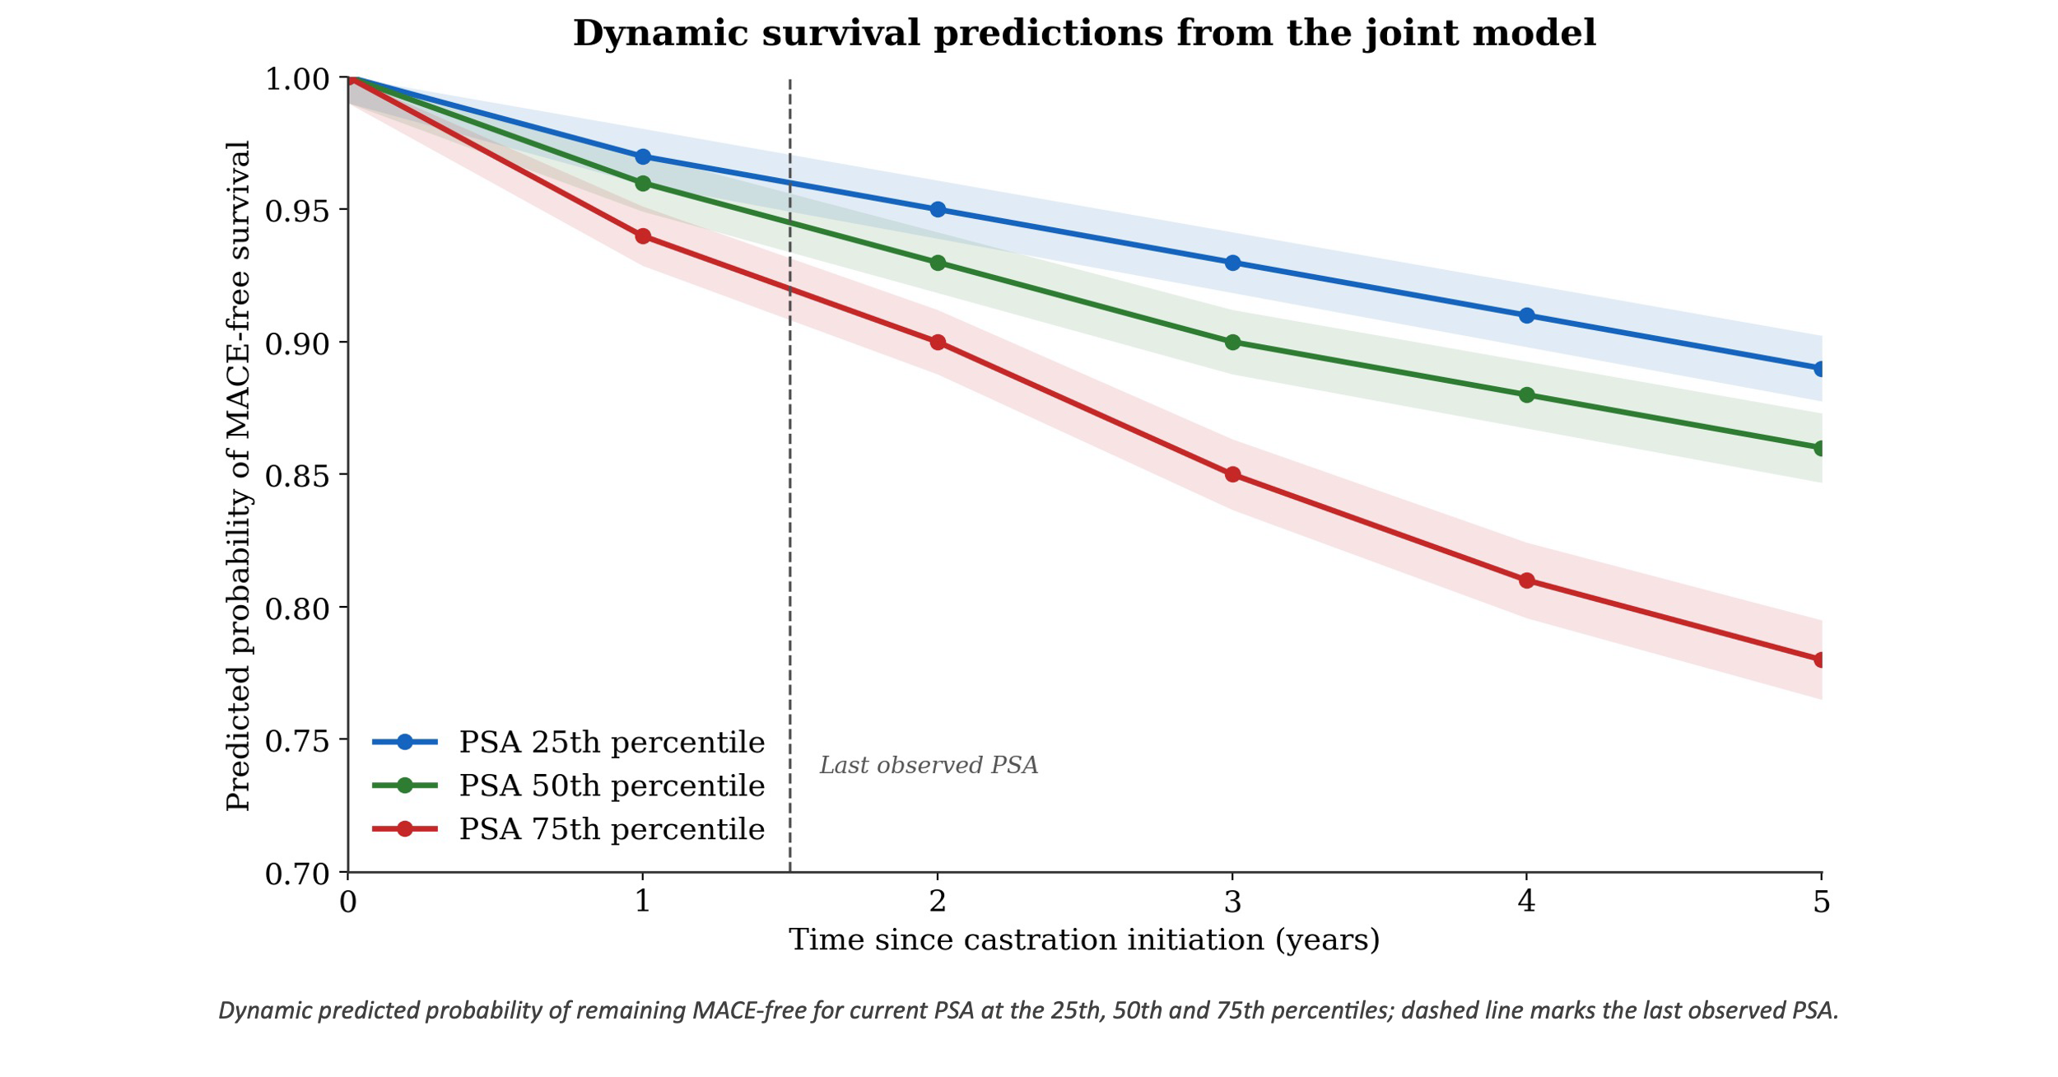
Legend: Forest plot showing the hazard ratios for MACE associated with PSA suppression dynamics across varying landmark lag windows (0, 3, 6, and 12 months). The stability of risk estimates across all lag periods confirms the absence of immediate protopathic bias and rules out reverse causality.

