Fig. 3. The fitting model of Cylindrospermum sp. FS 64 presented the relation between the growth, photosynthesis and time under different levels of salinity and alkalinity treatment. Each data-point represents different salinity and pH.

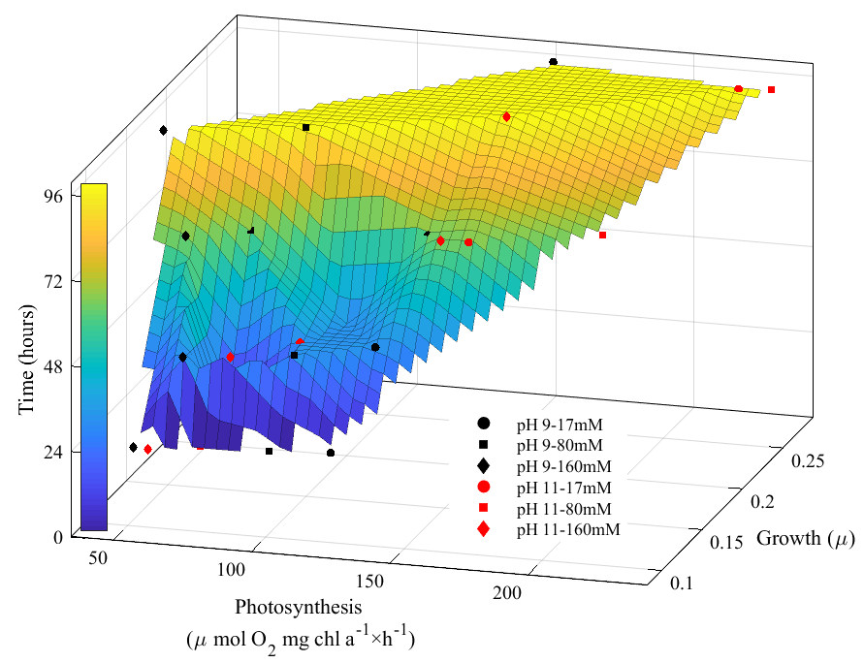
Fig. 3

