Supplementary Methods

Depressive Symptoms Phenotypes in UK Biobank
The Patient Health Questionnaire-9 (PHQ-9) is a validated screening tool for assessing depressive symptom severity¹. The PHQ-2² is a shorter version of the tool, which includes only the first two PHQ-9 questions, assessing the cardinal symptoms of depression (low mood and anhedonia). In UK Biobank (UKB), most participants have responded to the PHQ-2 at baseline assessment. In addition, we used PHQ-2 scores from up to seven further timepoints per individual. PHQ-9 scores were included from up to three timepoints (Table 1). For each symptom, respondents are asked, “Over the last 2 weeks, how often have you been bothered by any of the following problems?”. Possible responses and item-level scoring in UKB are as follows:
- Not at all (0)
- Several days (1)
- More than half the days (2)
- Nearly every day (3)
- Prefer not to answer (n/a)
This results in a range of 0-27 for PHQ-9 scores and 0-6 for PHQ-2 scores. For our study, we only included a PHQ-2/PHQ-9 score if all questions for that measure had been answered on that occasion (i.e. not missing or “Prefer not to answer”). This is to avoid imputation or treating missing/ambiguous responses as non-endorsement of the symptom.

Down sampling of PHQ-2
For equivalently powered GWAS of PHQ-9 and PHQ-2, the PHQ-2 analyses were down-sampled to match the PHQ-9 (N = 219,091). In addition, PHQ-2 scores were averaged over the same timepoints as were available for the PHQ-9 (i.e. average across max three occasions). If on any occasion, the PHQ-2 was fully answered but the PHQ-9 was not, then both scores would be set to missing to avoid averaging over more PHQ-2 timepoints than PHQ-9 timepoints.

Table 1. Patient Health Questionnaire-9 (PHQ-9) items in UK Biobank (UKB)
Symptom | UKB Timepoint | UKB Field
Little interest or pleasure in doing things* | Baseline (2006-2010) | 2060.0.0
Little interest or pleasure in doing things* | Repeat Assessment (2012-2013) | 2060.1.0
Little interest or pleasure in doing things* | Imaging (2014+) | 2060.2.0
Little interest or pleasure in doing things* | Repeat Imaging (2019+) | 2060.3.0
Little interest or pleasure in doing things* | Mental Health Questionnaire (2016-1017) | 20514.0.0
Little interest or pleasure in doing things* | Pain Questionnaire (2019) | 120104.0.0
Little interest or pleasure in doing things* | Health and Wellbeing Questionnaire (2022) | 28737.0.0
Little interest or pleasure in doing things* | Mental Wellbeing Questionnaire (2022-2023) | 29002.0.0
Feeling down, depressed, or hopeless* | Baseline (2006-2010) | 2050.0.0
Feeling down, depressed, or hopeless* | Repeat Assessment (2012-2013) | 2050.1.0
Feeling down, depressed, or hopeless* | Imaging (2014+) | 2050.2.0
Feeling down, depressed, or hopeless* | Repeat Imaging (2019+) | 2050.3.0
Feeling down, depressed, or hopeless* | Mental Health Questionnaire (2016-1017) | 20510.0.0
Feeling down, depressed, or hopeless* | Pain Questionnaire (2019) | 120105.0.0
Feeling down, depressed, or hopeless* | Health and Wellbeing Questionnaire (2022) | 28738.0.0
Feeling down, depressed, or hopeless* | Mental Wellbeing Questionnaire (2022-2023) | 29003.0.0
Trouble falling or staying asleep, or sleeping too much | Mental Health Questionnaire (2016-1017) | 20517.0.0
Trouble falling or staying asleep, or sleeping too much | Pain Questionnaire (2019) | 120106.0.0
Trouble falling or staying asleep, or sleeping too much | Mental Wellbeing Questionnaire (2022-2023) | 29004.0.0
Feeling tired or having little energy | Mental Health Questionnaire (2016-1017) | 20519.0.0
Feeling tired or having little energy | Pain Questionnaire (2019) | 120107.0.0
Feeling tired or having little energy | Mental Wellbeing Questionnaire (2022-2023) | 29005.0.0
Poor appetite or overeating | Mental Health Questionnaire (2016-1017) | 20511.0.0
Poor appetite or overeating | Pain Questionnaire (2019) | 120108.0.0
Poor appetite or overeating | Mental Wellbeing Questionnaire (2022-2023) | 29006.0.0
Feeling bad about yourself or that you are a failure or have let yourself or your family down | Mental Health Questionnaire (2016-1017) | 20507.0.0
 | Pain Questionnaire (2019) | 120109.0.0
 | Mental Wellbeing Questionnaire (2022-2023) | 29007.0.0
Trouble concentrating on things, such as reading the newspaper or watching television | Mental Health Questionnaire (2016-1017) | 20508.0.0
 | Pain Questionnaire (2019) | 120110.0.0
 | Mental Wellbeing Questionnaire (2022-2023) | 29008.0.0
Moving or speaking so slowly that other people could have noticed? Or the opposite – being so fidgety or restless that you have been moving around a lot more than usual | Mental Health Questionnaire (2016-1017) | 20518.0.0
 | Pain Questionnaire (2019) | 120111.0.0
 | Mental Wellbeing Questionnaire (2022-2023) | 29009.0.0
Thoughts that you would be better off dead or of hurting yourself in some way | Mental Health Questionnaire (2016-1017) | 20513.0.0
 | Pain Questionnaire (2019) | 120112.0.0
 | Mental Wellbeing Questionnaire (2022-2023) | 29010.0.0
*Included in the PHQ-2

Principal Component Analysis
European ancestry was inferred from genotypic data and genetic principal components (PCs) were calculated as follows using PLINK2³:
- Markers were QC’d across the whole cohort (all ancestries together):
  - Removing where MAC < 20
  - Remove where missing call rate > 0.02
  - Only keeping SNPs (no indels)
  - Only keeping bi-allelic SNPs
- Samples were then split into the ancestry clusters, only including samples which were used by UKB in their own PC calculation. Genetic similarity clusters of UKB participants were based on a random forest classification of PCs, following https://pan.ukbb.broadinstitute.org/docs/qc, using 1000 Genomes + Human Genome Diversity Panel.
Then within the European ancestry cluster:
- SNPs were pruned using --indep-pairwise with a window size of 1000, step size of 80, and r2 threshold of 0.1, and then removing SNPs with HWE p-value < 1x10⁻⁷, MAF < 0.01, missing call rate > 0.015

- PCs were calculated

- The whole ancestry cluster was projected into the PC space

- PC outliers were detected using nearest neighbour distances (see https://privefl.github.io/blog/detecting-outlier-samples-in-pca/) and removed

Genotyping, Imputation and Quality Control (QC)
Genotyping and imputation for UK Biobank is documented in detail by Bycroft et al.⁴. Approximately 50,000 participants were genotyped on the UK BiLEVE Axiom Array, with another ~440,000 participants genotyped on the UK Biobank Axiom Array. The two arrays share 95% of marker content. The genotyping procedure resulted in genotype calls for 489,212 samples at 812,428 unique markers. UKB’s QC pipeline included marker-based checks (e.g., batch and plate effects, departures from Hardy-Weinberg Equilibrium (HWE; p < 1x10-12)) and sample-based checks (e.g., missing rate > 0.05 and heterozygosity outliers). This QC process resulted in 488,377 samples and 805,426 (784,256 autosomal) markers.
Imputation was carried out by UKB using a subset of 670,739 high-quality markers (those passing the above QC) and with a MAF > 0.0001. The primary imputation reference panel was the Haplotype Reference Consortium (HRC) data, with a secondary reference panel which combined the UK10K and 1000 Genomes phase 3 reference panels. This resulted in an imputed dataset of 93,095,623 autosomal markers in 487,442 individuals.
For the present study we performed QC procedures on the imputed genotypes, retaining 19,268,305 autosomal bi-allelic single nucleotide polymorphisms (SNPs) with minor allele frequency > 0.001, imputation score > 0.1 and minor allele count > 20.
Step 1 of REGENIE⁵ fits a whole genome regression model using a subset of QC’d directly genotyped (array) markers. For this step we performed marker and sample-based QC on the 784,256 autosomal markers separately within the European ancestry cluster.
We excluded variants with:
- Minor allele count (MAC) < 100
- MAF < 0.01
- Missing genotype call rate > 10%
- HWE p-value < 1x10-15
And excluded samples with:
- Missing call rate > 10%.
Step 2 of REGENIE performs the GWAS on the imputed variants. For this step, we performed light QC, removing variants with:
- INFO score < 0.1
- MAC < 20
- MAF < 0.001

We used FUMA⁶ for identification of independently significant SNPs, lead SNPs and independent loci. Prior to importing results into FUMA, we removed SNPs with:
- MAF < 0.01
- INFO < 0.8

Supplementary Results

Causal mixture modelling with MiXeR
All univariate MiXeR analyses were sufficiently powered and fit well, with positive Akaike information criterion (AIC) and Bayesian information criterion (BIC) values for PHQ-9, PHQ-2 and MDD (26.98 and 17.35, 55.59 and 45.96, 816.07 and 806.62 respectively, Supplementary Table 1). This provides robust evidence that the univariate MiXeR model fit the data better than the infinitesimal model, which is used by LDSC. The PHQ-2 was estimated to be the most polygenic of the three traits, (13813 putative causal variants explaining 90% of SNP-based heritability, SD = 715), compared with the PHQ-9 (11661, SD = 646.81) and MDD (12810, SD = 251) (Supplementary Table 1).
Model fit for Bivariate MiXeR is assessed by comparing AIC/BIC values from the full MiXeR model (estimating polygenic overlap) to the AIC/BIC values from simpler models which assume either: (1) complete overlap; or (2) minimum overlap, where the minimum overlap is constrained by the observed genetic correlation between the two traits. A positive difference in AIC/BIC values between the full model and the simpler model gives support that the full model fits the data better⁷.
For all bivariate analyses, BIC differences were negative (Supplementary Table 1). However, BIC can be overly conservative in the context of MiXeR, and the authors state that AIC differences are a more appropriate test⁷. However, for PHQ-9 versus PHQ-2, both AIC values were also negative (best_vs_min_AIC = -1.56; best_vs_max_AIC = -1.90). This means that fitting the extra parameter to estimate the exact genetic overlap (11659 overlapping causal variants; >99% of PHQ-9 causal variants) in the full MiXeR model cannot be justified. However, this should be seen in the context of the high genetic correlation (r_{g} = 0.91, SD = 0.02), which constrains the minimum possible overlap to 11610 causal variants, and the fact that maximum possible overlap is 11661 (100% of PHQ-9 variants). This means that the estimate from the full MiXeR model would always be close to both the minimum and maximum possible values. Regardless, the AIC values mean that the bivariate MiXeR results for PHQ-9 versus PHQ-2 should be viewed with caution.

For PHQ-9 versus MDD, there was an estimated genetic overlap of 11026 (SD = 574) causal variants, 87% of which had concordant effect directions. The correlation of effect sizes between shared causal variants (ρ_{β}) was 0.91. The bivariate MiXeR model for PHQ-9 versus MDD fit the data better than assuming either minimum or maximum overlap (best_vs_min_AIC = 1.95; best_vs_max_AIC = 0.48) (Supplementary Table 1).

For PHQ-2 versus MDD, there was an estimated genetic overlap of 12578 (SD = 353) causal variants, 82% of which had concordant effect directions. The correlation of effect sizes between shared causal variants (ρ_{β}) was 0.85. Bivariate MiXeR fit the data better than assuming minimum overlap (best_vs_min_AIC = 6.41) but did not fit better than assuming maximum overlap (best_vs_max_AIC = -0.14) (Supplementary Table 1). However, the MiXeR authors specify that for highly overlapping traits, such as psychiatric disorders, a negative best_vs_max_AIC value is common, and it is possible that larger sample sizes would be able to distinguish the model from maximum overlap⁷. Either way, given the relatively stable model fit across iterations (Figure 4, main text), it is acceptable to present these findings, along with this caveat.

Supplementary Figures

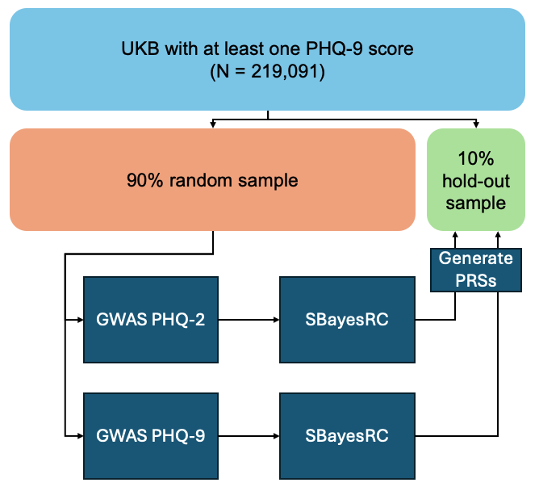
Supplementary Figure 1. PRS analyses in UKB. The following process was repeated ten times: a random 90% of individuals was sampled from the N = 219,091 having at least one PHQ-9 score. Then GWAS of mean PHQ-9 and mean PHQ-2 were performed. PRS weights for each depression scale were generated using SBayesRC⁸ and PRSs were calculated in the 10% hold-out sample and tested for association with lifetime MDD status.

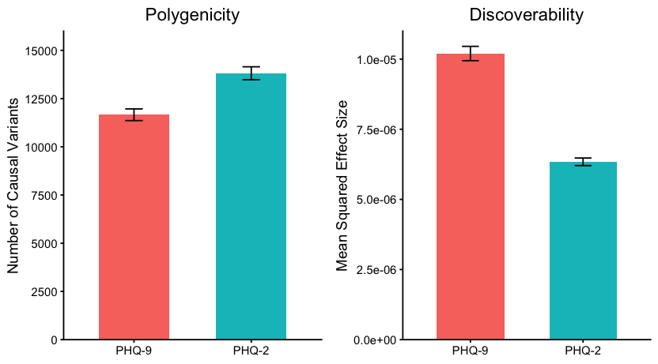
Supplementary Figure 2. Polygenicity and discoverability estimates for the PHQ-9 and the PHQ-2 from univariate MiXeR analyses. For each scale, the estimated number of causal variants explaining 90% of h²_{SNP} (left) and the mean squared effect size (σ_{β}²; right) are shown. Error bars represent 95% confidence intervals across the 20 iterations.

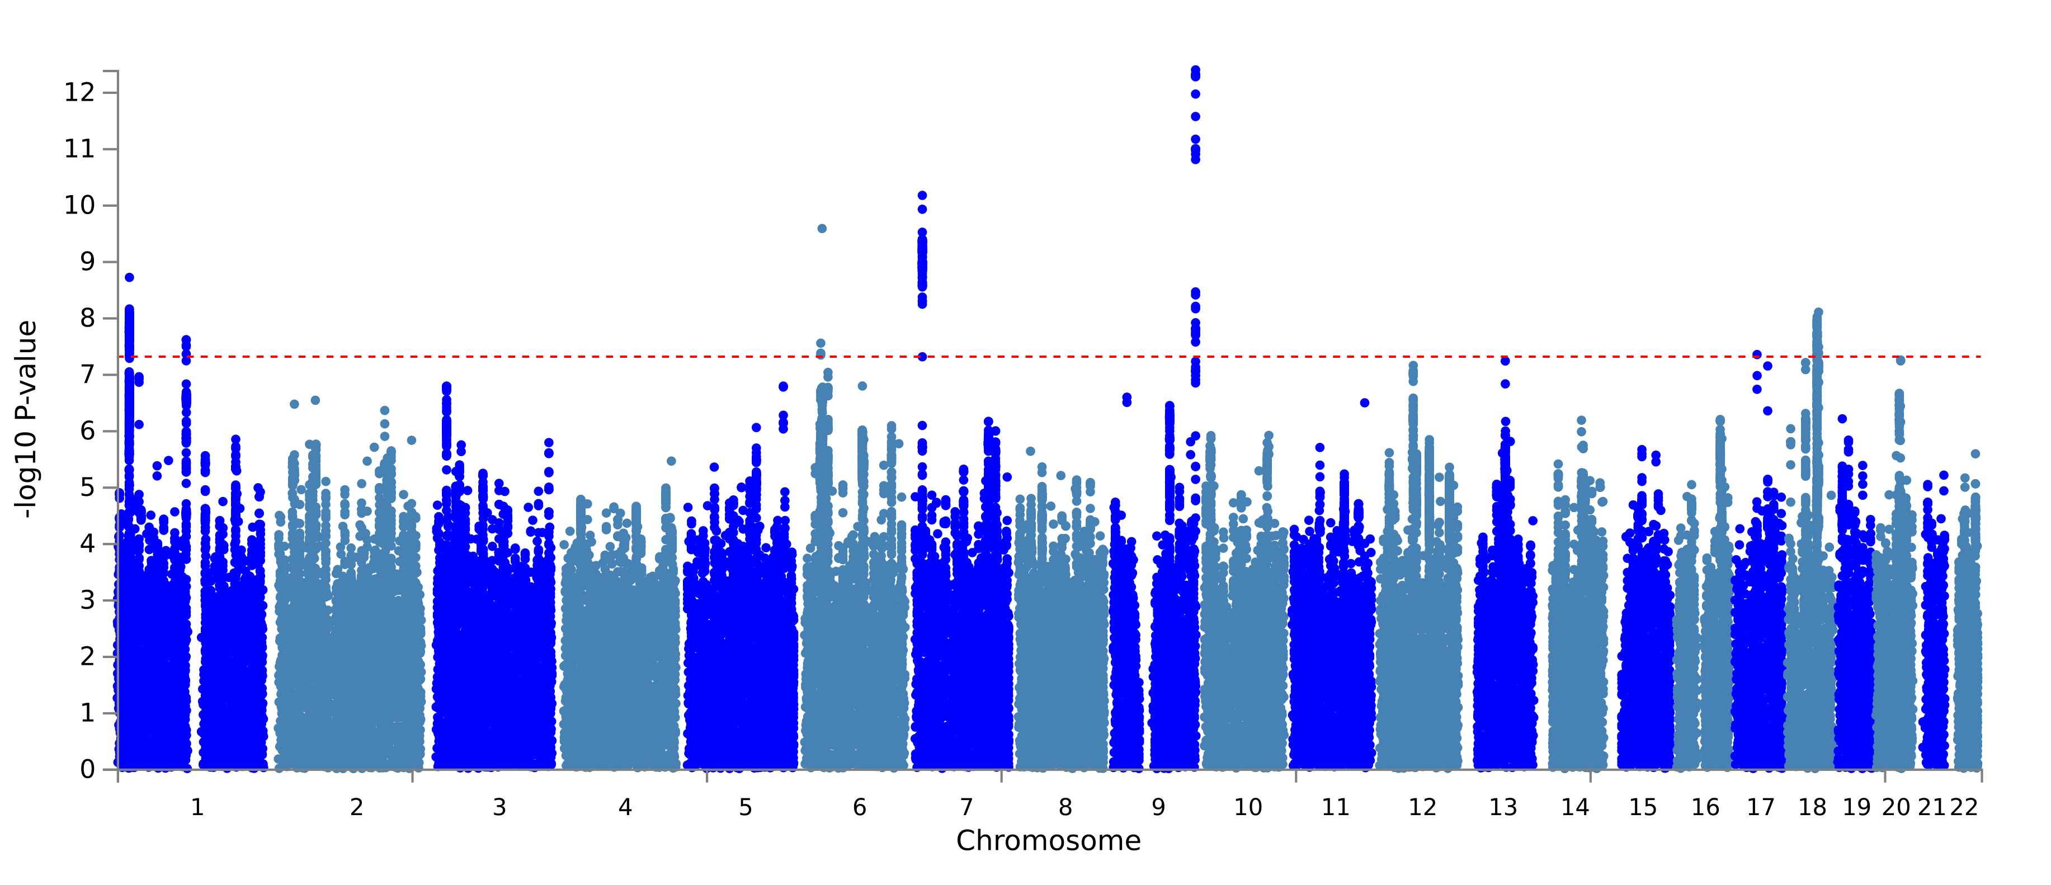
- PHQ2_meanof8_440k

- PHQ2_meanof8_220k
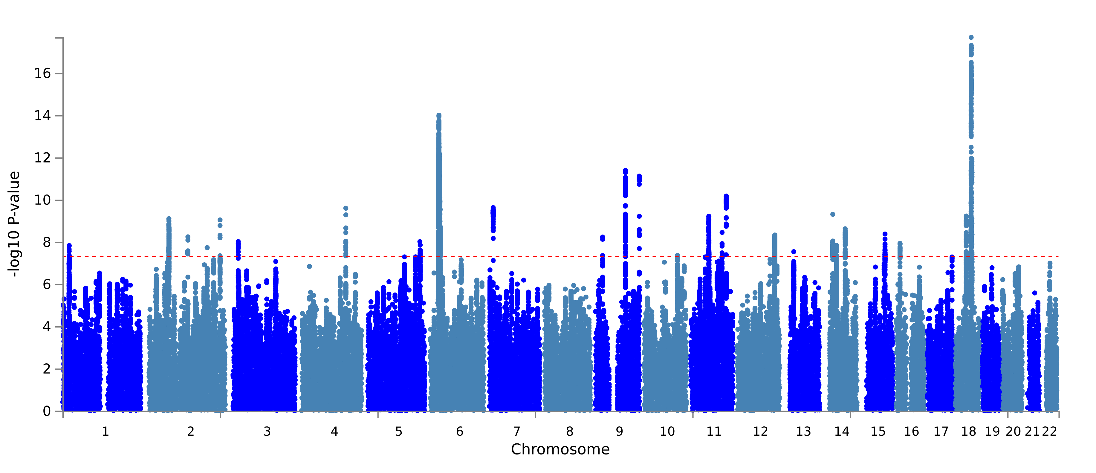
c. PHQ9_MWB_160k
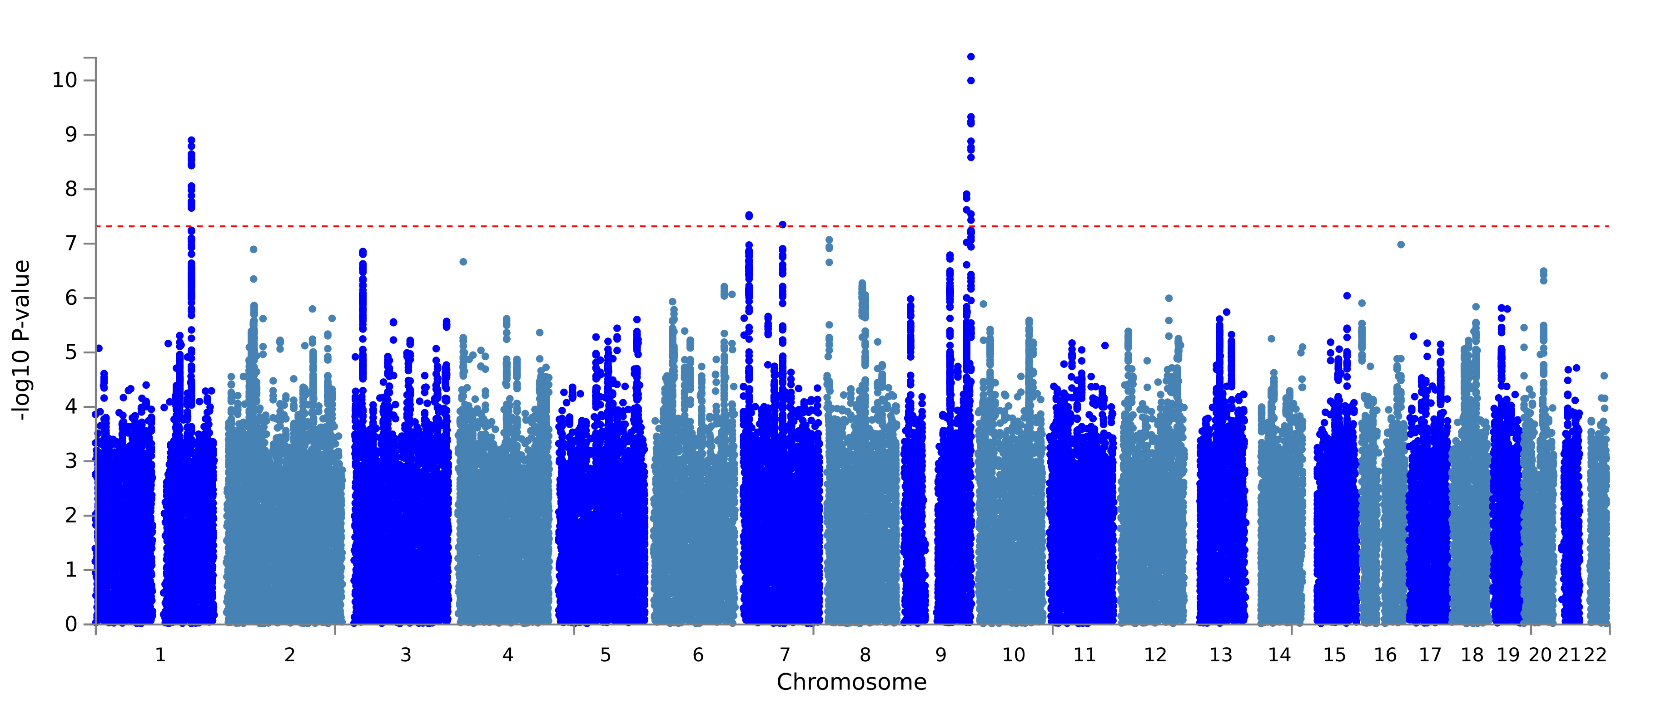
d. PHQ2_MWB_160k
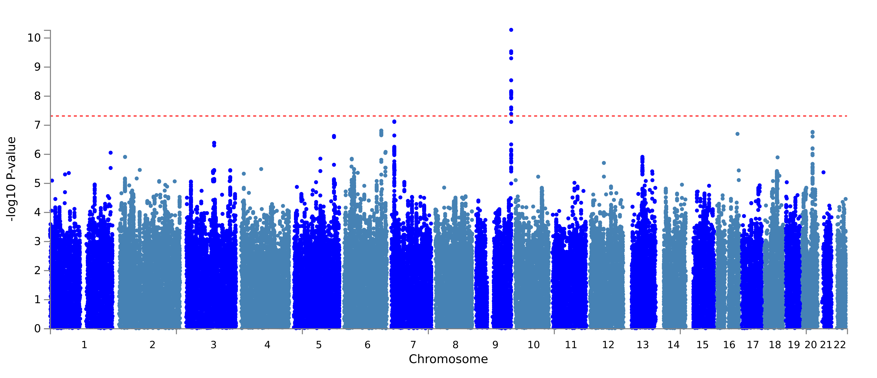
Supplementary Figure 3. Manhattan plots of GWAS in European UKB participants of (a) PHQ-2 with the same sample size (N = 219,091) but averaging across all available timepoints (max. 8); (b) PHQ-2, using the full sample (N = 440,721) and all available timepoints; (c) and (d) PHQ-9 and PHQ-2 respectively, restricting the sample to one timepoint (Mental Wellbeing Questionnaire, N = 159,944). X-axis shows the genomic position of each SNP and y-axis shows -log₁₀ p-value for each SNP association. Red dotted lines show genome-wide significance p-value threshold of 5x10⁻⁸.
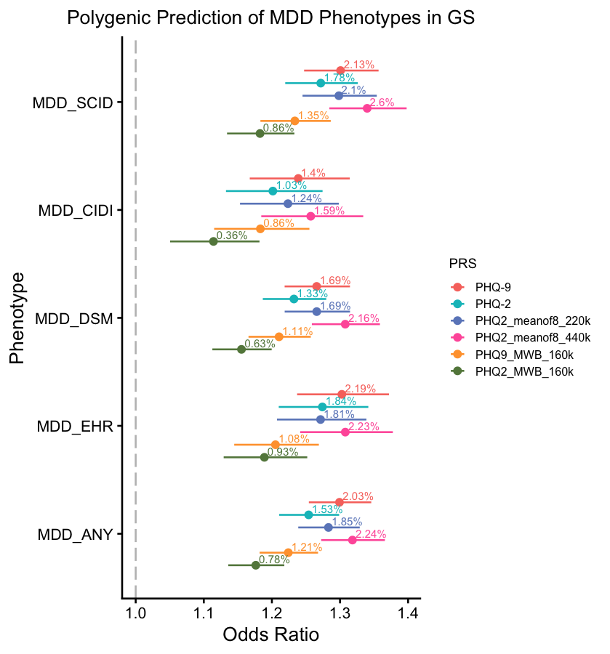
Supplementary Figure 4. Out-of-sample polygenic prediction of lifetime MDD phenotypes in Generation Scotland (N = 8338-18715). Points show odds ratio (OR) for an increase of one standard deviation in PRS for PHQ-9 (N = 219,091; mean of max. 3 timepoints; red), PHQ-2 (N = 219,091; mean of max. 3 timepoints; cyan), PHQ-2 (N = 219,091; mean of max. 8 timepoints; dark blue), PHQ-2 (N = 440,721; mean of max. 8 timepoints; pink), PHQ-9 (N = 159,944; one timepoint; orange) and PHQ-2 (N = 159,944; one timepoint; green). Percentages show liability-scale variance explained (R_{l}²). Error bars represent 95% confidence intervals for the OR. Lifetime MDD phenotypes: MDD_SCID: assessed using the Structured Clinical Interview for DSM-IV Disorders (SCID)⁹; MDD_CIDI: assessed using the Composite International Diagnostic Interview-Short Form (CIDI-SF)¹⁰; MDD_DSM: either SCID or CIDI (DSM-based) MDD definitions; MDD_EHR: based on electronic health records from primary and secondary care; MDD_ANY: any of the SCID, CIDI or EHR MDD definitions.

References
1. Kroenke, K., Spitzer, R.L. & Williams, J.B.W. The PHQ-9: validity of a brief depression severity measure. Journal of General Internal Medicine 16, 606-613 (2001).
2. Kroenke, K., Spitzer, R.L. & Janet, B.W.W. The Patient Health Questionnaire-2: Validity of a Two-Item Depression Screener. Medical care 41, 1284-1292 (2003).
3. Chang, C.C. et al. Second-generation PLINK: rising to the challenge of larger and richer datasets. GigaScience 4(2015).
4. Bycroft, C. et al. The UK Biobank resource with deep phenotyping and genomic data. Nature (London) 562, 203-209 (2018).
5. Mbatchou, J. et al. Computationally efficient whole-genome regression for quantitative and binary traits. Nature genetics 53, 1097-1103 (2021).
6. Watanabe, K., Taskesen, E., Van Bochoven, A. & Posthuma, D. Functional mapping and annotation of genetic associations with FUMA. Nature communications 8, 1826-11 (2017).
7. Van Der Meer, D. et al. Mapping the Genetic Landscape of Psychiatric Disorders With the MiXeR Toolset. Biological Psychiatry 98, 455-465 (2025).
8. Zheng, Z. et al. Leveraging functional genomic annotations and genome coverage to improve polygenic prediction of complex traits within and between ancestries. Nature Genetics 56, 767-777 (2024).
9. First, M.B. & Gibbon, M. The Structured Clinical Interview for DSM-IV Axis I Disorders (SCID-I) and the Structured Clinical Interview for DSM-IV Axis II Disorders (SCID-II). in Comprehensive handbook of psychological assessment, Vol. 2: Personality assessment. 134-143 (John Wiley & Sons, Inc., Hoboken, NJ, US, 2004).
10. Kessler, R.C., Andrews, G., Mroczek, D., Ustun, B. & Wittchen, H.U. The World Health Organization Composite International Diagnostic Interview short‐form (CIDI‐SF). International Journal of Methods in Psychiatric Research 7, 171-185 (1998).

