Supplementary Information
Enzymatic Defluorination of Perfluorooctanoic Acid by an Evolutionarily Distinct Haloacid Dehalogenase

Milad Torabfam ¹, Gizem Celebi Torabfam ², Stephen Kurilla ¹, Cristiano Dias ², Omowunmi Sadik ¹*
¹ Department of Chemistry and Environmental Sciences, 161 Warren Street, New Jersey Institute of Technology, University Heights, Newark, NJ 07102, USA
² Department of Physics, 161 Warren Street, New Jersey Institute of Technology, University Heights, Newark, NJ 07102, USA

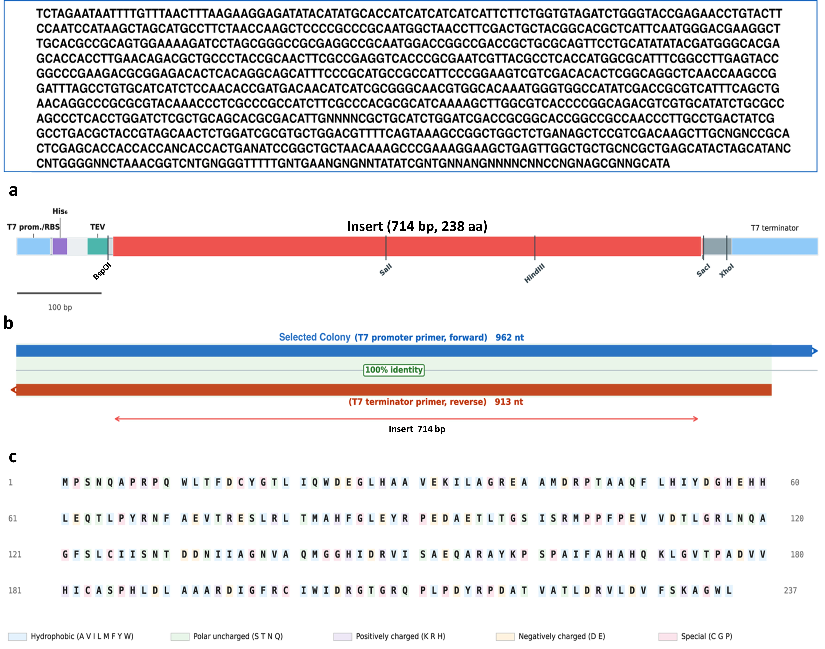
Figure S1. a) Linear map of the pET21a-LIC expression construct. The insert (714 bp, 238 aa) is flanked by BspOI (5′) and a TGA stop codon followed by SacI (3′); the N-terminal cassette encodes a His₆ affinity tag and TEV protease site. b) Sanger sequencing reads from T7 promoter (forward, 962 nt) and T7 terminator (reverse, 913 nt) primers provide complete double-stranded coverage of the insert with 100% sequence identity, confirming correct cloning without mutations. c) Deduced amino acid sequence of the insert (238 aa) translated from the confirmed nucleotide sequence. Residues are color-coded by physicochemical class: hydrophobic (blue), polar uncharged (green), positively charged (purple), negatively charged (orange), and special residues C/G/P (pink).

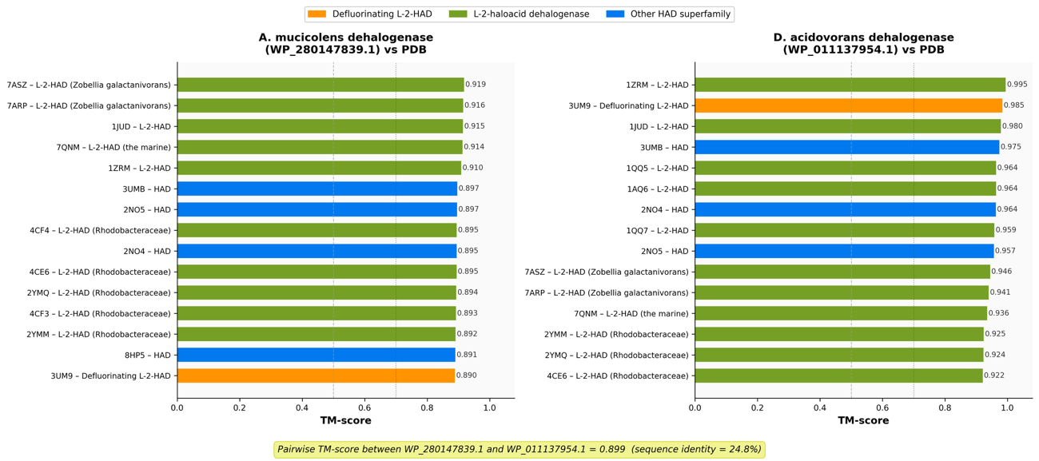
Figure S2. Structural homology of the A. mucicolens and D. acidovorans L-2-haloacid dehalogenases confirmed by Foldseek TM-align searches against the PDB. Three-dimensional structures of WP_280147839.1 (A. mucicolens; left panel) and WP_011137954.1 (D. acidovorans; right panel) were predicted using Boltz-2 and searched against the RCSB Protein Data Bank using Foldseek with TM-align scoring. Horizontal bars show the TM-score for the top 15 unique PDB hits per query, sorted in descending order. Bars are color-coded by functional category: orange, defluorinating L-2-haloacid dehalogenases; green, L-2-haloacid dehalogenases; blue, other HAD superfamily members. Dashed vertical lines indicate the same-fold threshold (TM-score = 0.5) and the same-superfamily threshold (TM-score = 0.7). The pairwise TM-score between the two predicted structures (0.899 at 24.8% sequence identity) is shown at the bottom. PDB accession codes are indicated for each hit. All 50 hits returned for each query exceeded TM-score 0.70, confirming unambiguous assignment to the HAD-II (L-2-haloacid dehalogenase) structural superfamily. Boltz-2 model quality: pTM = 0.935, pLDDT = 0.931 (WP_280147839.1); pTM = 0.951, pLDDT = 0.956 (WP_011137954.1). Foldseek searches against the PDB returned 50 significant hits for each query (e-value < 0.01). For the A. mucicolens enzyme (WP_280147839.1), all 50 hits had TM-scores exceeding 0.70, the threshold indicative of the same structural superfamily, with the top hit being the Zobellia galactanivorans L-2-haloacid dehalogenase (PDB: 7ASZ; TM-score = 0.919). Notably, two structurally characterized defluorinating L-2-haloacid dehalogenases - Bpro0530 (PDB: 3UM9; TM-score = 0.890) and Rha0230 (PDB: 3UMG; TM-score = 0.852) - ranked among the top structural matches, alongside the Xanthobacter autotrophicus L-2-haloacid dehalogenase (PDB: 1QQ5; TM-score = 0.869). For the D. acidovorans enzyme (WP_011137954.1), all 50 hits likewise exceeded a TM-score of 0.70, with the top hit being the L-2-haloacid dehalogenase reaction intermediate structure (PDB: 1ZRM; TM-score = 0.995), and the defluorinating dehalogenase Bpro0530 ranking second (PDB: 3UM9; TM-score = 0.985). The pairwise TM-score between the two predicted structures was 0.899, confirming near-identical fold topology despite only 24.8% sequence identity at the structural alignment level. Together, these results unambiguously establish that both enzymes adopt the HAD-II (L-2-haloacid dehalogenase) fold, and that the A. mucicolens enzyme is structurally most similar to experimentally characterised L-2-haloacid dehalogenases, including enzymes with demonstrated defluorination activity.

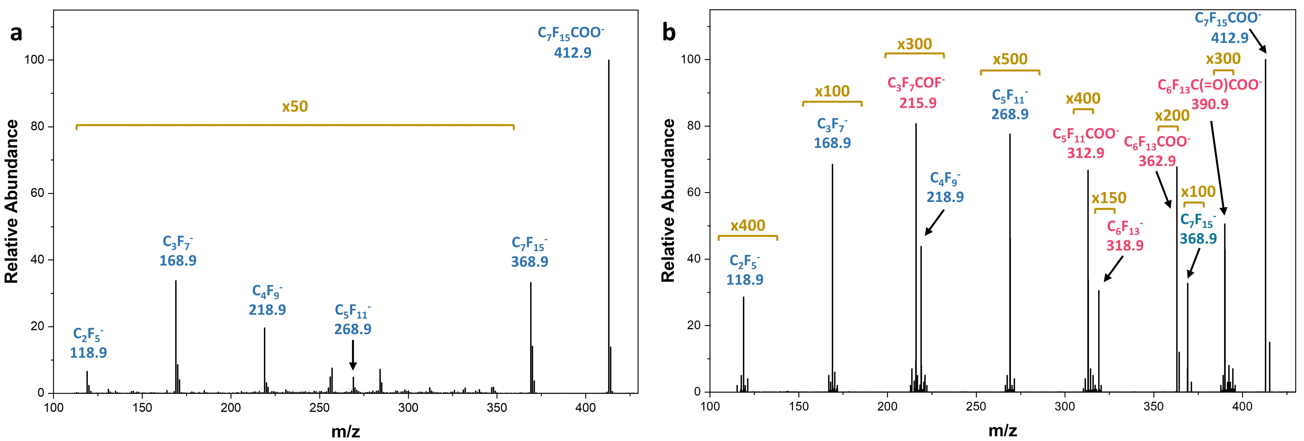
Figure S3. Negative-ion MS spectra of a) untreated PFOA control and b) enzymatically treated sample.

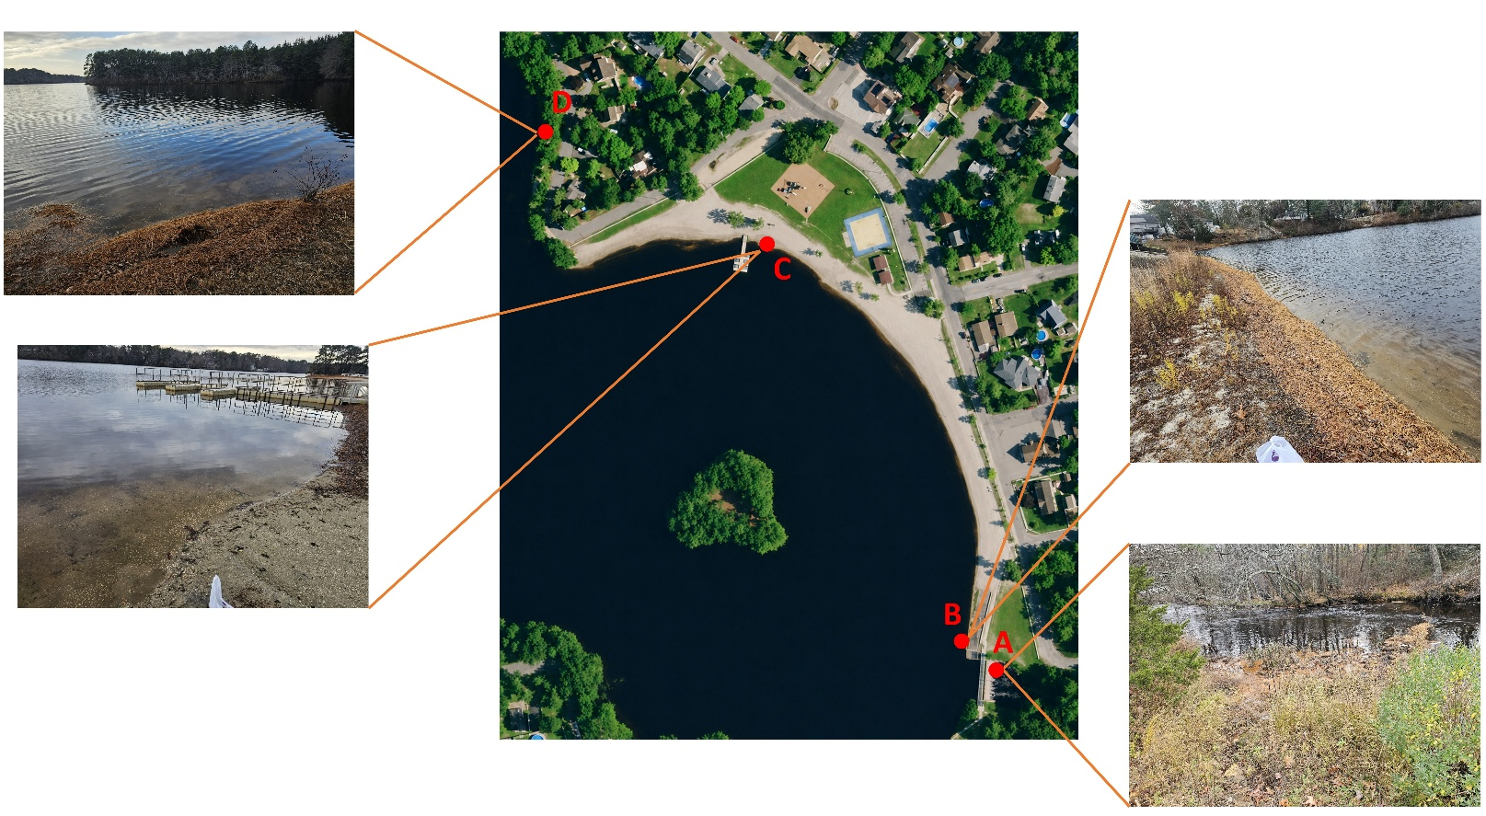
Figure S4. Pine Lake Park sampling site in New Jersey. The central image depicts the selected sampling points (A-D) around the PFAS-contaminated lake-associated area, with representative field photographs corresponding to each sampling location. These sites were chosen to capture spatial variability in soil/sediment conditions along the lake area.

Table S1. Enzymatic defluorination products of PFOA detected by direct-infusion negative-ion MS.
Neutral form | Product ions | [M-H]⁻ | Intensity
C₆F₁₃C(=O)COOH | C₆F₁₃C(=O)COO⁻ | 390.9640 | 3.891E+03
C₆F₁₃COOH | C₆F₁₃COO⁻ | 362.9691 | 7.818E+03
C₆F₁₃ | C₆F₁₃⁻ | 318.9792 | 4.702E+03
C₅F₁₁COOH | C₅F₁₁COO⁻ | 312.9723 | 3.850E+03
C₃F₇COF | C₃F₇COF⁻ | 215.9821 | 6.215E+03

Table S2. Calibration data parameters for fluoride ion quantification via ISE.
Nominal Concentration  (ppm) | Actual Concentration  after Dilution (ppm) | log₁₀ [Concentration] | Mean Potential  (mV) | Standard Deviation  (± mV)
0.02 | 0.01818 | -1.74041 | 137.0 | 4.5
0.03 | 0.02727 | -1.56431 | 128.5 | 3.0
0.125 | 0.113625 | -0.94453 | 89.7 | 4.1
0.25 | 0.22725 | -0.6435 | 71.7 | 2.5
0.5 | 0.4545 | -0.34247 | 52.7 | 3.0
1.0 | 0.909 | -0.04144 | 37.7 | 2.1
5.0 | 4.545 | 0.657534 | -2.9 | 0.7

Table S3. Mean peak areas and standard deviations across reference concentrations using IC technique.
F concentration (ppm) | Mean area (μS/cm s) | Standard deviation
5 | 47.38 | 0.45
1 | 8.81 | 0.2
0.1 | 0.91 | 0.032
0.01 | 0.22 | 0.017

