Supplementary Material

Table of contents

1 Breeding phenology ………………………..………………………..….………………….……...2
Fig. S1 Breeding phenology of the European robin ..……………………………………..…….……….2
Suppl.1.2 Results of breeding phenology calculation………………….…………..…………..………3
Table S1 Recovered robins ringed in breeding time (1960-2019) ….………..………………………3
2 Migration distances of the European robin ……..………………………………………..….4
Fig. S2 Migration distances of the European robin (detailed view) ……………………………..……4
3 Bias by recovery circumstances ……….………………………..………………………..…….5
Fig. S3 The number of reported migratory recoveries is biased in space and time by the
circumstances of recovery …..…………………………………………………………………..…………….5
4 Analysed subset of robins (notSHT) ………………………………………………….…………6
Table S2 Ringing and recovery coordinates and migration distance .……………………….……..6
Fig. S4. Migratory routes of the selected migratory robin subset …..……………..………….…….6
Table S3 Linear regression modelling ringing and recovery latitude and migratory distance...7
5 Ringing effort in European ringing schemes ………………………………..…………….….8
Table S4 Increasing ringing effort in breeding countries of migratory robins ………….…………8
6 Numbers of migratory recoveries over time …………………………………………..….….9
Table S5 Significant decline in the number of recoveries of migratory robins in 14 European ringing schemes ……………………………………………………………………………………..…………….9
Fig. S5 Generalised linear models (GLM(P) and qP) showing decreasing annual numbers of migratory recoveries over time ……………………………………………………………….…….…….….10
Fig. S6 Number of migrants recaptured by ringers ……………………………………………………..11
7 Populations trends in Sweden and ringing locations in Fennoscandia .…………….12
Fig. S7 Swedish bird survey, annual report of 2023, Erithacus rubecula ……………….………12
Fig. S8 Robin ringing locations in Fennoscandia ………………………………………..………..……12

1 Breeding phenology
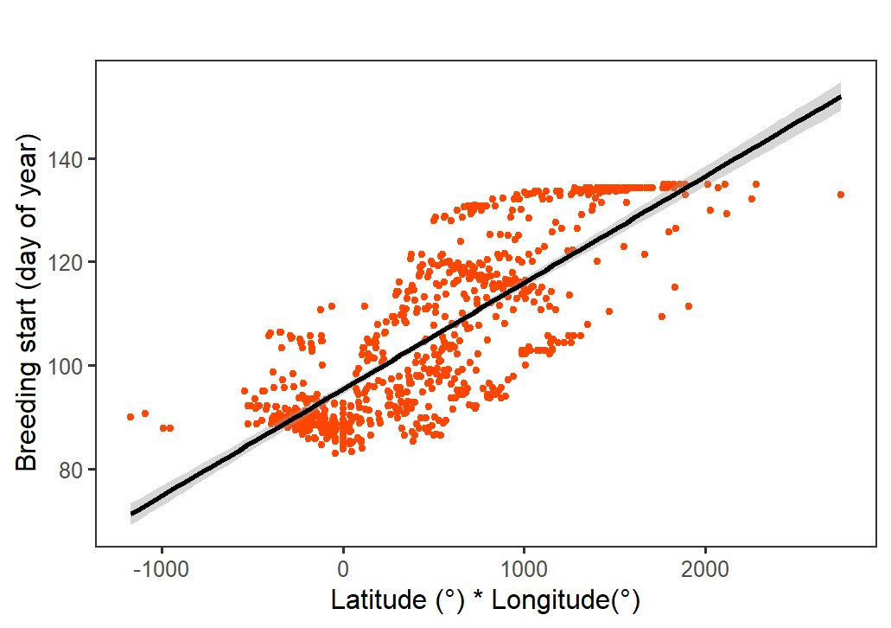
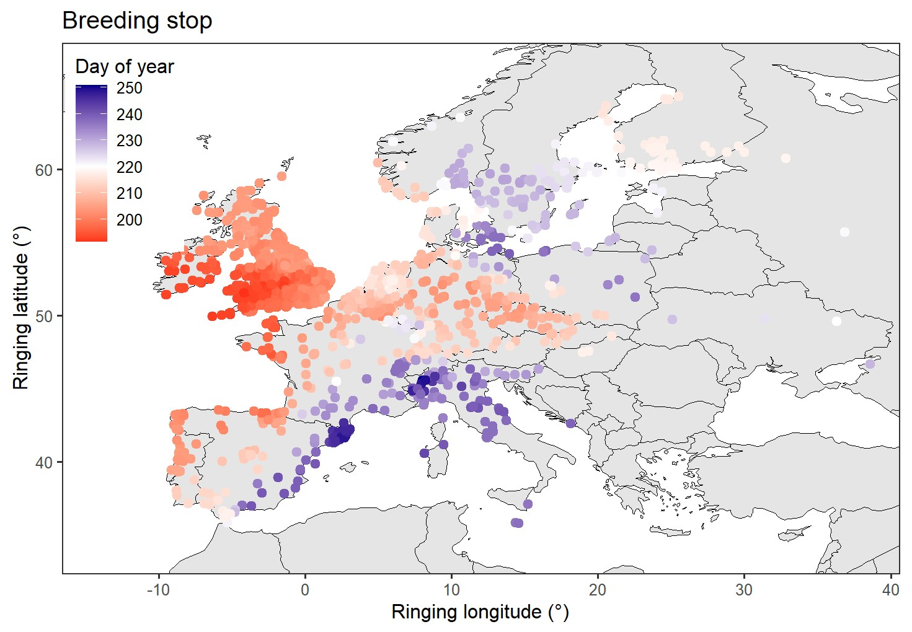
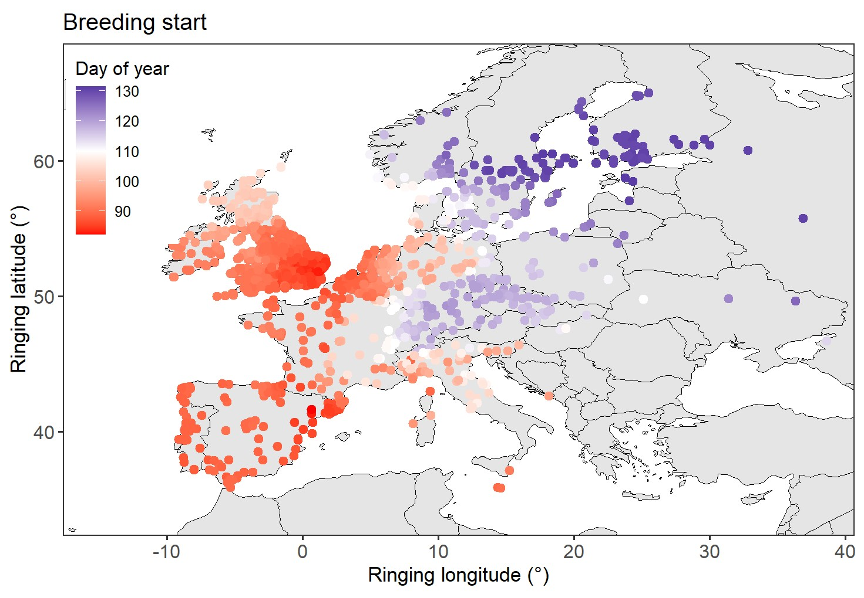
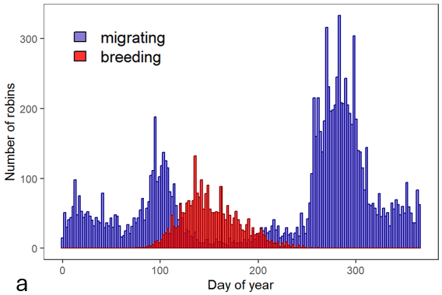
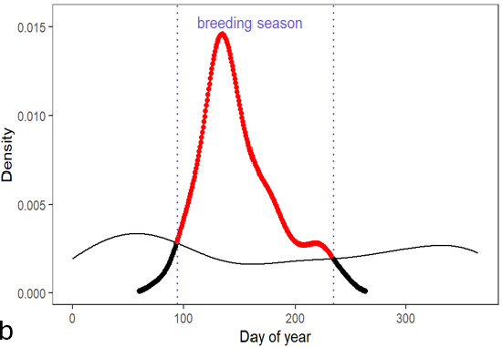
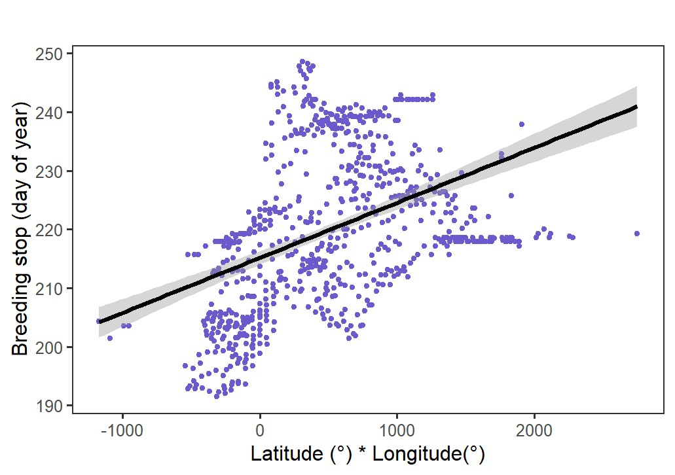
Fig. S1 Breeding phenology of the European robin a Temporal distribution of “migrating” and “breeding” robins. We defined robins in the breeding season (“breeding”) by the information “breeding patch”, status “N” (breeding) and age “1” (nestling). Migrating robins were defined by fat score and fuel load (calculated according to Kensley et al. 2000). b Example of density curves calculated for each robin by the 250 closest (lowest great circle distance) “breeding” (dotted curve) and the 250 closest “migrating” (slim black curve) robins. The start of the breeding period (left blue dashed line) was assumed to be the day on which the density of breeding robins exceeds that of migrating robins and vice versa for the end of the breeding period (right blue dashed line). c Start of the breeding season shown as colour gradient (midpoint (white) = day of year 110). d End of the breeding season shown as colour gradient (midpoint (white) = day of year 220). e, f Start and end of the breeding season as a function of Latitude * Longitude (start: p < 0.001, R² = 0.8445, stop: p < 0.001, R² = 0.515.).

1.2 Results of breeding phenology calculation
The breeding season of the robin starts later at more northern latitudes (p < 0.001, R² = 0.528) and more eastern longitudes (p < 0.001, R² = 0.4263), with the effect increasing with increasing latitude and longitude (latitude * longitude: p < 0.001, R² = 0.8445, Fig. S1e). The end of the breeding season seems to be less clearly defined. It is reasonable to assume that a later start to breeding activity results in a later completion of the breeding process. On the other hand, warmer climates not only allow for an earlier start to the breeding season but also increase the likelihood of a second or third brood, which should extend the breeding season. However, in our model, the breeding season ended earlier at more northerly latitudes (p = 0.00312, R² = 0.0952), but a later end to the breeding season was observed at more easterly longitudes (p < 0.001, R² = 0.3032). When latitude and longitude are modelled in interaction, the breeding season ends later at higher latitudes * longitudes (p < 0.001, R² = 0.515, Fig. S1f). For our purposes, calculating the exact start of the breeding season is crucial in order to exclude migrating birds. At the end of the breeding season, migration does not begin immediately, but rather the moulting period and preparation for migration, so that the probability of mistakenly including migrating individuals in the subset is lower.
The temporal distribution pattern of the start of breeding (start before or after year day 110) reflects the distribution of predominantly migratory and predominantly resident robin populations in Europe (Fig. S1c). Accordingly, a later start of breeding correlates with a longer migration distance (p < 0.001, F (1, 902) = 736.5, R² = 0.4489).

Table S1 Recovered robins ringed in breeding time (ribt) in 1960-2019

2 Migration distances of European robin
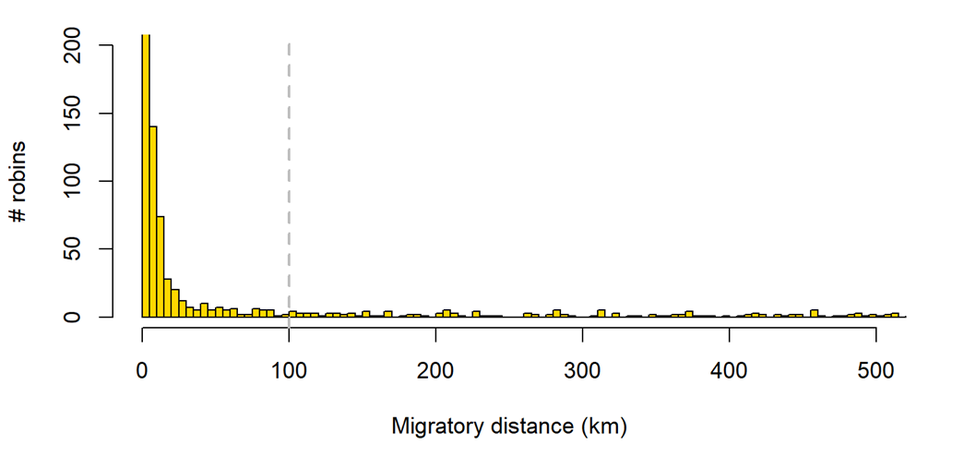

Fig. S2 Migration distances of the European robin (detailed view). The migration distances in the analysed data set range from 0 - 3999 km. A detailed view up to 500 km migration distance is shown. There is no clear gap between dispersal distances and migration. We included robin recoveries with a migration distance of at least 100 km (dotted vertical line) as migrants.
3 Bias by recovery circumstance
Fig. S3 The number of reported migratory recoveries is biased in space and time by the circumstances of recovery. (a) Recovery locations of shot and hunted robins. (b) Recovery locations of robins recovered by ringers. (c) and (d) Density of recoveries over ringing year (c) and explained by migration distance(d). Hunting and shooting - an effective recapture method that led to high recovery rates of migrants in the 1950s to 1970s - was banned under the Birds Directive (The Birds Directive, 2019), whereupon the number of reports decreased significantly to zero (c). Including these cases in the analyses (Ambrosini 2016), would not only have suggested a greater decrease in numbers of migrants than is realistically the case, but also a greater shift of wintering sites to the north, as recovery latitudes of shot/hunted recoveries are significantly further south than recovery latitudes of unintentionally recoveries (t₍₂₃₃₎ = 26.11, p < 0.001). Recaptures by ringers, on the other hand, suggest a slight increase of migratory recoveries (c, Fig. S6) albeit due to increasing ringing effort (Fig. 1b, Fig. S6) and show significantly shorter migration distances compared to the other recoveries (t₍₃₂₎ = 4.0911, p < 0.001), as they occur at more northerly latitudes compared to all other recaptures (t₍₇₁₇₎ = -3.4309, p < 0.001) and also compared to unintentional recaptures (notSHT) (t₍₃₃₎ = -2.6509, p = 0.0122).
a
d
c
b
4 Analysed subset of robins ringed during the breeding season and unintentionally (notSHT) recovered during the wintering season

Table S2 Ringing and recovery coordinates and migration distance. Mean of breeding sites and wintering sites of the analysed subset of migratory robins (not shot, hunted or trapped, notSHT), ringed in breeding time and recovered at wintering sites (n = 377).

 | Minimum | Median | Mean ± SD | Maximum
Ringing latitude (°) | 36.75 | 55.33 | 54.87 ± 4.39 | 65
Ringing longitude (°) | -5.371 | 10.8 | 10.83 ± 7.81 | 36.85
Recovery latitude (°) | 31.65 | 44.30 | 44.53 ± 5.6 | 59.87
Recovery longitude (°) | -8.98 | 0.72 | 1.67 ± 6.11 | 39.35
Migration distance (km) | 100.9 | 1453.4 | 1404.9 ± 903.24 | 3744.9

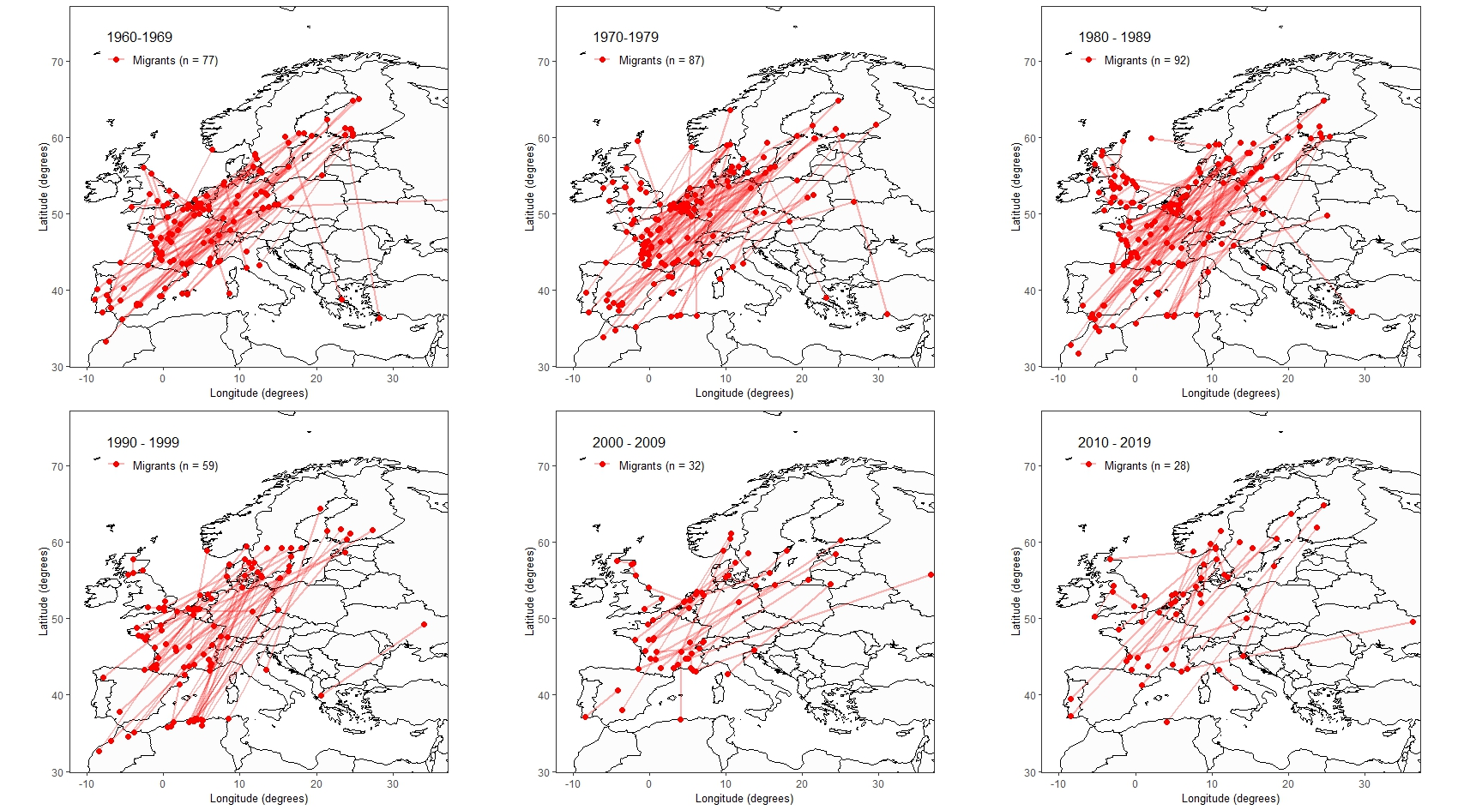
Fig. S4 Migratory routes of the selected migratory robin subset (ringed in breeding time and recovered not intentionally (notSHT, n=377)). Numbers of migratory recoveries have decreased, and recovery latitudes shifted northwards.

Table S3 Simple linear regression modelling ringing and recovery latitude of recovered migratory robins and migratory distance explained by ringing year. For migratory robins ringed in the breeding season, a linear regression for recovery latitudes ~ ringing year would show a highly significant northward shift in recovery latitudes, but partly due to biased recovery circumstances (as shown in Fig. S3).

5 Ringing effort in European ringing schemes

Table S4 Increasing ringing effort in most of the breeding countries of migratory European robins. Linear regression (LM) demonstrate significant increase in ringing effort in 13 Schemes out of 16 providing information about robin ringing totals (EURING | Ringing totals, 2025) during the study period (1960 – 2019).

6 Numbers of migratory recoveries over time

Table S5 Significant decline in the number of recoveries of migratory robins in 14 European ringing schemes. P-values of generalised linear models (GLM of the Poisson (P) and quasi-Poisson (qP) family) for the number of recovered migratory robins (dependent variable) explained by the ringing year. Listed are the p-values for the 14 ringing centres from 12 European countries with more than 5 recoveries of migratory robins in the period 1960-2019. For all ringing centres that provided data on ringing totals on the EURING homepage (EURING | Ringing totals), a significant decrease in migratory robin recoveries was detected.

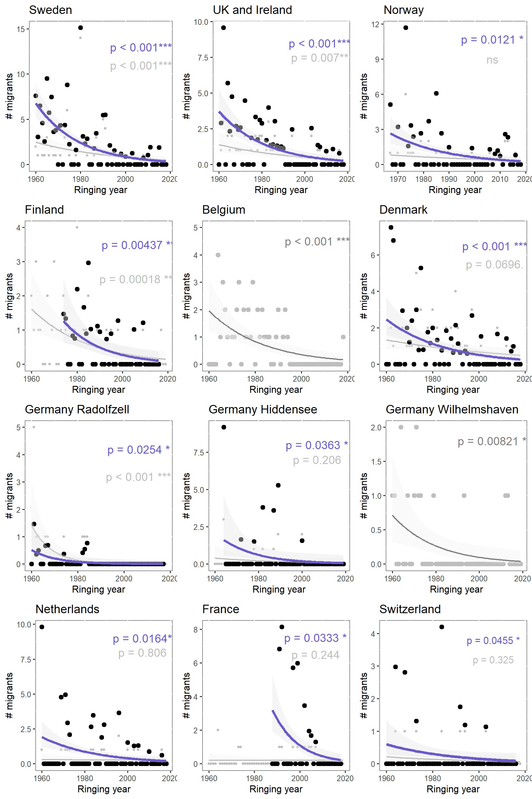

Fig. S5 Generalised linear models (GLM(P) and qP) showing decreasing annual numbers of migratory recoveries over time. Included are the 12 ringing schemes of which the highest number of migrants were recovered between 1960-2019 (more than 5). For ten of them, ringing totals were available at the EURING homepage. The uncorrected numbers are shown in grey, the numbers of migratory recoveries adjusted for ringing effort are shown in blue (the p-values of the GLM are shown in the same colour).

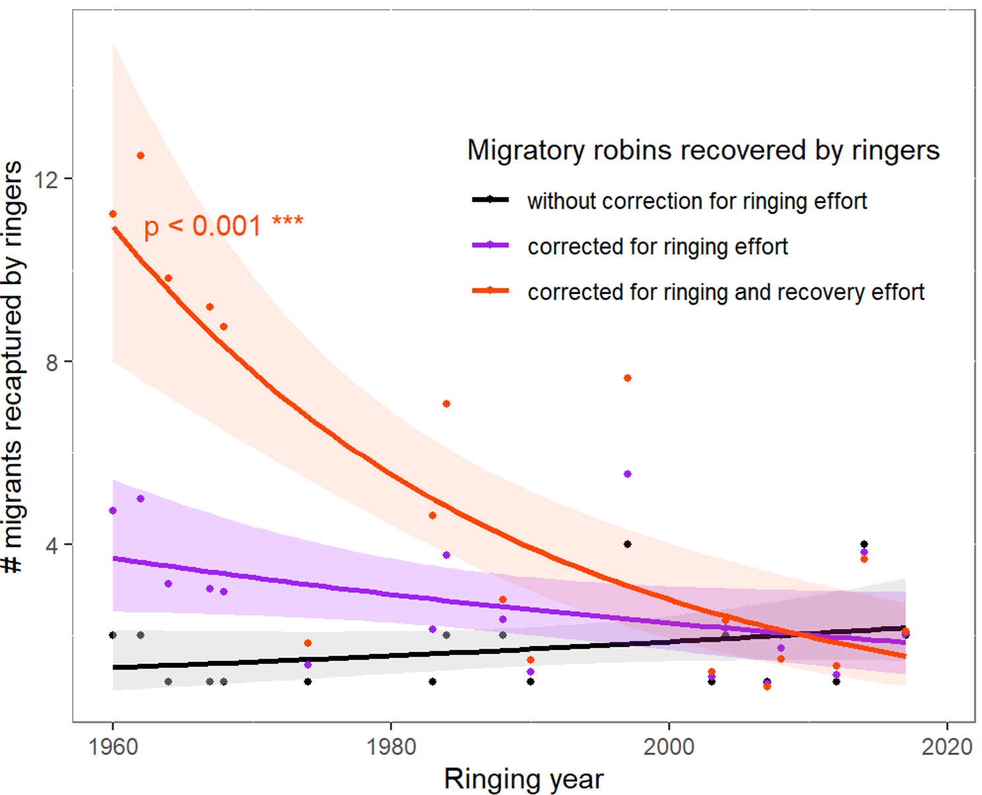
Fig. S6 Number of migrants recaptured by ringers. The absolute numbers of migratory robins ringed in breeding time recaptured by ringers (n = 31) have slightly increased (black, GLM(P), p = 0.35). If the ringing effort is taken into account, which affects the recapture probability both during ringing and again during recapture by ringers, the same pattern emerges as for the number of unintentionally recovered migrants (corrected once (purple): GLM(P), p = 0.11; corrected for ringing and for recapture probability (red), GLM(P), p < 0.001). Apparently, the increased ringing effort masks the fact that the number of robins recaptured by ringers is also decreasing.

7 Populations trends in Sweden and ringing locations in Fennoscandia
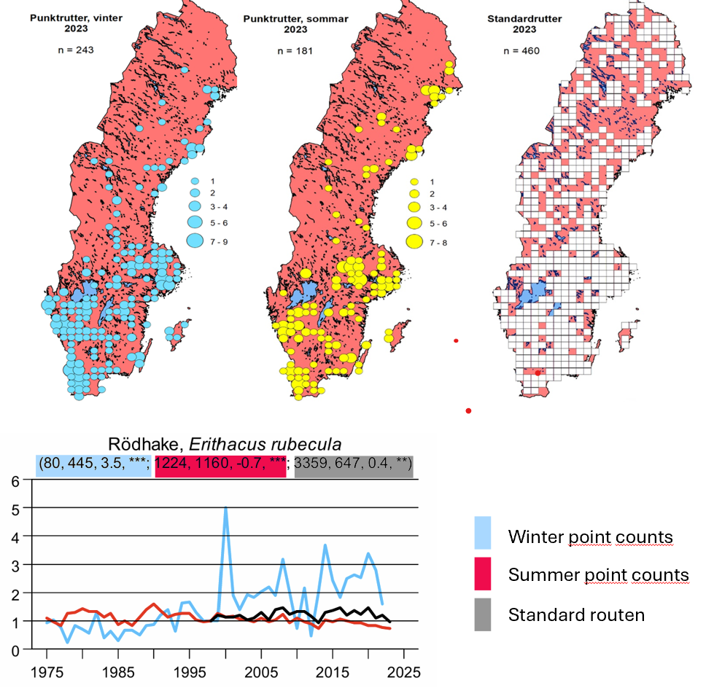
Fig. S7 Swedish bird survey, annual report of 2023, Erithacus rubecula. Swedish bird monitoring shows significantly increasing numbers of wintering robins in southern Sweden (blue line, ***), while the summer population in southern Sweden is declining (red line, ***). The breeding population trend for the whole of Sweden is increasing (standard routes, **), i.e. the population in the north is compensating for the decline in the population in the south. Figures taken from Swedish bird survey, annual report 2023 (Green et al., 2024).

Fig. S8 Robin ringing locations in Fennoscandia. Ringing location from both EURING datasets are shown. Bird ringing in Fennoscandia mainly takes place in the southern parts of the country.

