Supplemental Materials
- Supplementary Discussions
- Supplementary Figures
- Supplementary Tables
- Supplementary References

Supplementary Discussions
- Construction of nationally equitable emissions pathways
We construct nationally equitable emissions pathways consistent with the 1.5°C target by comparing, for each target country, a population-proportional equity baseline against a calibrated temperature-preserving counterfactual that replaces the country’s historical emissions with its equal per-capita share. The procedure is applied to all countries; for exposition we illustrate the steps with the United States (US).

The United States has historically emitted well above a population-proportional (equal per-capita) share (Supplementary Figure 1). A natural question is: what if the US had emitted only its equal per-capita share relative to the rest of the world? Under that counterfactual, US historical emissions would have been markedly lower. Because the end-of-century temperature target is fixed (1.5°C), lower past emissions by the US would have freed up headroom for higher global emissions later in the century—if we can construct a global future pathway that keeps the 2100 GMST exactly the same as in the original 1.5°C pathway.

To build that pathway, we proceed as follows. First, we replace US’s historical record (1950–2023) with its equitable per-capita history (the “counterfactual history”) and recompute global totals ¹⁻⁴. This historical substitution shifts the global temperature response. We then search for a temperature-preserving counterfactual future by holding the post-2023 shape (relative trend) of the original 1.5°C pathway and rescaling its overall level so that the simulated 2100 GMST matches exactly. Operationally, FAIR is used with a bisection search on the 2100 fossil CO₂ level to find the unique rescaling that restores the original 2100 temperature ^{5,6}. The rescaling is implemented by a simple linear transformation that keeps the curve’s shape but shifts its level. Let $E_{t}^{ori}$ be the original global fossil-CO₂ emissions at the year t, $E_{2023}^{cf}$ the counterfactual global emissions in 2023 (after replacing US history), and $E_{2100}^{target}$ the bisection-selected 2100 emission level that preserves the 2100 GMST. The Equation (S1) defines a single, year-invariant scale. Then for any future year t until 2100, the counterfactual global future is adjusted according to the Equation (S2).

$Scale= \frac{E_{2100}^{target}-E_{2023}^{cf}}{E_{2100}^{ori}-E_{2023}^{ori}}$ (S1)
$E_{t}^{cf}=E_{2023}^{cf}+Scale×(E_{t}^{ori}-E_{2023}^{ori})$ (S2)

Intuitively, each future year keeps the same inter-annual increment as in the original pathway (the term $E_{t}^{ori}-E_{2023}^{ori}$), multiplied by a common factor that raises or lowers the entire trajectory so that the 2100 temperature is preserved. This gives a temperature-preserving counterfactual global pathway consistent with the US “what-if” history. In constructing counterfactual histories, we considered fossil CO₂, CH₄, and N₂O emissions. For the future, however, only fossil CO₂ trajectories were rescaled using the bisection-based adjustment above. CH₄ and N₂O were simply allocated in proportion to national population shares under the 1.5°C pathway, reflecting a simplifying assumption that all countries will align their future CH₄ and N₂O emissions with equitable quotas. This simplifying assumption may bias the allocation in favor of historically high-emitting countries.

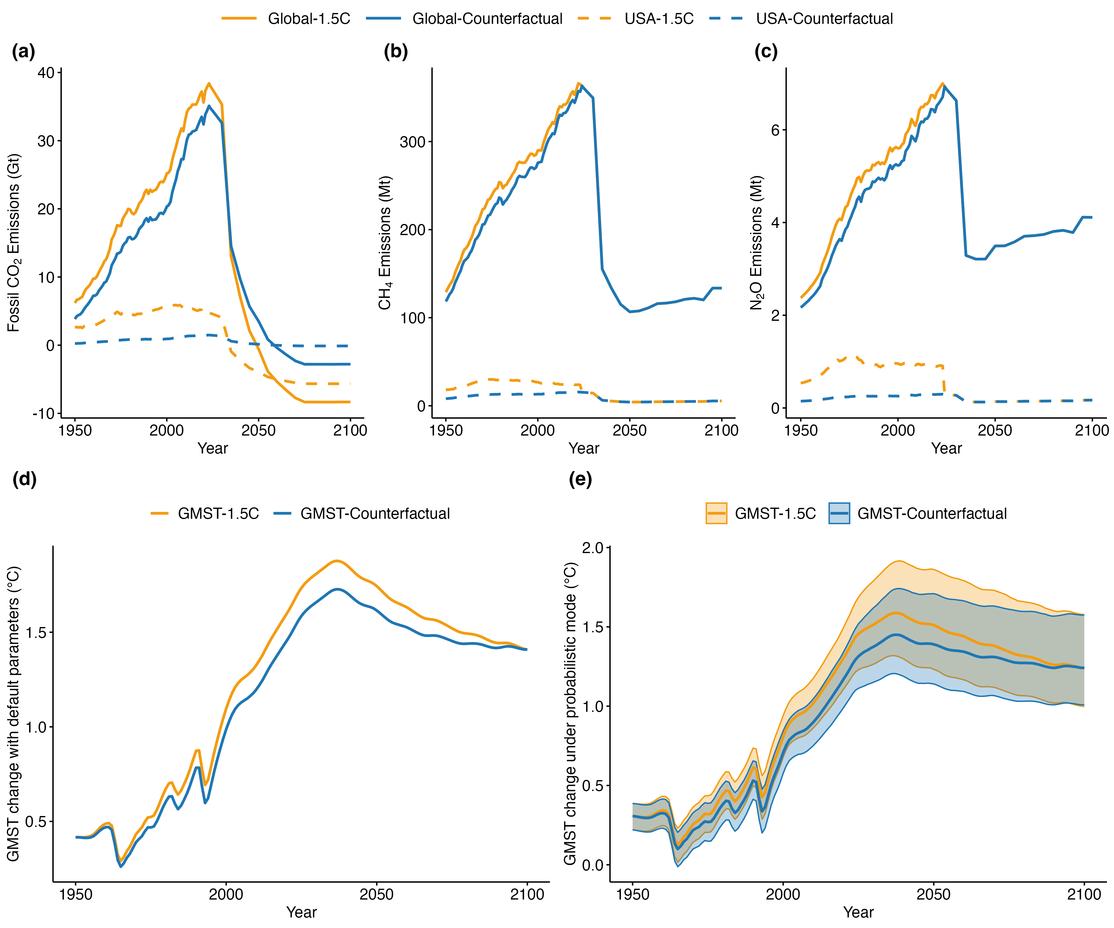
Supplementary Figure 1. Constructing the warming-excess equity framework to derive national equitable emissions pathways. (a–c), Global and national (US) emissions trajectories for fossil CO₂ (a), CH₄ (b), and N₂O (c). Fossil CO₂ counterfactuals are generated by rescaling the original 1.5°C pathway using the bisection method to preserve the 2100 GMST, whereas CH₄ and N₂O futures are allocated proportionally to population shares under the 1.5°C pathway without additional historical-responsibility adjustments. Orange lines denote the original 1.5°C pathway, and blue lines the counterfactual scenarios. (d), GMST anomalies simulated using the FAIR model with default parameters. (e), Probabilistic GMST outcomes from Monte Carlo simulations (n = 10,000) with a calibrated ensemble of FAIR parameter sets. Solid lines show the median, and shaded areas the 10th–90th percentile range.

After allocating the country’s equitable share of future emissions based on population, the remaining difference between the original global emission trajectory and the counterfactual emission trajectory represents the additional reductions that country must undertake to meet its historical emissions responsibility. In the US case, this results in a more stringent emissions reduction trajectory, reaching net-negative emissions before mid-century (Supplementary Figure 1a, dashed orange curve). Quantitatively, the US would need to achieve approximately −305 Gt CO₂ cumulative net-negative emissions by 2100. Repeating the same “what-if” construction country by country yields diagnostic, country-specific responsibility requirements while keeping the global 2100 temperature unchanged. These responsibility pathways are country-specific, since each arises from a distinct historical substitution.

- Sensitivity to the equity principle and historical responsibility starting year
The analysis in the main text adopts the equal per-capita principle, assuming that everyone in the world has the same emission allowance. To accommodate diverse ethical perspectives on climate justice, we introduce two alternative frameworks for sensitivity analysis, including the national capacity principle and the contraction and convergence principle. We further compare how these alternative principles translate into differences in national net-negative emissions pathways.

The alternative equity principles substantially reshape national emission pathways compared with the equal per-capita baseline (Supplementary Figures 2-3). The national capacity principle tightens the late-century requirements for high-income countries. By 2100, the United States reaches roughly −7.0 Gt CO₂ yr⁻¹ under national capacity versus about −6.3 Gt CO₂ yr⁻¹ under equal per-capita (a deepening of 0.7 Gt CO₂ yr⁻¹), with Germany, Japan, and Russia becoming about 0.3–0.4 Gt CO₂ yr⁻¹ more negative than under equal per-capita. This tightening also slightly advances the onset of net-negative allowances for several high-income countries.

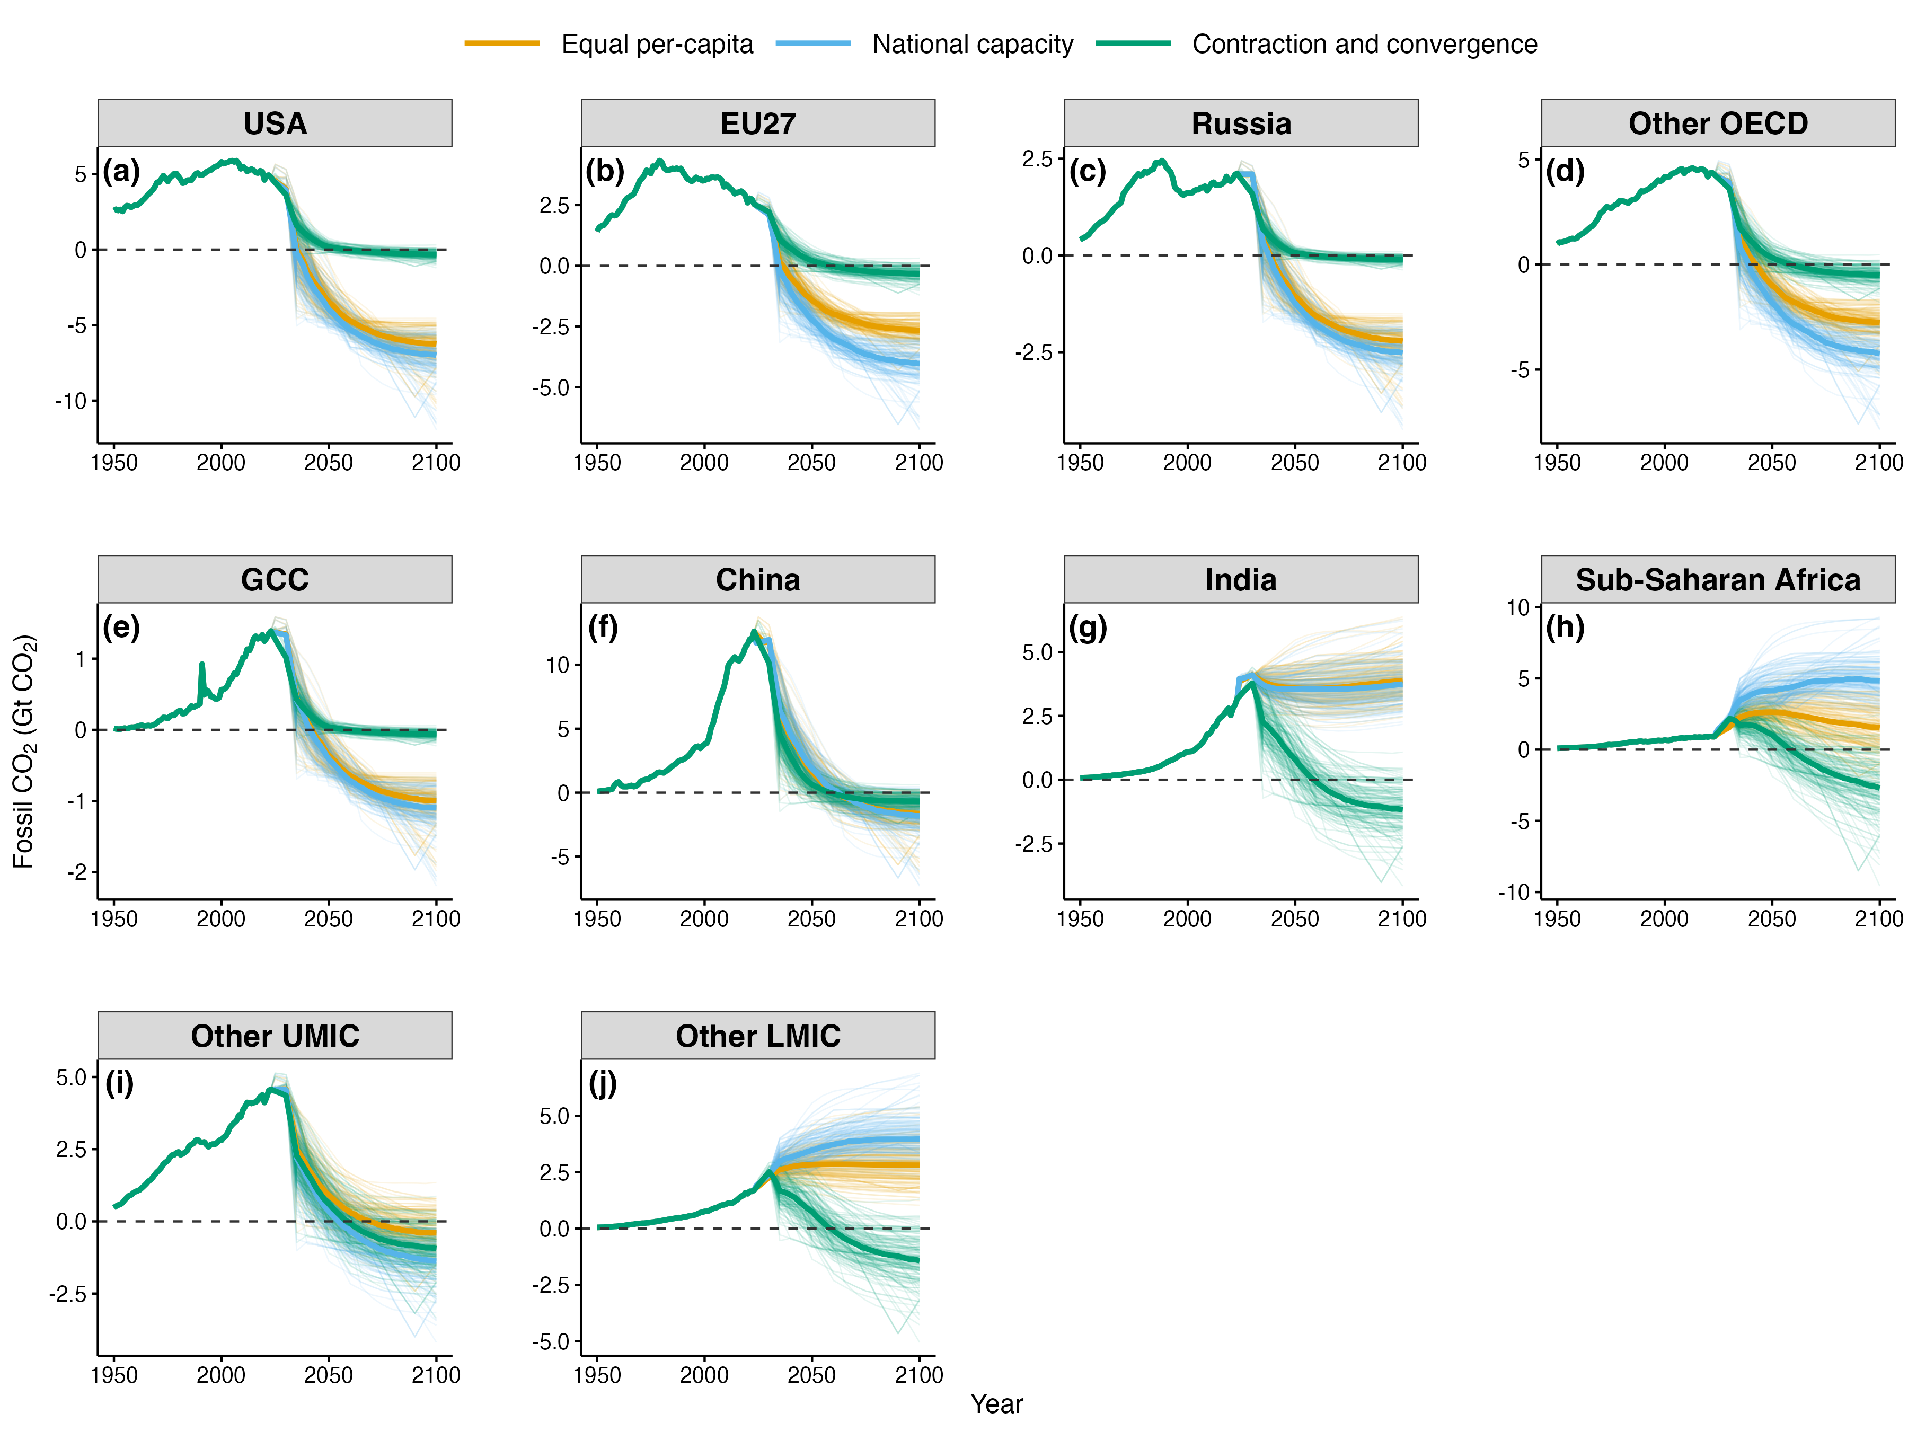
Supplementary Figure 2. Fair-share-corrected fossil CO₂ emission pathways for ten world regions under three different equity principles. The panels show historical and projected fossil CO₂ emission pathways from 1950 to 2100 for the United States (USA) (a), European Union (EU27) (b), Russia (c), other OECD economies (Other OECD) (d), Gulf Cooperation Council countries (GCC) (e), China (f), India (g), Sub-Saharan Africa (SSA) (h), other upper-middle-income countries (Other UMIC) (i), and other lower-middle- and low-income countries (Other LMIC) (j). Three equity frameworks are compared, including the Equal Per-capita (orange), National Capacity (blue), and Contraction and Convergence (green) principles. Thick dark lines show the median pathway for each starting year, while thin lines show all individual scenarios.

The contraction and convergence principle produces an opposite redistribution after the convergence year. Because allocations transition from the status-quo emissions toward per-capita equality by 2050, the trajectories for today’s high emitters rapidly collapse toward the converged level and remain near-zero thereafter (e.g., the United States stays around −0.3 Gt CO₂ yr⁻¹ by 2100). At the same time, developing economies’ late-century allowance spaces are substantially compressed. India shifts from a persistently positive allowance under the other principles to a net-negative pathway (about −1.2 Gt CO₂ yr⁻¹ by 2100). China’s projected allowances are relatively similar across the three principles.

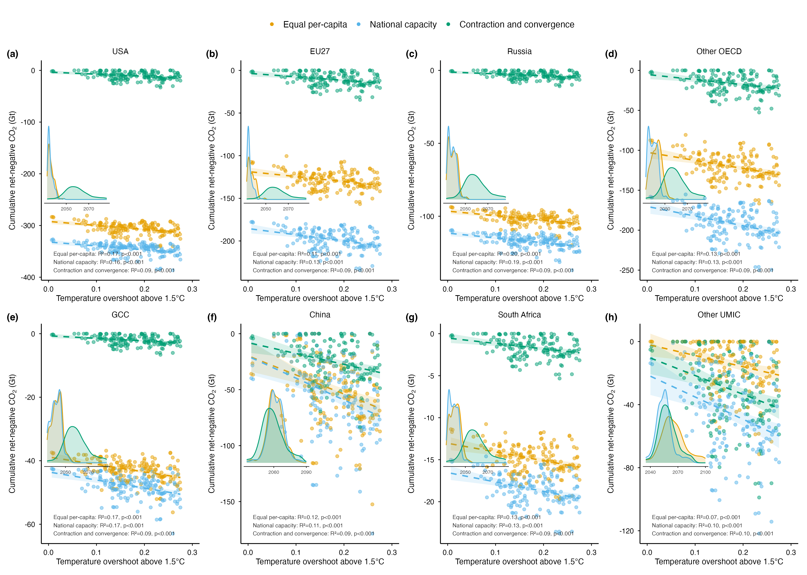
Supplementary Figure 3. Relationship between temperature overshoot above 1.5°C and cumulative net-negative CO₂ requirements under three equity principles. Panels show the cumulative net-negative fossil CO₂ emissions to 2100 for eight regions: USA (a), EU27 (b), Russia (c), Other OECD (d), GCC (e), China (f), South Africa (g), and Other UMIC (h) (South Africa is shown separately in place of the broader Sub-Saharan Africa group because it is the dominant net-negative emitter within that region). Colors denote the three equity principles: Equal per-capita (orange), National capacity (blue), and Contraction and convergence (green). Each point represents one 1.5°C-consistent pathway, and insets report the fitted linear relationship for each principle and the probability density distribution of the first net-negative emission year.

National pathways are also highly sensitive to the historical responsibility starting year (Supplementary Figures 4–5) ⁷⁻⁹. This sensitivity is implemented by recalculating cumulative warming contributions from alternative baseline years (1950, 1970, or 1992) onward, while keeping the same global temperature constraint and pathway ensemble. Earlier starting years place greater weight on long-run industrial emissions and therefore imply earlier and deeper net-negative pathways for long-industrialized economies. For the United States, the median 2100 fossil CO₂ level shifts from –6.3 Gt CO₂ yr⁻¹ under a 1950 baseline to –5.3 under 1970 and –3.8 under 1992, while the median first net-negative year moves from 2036 to 2037 and then 2040. The same pattern holds for the European Union, with its median 2100 level becoming progressively shallower from –2.7 to –2.2 to –1.3 Gt CO₂ yr⁻¹, and for Russia, where the corresponding value changes from –2.2 to –2.0 to –1.4, with net-negative entry delayed from 2039 to 2040 and then 2044.

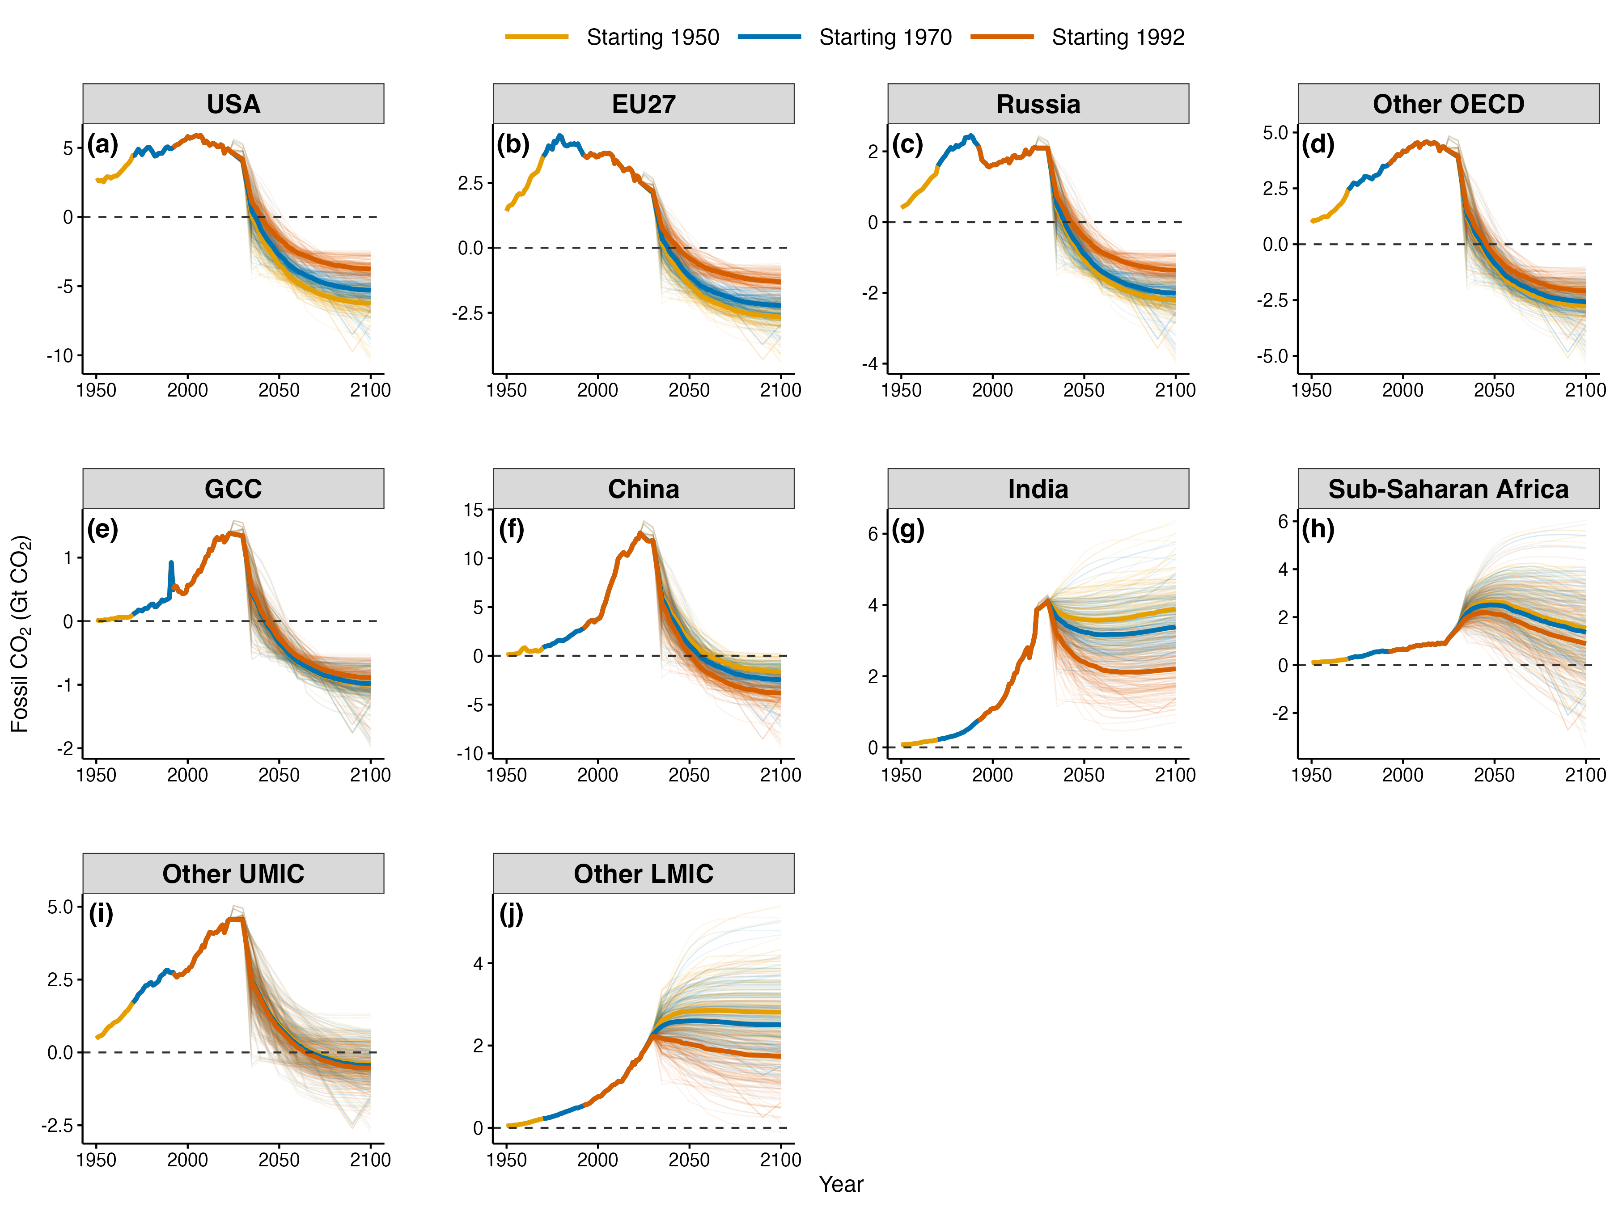
Supplementary Figure 4. Comparison of fair-share-corrected CO₂ emission pathways under different historical responsibility starting years for representative countries. The panels show historical and projected fossil CO₂ emission pathways from 1950 to 2100 for the USA (a), EU27 (b), Russia (c), Other OECD (d), GCC (e), China (f), India (g), SSA (h), Other UMIC (i), Other LMIC (j). Colors denote the three historical responsibility starting years used in the allocation framework: 1950 (orange), 1970 (blue), and 1992 (brown). Thick dark lines show the median pathway for each starting year, while thin lines show all individual scenarios.

For emerging economies, the pattern differs. Because later starting years place greater weight on recent emissions growth, China’s pathway becomes substantially more stringent as the baseline shifts forward: its median 2100 fossil CO₂ level deepens from –1.6 Gt CO₂ yr⁻¹ under a 1950 baseline to –2.5 under 1970 and –3.8 under 1992, while median net-negative entry advances from 2061 to 2056 and then 2051. Other emerging economies, such as Mexico and Türkiye, show the same qualitative pattern, though at much smaller magnitudes: Mexico’s net-negative entry advances from 2059 to 2058 and 2056, and Türkiye’s entry advances from 2066 to 2063 and 2058. By contrast, India remains on a positive pathway under all three starting years, with median 2100 emissions declining from 3.9 to 3.4 to 2.2 Gt CO₂ yr⁻¹ but never reaching net-negative emissions.

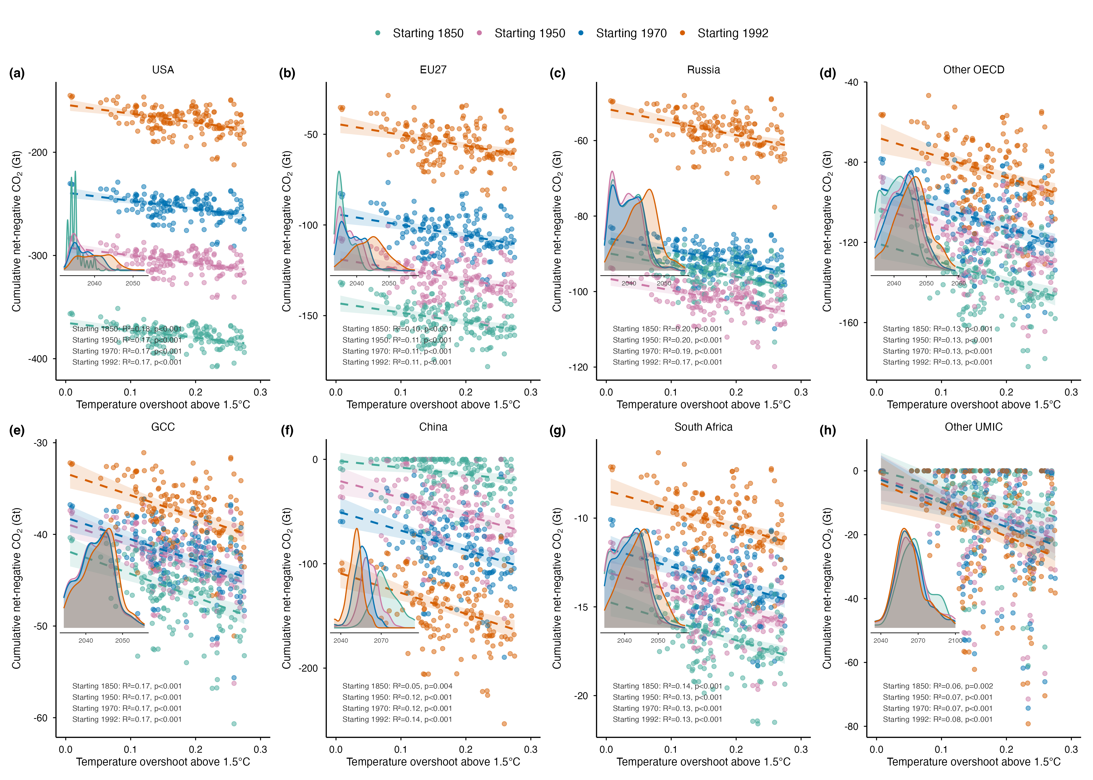
Supplementary Figure 5. Relationship between temperature overshoot above 1.5°C and cumulative net-negative CO₂ requirements under different historical responsibility starting years. Panels show cumulative net-negative fossil CO₂ emissions to 2100 for eight regions: USA (a), EU27 (b), Russia (c), Other OECD (d), GCC (e), China (f), South Africa (g), and Other UMIC (h) (South Africa is shown separately in place of the broader Sub-Saharan Africa group because it is the dominant net-negative emitter within that region). Colors denote the three historical responsibility starting years used in the allocation framework: 1850 (green), 1950 (orange), 1970 (blue), and 1992 (pink). Each point represents one 1.5°C-consistent pathway scenario. Insets report the fitted linear relationship for each starting year and the probability density distribution of the first net-negative emission year.

Supplementary Figures
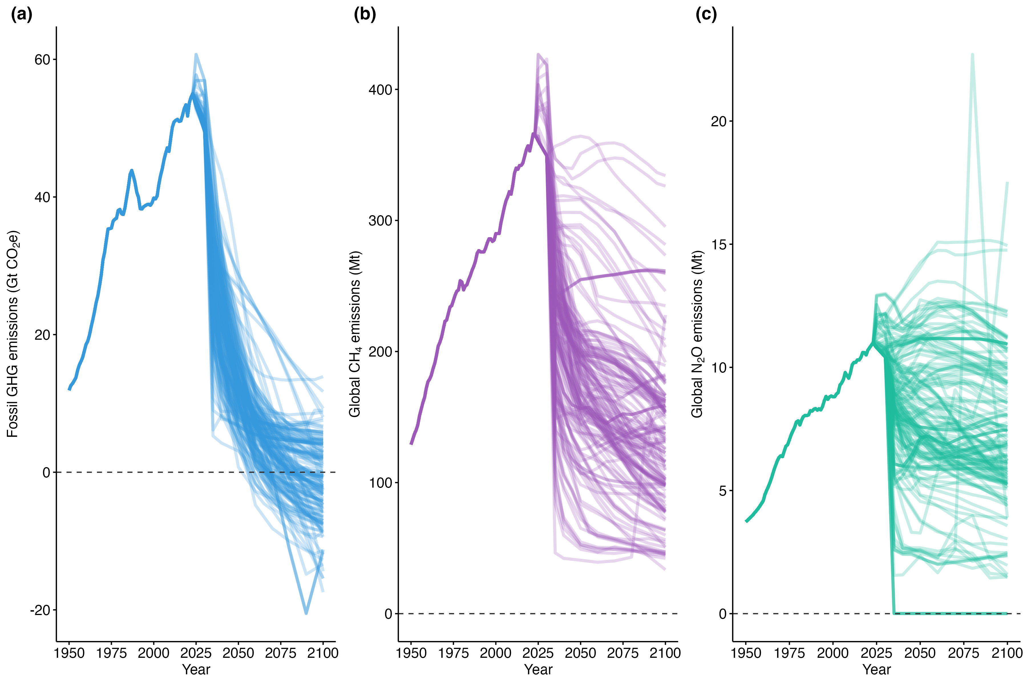
Supplementary Figure 6. Global historical and projected emissions of major greenhouse gases under the 1.5°C-consistent pathways. (a), Fossil fuel CO₂ emissions (Gt). (b), Global CH₄ emissions (Mt). (c), Global N₂O emissions (Mt).

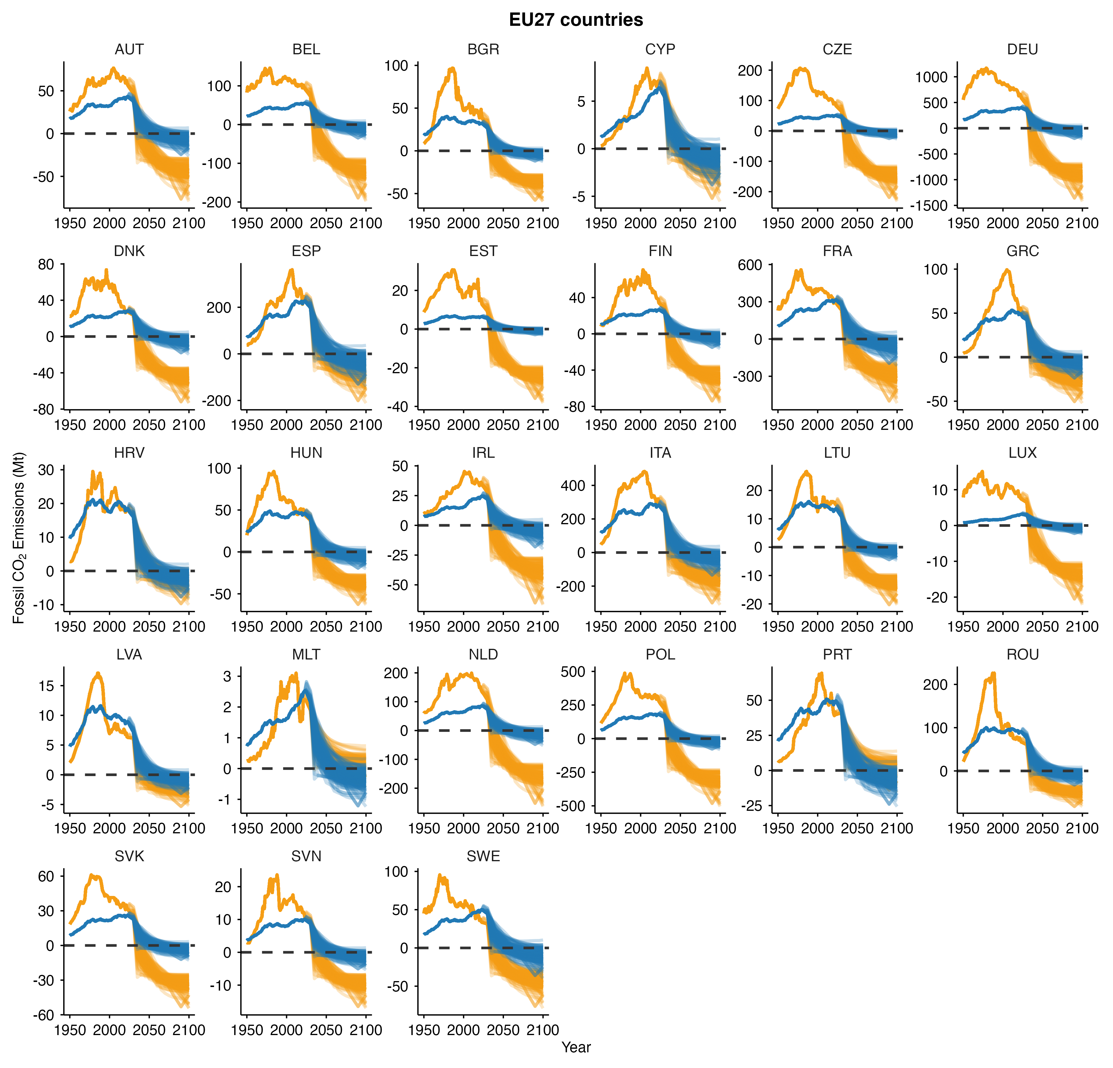
Supplementary Figure 7. Fossil CO₂ emissions of the EU27 countries under the fair-share-corrected pathway (orange) and the equal per-capita future allocation (blue). Each line corresponds to one 1.5°C-consistent pathway.

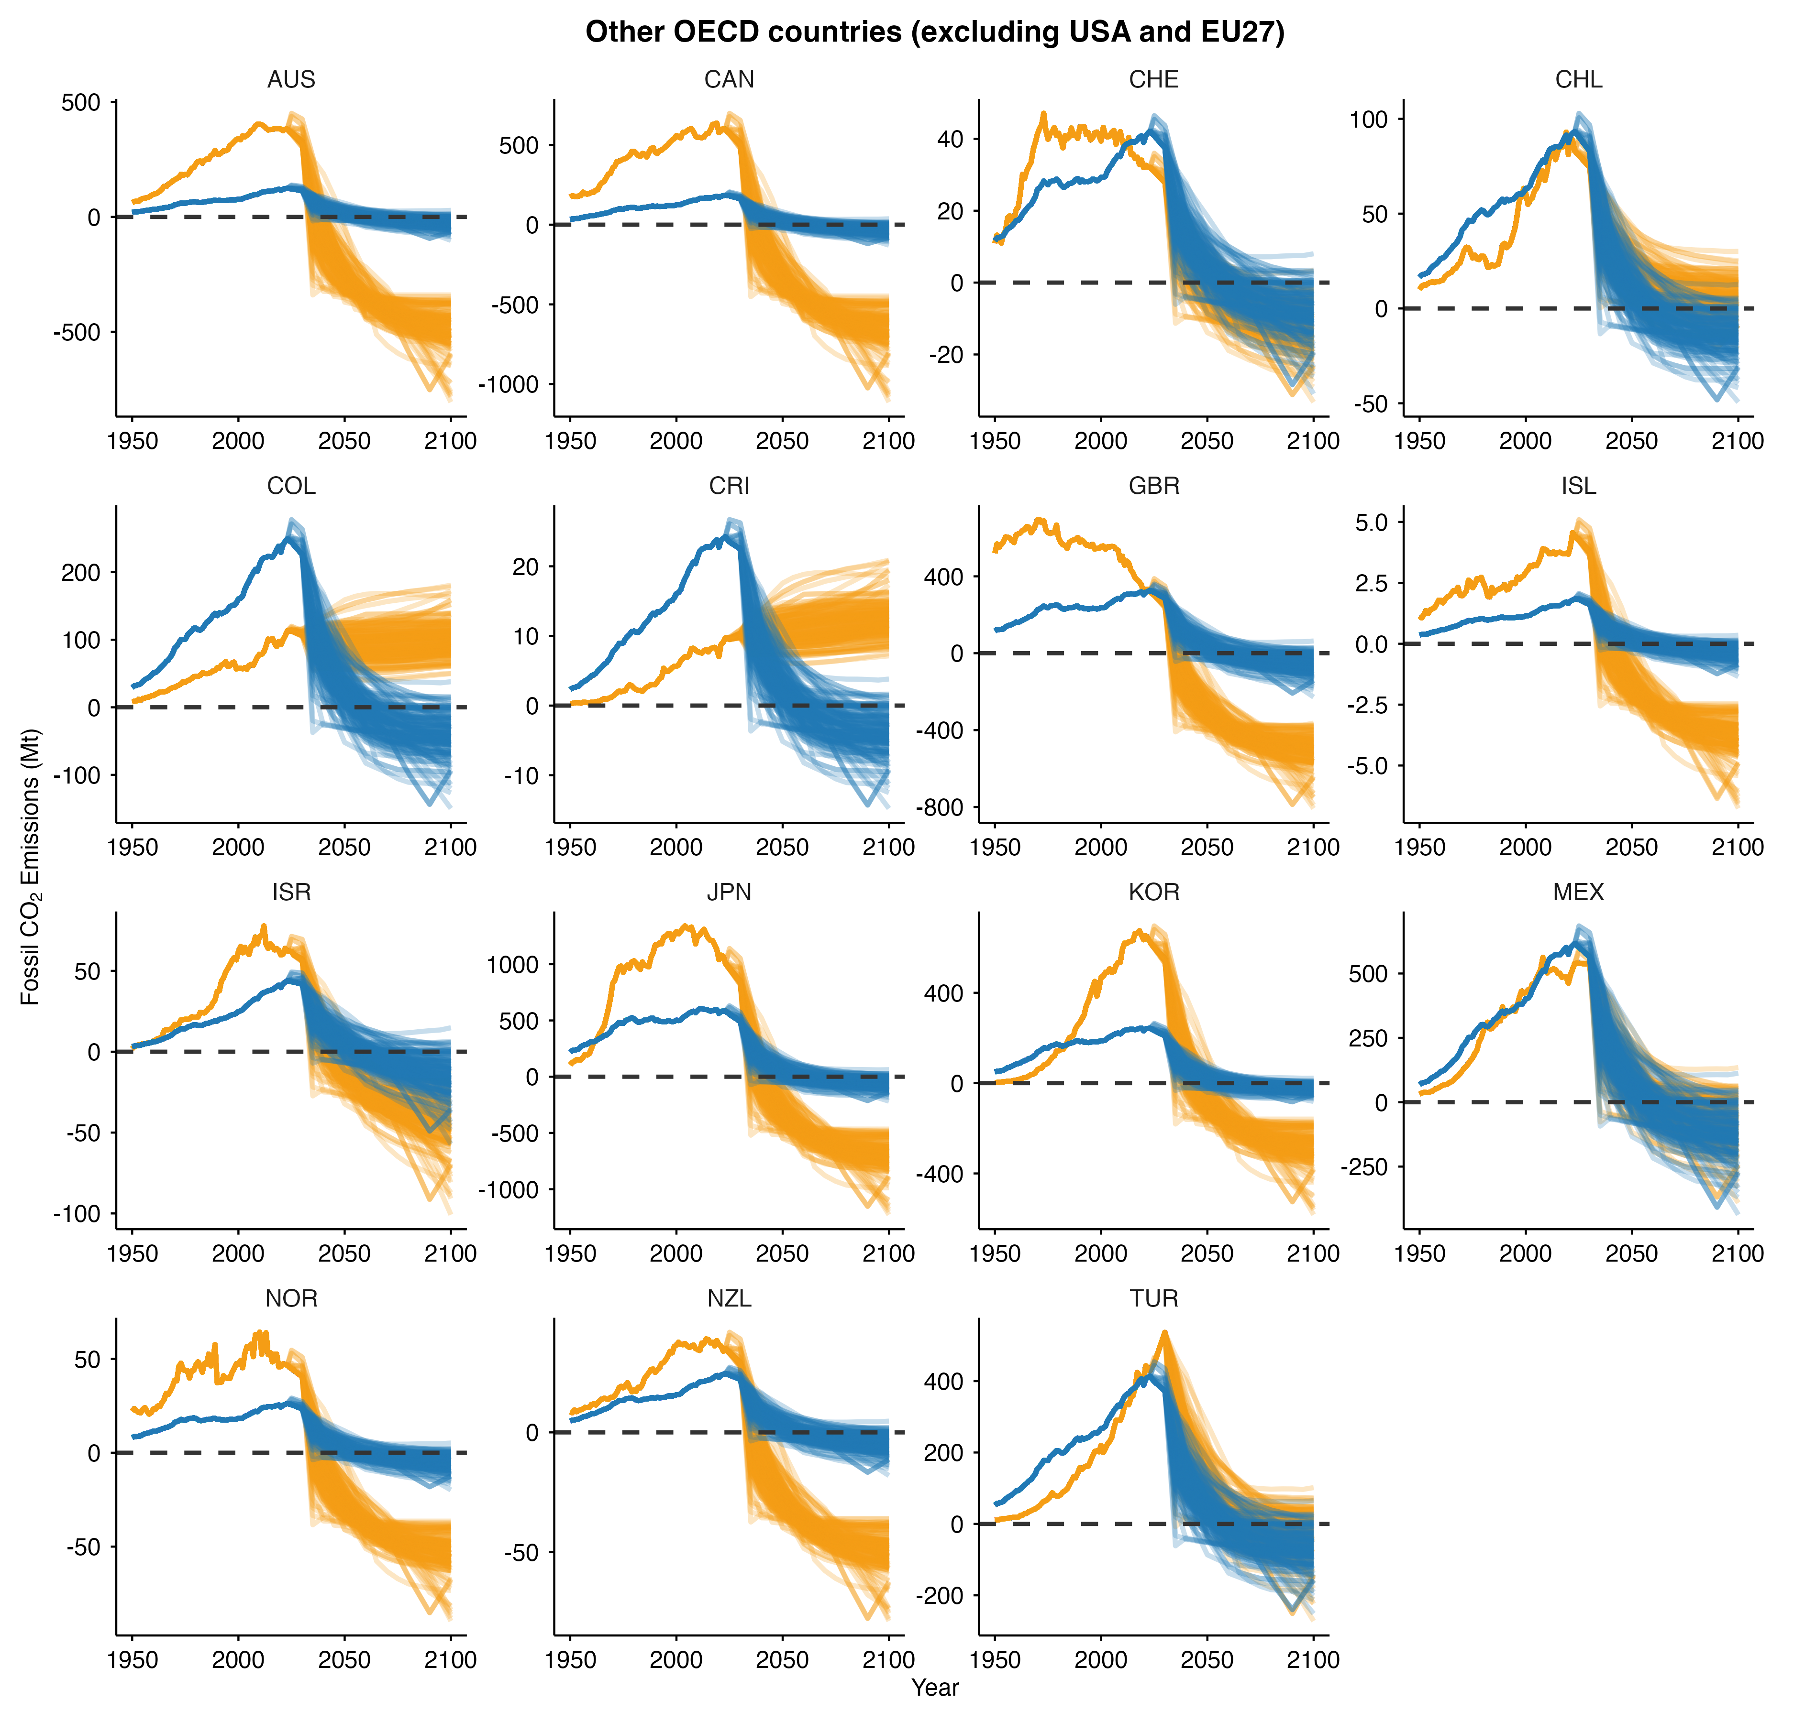
Supplementary Figure 8. Fossil CO₂ emissions for the OECD countries (excluding the US and EU27) under the fair-share-corrected pathway (orange) and the equal per-capita future allocation (blue). Each line corresponds to one 1.5°C-consistent pathway.

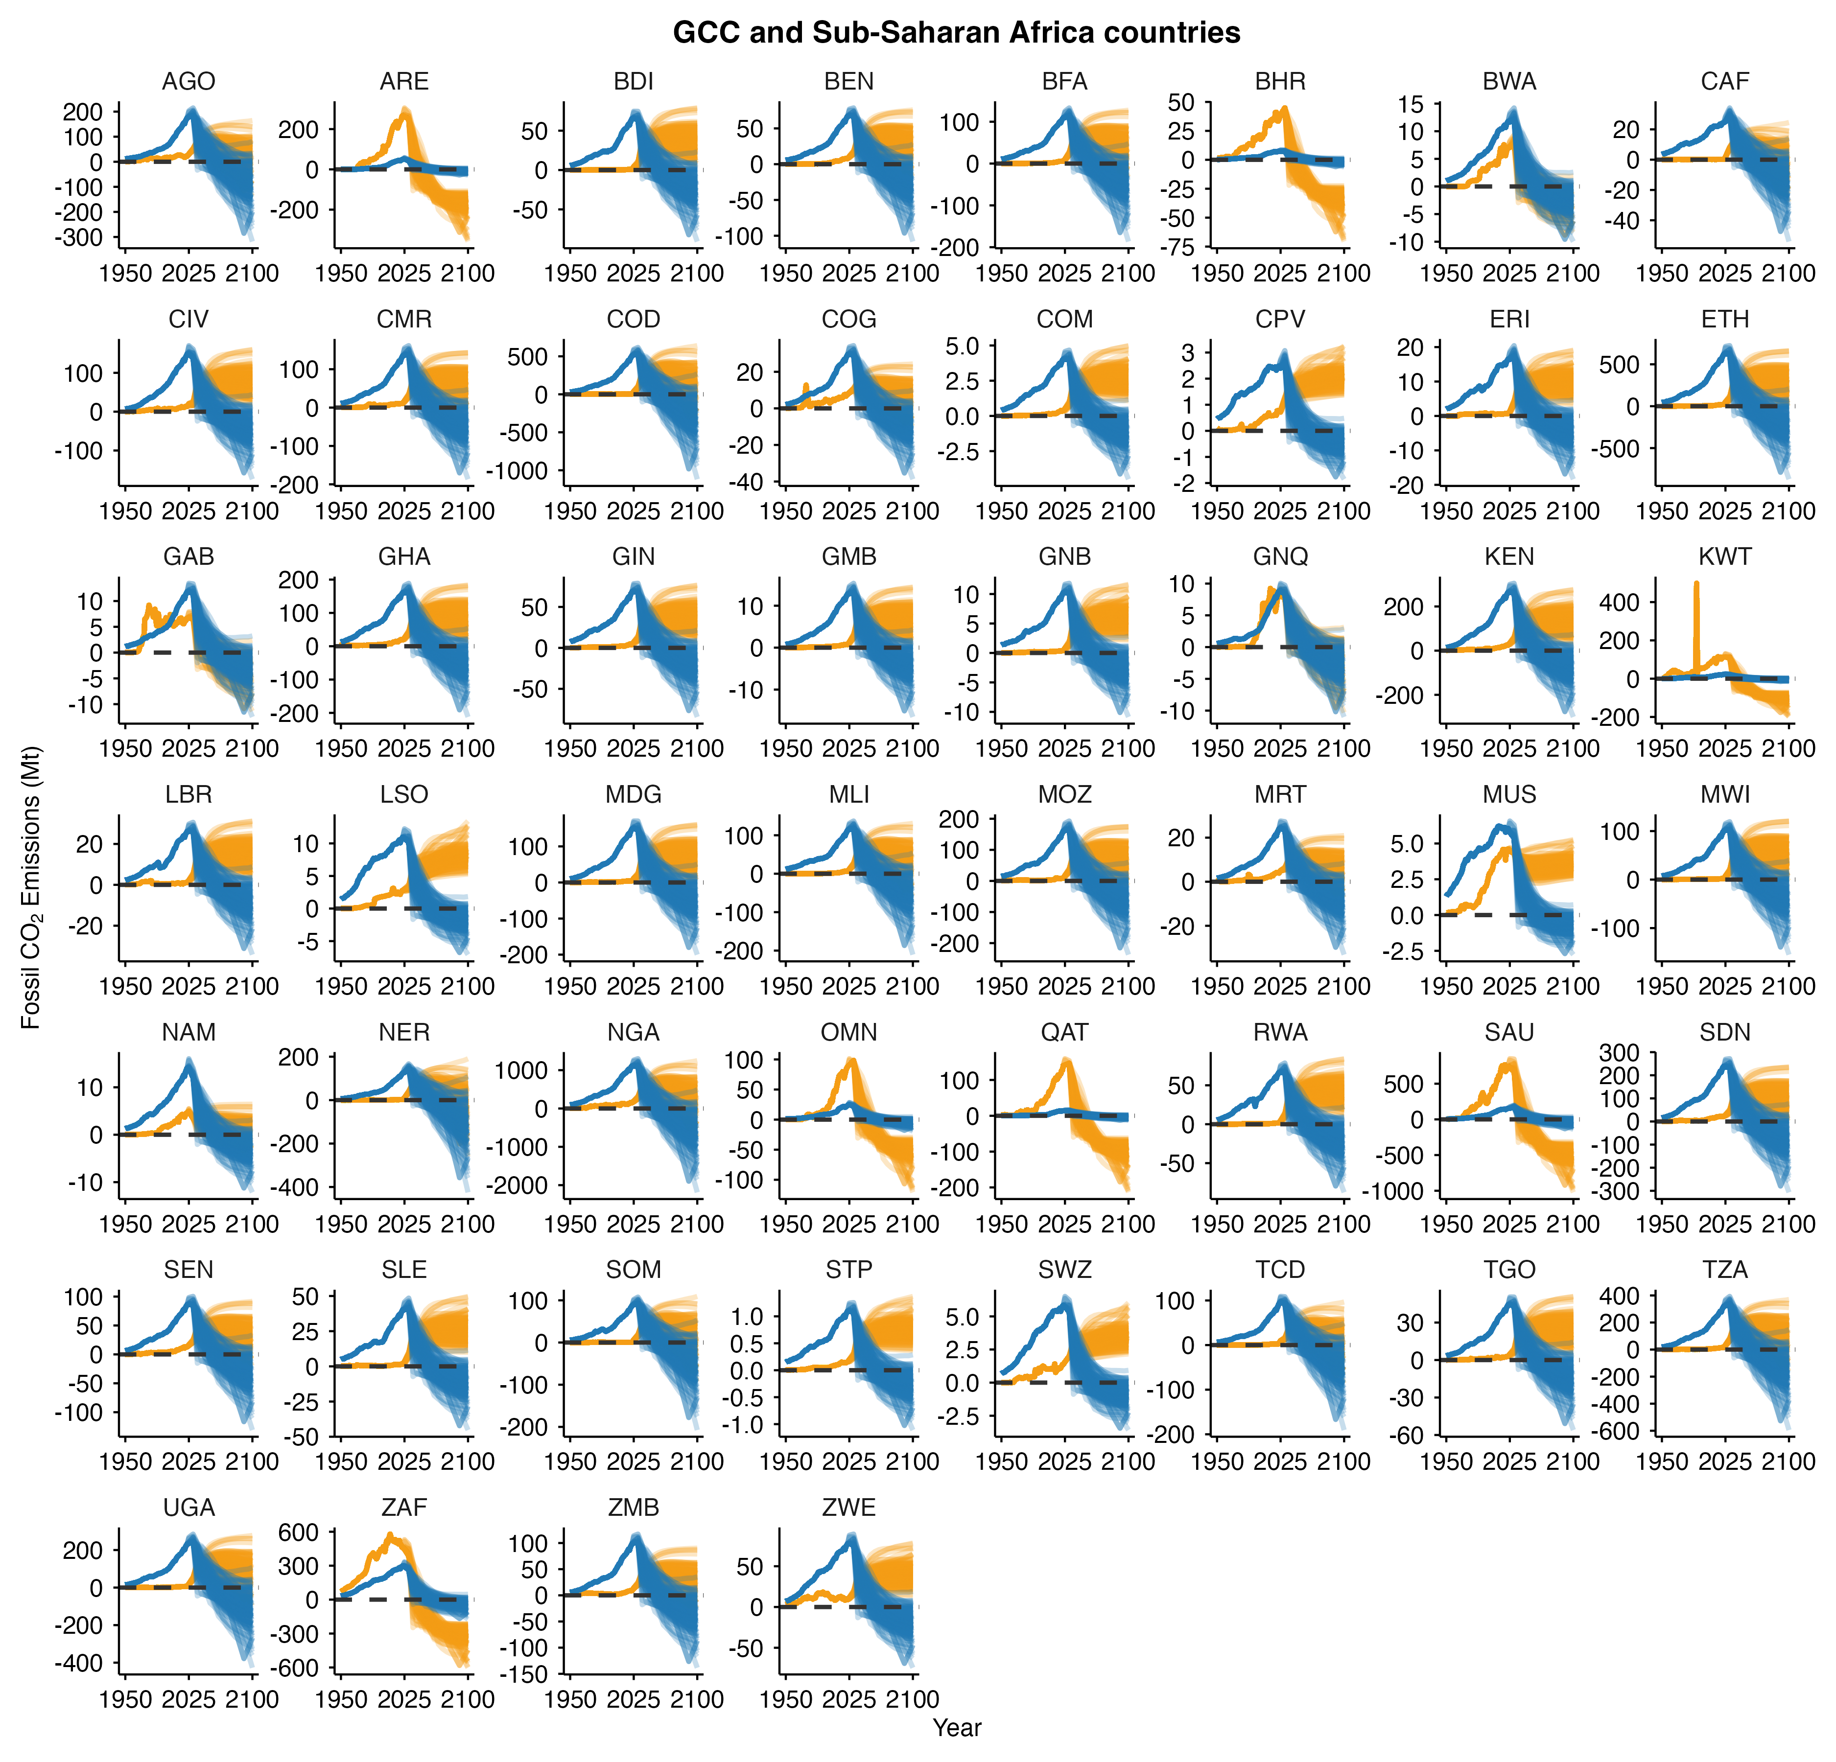
Supplementary Figure 9. Fossil CO₂ emissions for the Gulf Cooperation Council countries (GCC) and Sub-Saharan Africa countries under the fair-share-corrected pathway (orange) and the equal per-capita future allocation (blue). Each line corresponds to one 1.5°C-consistent pathway.

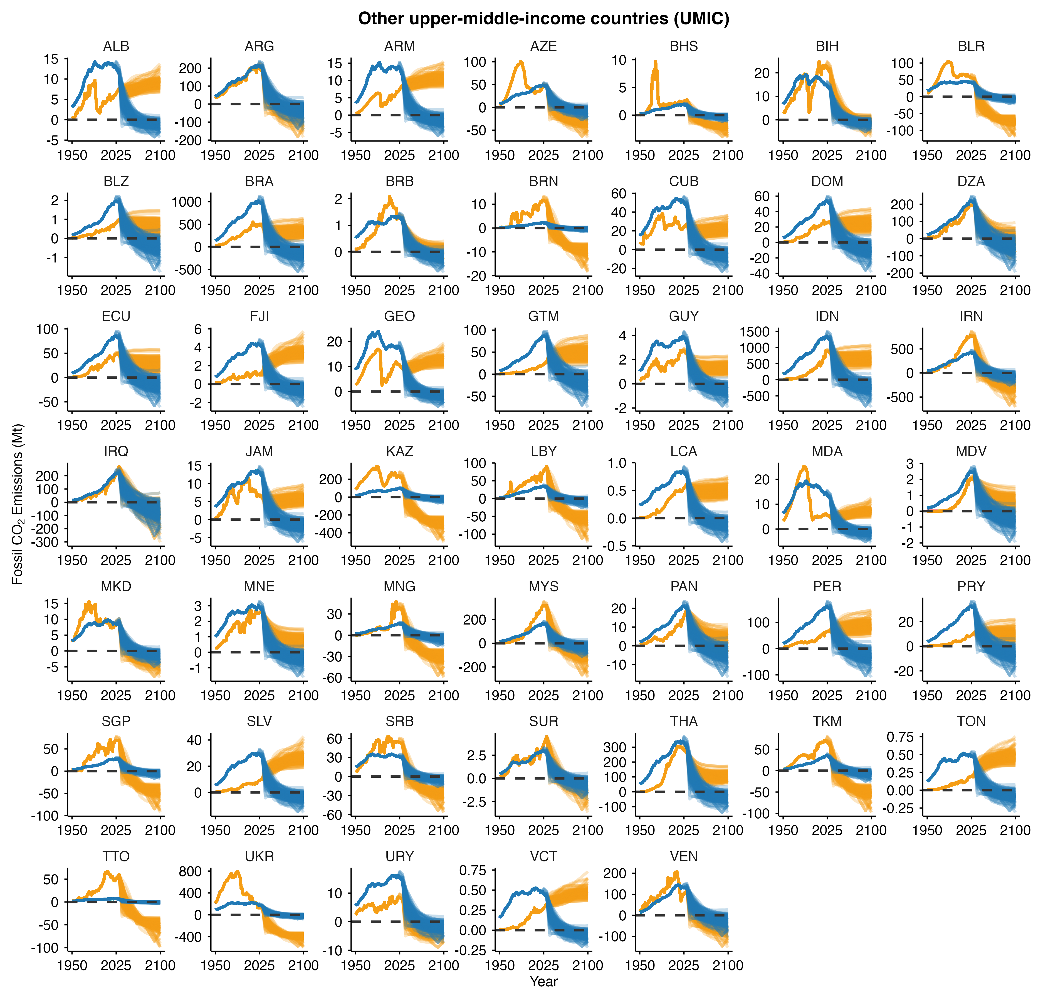
Supplementary Figure 10. Fossil CO₂ emissions for other upper-middle-income countries under the fair-share-corrected pathway (orange) and the equal per-capita future allocation (blue). Each line corresponds to one 1.5°C-consistent pathway.

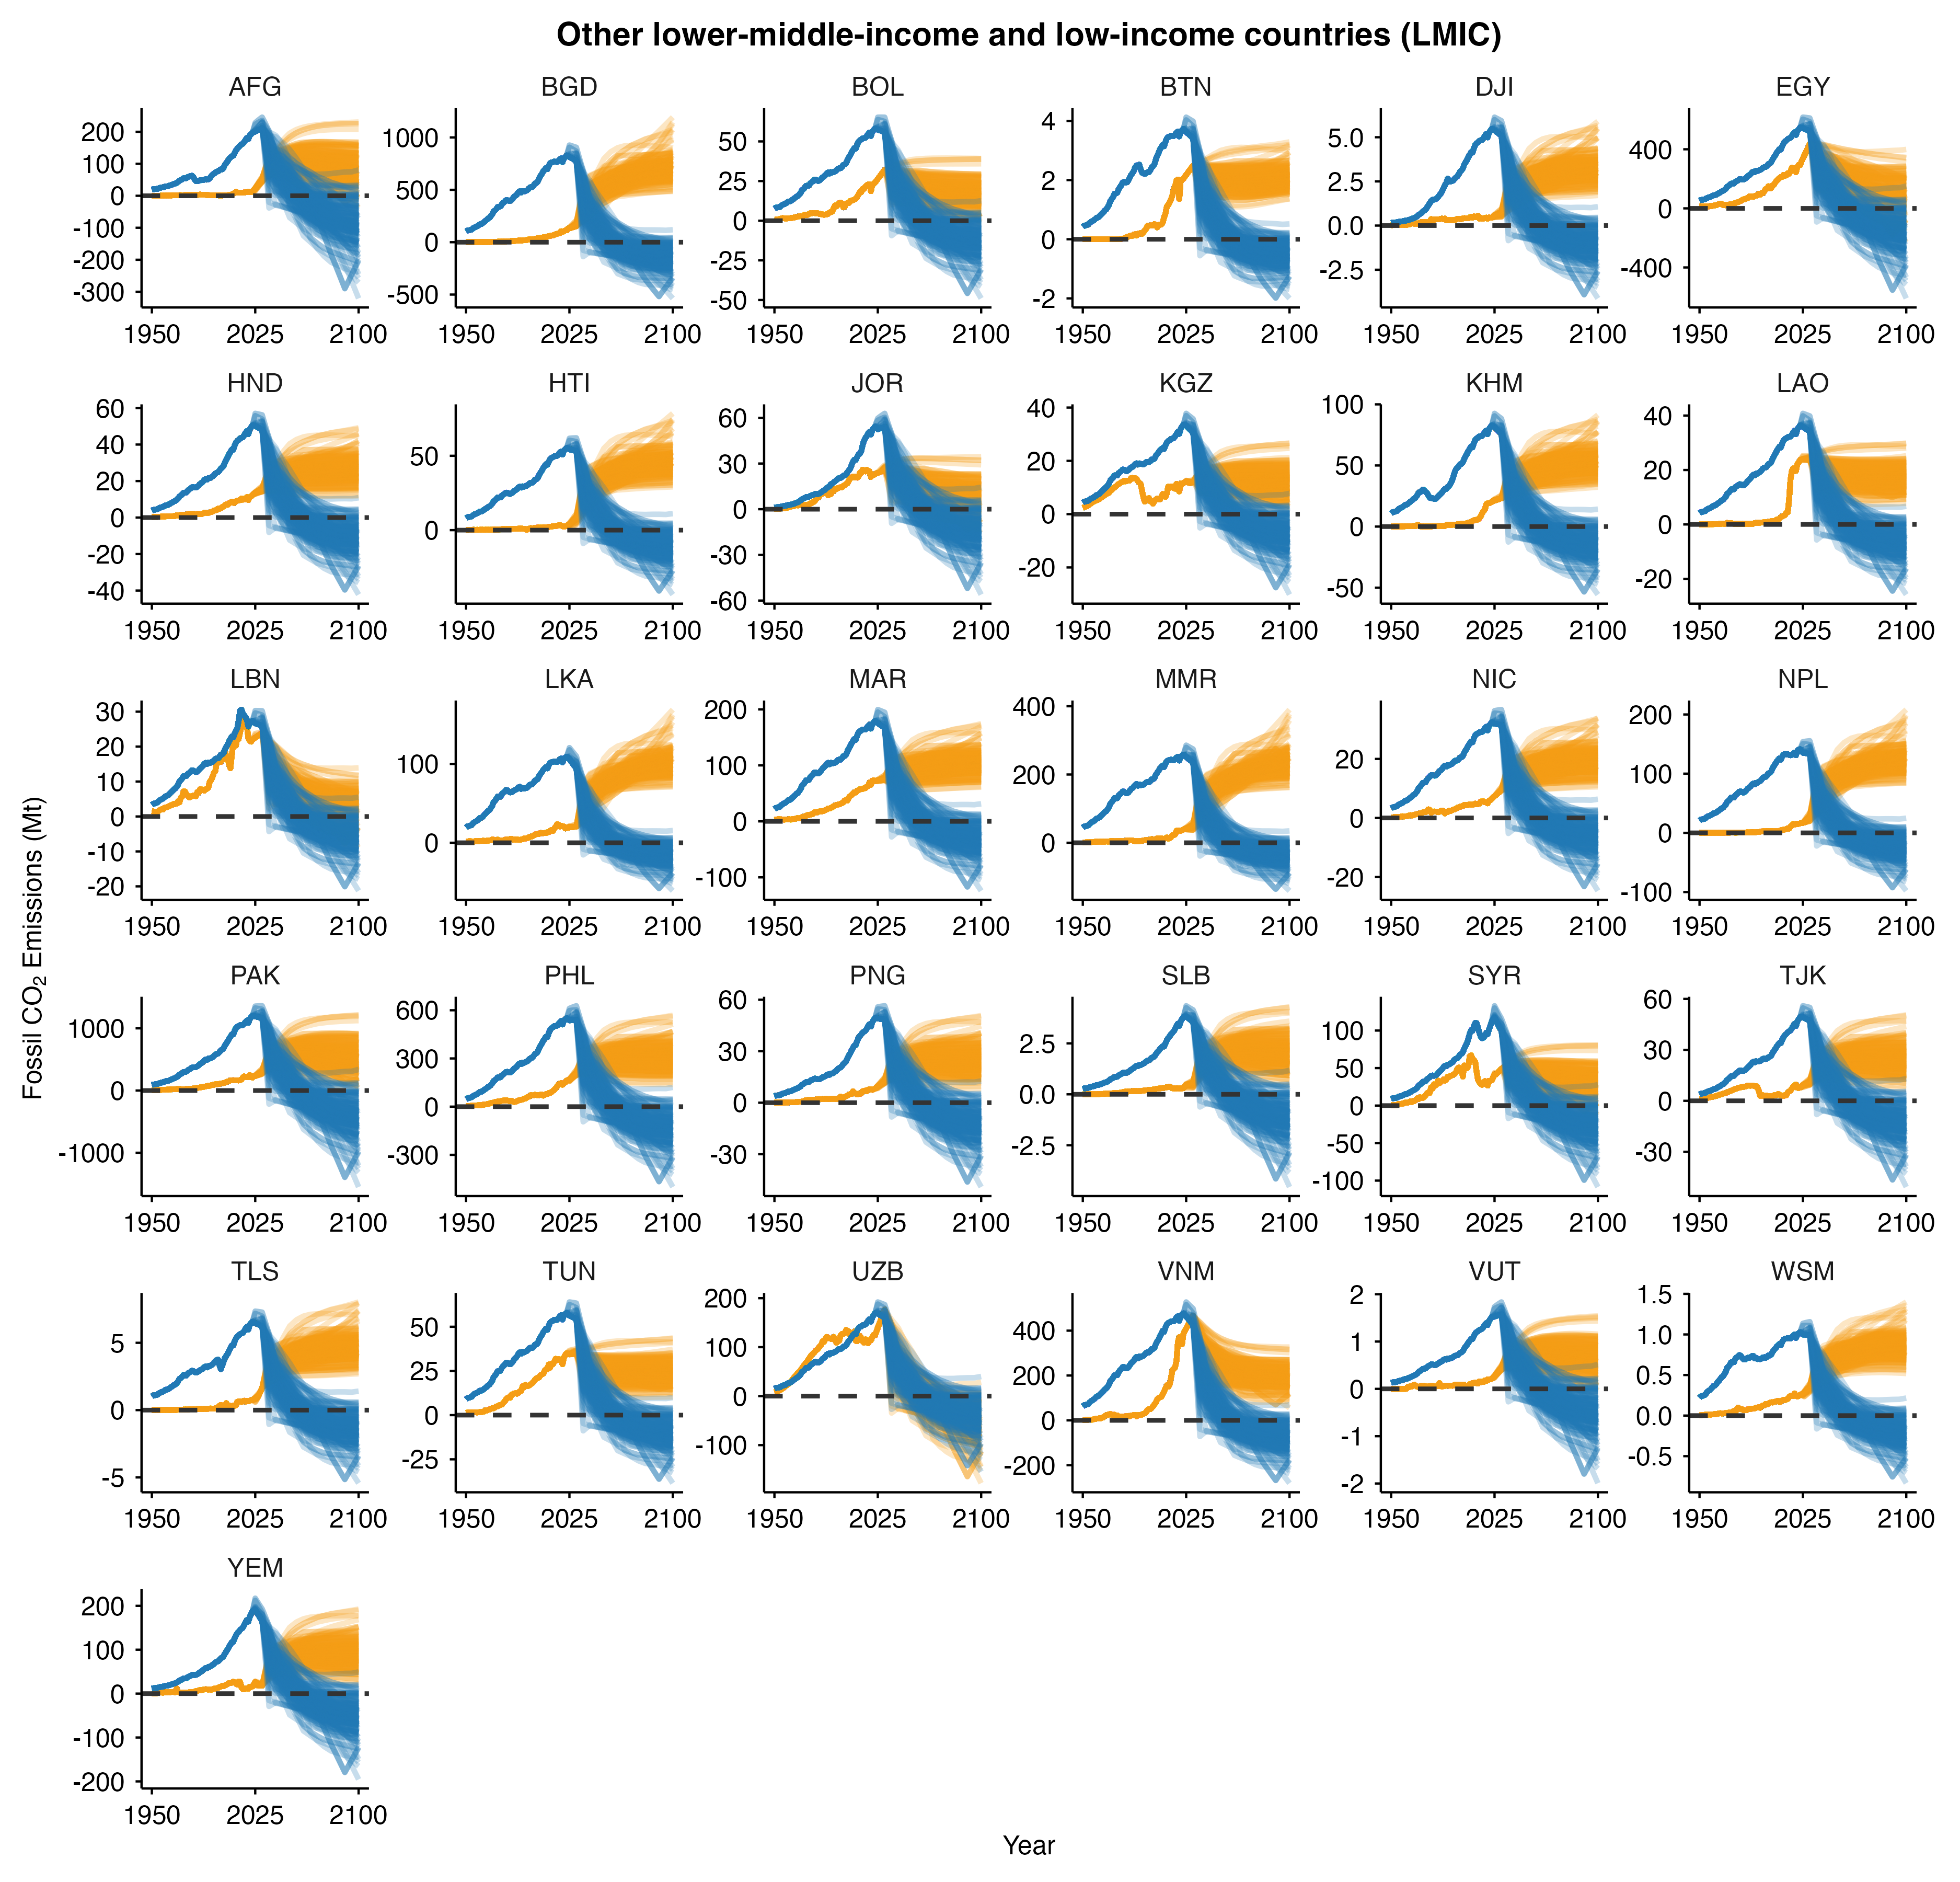
Supplementary Figure 11. Fossil CO₂ emissions for other lower-middle-income countries under the fair-share-corrected pathway (orange) and the equal per-capita future allocation (blue). Each line corresponds to one 1.5°C-consistent pathway.

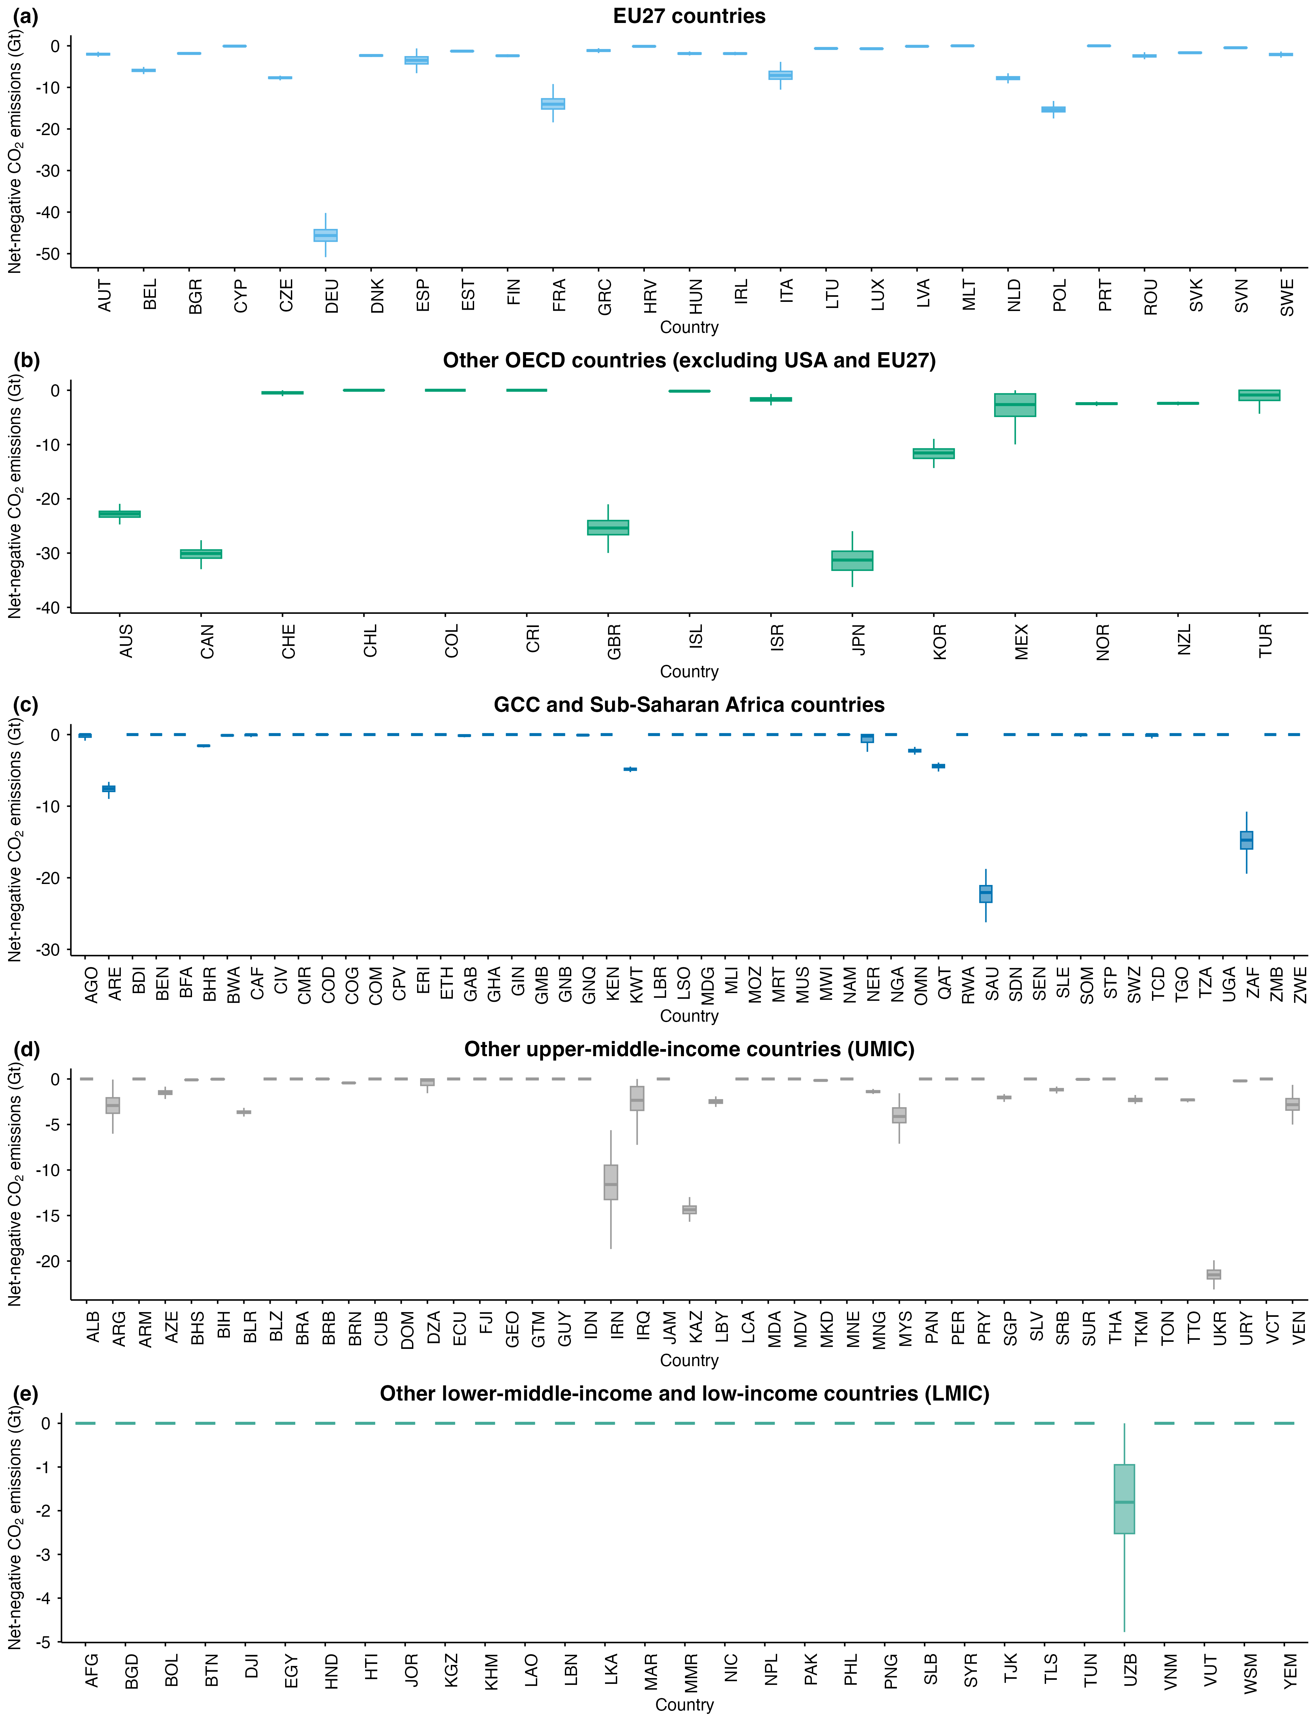
Supplementary Figure 12. Cumulative net-negative CO₂ emissions requirements by 2100 under the warming-excess equity framework. (a-d), Cumulative net-negative emissions CO₂ for countries in four groups: the EU27 (a), OECD countries excluding the US and EU27 (b), GCC and Sub-Saharan Africa countries (c), other upper-middle-income countries (d), and other lower-middle-income countries (e). Boxes indicate the interquartile range (25th–75th percentiles), whiskers span the 10th–90th percentiles, and horizontal lines represent the medians across the set of 1.5°C-consistent scenarios.

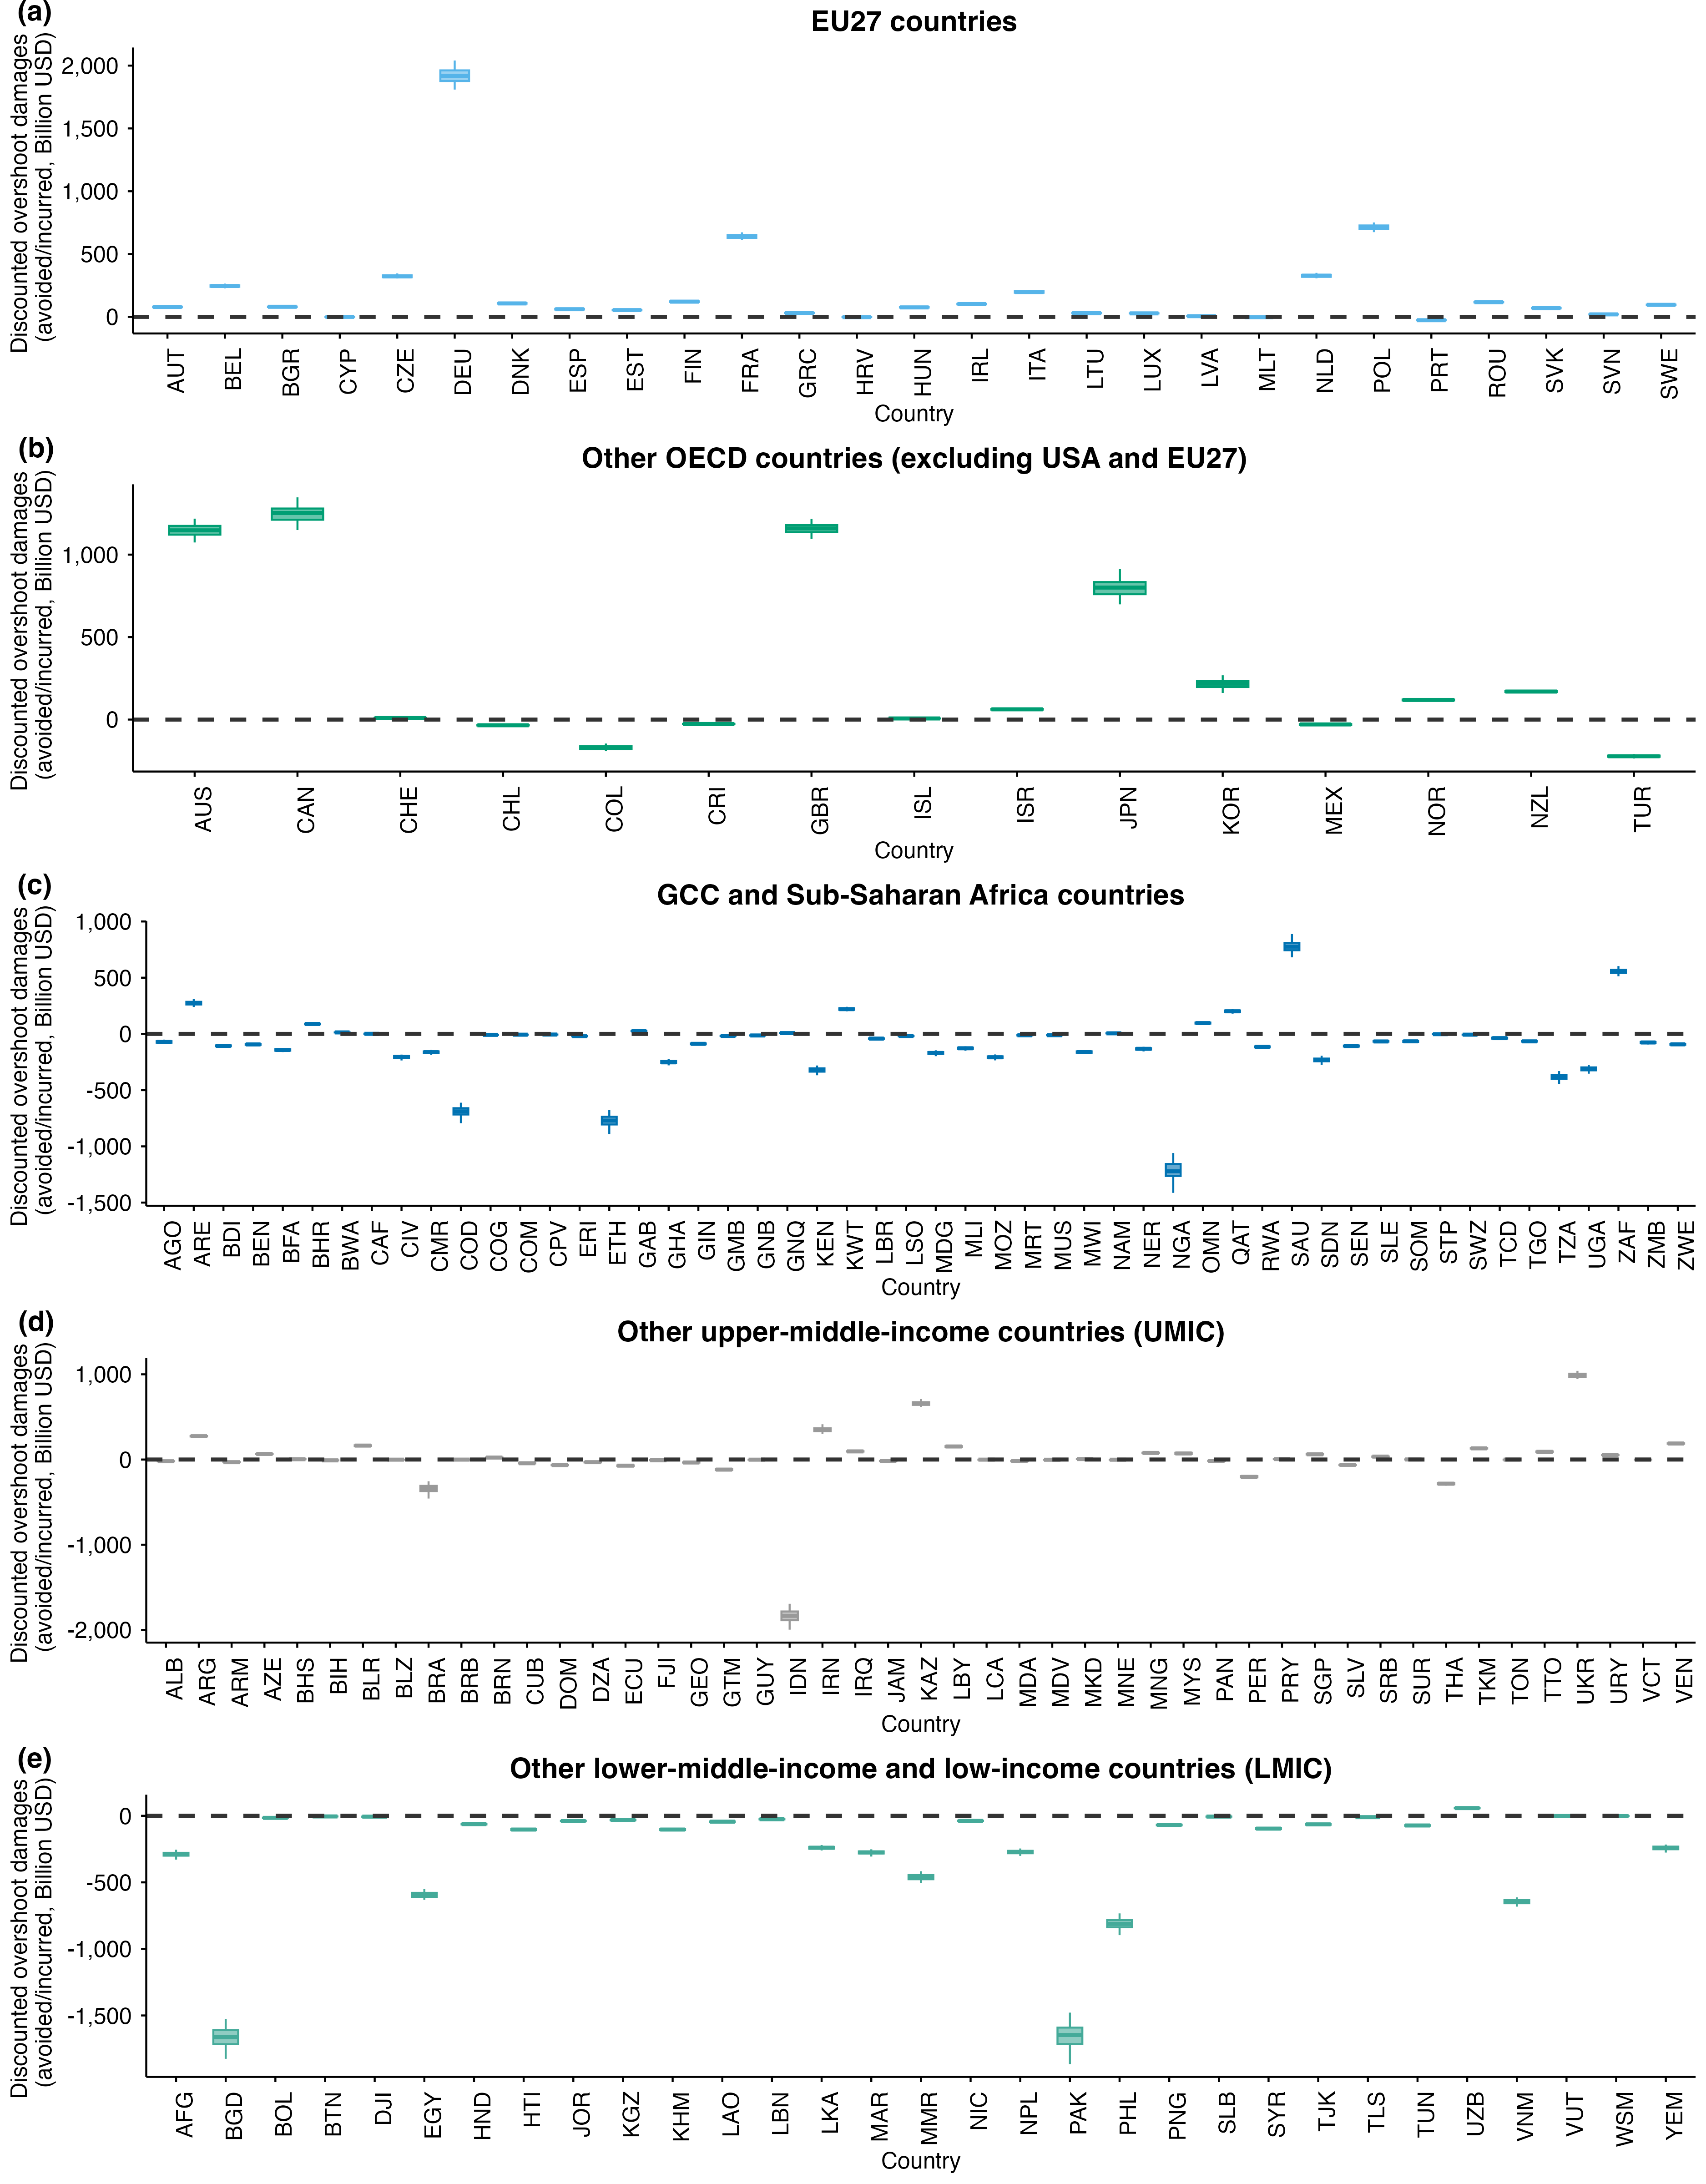
Supplementary Figure 13. Incurred discounted climate damages (positive values) or avoided damages (negative values) due to temperature deviations relative to equitable counterfactuals, shown for individual countries grouped by the EU27 (a), OECD countries excluding the US and EU27 (b), GCC and Sub-Saharan Africa countries (c), other upper-middle-income countries (d), and other lower-middle-income countries (e). Box plots indicate the median, interquartile range, and 10th–90th percentile ranges across scenario ensembles. Dashed horizontal lines represent zero net damages.

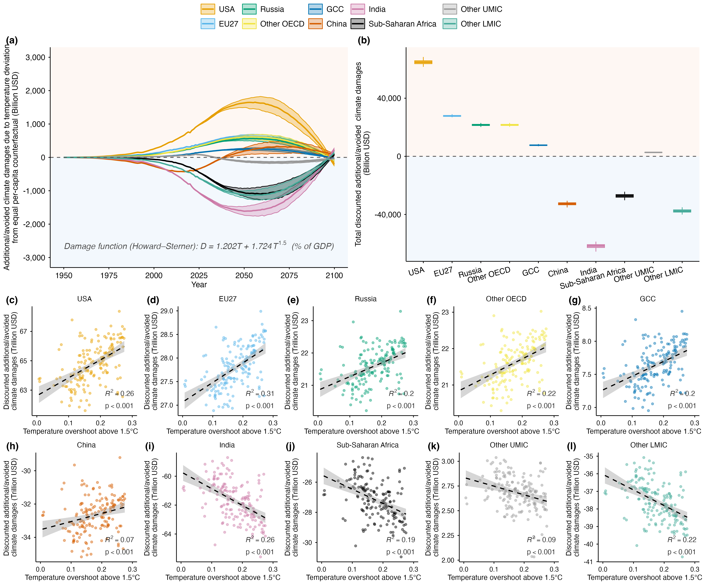
Supplementary Figure 14. Attributed global climate damages arising from historical emission imbalances under the warming-excess equity framework using the Howard–Sterner specification of climate damage functions. ¹⁰ (a), Annual attributed global climate damages by region, 1950–2100. Solid lines show cross-scenario medians; shaded bands span the 10th–90th percentile range across 161 1.5°C-consistent pathways. Positive values represent additional global economic damages attributed to a region's historical excess warming above the equal per-capita baseline; negative values represent global damages avoided owing to below-baseline historical emissions. (b), Total discounted attributed global climate damages by region, aggregated over 1950–2100, for ten regions: USA, EU27, Russia, Other OECD (excluding USA and EU27), GCC, China, India, Sub-Saharan Africa, Other UMIC, and Other LMIC. Boxes span the interquartile range; horizontal lines show medians; whiskers extend to the 10th and 90th percentiles. (c–l), Relationship between peak temperature overshoot above 1.5°C and total discounted attributed or avoided global climate damages for USA (c), EU27 (d), Russia (e), Other OECD (f), GCC (g), China (h), India (i), Sub-Saharan Africa (j), Other UMIC (k), and Other LMIC (l). Each point represents one 1.5°C-consistent pathway. Dashed lines show least-squares regression fits with 95% confidence intervals. Damage estimates for each pathway are computed as the median outcome of 10,000 Monte Carlo simulations.

Supplementary Tables
Supplementary Table 1. 1.5°C-consistent scenarios classified as C1 and C2 categories based on temperature outcomes
Category | Scenarios
C1 | ADVANCE_2020_1.5C-2100 (AIM/CGE 2.0); EMF33_WB2C_cost100 (AIM/CGE 2.1); EMF33_WB2C_full (AIM/CGE 2.1); TERL_15D_LowCarbonTransportPolicy (AIM/CGE 2.1); TERL_15D_NoTransportPolicy (AIM/CGE 2.1); Ratchet-1.5-allCDR (En-ROADS-96); Ratchet-1.5-limCDR (En-ROADS-96); EMF33_WB2C_full (GCAM 4.2); EMF33_WB2C_limbio (GCAM 4.2); EMF33_WB2C_nobeccs (GCAM 4.2); EMF33_WB2C_nofuel (GCAM 4.2); EMF33_WB2C_none (GCAM 4.2); SSP1_SPA1_19I_D_LB (IMAGE 3.2); SSP2_SPA2_19I_D (IMAGE 3.2)
C2 | ADVANCE_2030_Price1.5C (AIM/CGE 2.0); EMF30_Slower-to-faster+SLCF (AIM/CGE 2.0); EMF30_Slower-to-faster+SLCF+HFC (AIM/CGE 2.0); SSP1-19 (AIM/CGE 2.0); SSP2-19 (AIM/CGE 2.0); CD-LINKS_NPi2020_400 (AIM/CGE 2.1); EN_NPi2020_300f (AIM/CGE 2.2); EN_NPi2020_400f (AIM/CGE 2.2); EN_NPi2020_500f (AIM/CGE 2.2); 1.5C (AIM/Hub-Global 2.0); EMF33_1.5C_cost100 (BET EMF33); EMF33_1.5C_full (BET EMF33); EMF33_1.5C_nofuel (BET EMF33); Ratchet-1.5-limCDR-noOS (C-ROADS-5.005); Ratchet-1.5-noCDR (C-ROADS-5.005); Ratchet-1.5-noCDR-noOS (C-ROADS-5.005); CD-LINKS_NPi2020_400 (COPPE-COFFEE 1.0); EMF33_1.5C_limbio (DNE21+ V.14E2); SSP1-19 (GCAM 4.2); SSP2-19 (GCAM 4.2); SSP5-19 (GCAM 4.2); NGFS2_Divergent Net Zero Policies (GCAM 5.3); NGFS2_Net-Zero 2050 (GCAM 5.3); R_MAC_30_n8 (GCAM 5.3); R_MAC_35_n8 (GCAM 5.3); R_MAC_40_n8 (GCAM 5.3); R_MAC_45_n8 (GCAM 5.3); R_MAC_50_n8 (GCAM 5.3); R_MAC_55_n8 (GCAM 5.3); SSP1-DACCS-1p9-3pctHR (GCAM 5.3); SSP1-noDACCS-1p9-3pctHR (GCAM 5.3); SSP4-DACCS-1p9-3pctHR (GCAM 5.3); SSP4-noDACCS-1p9-3pctHR (GCAM 5.3); SSP_SSP1 (GCAM 5.3); SSP_SSP3 (GCAM 5.3); SSP_SSP4 (GCAM 5.3); GCAM_1.5C_high_os_high-cost-DAC (GCAM5.2_NET); GCAM_1.5C_high_os_low-cost-DAC (GCAM5.2_NET); EN_INDCi2030_600f (GEM-E3_V2021); EN_INDCi2030_600f_COV (GEM-E3_V2021); EN_INDCi2030_600f_COV_NDCp (GEM-E3_V2021); EN_INDCi2030_600f_NDCp (GEM-E3_V2021); EN_NPi2020_400f (GEM-E3_V2021); EN_NPi2020_500f (GEM-E3_V2021); EN_NPi2020_600f (GEM-E3_V2021); EN_NPi2020_600f_COV (GEM-E3_V2021); ADVANCE_2020_1.5C-2100 (IMAGE 3.0.1); CD-LINKS_NPi2020_400 (IMAGE 3.0.1); IMA15-AGInt (IMAGE 3.0.1); IMA15-Def (IMAGE 3.0.1); IMA15-Eff (IMAGE 3.0.1); IMA15-LiStCh (IMAGE 3.0.1); IMA15-LoNCO2 (IMAGE 3.0.1); IMA15-Pop (IMAGE 3.0.1); IMA15-RenElec (IMAGE 3.0.1); IMA15-TOT (IMAGE 3.0.1); SSP1-19 (IMAGE 3.0.1); SSP1_SPA1_19I_D (IMAGE 3.2); SSP1_SPA1_19I_LI (IMAGE 3.2); SSP1_SPA1_19I_LIRE (IMAGE 3.2); SSP1_SPA1_19I_LIRE_LB (IMAGE 3.2); SSP1_SPA1_19I_RE (IMAGE 3.2); SSP1_SPA1_19I_RE_LB (IMAGE 3.2); SSP2_SPA1_19I_LIRE_LB (IMAGE 3.2); SSP2_SPA1_19I_RE_LB (IMAGE 3.2); SSP2_SPA2_19I_LI (IMAGE 3.2); SSP2_SPA2_19I_LIRE (IMAGE 3.2); SSP2_SPA2_19I_RE (IMAGE 3.2); ADVANCE_2020_1.5C-2100 (MESSAGE-GLOBIOM 1.0); EMF33_1.5C_cost100 (MESSAGE-GLOBIOM 1.0); EMF33_1.5C_full (MESSAGE-GLOBIOM 1.0); SSP1-19 (MESSAGE-GLOBIOM 1.0); SSP2-19 (MESSAGE-GLOBIOM 1.0); CD-LINKS_NPi2020_400 (MESSAGEix-GLOBIOM 1.0); EN_NPi2020_200f (MESSAGEix-GLOBIOM_1.1); EN_NPi2020_300f (MESSAGEix-GLOBIOM_1.1); SSP2_openres_lc_100 (MESSAGEix-GLOBIOM_GEI 1.0); SSP2_openres_lc_120 (MESSAGEix-GLOBIOM_GEI 1.0); SSP2_openres_lc_CB400 (MESSAGEix-GLOBIOM_GEI 1.0); SSP2_openres_lc_CB450 (MESSAGEix-GLOBIOM_GEI 1.0); SSP2_openres_lc_CB500 (MESSAGEix-GLOBIOM_GEI 1.0); SSP2_openres_lc_CB550 (MESSAGEix-GLOBIOM_GEI 1.0); SSP2_openres_lc_CB600 (MESSAGEix-GLOBIOM_GEI 1.0); ADVANCE_2020_1.5C-2100 (POLES ADVANCE); ADVANCE_2030_1.5C-2100 (POLES ADVANCE); ADVANCE_2030_Price1.5C (POLES ADVANCE); CD-LINKS_INDC2030i_400 (POLES CD-LINKS); CD-LINKS_NPi2020_400 (POLES CD-LINKS); EMF30_ClimPolicy (POLES EMF30); EMF30_ClimPolicy+SLCF (POLES EMF30); EMF30_Slower-to-faster (POLES EMF30); EMF30_Slower-to-faster+SLCF (POLES EMF30); EMF30_Slower-to-faster+SLCF+HFC (POLES EMF30); EMF33_1.5C_cost100 (POLES EMF33); EMF33_1.5C_full (POLES EMF33); EMF33_1.5C_limbio (POLES EMF33); EMF33_1.5C_nofuel (POLES EMF33); EMF33_WB2C_cost100 (POLES EMF33); EMF33_WB2C_limbio (POLES EMF33); EMF33_WB2C_nobeccs (POLES EMF33); EMF33_WB2C_nofuel (POLES EMF33); EMF33_WB2C_none (POLES EMF33); ADVANCE_2020_1.5C-2100 (REMIND 1.7); ADVANCE_2030_1.5C-2100 (REMIND 1.7); ADVANCE_2030_Price1.5C (REMIND 1.7); CEMICS-1.5-CDR12 (REMIND 1.7); CEMICS-1.5-CDR20 (REMIND 1.7); CEMICS-1.5-CDR8 (REMIND 1.7); CEMICS_GDPgrowth_1p5 (REMIND 2.1); CEMICS_HotellingConst_1p5 (REMIND 2.1); CEMICS_Linear_1p5 (REMIND 2.1); LeastTotalCost_LTC_brkLR15_SSP1_P50 (REMIND 2.1); R2p1_SSP1-PkBudg1100 (REMIND 2.1); R2p1_SSP1-PkBudg900 (REMIND 2.1); START_Net-zero (REMIND-H13 2.1); START_Net-zero_noLandUse_CDRlim (REMIND-H13 2.1); START_Net-zero_noNuc_lowVRE (REMIND-H13 2.1); SSP1-19 (REMIND-MAgPIE 1.5); SSP2-19 (REMIND-MAgPIE 1.5); SSP5-19 (REMIND-MAgPIE 1.5); CD-LINKS_INDC2030i_400 (REMIND-MAgPIE 1.7-3.0); CD-LINKS_NPi2020_400 (REMIND-MAgPIE 1.7-3.0); EMF33_1.5C_cost100 (REMIND-MAgPIE 1.7-3.0); EMF33_1.5C_full (REMIND-MAgPIE 1.7-3.0); EMF33_1.5C_nofuel (REMIND-MAgPIE 1.7-3.0); PEP_1p5C_full_eff (REMIND-MAgPIE 1.7-3.0); PEP_1p5C_full_goodpractice (REMIND-MAgPIE 1.7-3.0); PEP_1p5C_full_netzero (REMIND-MAgPIE 1.7-3.0); PEP_1p5C_red_eff (REMIND-MAgPIE 1.7-3.0); SMP_1p5C_Def (REMIND-MAgPIE 1.7-3.0); SMP_1p5C_Sust (REMIND-MAgPIE 1.7-3.0); SMP_1p5C_early (REMIND-MAgPIE 1.7-3.0); SMP_1p5C_lifesty (REMIND-MAgPIE 1.7-3.0); SMP_1p5C_regul (REMIND-MAgPIE 1.7-3.0); CEMICS_SSP1-1p5C-fullCDR (REMIND-MAgPIE 2.1-4.2); CEMICS_SSP1-1p5C-minCDR (REMIND-MAgPIE 2.1-4.2); SusDev_SDP-PkBudg1000 (REMIND-MAgPIE 2.1-4.2); SusDev_SSP1-PkBudg900 (REMIND-MAgPIE 2.1-4.2); DeepElec_SSP2_def_Budg900 (REMIND-MAgPIE 2.1-4.3); Eff_1p5 (REMIND_EU 2.0); Incumb_1p5 (REMIND_EU 2.0); NewPl_1p5 (REMIND_EU 2.0); EN_INDCi2030_500f (WITCH 5.0); SSP1-19 (WITCH-GLOBIOM 3.1); SSP4-19 (WITCH-GLOBIOM 3.1); ADVANCE_2020_1.5C-2100 (WITCH-GLOBIOM 4.2); CD-LINKS_NPi2020_400 (WITCH-GLOBIOM 4.4)

Supplementary References
1 Matthews, H. D. Quantifying historical carbon and climate debts among nations. Nat. Clim. Change 6, 60-64 (2016). https://doi.org/10.1038/nclimate2774
2 Rajamani, L. et al. National ‘fair shares’ in reducing greenhouse gas emissions within the principled framework of international environmental law. Clim. Policy 21, 983-1004 (2021). https://doi.org/10.1080/14693062.2021.1970504
3 Ridgley, M. A. Fair sharing of greenhouse gas burdens. Energy Policy 24, 517-529 (1996). https://doi.org/https://doi.org/10.1016/0301-4215(96)00034-1
4 Dooley, K. et al. Ethical choices behind quantifications of fair contributions under the Paris Agreement. Nat. Clim. Change 11, 300-305 (2021). https://doi.org/10.1038/s41558-021-01015-8
5 Smith, C. J. et al. FAIR v1.3: a simple emissions-based impulse response and carbon cycle model. Geosci. Model Dev. 11, 2273-2297 (2018). https://doi.org/https://doi.org/10.5194/gmd-11-2273-2018
6 Rennert, K. et al. Comprehensive evidence implies a higher social cost of CO2. Nature 610, 687-692 (2022). https://doi.org/https://doi.org/10.1038/s41586-022-05224-9
7 Hahn, T., Morfeldt, J., Höglund, R., Karlsson, M. & Fetzer, I. Estimating countries’ additional carbon accountability for closing the mitigation gap based on past and future emissions. Nat. Commun. 15, 9707 (2024). https://doi.org/10.1038/s41467-024-54039-x
8 Jones, M. W. et al. National contributions to climate change due to historical emissions of carbon dioxide, methane, and nitrous oxide since 1850. Sci. Data 10, 155 (2023). https://doi.org/10.1038/s41597-023-02041-1
9 Li, M., Pelz, S., Lamboll, R., Wang, C. & Rogelj, J. A principle-based framework to determine countries’ fair warming contributions to the Paris Agreement. Nat. Commun. 16, 1043 (2025). https://doi.org/10.1038/s41467-025-56397-6
10 Howard, P. H. & Sterner, T. Methodology Matters: A Careful Meta-Analysis of Climate Damages. Environ. Resour. Econ. 88, 3289-3327 (2025). https://doi.org/10.1007/s10640-025-01016-7

