Supplementary Information
Broadband radio-frequency chaos synthesis with Vernier chaotic microcombs

I. Theoretical framework of Vernier RF chaos synthesis
The configuration and operating principle of the Vernier dual-comb architecture are shown in Fig. S1. The reconstruction process relies on multiheterodyne beating between two chaotic microcombs with slightly detuned repetition rates, which deterministically maps distributed optical stochastic dynamics into discrete radio-frequency (RF) bands. As shown in Fig. S1a, the key parameters are the repetition-rate detuning Δf_{rep} = FSR₁-FSR₂ (assuming FSR₁ > FSR₂) and the pump-frequency offset Δf_{p}. Through multiheterodyne beating, selected pairs of optical comb lines are translated into RF frequencies. For spectral-element pairs located on the short-wavelength, or blue-detuned, side of the pump, the mapped RF centre frequencies are given by:
(S1)
For spectral-element pairs located on the long-wavelength, or red-detuned, side of the pump, the corresponding RF centre frequencies become:
(S2)
As shown in Fig. S1b, the effective bandwidths of these heterodyne envelopes are denoted as B₁, B₂, …, B_{n}, respectively. In addition to these heterodyne components, a baseband component with bandwidth B₀, originating from intra-comb beating, persists at low frequencies. In the Vernier architecture, spectral elements from both sides of the pump are mapped onto discrete RF frequency grids. The system can therefore be viewed as two Vernier mapping scales with the same frequency resolution but differing graduations. For bandwidth synthesis, spectral elements are typically selected from the same side of the pump to maintain ordered RF-band concatenation. When the mapped bands are densely arranged with minimal spectral overlap, the total effective bandwidth B of the reconstructed RF chaotic waveform can be approximated by the cumulative bandwidth contributions of the selected mapped elements:
(S3)
In a single-comb configuration, by contrast, the absence of multiheterodyne mapping causes the chaotic spectral components to remain concentrated near the baseband, so the accessible RF chaotic bandwidth is limited mainly by B₀. The Vernier architecture therefore provides a deterministic mechanism for translating distributed optical stochastic dynamics into separated RF bands and reconstructing them as a broadband RF chaotic waveform. This mapping relation forms the physical basis for scalable RF chaos reconstruction from distributed chaotic microcomb spectra.
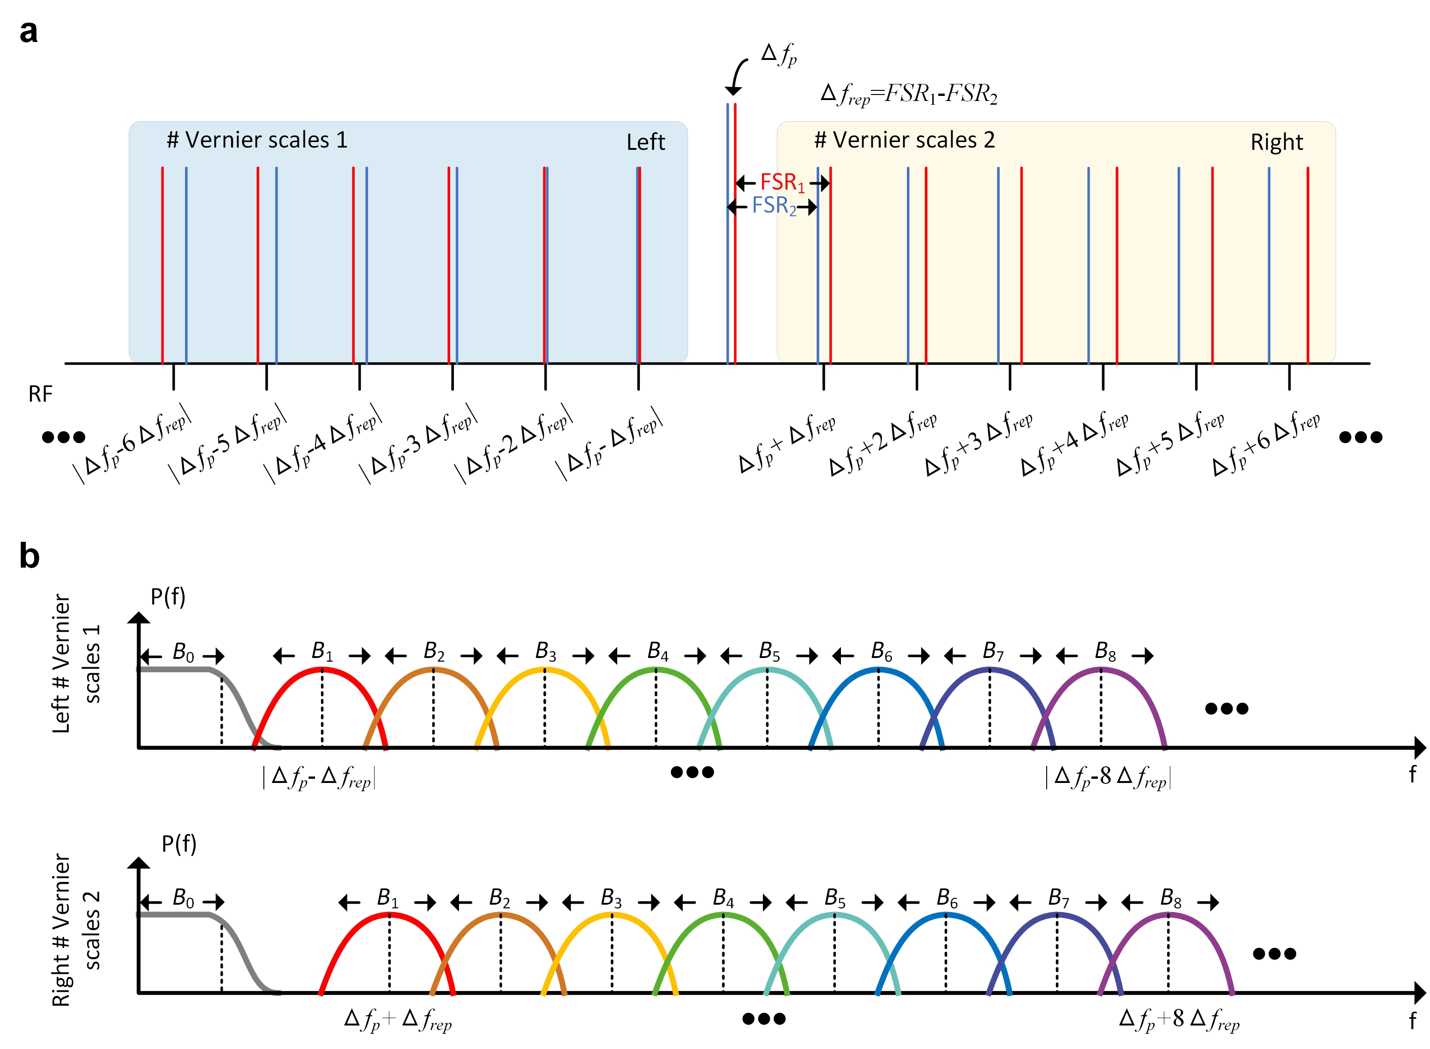

Fig. S1| Theoretical framework of the dual-comb Vernier structure. a, definition of basic physical parameters within the dual-comb architecture, including the pump frequencies, repetition rates, and the repetition rate offset. b, schematic illustration of the RF spectral mapping and transduction of spectral-element pairs originated from the blue- and red-shifted sides of the pump.

II. Experimental setup schematics and system characterizations
Fig. S2a presents the experimental setup used for Vernier chaos reconstruction. Two independent continuous-wave (CW) lasers pump a pair of Si₃N₄ microresonators (MRs) co-integrated on a monolithic platform, with a repetition-rate offset Δf_{rep} of 2.5 GHz. By tuning the pump-resonance detuning, both resonators are driven into spatiotemporal chaotic states. The resulting chaotic microcombs are combined to form a dual-comb configuration. After suppression of the residual pump components, the comb spectra are amplified using an erbium-doped fiber amplifier (EDFA). Because the two chaotic microcombs are generated from independent free-running pump lasers without mutual phase locking, the system does not require active phase stabilization or carrier-envelope control. A programmable wavelength-selective switch (WSS) is subsequently employed to select and aggregate spectral elements for RF-domain reconstruction. The selected spectral components are injected into a reflective semiconductor optical amplifier (RSOA), whose saturated-gain response redistributes the spectral power of the synthesized signal [¹]. The aggregated optical field is finally detected by a high-speed photodetector (PD), where multiheterodyne beating maps distributed optical stochastic dynamics into the RF domain.
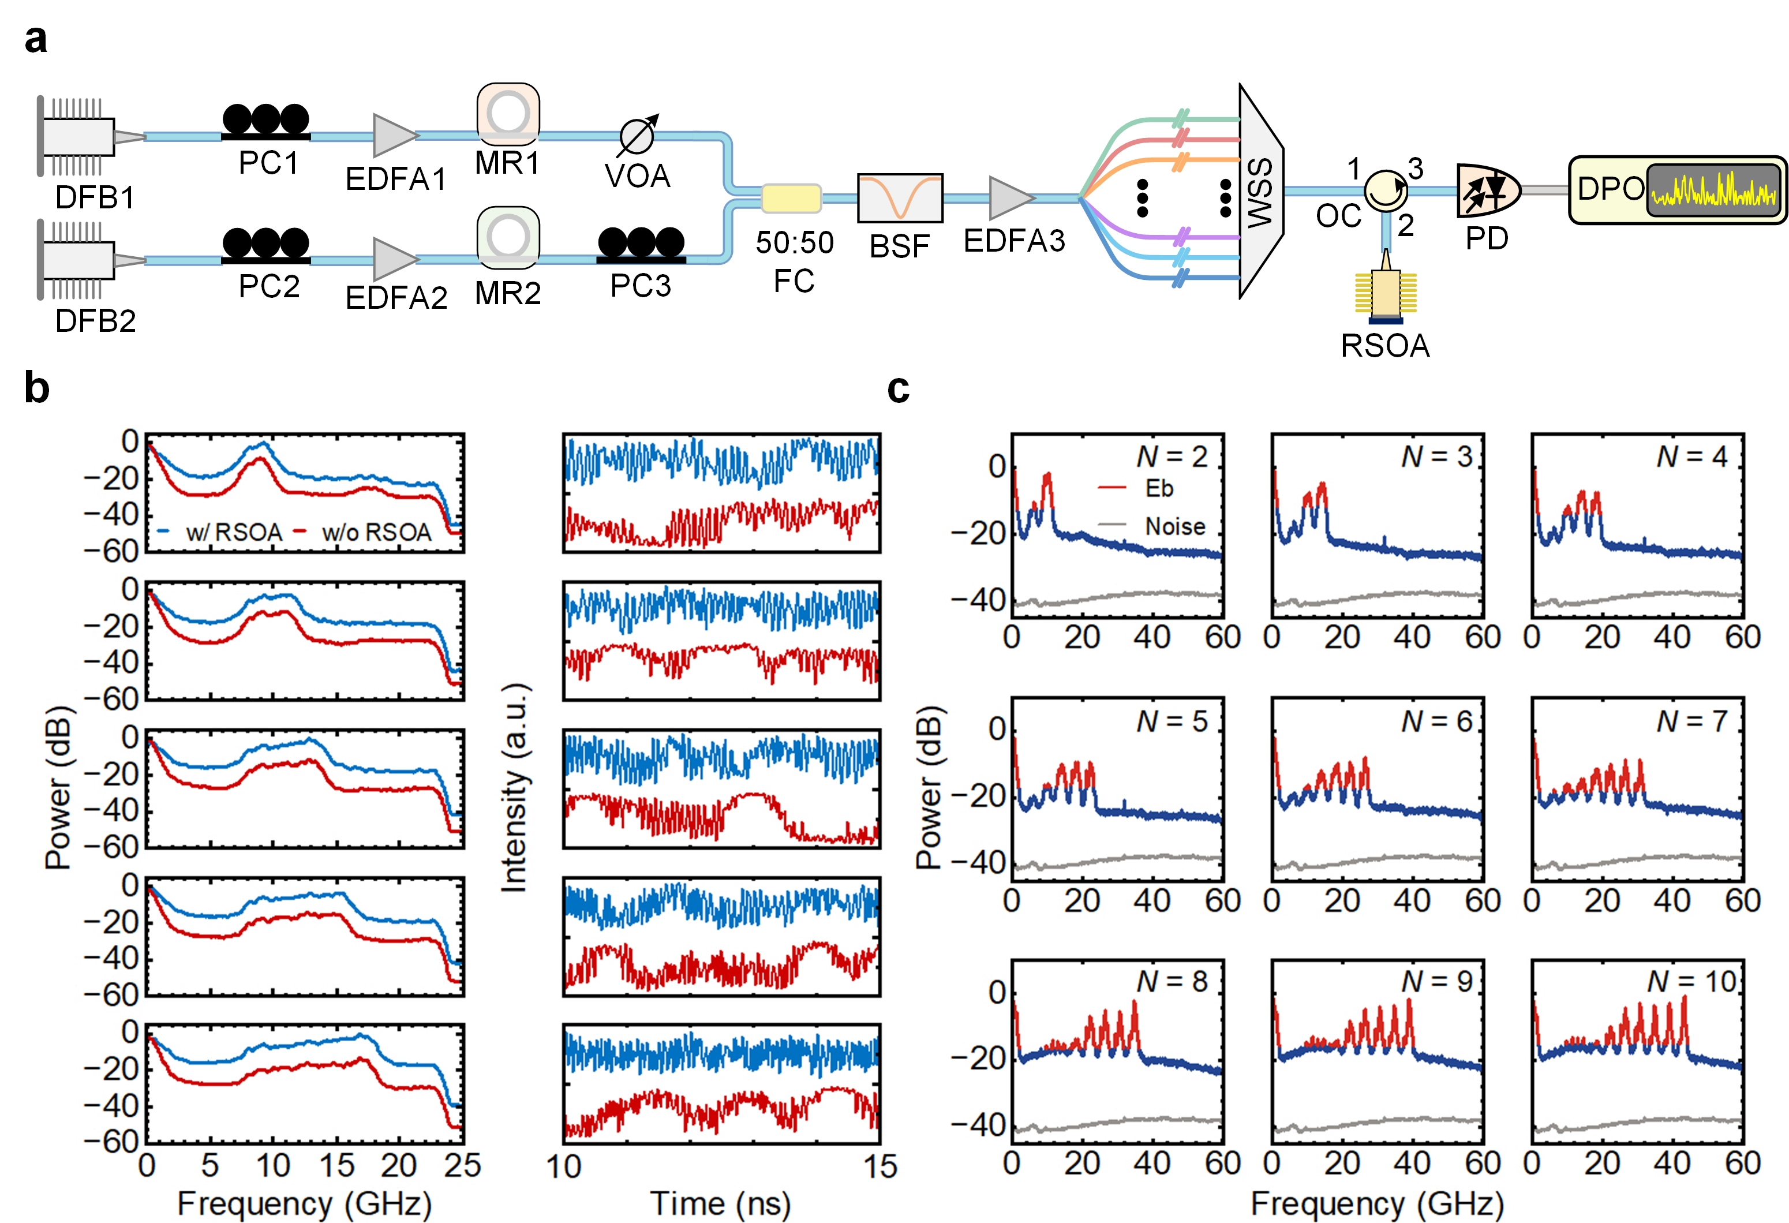

Fig. S2| Experimental setup and system characterizations for Vernier RF chaos reconstruction. a, Experimental setup, DFB, distributed feedback laser, PC, polarization controller; EDFA, erbium-doped fiber amplifier; VOA, variable optical attenuator; FC, fiber coupler; BSF, band-stop filter, OC, optical circulator; RSOA, reflective semiconductor optical amplifier; DPO, digital phosphor oscilloscope. b, RF spectra and temporal traces as the number of reconstructed spectral elements increases. Red and blue curves correspond to direct multiheterodyne mapping and RSOA-assisted mapping, respectively. The saturated-gain response of the RSOA suppresses excessive low-frequency components and increases the relative contribution of higher-frequency mapped components, improving spectral flatness and effective bandwidth. c, Evolution of the reconstructed RF chaotic spectra as the number of spectral-element pairs increases.
Fig. S2b compares the spectral and temporal evolution of the reconstructed RF chaotic waveform as the number of aggregated spectral elements increases from one to five. Without RSOA processing (red traces), the accumulation of low-frequency components produces pronounced slowly varying temporal envelopes, limiting the growth of the effective bandwidth (defined using the 80% energy criterion [²]). Under direct multiheterodyne aggregation, the effective bandwidth increases from 2.71 GHz to 4.83 GHz. When the selected spectral elements are processed by the RSOA (blue traces), the saturated-gain response redistributes the spectral power and enhances the relative contribution of higher-frequency mapped components within the receiver dynamic range. As a result, the reconstructed RF spectrum becomes flatter, and the effective bandwidth increases from 5.52 GHz to 11.76 GHz. These results show that the RSOA acts primarily as a spectral equalizer that improves RF bandwidth utilization, rather than as an independent source of stochastic dynamics.
As the number of aggregated spectral-element pairs N increases from 2 to 10, the effective bandwidth of the reconstructed RF chaotic waveform expands from 7.83 GHz to 25.19 GHz. The achievable scaling is ultimately constrained by the signal-to-noise ratio (SNR) associated with photodetection [³]. The total optical field can be expressed as:
(S4)
Owing to the square-law response of the photodetector, the detected current is
(S5)
where the first term corresponds to the direct-current (DC) contribution and the second term contains the heterodyne beating products. For a spectral-element pair (m,n), the power of a single beat note P_{mn} is given by:
(S6)
Assuming the total optical power P_{tot} is finite and fixed, distributed across N spectral elements such that , it follows that . Consequently, the power of an individual beat note scales inversely with the square of the element count:
(S7)
This derivation elucidates the physical origin of the sharp SNR degradation as N increases. Fig. S2c illustrates this effect for N = 10. Owing to the non-uniform gain profile of the EDFA and the intrinsic power variation of the microcomb spectrum, beat notes generated by spectral elements located near the pump frequency exhibit reduced amplitudes and gradually approach the noise floor. These results indicate that bandwidth scaling through spectral aggregation is accompanied by a progressive reduction in beat-note SNR, imposing a practical constraint on entropy reconstruction using large numbers of spectral elements.

III. Spectral broadening and spectral-element spacing in RF chaos synthesis
Fig. S3a illustrates the spectral-broadening scheme used to increase the bandwidth contribution of individual mapped spectral elements. A broadband chaotic signal generated by an external-cavity laser is used to phase-modulate the chaotic microcomb. After propagation through a dispersive single-mode fiber (SMF), the imposed phase fluctuations are converted into intensity fluctuations through chromatic dispersion, resulting in broadened stochastic spectral envelopes around each comb tooth.
The influence of spectral broadening on the effective bandwidth of individual mapped spectral elements is analyzed in Fig. S3b. Prior to broadening, the effective bandwidth exhibits a non-monotonic dependence on the spectral element index. For elements located close to the pump, the corresponding heterodyne components are densely distributed in the RF domain, leading to strong spectral overlap and limited bandwidth. As the spectral element index increases, the overlap is reduced and the spectral occupancy becomes more uniform, resulting in an increase in effective bandwidth. For larger indices, however, the heterodyne components become increasingly separated and the RF spectrum evolves into isolated narrow peaks, reducing the effective bandwidth evaluated using the 80% energy criterion.
After spectral broadening, the effective bandwidth of individual mapped elements increases substantially and gradually approaches a stable value at larger indices. This behavior indicates that the broadened stochastic sidebands partially fill the frequency gaps between neighboring heterodyne components, thereby increasing the RF spectral occupancy associated with each mapped element. The measured spectra remain well above the electronic noise floor over the effective bandwidth, confirming that the bandwidth increase is signal dominated rather than noise-floor limited.
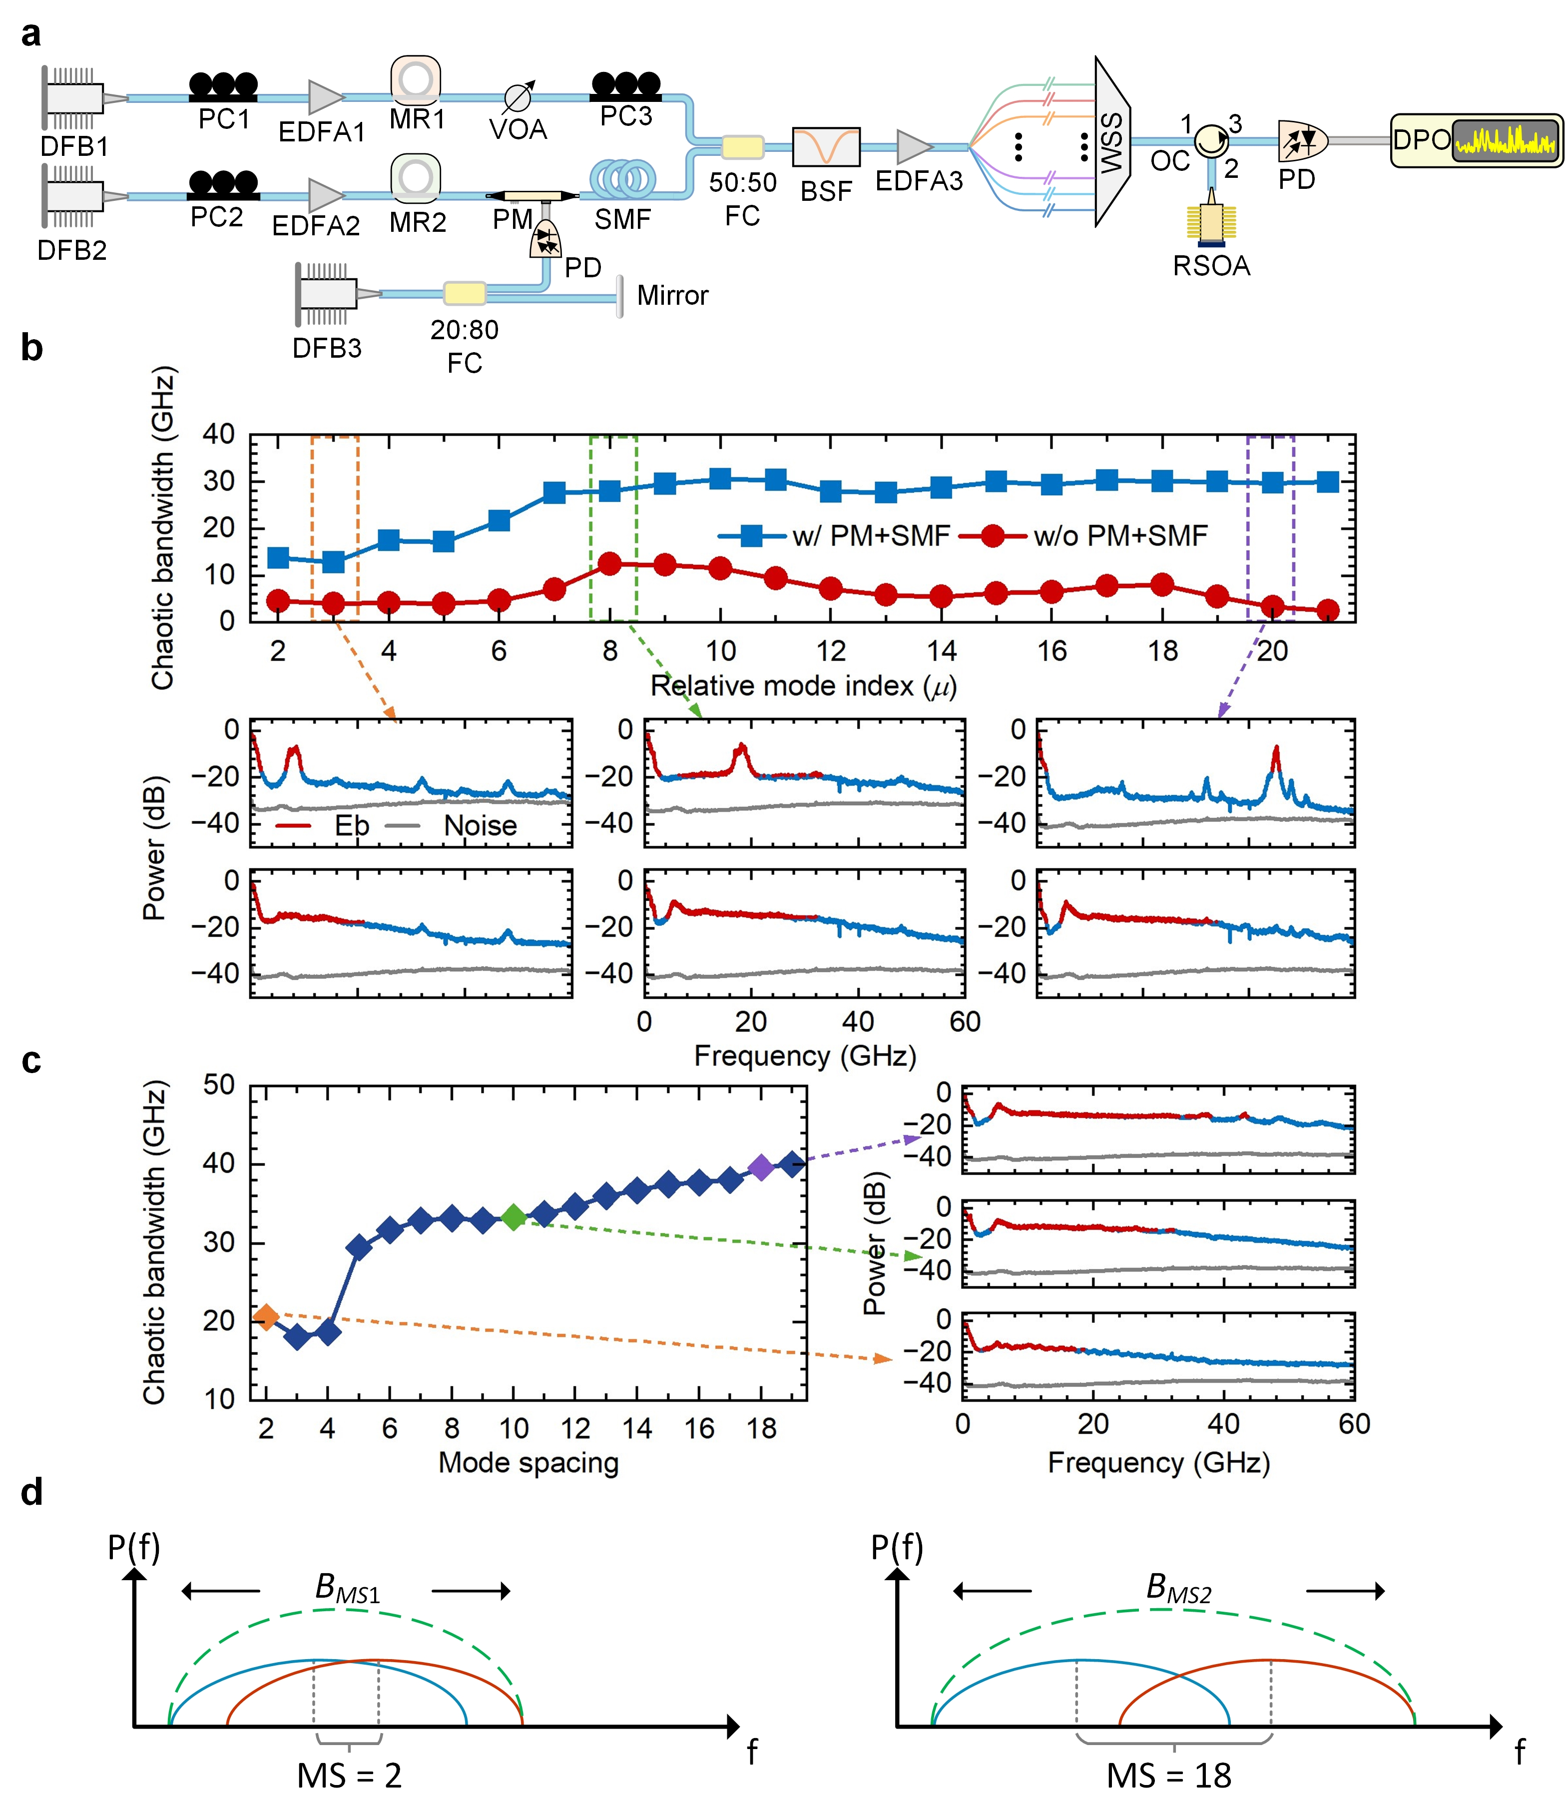

Fig. S3| Spectral broadening and spacing optimization for efficient RF chaos synthesis. a, Experimental configuration for spectral broadening. A phase modulator (PM) broadens the chaotic microcomb teeth, and subsequent propagation through a single-mode fiber (SMF) converts the induced phase fluctuations into intensity fluctuations. b, Effective RF chaotic bandwidth of individual mapped spectral-element pairs before and after spectral broadening. Spectral broadening increases the bandwidth contribution of each mapped element while the measured spectra remain above the electronic noise floor. c, Influence of spectral-element spacing on RF chaos synthesis. The RF chaotic bandwidth synthesized from two broadened spectral-element pairs is shown as a function of their mode spacing. Larger spacing reduces overlap between adjacent mapped RF bands and improves effective bandwidth utilization. d, Schematic illustration of bandwidth expansion for different mode spacings.
Fig. S3c examines the influence of spectral element spacing on RF chaos synthesis. Two broadened spectral-element pairs are selected and synthesized while varying their mode spacing (MS). As the spacing increases, the overlap between the corresponding heterodyne components is progressively reduced, leading to a broader and more uniform RF spectrum. For example, a mode spacing of MS = 8 corresponds to an RF separation of 20 GHz under a repetition rate offset of 2.5 GHz. The measured spectra indicate that the synthesized bandwidth is strongly influenced by the degree of overlap between adjacent mapped entropy bands.
The underlying mechanism is schematically illustrated in Fig. S3d. For small mode spacing, substantial overlap exists between neighboring heterodyne components, resulting in redundant spectral occupancy and a synthesized bandwidth B_{MS1}. As the mode spacing increases, the overlap is reduced and a larger portion of the RF spectrum becomes effectively utilized, yielding a broader reconstructed bandwidth B_{MS2} (B_{MS2}>B_{MS1}). These observations indicate that entropy reconstruction is governed not only by the bandwidth carried by individual spectral elements but also by the overlap topology established during spectral aggregation. Optimizing the spacing between mapped spectral elements therefore provides an effective approach for improving spectral utilization efficiency and reducing the number of channels required for broadband entropy reconstruction.

IV. Numerical modeling of Vernier RF chaos reconstruction
To support the experimental observations and investigate the scalability of the proposed architecture beyond the bandwidth of the available hardware, numerical simulations were performed for both the chaotic dual-comb generation process and the spectral-broadening stage. The intracavity dynamics of the two MRs were modelled using the generalized Lugiato-Lefever equation (LLE) [^{4,5}]:
(S8)
where t_{R} represents the roundtrip time, E(t,τ) denotes the slowly varying intracavity field envelope. Here, t corresponds to the slow time scale describing the evolution of the field, while τ indicates the fast time variable in MR reference frame. The remaining parameters are the intrinsic roundtrip loss α_{i}, the total cavity loss α₀ = (α_{i} +θ)/2, the coupling coefficient θ, the pump-resonance detuning δ₀, the resonator length L, the nonlinear coefficient γ, and the pump field E_{pump}. β₂ denotes the second-order group-velocity dispersion (GVD), while higher-order dispersion terms are neglected.
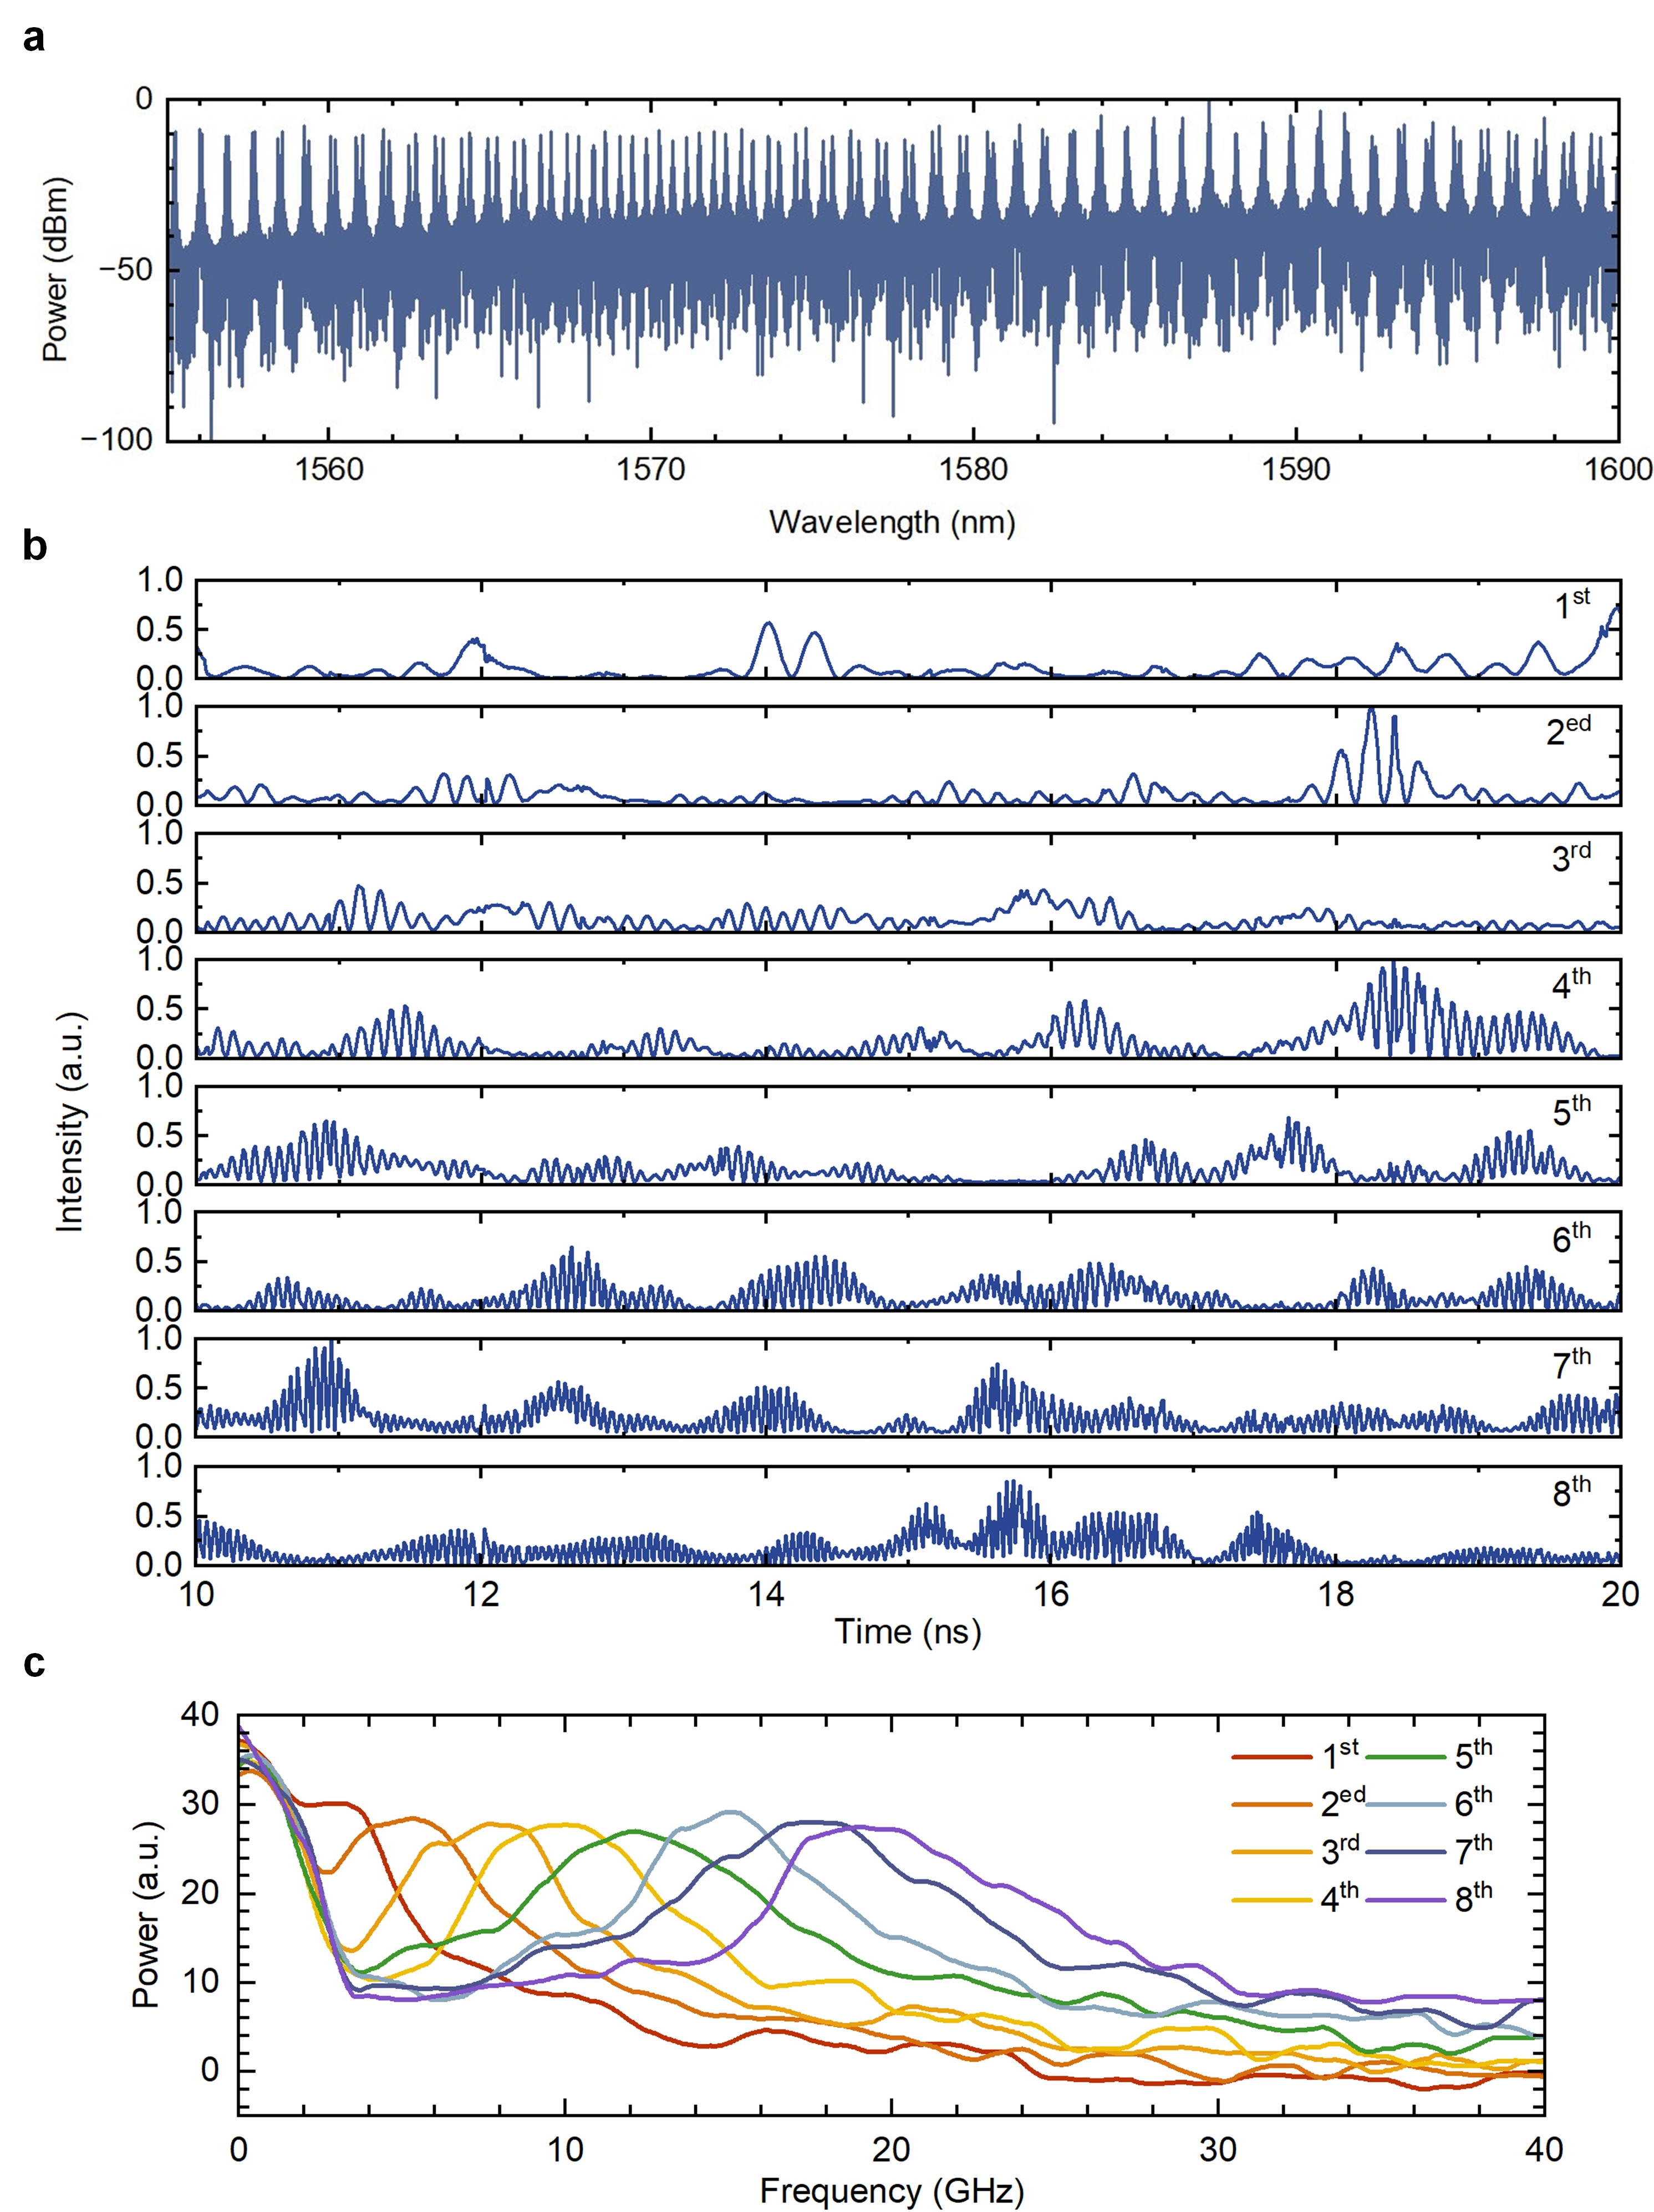

Fig. S4| Numerical characterization of the Vernier dual-comb characteristics. a, simulated optical spectra of the dual-comb architecture. b, Transient temporal waveforms of 8 representative pairs of spectral elements. c, corresponding RF envelopes of the eight spectral element pairs.

To reproduce the experimental Vernier configuration, the free spectral ranges (FSRs) of the two MRs were set to 102.5 GHz and 100 GHz, respectively, corresponding to a repetition-rate offset Δf_{rep} of 2.5 GHz. The simulated intracavity fields were resampled onto a common temporal grid and coherently combined to form the dual-comb system:
(S9)
where E₁ and E₂ denote the field of MR₁ and MR₂, respectively.
Figure S4a shows the optical spectra of the two chaotic microcombs, while Figs. S4b, c present representative temporal waveforms and RF spectra obtained from eight spectral-element pairs located on the red-detuned side of the pump. The simulated RF components exhibit discrete frequency translations determined by Δf_{rep}, reproducing the Vernier mapping observed experimentally.
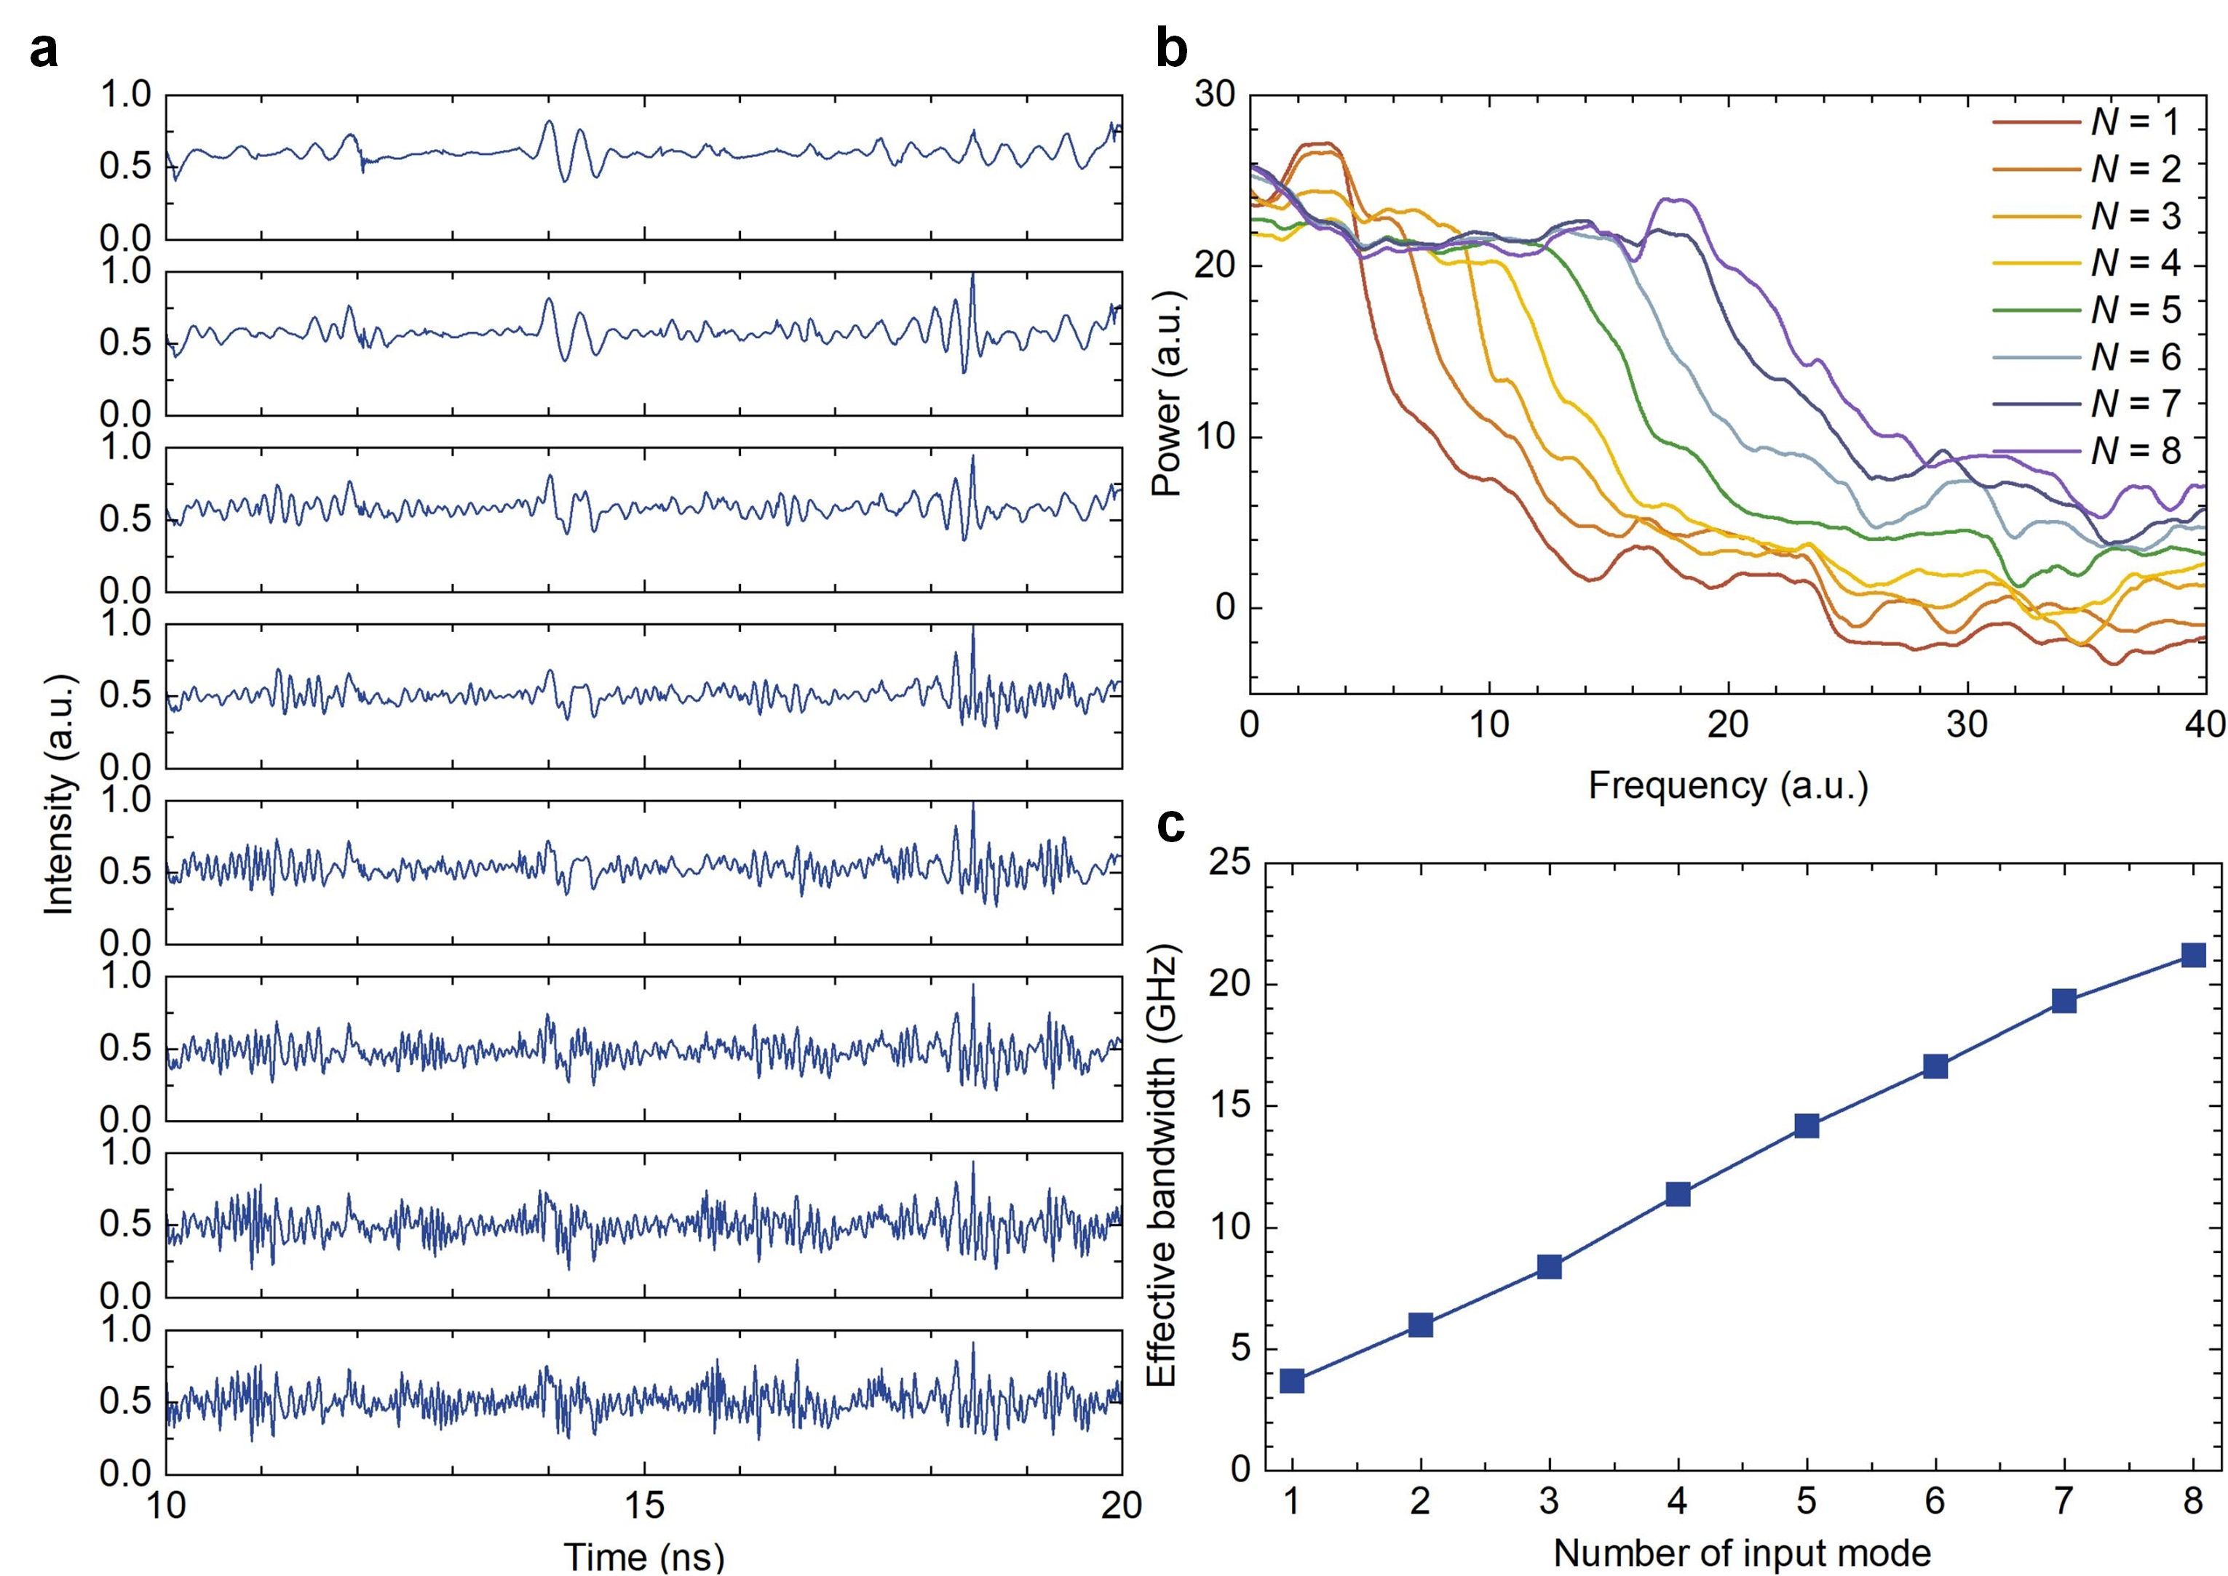
Fig. S5| Simulated RF-band scaling with increasing spectral-element count. a, Temporal waveforms of the reconstructed RF chaotic signal as the number of spectral elements increases from one to eight. b, Corresponding evolution of the RF spectra, showing progressive spectral filling and bandwidth expansion in the RF domain. c, Effective RF chaotic bandwidth as a function of spectral-element count, demonstrating the scalability of Vernier RF-band reconstruction.
Figure S5 investigates the scaling behavior of entropy reconstruction as the number of aggregated spectral elements increases. The reconstructed temporal waveforms and RF spectra are shown in Figs. S5a, b. The effective RF entropy bandwidth extracted from the synthesized signals is summarized in Fig. S5c. An approximately linear relationship is observed between the reconstructed bandwidth and the number of aggregated spectral elements, consistent with the Vernier RF-band synthesis model described in Section I.
To investigate the bandwidth-scaling capability of the architecture in the spectral-broadening regime, additional simulations were performed for the configuration described in Fig. 3. The resonator FSRs were adjusted to 300 GHz and 320 GHz, respectively, enabling larger RF mapping intervals and reducing overlap between adjacent mapped bands. Chaotic optical spectral broadening was applied to the chaotic microcomb generated by MR1. In this configuration, the broadening was driven by a modulated chaotic signal generated from a distributed-feedback (DFB) laser subjected to external optical feedback. The nonlinear dynamics of the DFB laser were modelled using the Lang-Kobayashi (L-K) rate equations [⁶]:
(S10)
(S11)
(S12)
where E_{c}(t) denotes the optical field of the chaotic DFB laser. The remaining parameters include the linewidth-enhancement factor α, the active region gain G, the photon lifetime τ_{p}, the internal cavity round-trip time τ₀, the feedback delay τ, the carrier frequency ω₀, the spontaneous emission rate β, the number of transparent carriers N₀, the laser operating current I, the carrier lifetime τ_{N}, the gain saturation factor ε, the differential gain g, a noise signal with zero mean and a variance of 1 χ.
The spectral broadening process is modeled as a phase-modulation stage followed by dispersive propagation [⁷]:
(S13)
(S14)
where Ω_{PM} denotes the modulation depth. E_{c} denotes the chaotic signal produced by DFB laser. τ_{PM} represents the delay of feedback phase modulation. E_{PM} is the field of after phase modulation. The N[|E_{c}(t-τ_{PM})|²] represents the normalized driver signal. The transfer function of the dispersive fiber is
(S15)
(S16)
(S17)
where β₂^{SMF} is the group velocity dispersion in fiber. L_{SMF} is the fiber length. F⁻¹ represent the inverse Fourier transform. h_{D}(t) is the unit impulse response of H_{D}(ω). E_{PM+SMF} is the field of MR1 after spectral broadening.
These simulations reproduce the experimentally observed Vernier frequency translation and the near-linear RF bandwidth scaling with spectral-element number. They are used to validate the RF-band reconstruction mechanism and to explore bandwidth scaling under enlarged mapping intervals and detection bandwidths.

V. Perspectives on heterogeneous photonic integration
Although the present work is implemented using a hybrid experimental platform, recent advances in heterogeneous photonic integration suggest possible routes towards chip-scale realization of the Vernier RF chaos reconstruction architecture. The key functional modules required for chaotic microcomb generation, spectral broadening, RF-domain reconstruction and photodetection have each been demonstrated in integrated or heterogeneous photonic platforms. Combining silicon nitride (Si₃N₄) MRs with thin-film lithium niobate (TFLN), III–V gain sections and integrated photodetectors could therefore provide a pathway towards more compact implementations. The chaotic microcomb generation stage could be implemented using integrated Kerr MRs pumped by on-chip semiconductor lasers or heterogeneously integrated III–V gain sections. For example, Stern et al. demonstrated heterogeneous integration of III–V gain sections with ultra-low-loss Si₃N₄ waveguides, enabling compact laser-integrated Kerr-comb systems [⁸]. Within the present architecture, integrated gain sections could provide optical pumping for the dual MRs, while an additional RSOA operated in the saturation regime could be used for spectral equalization before photodetection. Such functions are compatible with established heterogeneous-integration approaches, although practical implementation would require co-design of pump power, thermal tuning, spectral filtering and receiver dynamic range.
The spectral-broadening stage could be implemented using integrated electro-optic modulation and dispersive engineering. TFLN is a promising platform for this purpose because of its high electro-optic efficiency and low propagation loss. Recent demonstrations of integrated electro-optic pulse shaping and chirped Bragg gratings (CBGs) on TFLN platforms [⁹] indicate that phase modulation and large on-chip dispersion can be realized in compact footprints. Compared with standard optical fibers, integrated CBGs can provide large dispersion within millimeter-scale devices, offering a potential route to compact implementation of the phase-modulation and dispersive-conversion stage used in this work.
Together, these developments suggest that the proposed Vernier RF chaos reconstruction framework is compatible with emerging heterogeneous photonic-integration technologies. Future implementations could integrate chaotic microcomb generation, spectral broadening, RF-domain reconstruction and photodetection on a common platform, enabling more compact stochastic photonic systems. Such integrated architectures may support high-speed physical random-bit generation, stochastic computing, intelligent sensing and neuromorphic photonics, while further work will be required to address pump integration, thermal control, spectral programmability and electronic readout bandwidth.

References
- Qian, J.-H. et al. Delayed interference-based broadband optical chaos generation in a mutual coupled RSOA and DFB system. Opt. Lett. 50, 3381-3384 (2025).
- Lin, F.-Y., Chao, Y.-K. & Wu, T.-C. Effective bandwidths of broadband chaotic signals. IEEE J. Quantum Electron. 48, 1010-1014 (2012).
- Newbury, N. R., Coddington, I. & Swann, W. Sensitivity of coherent dual-comb spectroscopy. Opt. Express 18, 7929-7945 (2010).
- Herr, T. et al. Temporal solitons in optical microresonators. Nat. Photon. 8, 145-152 (2014).
- Coen, S. & Erkintalo, M. Universal scaling laws of Kerr frequency combs. Opt. Lett. 38, 1790-1792 (2013).
- Lang, R. & Kobayashi, K. External optical feedback effects on semiconductor laser injection laser properties. IEEE J. Quantum Electron. 16, 347-355 (1980).
- Li, A.-R. et al. Massive bandwidth-enhanced chaotic generation based on microresonator cascaded by phase modulator and dispersive component. J. Lightw. Technol. 42, 8730-8739 (2024).
- Stern, B., Ji, X.-C., Okawachi, Y., Gaeta, A. L. & Lipson. M. Battery-operated integrated frequency comb generator. Nature 562, 401-405 (2018).
- Yu, M.-J. et al. Integrated femtosecond pulse generator on thin-film lithium niobate. Nature 612, 252-258 (2022).

