Methods
The test facilities of Transpharmation Canada Ltd comply with all local regulations governing the care and use of laboratory animals. All procedures were designed to prevent discomfort, distress, and pain to the animals in accordance with the principles of The Animal for Research Act of Ontario and the guidelines of the Canadian Council on Animal Care (CCAC). The protocol of the present study was reviewed and approved by the study facility’s Animal Care Committee (ACC) before the start of the trial as per ACC Terms of Reference. The study facility is accredited by the Ontario Ministry of Agriculture, Food, and Rural Affairs (OMAFRA) as a recognized Research Facility (Certificate #0125-02) and is accredited by the CCAC as meeting the standards of a Good Animal Practice Facility.

Animal housing
Animals were housed in plastic-coated steel pens (4 per pen) with epoxy-coated cement floors equipped with elevated resting platforms. A photoperiod of ~12h was maintained, temperature was kept between 15 – 28°C with radiant floor heating and forced air heating, and room ventilation was controlled by air exchanger and set at a level required to maintain the environmental humidity levels between 30-70%. Socialization and enrichment were provided in the form of toys, group housing, and human interaction. When necessitated, individual housing in stainless-steel cages was temporarily utilized for specific health monitoring or technical/husbandry interventions.

Trial design
The study was of a randomized, parallel-group design with all personnel involved in the investigation being blinded for treatment allocation. Additional endpoints included fecal Bristol stool scale scoring (individual and pen level), fecal metagenomics, fecal and blood metabolomics, and exploratory biomarkers in blood. Following baseline anxiety assessments, the twenty-four remaining dogs were first ranked according to post-thunder serum cortisol level such that the dog with the highest cortisol value received a rank of 1. The dogs were then ranked according to post-travel cortisol response using the same method. Any dogs with the same cortisol value were ranked alphabetically by given name. The sum of the two ranks (i.e., the cumulative rank) was determined for each dog and the dogs listed by cumulative rank in descending order from lowest cumulative rank (best cortisol response) to highest cumulative rank (poorest cortisol response). Any dogs with the same cumulative rank were again ranked alphabetically by given name. Dogs were then allocated to one of two treatment groups using an ABBAABBA block pattern according to descending cumulative rank.
Assigned groups were assessed for equivalent balance of cortisol responses, activity responses during thunder presentation (i.e., hyperactive or hypoactive), and sex equivalency. Finalized groups were randomly assigned a treatment condition.

Health observations
Health observations were performed twice daily, and fecal scores at the pen level were included in these daily observations. Body weights were measured once weekly for the duration of the trial. Veterinary examinations were performed once during baseline and again at the end of the trial.

Statistical analyses of heart rate
For the heart rate (HR) measurements, as an initial manipulation check, we assessed whether the stress tasks elicited the expected physiological response using generalized least squares (GLS) models. These models tested whether the mean HR reactivity (delta of post-challenge and pre-challenge HR) exceeded zero, reflecting an average increase in HR from baseline to stress, while assuming equal correlation between repeated measures within each dog (compound symmetry) and allowing residual variances to differ across sessions and treatment groups.
Separate generalized additive models (GAMs) with Gaussian error distribution were fitted for the thunderstorm and car-ride test HR reactivity scores, as preliminary analyses indicated nonlinearity in linear mixed models. Each GAM predicted post-treatment HR reactivity from the treatment group (LBHF vs. placebo). To adjust for baseline differences, we included the pre-treatment HR values from the corresponding baseline and stress phases as penalized smooth terms in each model (pre-thunder and thunder for the thunderstorm test; pre-ride and ride for the car-ride test). Sex was included as a fixed effect, as groups were stratified by sex at randomization, and pen membership was modeled as a random effect to account for potential shared environmental influences among dogs housed together.
To validate HR as a physiological indicator of stress in the context of the two models, we examined its relationship with behavioral stress scores. For each dog and session, HR values from the stress phase of the test (3-minute thunder phase; 10-minute car ride) were paired with the corresponding score. Linear mixed-effects models were then fitted with HR as the dependent variable and behavioral score as the predictor, including a random intercept for dog to account for repeated measures across pre- and post-treatment sessions. Because behavioral stress scores are ordinal in nature, they were rank transformed prior to analysis.

Results

LBHF did not affect blood levels of alkaline phosphatases
Based on asymptotic Wald tests, no evidence was found for a significant treatment effect: The effect estimate for ALP (on the log-scale) was -0.17 ± 0.14, p = 0.26) and for the steroid-induced fractions (on the log-odds scale) was 0.1 ± 0.21, p = 0.63).

Figures
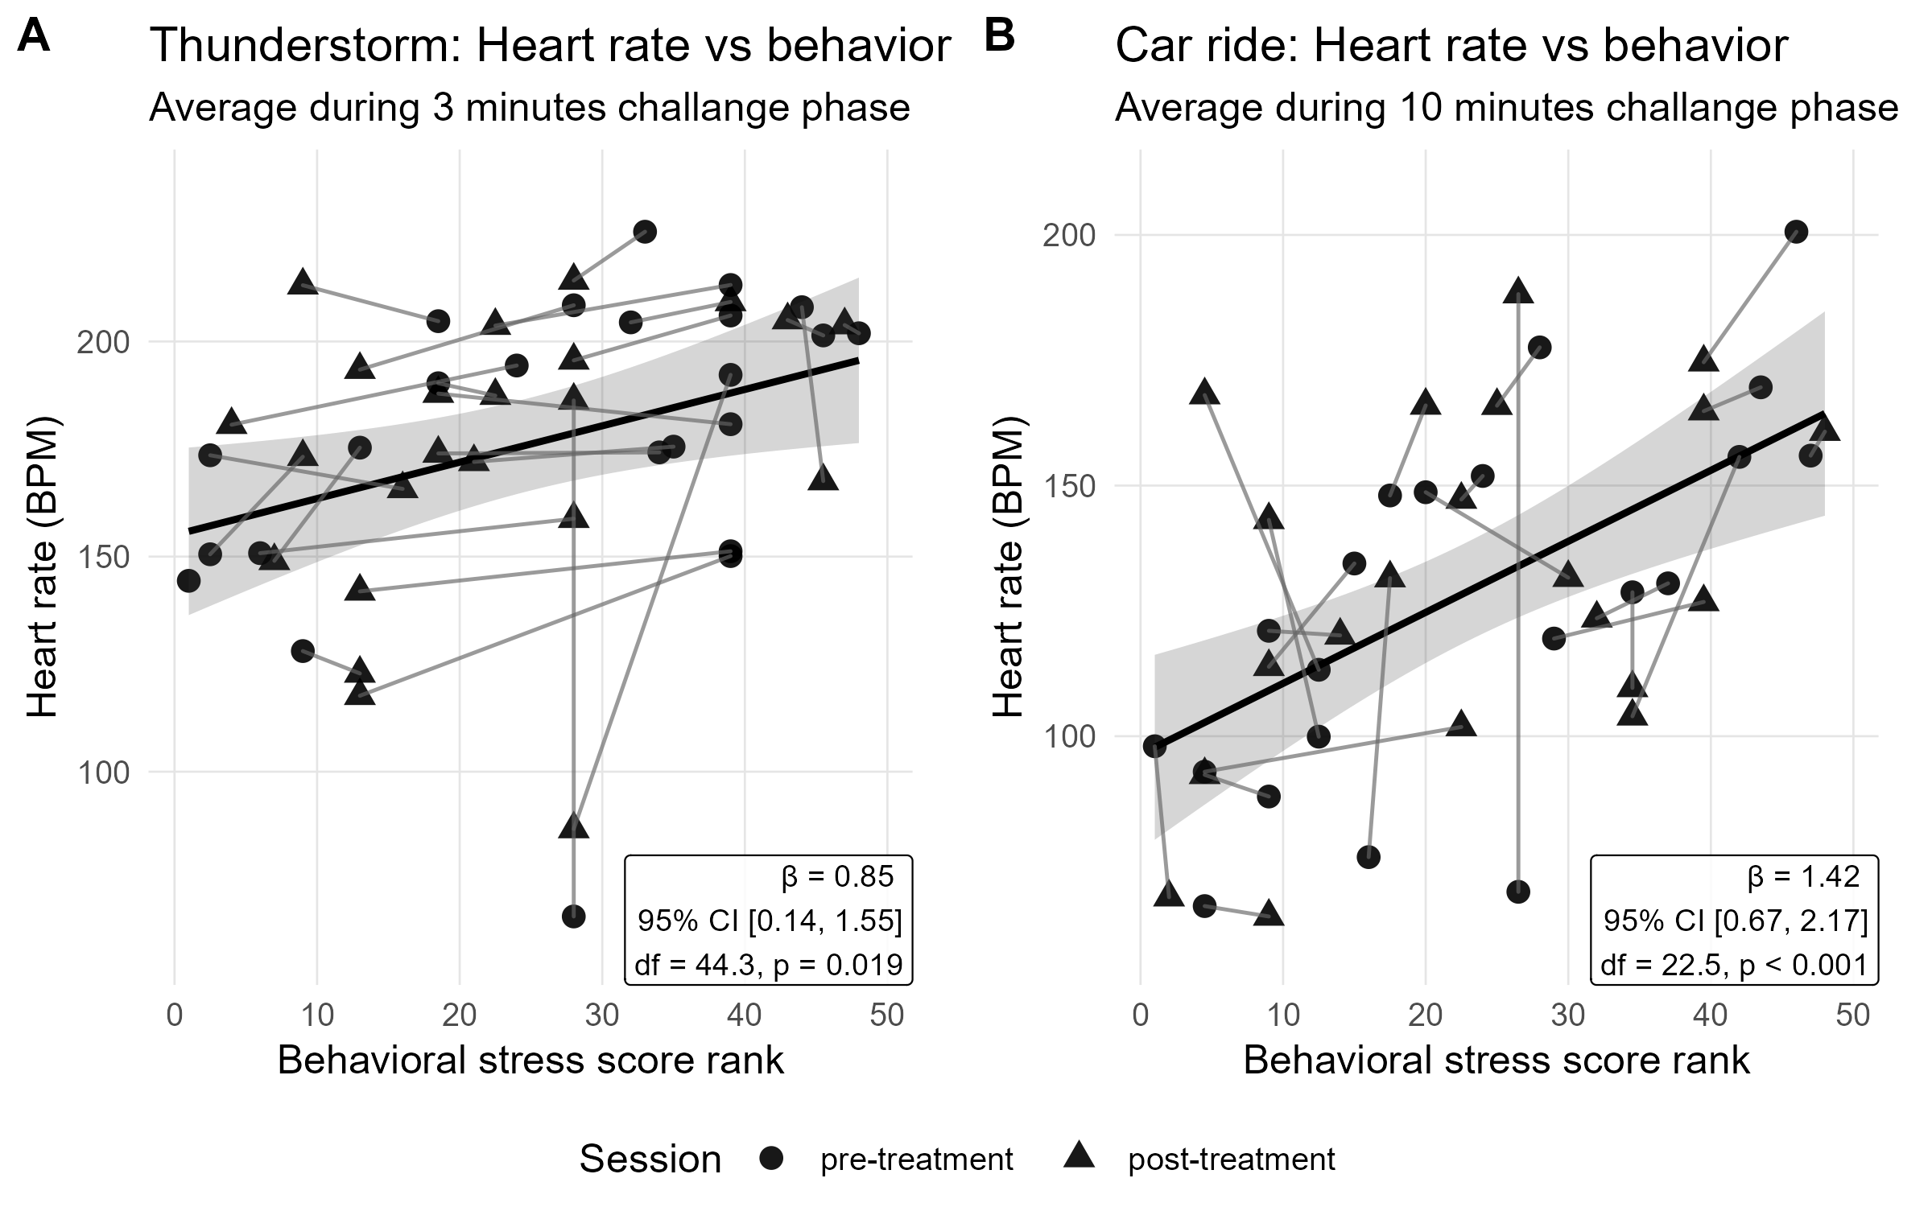
Supplementary Fig. 1 Association between behavioral stress scores and heart rate during the stress phases of the thunderstorm (A), and car ride (B) tests. Each point represents a dog at a given test session (pre- or post-treatment), with thin connectors indicating paired observations from the same dog across sessions. Solid regression lines show the population-level fit from linear mixed-effects models, and shaded areas represent 95% confidence intervals.
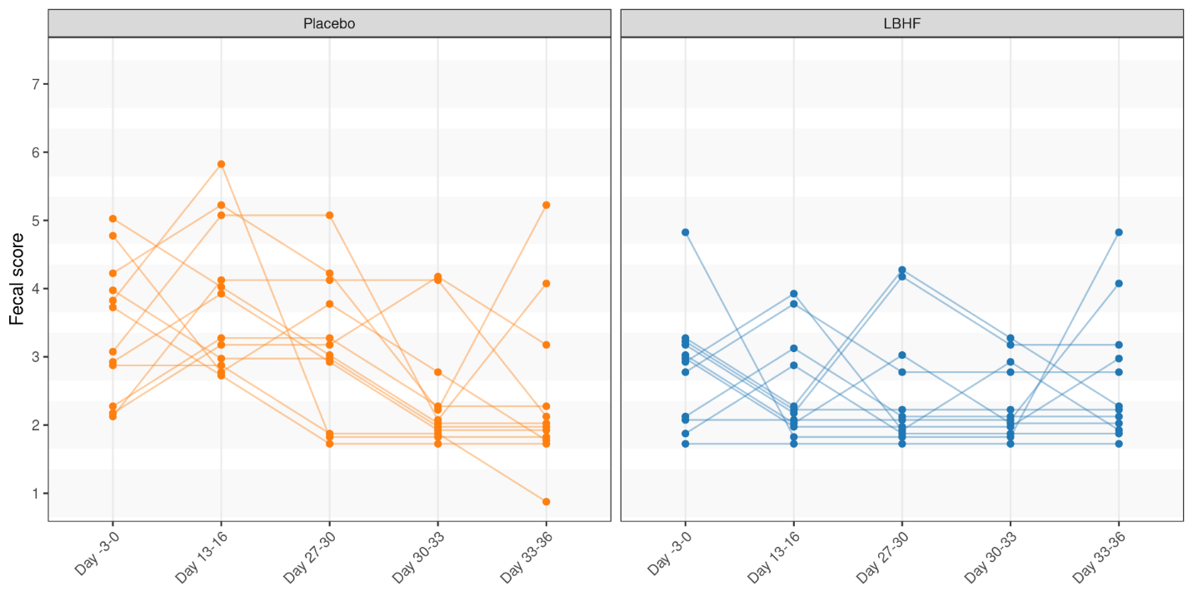
Supplementary Fig. 2. Individual Bristol Stool Scale (BSS) scores at various time points. A lower score indicates more solid feces hence slower gastrointestinal transit time.
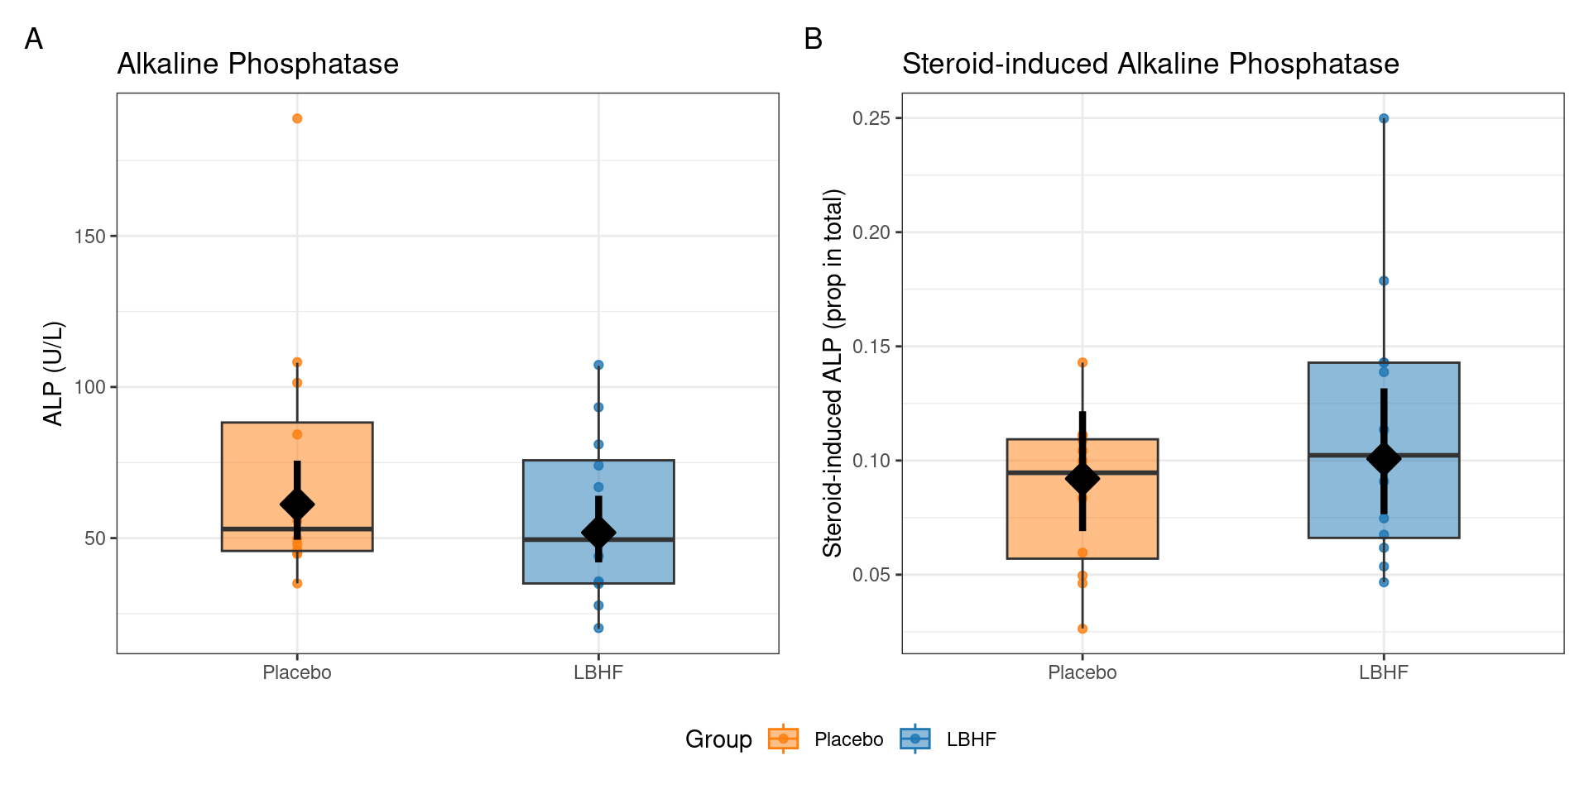
Supplementary Figure 3. Alkaline phosphatase levels are not significantly influence by LBHF intervention. Alkaline phosphatase levels (A) and the proportion of steroid-induced ALP in the total (B) at follow-up. The black diamonds and intervals represent the model-based estimated marginal means (back-transformed from their original log- and logit scale) along with the corresponding 95% confidence intervals.
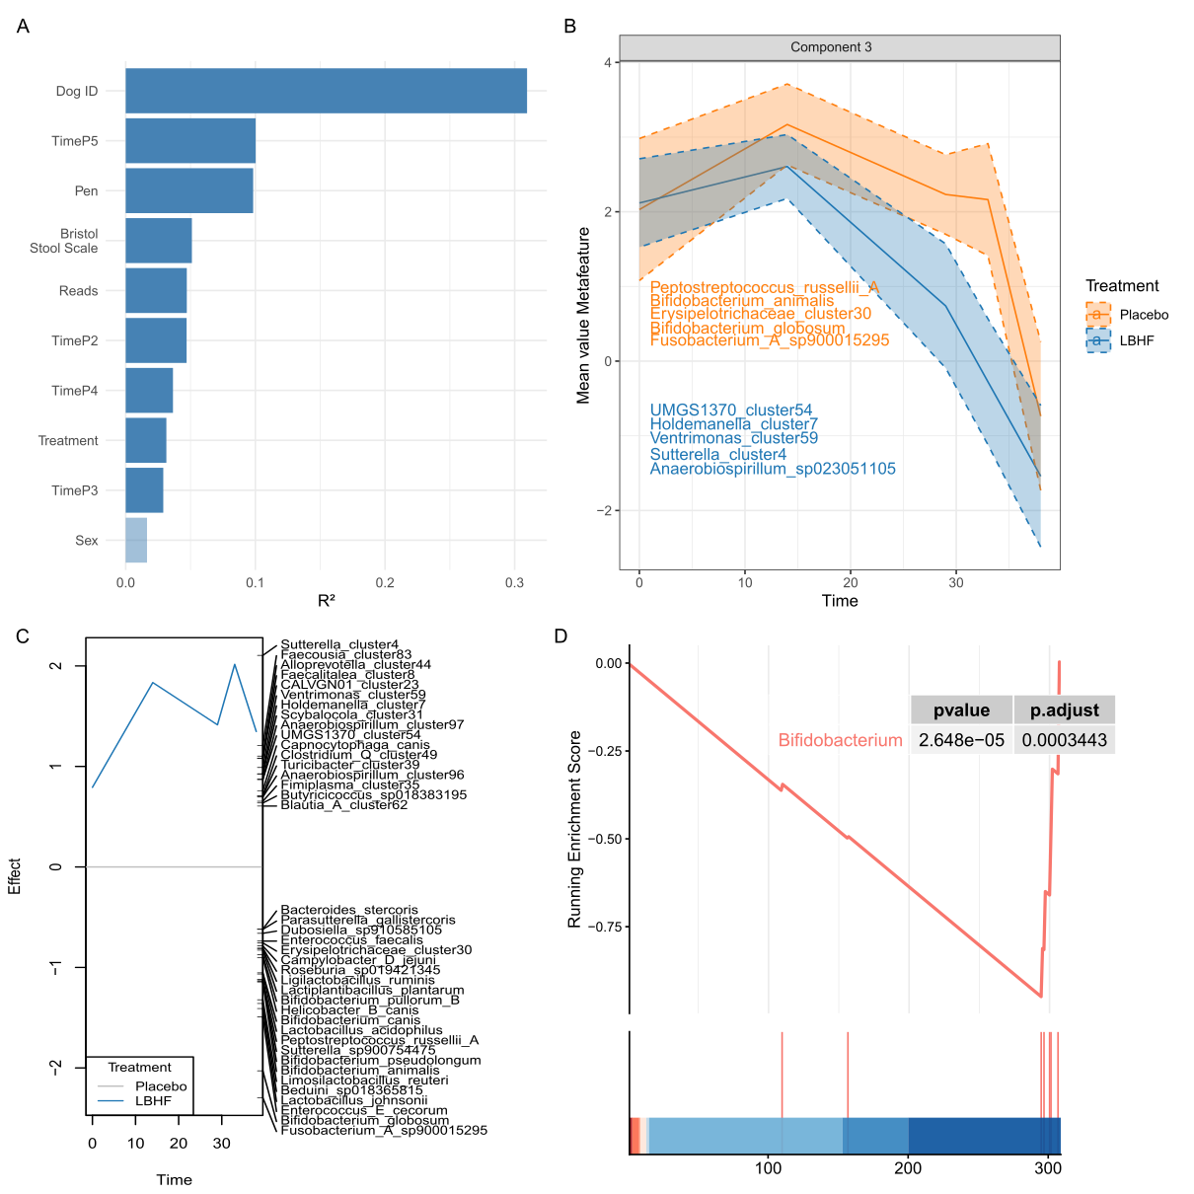
Supplementary Figure 4. Multivariate based assessment of intervention effect. A. Partitioning of the inter-sample variability of species-level Aitchison distances using PERMANOVA. Bars indicate the variability explained in univariable models. B. Metafeatures through time from the component 3 obtained in TEMTED. Metafeature indicates the log ratio of highest and lowers loads of the component (top 5 taxa with the highest and lowest loads are labelled in the plot). Component 3 was significantly associated with treatment (FDR=0.007). C. Principal response curve (PRC) identifies an axis of variation with a significant interaction between treatment and time (p = 8x10⁻³). Top upper and lower loads are represented in the plot. E. Gene set enrichment analysis of genus taxonomy for taxa loads of PRC identifies a genera significantly enrichment in and lower loads. The upper pane presents the ranking enrichment scores, while the lower shows the load ranking (1=higher ranking), and bars indicate the rank of the species within each of the genera.
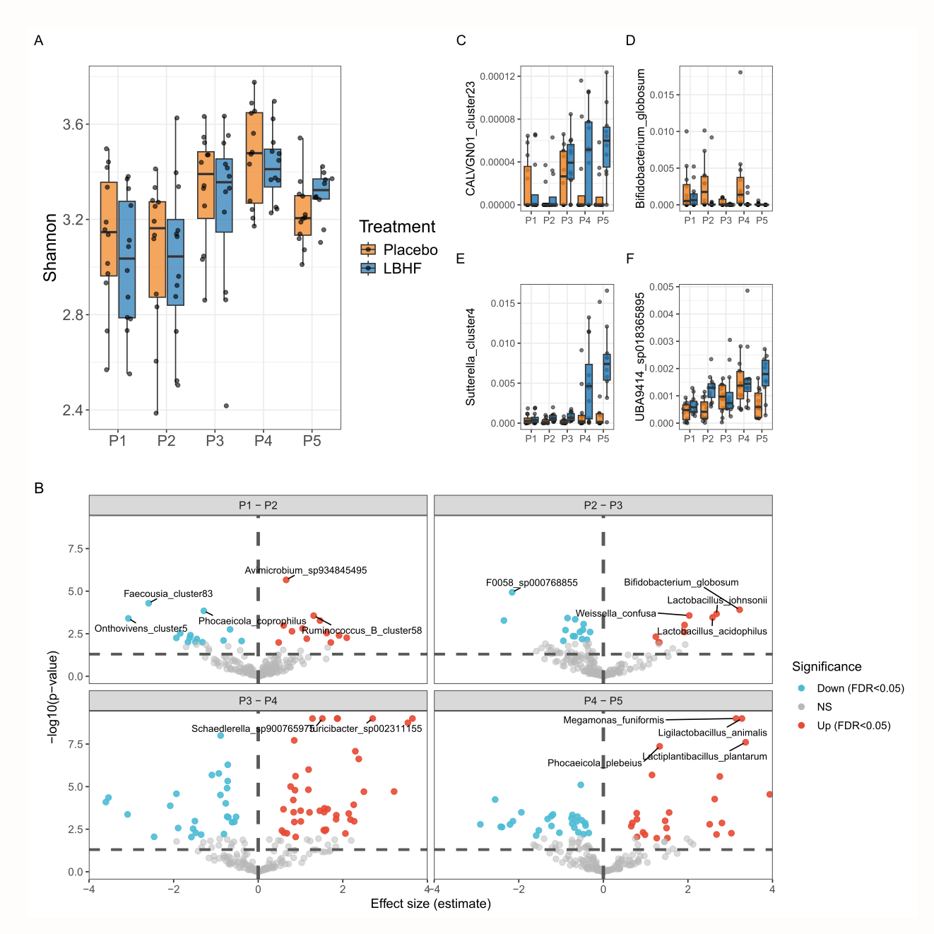
Supplementary Figure 5. LBHF effects on microbial species abundance and sample’s alpha diversity. A. Alpha diversity (Shannon) changes during study timepoints in a similar fashion for treatment groups, with the exception of a trend for a differential P5 effect between treatment groups. B. Volcano plot depicting the summary statistics of species-level clr-transformed abundances changing between contiguous timepoints. Color points represent associations under an FDR significance cut-off of 0.05. C-F. Relative abundances in time of four taxa with significantly different abundance between treatment groups.

Tables
Sup. Table 1. Anxiety scoring. Scoring scale of behaviours included in the global anxiety score
Sup. Table 2. Plasma metabolomics: Baseline and Follow-up stress effect. Plasma metabolomics: Baseline and follow-up paired test results.
Sup. Table 3. Plasma metabolomics: Wilcoxon test group differences. Plasma metabolomics: Wilcoxon rank-sum test for group differences in delta values between pre-treatment between the stress phase and baseline
Sup. Table 4. Plasma metabolomics: Interaction effect time/treatment. Plasma metabolomics: Linear mixed model interaction effect (time x treatment).
Sup. Table 5. Microbiome: Univariate models time effect. Microbiome: Univariate models for time effect (species).
Sup. Table 6. Microbiome: Univariate models treatment and interaction effect. Microbiome: Univariate models for interaction effect (species).
Sup. Table 7. Fecal metabolomics, TEMPTED Components VS treatments. Fecal metabolomics: TEMPTED component Wilcoxon test results (LB vs Placebo).
Sup. Table 8. Fecal metabolomics: Time effect. Fecal metabolomics: Univariate models for time effect.
Sup. Table 9. Fecal metabolomics: Interaction effect. Fecal metabolomics: Univariate models for interaction effect.

