Experimental study on foam drainage of AFFF: Additive regulation, thermal transition, and fire-extinguishing verification

Supplementary Materials

S1. Experiments on formulated solutions with a single hydrocarbon surfactant system
Since the fluorocarbon surfactants STAR-2157/2470 used in this experiment are newly developed products, it was necessary to evaluate the performance parameters of solutions and foams formulated by blending STAR-2157/2470 with single hydrocarbon surfactants before designing qualified formulations. The experimental formulations for the single‑hydrocarbon‑surfactant system are listed in Table S1. In these formulations, only STAR-2157 was used as the fluorocarbon surfactant at a concentration of 0.1%, corresponding to a pure fluorosurfactant concentration of 0.027%. Four types of hydrocarbon surfactants were selected: nonionic APG0810, zwitterionic CAB-35, anionic K12, and cationic CTAB, each at a concentration of 0.5%. Three xanthan gum concentrations (0%, 0.01%, and 0.03%) were applied, resulting in a total of 12 formulated solutions.

Table S1 Formulation design for experiments on solutions with a single hydrocarbon surfactant system.
Formulation | STAR-2157  concentration | Hydrocarbon surfactant |  |  |  | Xanthan gum concentration
Formulation | STAR-2157  concentration | Nonionic APG0810 | Zwitterionic CAB-35 | Anionic  K12 | Cationic CTAB | Xanthan gum concentration
A-1 | 0.027% | 0.5% | － | － | － | 0%
A-2 | 0.027% | － | 0.5% | － | － | 0%
A-3 | 0.027% | － | － | 0.5% | － | 0%
A-4 | 0.027% | － | － | － | 0.5% | 0%
A-5 | 0.027% | 0.5% | － | － | － | 0.01%
A-6 | 0.027% | － | 0.5% | － | － | 0.01%
A-7 | 0.027% | － | － | 0.5% | － | 0.01%
A-8 | 0.027% | － | － | － | 0.5% | 0.01%
A-9 | 0.027% | 0.5% | － | － | － | 0.03%
A-10 | 0.027% | － | 0.5% | － | － | 0.03%
A-11 | 0.027% | － | － | 0.5% | － | 0.03%
A-12 | 0.027% | － | － | － | 0.5% | 0.03%

S1.1. Surface tension
The surface tensions of the formulated solutions with single hydrocarbon surfactants, measured using a BP100 tensiometer, are shown in Fig. S1. Each formulation was measured 2-3 times and the average value was taken. The data indicate that, when blended with STAR-2157, the ability to reduce surface tension follows the order: APG0810>CAB-35>K12>CTAB. The solutions containing nonionic APG0810 or zwitterionic CAB-35 exhibit relatively low surface tensions, reaching approximately 17 mN/m. In contrast, the solutions containing anionic K12 and cationic CTAB show surface tensions of 24 mN/m and 32 mN/m, respectively. Furthermore, the xanthan gum concentration has a slight effect on the surface tension. As the xanthan gum concentration increases, the surface tension of the APG0810, K12, and CTAB blends gradually increases, whereas that of the CAB-35 blend decreases. Moreover, the surface tension of the K12 blend is relatively insensitive to the xanthan gum concentration.
.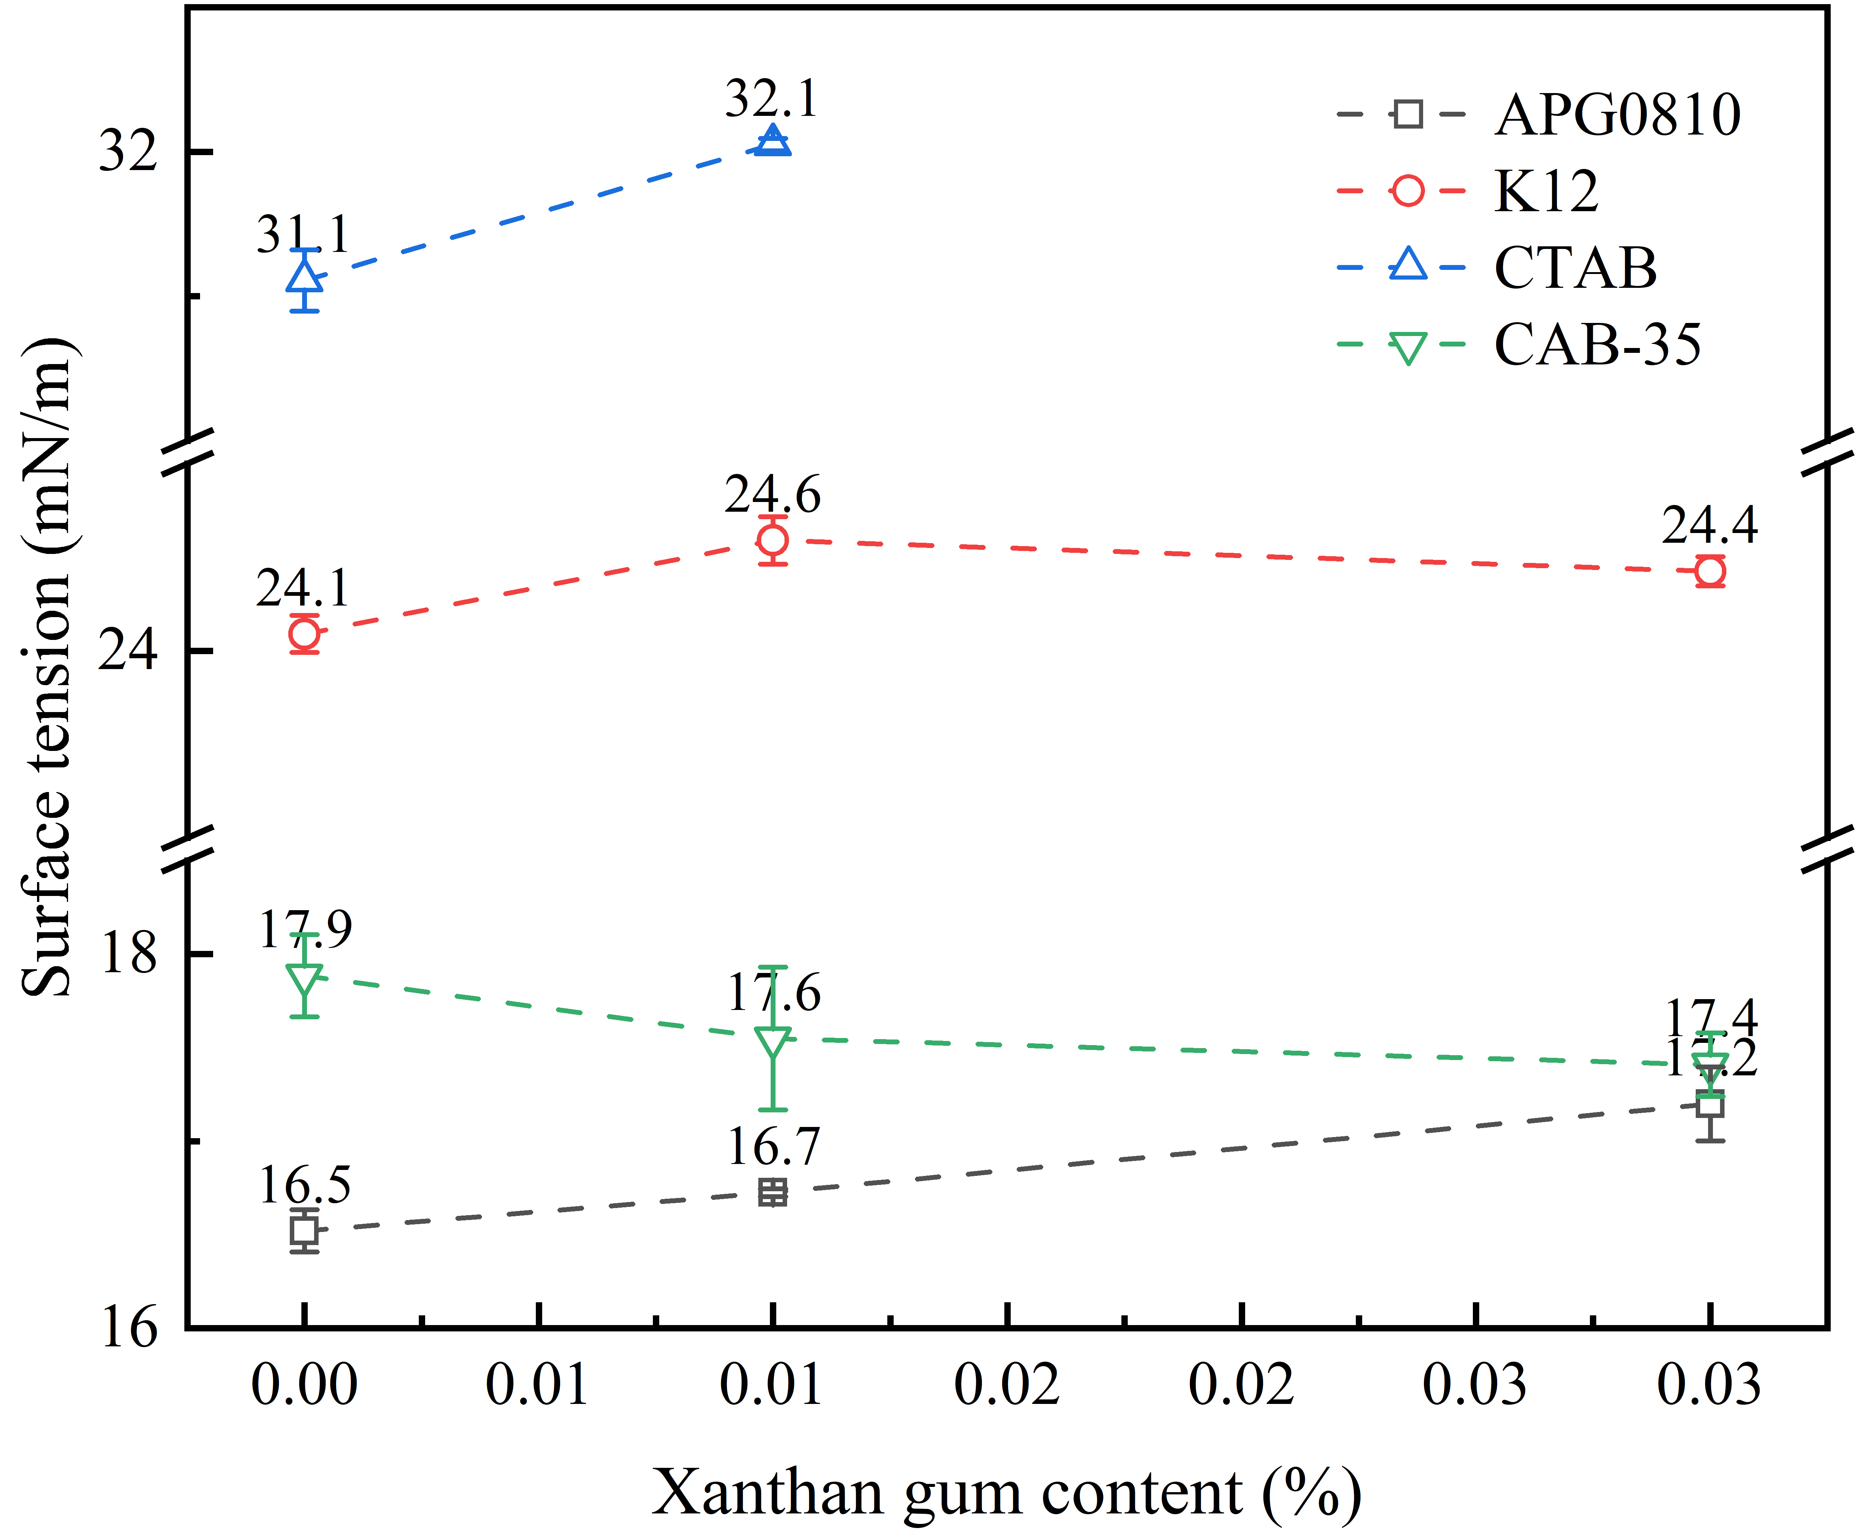
Fig. S1. Surface tension of formulated solutions with a single hydrocarbon surfactant system.

S1.2. Study on foam drainage behavior
The foamability and foam properties of solutions containing different types of hydrocarbon surfactants blended with the fluorocarbon surfactant vary. Therefore, this orthogonal experiment was designed to screen the hydrocarbon surfactant that exhibits the best blending performance with STAR-2157. Fig. S2 shows the time evolution of drained liquid volume from foams generated from formulations with different hydrocarbon surfactant types at various xanthan gum concentrations. In general, the slope of the drained liquid volume vs. time curve for the formulation containing the anionic surfactant K12 is the smallest among the four hydrocarbon surfactants, indicating that K12 has the best effect on prolonging the foam drainage time.
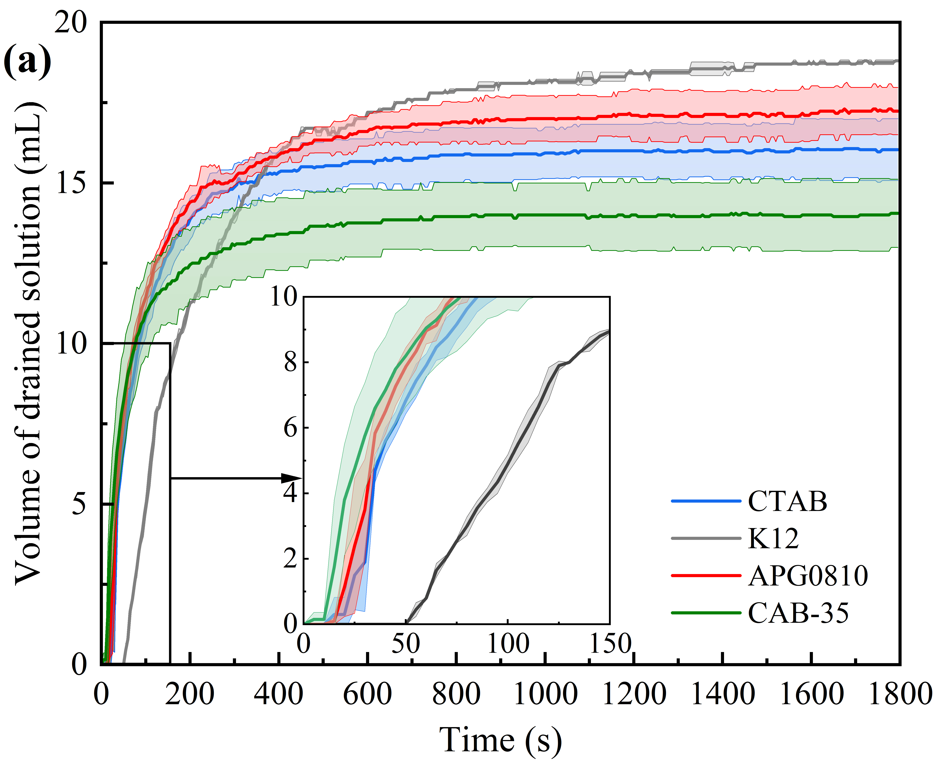 | 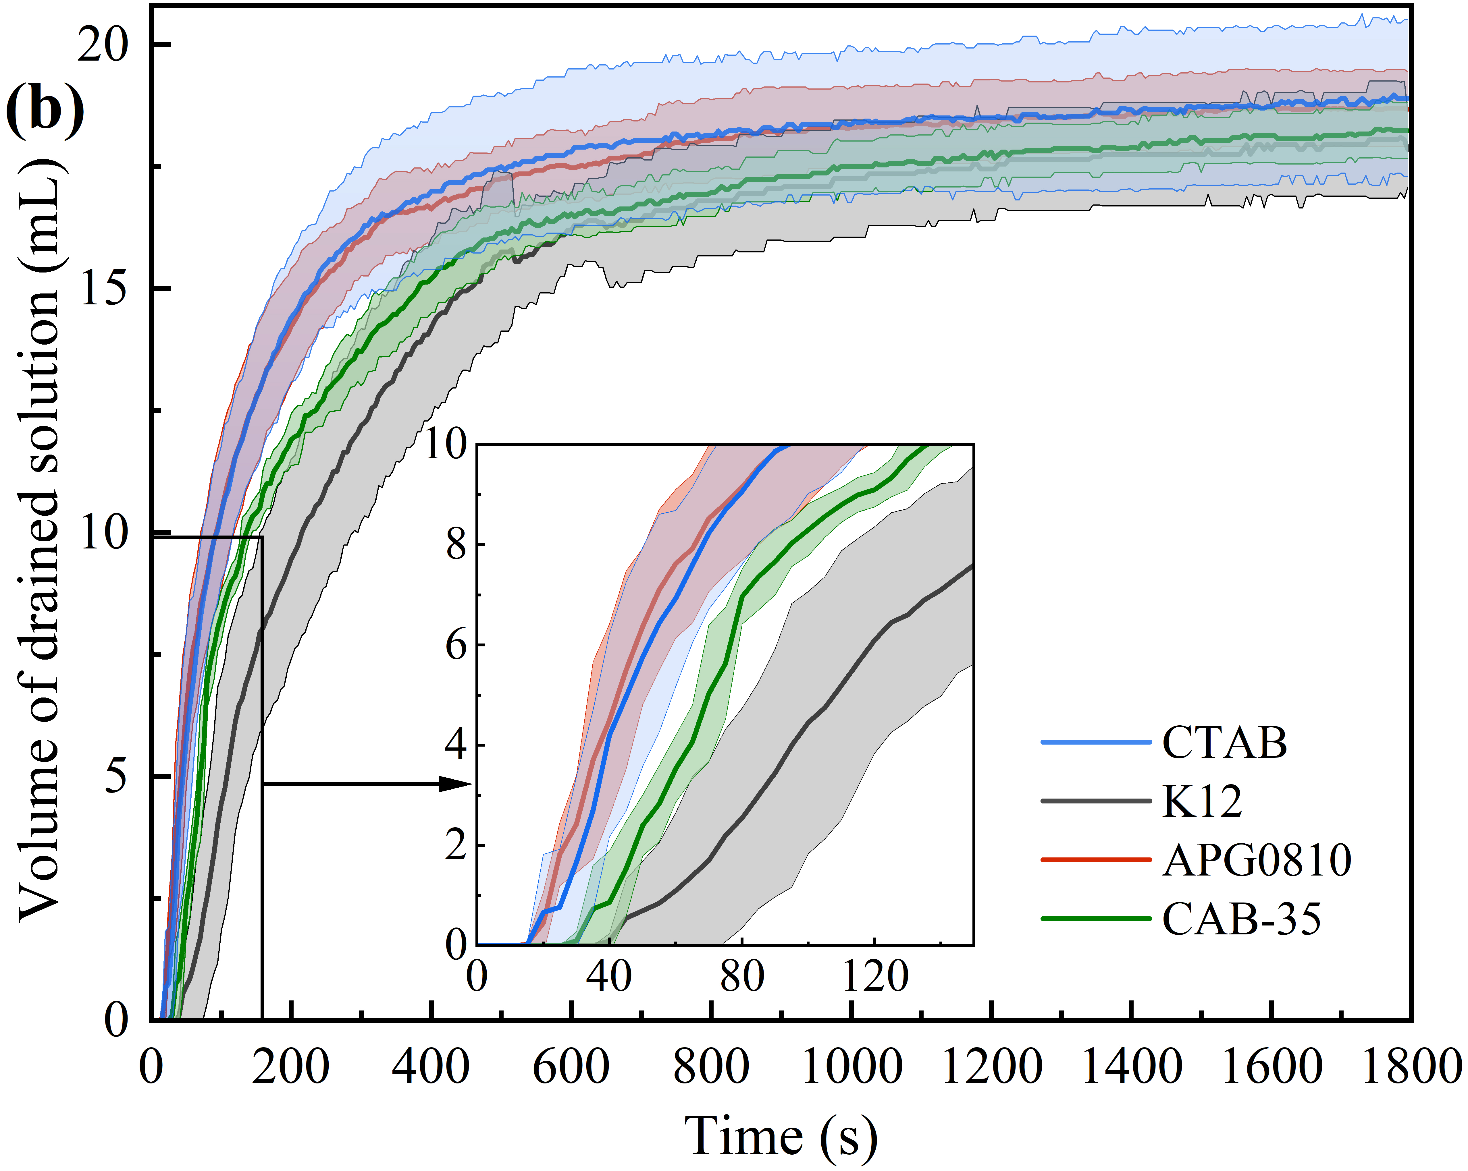
(a) Xanthan gum 0 % | (b) Xanthan gum 0.01 %
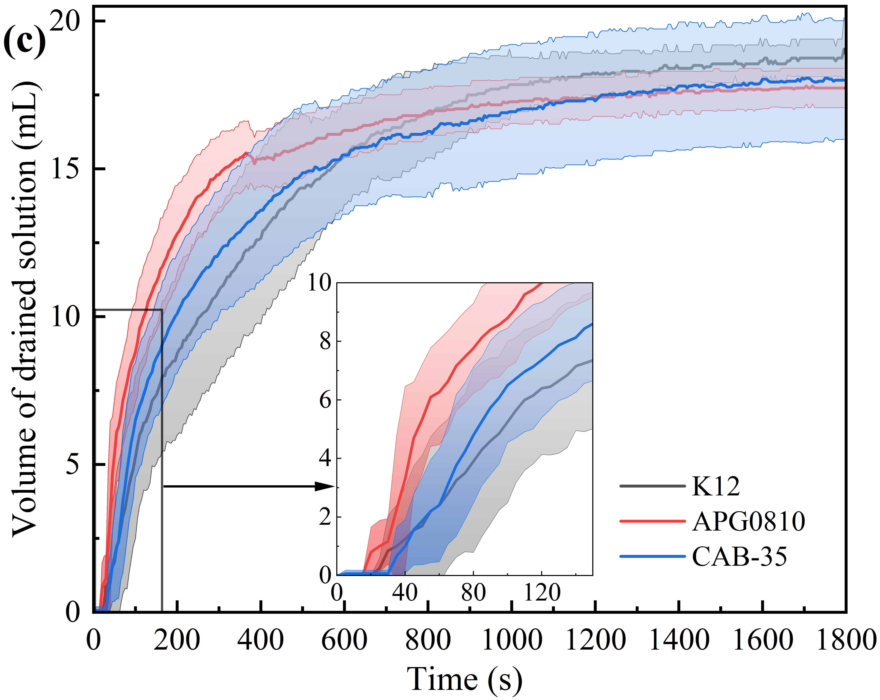
(c) Xanthan gum 0.03%
Fig. S2. Time evolution of drained liquid volume from foams of formulated solutions with different types of hydrocarbon surfactants at various xanthan gum concentrations.

S2. Formulations of multi-additive blending systems
The experimental formulation design for the multi‑hydrocarbon‑surfactant blending systems is shown in Table S2, comprising a total of 16 formulations. In these formulations, the fluorocarbon surfactant STAR-2157/2470 was blended at a ratio of 3:1, with a total fluorosurfactant concentration of 0.027%. The total hydrocarbon surfactant concentration was 0.5%, and the APG0810:CAB-35:K12 ratios included four variations: 2.5:2.5:0, 2:2:1, 1.5:1.5:2, and 1:1:3. The xanthan gum concentration covered four levels ranging from 0% to 0.03%.
Table S2 Formulation design for experiments on multi-hydrocarbon surfactant blending systems.
Formulation | 2157:2470 ratio | APG0810 concentration | CAB-35 concentration | K12 concentration | Xanthan gum concentration
B-1 | 3:1 | 0.25% | 0.25% | 0% | 0%
B-2 | 3:1 | 0.25% | 0.25% | 0% | 0.01%
B-3 | 3:1 | 0.25% | 0.25% | 0% | 0.02%
B-4 | 3:1 | 0.25% | 0.25% | 0% | 0.03%
B-5 | 3:1 | 0.2% | 0.2% | 0.1% | 0%
B-6 | 3:1 | 0.2% | 0.2% | 0.1% | 0.01%
B-7 | 3:1 | 0.2% | 0.2% | 0.1% | 0.02%
B-8 | 3:1 | 0.2% | 0.2% | 0.1% | 0.03%
B-9 | 3:1 | 0.15% | 0.15% | 0.2% | 0%
B-10 | 3:1 | 0.15% | 0.15% | 0.2% | 0.01%
B-11 | 3:1 | 0.15% | 0.15% | 0.2% | 0.02%
B-12 | 3:1 | 0.15% | 0.15% | 0.2% | 0.03%
B-13 | 3:1 | 0.1% | 0.1% | 0.3% | 0%
B-14 | 3:1 | 0.1% | 0.1% | 0.3% | 0.01%
B-15 | 3:1 | 0.1% | 0.1% | 0.3% | 0.02%
B-16 | 3:1 | 0.1% | 0.1% | 0.3% | 0.03%

S3. Formulation and characterization parameters of formulated solutions C-1 to C-4
The additive compositions of the formulations (C-1 to C-4) used in the foam drainage experiments are listed in Table S3. The variable is the xanthan gum concentration, ranging from 0% to 0.3%. Other additives are fixed: total fluorosurfactant concentration 0.04%, STAR-2157:2470 ratio 3:1, total hydrocarbon surfactant concentration 0.3%, APG0810:CAB-35:K12 ratio 2:2:0.5, and cosolvent diethylene glycol monobutyl ether concentration 0.5%. The measured characterization parameters of formulations C-1 to C-4 are shown in Table S4. All four formulated solutions exhibit a spreading coefficient S greater than 0 mN/m.
Table S3 Compositions of formulations C-1 to C-4.
Formulation | Total fluorosurfactant concentration | 2157:2470 ratio | Total hydrocarbon surfactant concentration | APG0810:CAB-35:K12 ratio | Xanthan gum concentration | Diethylene glycol monobutyl ether concentration
C-1 | 0.04% | 3:1 | 0.3% | 2:2:0.5 | 0.03% | 0.5%
C-2 | 0.04% | 3:1 | 0.3% | 2:2:0.5 | 0.02% | 0.5%
C-3 | 0.04% | 3:1 | 0.3% | 2:2:0.5 | 0.01% | 0.5%
C-4 | 0.04% | 3:1 | 0.3% | 2:2:0.5 | 0 % | 0.5%

Table S4 Characterization parameters of foam drainage experimental formulations.
Formulation | Surface tension / mN/m | Interfacial tension  / mN/m | Spreading coefficient S / mN/m
C-1 | 17.2 | 1.6 | 1.0
C-2 | 17.1 | 1.7 | 1.0
C-3 | 17.1 | 1.9 | 0.8
C-4 | 16.7 | 2.5 | 0.6

S4. Formulation and characterization of blended solutions for fire-extinguishing tests

S4.1. Formulations of blended solutions for fire-extinguishing experiments
The formulation design for the fire‑extinguishing experiments is shown in Table S5. The variables studied include total fluorosurfactant concentration, total hydrocarbon surfactant concentration, the APG0810:CAB-35:K12 ratio, and xanthan gum concentration. The ratio of the two fluorosurfactants was fixed at 3:1, and the cosolvent diethylene glycol monobutyl ether concentration was 0.5%, which was used to accelerate the dissolution of xanthan gum during concentrate preparation. Among these formulations, ZY-1 to ZY-3 were designed to investigate the effect of the K12 proportion within the APG0810:CAB-35:K12 ratio; ZY-4 to ZY-7 were designed to explore the influence of xanthan gum concentration on actual fire-extinguishing performance; and formulations ZY-8 to ZY-25 were designed to study the synergistic effects of total fluorosurfactant concentration, total hydrocarbon surfactant concentration, the APG0810:CAB-35 ratio, and xanthan gum concentration on actual fire-extinguishing performance.

Table S5 Fire‑extinguishing test formulations (Formulations ZY-1~25).
Formulation | Total fluorosurfactant concentration | 2157:2470 ratio | Total hydrocarbon surfactant concentration | APG0810:CAB-35:K12 ratio | Xanthan gum concentration | Diethylene glycol monobutyl ether concentration
ZY-1 | 0.027% | 3:1 | 0.3% | 2:2:0.5 | 0.03% | 0.5%
ZY-2 | 0.027% | 3:1 | 0.3% | 2:2.5:0.5 | 0.03% | 0.5%
ZY-3 | 0.027% | 3:1 | 0.3% | 2.5:2.5:0.5 | 0.03% | 0.5%
ZY-4 | 0.04% | 3:1 | 0.3% | 2:2:0.5 | 0.03% | 0.5%
ZY-5 | 0.04% | 3:1 | 0.3% | 2:2:0.5 | 0.02% | 0.5%
ZY-6 | 0.04% | 3:1 | 0.3% | 2:2:0.5 | 0.01% | 0.5%
ZY-7 | 0.04% | 3:1 | 0.3% | 2:2:0.5 | 0% | 0.5%
ZY-8 | 0.04% | 3:1 | 0.3% | 1:1 | 0.03% | 0.5%
ZY-9 | 0.04% | 3:1 | 0.4% | 1:1 | 0.03% | 0.5%
ZY-10 | 0.04% | 3:1 | 0.5% | 1:1 | 0.03% | 0.5%
ZY-11 | 0.04% | 3:1 | 0.3% | 1:2 | 0.03% | 0.5%
ZY-12 | 0.04% | 3:1 | 0.4% | 1:2 | 0.03% | 0.5%
ZY-13 | 0.04% | 3:1 | 0.5% | 1:2 | 0.03% | 0.5%
ZY-14 | 0.04% | 3:1 | 0.3% | 1:1 | 0.02% | 0.5%
ZY-15 | 0.04% | 3:1 | 0.4% | 1:1 | 0.02% | 0.5%
ZY-16 | 0.04% | 3:1 | 0.5% | 1:1 | 0.02% | 0.5%
ZY-17 | 0.04% | 3:1 | 0.3% | 1:2 | 0.02% | 0.5%
ZY-18 | 0.04% | 3:1 | 0.4% | 1:2 | 0.02% | 0.5%
ZY-19 | 0.04% | 3:1 | 0.5% | 1:2 | 0.02% | 0.5%
ZY-20 | 0.027% | 3:1 | 0.3% | 1:1 | 0.03% | 0.5%
ZY-21 | 0.027% | 3:1 | 0.4% | 1:1 | 0.03% | 0.5%
ZY-22 | 0.027% | 3:1 | 0.5% | 1:1 | 0.03% | 0.5%
ZY-23 | 0.027% | 3:1 | 0.3% | 1:2 | 0.03% | 0.5%
ZY-24 | 0.027% | 3:1 | 0.4% | 1:2 | 0.03% | 0.5%
ZY-25 | 0.027% | 3:1 | 0.5% | 1:2 | 0.03% | 0.5%
Notes: (1) The concentrations of the components in the table above are those of the concentrate after dilution; the foam solution used for firefighting is prepared by diluting the concentrate at a ratio of 6%; (2) The ZY-4 to ZY-7 formulations have the same components as the C-1 to C-4 formulations in the previous section.

S4.2. Characterization parameters of the formulated solutions for fire-extinguishing experiments
Table S6 presents data on the surface tension, interfacial tension, spreading coefficient, and expansion ratio of formulations ZY-1 to ZY-25. The spreading coefficient S of all 25 formulations is generally greater than 0 mN/m, and the expansion ratios measured according to the national standard are all greater than 10.

Table S6 Characterization parameters of the formulated solutions for fire-extinguishing experiments (Formulations ZY-1~25).
Formulation | Surface tension / mN/m | Interfacial tension  / mN/m | Spreading coefficient S / mN/m | Expansion ratio
ZY-1 | 17.5 | 1.7 | 0.6 | 10.6
ZY-2 | 17.5 | 1.5 | 0.8 | 10.6
ZY-3 | 17.4 | 1.5 | 0.8 | 10.6
ZY-4 | 17.2 | 1.6 | 1.0 | 10.0
ZY-5 | 17.1 | 1.7 | 1.0 | 11.0
ZY-6 | 17.1 | 1.9 | 0.8 | 10.3
ZY-7 | 16.7 | 2.5 | 0.6 | 10.6
ZY-8 | 16.8 | 1.4 | 1.6 | 10.3
ZY-9 | 16.7 | 1.4 | 1.7 | 11.4
ZY-10 | 16.9 | 1.3 | 1.6 | 11.0
ZY-11 | 16.8 | 1.6 | 1.4 | 10.6
ZY-12 | 16.7 | 1.6 | 1.5 | 10.6
ZY-13 | 17.1 | 1.7 | 1.0 | 11.4
ZY-14 | 16.8 | 1.2 | 1.8 | 11.4
ZY-15 | 16.5 | 1.1 | 2.2 | 11.4
ZY-16 | 16.4 | 1.2 | 2.2 | 11.8
ZY-17 | 17.0 | 1.4 | 1.4 | 11.4
ZY-18 | 16.7 | 1.4 | 1.7 | 11.0
ZY-19 | 16.7 | 1.5 | 1.6 | 11.8
ZY-20 | 17.1 | 1.1 | 1.6 | 10.6
ZY-21 | 17.0 | 1.3 | 1.5 | 11.4
ZY-22 | 17.6 | 1.3 | 0.9 | 11.0
ZY-23 | 17.0 | 1.7 | 1.1 | 10.6
ZY-24 | 17.6 | 1.9 | 0.3 | 11.0
ZY-25 | 18.4 | 1.8 | -0.4 | 11.8

