Genetic diversity of toxigenic Fusarium verticillioides associated with Maize Grains in India
Vishwambar Navale ^{1, 2}, Koteswara Rao Vamkudoth^{1, 2}*
¹Biochemical Sciences Division, CSIR-National Chemical Laboratory, Pune-411008, Maharashtra, India.
²Academy of Scientific and Innovative Research (AcSIR), Ghaziabad, India
v.koteswara@ncl.res.in*

Figure 1. Molecular identification of Fusarium species by targeting TEF1-α gene. Lane M - 100bp DNA ladder, lane 1 to 7 Fusarium isolates.

Figure 2 (a). Molecular detection of Fumonisin by targeting Fum1 gene specific primers. Lane M- 100bp DNA ladder, lane 1 to 13 Fusarium isolates, lane 14 –ve control.

Figure 2(b). Molecular detection of Fumonisins by targeting FUM13 gene specific primers. Lane M- 100bp DNA ladder, lane 1 to 14 Fusarium isolates, lane 15 –ve control.
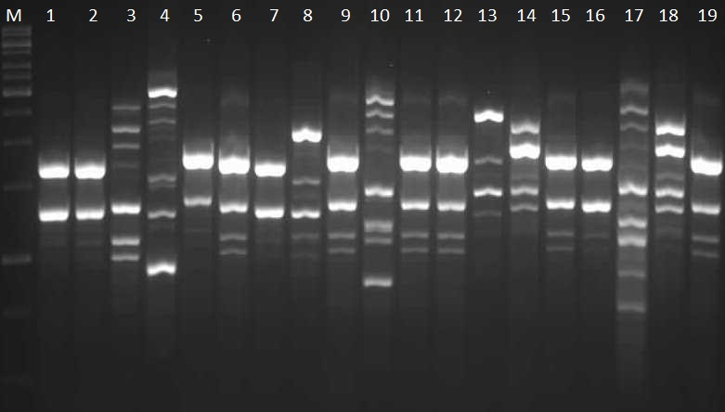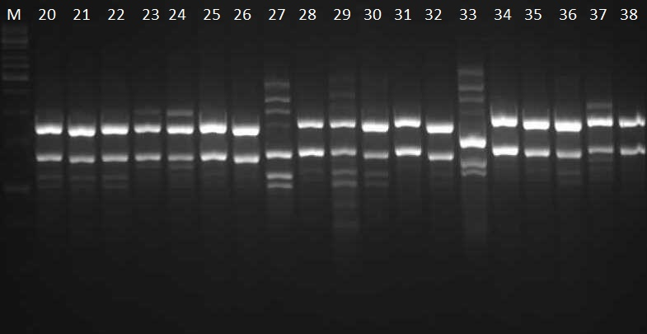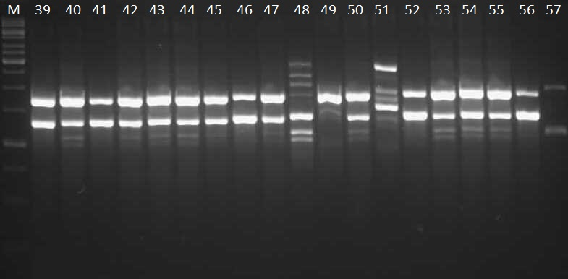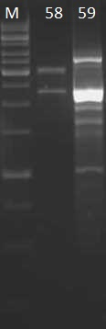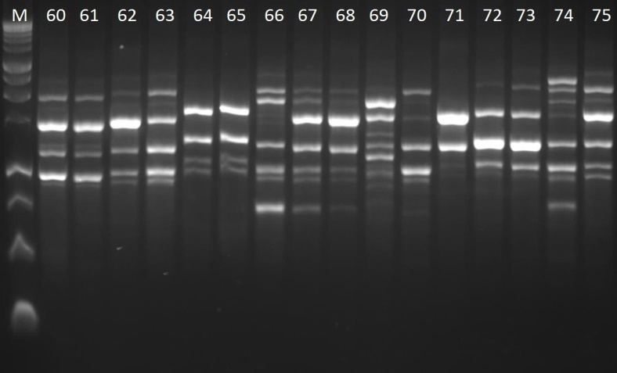

Figure 3(a). PCR amplification of Fusarium isolates by (AG)₈C ISSR primer. Lane M- 1Kb DNA ladder, lane 1 to 75 Fusarium isolates.

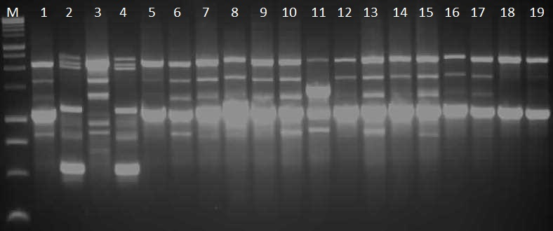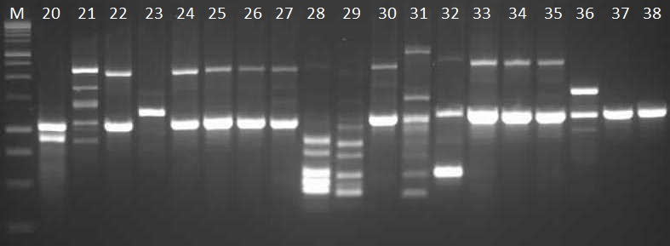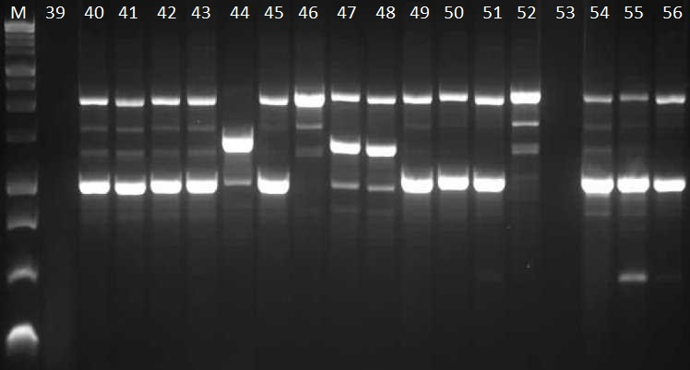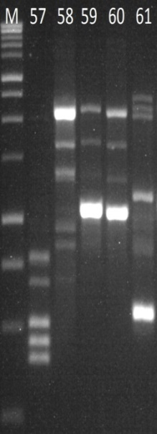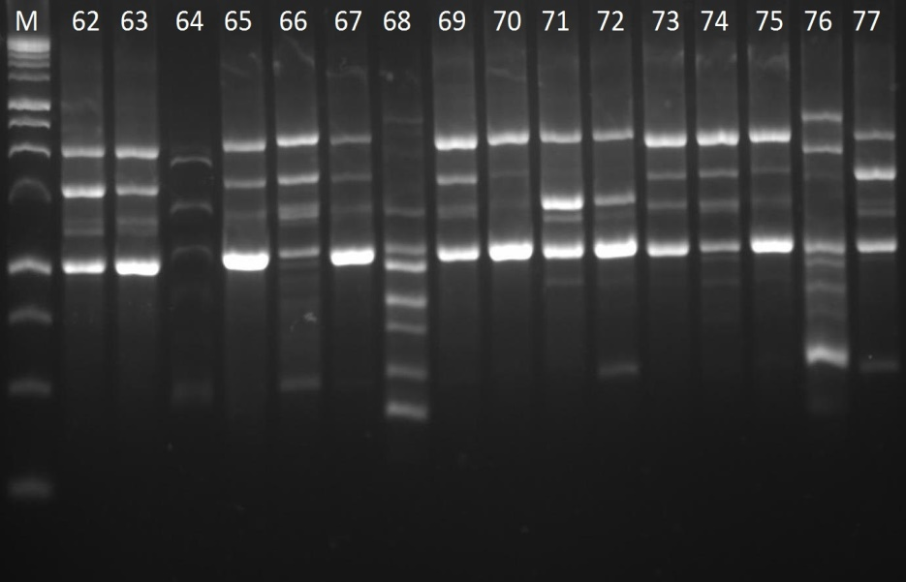
Figure 3(b). PCR amplification of Fusarium isolates by (AG)₈G ISSR primer. Lane M- 1Kb DNA ladder, lane 1 to 75 Fusarium isolates.

Table 1. Primers used in present study for molecular identification, mycotoxin detection and diversity study
Primer name | Primer sequence (5’ – 3’) | Gene targeted | Tm (˚C) | Amplicon size(bp) | Reference
EF1 F | ATGGGTAAGGARGACAAGAC | THF1-α | 58 | 300 | O'Donnell et al (1998)
EF2 R | GGARGTACCAGTSATCATGTT
Vert f 1 | GCGGGAATTCAAAAGTGGCC |  | 59 | 400 | Patino et al (2004)
Vert f 2 | GAGGGCGCGAAACGGATCGG
Fum1F | GAATCACCCTCAAGCACCAC | FUM1 | 58 | 927 | Present study
Fum1R | CTTCATGGCTCTCAGAGCTTG
Fum13 F | CTATGCTGTGCTTGTCAAGACTC | FUM13 | 57 | 852 | Present study
Fum13 R | CTCCTGACAATCTCTCCGATCTC
ISSR-1 | CACACACACACAGT- (CA)6GT | ISSR | 45 | - | -
ISSR-2 | CTCTCTCTCTCTCTCTTC - (CT)9TC | ISSR | 50 | - | -
ISSR-3 | CACCACCACGC -(CAC)4GC | ISSR | 54 | - | -
ISSR-4 | CACACACACACACACAA-(CA)9A | ISSR | 47 | - | -
ISSR-5 | CACACACACACAAG -(CA)7AG | ISSR | 48 | - | -
ISSR-6 | GAGAGAGAGAGAGG -(GA)7GG | ISSR | 46 | - | -
ISSR-7 | CTCTCTCTCTCTCTCTGC - (CT)8GC | ISSR | 50 | - | -
ISSR-8 | GTGGTGGTGGTGGTG - (GTG)6 | ISSR | 59 | - | -
ISSR-9 | GAGAGAGAGAGAGAGAGAC-(GA)10C | ISSR | 52 | - | -
ISSR-10 | GAGAGAGAGAGAGAGAGAT- (GA)10T | ISSR | 51 | - | -
UBC808 | GAGAGAGAGAGAGAGC -(AG)8C | ISSR | 47 | - | -
UBC809 | AGAGAGAGAGAG AGA GG -(AG)8G | ISSR | 48 | - | -
UBC811 | GAGAGAGAGAGAGAGAC -(GA)8C | ISSR | 47 | - | -
UBC813 | CTCTCTCTCTCTCTCTT- (CT)8T | ISSR | 46 | - | -
UBC815 | CTCTCTCTCTCTCTCTG - (CT)8G | ISSR | 47 | - | -
UBC816 | CACACACACACA CACAT - (CA)8T | ISSR | 47 | - | -
UBC818 | CACACACACACACACAG -(CA)8G | ISSR | 51 | - | -
UBC819 | GTCTGTGTGTGTGTGTA - (GT)8A | ISSR | 49 | - | -
UBC825 | ACACACACACACACACT- (AC)8T | ISSR | 51 | - | -
UBC864 | ATGATGATGATGATGATG - (ATG)6 | ISSR | 44 | - | -

Table 2. Molecular and analytical based detection of fumonisins (FUM) produced by Fusarium species

Isolates code | Fusarium spp. | Source | PCR | PCR | LC-MS
 |  |  | FUM1 | FUM13 | FUM
BIONCL-1 | F.verticillioides | Sillod, Maharashtra | + | + | +
BIONCL-2 | F.verticillioides | Buldhana, Maharashtra | + | + | +
BIONCL-4 | F.verticillioides | Warangal, Andhra Pradesh | + | + | +
BIONCL-6 | F.verticillioides | Jodhpur, Rajasthan | + | + | +
BIONCL-7 | F.verticillioides | Coimbatore, Tamilnadu | + | + | +
BIONCL-8 | F.verticillioides | Lucknow, Uttar Pradesh | + | + | +
BIONCL-9 | F.verticillioides | Vijayawada, Andhra Pradesh | + | + | +
BIONCL-10 | F.verticillioides | Sillod, Maharashtra | + | + | +
BIONCL-11 | F.verticillioides | Coimbatore, Tamilnadu | + | + | +
BIONCL-12 | F.verticillioides | Vijayawada, Andhra Pradesh | + | + | +
BIONCL-14 | F.verticillioides | Pune, Maharashtra | + | + | +
BIONCL-16 | F.verticillioides | Patna, Bihar | + | + | +
BIONCL-17 | F.verticillioides | Beed, Maharashtra | + | + | +
BIONCL-18 | F.verticillioides | Aurangabad, Maharashtra | + | + | +
BIONCL-19 | F.verticillioides | Shimoga, Karnataka | + | + | +
BIONCL-20 | F.verticillioides | Coimbatore, Tamilnadu | + | + | +
BIONCL-22 | F.verticillioides | Udaipur, Rajasthan | - | - | -
BIONCL-23 | F.verticillioides | Coimbatore, Tamilnadu | - | - | -
BIONCL-24 | F.verticillioides | Bidar, Karnataka | + | + | +
BIONCL-25 | F.verticillioides | Jaipur, Rajasthan | + | + | +
BIONCL-26 | F.verticillioides | Khammam, Andhra Pradesh | - | - | -
BIONCL-27 | F.verticillioides | Jodhpur, Rajasthan | + | + | +
BIONCL-28 | F.verticillioides | Khammam, Andhra Pradesh | + | + | +
BIONCL-29 | F.verticillioides | Aurangabad, Maharashtra | + | + | +
BIONCL-30 | F.verticillioides | Coimbatore, Tamilnadu | + | + | +
BIONCL-31 | F.verticillioides | Jalna, Maharashtra | + | + | +
BIONCL-32 | F.verticillioides | Khammam, Andhra Pradesh | + | + | +
BIONCL-33 | F.verticillioides | Aurangabad, Maharashtra | + | + | +
BIONCL-34 | F.verticillioides | Jaipur, Rajasthan | + | + | +
BIONCL-35 | F.verticillioides | Sillod, Maharashtra | + | + | +
BIONCL-37 | F.verticillioides | Sillod, Maharashtra | - | + | +
BIONCL-38 | F.verticillioides | Coimbatore, Tamilnadu | + | + | +
BIONCL-39 | F.verticillioides | Jaipur, Rajasthan | - | - | -
BIONCL-40 | F.verticillioides | Jalgaon, Maharashtra | - | - | -
BIONCL-42 | F.verticillioides | Indore, Madhya Pradesh | + | + | +
BIONCL-43 | F.verticillioides | Ranchi, Jharkhand | + | + | +
BIONCL-44 | F.verticillioides | Pune, Maharashtra | + | + | +
BIONCL-45 | F.verticillioides | Gulbarga, Karnataka | + | + | +
BIONCL-47 | F.verticillioides | Beed, Maharashtra | + | + | +
BIONCL-48 | F.verticillioides | Udaipur, Rajasthan | + | + | +
BIONCL-49 | F.verticillioides | Jodhpur, Rajasthan | + | + | +
BIONCL-50 | F.verticillioides | Warangal, Andhra Pradesh | + | + | +
BIONCL-51 | F.verticillioides | Coimbatore, Tamilnadu | + | + | +
BIONCL-52 | F.verticillioides | Kotdwar, Uttarakhand | + | + | +
BIONCL-53 | F.verticillioides | Pallavi, Uttarakhand | + | + | +
BIONCL-54 | F.verticillioides | Rudraprayag, Uttarakhand | + | + | +
BIONCL-55 | F.verticillioides | Indore, Madhya Pradesh | - | - | -
BIONCL-56 | F.verticillioides | Vijaypura, Karnataka | + | + | +
BIONCL-57 | F.verticillioides | Jodhpur, Rajasthan | + | + | +
BIONCL-58 | F.verticillioides | Jaipur, Rajasthan | + | + | +
BIONCL-59 | F.verticillioides | Bagalkot, Karnataka | + | + | +
BIONCL-64 | F.verticillioides | Udaipur, Rajasthan | + | + | +
BIONCL-71 | F.verticillioides | Beed, Maharashtra | + | + | +
BIONCL-75 | F.verticillioides | Vijayawada, Andhra Pradesh | + | + | +
BIONCL-60 | F. foetens | Warangal, Andhra Pradesh | + | + | +
BIONCL-65 | F. foetens | Jodhpur, Rajasthan | + | + | +
BIONCL-67 | F. coffeatum | Devanagri , Karnataka | + | + | +
BIONCL-68 | F. coffeatum | Sillod, Maharashtra | + | + | +
BIONCL-69 | F. coffeatum | Indore, Madhya Pradesh | + | + | +
BIONCL-72 | F. coffeatum | Jalgaon, Maharashtra | + | + | +
BIONCL-73 | F. euwallaceae | Ranchi, Jharkhand | + | + | +

