Supporting Information for
Stretchable Supercapacitor at -30 ºC
Jin et al
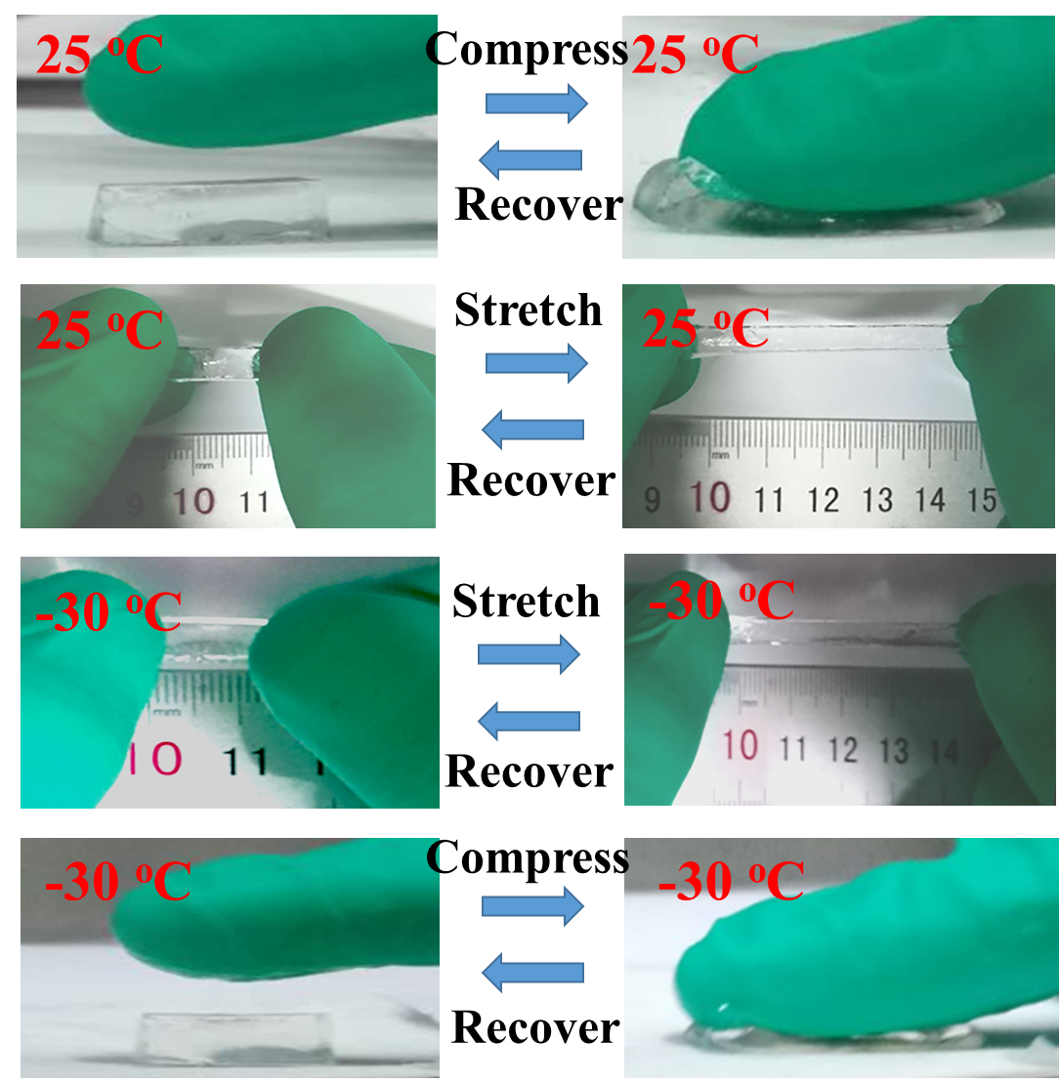
Supplementary Figure 1. The high compression and excellent stretchability of AF-OHP at 25 ºC and -30 °C.
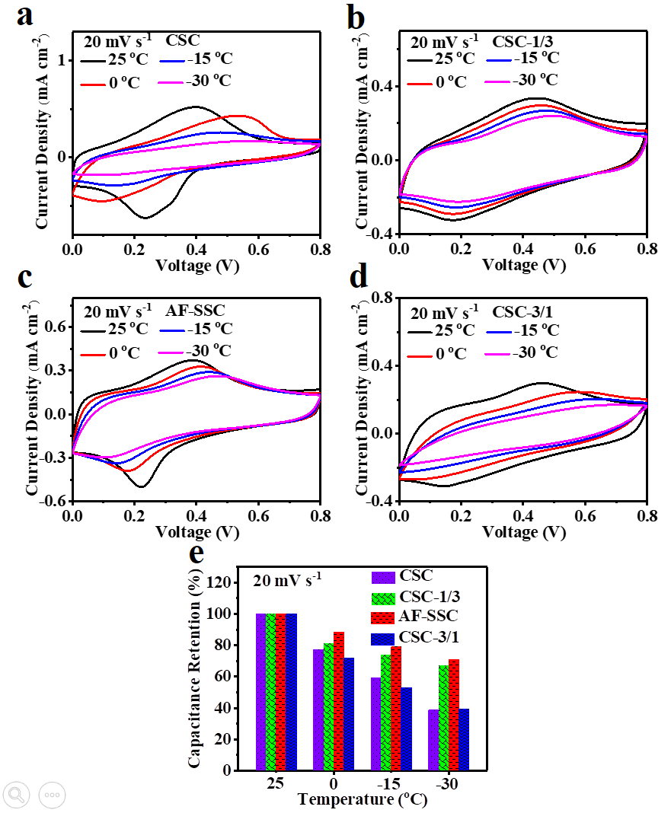
Supplementary Figure 2. a-d) The CV curves under different temperature of the integrated CSC, CSC-1/3, AF-SSC, CSC-3/1 when the volume ratios of EG/W are 0, 1/3, 1/1, 3/1, respectively. e) The capacitance retention of CSC, CSC-1/3, AF-SSC, and CSC-3/1 under the different temperature. In order to investigate the influence of the addition of EG on the anti-freezing performance, SCs denoted as CSC, CSC-1/3, AF-SSC and CSC-3/1 were fabricated with electrolytes the volume ratios of EG/W are 0, 1/3, 1/1, 3/1, respectively. Obviously, the capacitance retention of AF-SSC under 0 ºC, -15 ºC and -30 ºC at the scan rate of 20 mV s⁻¹, reach 88.3%, 79% and 71%, respectively, preceding those of other three control SCs (Fig. 6d and Supplementary 15).

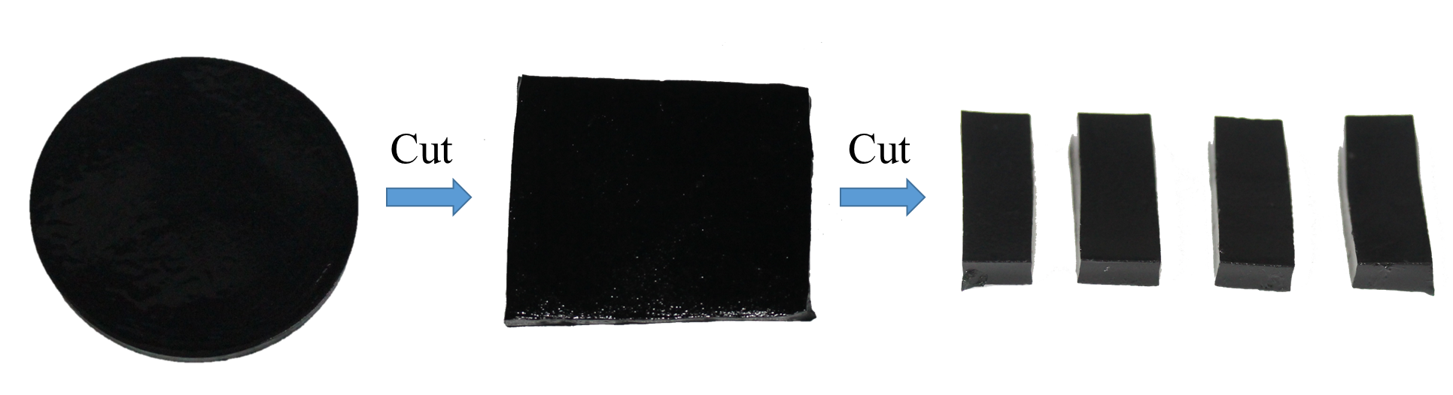
Supplementary Figure 3. The integrated device units of different shapes prepared by simple cutting technology.
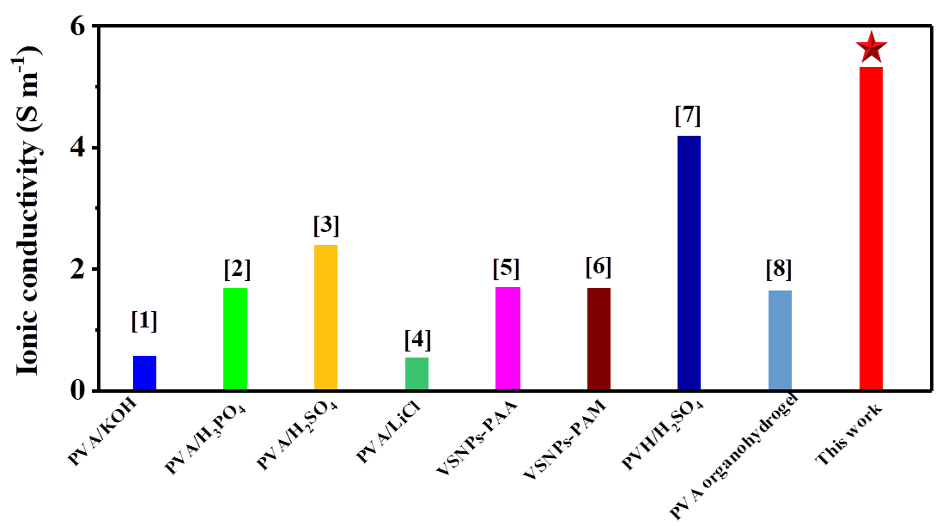
Supplementary Figure 4. The ionic conductivity of AF-OHP and the previously reported polyelectrolytes at room temperature. [1] Electrochim Acta 56, 6881- 6886 (2011); [2] Ionics 13, 231-234 (2007); [3] J. Power Sources 266, 488-495 (2014); [4] J. Mater. Chem. A 5, 2759-2767 (2017); [5] Nat. Commun. 6, 10310 (2015); [6] Angew. Chem., Int. Ed. 56, 9141-9145 (2017); [7] J. Mater. Chem. A 6, 2500-2506 (2018); [8] Adv. Energy Mater. 8, 1801967 (2018).

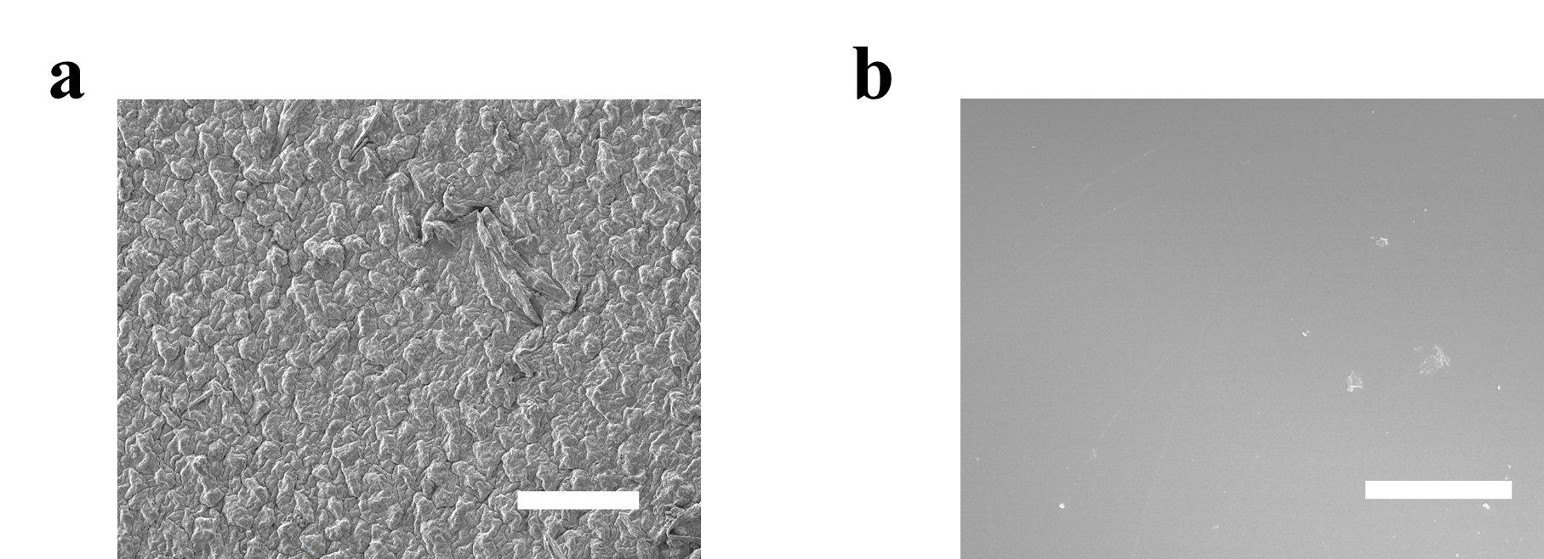
Supplementary Figure 5. The surface morphology of a) oven-dried AF-SSC (Scale bar: 200 μm) and b) pure AF-OHP (Scale bar: 80 μm).
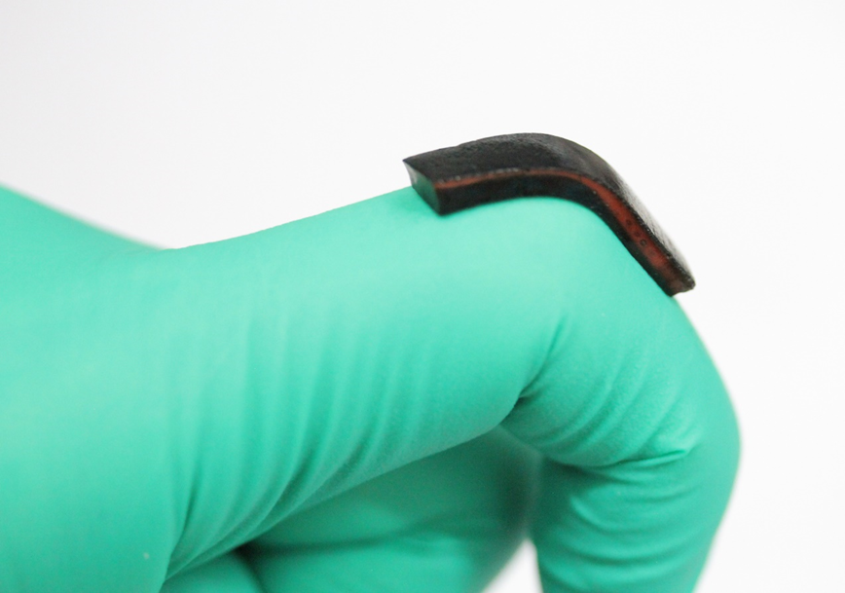
Supplementary Figure 6. AF-SSC stably adhering to the surface of rubber gloves substrates without the extra adhesives even at the bending and stretching conditions.
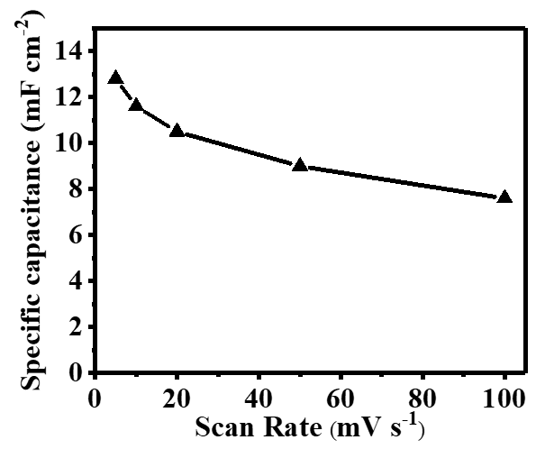
Supplementary Figure 7. Specific capacitances of AF-SSC at the diverse scan rate.
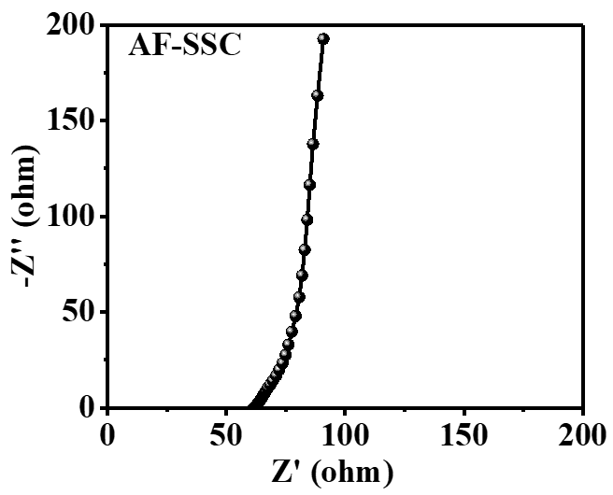
Supplementary Figure 8. The electrochemical impedance spectroscopy of AF-SSC at the room temperature.
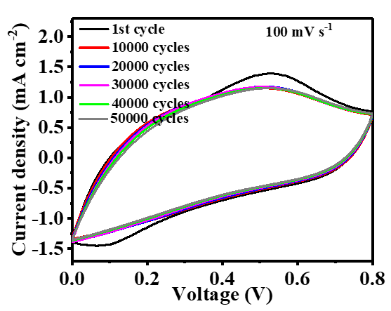
Supplementary Figure 9. The CV curves after the different cycles at 100 mV s⁻¹ of AF-SSC under the room temperature.
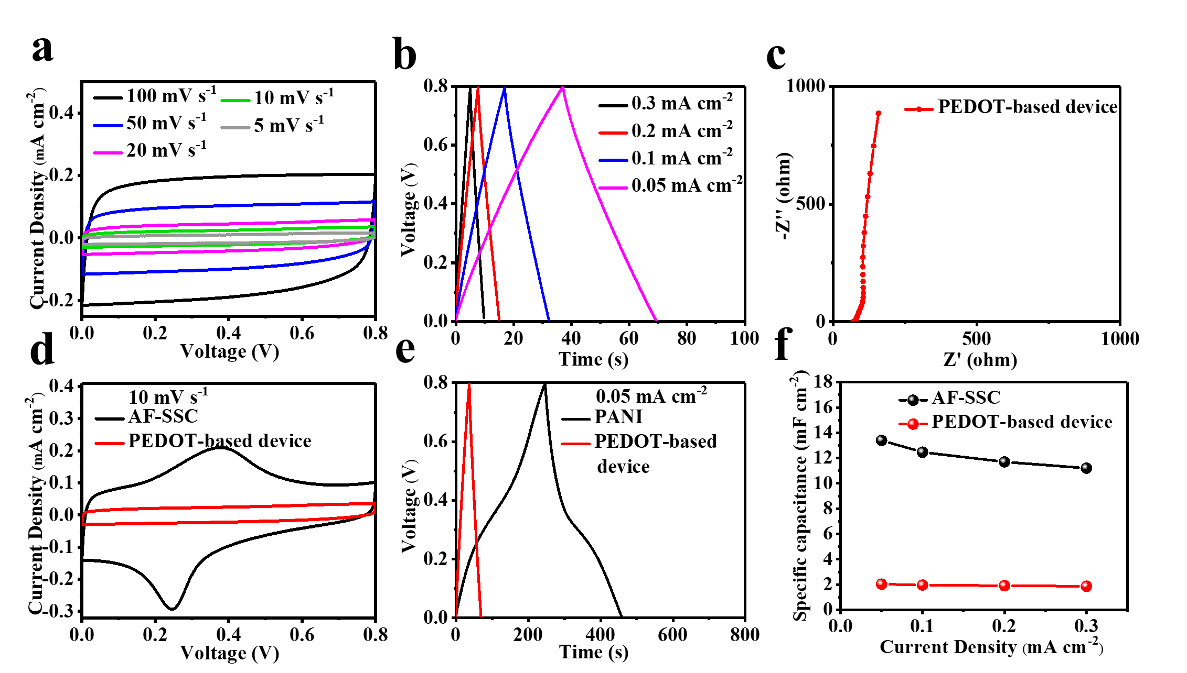
Supplementary Figure 10. a) The CV curves, b) GCD curves and c) electrochemical impedance spectroscopy of the integrated SC based on PEDOT. d) The CV curves at 10 mV s⁻¹, e) GCD curves at 0.05 mA cm⁻² and f) rate performance of the PEDOT-based device and AF-SSC. The CV curves of the PEDOT-based device present a quasi-rectangular shape and mirror-image symmetry at the scan rate of 5 to 100 mV s⁻¹, revealing its excellent capacitive behavior (Supplementary Figure 10a). As shown in Supplementary Figure 10b, the GCD curves at current densities ranging from 0.02 to 0.3 mA cm⁻² exhibit typical triangular profiles, indicating highly reversible charge-discharge behavior of the device. The electrochemical impedance spectroscopy is performed to prove the small resistance and good capacitance behavior of the constructed SC device (Supplementary Figure 10c). However, compared with the PEDOT-based device, AF-SSC shows larger CV integral area, longer discharge time and higher specific capacity by reason of better pseudocapacitive characteristics of PANI (Supplementary Figure 10e-f).
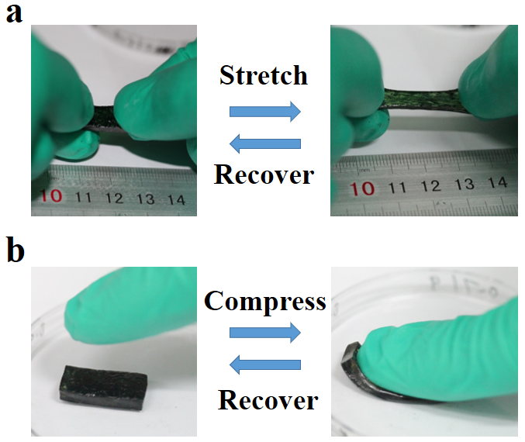
Supplementary Figure 11. The high compression and excellent stretchability of AF-SSC after vacuum treatment for 20 h.
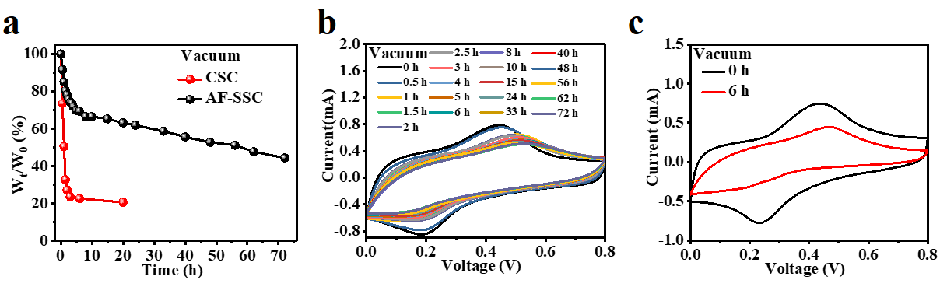
Supplementary Figure 12. a) The mass retention of AF-SSC and CSC under vacuum environment for different time. The CV curves at the scan rate of 50 mV s⁻¹ of b) AF-SSC and c) CSC under vacuum environment for different time.
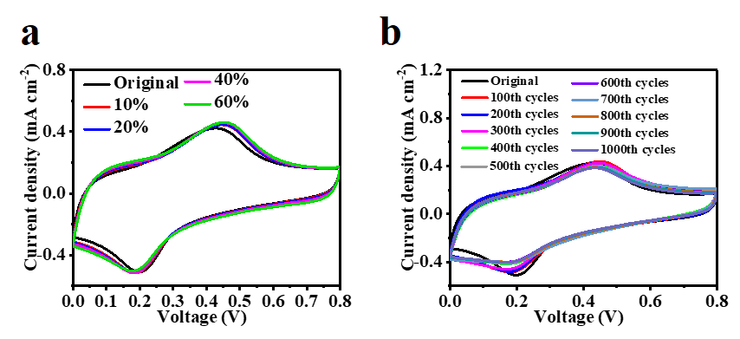
Supplementary Figure 13. CV curves at the scan rate of 20 mV s⁻¹ of AF-SSC a) under different compress ratio and b) after different compress/release cycles from the initial to 60%.
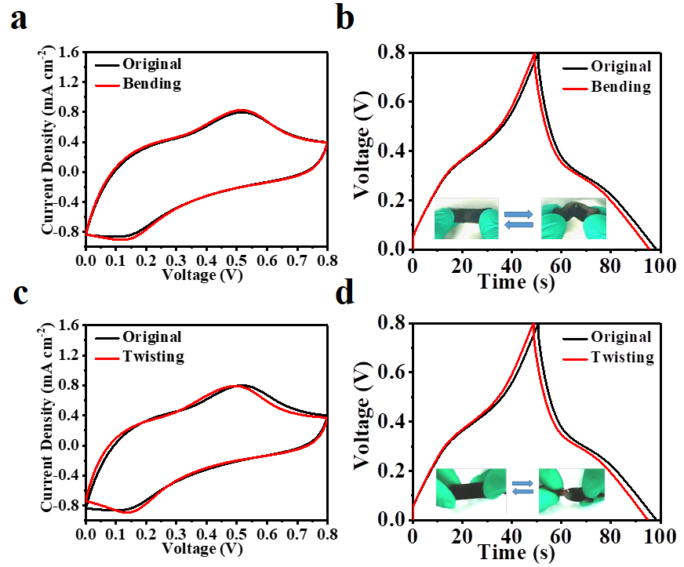
Supplementary Figure 14. a) The CV curves at the scan rate of 20 mV s⁻¹ and b) The GCD curves at the current density of 0.2 mA cm⁻² of AF-SSC under bending. c) The CV curves at the scan rate of 20 mV s⁻¹ and d) The GCD curves at the current density of 0.2 mA cm⁻² of AF-SSC under twisting.
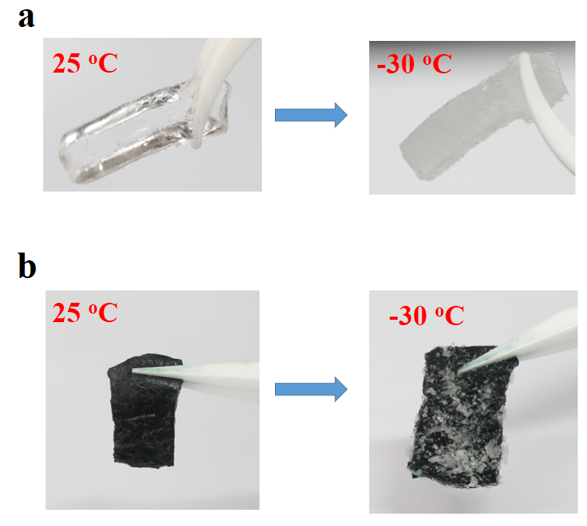
Supplementary Figure 15. The optical photograph of a) the frozen C-PAM hydrogel polyelectrolyte and b) the frozen CSC at -30 ºC.
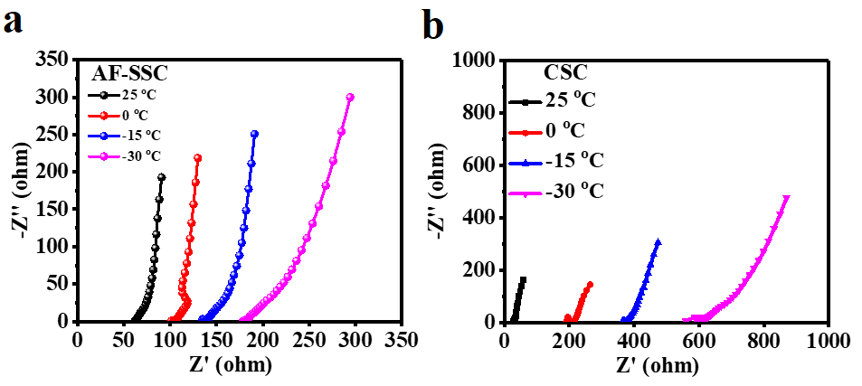
Supplementary Figure 16. The electrochemical impedance spectroscopy under different temperature of a) AF-SSC and b) CSC.
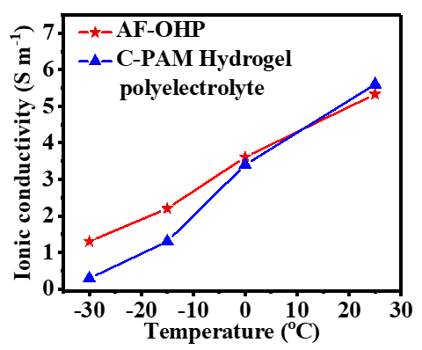
Supplementary Figure 17. The ionic conductivity of AF-OHP and C-PAM polyelectrolyte under different temperature.
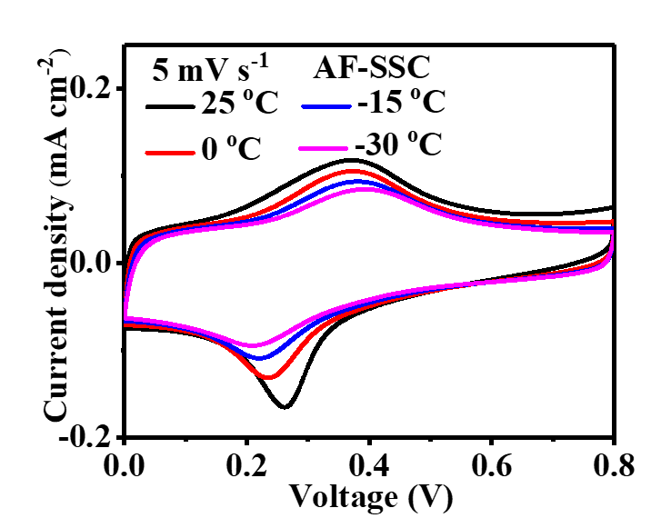
Supplementary Figure 18. CV curves of AF-SSC under different temperature.
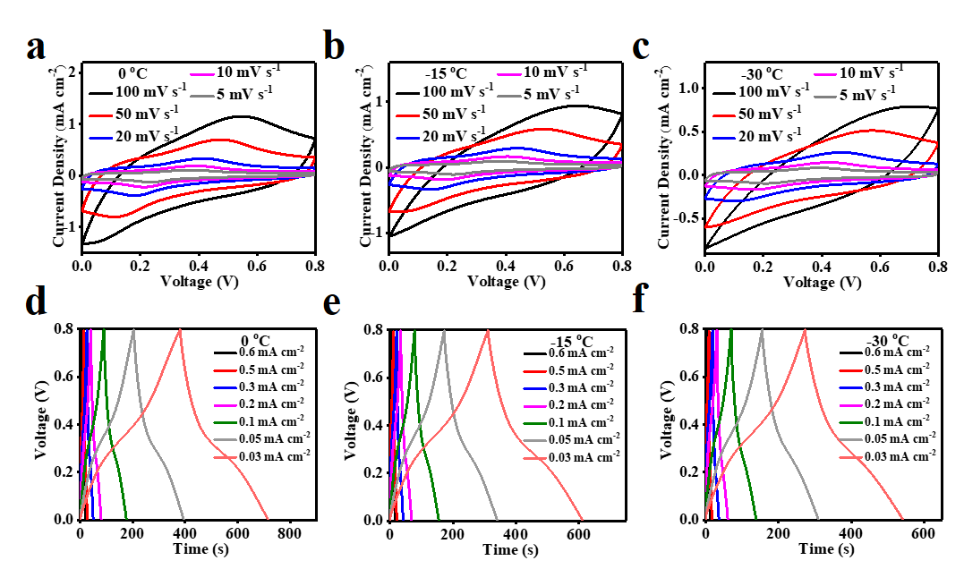
Supplementary Figure 19. The CV curves at the different scan rate a) under 0 ºC, b) under -15 ºC, and c) under -30 ºC. The GCD curves at the different current density d) under 0 ºC, e) under -15 ºC and f) under -30 ºC.
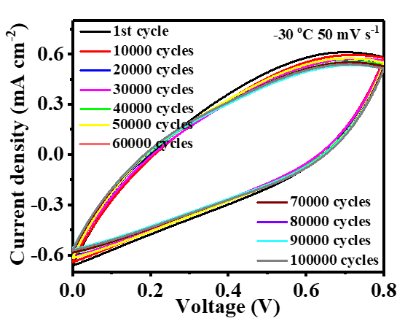
Supplementary Figure 20. The CV curves after the different cycles at 50 mV s⁻¹ of AF-SSC under -30 ºC.

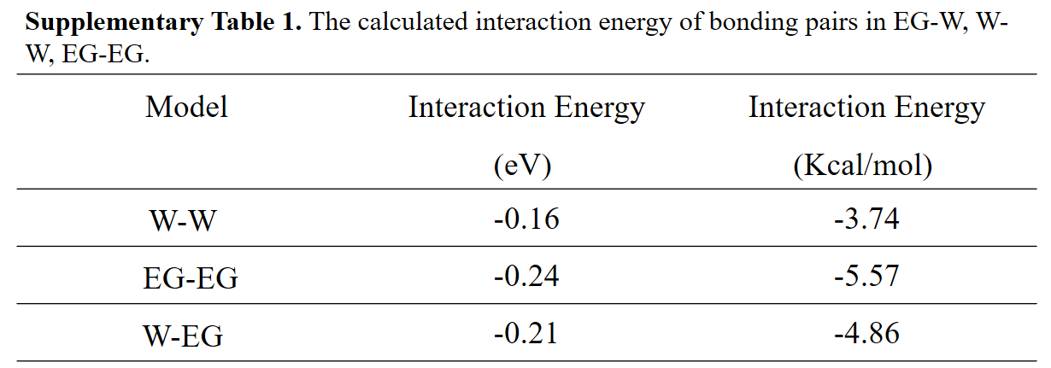
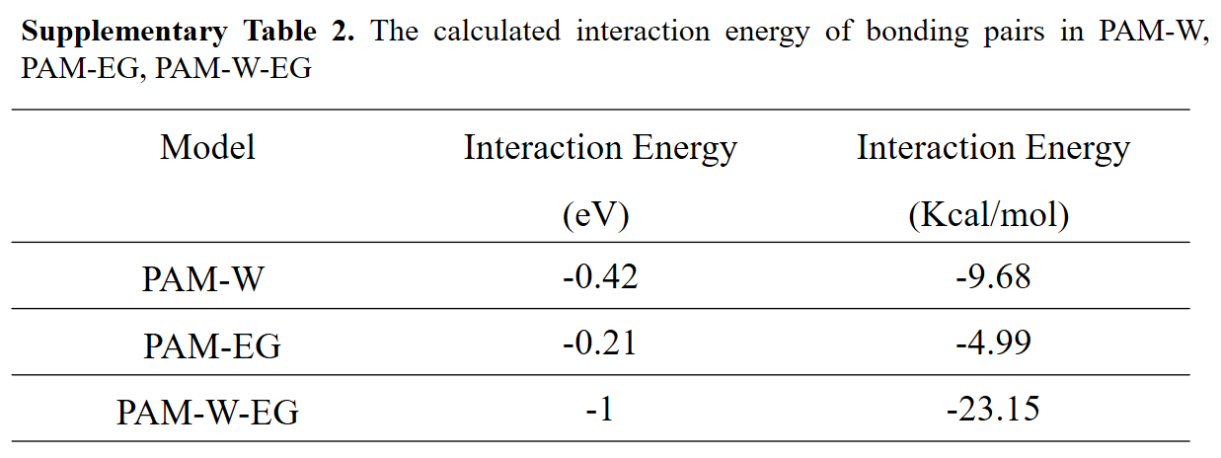
Supplementary Table 3 Multifunctional comparison of AF-SSC and the previously reported SSCs
 | Temperature tolerance | Stretch Ratio | Substrate/ Geometric design | Cycles life, capacitance retention | Reversible compression ratio | Processability | Anti-drying ability
This work | -30 ºC to 25 ºC | 200% at 25 and -30 ºC | No Need | 100000 cycles at -30 oC，91.7%; 50000 cycles at 25 ºC, 84.7% | 60% | Yes | Yes
[1] Adv Energy Mater 2016, 6, 1600050 | Room Temperature | 50% | Polydimethylsiloxane (PDMS) | 10000 cycles, 96% | No | No | No
[2] Adv Energy Mater 2017, 7, 1600976 | Room Temperature | 20% | Helical structure | 5000 cycles, 80% | No | No | No
[3] Adv Funct Mater. 2017, 27, 1704353 | Room Temperature | 30% | PDMS | 2000 cycles, 100% | No | No | No
[4] Angew Chem Int Ed 2013, 52, 13453 | Room Temperature | 100% | Elastic fiber | 1000 cycles, 100% | No | No | No
[5] Adv Mater 2018, 30, 1800124 | Room Temperature | 40% | Spring structure | 17000 cycles, 86% | No | No | No
[6] Nano Energy 2017, 39, 219 | Room Temperature | 100% | Elastic fiber | 5000 cycles, 90.7% | No | No | No
[7] Nano Energy 2016, 27, 230 | Room Temperature | 130% | Urethane plastic fiber | None | No | No | No
[8] ACS Nano 2017, 11, 9490 | Room Temperature | 100% | Knitting structure | 6000 cycles, 78% | No | No | No
[9] ACS Nano 2017, 11, 2066 | Room Temperature | 100% | Spring structure | None | No | No | No
[10] ACS Nano 2019, 13, 10469 | Room Temperature | 50% | Knitted fabric | 10000 cycles, 76% | No | No | No
[11] Adv Mater 2009, 21, 4793 | Room Temperature | 30% | PDMS | 1000 cycles, 100% | No | No | No
[12] Advanced Materials, 2014, 26, 4444. | Room Temperature | 100% | PDMS | 2000 cycles, 98% | No | No | No
[13] Nature Commun, 2016, 7:13811 | Room Temperature | 30% | Coiled structure | 1000 cycles, 98.4% | No | No | No
[14] Adv. Funct. Mater. 2015, 25, 4601 | Room Temperature | 30% | PVA film | 1000 cycles, 97% | No | No | No
[15] Nat Commun 2020, 11, 62 | Room Temperature | 200% | Polyvinyl alcohol (PVA) | 6000 cycles, 80% | 50% | No | No
[16] Nat Commun, 2019, 10, 536 | Room Temperature | 1000% | Wrinkle | 10000 cycles, ~96% | No | No | No
[17] Nat. Commun. 6, 10310 (2015). | Room Temperature | 600% | Wrinkle | None | 80% | No | No
[18] Adv Mater 2018, 30, 1704531 | Room Temperature | 500% | Geometric design | 10000 cycles, 95% | No | Yes | No
[19] Adv Mater. 2019, 31, 1900573 | Room Temperature | 800% | Gold nanoparticle/CNT/poly(acrylamide) | 10000 cycles, 93% | No | No | No
[20] Nano Energy 2015, 11, 518 | Room Temperature | 20% | Steel mesh | 10000 cycles, 98% | No | No | No
[21] Adv. Energy Mater. 2019, 9, 1900618 | Room Temperature | 300% | Elastomer substrates | 10000 cycles, 91.6% | No | No | No
[22] Adv. Energy Mater. 2017, 7, 1601814 | Room Temperature | 400% | Polyurethane | 10000 cycles, 92% | No | No | No
[23] ACS Nano 2020, 14, 3576 | Room Temperature | 300% | Elastomer substrates | 10000 cycles, 85% | No | No | No
[24] Angew. Chem. Int. Ed.2016, 55, 9191-9195 | Room Temperature | 240% | PDMS | 10000 cycles, 98% | No | No | No
[25] ACS Nano 2016, 10, 5204-5211. | Room Temperature | 200% | Silicon rubber | None | No | No | No
[26] Energy Storage Materials, 2020, 25, 124. | Room Temperature | 200% | Elastic fiber | None | No | No | No
[27] ACS Nano, 2015, 9, 6088. | Room Temperature | 100% | Elastic fiber | 10000 cycles, 99% | No | No | No
[28] Adv. Mater. 2013, 25, 2326 | Room Temperature | 200% | Spring structure | None | No | No | No
[29] Adv. Energy Mater. 2016, 7, 1602021 | Room Temperature | 600% | Rubber fiber | 1000 cycles, 100% | No | No | No
[30] Nano Lett. 2016, 16, 7677 | Room Temperature | 200% | Elastic fiber | 1000 cycles, 94.8% | No | No | No
[31] Angew. Chem., Int. Ed. 2017, 56, 9141 | Room Temperature | 1000% | Wrinkle | None | 50% | No | No
[32] Angew Chem Int Ed 2019, 58, 15707-15711 | Room Temperature | 200% | Wrinkle | 4000 cycles, 95.2% | No | No | No

