TABLES

Table S1 - Descriptive Statistics
Variable | Mean | SD | Median | Min | Max
Protest participation | 0.152 | 0.359 | 0 | 0 | 1
Happiness | 1.918 | 0.733 | 2 | 1 | 4
Post-materialism | 1.992 | 1.201 | 2 | 0 | 5
Age | 42.406 | 16.278 | 40 | 13 | 103
Sex | 1.515 | 0.500 | 2 | 1 | 2
Education | 2.050 | 0.742 | 2 | 1 | 3
Income level | 4.741 | 2.277 | 5 | 1 | 10
Interest in politics | 2.616 | 0.953 | 3 | 1 | 4
Source: Integrated Values Survey (IVS), 1989–2022. N = 245,418 (analytic sample).
Protest participation: 1 = has joined a peaceful demonstration, 0 = has not. Happiness: 1 = very happy to 4 = not at all happy. Post-materialism: Inglehart 12-item index, 0–5 (higher = more post-materialist). Sex: 1 = male, 2 = female. Education: 1 = lower, 2 = middle, 3 = upper. Income level: self-reported decile, 1 = lowest to 10 = highest. Interest in politics: 1 = not at all interested to 4 = very interested.

Table S2 Predicted Probabilities of Protest Participation (Model 6)
Happiness | Post-materialism level | Predicted probability | 95% CI
Very happy (1) | 0 | 0.098 | [0.076, 0.127]
Very happy (1) | 1 | 0.123 | [0.095, 0.157]
Very happy (1) | 2 | 0.152 | [0.119, 0.193]
Very happy (1) | 3 | 0.188 | [0.148, 0.235]
Very happy (1) | 4 | 0.229 | [0.182, 0.283]
Very happy (1) | 5 | 0.276 | [0.222, 0.337]
Quite happy (2) | 0 | 0.109 | [0.084, 0.140]
Quite happy (2) | 1 | 0.133 | [0.104, 0.170]
Quite happy (2) | 2 | 0.163 | [0.128, 0.205]
Quite happy (2) | 3 | 0.197 | [0.156, 0.246]
Quite happy (2) | 4 | 0.236 | [0.189, 0.291]
Quite happy (2) | 5 | 0.281 | [0.227, 0.342]
Not very happy (3) | 0 | 0.120 | [0.093, 0.154]
Not very happy (3) | 1 | 0.145 | [0.113, 0.184]
Not very happy (3) | 2 | 0.174 | [0.136, 0.218]
Not very happy (3) | 3 | 0.207 | [0.164, 0.257]
Not very happy (3) | 4 | 0.244 | [0.195, 0.301]
Not very happy (3) | 5 | 0.286 | [0.230, 0.348]
Not at all happy (4) | 0 | 0.133 | [0.103, 0.170]
Not at all happy (4) | 1 | 0.157 | [0.123, 0.199]
Not at all happy (4) | 2 | 0.185 | [0.146, 0.232]
Not at all happy (4) | 3 | 0.216 | [0.172, 0.269]
Not at all happy (4) | 4 | 0.252 | [0.201, 0.311]
Not at all happy (4) | 5 | 0.291 | [0.233, 0.356]
Notes. Predicted probabilities of protest participation from Model 6 at each combination of happiness (4 levels) and post-materialism (6 levels), with 95% confidence intervals in brackets. Country and year fixed effects held at sample averages. Clustered standard errors by country.

Table S3 Average Marginal Effects (Models 5 and 6)
 | Model 5 |  |  | Model 6
Variable | AME | SE | 95% CI | AME | SE | 95% CI
Education | 0.047 | 0.001 | [0.045, 0.049] | 0.047 | 0.001 | [0.045, 0.049]
Interest in politics | -0.060 | 0.001 | [-0.062, -0.059] | -0.060 | 0.001 | [-0.062, -0.059]
Post-materialism | 0.027 | 0.001 | [0.026, 0.028] | 0.027 | 0.001 | [0.026, 0.028]
Female (vs. male) | -0.026 | 0.001 | [-0.029, -0.024] | -0.026 | 0.001 | [-0.029, -0.024]
Happiness | 0.008 | 0.001 | [0.006, 0.010] | 0.008 | 0.001 | [0.006, 0.010]
Age | 0.000 | 0.000 | [-0.000, 0.001] | 0.000 | 0.000 | [-0.000, 0.001]
Income | 0.000 | 0.000 | [-0.001, 0.000] | 0.000 | 0.000 | [-0.001, 0.000]
Notes. Average marginal effects from Model 5 (additive) and Model 6 (with happiness × post-materialism interaction), both with country and year fixed effects and clustered standard errors by country. 95% confidence intervals in brackets. All effects shown are significant at p < .001 except age (p = .642) and income (p = .369). Variables ordered by absolute magnitude. Interest in politics is reverse-coded (1 = very interested, 4 = not at all).
AMEs are virtually identical across Models 5 and 6, indicating that the happiness × post-materialism interaction does not meaningfully shift the average effects of either variable.

Table S4 Robustness Check: Model 6 across Alternative Protest Measures

DV | Term | Estimate | SE | OR | p
Protest participation (main, strict) | Happiness | 0.112 | 0.030 | 1.119 | < .001
Protest participation (main, strict) | Post-materialism | 0.267 | 0.037 | 1.306 | < .001
Protest participation (main, strict) | Happiness × Post-materialism | -0.017 | 0.013 | 0.983 | .181
Protest participation or willingness (broad) | Happiness | 0.100 | 0.031 | 1.105 | .001
Protest participation or willingness (broad) | Post-materialism | 0.179 | 0.026 | 1.196 | < .001
Protest participation or willingness (broad) | Happiness × Post-materialism | 0.003 | 0.009 | 1.003 | .743
Notes. Coefficients from Model 6 specification with country and year fixed effects, clustered standard errors by country. Strict measure (main analysis): 1 = have participated in protest, 0 = otherwise. Broad measure: 1 = have participated or might participate, 0 = would never participate. OR = odds ratio.

Table S5 Sample Composition by Country and Survey Year
Country | N | Waves | Survey Years
Albania | 1500 | 2 | 1998, 2002
Argentina | 3680 | 4 | 1995, 1999, 2013, 2017
Armenia | 3767 | 3 | 1997, 2011, 2021
Australia | 5541 | 4 | 1995, 2005, 2012, 2018
Bangladesh | 1017 | 1 | 2001
Belarus | 1666 | 1 | 1996
Belgium | 4978 | 4 | 1997, 2006, 2014, 2018
Bulgaria | 1394 | 2 | 1997, 2006
Canada | 7323 | 3 | 2000, 2006, 2020
Chile | 4451 | 5 | 1996, 2000, 2006, 2012, 2018
China | 4646 | 2 | 2013, 2018
Cyprus | 2806 | 3 | 2006, 2011, 2019
Czech Republic | 1927 | 2 | 1998, 2022
Egypt | 8202 | 4 | 2001, 2008, 2013, 2018
Estonia | 2323 | 2 | 1996, 2011
Finland | 1687 | 2 | 1996, 2005
France | 847 | 1 | 2006
Georgia | 7241 | 5 | 1996, 2009, 2012, 2014, 2018
Germany | 6486 | 4 | 1997, 2006, 2013, 2018
Greece | 1092 | 1 | 2017
Hungary | 913 | 1 | 2009
India | 9845 | 6 | 1990, 1995, 2001, 2006, 2012, 2023
Indonesia | 5363 | 3 | 2001, 2006, 2018
Iran | 1413 | 1 | 2020
Iraq | 2225 | 2 | 2013, 2018
Italy | 611 | 1 | 2005
Japan | 3396 | 4 | 2000, 2005, 2010, 2019
Jordan | 4458 | 4 | 2001, 2007, 2014, 2018
Kyrgyzstan | 3428 | 3 | 2003, 2011, 2020
Latvia | 1028 | 1 | 1996
Lithuania | 738 | 1 | 1997
Malaysia | 3761 | 3 | 2006, 2012, 2018
Mexico | 6863 | 5 | 1996, 2000, 2005, 2012, 2018
Moldova | 2562 | 3 | 1996, 2002, 2006
Mongolia | 1634 | 1 | 2020
Montenegro | 834 | 2 | 1996, 2001
Morocco | 3641 | 4 | 2001, 2007, 2011, 2021
Netherlands | 3561 | 3 | 2006, 2012, 2022
New Zealand | 2259 | 4 | 1998, 2004, 2011, 2020
Nigeria | 7066 | 5 | 1990, 1995, 2000, 2012, 2018
North Macedonia | 1450 | 2 | 1998, 2001
Norway | 1945 | 2 | 1996, 2007
Pakistan | 4436 | 3 | 2001, 2012, 2018
Peru | 5835 | 5 | 1996, 2001, 2006, 2012, 2018
Philippines | 3531 | 3 | 2001, 2012, 2019
Poland | 2591 | 3 | 1997, 2005, 2012
Romania | 4643 | 4 | 1998, 2005, 2012, 2018
Russia | 6811 | 4 | 1995, 2006, 2011, 2017
Serbia | 3585 | 4 | 1996, 2001, 2006, 2017
Slovakia | 1904 | 2 | 1998, 2022
Slovenia | 1727 | 2 | 2005, 2011
South Africa | 12253 | 5 | 1990, 1996, 2001, 2006, 2013
South Korea | 6822 | 6 | 1990, 1996, 2001, 2005, 2010, 2018
Spain | 3531 | 4 | 1995, 2000, 2007, 2011
Sweden | 2860 | 3 | 1996, 2006, 2011
Switzerland | 2739 | 3 | 1989, 1996, 2007
Taiwan | 4184 | 4 | 1998, 2006, 2012, 2019
Thailand | 3721 | 3 | 2007, 2013, 2018
Turkey | 10190 | 6 | 1990, 1996, 2001, 2007, 2011, 2018
Ukraine | 5077 | 4 | 1996, 2006, 2011, 2020
United Kingdom | 2518 | 2 | 2005, 2022
United States | 7941 | 5 | 1995, 1999, 2006, 2011, 2017
Uruguay | 3240 | 4 | 1996, 2006, 2011, 2022
Vietnam | 3394 | 3 | 2001, 2006, 2020
Total | 245418 |  | 1989–2022

FIGURES

Figure S1. Sample construction flowchart.
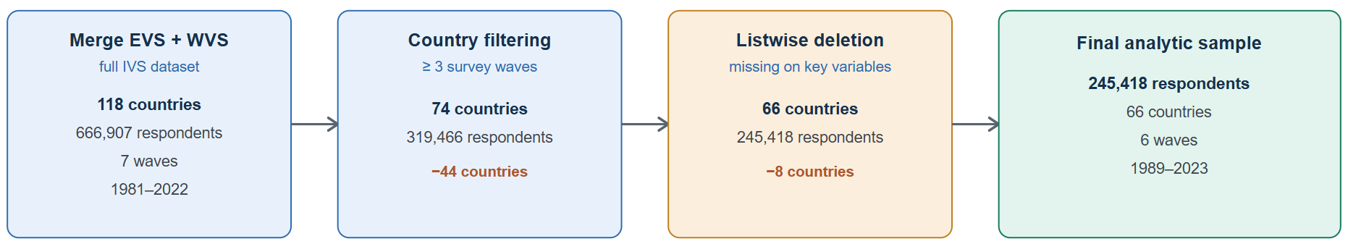

Figure S2. Coefficient estimates from Model 5 (log-odds, 95% CI).
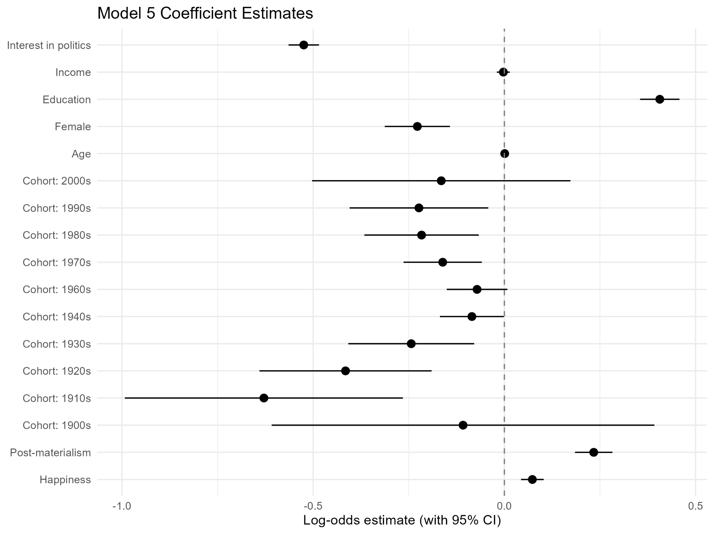

Figure S3. Coefficient estimates from Model 6 (odds ratios, 95% CI).
