Table 6. Salinity tolerance index (STI) of cotton genotypes under different salt stress levels.
Genotype | Code | Name | STI
Genotype | Code | Name | 3000 ppm | 6000 ppm | 9000 ppm
1 | G1 | Giza 75 | 1.22 T | 1.26 T | 1.19 MT
2 | G2 | Giza 85 | 1.22 T | 1.25 T | 1.22 T
3 | G3 | Giza 86 | 1.26 T | 1.44 T | 1.34 T
4 | G4 | Giza 89 | 1.07 MT | 1.13 MT | 1.15 MT
5 | G5 | Suvin | 1.16 MT | 1.16 MT | 1.12 MT
6 | G6 | PimaS6 | 1.30 T | 1.27 T | 1.10 MT
7 | G7 | TNB | 1.42 T | 1.09 MT | 1.10 MT
8 | G8 | Giza 45 | 1.06 MT | 1.07 MT | 1.26 T
9 | G9 | Giza 67 | 1.52 T | 1.05 MT | 1.21 T
10 | G10 | Giza 69 | 0.98 MT | 1.05 MT | 1.05 MT
11 | G11 | Giza 70 | 1.20 T | 1.19 MT | 1.14 MT
12 | G12 | Giza 74 | 1.17 MT | 1.15 MT | 0.99 MT
13 | G13 | Giza 77 | 0.93 MT | 1.00 MT | 0.68 S
14 | G14 | Giza 80 | 1.09 MT | 0.67 S | 0.57 S
15 | G15 | Giza 83 | 0.95 MT | 0.75 S | 0.54 S
16 | G16 | Giza 87 | 1.12 MT | 0.66 S | 1.24 T
17 | G17 | Giza 88 | 1.23 T | 0.58 S | 1.28 T
18 | G18 | Giza 91 | 0.97 MT | 0.87 MT | 1.36 T
19 | G19 | Giza 92 | 1.12 MT | 1.18 MT | 1.17 MT
20 | G20 | Giza 95 | 1.38 T | 1.21 T | 1.17 MT
21 | G21 | Alexandria hairy | 0.80 MT | 1.29 T | 1.15 MT
22 | G22 | Giza 36 | 1.13 MT | 1.12 MT | 1.12 MT
23 | G23 | Giza 31 | 1.13 MT | 1.11 MT | 1.23 T
24 | G24 | BBB | 1.12 MT | 1.10 MT | 1.04 MT
25 | G25 | Giza 94 | 1.12 MT | 1.07 MT | 1.10 MT
26 | G26 | Giza 68 | 1.05 MT | 1.17 MT | 1.02 MT
27 | G27 | 6022 | 0.69 S | 1.00 MT | 0.72 S
28 | G28 | Sea island | 0.82 MT | 1.04 MT | 0.90 MT
Min. |  |  | 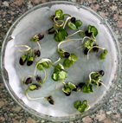  0.69 (27) | 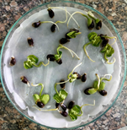  0.58 (17) | 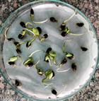  0.54 (15)
Max. |  |  | 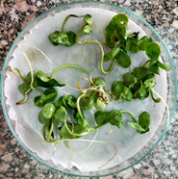  1.52 (9) | 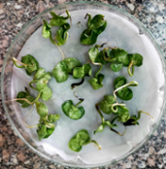  1.44 (3) | 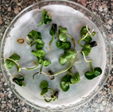  1.36 (19)
No. of tolerant genotypes |  |  | 9 | 6 | 8
No. of moderately tolerant |  |  | 18 | 18 | 16
No. of sensitive genotypes |  |  | 1 | 4 | 4
T = Tolerant, MT = moderately tolerant, S = Sensitive.

