Table S1. Summary of the emergence of Culicoides species from the tree holes sampled.

Tree family | Tree scientific name | Tree common name | Total trees sampled (n) | Trees with midges  (n) | Midge species emerged (n) | Total midges emerged  (n) | Midges emerged per tree*  (mean ± SE)
Altingiaceae | Liquidambar styraciflua | Sweetgum | 11 | 7 | 5 | 70 | 6.4 ± 4.5
Fagaceae | Quercus nigra | Water Oak | 11 | 4 | 4 | 42 | 3.8 ± 2.0
Ulmaceae | Ulmus alata | Winged elm | 3 | 0 | 0 | 0 | 0.0 ± 0.0
Oleaceae | Ligustrum sinense | Chinese Privet | 2 | 2 | 2 | 9 | 4.5 ± 3.5
Ulmaceae | Ulmus americana | American Elm | 1 | 1 | 3 | 12 | 12.0 ± 0.0
Juglandaceae | Carya illinoinensis | Pecan | 1 | 0 | 0 | 0 | 0.0 ± 0.0
Rosaceae | Prunus serotina | Black cherry | 1 | 0 | 0 | 0 | 0.0 ± 0.0
Fagaceae | Quercus falcata | Cherrybark oak | 1 | 0 | 0 | 0 | 0.0 ± 0.0
Pinaceae | Pinus taeda | Loblolly pine | 1 | 0 | 0 | 0 | 0.0 ± 0.0
Betulaceae | Carpinus caroliniana | Ironwood | 1 | 0 | 0 | 0 | 0.0 ± 0.0

*Calculated as total number of midges emerged/total number of trees sampled.

Table S2. Co-occurrence of Culicoides species (n) in different tree holes at Bob R. Jones Idlewild Research Station, East Feliciana parish, Louisiana, USA.

Treehole id | Tree species | C. hinmani |  |  | C. guttipennis |  | C. arboricola |  | C. nanus |  | C. debilipalpis |  | C. paraensis |  | C. beckae |  | Total
1 | Sweetgum |  | 49 | 0 |  | 0 |  | 0 |  | 1 |  | 0 |  | 0 |  | 50
23 | Sweetgum |  | 4 | 1 |  | 2 |  | 0 |  | 0 |  | 2 |  | 0 |  | 9
32 | Sweetgum |  | 0 | 0 |  | 1 |  | 0 |  | 3 |  | 2 |  | 0 |  | 6
31 | Sweetgum |  | 0 | 0 |  | 2 |  | 0 |  | 0 |  | 0 |  | 0 |  | 2
9 | Sweetgum |  | 0 | 1 |  | 0 |  | 0 |  | 0 |  | 0 |  | 0 |  | 1
13 | Sweetgum |  | 0 | 1 |  | 0 |  | 0 |  | 0 |  | 0 |  | 0 |  | 1
29 | Sweetgum |  | 0 | 1 |  | 0 |  | 0 |  | 0 |  | 0 |  | 0 |  | 1
19 | Water Oak |  | 0 | 13 |  | 6 |  | 0 |  | 0 |  | 0 |  | 0 |  | 19
22 | Water Oak |  | 5 | 0 |  | 7 |  | 0 |  | 0 |  | 0 |  | 0 |  | 12
11 | Water Oak |  | 0 | 4 |  | 5 |  | 0 |  | 0 |  | 0 |  | 0 |  | 9
4 | Water Oak |  | 0 | 0 |  | 1 |  | 0 |  | 0 |  | 0 |  | 1 |  | 2
21 | Chinese Privet |  | 0 | 8 |  | 0 |  | 0 |  | 0 |  | 0 |  | 0 |  | 8
33 | Chinese Privet |  | 0 | 0 |  | 0 |  | 0 |  | 0 |  | 1 |  | 0 |  | 1
5 | American Elm |  | 1 | 1 |  | 0 |  | 10 |  | 0 |  | 0 |  | 0 |  | 12
 | Total |  | 59 | 30 |  | 24 |  | 10 |  | 4 |  | 5 |  | 1 |  | 133

Table S3. Model averaging summary of individual Culicoides species.

Species | Full model | Total models generated  (n) | Models ranked delta AICc < 2 (n)
C. hinmani | glm(C.hinmani ~ standing.water.present + moss.present + area.of.treehole.opening + height.from.ground + distance.to.water, data = data.log, family = “poisson”) | 32 | 3
C. guttipennis | glm(C.guttipennis ~ standing.water.present + moss.present + area.of.treehole.opening + height.from.ground + distance.to.water, data = data.log, family = “poisson”) | 32 | 4
C. arboricola | glm(C.arboricola ~ standing.water.present + moss.present + area.of.treehole.opening + height.from.ground + distance.to.water, data = data.log, family = “poisson”) | 32 | 2
C. nanus | glm(C.nanus ~ standing.water.present + moss.present + height.from.ground, data = data.log, family = “poisson”, method = “brglm_fit”) | 8 | 7
C. paraensis | glm(C.paraensis ~ standing.water.present + moss.present + area.of.treehole.opening + height.from.ground + distance.to.water, data = data.log, family = "poisson", method = “brglm_fit”) | 32 | 4
C. debilipalpis | glm(C.debilipalpis ~ standing.water.present + moss.present + area.of.treehole.opening + height.from.ground + distance.to.water, data = data.log, family = "poisson", method = “brglm_fit”) | 32 | 5
C. beckae | glm(C.beckae ~ standing.water.present + moss.present + area.of.treehole.opening + height.from.ground + distance.to.water, data = data.log, family = "poisson", method = “brglm_fit”) | 32 | 4

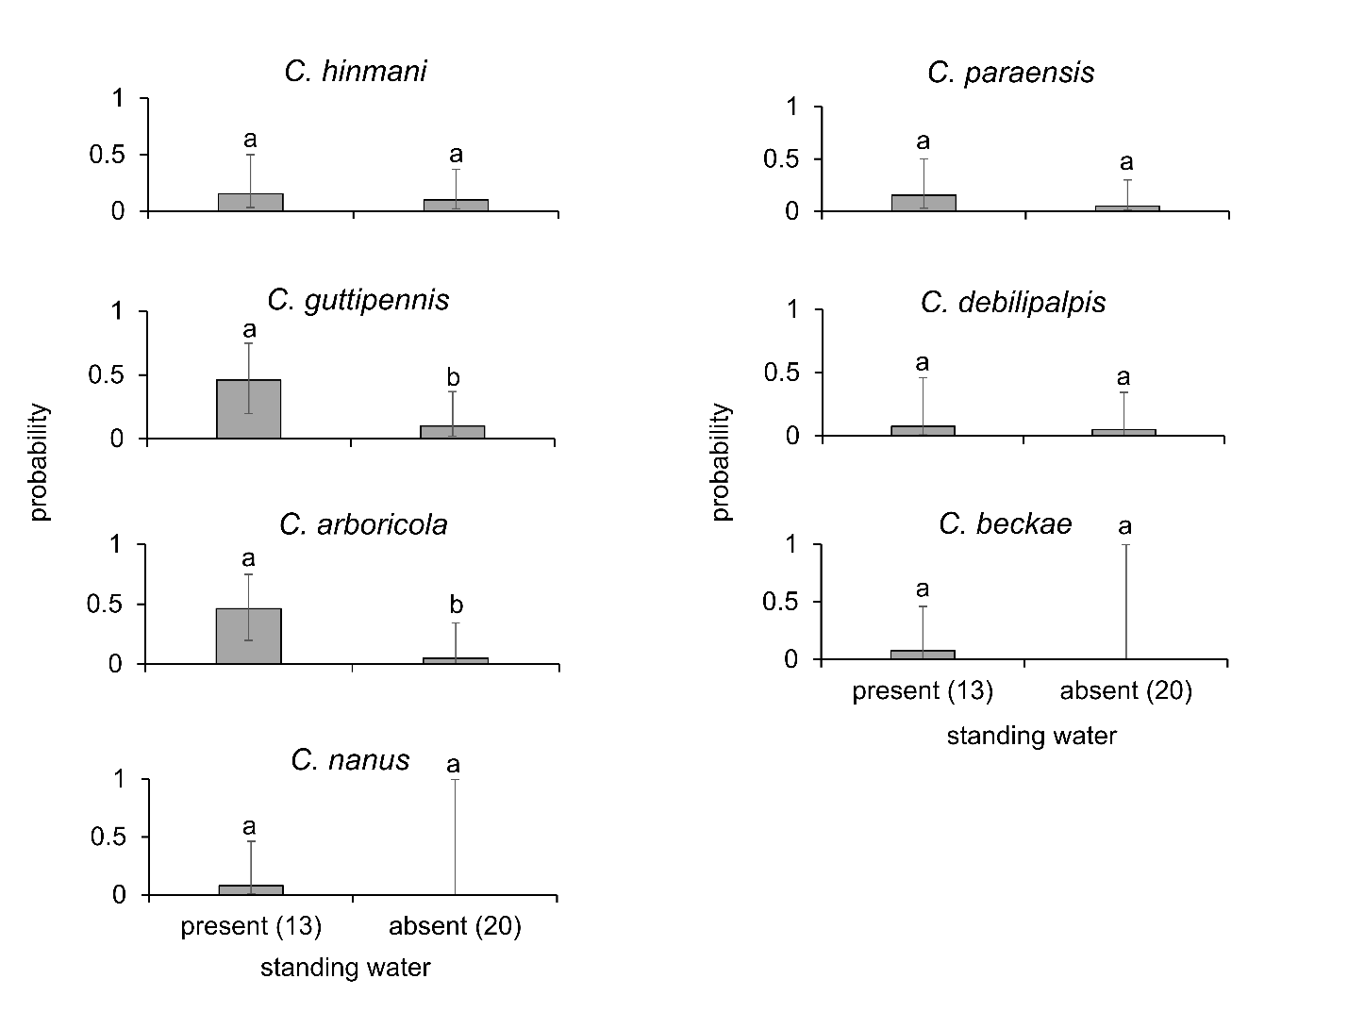
Fig. S1. The effect of standing water on the presence of individual Culicoides species. Values in parentheses along x-axis represent the number of tree holes sampled.

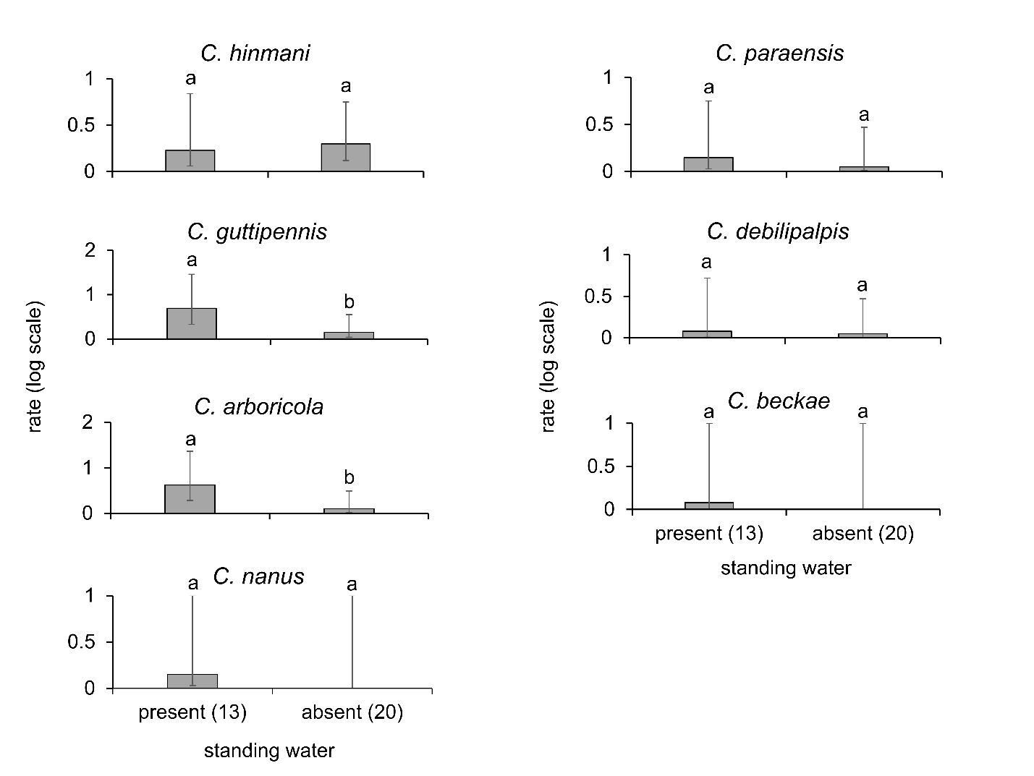
Fig. S2. The effect of standing water on the abundance of individual Culicoides species. Values in parentheses along x-axis represent the number of tree holes sampled.

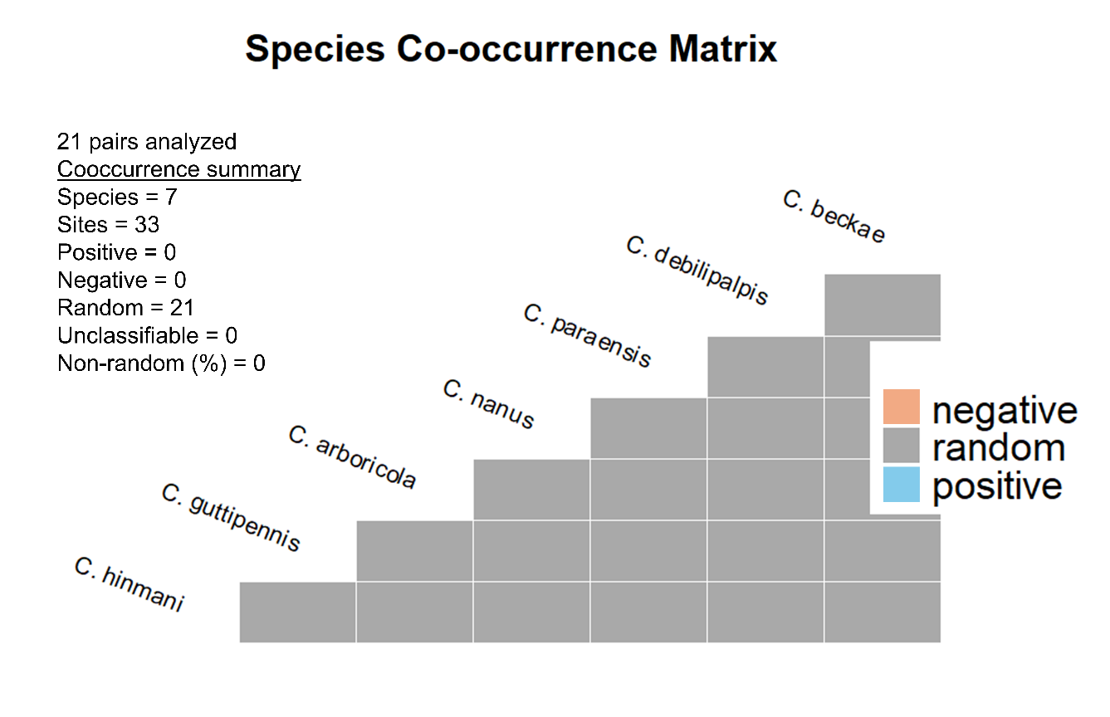
Fig. S3. The co-occurrence matrix of Culicoides species in the tree holes sampled.

