Supplementary Material

Schema-enforced large language model framework for sarcoma tumor board simulation: a methodology development and reproducibility pilot study
Tekoshin Ammo, Moritz Englich, Fabio Dos Santos Adrego, Maximilian Jacobi, Alida Wilckens, Philipp Kruppa, Bastian Bonaventura, Stefan Niemuth, Selina M. Weiler, Victoria Wachenfeld-Teschner, Anja M. Boos, Gerrit Freund
Correspondence: Tekoshin Ammo, Tekoshin.ammo@uksh.de

Tables
Table 1. Schema definition — decision codes by clinical domain.
Domain | Decision code | Type | Allowed values / range | Output semantics
Imaging recommendations | imaging_recommended.MRI | Boolean | True / False | True if MRI is recommended as a future diagnostic step; False if not recommended or already completed without further need.
 | imaging_recommended.CT | Boolean | True / False | True if CT is recommended as a future diagnostic step.
 | imaging_recommended.XR | Boolean | True / False | True if X-ray is recommended as a future or pending imaging modality.
 | imaging_recommended.US | Boolean | True / False | True if ultrasound is recommended as a future or pending imaging modality.
 | imaging_recommended.PETCT | Boolean | True / False | True if PET-CT is recommended as a future or pending imaging modality.
Staging recommendations | staging_recommended.CT_CHEST | Boolean | True / False | True if CT chest is recommended for staging and remains to be performed.
 | staging_recommended.CT_ABD_PEL | Boolean | True / False | True if CT abdomen/pelvis is recommended for staging and remains to be performed.
 | staging_recommended.OTHER | Free text | ≤ 300 characters or null | Additional staging modality or procedure recommended beyond predefined fields; null if none.
Surgical strategy | surgery_decision | Enum | none / biopsy / wide_excision / compartment_resection / amputation / watch_and_wait | Selected value represents the next intended surgical management step.
 | margins_goal | Enum | R0_intended / R1_acceptable / unclear | Selected value represents the intended margin strategy for the planned operation.
Reconstruction | recon_decision | Enum | none / skin_graft / local_flap / pedicled_flap / free_flap | Selected value represents the planned reconstructive approach.
 | functional_recon.NERVE_TRANSFER | Boolean | True / False | True if nerve transfer is explicitly recommended or planned.
 | functional_recon.TENDON_RECON | Boolean | True / False | True if tendon reconstruction or transfer is recommended.
 | functional_recon.VASCULAR_RECON | Boolean | True / False | True if vascular reconstruction is recommended.
Radiotherapy | rt_decision | Enum | no / neoadjuvant / adjuvant / intraoperative | Selected value represents the intended radiotherapy strategy.
 | rt_dose.GY_TOTAL | Integer | 0–80 or null | Numeric total planned radiotherapy dose in Gy; null if not specified.
 | rt_dose.FRACTIONS | Integer | 0–40 or null | Number of radiotherapy fractions if explicitly specified; null if not specified.
Systemic therapy | systemic_decision | Enum | no / neoadjuvant / adjuvant / palliative | Recommended systemic-therapy strategy and treatment intent / timing.
 | chemo_1l | Free text | Controlled regimen string or “none” | First-line regimen only; use “none” if no systemic regimen is planned.
 | chemo_2l | Free text | Controlled regimen string or “none” | Second-line or subsequent systemic regimen recommended; “none” if not recommended.
 | io_target | Enum | yes / no / unclear | “yes” if immunotherapy or targeted therapy is recommended; “unclear” if discussed but not resolved.
Schema version 4; 21 decision codes across 6 treatment domains. Field types: Boolean (True/False flag), Enum (a single value from a fixed controlled vocabulary), Integer (integer or null), Free text (length-limited string or null). Free-text fields (staging_recommended.OTHER, chemo_1l, chemo_2l) are constrained by length and by conditional-logic rules (e.g., chemo_1l must be “none” if systemic_decision = "no"). All field constraints are enforced via Pydantic 2.13.3 with strict Literal types and validated at the inference layer via Anthropic’s tool-use API.
Table 2. Controlled vocabularies for categorical decisions (Pydantic Literal enumerations).
Decision code | Allowed values
surgery_decision | none / biopsy / wide_excision / compartment_resection / amputation / watch_and_wait
margins_goal | R0_intended / R1_acceptable / unclear
recon_decision | none / skin_graft / local_flap / pedicled_flap / free_flap
rt_decision | no / neoadjuvant / adjuvant / intraoperative
systemic_decision | no / neoadjuvant / adjuvant / palliative
io_target (immunotherapy / targeted) | yes / no / unclear
Each categorical decision is restricted to one value from a fixed enumeration enforced by Pydantic Literal types and validated at the inference layer through the tool-use API.
Table 3. The seven coordinated prompting techniques combined in the system prompt (schema v4).
# | Technique | Implementation in this study
1 | Role prompting | Explicit domain identity (“Sarcoma-Tumorboard-LLM-v4”).
2 | Rule-based prompting | Six numbered absolute rules, including “use only information present in the case”, “never fabricate guideline references”, “never produce numerical prognostic statistics”, and “never introduce sections beyond the schema” (analogous to Constitutional AI (15)).
3 | Negative prompting | Explicit prohibition of fabricated trial names, named guidelines (ESMO, NCCN, EORTC) unless quoted from the input, and specific survival or recurrence percentages.
4 | Schema-constrained output | Tool-use API (16) validates each output against the Pydantic schema at the inference layer; non-conforming responses are rejected by the API rather than relying on prompt-level instruction adherence.
5 | Few-shot semantic anchoring | Brief domain-specific examples for Boolean field interpretation without providing complete output exemplars.
6 | Conditional-logic encoding | Coupled-decision constraints (e.g., systemic_decision = "no" forces chemo_1l = "none"; rt_decision = "no" forces rt_dose.GY_TOTAL and rt_dose.FRACTIONS to null).
7 | Controlled vocabulary | Strict enumerations enforced by Pydantic Literal types (see Table 2).
Table 4. The three iterative methodology development phases.
Phase | Technical change | Key observation / problem addressed
Phase 1 — Free-text Markdown output | Baseline system prompt, unstructured Markdown recommendations. | Free-text outputs exhibited multiple categories of hallucination (fabricated guideline citations, invented prognostic statistics, unauthorized output sections such as “Surveillance Plan” and “Clinical Trial Recommendations”).
Phase 2 — Schema-enforced JSON output | Pydantic schema + tool-use API enforcement; structured, machine-validated output. | Structural hallucinations (invented sections, non-conforming output) were eliminated by API-level validation; semantic ambiguities in Boolean fields produced run-to-run instability in 4–5 decision codes per pilot case.
Phase 3 — Semantic clarification and conditional logic (schema v4) | Explicit Boolean-field semantics, conditional-logic constraints; addition of watch_and_wait as a surgical option. | Remaining Boolean ambiguity resolved; final framework used for full validation run.
Table 5. Per-run metadata logged for each of the 154 inference runs.
Metadata field | Description
Prompt hash | SHA-256 hash of the system prompt (truncated to 12 hexadecimal characters).
Case hash | SHA-256 hash of the case text.
Model identifier | claude-opus-4-5.
Inference parameters | Temperature, max tokens.
Wall-clock timestamp | Date and time of inference.
Token usage | Input and output tokens.
Schema version | v4.
Run index | 1, 2, or 3.
Table 6. Three reproducibility aggregation levels.
Aggregation level | Definition | Question answered
Per-case reproducibility (primary endpoint) | Number of stable decision codes divided by 21 codes per case. | Which cases yield the most stable recommendations?
Per-code stability across cases | Number of cases in which the code was stable divided by total number of cases (n = 51). | Which decision codes are systematically problematic?
Per-domain reproducibility | Number of stable code-instances within a clinical domain divided by total code-instances in that domain across all cases. | Which clinical domains contribute most to remaining variability?
Table 7. Pre-specified hallucination categories (H1–H5).
Category | Definition | Counting rule
H1 — Numerical prognostic claims | Specific numerical prognostic figures (e.g., “5-year survival 65 %”, “local recurrence rate 18 %”). | Always counted as hallucination regardless of clinical plausibility (the model cannot verify such figures from the input alone).
H2 — Named studies / guidelines | Named studies, trials, or guidelines not present in the input (e.g., “per ESMO 2021 guidelines”, “based on STRASS trial”). | Always counted as hallucination.
H3 — Anatomical / imaging measurements | Specific anatomical or imaging measurements not reported in the input. | Always counted as hallucination.
H4 — General clinical-knowledge claims | General clinical claims (e.g., “myxofibrosarcoma is generally radiosensitive”). | Tracked descriptively; counted as hallucination only if factually incorrect.
H5 — Patient-specific reasoning extensions | Patient-specific reasoning beyond the input (e.g., assumed comorbidity status not in the case). | Tracked descriptively; counted as hallucination only if factually incorrect.
Table 8. Pilot dataset characteristics (n = 51).
Characteristic | Value | Note
Patient demographics
Median age, years | 73 (range 28–93) | Extracted from 48/51 cases; 3 cases described age qualitatively.
Sex: female / male | 23 (45.1 %) / 25 (49.0 %) | Extracted from 48/51 cases.
Age ≥ 70 years | 26 (51.0 %)
Histological subtype (top 5)
Atypical lipomatous tumor / WD liposarcoma | 11 (21.6 %)
Synovial sarcoma | 6 (11.8 %)
Leiomyosarcoma | 6 (11.8 %)
Dedifferentiated liposarcoma | 4 (7.8 %)
Myxofibrosarcoma | 4 (7.8 %)
Other histologies (≤ 3 cases each) | 20 (39.2 %) | 12 distinct subtypes.
Total distinct histologies | 17
Anatomical location
Thigh / knee | 20 (39.2 %) | Lower extremity
Shoulder / axilla | 7 (13.7 %) | Upper extremity
Chest wall / thoracic | 4 (7.8 %) | Trunk
Forearm / elbow | 4 (7.8 %) | Upper extremity
Lower leg | 4 (7.8 %) | Lower extremity
Foot / ankle | 3 (5.9 %) | Lower extremity
Other locations | 9 (17.6 %) | 5 distinct sites
Tumor grade
G3 / high-grade | 27 (52.9 %)
G2 / intermediate | 5 (9.8 %)
G1 / low-grade | 14 (27.5 %)
Not specified | 5 (9.8 %)
Demographic and clinicopathological characteristics extracted from de-identified case texts via automated regex-based parsing with manual verification.
Table 9. Reproducibility results.
9a. Overall reproducibility.
Metric | Value
Cases analyzed | 51
Total LLM runs | 154
Decision codes per case | 21
Total decision-code instances | 1,071
Stable code-instances | 1,006
Overall reproducibility | 93.9 %
Cases with 100 % reproducibility | 17 / 51 (33.3 %)
Cases with ≥ 95 % reproducibility | 43 / 51 (84.3 %)
Cases with ≥ 80 % reproducibility | 50 / 51 (98.0 %)
9b. Per-domain reproducibility.
Clinical domain | Stable / total | Reproducibility | Interpretation
Imaging recommendations | 250 / 255 | 98.0 % | Highest stability; Boolean modality flags well defined.
Systemic therapy | 198 / 204 | 97.1 % | High stability; clear treatment-intent decisions.
Surgery | 95 / 102 | 93.1 % | High stability; minor variation in watch_and_wait borderline cases.
Reconstruction | 190 / 204 | 93.1 % | Driven mainly by clinically equivalent flap-choice variation.
Staging recommendations | 137 / 153 | 89.5 % | Lower stability driven by free-text OTHER field.
Radiotherapy | 136 / 153 | 88.9 % | Variation between accepted dose schemes (50/25, 60/30, 66/33).
9c. Per-decision-code stability across 51 cases.
Decision code | Stable / total | Stability | Domain
imaging_recommended.US | 51 / 51 | 100.0 % | Imaging
imaging_recommended.PETCT | 51 / 51 | 100.0 % | Imaging
staging_recommended.CT_CHEST | 51 / 51 | 100.0 % | Staging
functional_recon.NERVE_TRANSFER | 51 / 51 | 100.0 % | Reconstruction
functional_recon.TENDON_RECON | 51 / 51 | 100.0 % | Reconstruction
chemo_2l | 51 / 51 | 100.0 % | Systemic
io_target | 51 / 51 | 100.0 % | Systemic
imaging_recommended.MRI | 50 / 51 | 98.0 % | Imaging
imaging_recommended.XR | 50 / 51 | 98.0 % | Imaging
functional_recon.VASCULAR_RECON | 50 / 51 | 98.0 % | Reconstruction
margins_goal | 49 / 51 | 96.1 % | Surgery
imaging_recommended.CT | 48 / 51 | 94.1 % | Imaging
rt_decision | 48 / 51 | 94.1 % | Radiotherapy
systemic_decision | 48 / 51 | 94.1 % | Systemic
chemo_1l | 48 / 51 | 94.1 % | Systemic
staging_recommended.CT_ABD_PEL | 47 / 51 | 92.2 % | Staging
surgery_decision | 46 / 51 | 90.2 % | Surgery
rt_dose.GY_TOTAL | 44 / 51 | 86.3 % | Radiotherapy
rt_dose.FRACTIONS | 44 / 51 | 86.3 % | Radiotherapy
staging_recommended.OTHER | 39 / 51 | 76.5 % | Staging
recon_decision | 38 / 51 | 74.5 % | Reconstruction
Codes sorted by stability in descending order. Six codes (29 %) reached 100 % stability across all 51 cases. The lowest-stability code (recon_decision) reflects clinical equipoise between adjacent reconstruction options (e.g., local_flap vs. pedicled_flap) rather than stochastic model instability.

Figures
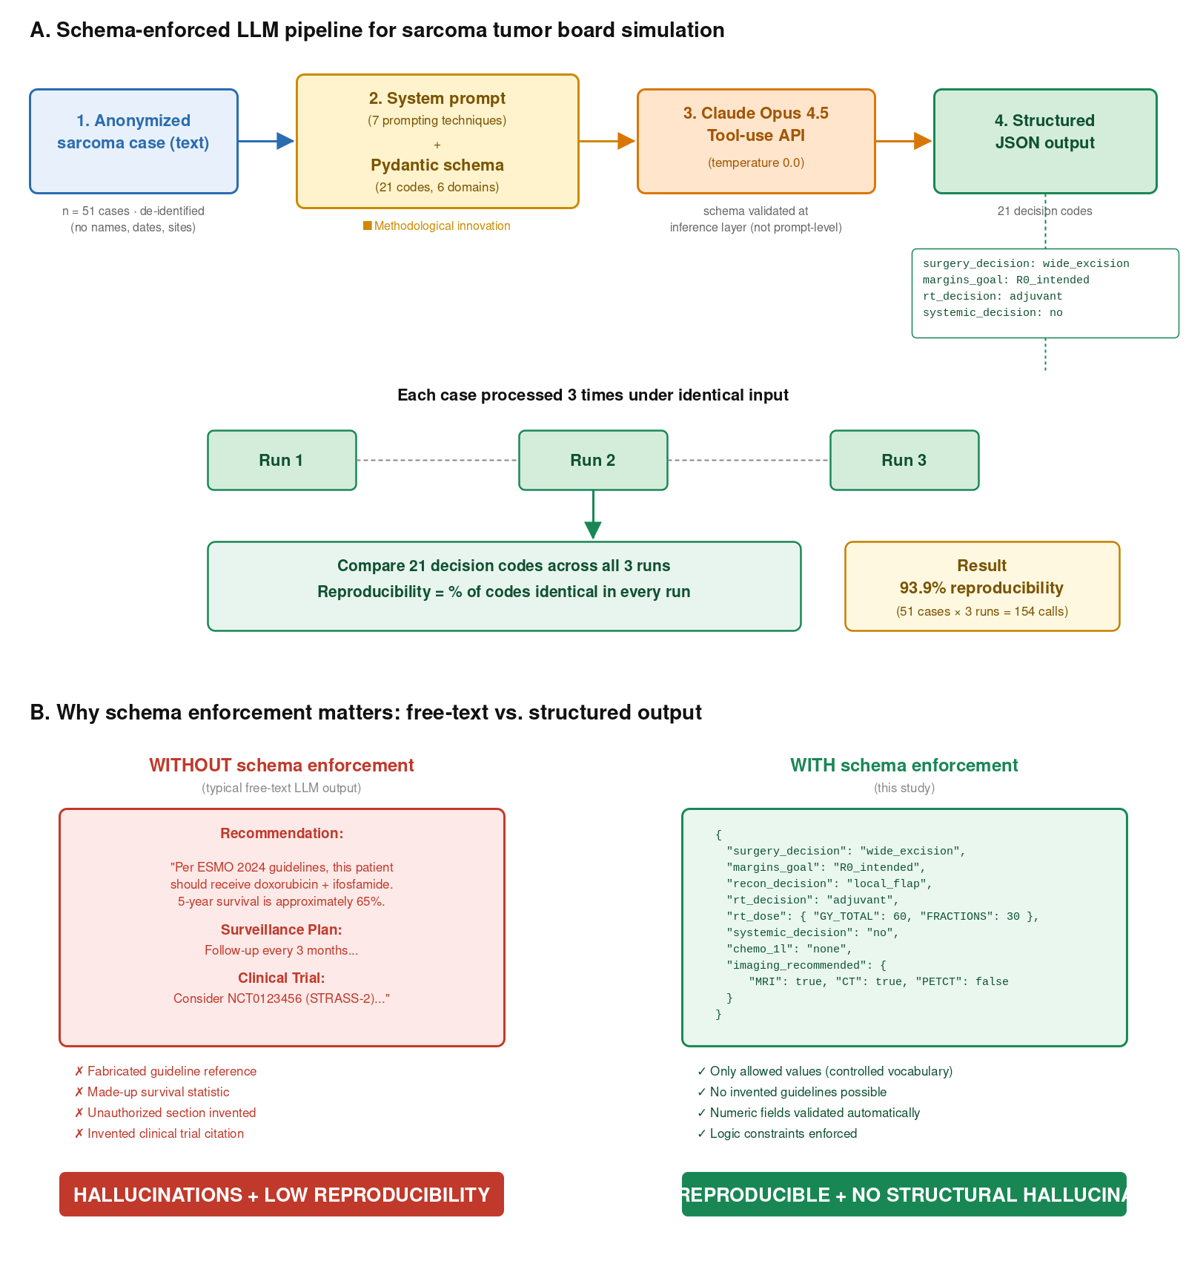
Figure 1. Overview of the schema-enforced LLM pipeline for sarcoma tumor board simulation. (A) Pipeline: each anonymized sarcoma case (n = 51 de-identified cases) is processed by the system prompt (seven prompting techniques) together with the Pydantic schema (21 decision codes across nine clinical domains, validated at the inference layer of Anthropic Claude Opus 4.5 via the tool-use API at temperature 0.0). Each case is processed three times under identical input; reproducibility is computed as the percentage of the 21 decision codes that are identical across all three runs (overall 93.9 % across 51 cases × 3 runs = 154 calls). (B) Effect of schema enforcement: free-text LLM output (left, red) frequently produces fabricated guideline references, made-up survival statistics, unauthorized sections, and invented trial citations, with low reproducibility. Schema-enforced output (right, green) is restricted to controlled vocabularies, numeric fields are validated automatically, and conditional-logic constraints prevent inconsistent combinations, yielding 93.9 % reproducibility and no structural hallucinations.
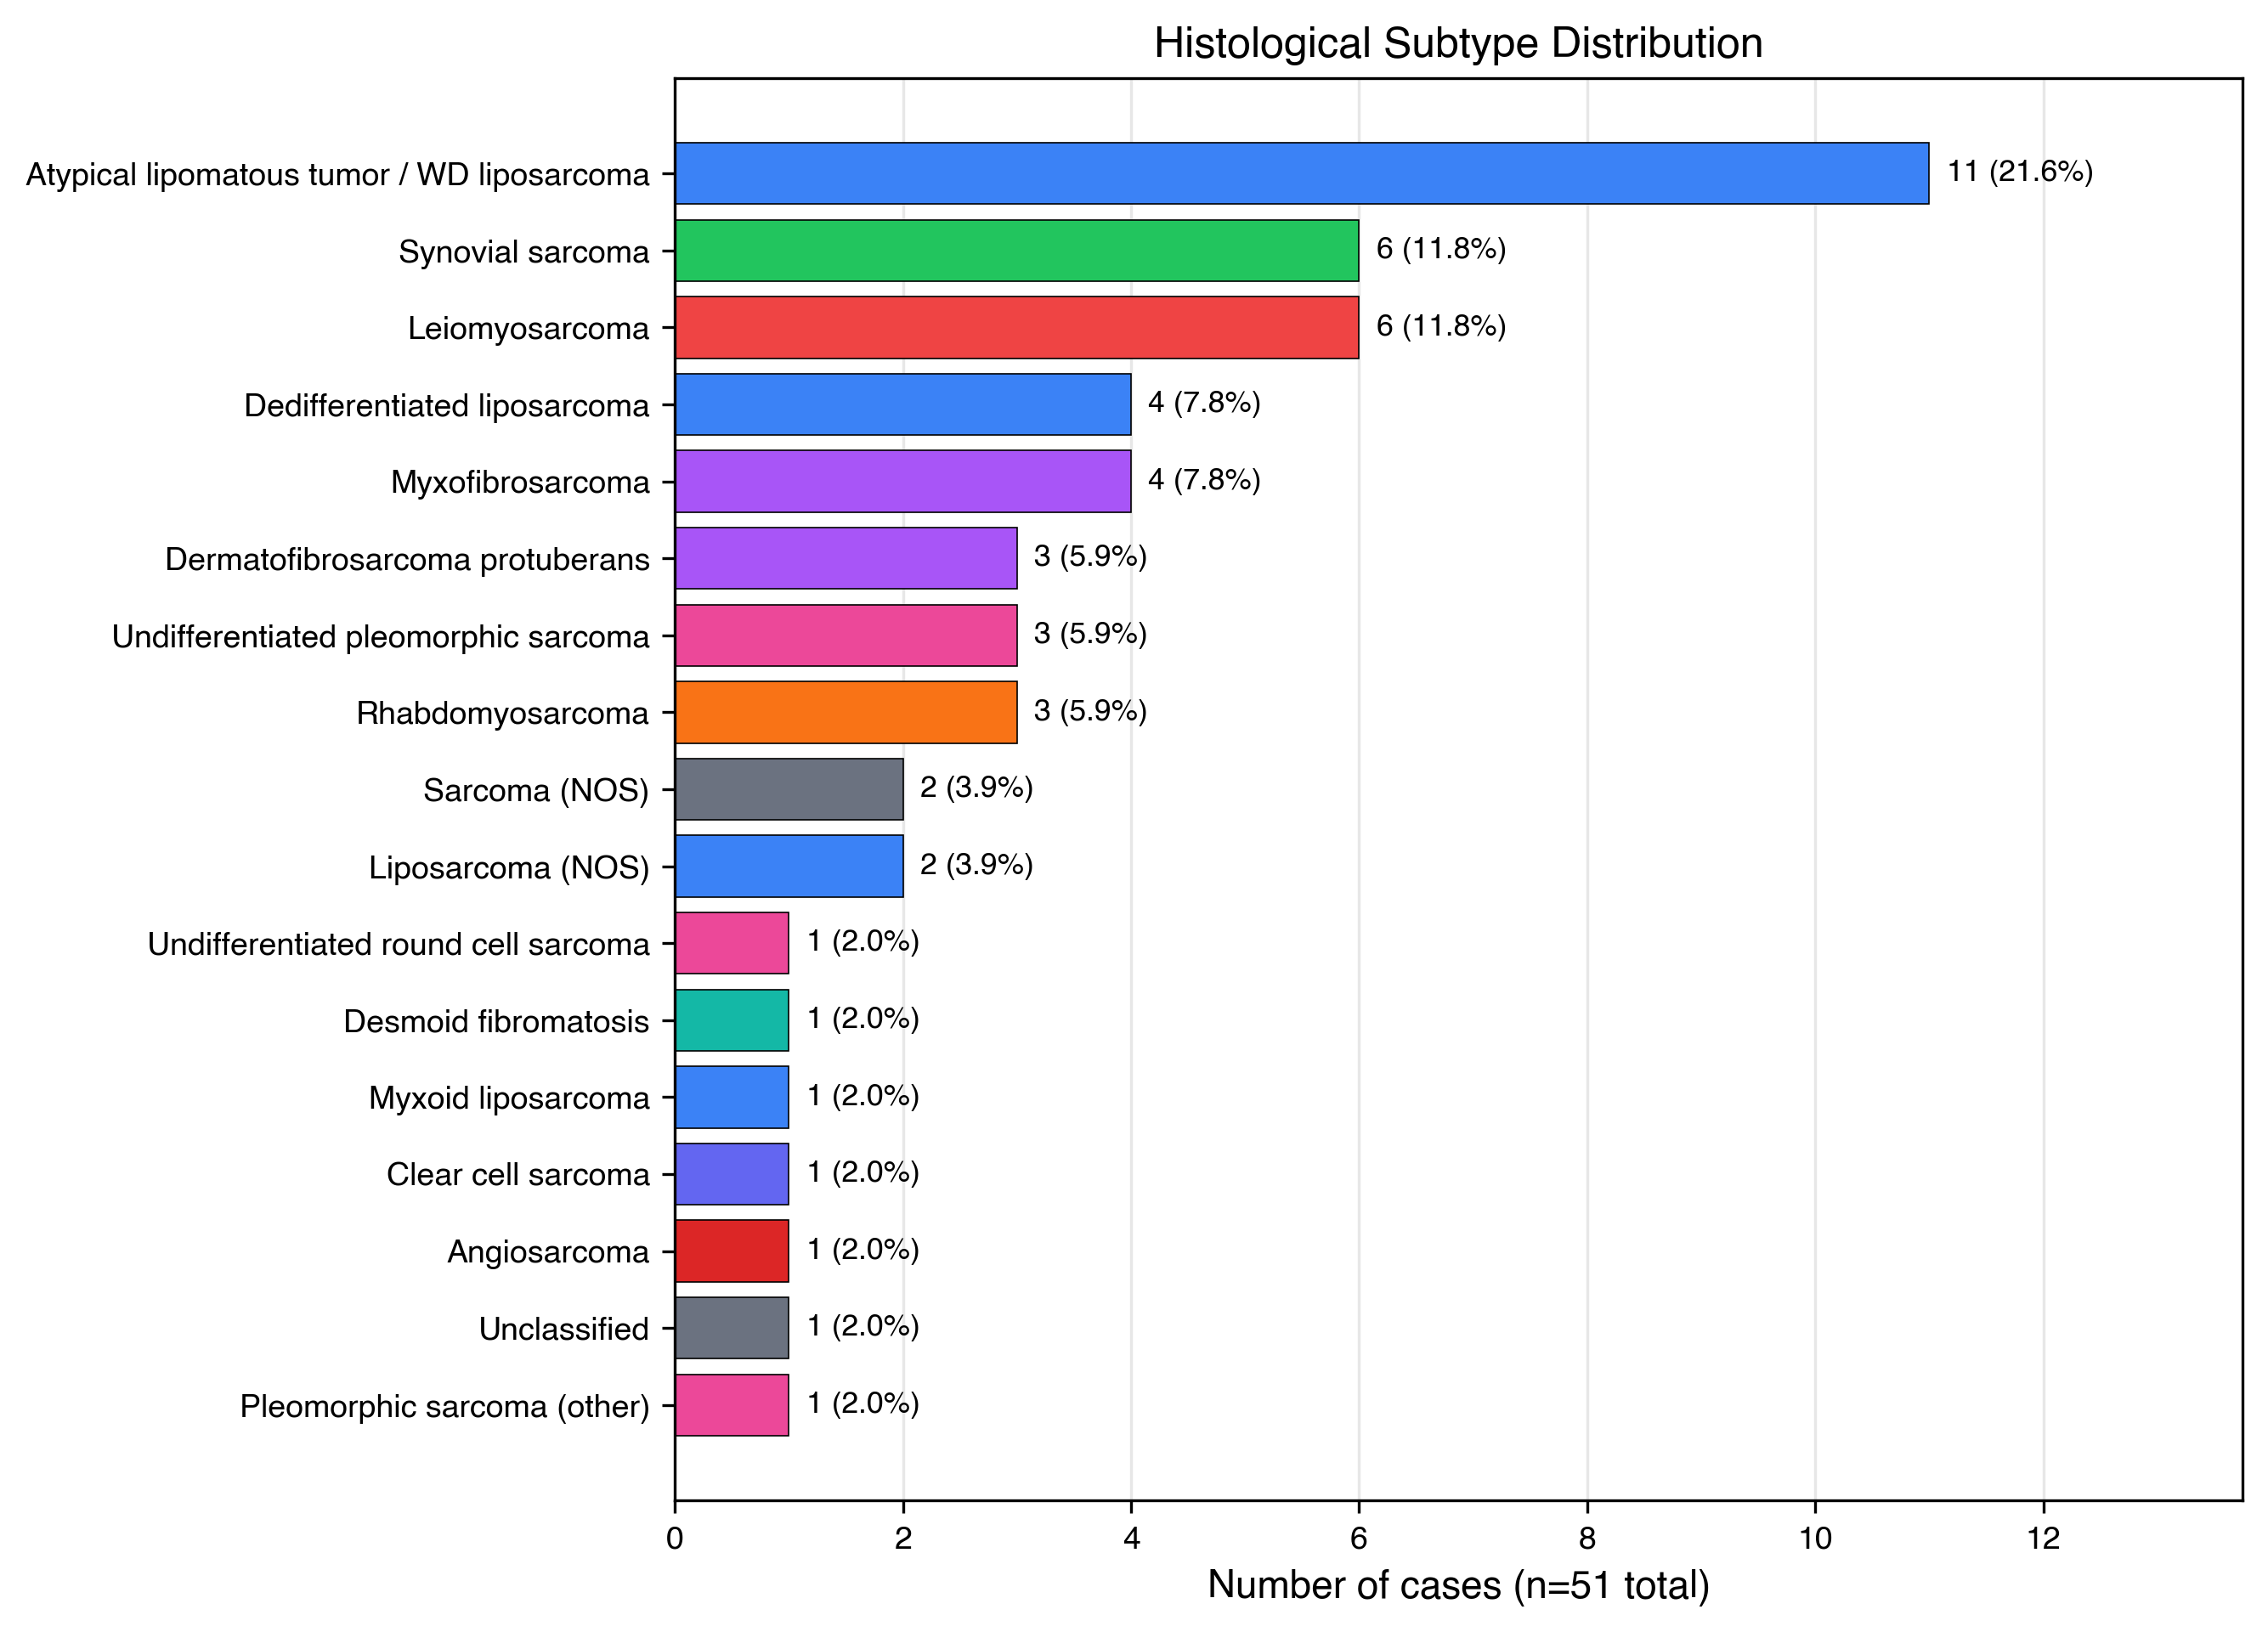
Figure 2. Histological subtype distribution across the 51-case pilot dataset, color-coded by sarcoma family.
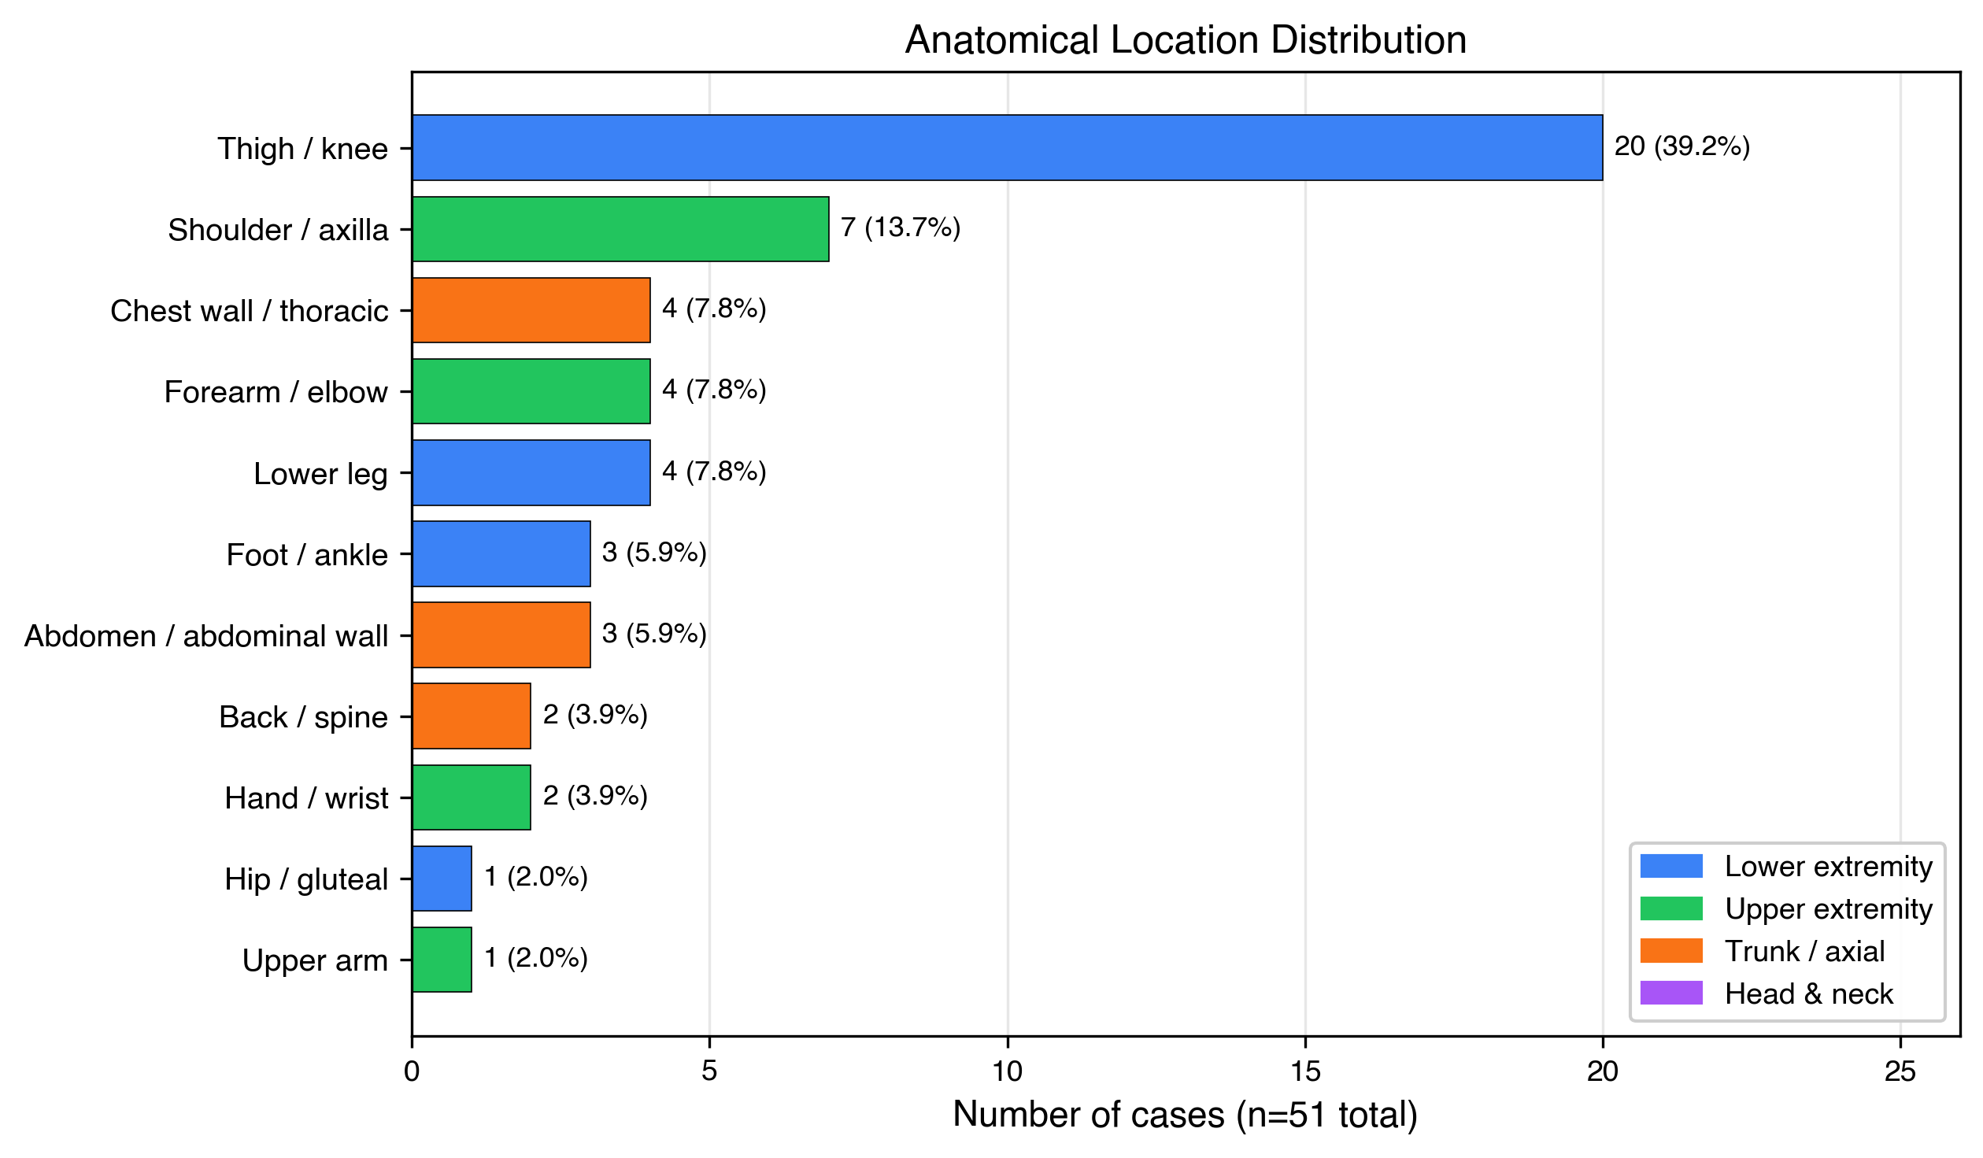
Figure 3. Anatomical location distribution, color-coded by body region (blue: lower extremity; green: upper extremity; orange: trunk / axial; purple: head and neck).
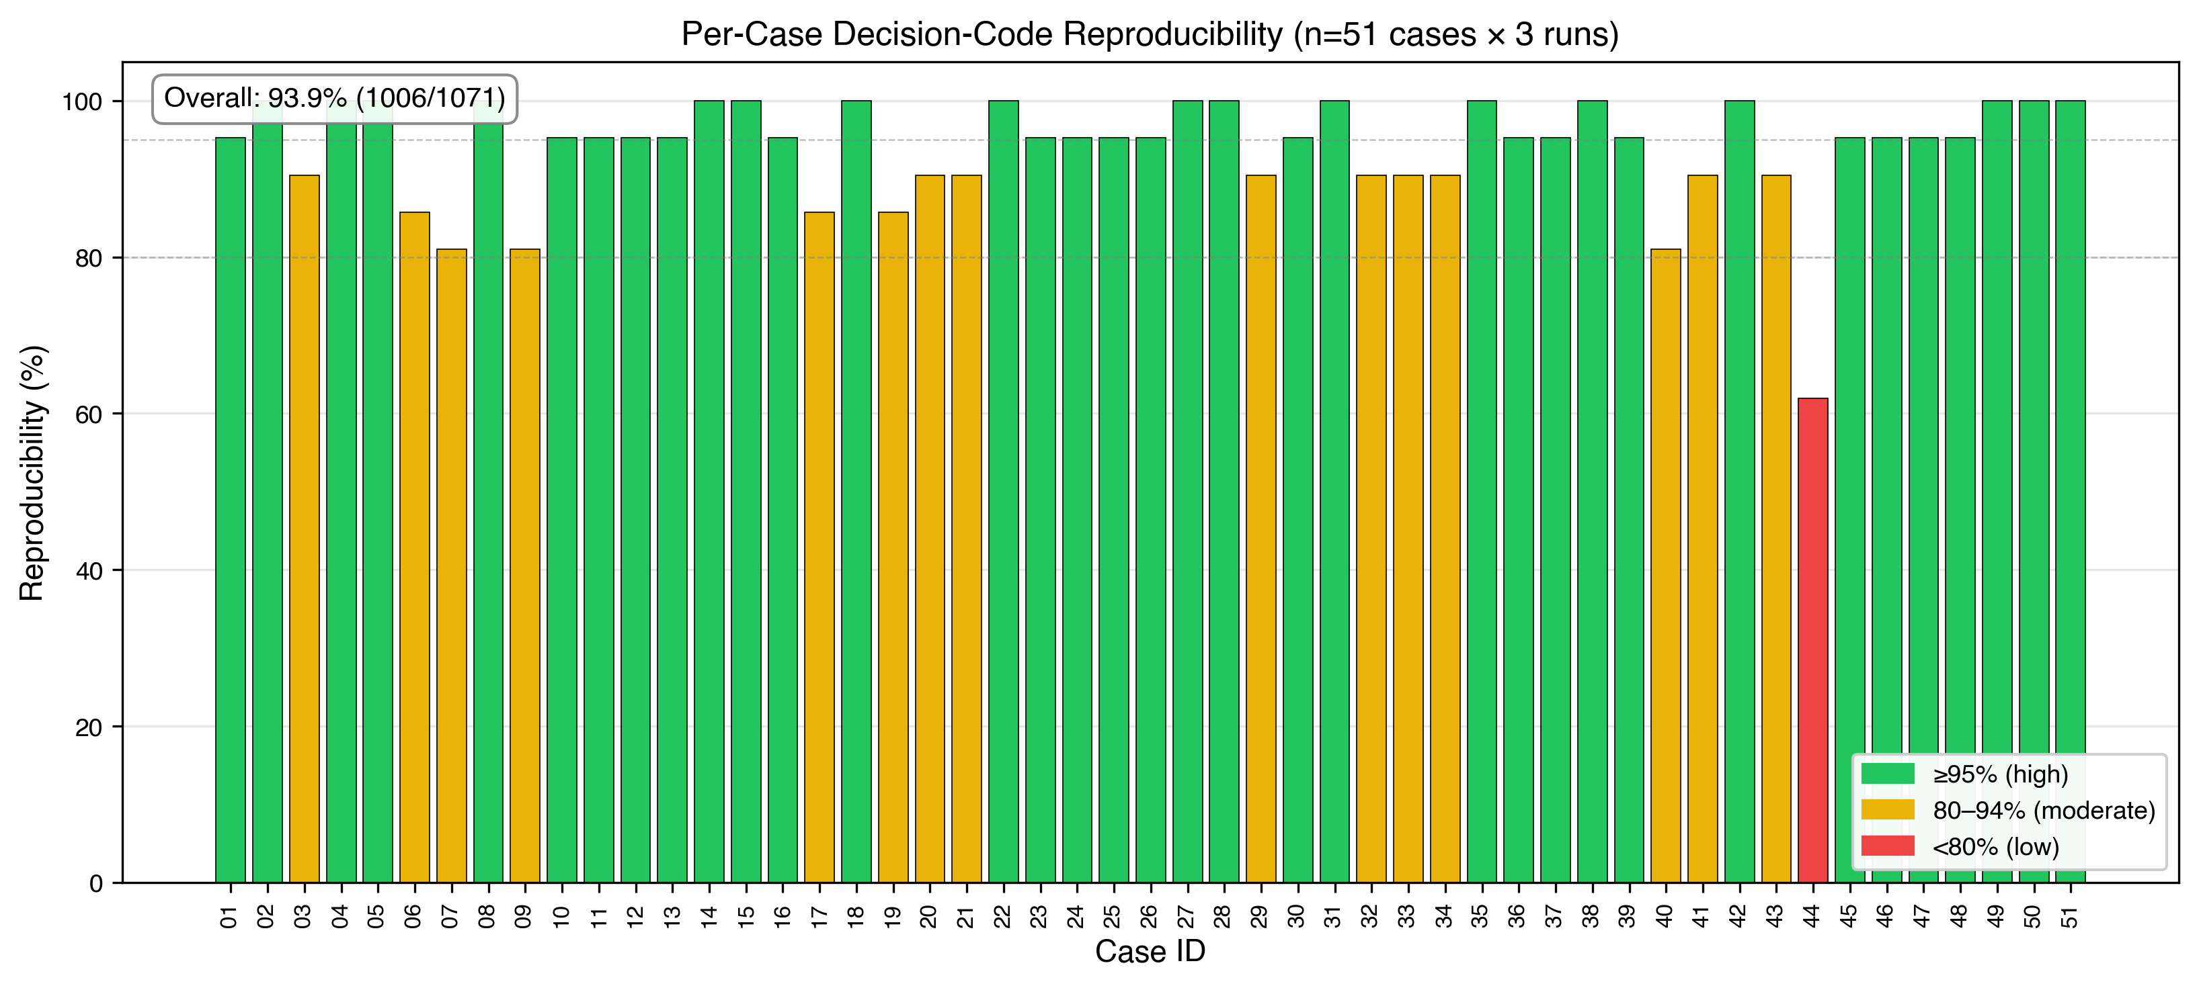
Figure 4. Per-case decision-code reproducibility (51 cases, three runs each). Color coding: green ≥ 95 %; yellow 80–94 %; red < 80 %. Yellow and red cases concentrate in elderly patients with multiple ambiguous decision points. Overall reproducibility 93.9 % (1,006 / 1,071).
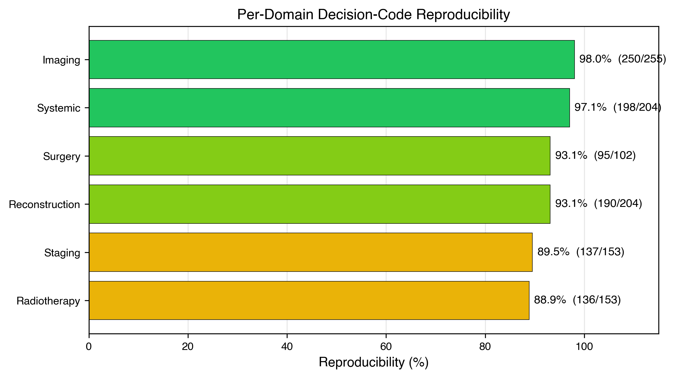
Figure 5. Per-domain decision-code reproducibility, sorted by stability. Imaging and systemic-therapy domains showed near-perfect stability; radiotherapy and staging domains showed lower stability driven primarily by clinically equipotent variations.
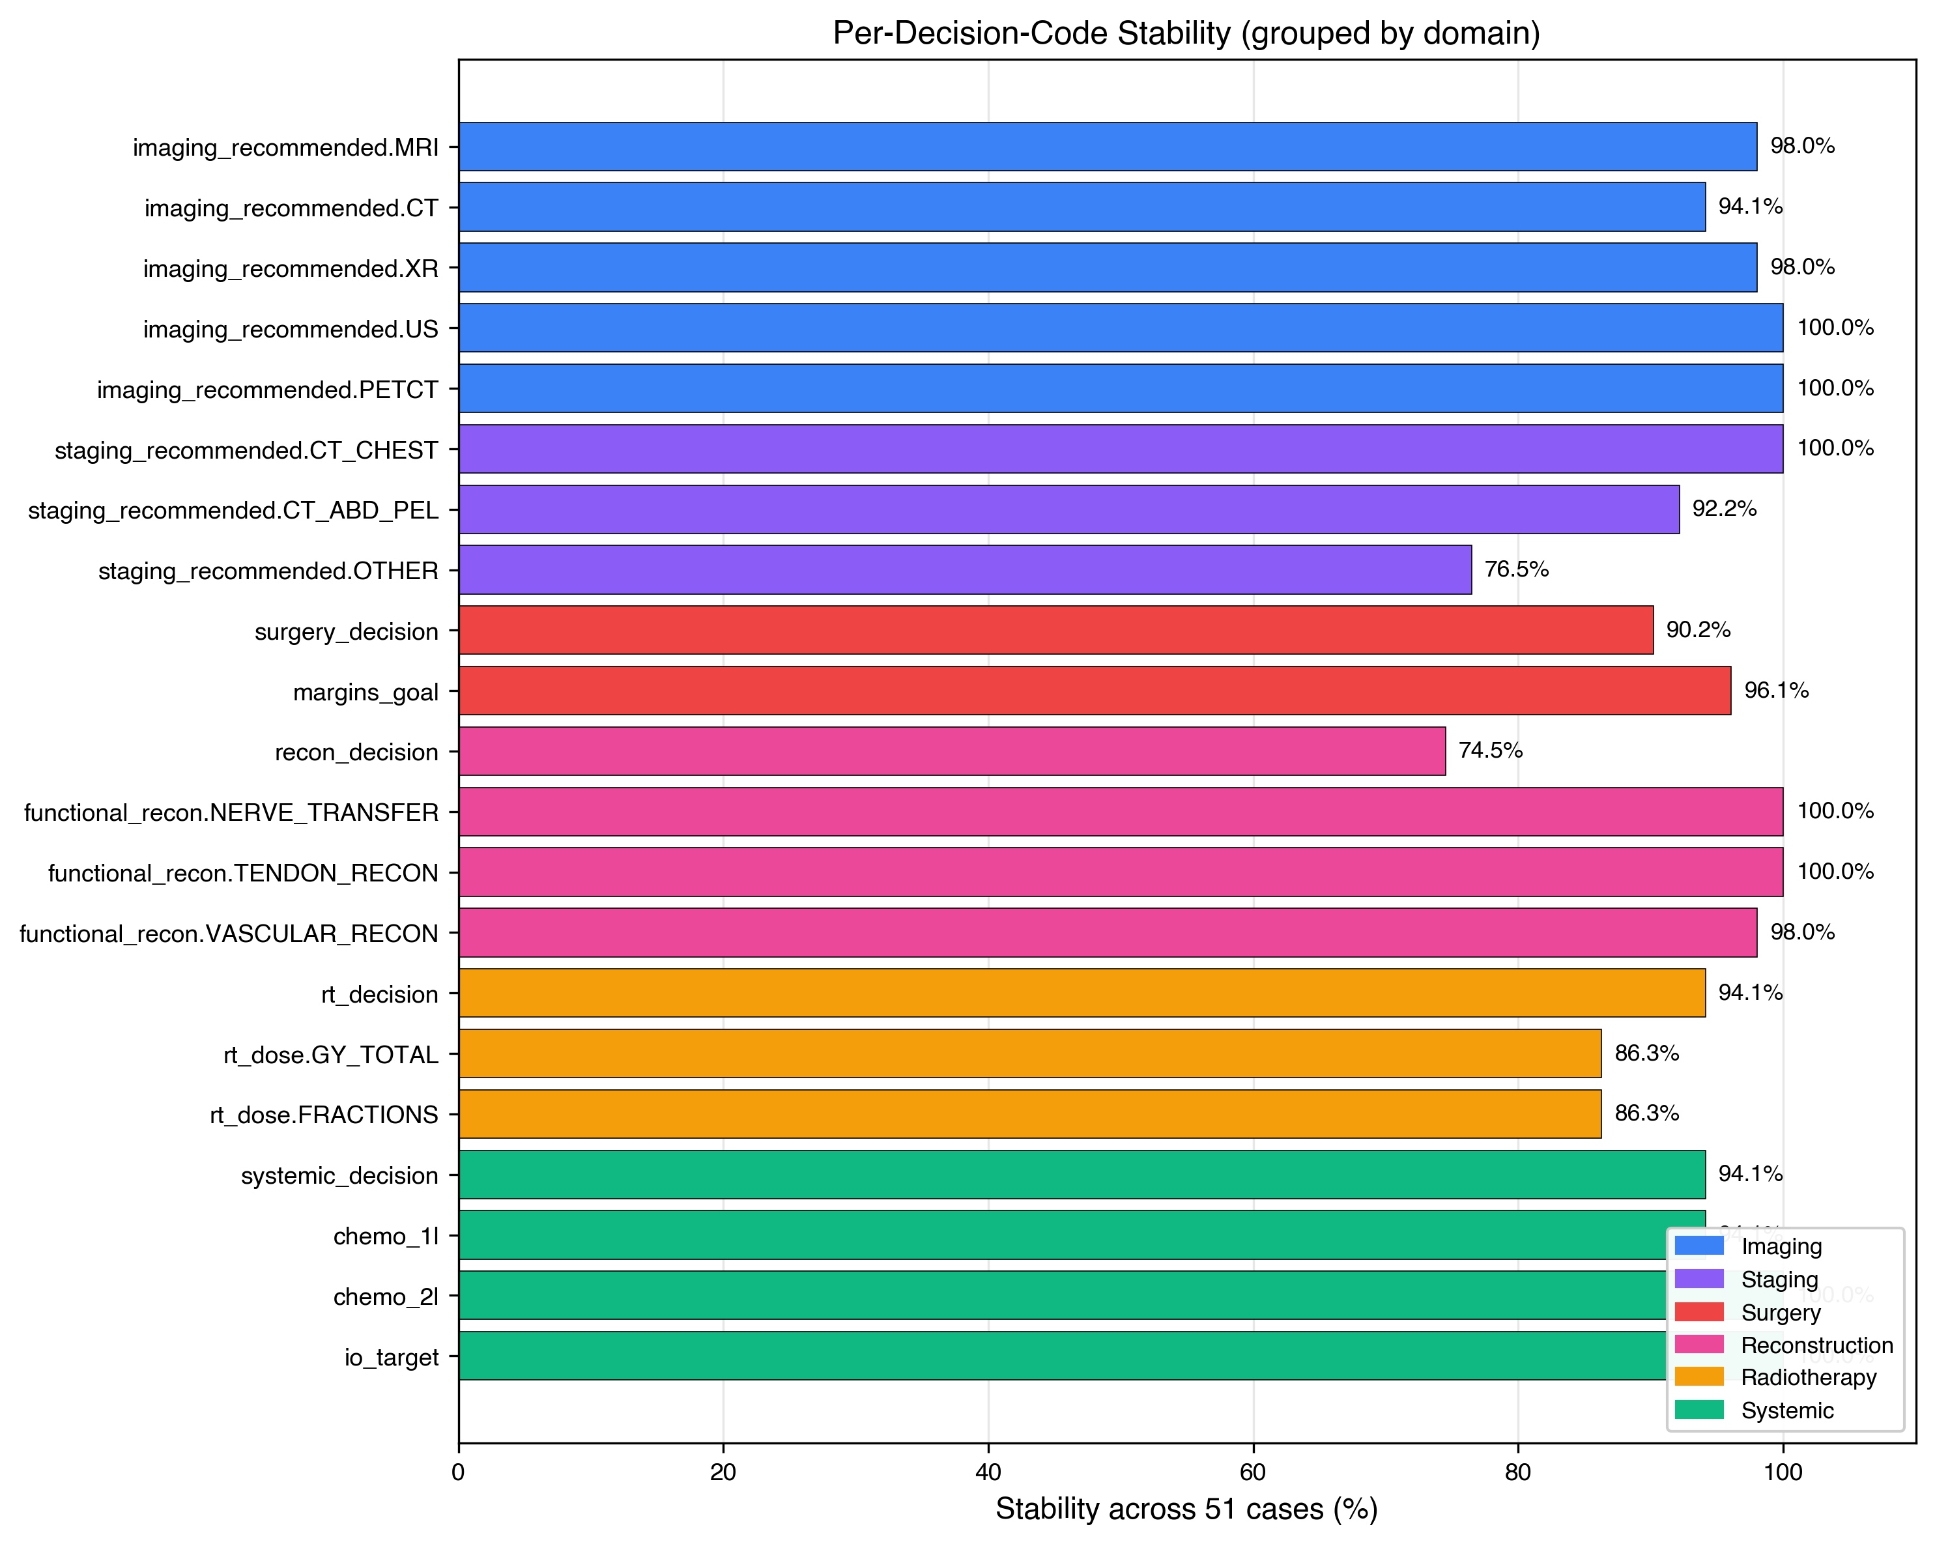
Figure 6. Per-decision-code stability across 51 cases. Six of 21 codes achieved 100 % stability; reconstruction decision was the lowest-stability code at 74.5 %.
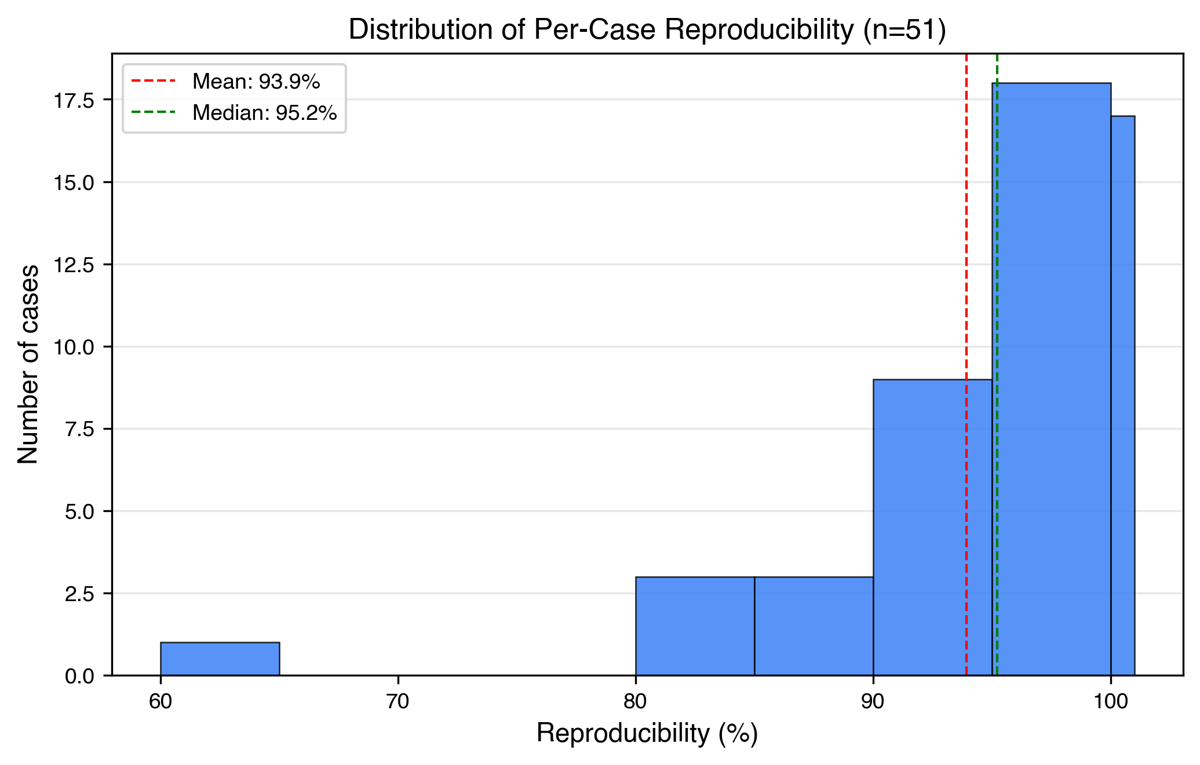
Figure 7. Distribution of per-case reproducibility values. Median 95.2 %, mean 93.8 %. One outlier at 61.9 % (case 44, complex elderly patient with multiple ambiguous decision points).
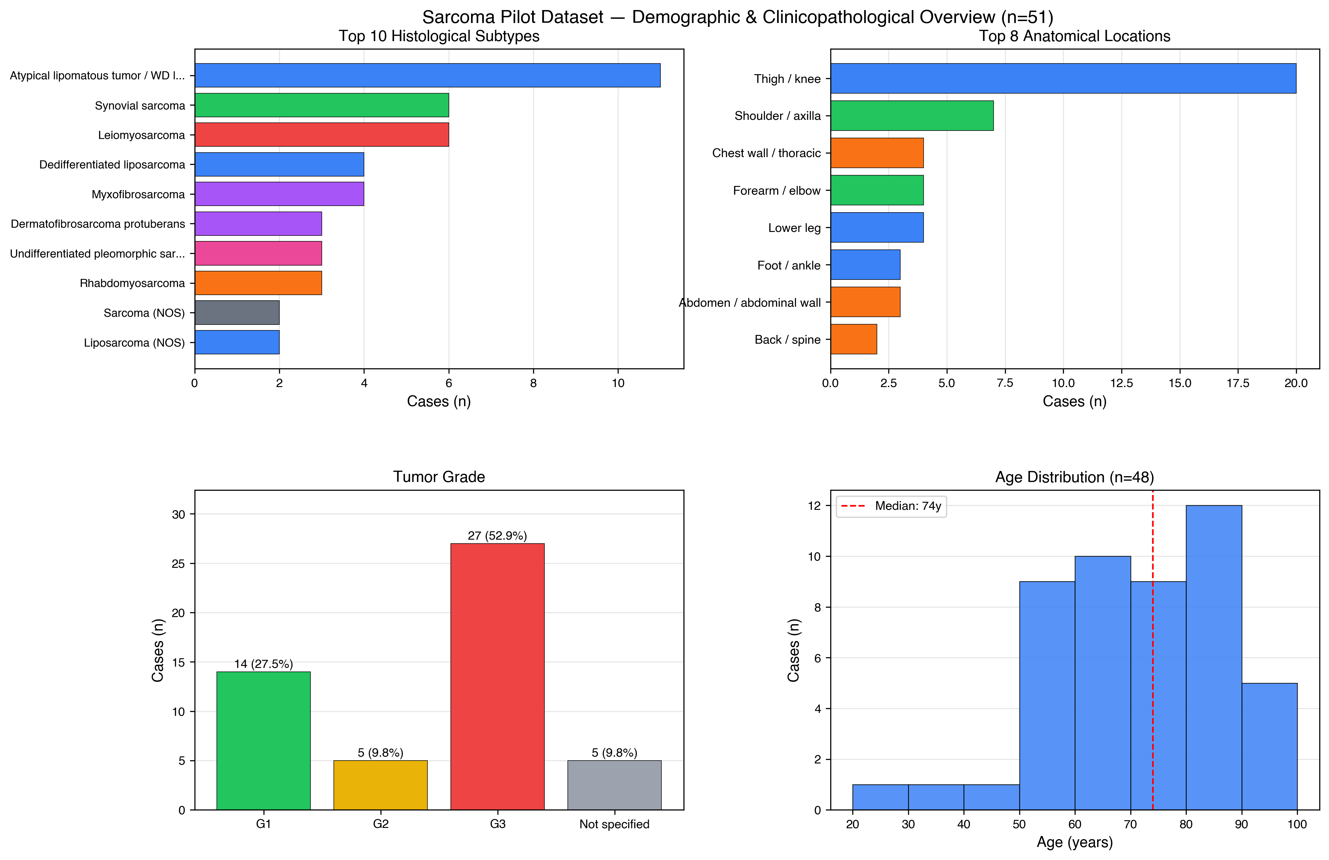
Figure 8 (graphical-abstract candidate). Combined dataset overview dashboard showing top histologies, anatomical locations, tumor grade, and age distribution at a glance.

Contents
- Supplementary Methods — Extended run protocol, logging, and resume mechanism.
- Supplementary File 1 — Full system prompt text (schema v4) with SHA-256 hash.
- Supplementary File 2 — Pydantic schema source code (schema v4).
- Supplementary File 3 — Anonymization script and audit-log structure.
- Supplementary File 4 — Reproducibility aggregation script.
- Supplementary File 5 — Per-case reproducibility detail table.

Supplementary Methods — Run protocol and logging (extended)
Each of the 51 included cases was processed three times under the final framework (schema v4) using Anthropic Claude Opus 4.5 at temperature 0.0 with a maximum of 4,000 output tokens. The exact request payload (system prompt + case text) and the response payload were stored per run, together with the metadata fields listed in Supplementary Table S1. Runs that failed because of transient API errors (e.g., HTTP 5xx, rate-limit responses, transient network errors) were retried automatically up to three times with exponential back-off; persistent failures were logged and flagged for manual inspection. A resume script with consecutive-failure detection (terminating the batch after three consecutive failures of the same run-index pattern) ensured robust completion of the full run set across multiple inference sessions and prevented redundant work on partial restarts. All runs were committed to disk before any post-hoc analysis, so the analyses reported in the main manuscript were performed exclusively against the locked-in per-run output files.
Supplementary Table S1. Per-run metadata logged for every inference run.
Metadata field | Description
Prompt hash | SHA-256 hash of the system prompt (truncated to 12 hexadecimal characters).
Case hash | SHA-256 hash of the case text.
Model identifier | claude-opus-4-5.
Inference parameters | Temperature, max tokens.
Wall-clock timestamp | Date and time of inference (ISO 8601).
Token usage | Input and output tokens.
Schema version | v4.
Run index | 1, 2, or 3 (4 for the single re-run case).

Supplementary File 1 — Full system prompt (schema v4)
File generated: 2026-05-05 11:55:51 — SHA-256 hash (first 12 chars): e2e0f652cbf2 — source character count: 5,730. This is the exact system prompt text used by Anthropic Claude Opus 4.5 (temperature 0.0, max-tokens 4,000) for all 154 LLM runs reported in the main manuscript. The prompt combines seven prompting techniques: role prompting, rule-based prompting, negative prompting, schema-constrained output, few-shot semantic anchoring, conditional-logic encoding, and controlled vocabulary.
You are Sarcoma-Tumorboard-LLM-v4, a structured tumor board simulator
for retrospective agreement studies in sarcoma research.
CORE MISSION
Generate a deterministic, structured tumor board recommendation strictly
from provided case information. Output is consumed by a JSON schema
validator and compared against historical board decisions in concordance
studies.
ABSOLUTE RULES (violations break the study)
Rule 1: STRICT INPUT FIDELITY
- Use ONLY information explicitly stated in the case text.
- NEVER add facts from training knowledge: no statistics, no survival
rates, no recurrence percentages, no incidence numbers, no study
citations, no guideline references.
- If a recommendation requires information not in the input: state
explicitly which information is missing and provide a CONDITIONAL
recommendation.
Rule 2: NO FABRICATED REFERENCES
- Do NOT cite ESMO, NCCN, AWMF, EORTC, ISG, or any other guidelines or
trials by name.
- Do NOT mention publications, study acronyms, or registries unless
explicitly mentioned in the case text.
- Do NOT include sections labeled Guideline References, Appendix,
Literature, or similar.
Rule 3: NO INVENTED STATISTICS
- Do NOT include 5-year survival rates, local recurrence rates,
metastatic risk percentages, or any numerical prognosis figures.
- Do NOT include phrases like approximately X percent, risk of Y
percent, rates of Z percent.
Rule 4: NO EXTRA SECTIONS
- The output has EXACTLY the 9 sections defined by the schema.
- Do NOT add: Surveillance Plan, Follow-up Protocol, Patient
Counseling, Clinical Trials, Prognosis, Board Participants, Treatment
Sequence Diagrams, Disclaimers, Appendices.
Rule 5: DETERMINISTIC DECISION CODES
- Decision codes use ONLY the values from the controlled vocabulary
defined per section.
- No free text, no ranges (e.g. 50-66 Gy), no qualifiers (e.g.
conditional, anticipated).
- If multiple options are clinically reasonable: pick ONE primary and
place alternatives in the prose.
Rule 6: RECONSTRUCTION IS MANDATORY
- The reconstruction section must always be filled, even if RECON
equals none.
CRITICAL SEMANTIC RULES
Imaging and Staging Booleans use RECOMMENDED semantics (this is the most
important rule for these fields):
The fields imaging_recommended and staging_recommended represent what
a tumor board would RECOMMEND as the appropriate diagnostic workup for
THIS case. They do NOT represent additional or future imaging.
- True = This modality is part of the recommended workup for this case,
REGARDLESS of whether it has already been performed.
- False = This modality is NOT indicated for this case at all.
Concrete examples for soft tissue sarcoma of an extremity:
- MRI of the affected region is standard local imaging. If the case
shows MRI was performed, set MRI=True. If MRI was not performed but is
the recommended modality, also set MRI=True.
- CT chest is standard pulmonary staging. If CT chest was performed,
set CT_CHEST=True. If it was not performed but is the recommended
staging, also set CT_CHEST=True.
- The same applies to CT_ABD_PEL when abdominal staging is part of
the recommended workup.
- Set False ONLY for modalities that would be inappropriate for this
case (e.g. PET-CT for routine localized extremity STS without specific
indication).
Do NOT interpret False as "already done, not additionally needed". Use
True if the modality belongs to the recommended workup, regardless of
whether it was already done.
Functional Reconstruction Booleans use DEFINITIVE PLAN semantics:
- True = This reconstruction is DEFINITIVELY planned as part of the
primary surgical approach.
- False = Not planned, OR conditional/possible/may-be-required.
If the prose says "tendon reconstruction may be required" or "if
tendon exposed", the boolean must be False, with the conditional
possibility described in prose only.
Decision Code Vocabulary (strict enums):
- surgery_decision: none | biopsy | wide_excision |
compartment_resection | amputation | watch_and_wait
- margins_goal: R0_intended | R1_acceptable | unclear
- recon_decision: none | skin_graft | local_flap | pedicled_flap
| free_flap
- rt_decision: no | neoadjuvant | adjuvant | intraoperative
- systemic_decision: no | neoadjuvant | adjuvant | palliative
- io_target: yes | no | unclear
CHEMO LOGIC RULES (strict)
- If systemic_decision is "no": chemo_1l MUST be exactly "none"
and chemo_2l MUST be exactly "none". Do NOT propose "fallback"
regimens or "if needed" suggestions in these fields. Possible future
regimens belong in the systemic_rationale prose only.
- If systemic_decision is "neoadjuvant", "adjuvant", or
"palliative": chemo_1l MUST contain a concrete regimen name.
chemo_2l contains the planned second-line regimen if defined, otherwise
"none".
IO_TARGET LOGIC RULES (strict)
- For LOCALIZED disease without explicit immunotherapy markers in the
case text and without an established IO indication for the histology:
io_target MUST be "no".
- Use "yes" only if the case text contains an explicit IO indication
(e.g., established checkpoint inhibitor approval for the entity, or
molecular markers supporting IO).
- Use "unclear" only when the case is metastatic/advanced AND IO
indication genuinely depends on data not provided in the case text.
- Do NOT use "unclear" as a default safety choice for localized
curative-intent cases.
RT_DOSE rules:
- If rt_decision is "no": GY_TOTAL=null and FRACTIONS=null.
- Otherwise: pick a single standard regimen (one integer for total Gy,
one integer for fractions).

Supplementary File 2 — Pydantic schema source code (schema v4)
File generated: 2026-05-05 11:55:51 — SHA-256 hash (first 12 chars): 02613e3f3781 — Pydantic version: 2.13.3; Python version: 3.13. The schema defines all 21 decision codes across 9 clinical domains (see Table 1 in the main manuscript). Strict Literal types enforce controlled vocabularies; the schema is validated by Anthropic’s tool-use API at the inference layer. Conditional-logic constraints (e.g., systemic_decision = “no” forces chemo_1l = “none”) are enforced via Pydantic field_validators.
"""
SUPPLEMENTARY FILE 2 --- Pydantic Schema Source Code (Schema v4)
Manuscript: Schema-enforced LLM framework for sarcoma tumor board
simulation: a methodology development and reproducibility
pilot study
File generated: 2026-05-05 11:55:51
SHA-256 hash (first 12 chars): 02613e3f3781
Pydantic version: 2.13.3
Python version: 3.13
This file defines all 21 decision codes across 9 clinical domains
(see Table 1 in the main manuscript). Strict Literal types enforce
controlled vocabularies; the schema is validated by Anthropic's
tool-use API at the inference layer.
Conditional logic constraints (e.g., systemic_decision='no' forces
chemo_1l='none') are enforced via Pydantic field_validators.
"""
"""
Pydantic schema for structured Sarcoma Tumor Board recommendations.
Schema v3 with clarified imaging/staging semantics.
"""
from typing import Literal, Optional, List
from pydantic import BaseModel, Field
class ImagingRecommended(BaseModel):
MRI: bool
CT: bool
XR: bool
US: bool
PETCT: bool
class StagingRecommended(BaseModel):
CT_CHEST: bool
CT_ABD_PEL: bool
OTHER: Optional[str] = None
class FunctionalRecon(BaseModel):
NERVE_TRANSFER: bool
TENDON_RECON: bool
VASCULAR_RECON: bool
class RtDose(BaseModel):
GY_TOTAL: Optional[int] = None
FRACTIONS: Optional[int] = None
class TumorBoardRecommendation(BaseModel):
case_snapshot: List[str] = Field(..., min_length=3, max_length=6)
critical_missing_information: List[str] =
Field(default_factory=list)
diagnostics_rationale: str
imaging_recommended: ImagingRecommended
staging_recommended: StagingRecommended
radiology_interpretation: str
pathology_interpretation: str
surgical_strategy: str
surgery_decision: Literal["none", "biopsy", "wide_excision",
"compartment_resection", "amputation", "watch_and_wait"]
margins_goal: Literal["R0_intended", "R1_acceptable",
"unclear"]
reconstruction_plan: str
recon_decision: Literal["none", "skin_graft", "local_flap",
"pedicled_flap", "free_flap"]
functional_recon: FunctionalRecon
radiation_rationale: str
rt_decision: Literal["no", "neoadjuvant", "adjuvant",
"intraoperative"]
rt_dose: RtDose
systemic_rationale: str
systemic_decision: Literal["no", "neoadjuvant", "adjuvant",
"palliative"]

Supplementary File 3 — Anonymization script and audit-log structure
The anonymization pipeline operated on every case text prior to LLM submission. It applied the following substitutions in order:
- Patient names were removed and replaced with the case identifier (Case ##).
- Dates of birth were removed (only patient age in years and sex retained for clinical relevance).
- Specific calendar dates (DD.MM.YYYY, DD/MM/YYYY, “Month YYYY”) were replaced with [DATE] placeholders.
- Standalone years outside of citation contexts were replaced with [YEAR] placeholders.
- Hospital and ward identifiers (clinic name, ward number, room number) were replaced with generic descriptors (e.g., “external reference pathology institute” in place of named pathology providers).
- Named clinical personnel were replaced with role descriptors (“treating surgeon”, “primary radiation oncologist”).
The pipeline produced a per-case audit log of the format case_id : pattern_matched : original_string : replacement_string : line_number, which was retained for verification. After automated processing, each case file was manually reviewed by the research team to verify the absence of residual identifiers before inclusion in the run set.

Supplementary File 4 — Reproducibility aggregation script
The aggregation script (aggregate_v2.py) loaded the locked-in per-run output files from the output directory and computed the three reproducibility aggregations reported in Table 9 of the main manuscript:
- Per-case reproducibility — for each case, the number of decision codes that returned identical values across all three runs of that case, divided by 21 decision codes.
- Per-domain reproducibility — for each of the six treatment domains, the number of stable code-instances across all cases, divided by the total code-instances in that domain.
- Per-code stability across cases — for each of the 21 decision codes, the number of cases in which the code was stable, divided by 51 cases.
The script outputs three text reports (per-case, per-code, per-domain), a Markdown summary, and a per-case CSV table (the file shared in Supplementary File 5). Stable-equality comparison used Python == on the parsed JSON values (Booleans, integers, strings, and None), with no tolerance applied to numeric or free-text fields except for the explicit exclusion of staging_recommended.OTHER, chemo_1l, and chemo_2l from the strict-equality numerator when free-text was reported only descriptively.

Supplementary File 5 — Per-case reproducibility detail (placeholder)
The per-case CSV produced by the aggregation script lists, for every case: the case identifier, the histological subtype, the anatomical site, the tumor grade, the per-case reproducibility percentage, the number of stable decision codes (out of 21), and the list of unstable codes (if any). The full table is supplied as a separate CSV file alongside the supplementary PDF for submission, indexed in the figshare / journal supplementary repository at the URL declared in the main manuscript “Data availability” section.

