Table 1 Means and Standard Deviations for Attentional Measures (K coefficient) for the Full Sample.
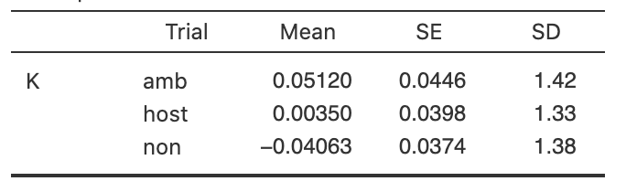
Table 2 Means and Standard Deviations for Interpretive Measures (Intention and Blame Attributions) for the Full Sample.
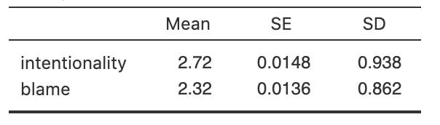
Table 3 Means and Standard Deviations for Attentional Measures (K coefficient) by Group.
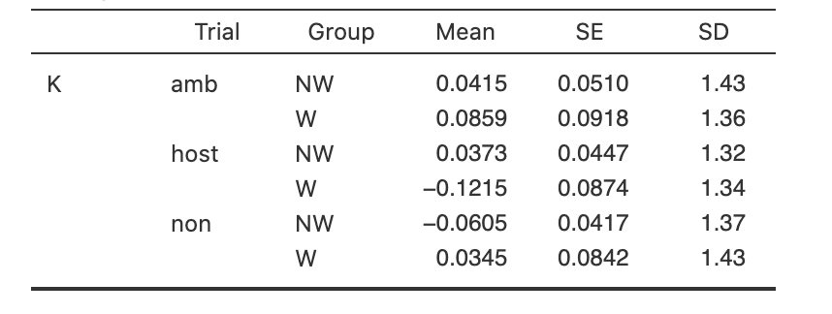
Table 4 Means and Standard Deviations for Interpretive Measures (Intention and Blame Attributions) by Group.
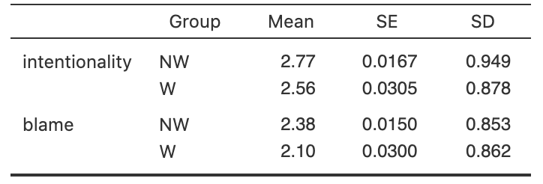

Table 5 Pearson's r Correlation Matrix for Study Variables for the Full Sample, Offenders, and Non-offenders.
Full Sample
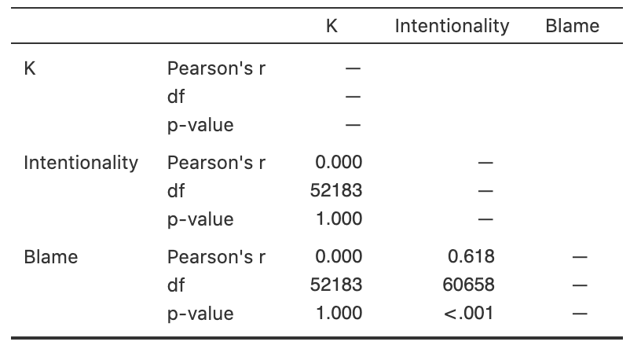
Non-offenders
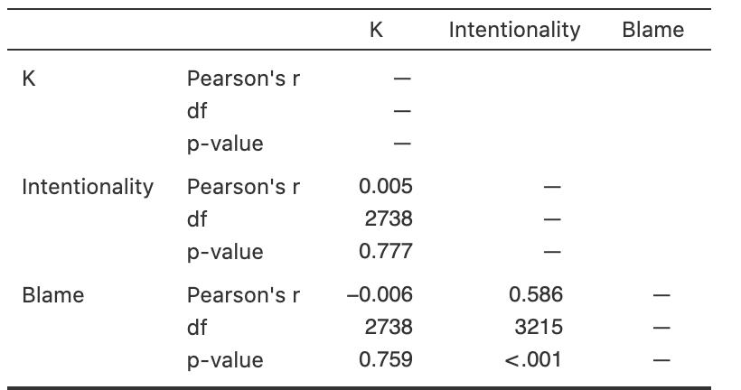

Offenders
