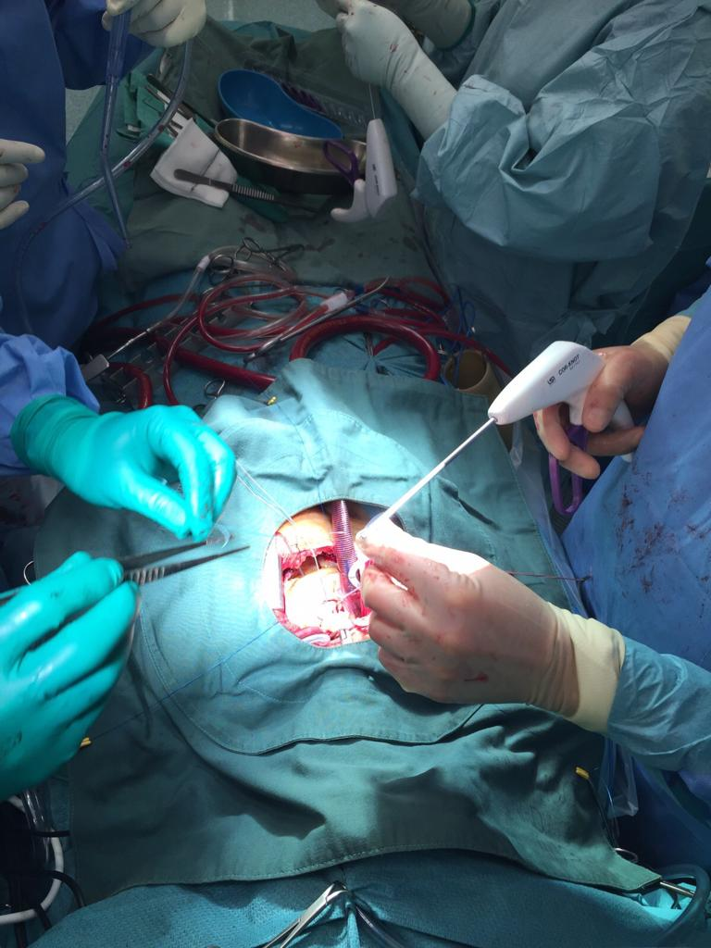

Figure: Corknot preperation during AVR via upper J mini sternotomy
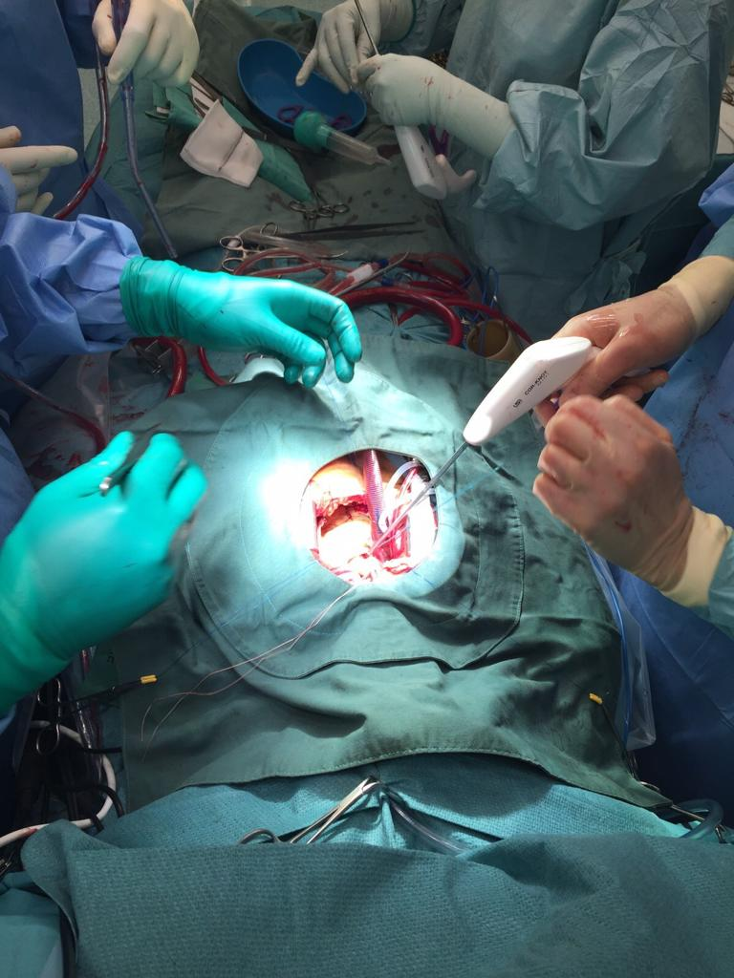

Figure: Corknot Application during AVR via upper J mini sternotomy

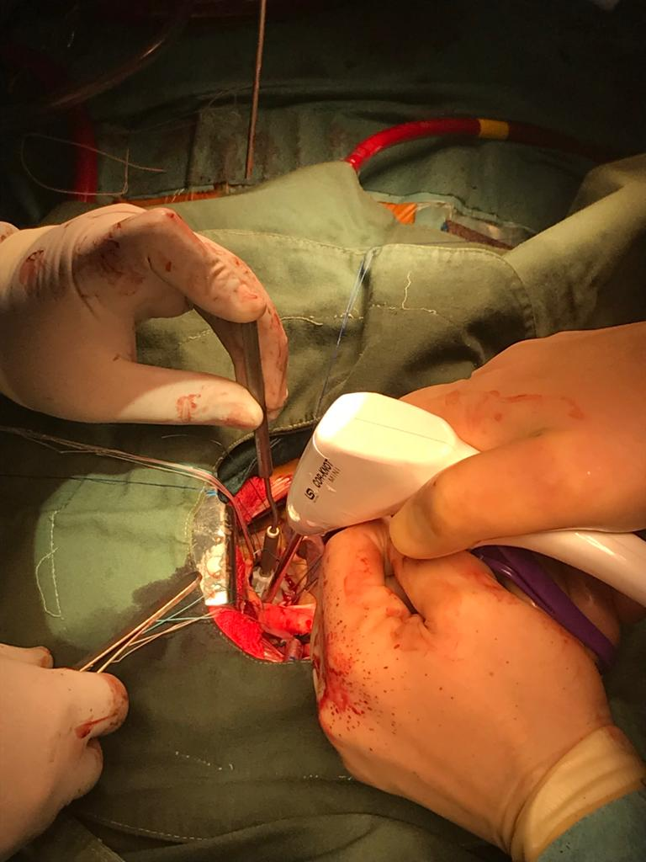

Figure: Corknot delivery during AVR via upper J mini sternotomy

