Comparative study of the compatibility of aliphatic polyketone tercopolymer blends using a technique combining scanning electron microscopy and energy-dispersive X-ray spectroscopy.
.
Shichoon Lee*

*E-mail: tonygren@jwu.ac.kr
*Dept. of Materials Science and Engineering, Jungwon University, 85 Munmu-ro Goesan-eup, Chung-buk,28024, Republic of Korea

Supporting Information.
If SEM/EDS elemental analysis can evaluate compatibility as effectively as TEM observation, it would be a convenient and useful alternative. In this study, a two-step staining method using PTA and OsO4 reagents was performed to enhance the contrast of the PA domains. As can be seen in Supplementary Information Figure 1, the contrast of the domains was enhanced. The TEM image of the PK70/SAN30 blend shows that the size of the dispersed SAN domains is greater than 1 μm, which is consistent with the results of the SEM/EDS analysis.

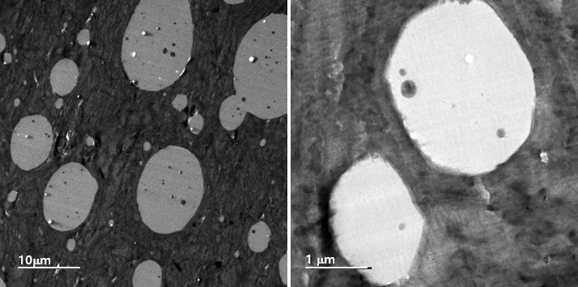
Figure S1, TEM image of PK70/SAN30 blend.

Figure S2 showed of SEM/EDS elemental mapping for the fractured surface perpendicular to the flow direction in PK/SAN blend with the addition as a compatibilizer for PK/SAN/additive = 70/25/5. SAN domain phase and its interface is evident with SEM/EDS O elemental mapping, and its size was getting smaller comparing to that of PK70/SAN30 as seen in figure 1c and 1d.
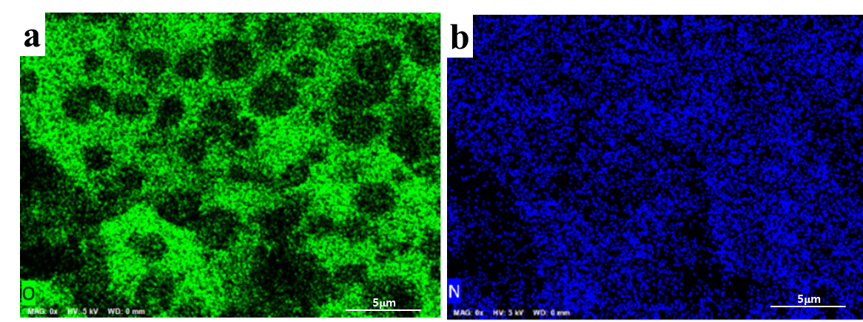
Figure S2. Observation of SEM/EDS elemental mapping for the surface perpendicular to the flow direction in PK/SAN blend with the addition as a compatibilizer for PK/SAN/additive = 70/25/5. a) SEM/EDS O elemental mapping for PK/SAN/additive = 70/25/5, b) SEM/EDS N elemental mapping.

For PK70/SAN30 blend, the matrix and domain were divided left and right based on the SAN domain boundary observed in the SEM image, and their respective background values ​​were calculated. The intensities of at least 15 pulse points in each background region of the SAN domain boundary were averaged, and the standard deviation was calculated. The background values ​​for each matrix and domain were calculated to be 168 and 84, respectively, with a standard deviation of 8.2 or less. The pulse intensity was normalized based on the background values ​​of the PK matrix and SAN domain to 1 and 0, respectively. This allowed us to locate scan distance positions corresponding to 16% and 84% of the background value, respectively. The interfacial thickness was estimated based on the background values ​​between each region; specifically, it is determined by calculating the scan distance from the point where the background line of each region intersects with the region where the pulse intensity rapidly increases or decreases around the vertical dashed line (observed as the domain boundary in the SEM image of Figure 7a).

Table S1. A background value is set, and the interface thickness is estimated based on that background value.
b
0.33μm
0.50μm
30
56
24
0
1.1
2.2
3.3
4.4
5.5
Scan length (μm)
