Supplementary Material
Supplementary Table S1. Variance inflation factors (VIF) for the multivariable Cox regression model.
Variable | VIF
Albumin | 2.15
Charlson Comorbidity Index | 2.08
Prognostic Nutritional Index | 2.08
SOFA score | 1.58
Chronic kidney disease | 1.57
Invasive mechanical ventilation | 1.43
Age at admission | 1.35
Lactate-to-albumin ratio | 1.27
ACAG | 1.20
Congestive heart failure | 1.17
Diabetes mellitus | 1.16
Neutrophil-to-lymphocyte ratio | 1.14
Acute kidney injury | 1.08
Sex (male) | 1.03
Note: VIF = variance inflation factor. A VIF >10 is generally considered indicative of severe multicollinearity requiring remedial action. All VIF values in the final model were <5, confirming the absence of significant collinearity among the 14 covariates. The modest VIF values for albumin (2.15) and ACAG (1.20) support their joint inclusion despite the fact that ACAG incorporates albumin in its calculation, as these two variables capture distinct clinical domains (nutritional status vs. composite acid-base status).

Supplementary Table S2. Sensitivity analysis: multivariable Cox regression for 90-day readmission using the second MICE imputed dataset.
Variable | HR (95% CI) | P-value
Age | 1.00 (0.98-1.02) | 0.869
Male sex | 1.22 (0.84-1.77) | 0.286
SOFA score | 1.00 (0.93-1.06) | 0.890
Charlson Comorbidity Index | 1.03 (0.93-1.13) | 0.600
Acute kidney injury | 1.11 (0.64-1.93) | 0.700
Albumin | 0.76 (0.49-1.18) | 0.221
LAR | 1.10 (0.78-1.55) | 0.599
Invasive mechanical ventilation | 0.91 (0.59-1.40) | 0.660
Congestive heart failure | 1.54 (1.04-2.29) | 0.032
Chronic kidney disease | 1.05 (0.65-1.69) | 0.847
Diabetes mellitus | 1.02 (0.68-1.52) | 0.936
NLR | 1.01 (1.00-1.02) | 0.068
ACAG | 0.96 (0.92-1.00) | 0.069
PNI | 1.01 (0.98-1.04) | 0.452
Note: N = 3,678 patients; 168 events. The model included the same 14 covariates as the primary analysis but used the second MICE imputed dataset (m = 2) instead of the first. Results were consistent with those obtained from the first imputed dataset, supporting the robustness of the primary findings. The marginally non-significant P-value for ACAG (0.069) in this replication reflects inherent variability across imputed datasets rather than a true null effect; the point estimate (0.96) and confidence interval (0.92-1.00) remained consistent with the primary estimate. Abbreviations: HR, hazard ratio; CI, confidence interval.

Supplementary Table S3. Sensitivity analysis: complete-case multivariable Cox regression for 90-day readmission.
Variable | HR (95% CI) | P-value
Age | 1.02 (0.99-1.05) | 0.271
Male sex | 1.64 (0.88-3.06) | 0.121
SOFA score | 0.98 (0.89-1.08) | 0.659
Charlson Comorbidity Index | 0.96 (0.80-1.13) | 0.602
Acute kidney injury | 4.00 (0.54-29.60) | 0.175
Albumin | 1.77 (0.58-5.43) | 0.315
LAR | 1.01 (0.57-1.78) | 0.971
Invasive mechanical ventilation | 1.21 (0.50-2.94) | 0.679
Congestive heart failure | 1.76 (0.94-3.30) | 0.079
Chronic kidney disease | 0.79 (0.35-1.81) | 0.579
Diabetes mellitus | 1.38 (0.73-2.60) | 0.320
NLR | 1.00 (0.98-1.02) | 0.843
ACAG | 0.93 (0.87-1.00) | 0.061
PNI | 0.94 (0.85-1.03) | 0.195
Note: Note: N = 939 patients; 46 events (90-day readmissions). Sample size was reduced owing to listwise deletion of cases with any missing covariate data. The model included the same 14 covariates as the primary analysis. The direction of effect estimates was consistent with the primary MICE-based analysis, although confidence intervals were wider due to the reduced sample size. Abbreviations: HR, hazard ratio; CI, confidence interval.

Supplementary Table S4. Association between missingness of key laboratory variables and 90-day readmission.
Variable | Missing (%) | Readmission rate: missing | Readmission rate: complete | P-value*
Lactate | 38.4% | 4.1% | 4.9% | 0.293
Albumin | 45.5% | 4.2% | 4.9% | 0.341
Blood urea nitrogen | 0.1% | 0% | 4.6% | 1.000
Absolute neutrophil count | 38.3% | 3.4% | 5.3% | 0.009
Absolute lymphocyte count | 38.2% | 3.4% | 5.3% | 0.009
Note: N = 3,678 patients. *P-values were calculated using Fisher's exact test. Missingness of absolute neutrophil count and absolute lymphocyte count was significantly associated with a lower 90-day readmission rate, suggesting that the missing-at-random assumption required for valid multiple imputation may not be fully satisfied for these two variables. See Discussion (Limitations section) for a detailed interpretation of these findings and their implications for the analysis of the neutrophil-to-lymphocyte ratio. Missingness of albumin and lactate was not significantly associated with the primary outcome.

Supplementary Table S5. Number and percentage of missing values for all variables.
Variable | Missing N | Missing %
C-reactive protein | 3,486 | 94.78%
NT-proBNP | 3,237 | 88.01%
Troponin T | 2,475 | 67.29%
Albumin | 1,672 | 45.46%
PaO₂/FiO₂ ratio | 1,527 | 41.52%
Lactate | 1,414 | 38.44%
Absolute neutrophil count | 1,408 | 38.28%
Absolute lymphocyte count | 1,406 | 38.23%
Height | 1,391 | 37.82%
ALT | 1,197 | 32.54%
ALP | 1,195 | 32.49%
Total bilirubin | 1,190 | 32.35%
AST | 1,174 | 31.92%
Marital status | 321 | 8.73%
PTT | 193 | 5.25%
INR | 179 | 4.87%
PT | 179 | 4.87%
Insurance | 17 | 0.46%
Temperature | 9 | 0.24%
BUN | 2 | 0.05%
Note: N = 3,678 patients. Variables are sorted in descending order of missing percentage. Variables with >50% missing data (C-reactive protein, N-terminal pro-B-type natriuretic peptide, and troponin T) were excluded from the multiple imputation model and all subsequent analyses. The remaining variables were imputed using MICE with m = 5 imputed datasets. Variables with 0.00% missing had complete data for all 3,678 patients.

Supplementary Figure Legends

Supplementary Figure S1. Missing data pattern heatmap.

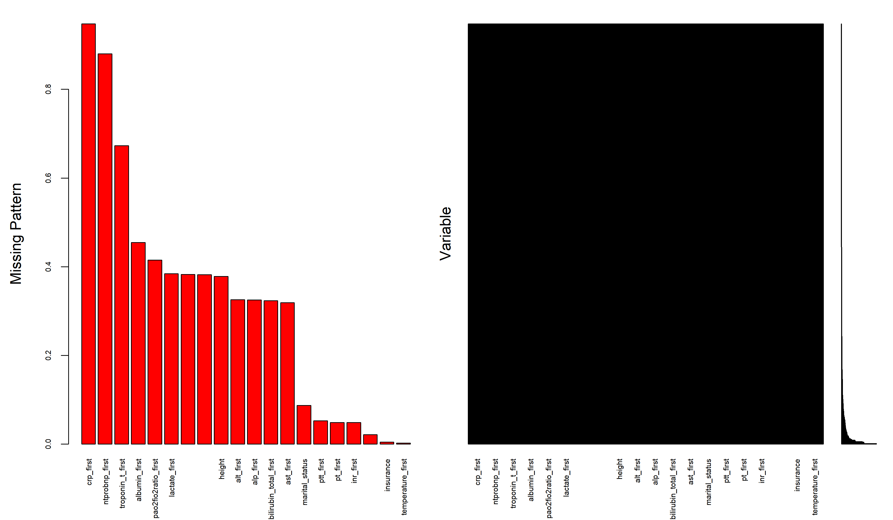
Note: Heatmap displaying missing data patterns for the top 20 variables with the highest percentages of missing values. Each column represents a variable, and each row represents a specific pattern of missingness. Blue indicates observed (non-missing) values; red indicates missing values. The bar chart on the left shows the overall proportion of missing data for each variable. Missingness was concentrated primarily among laboratory-derived variables (e.g., C-reactive protein 94.8%, N-terminal pro-B-type natriuretic peptide 88.0%, albumin 45.5%, lactate 38.4%), while comorbidity diagnoses, demographic characteristics, and severity scores were nearly complete (0-1% missing). This pattern is consistent with the clinical reality of ICU care, in which not all laboratory tests are uniformly performed, whereas administrative and comorbidity data are systematically recorded.

Supplementary Figure S2. Variable importance ranking based on Wald chi-squared statistics from the multivariable Cox model.
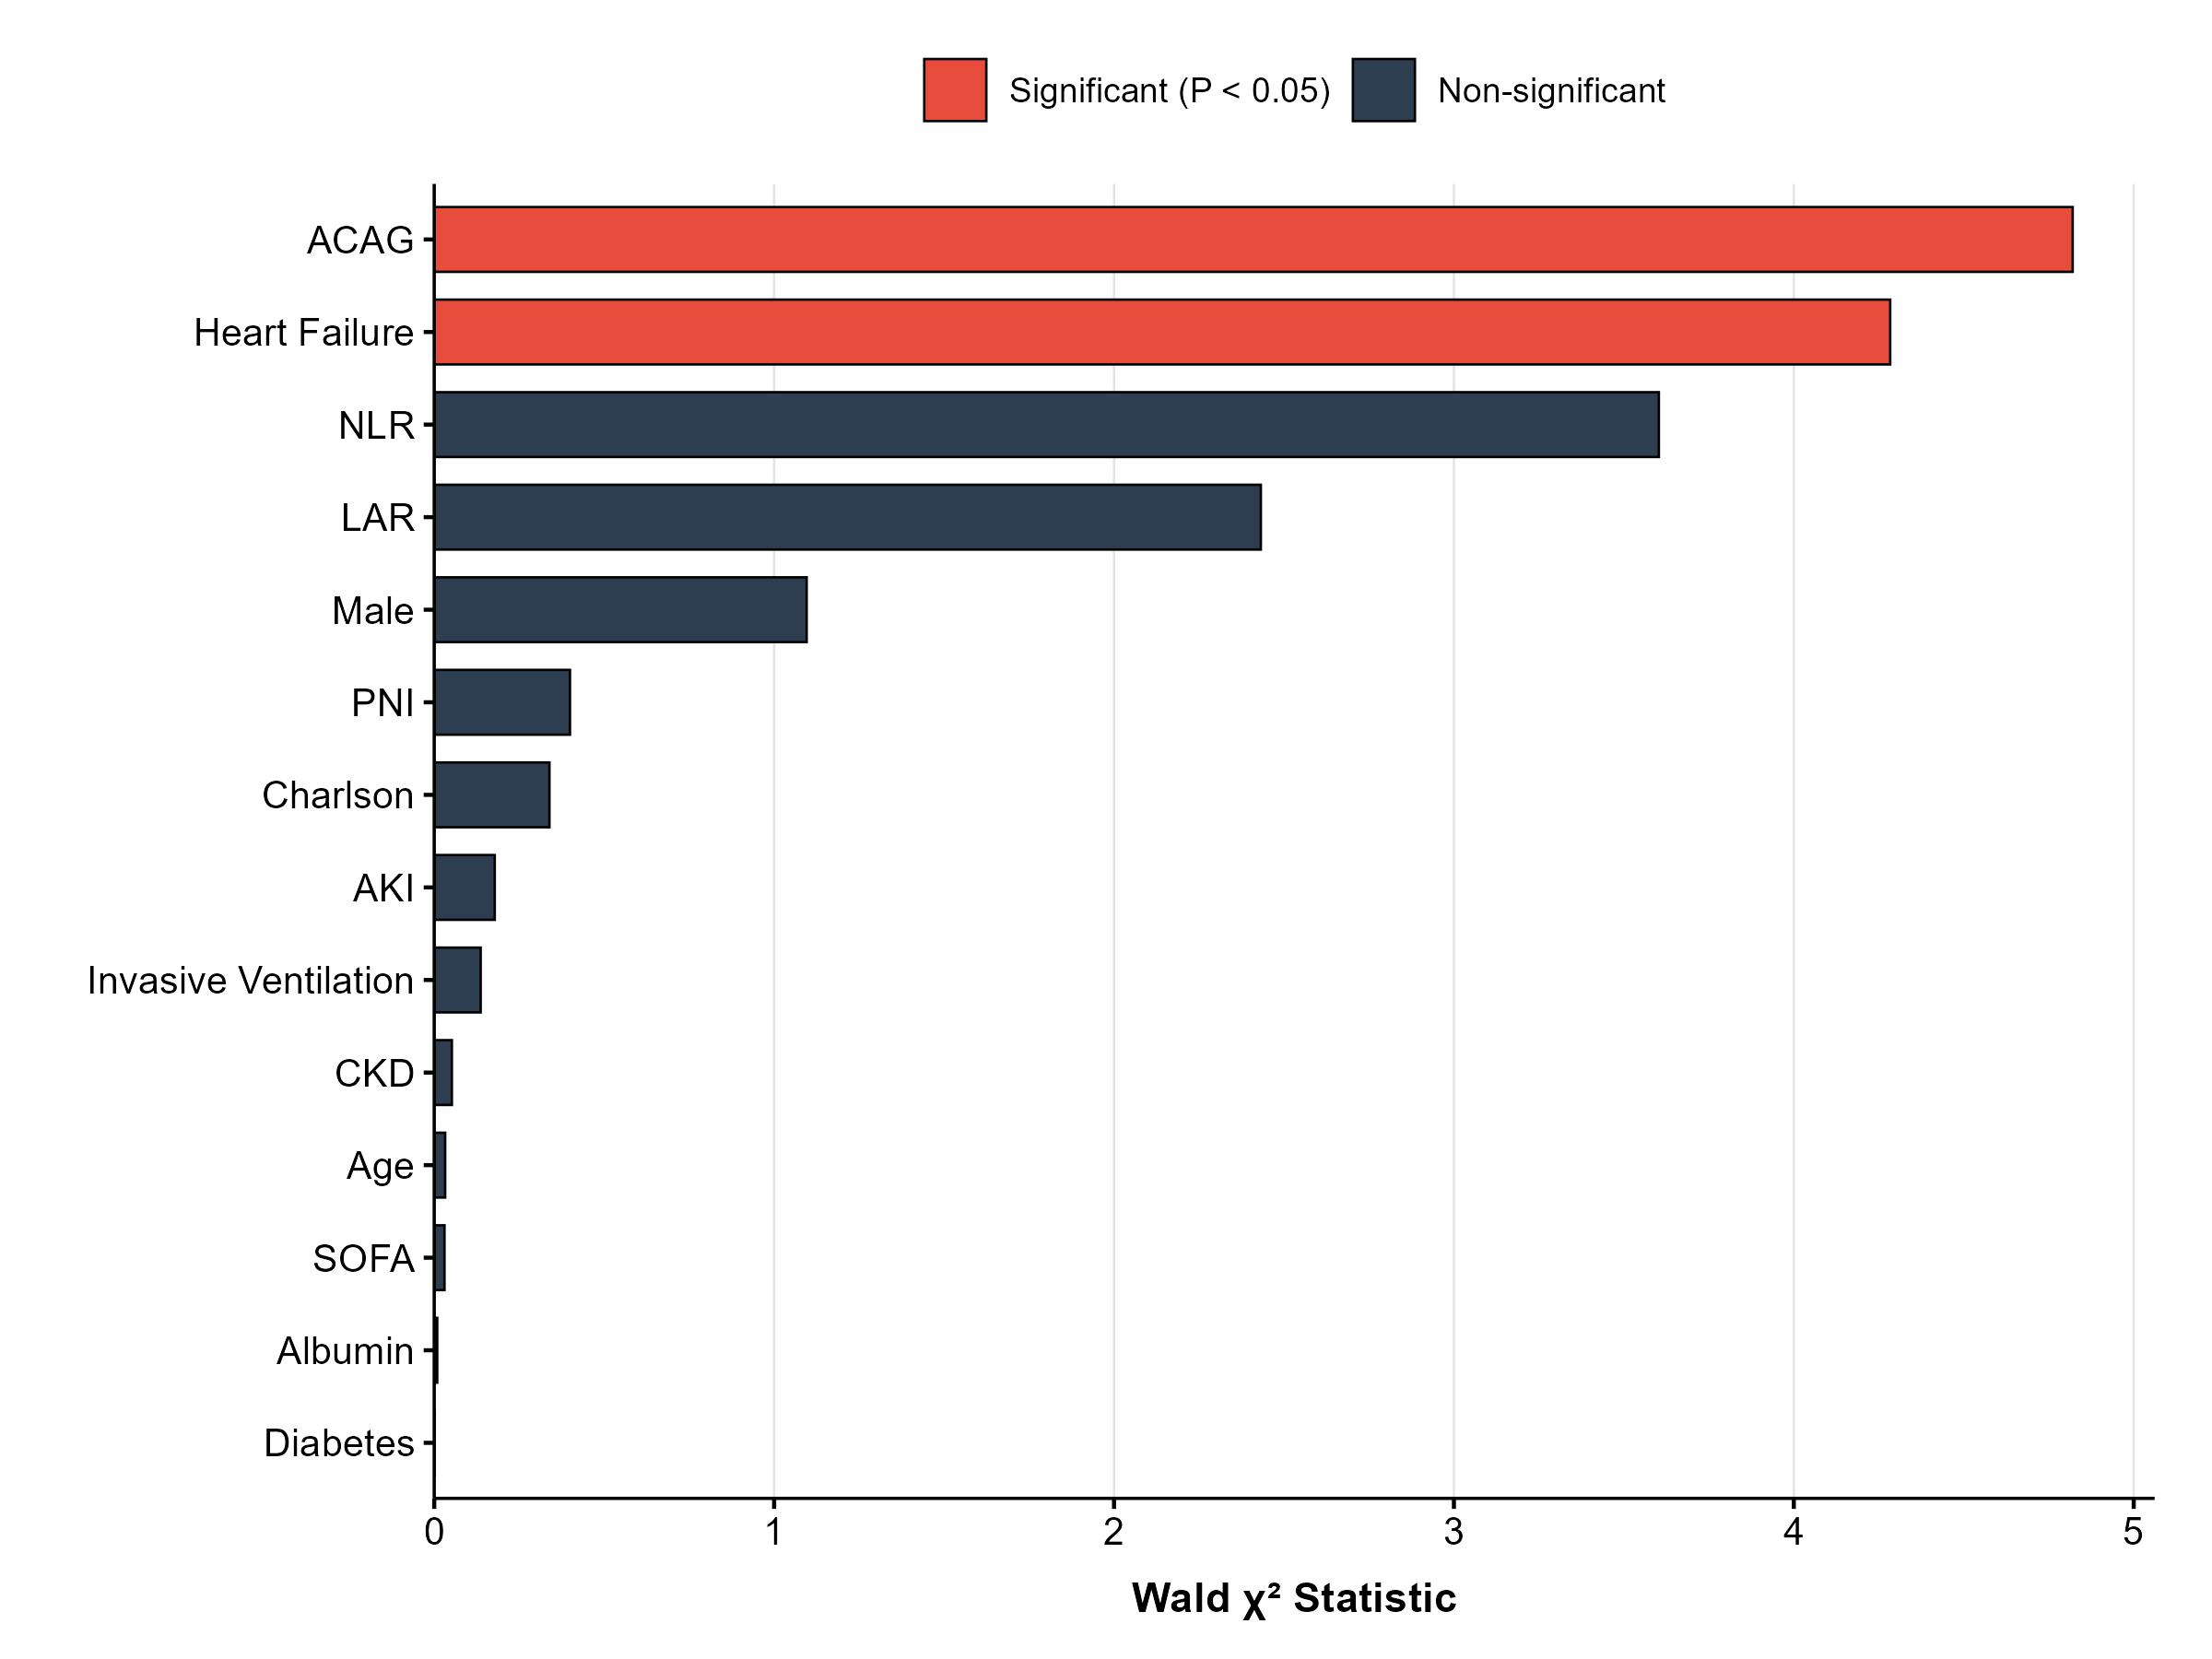
Note: Bar chart showing the Wald chi-squared statistic for each covariate in the multivariable Cox regression model, quantifying its relative contribution to the prediction of 90-day readmission. Red bars denote statistically significant predictors (P < 0.05); dark gray bars denote non-significant predictors (P >= 0.05). ACAG (albumin-corrected anion gap), congestive heart failure, and NLR (neutrophil-to-lymphocyte ratio) were the three most influential predictors in the model. Abbreviations: LAR, lactate-to-albumin ratio; CKD, chronic kidney disease; PNI, prognostic nutritional index; SOFA, Sequential Organ Failure Assessment.

Supplementary Figure S3. Restricted cubic spline (4 knots) for the association between albumin-corrected anion gap and 90-day readmission.

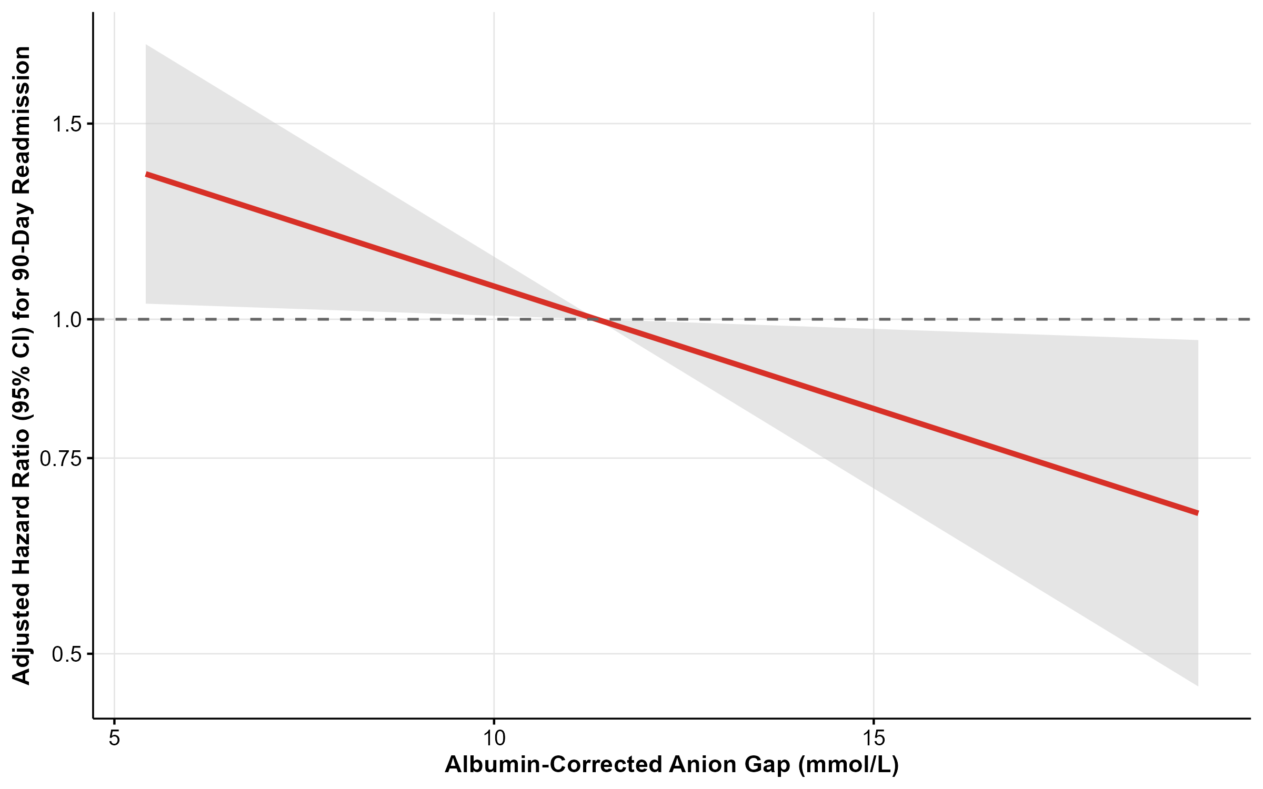
Note: Restricted cubic spline with four knots (located at the 5th, 35th, 65th, and 95th percentiles of the ACAG distribution) showing the adjusted hazard ratio (solid red line) and 95% confidence interval (shaded area) for 90-day readmission as a function of albumin-corrected anion gap (ACAG). The reference value (HR = 1.0) is set at the median ACAG level (11.4 mmol/L). The model was adjusted for age, sex, SOFA score, Charlson Comorbidity Index, acute kidney injury, albumin, lactate-to-albumin ratio, invasive mechanical ventilation, congestive heart failure, chronic kidney disease, diabetes, neutrophil-to-lymphocyte ratio, and prognostic nutritional index. The test for nonlinearity was not significant (P = 0.448), indicating that the protective association between ACAG and readmission is approximately linear within the observed range of ACAG values in this cohort.

Supplementary Figure S4. Subgroup analysis of the association between acute kidney injury and 90-day readmission.

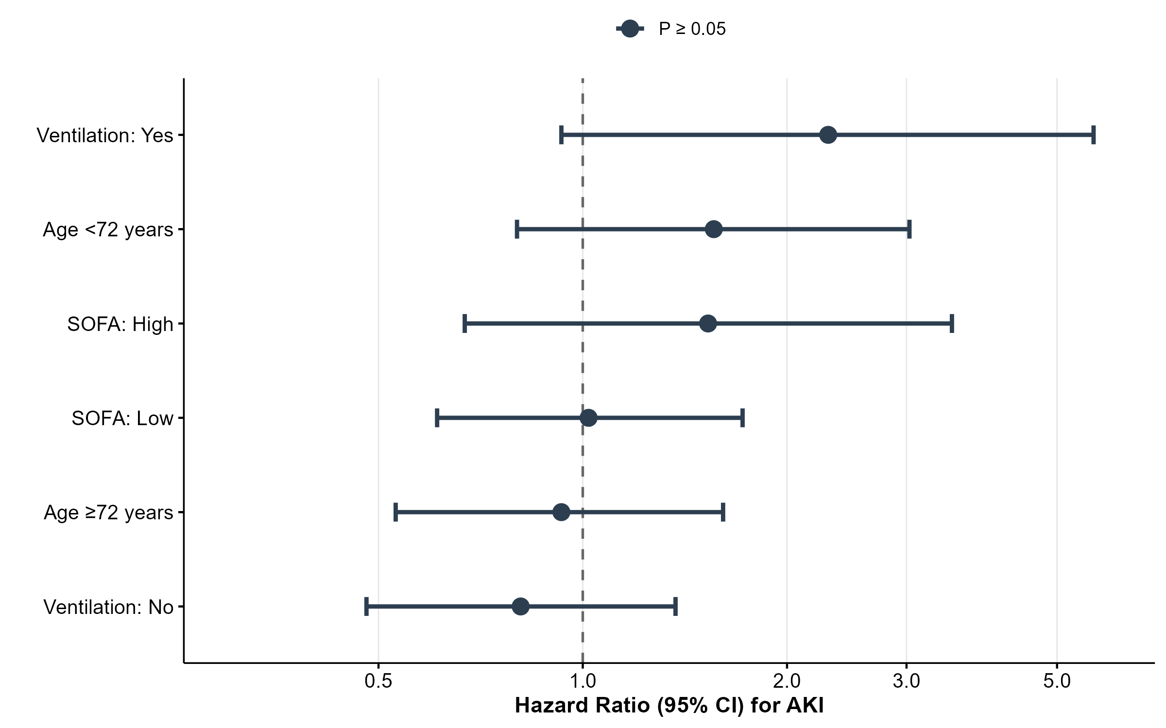
Note: Forest plot of adjusted hazard ratios (HR) for the association between acute kidney injury (AKI) and 90-day readmission across pre-specified subgroups. Hazard ratios were adjusted for age and sex. Horizontal bars represent 95% confidence intervals. All P-interaction values were > 0.05, indicating no statistically significant effect modification. A marginal interaction between AKI and invasive mechanical ventilation (IMV) status was observed (P-interaction = 0.052), with a wider confidence interval in the IMV subgroup reflecting the limited number of events. Given the exploratory nature of this analysis, this finding should be interpreted with caution and warrants replication in larger cohorts.

