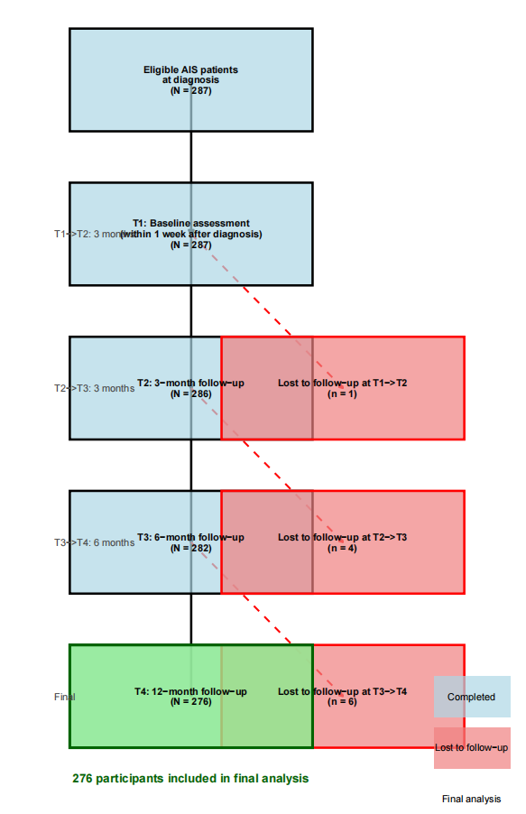
Supplementary eFigure 1. Flow chart from discharge to one-year follow-up at diagnosis

Supplementary eTable 1. Comparison of characteristics between patients included in the study and patients lost to follow-up
Variables | Item | Patients included in the study (n = 276) | Patients lost to follow-up (n = 11) | P
Gender | Man | 136 (49.3) | 5 (45.5) | 0.806
Gender | Woman | 140 (50.7) | 6 (54.5) | 0.806
Age | <12 year | 218 (79.0) | 7 (63.6) | 0.242
Age | ≥12 year | 58 (21.0) | 4 (36.4) | 0.242
Education level | Primary school | 165 (59.8) | 6 (54.5) | 0.683
Education level | Junior high school | 98 (35.5) | 5 (45.5) | 0.683
Education level | High school or above | 13 (4.7) | 0 (0.0) | 0.683
Only-child status | Yes | 169 (61.2) | 8 (72.7) | 0.438
Only-child status | No | 107 (38.8) | 3 (27.3) | 0.438
Monthly household income per capita | <5000 RMB | 74 (26.8) | 5 (45.5) | 0.346
Monthly household income per capita | 5001-10000 RMB | 113 (40.9) | 3 (27.3) | 0.346
Monthly household income per capita | >10000 RMB | 89 (32.2) | 3 (27.3) | 0.346
Primary carer | Father | 85 (59.0) | 7 (63.6) | 0.629
Primary carer | Mother | 48 (33.3) | 4 (36.4) | 0.629
Primary carer | Others | 11 (7.6) | 0 (0.0) | 0.629
Place of residence | Cities and towns | 61 (42.4) | 2 (18.2) | 0.106
Place of residence | Village | 83 (57.6) | 9 (81.8) | 0.106
Family genetic history | No | 125 (86.8) | 8 (72.7) | 0.190
Family genetic history | Yes | 19 (13.2) | 3 (27.3) | 0.190
Combine other health conditions | No | 140 (97.2) | 10 (90.9) | 0.317
Combine other health conditions | Yes | 4 (2.8) | 1 (9.1) | 0.317
Cobb angle (°) | 10-20 | 125 (45.3) | 6 (54.5) | 0.763
Cobb angle (°) | 21-40 | 76 (27.5) | 2 (18.2) | 0.763
Cobb angle (°) | 41-50 | 75 (27.3) | 3 (27.3) | 0.763
Risser sign | 0~1 level | 54 (19.6) | 10 (14.4) | 0.728
Risser sign | 2~3 level | 188 (68.1) | 1 (69.7) | 0.728
Risser sign | 4~5 level | 75 (12.3) | 0 (15.9) | 0.728
Therapy method | Observation + Splint treatment | 257 (93.1) | 10 (90.9) | 0.558
Therapy method | Operative treatment | 19 (6.9) | 1 (9.1) | 0.558

Supplementary eTable 2. Model Selection Criteria of the Growth Mixture Model (GMM) analysis
Class | LL | AIC | BIC |  | aBIC | Entropy | P vaule |  | Class probability
 |  |  |  |  |  |  | LMR | BLRT | Class probability
1 | -3068.063 | 6156.125 |  | 6192.329 | 6160.621 | - | - | - | -
2 | -3013.516 | 6053.031 |  | 6100.097 | 6058.876 | 0.955 | <0.001 | <0.001 | 0.54/0.45
3 | -2918.450 | 5868.899 |  | 5926.826 | 5876.092 | 0.986 | 0.001 | <0.001 | 0.52/0.33/0.15
4 | -2887.280 | 5812.561 |  | 5881.349 | 5821.103 | 0.984 | 0.114 | <0.001 | 0.03/0.33/0.15/0.49
5 | -2860.082 | 5764.163 |  | 5843.812 | 5774.054 | 0.989 | 0.142 | <0.001 | 0.05/0.49/0.03/0.13/0.30

Supplementary eTable 3. Parameter estimates for the three-class model with free estimation
Means |  | SE | t values | P values
Class 1（n=144）
Intercept | 23.075 | 0.312 | 74.032 | <0.001
Slope | 0.610 | 0.041 | 14.881 | <0.001
Class 2（n=91）
Intercept | 32.356 | 0.352 | 91.916 | <0.001
Slope | 1.442 | 0.058 | 24.969 | <0.001
Class 3（n=41）
Intercept | 46.582 | 0.577 | 80.684 | <0.001
Slope | 1.074 | 0.097 | 11.129 | <0.001

Supplementary eFigure 2. Variation within estimated trajectories
Note: Class 1 = stable low-risk group; Class 2 = moderately increasing group; Class 3 = persistent high-risk group.

