Supplementary Materials for

2D Flexible IrO₂ Crystal Boosting High-efficiency Proton Exchange Membrane Water Electrolysis

Kang Hua¹, Yufeng Qin¹, Yubo Liu¹, Yang Yue¹, Louyu Jing¹, Gang Wang¹, Hengshen Zhao¹, Deren Yang¹*, Jianguo Liu¹*

¹Beijing Laboratory of New Energy Storage Technology, Institute of Energy Power Innovation, North China Electric Power University, 2 Beinong Road, Beijing 102206, P. R. China.

*Corresponding author(s). E-mail(s): yangderen@ncepu.edu.cn; jianguoliu@ncepu.edu.cn

Ι. Supplementary Figures and Tables
Supplementary Figures 1-56
Supplementary Tables 1-9
ΙΙ. Supplementary references
Ⅲ. Other Supplementary Materials for this manuscript include the following:
Movies S1 to S3

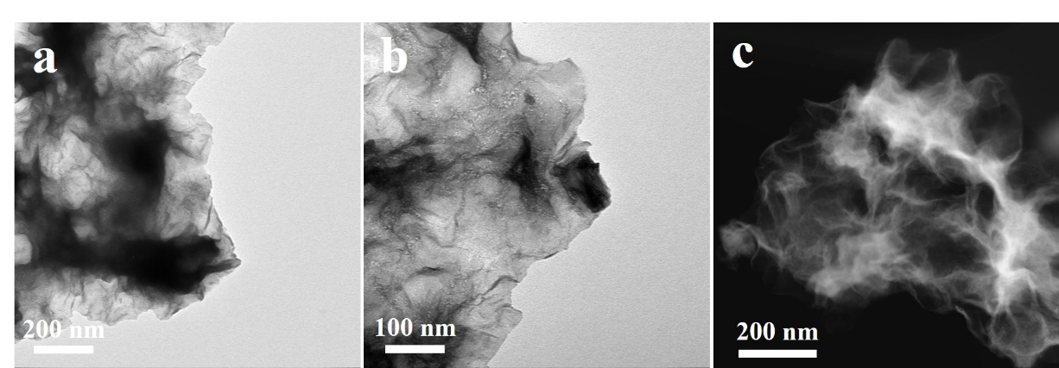
Supplementary Fig. S1. TEM image of flexible IrO₂.

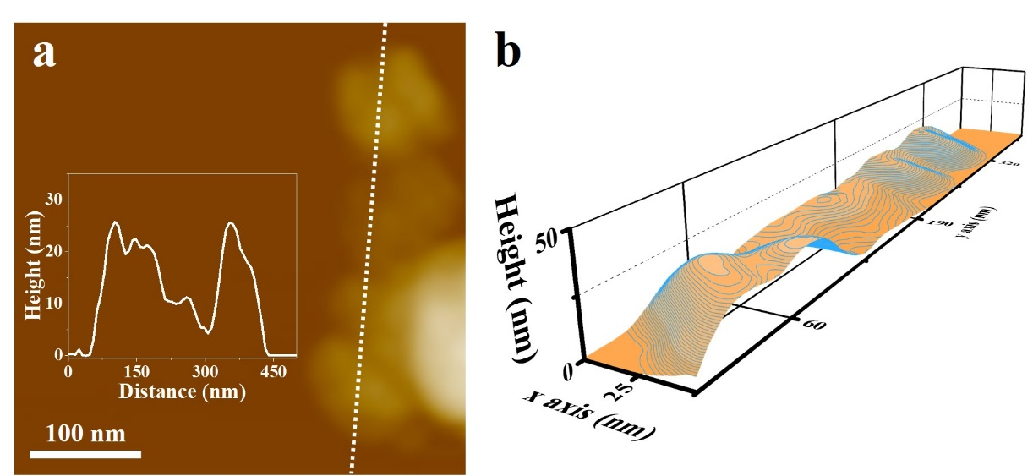
Supplementary Fig. S2. 3D AFM image of flexible IrO₂ on a mica substrate.

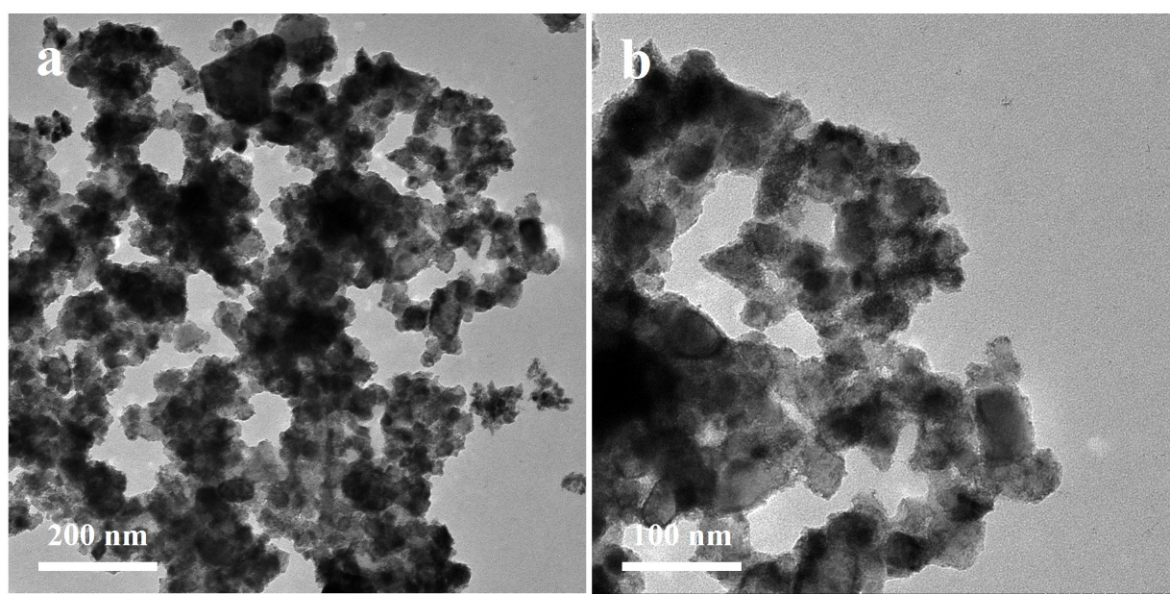
Supplementary Fig. TEM images of IrO₂ NPs.

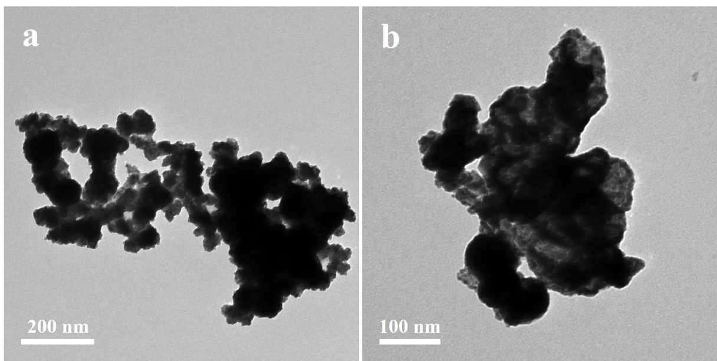
Supplementary Fig. S4. TEM images of Com. IrO₂ (Umicore).

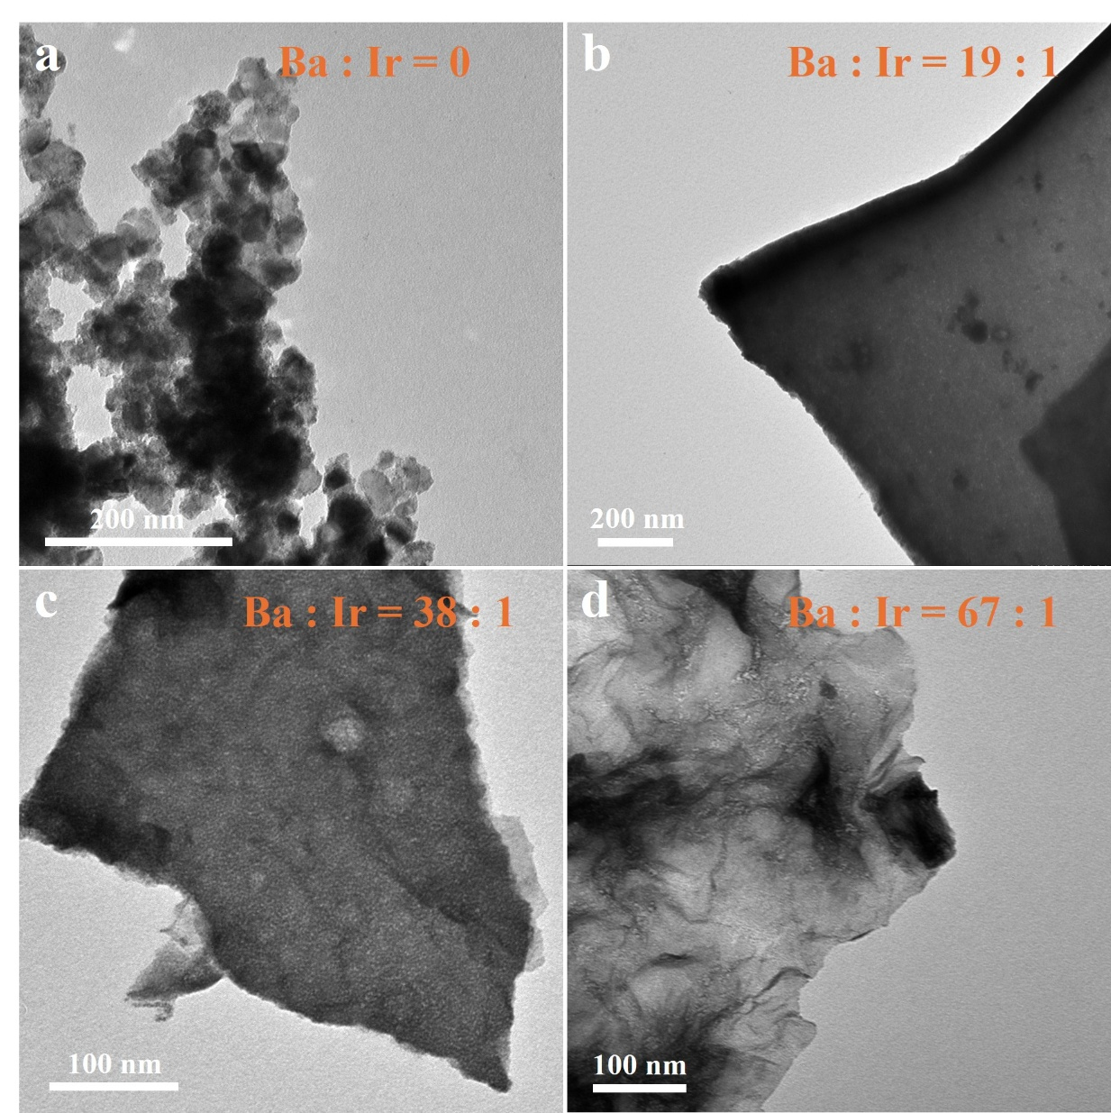
Supplementary Fig. S5. TEM images of IrO₂ synthesized with molar ratios of Ba to Ir of (a) 0, (b) 19:1, (c) 38:1 and (d) 67:1, respectively.
Supplementary Fig. S6. XRD patterns of IrO₂ synthesized molar ratios of Ba to Ir of 0, 19:1, 38:1 and 67:1, respectively

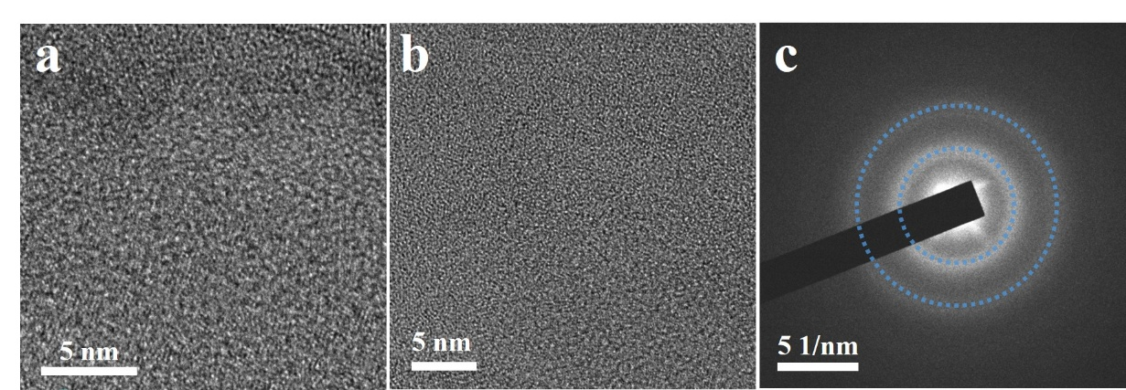
Supplementary Fig. S7. HR-TEM images and corresponding fast Fourier transform (FFT) diagrams of flexible IrO₂.

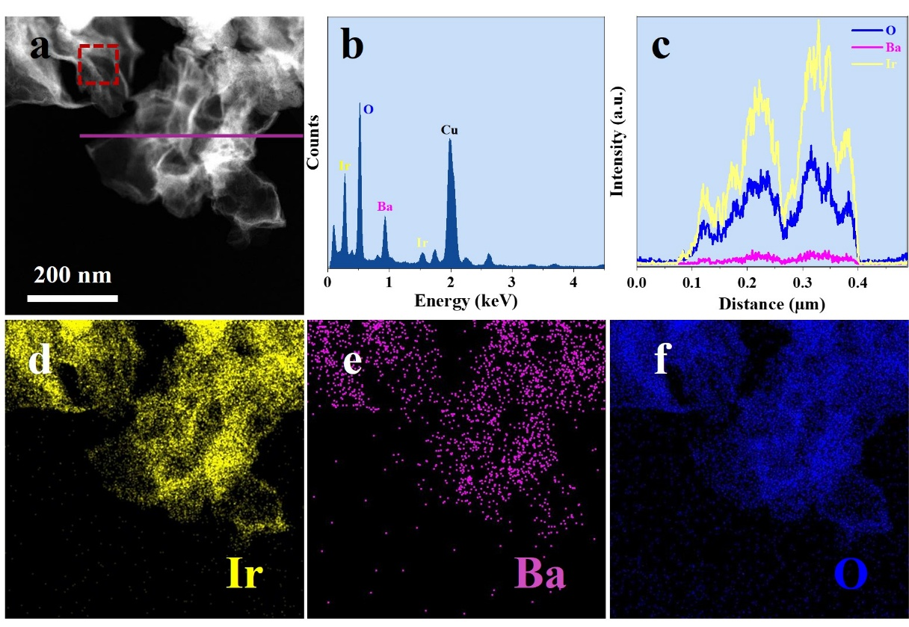
Supplementary Fig. S8. (a) STEM image of flexible IrO₂. (b) EDX spectrum of flexible IrO₂ in the red dashed box of (a). (c) Distribution of Ir, O, and Ba along the purple line in (a). (d-f) elemental mapping of Ir, O, and Ba of (a).

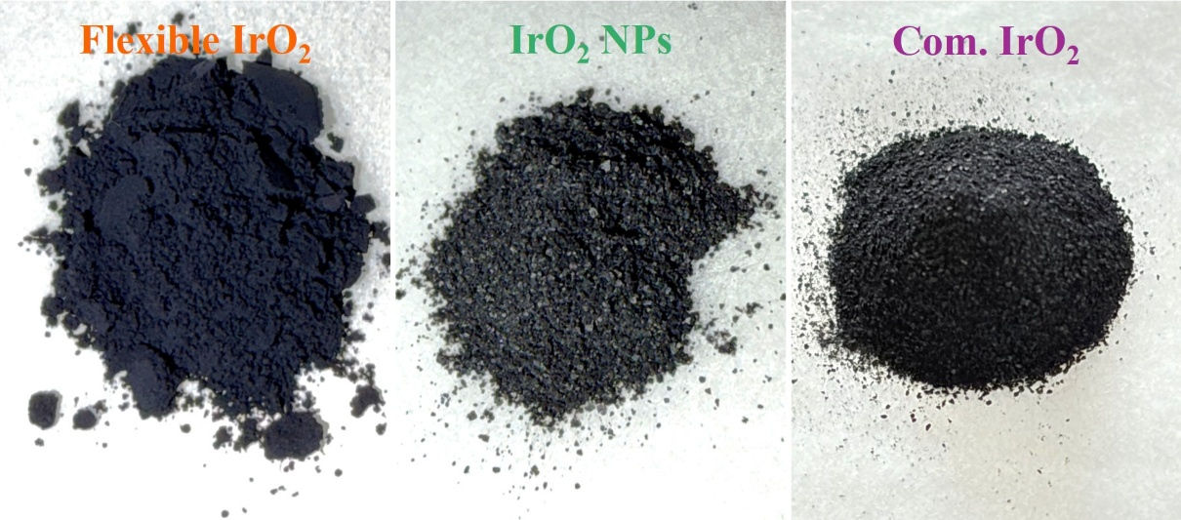
Supplementary Fig. S9. Digital photographs of flexible IrO₂, IrO₂ NPs and Com. IrO₂ (Umicore) on weighing paper.
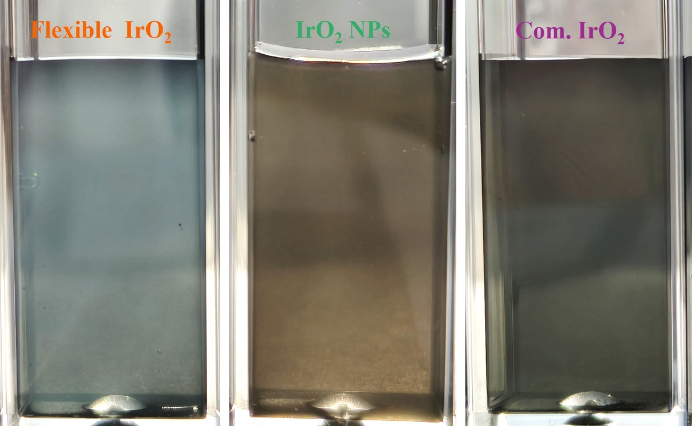
Supplementary Fig. S10. Digital photographs of flexible IrO₂, IrO₂ NPs and Com. IrO₂ (Umicore) dispersed in aqueous solution.

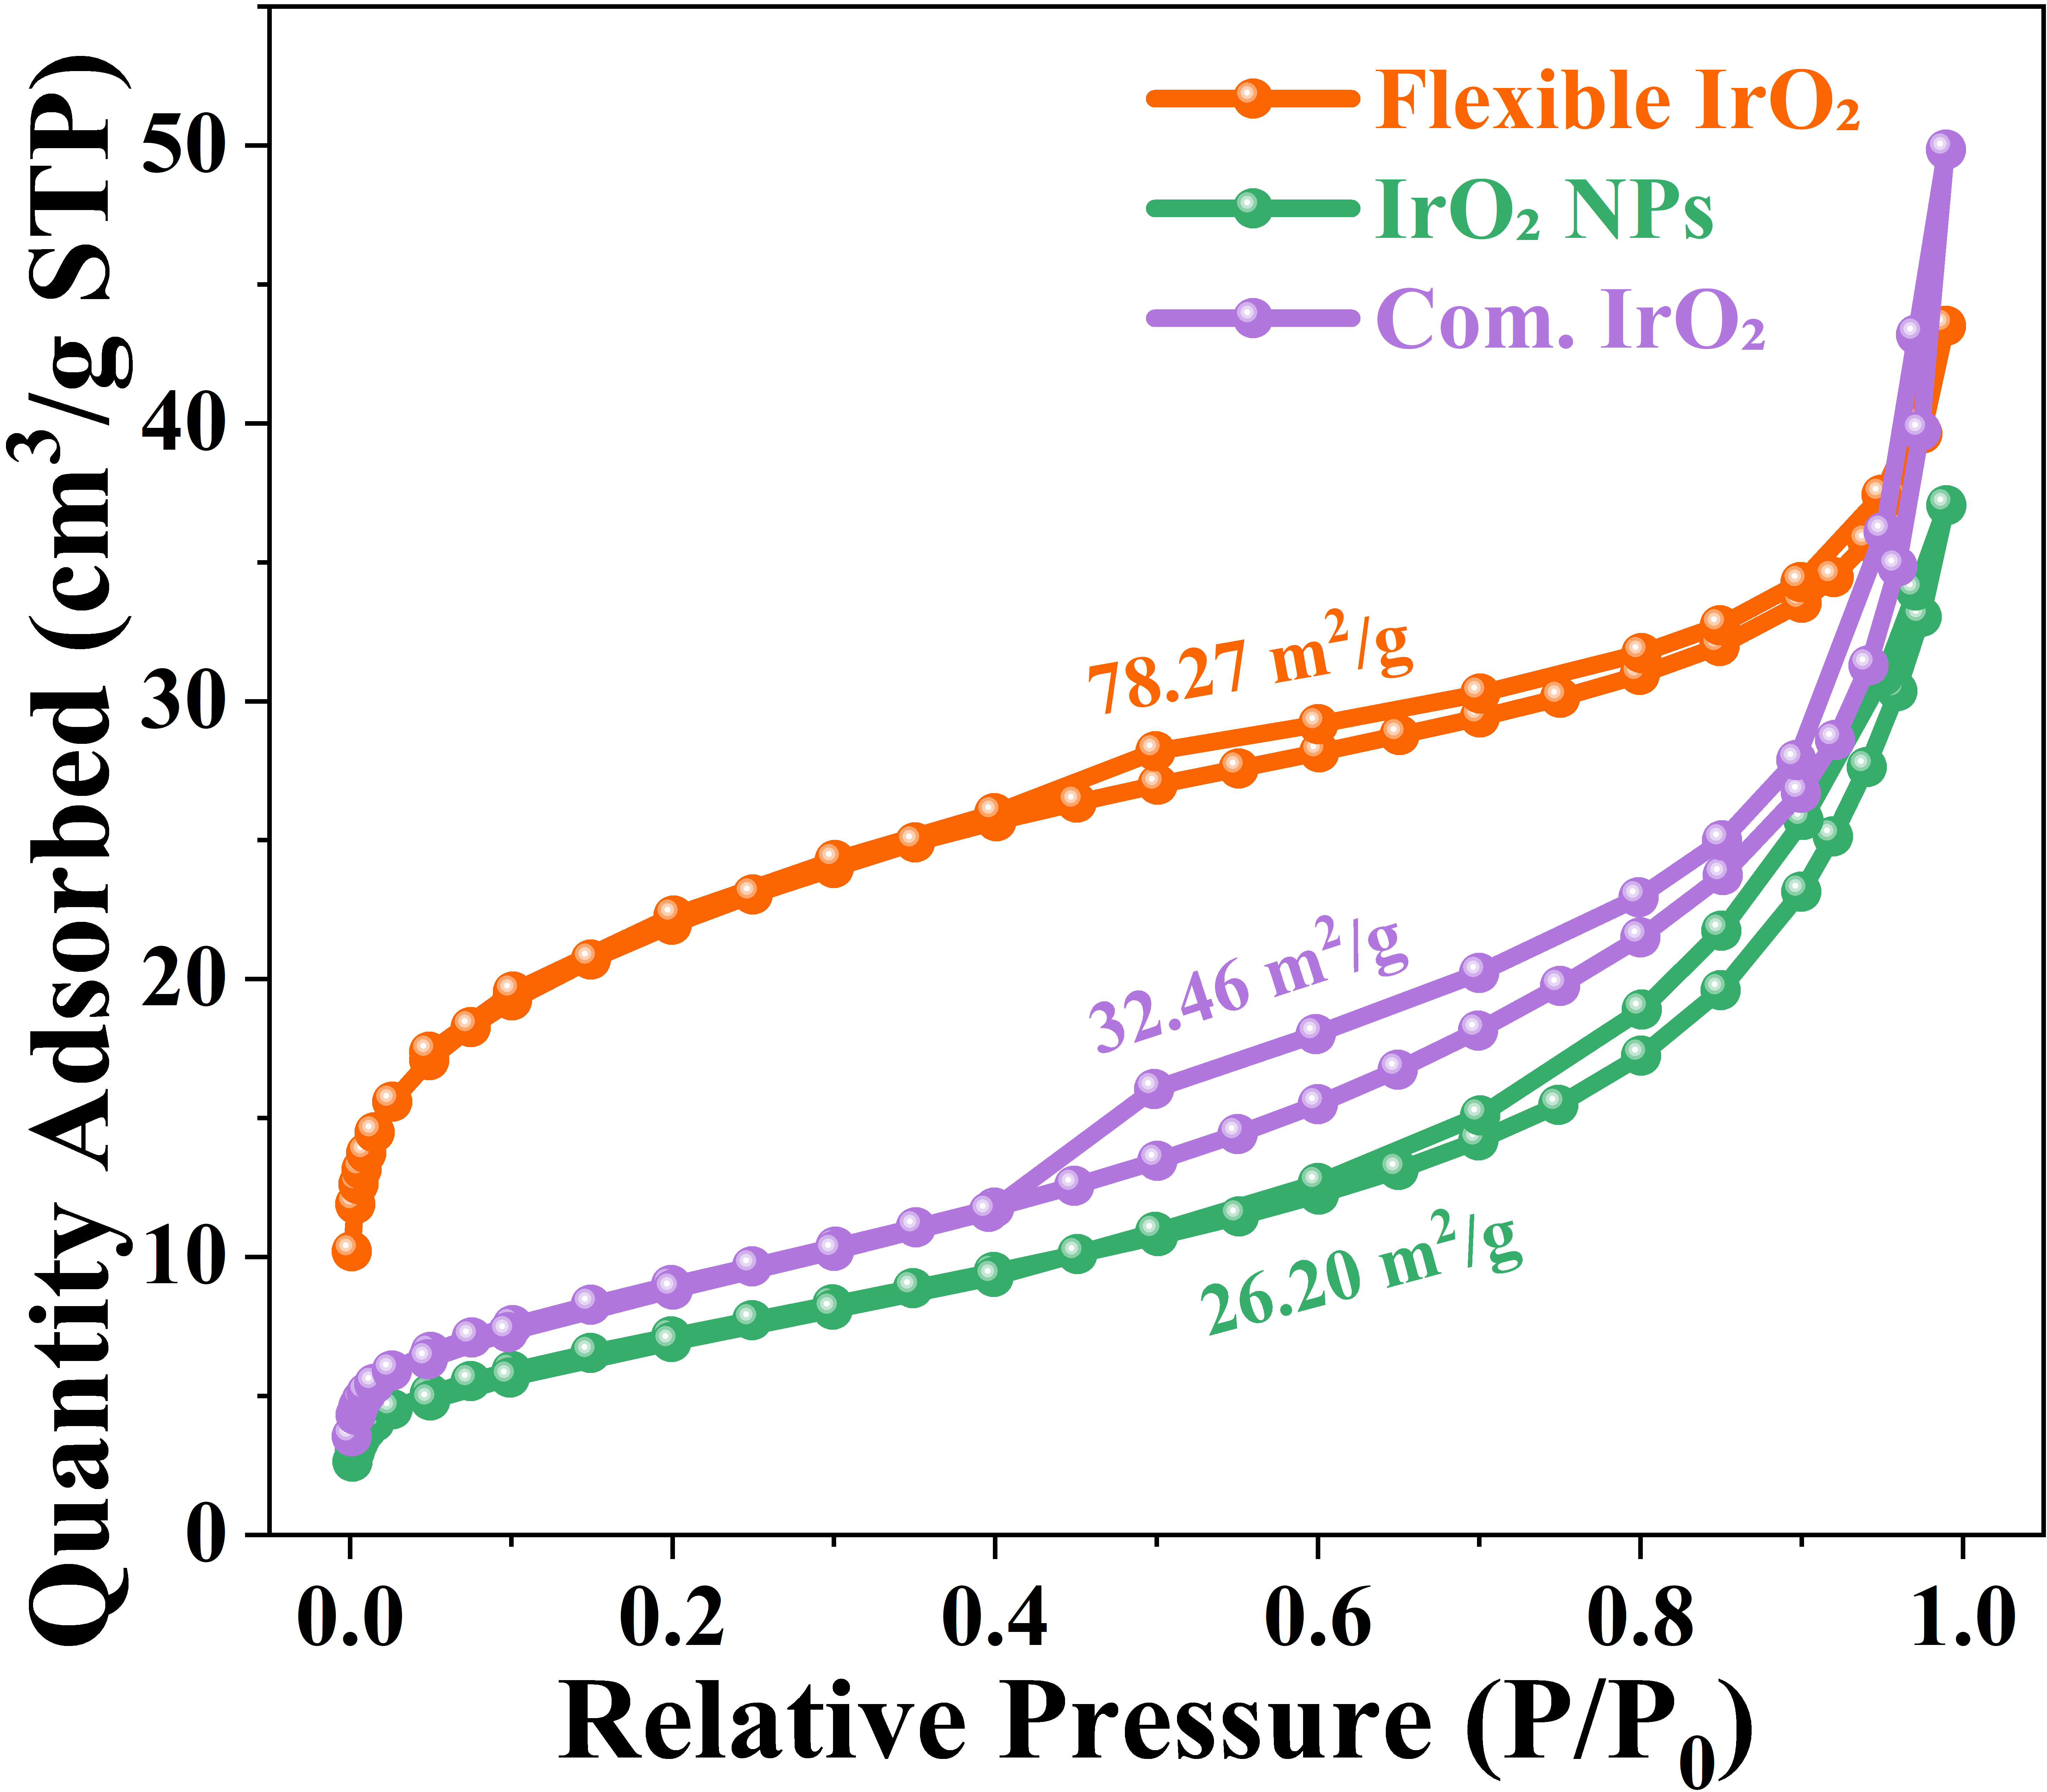
Supplementary Fig. S11. Nitrogen adsorption-desorption isotherms of flexible IrO₂, IrO₂ NPs and Com. IrO₂ (Umicore).

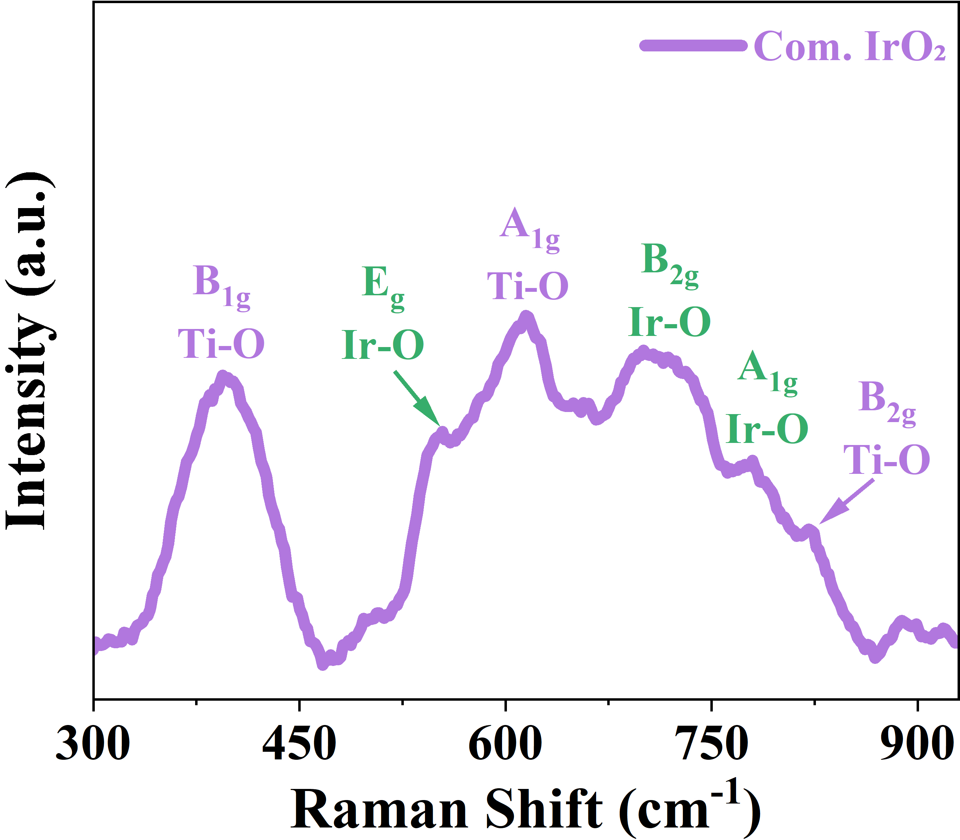
Supplementary Fig. S12. Raman spectra of Com. IrO₂ (Umicore).

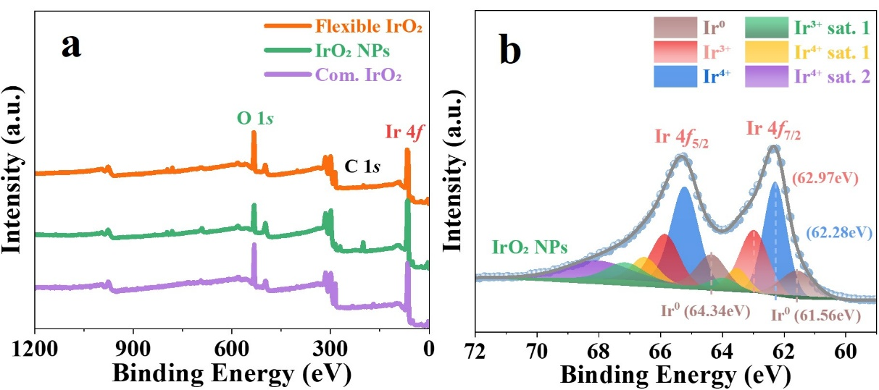
Supplementary Fig. S13. (a) XPS spectra of flexible IrO₂, IrO₂ NPs and Com. IrO₂ (Umicore), respectively. (b) Ir 4 f XPS spectra of IrO₂ NPs.
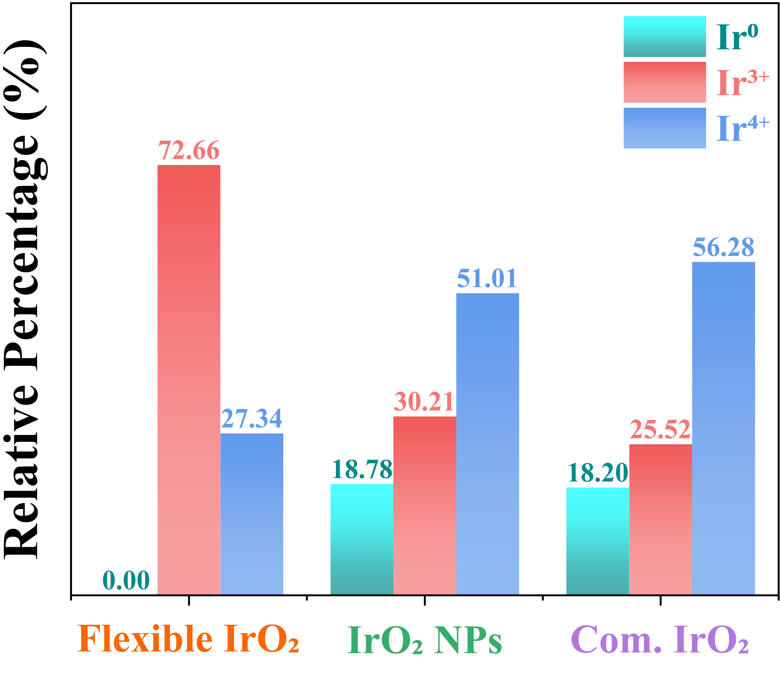
Supplementary Fig. S14. Comparison of the relative percentages of Ir in different oxidation states in flexible IrO₂, IrO₂ NPs and Com. IrO₂ (Umicore).

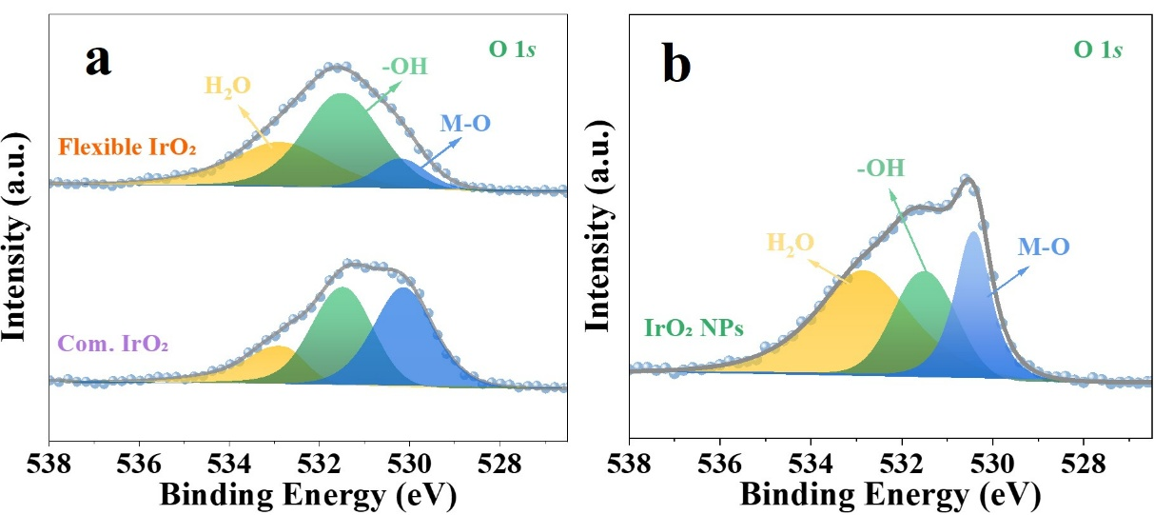
Supplementary Fig. S15. (a) O 1s XPS spectra of flexible IrO₂ and Com. IrO₂ (Umicore). (b) O 1s XPS spectra of IrO₂ NPs.

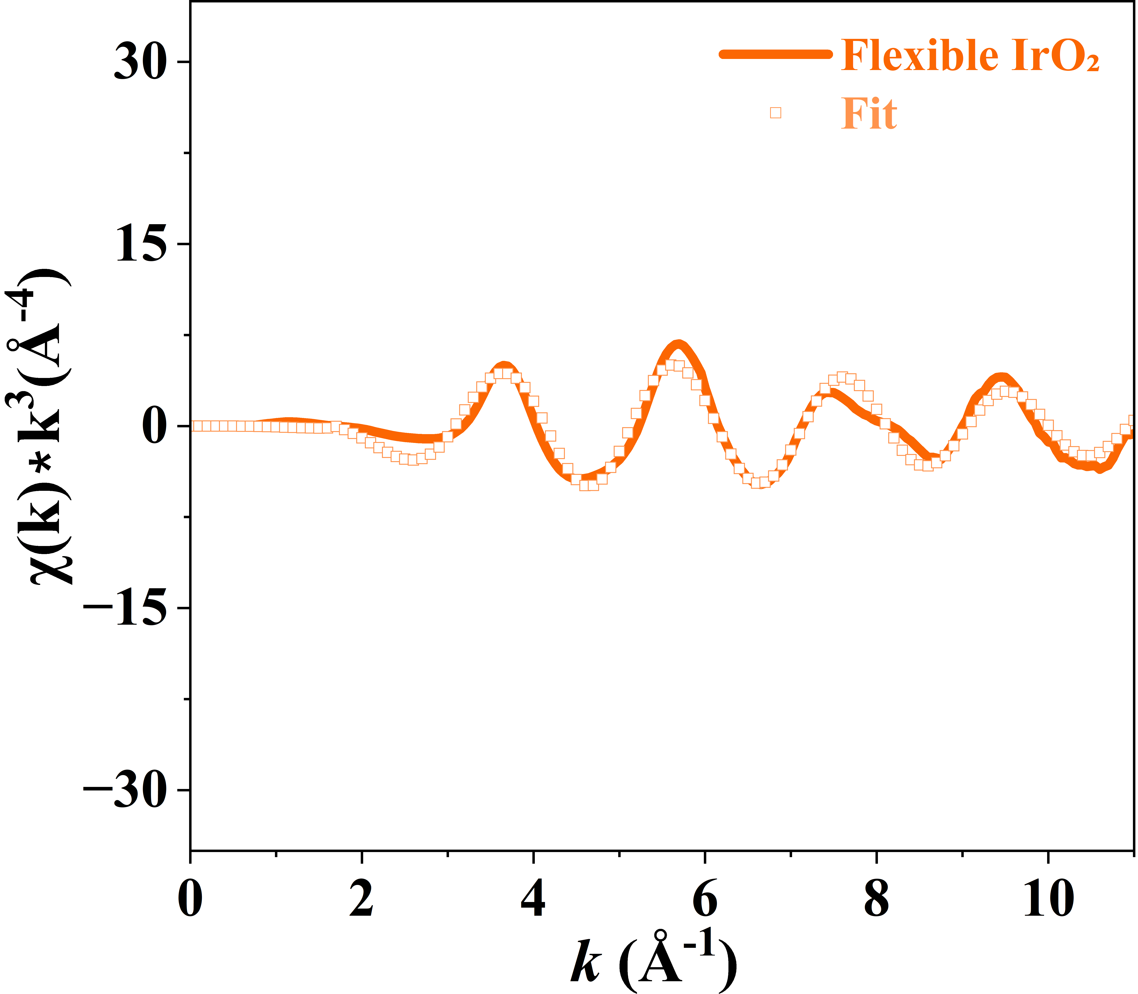
Supplementary Fig. S16. Fitting curves of the FT-EXAFS spectra of Ir in k space for flexible IrO₂.

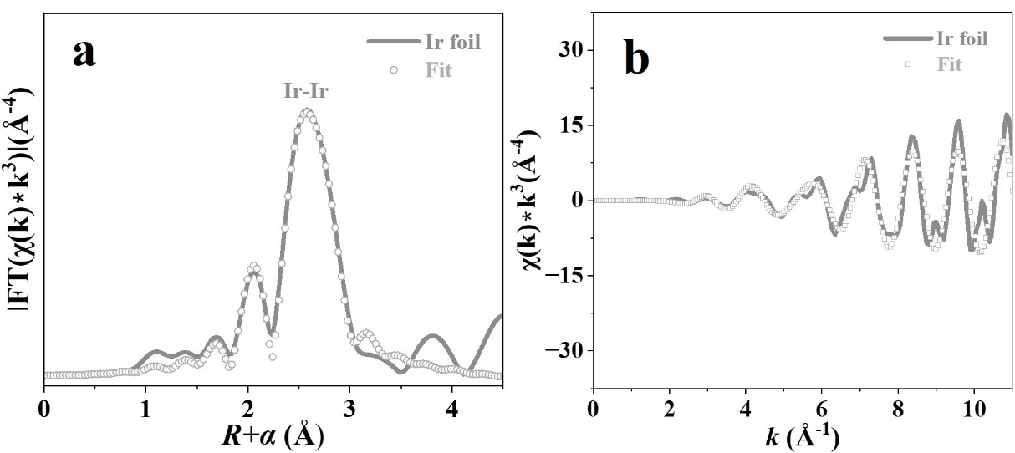
Supplementary Fig. S17. Fitting curves of the FT-EXAFS spectra of Ir in (a) R space and (b) k space for Ir foil.
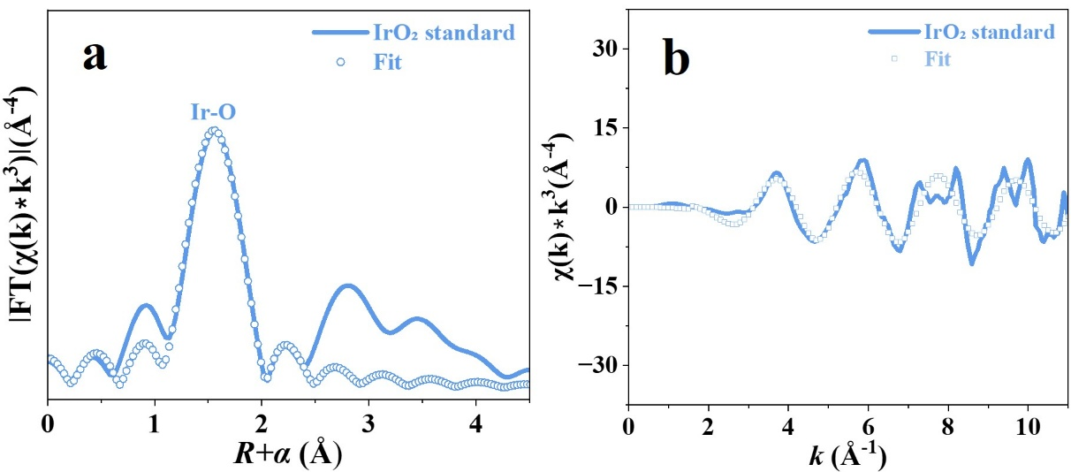
Supplementary Fig. S18. Fitting curves of the FT-EXAFS spectra of Ir in (a) R space and (b) k space for IrO₂ standard.

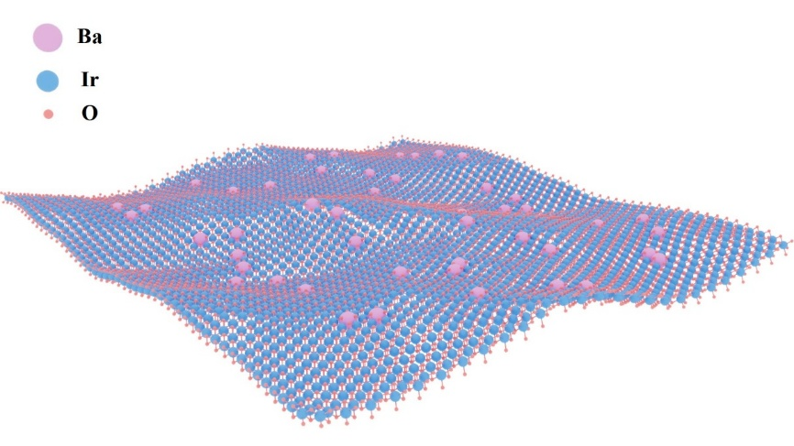
Supplementary Fig. S19. The structural model of flexible IrO₂ was constructed based on morphological characterization results.
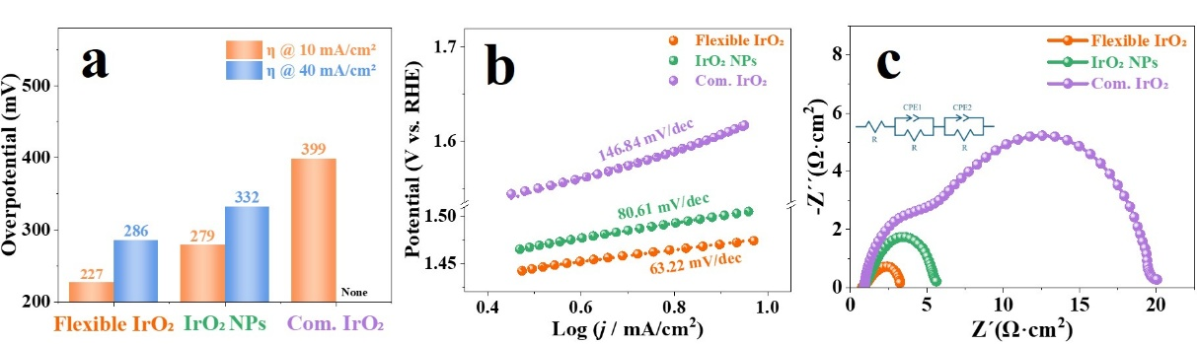
Supplementary Fig. S20. (a) Overpotentials to reach 10 and 40 mA/cm² for flexible IrO₂, IrO₂ NPs, and Com. IrO₂ (Umicore) catalysts on glassy carbon (GC) electrode. (b) Tafel plots and (c) EIS plots of flexible IrO₂, IrO₂ NPs and Com. IrO₂ (Umicore) catalysts on GC electrode.

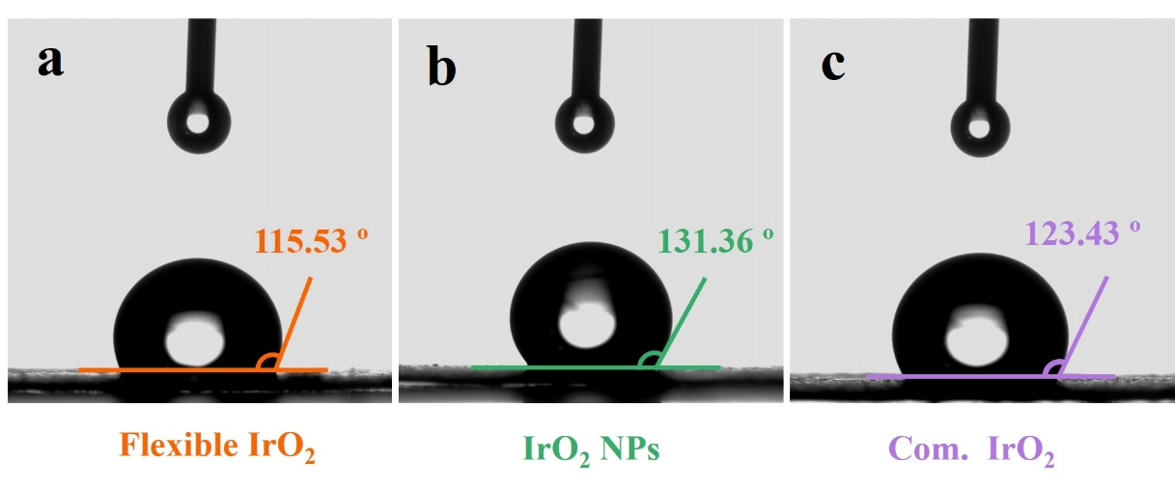
Supplementary Fig. S21. Static water contact angle measurements of (a) flexible IrO₂, (b) IrO₂ NPs and (c) Com. IrO₂ (Umicore) catalysts on carbon paper.
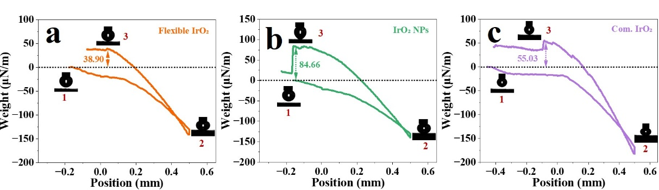
Supplementary Fig. S22. Adhesion test of membrane electrodes to bubbles with (a) flexible IrO₂, (b) IrO₂ NPs and (c) Com. IrO₂ (Umicore) catalysts on MEA, bubbles contact membrane electrode at position 1, are compressed to maximum extent at position 2, and are detached from membrane electrode at position 3.

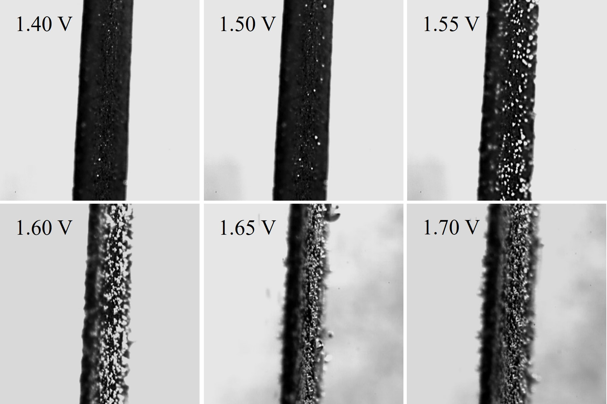
Supplementary Fig. S23. In situ microscopic images of flexible IrO₂ catalysts on carbon paper (Side view) during the OER process.
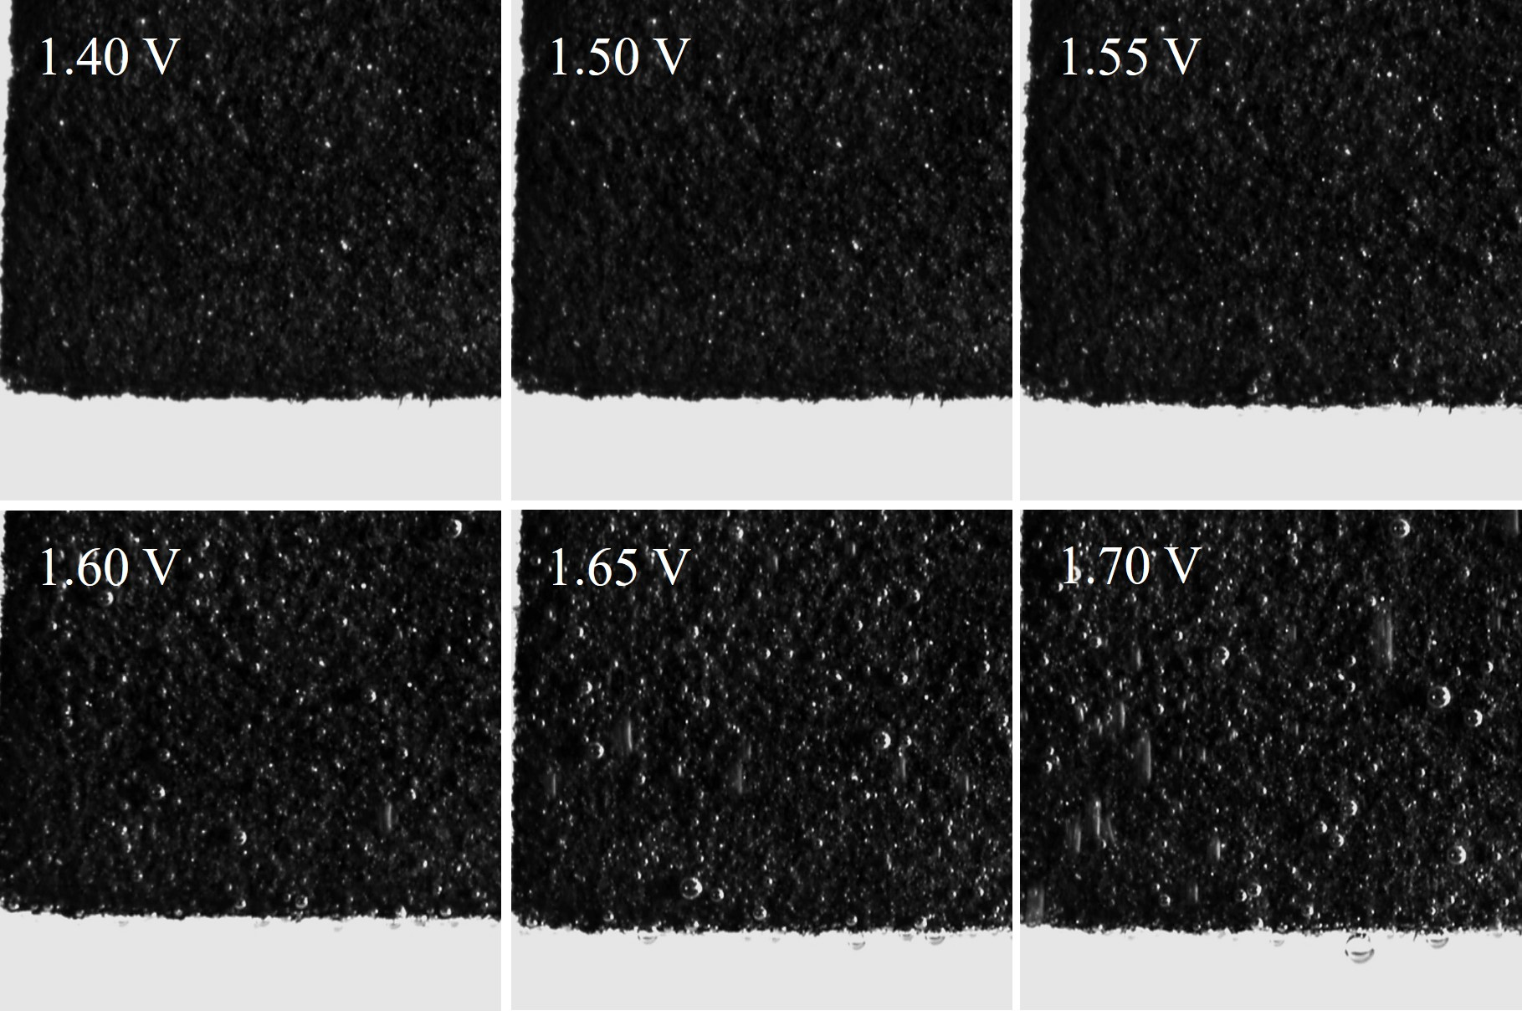
Supplementary Fig. S24. In situ microscopic images of flexible IrO₂ catalysts on carbon paper (Front view) during the OER process.

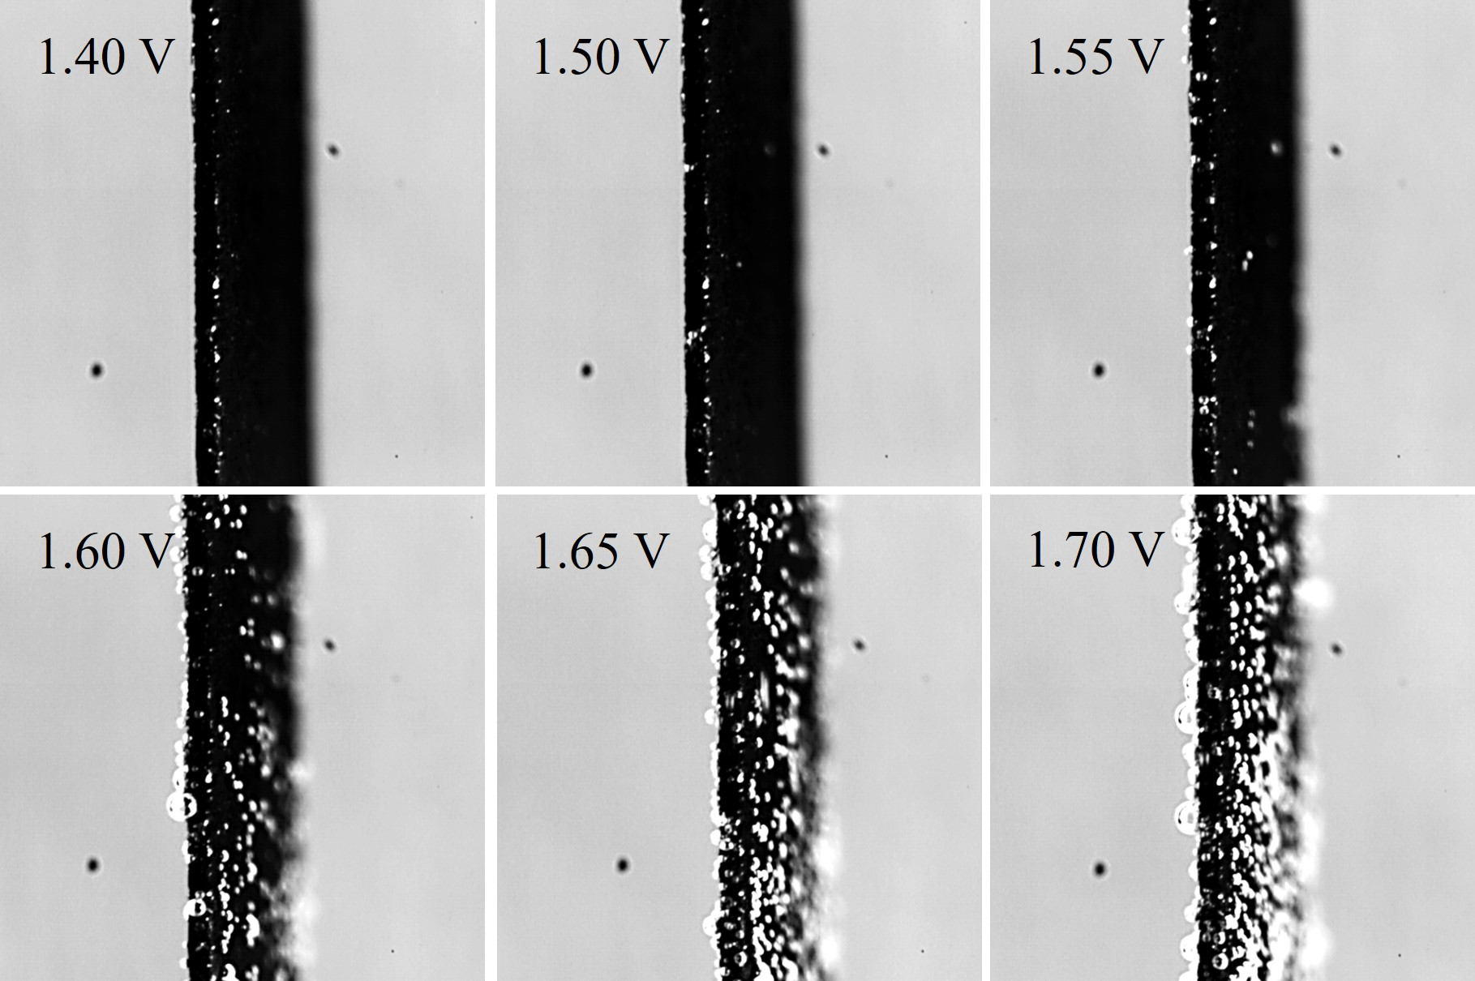
Supplementary Fig. S25. In situ microscopic images of IrO₂ NPs catalysts on carbon paper (Side view) during the OER process.
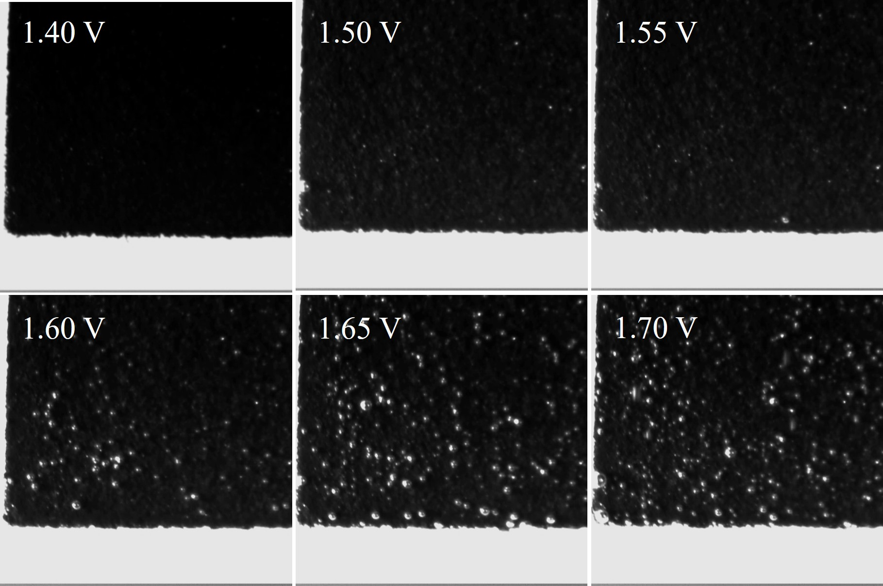
Supplementary Fig. S26. In situ microscopic images of IrO₂ NPs catalysts on carbon paper (Front view) during the OER process.

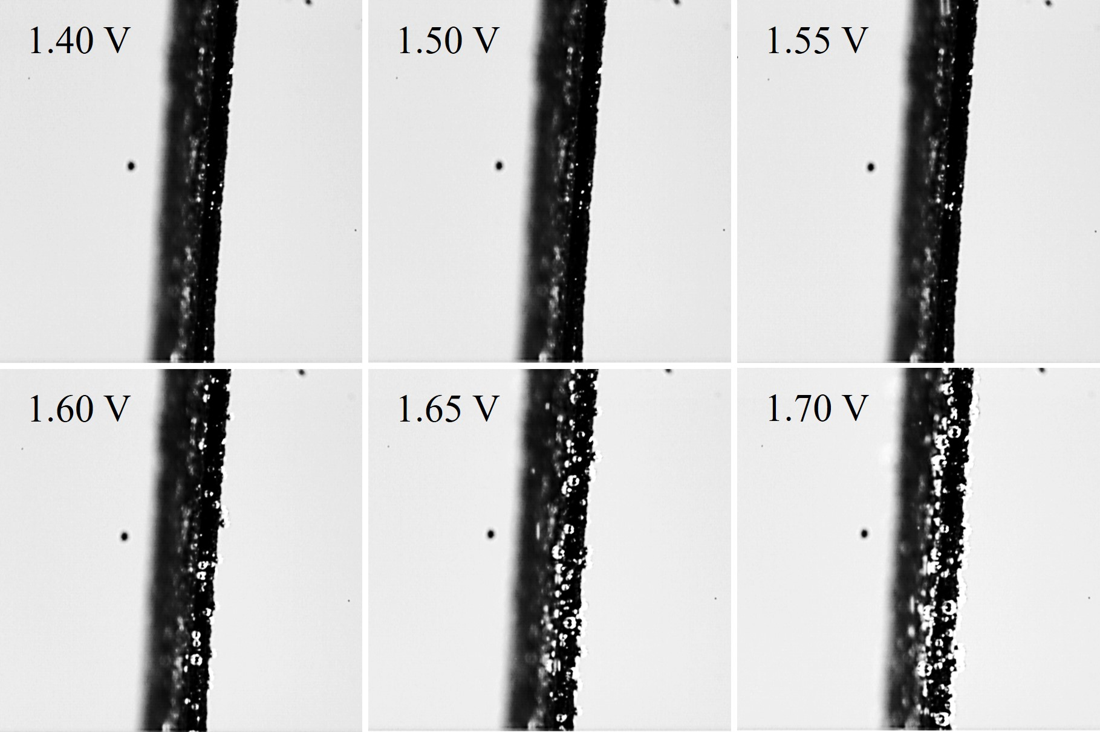
Supplementary Fig. S27. In situ microscopic images of Com. IrO₂ (Umicore) catalysts on carbon paper (Side view) during the OER process.
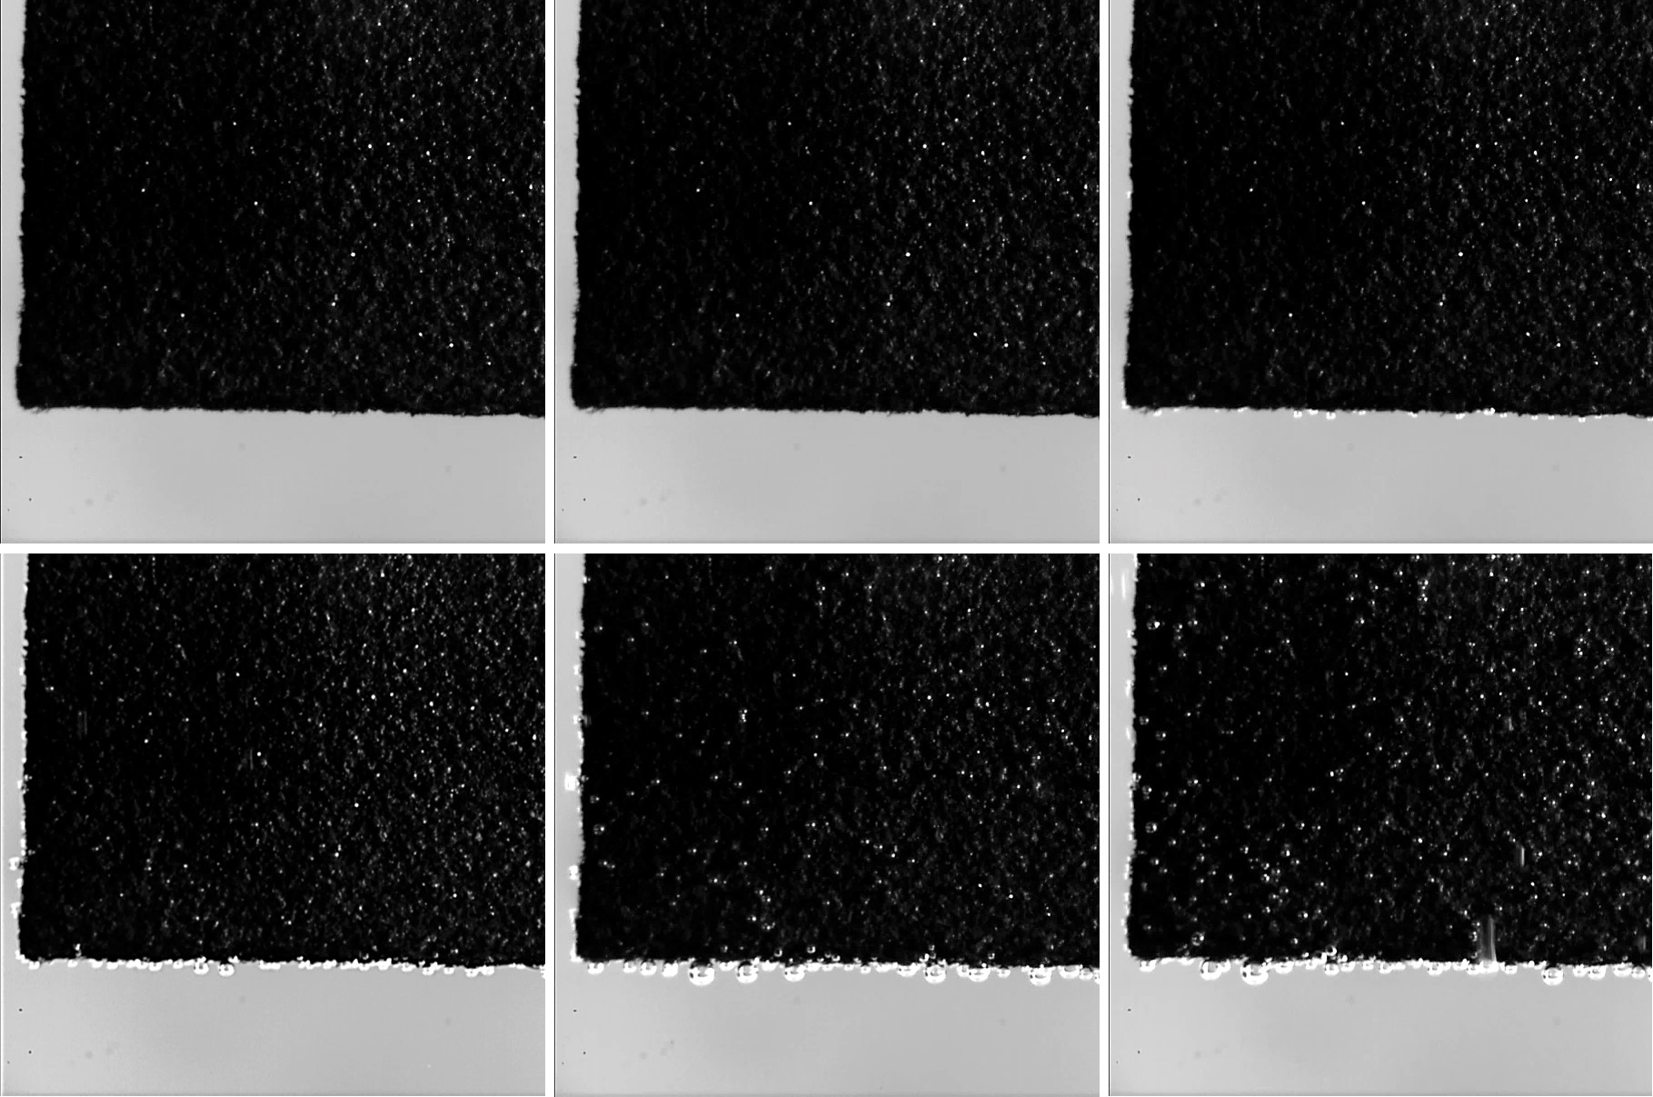
Supplementary Fig. S28. In situ microscopic images of Com. IrO₂ (Umicore) catalysts on carbon paper (Front view) during the OER process.

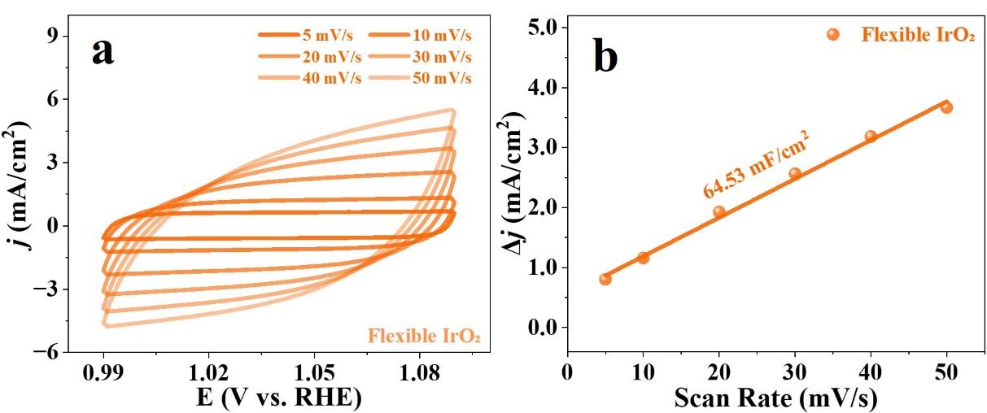
Supplementary Fig. S29. (a) CV curves of flexible IrO₂ on glassy carbon electrode at different scan rates from 5 to 50 mV/s in a non-Faradaic region with the potential between 0.99 and 1.09 V vs RHE under 0.5 M H₂SO₄. (b) Corresponding C_{dl} plots of flexible IrO₂. (without iR-compensation)
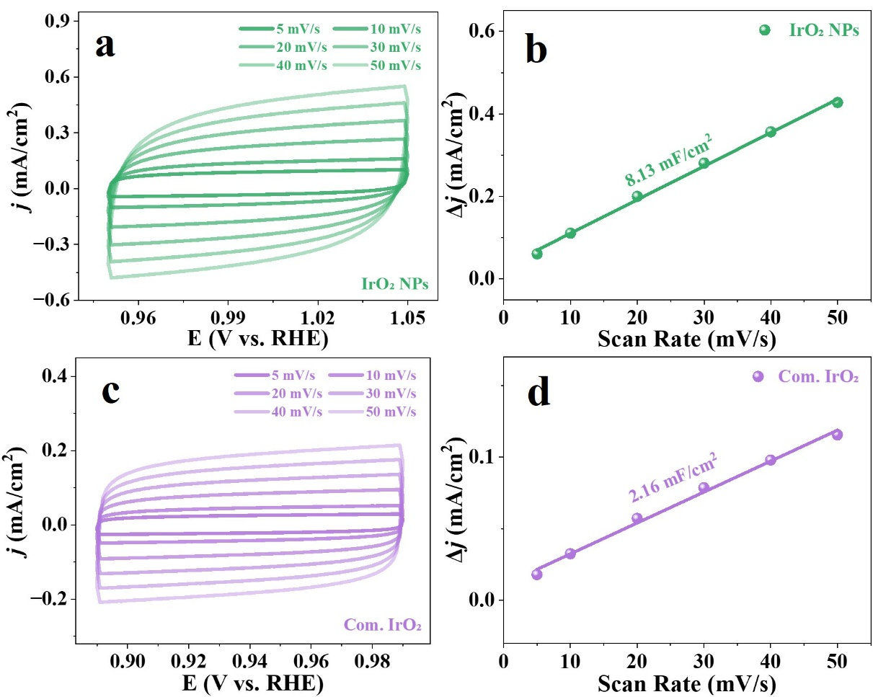
Supplementary Fig. S30. CV curves for (a) IrO₂ NPs, (c) Com. IrO₂ (Umicore) on glassy carbon electrode at different scan rates from 5 to 50 mV/s in a non-Faradaic region under 0.5 M H₂SO₄. Corresponding C_{dl} plots of (b) IrO₂ NPs and (d) Com. IrO₂ (Umicore). (without iR-compensation)
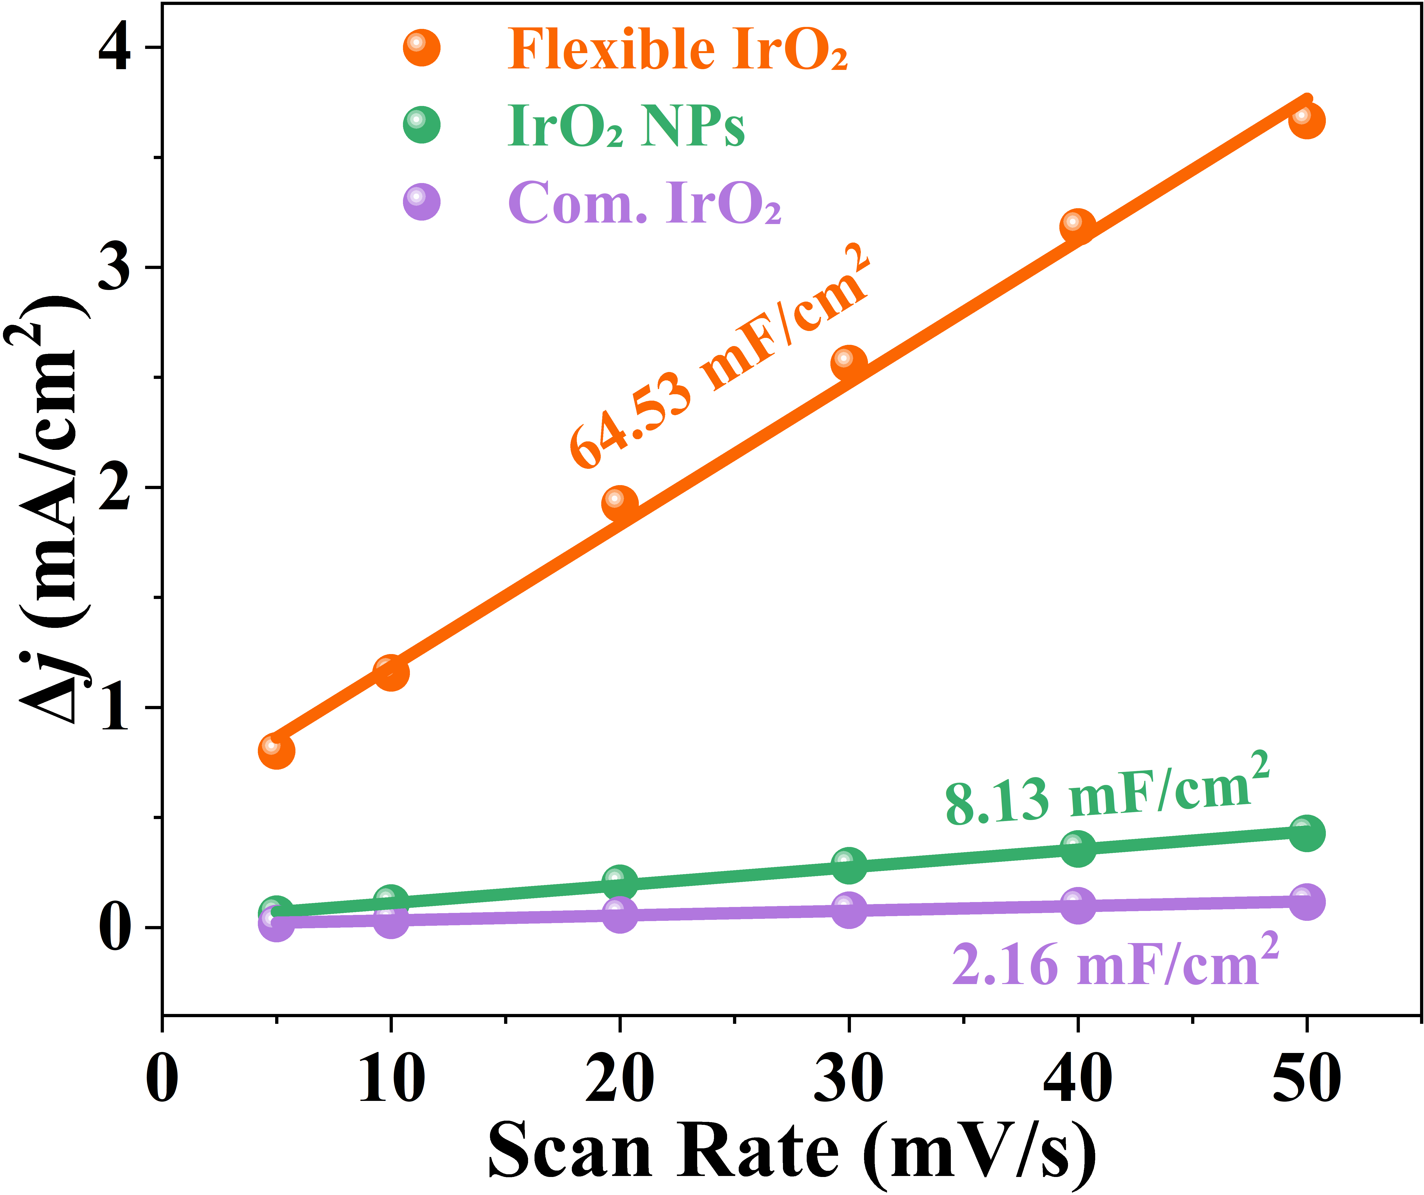
Supplementary Fig. S31. C_{dl} plots comparison for flexible IrO₂, IrO₂ NPs and Com. IrO₂ (Umicore) catalysts on glassy carbon electrode. (without iR-compensation)

Supplementary Fig. S32. Comprehensive comparisons of overpotentials and stability of flexible IrO₂ and the state-of-the-art acidic OER catalysts.
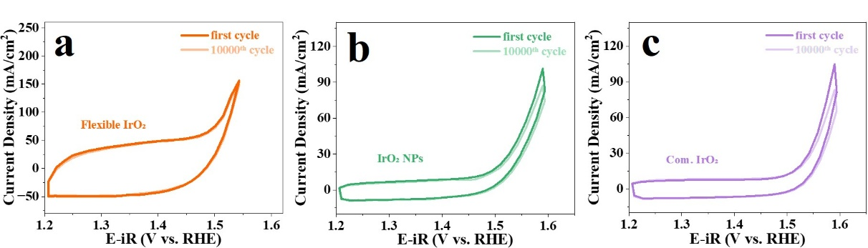
Supplementary Fig. S33. CV curves of the first and 10000th CV cycles between 1.2-1.6 V for (a) flexible IrO₂, (b) IrO₂ NPs and (c) Com. IrO₂ (Umicore). (with iR-compensation)

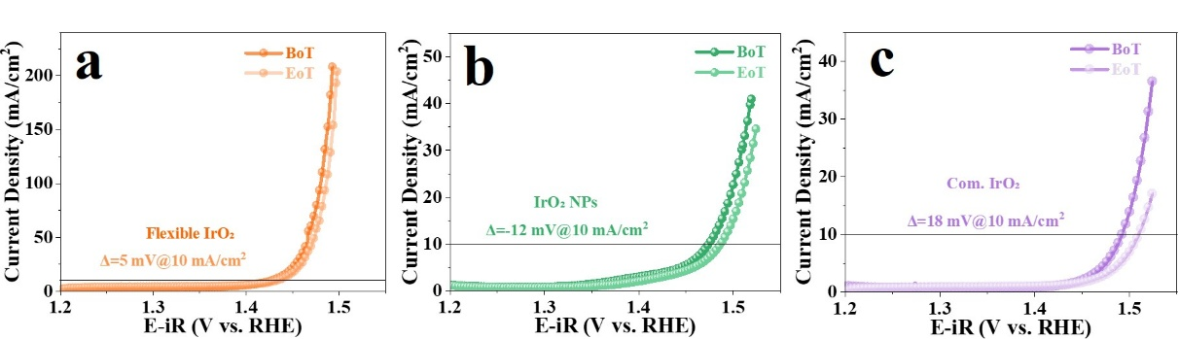
Supplementary Fig. S34. LSV curves of (a) flexible IrO₂, (b) IrO₂ NPs and (c) Com. IrO₂ (Umicore) before and after 10000 CVs. (with iR-compensation)

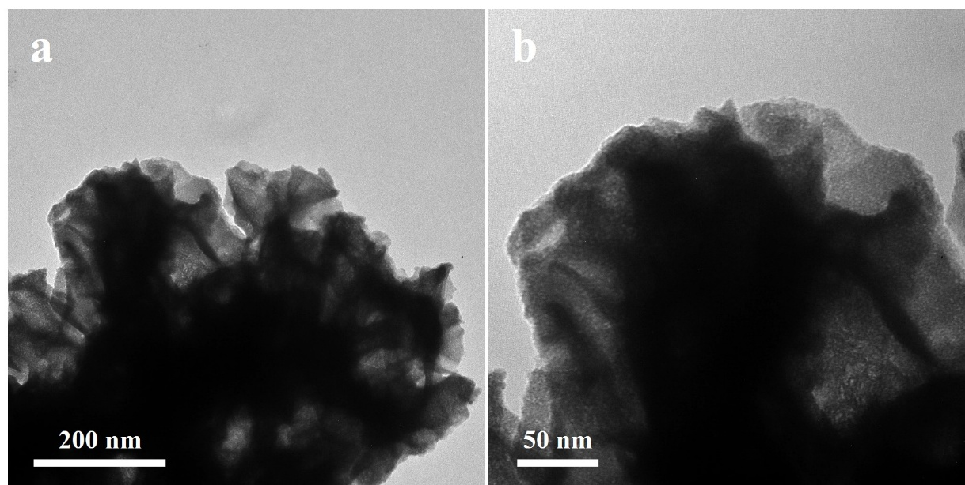
Supplementary Fig. S35. TEM image of flexible IrO₂ after durability test at 10 mA/cm² for 1000 h.

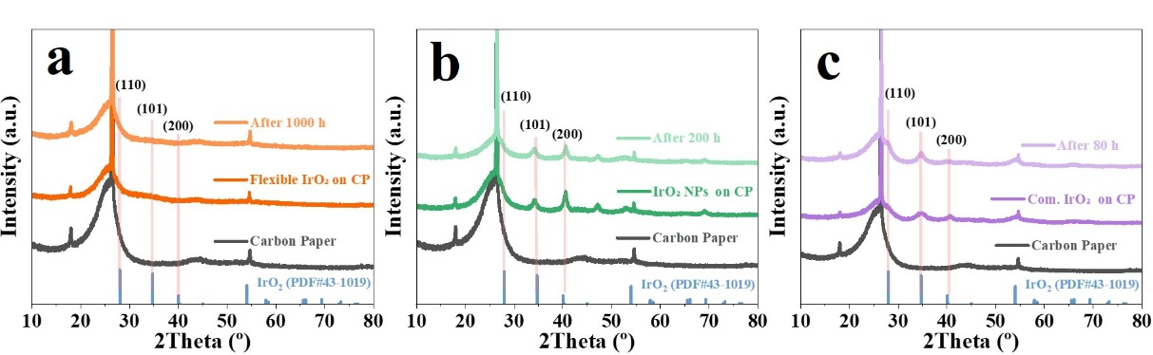
Supplementary Fig. S36. Comparison of XRD before and after durability test at 10 mA/cm² for (a) flexible IrO₂, (b) IrO₂ NPs and (c) Com. IrO₂ (Umicore) catalysts. (on Carbon paper)
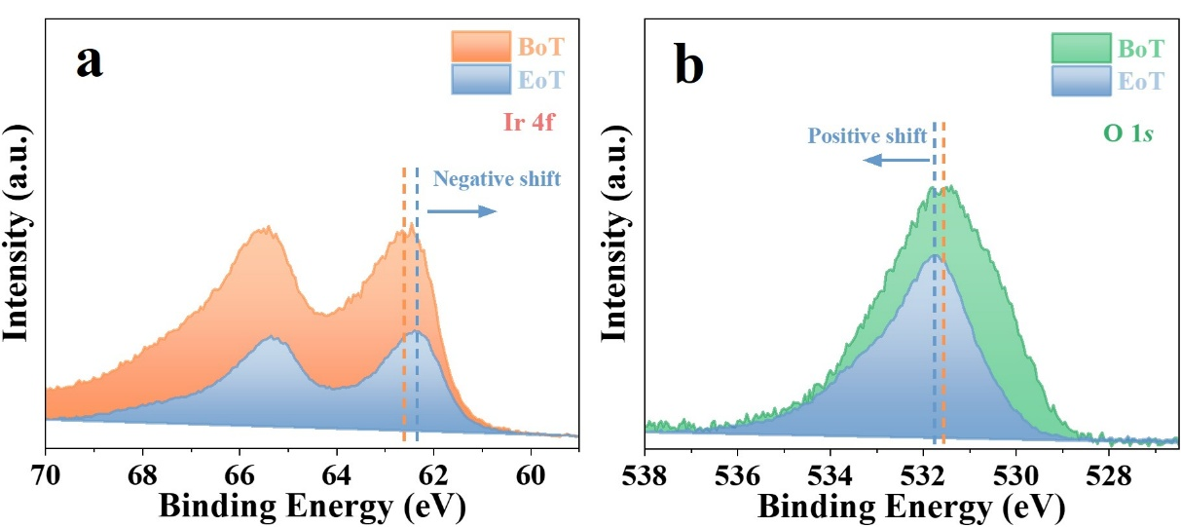
Supplementary Fig. S37. Ir 4f and O 2p XPS spectra of flexible IrO₂ after 1000 h stability test.

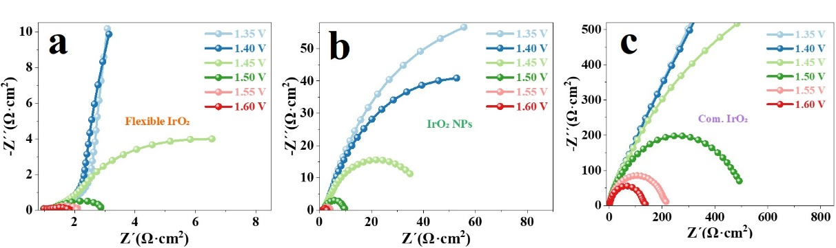
Supplementary Fig. S38. Nyquist plots for OER on the (a) flexible IrO₂, (b) IrO₂ NPs and (c) Com. IrO₂ (Umicore) catalysts in 0.5 M H₂SO₄. EIS tests were performed using GC electrode at different applied potentials versus RHE in the frequency range of 0.1 Hz to 10 kHz. (without iR-compensation)
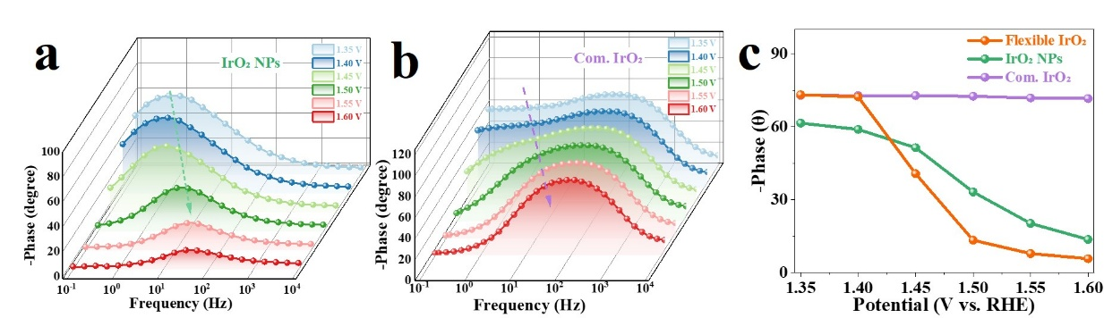
Supplementary Fig. S39 Operando EIS spectra for (a) IrO₂ NPs and (b) Com. IrO₂ (Umicore) from 1.35 to 1.6 V versus RHE. (c) Changes in the phase angle as the OER potential increases. (without iR-compensation)

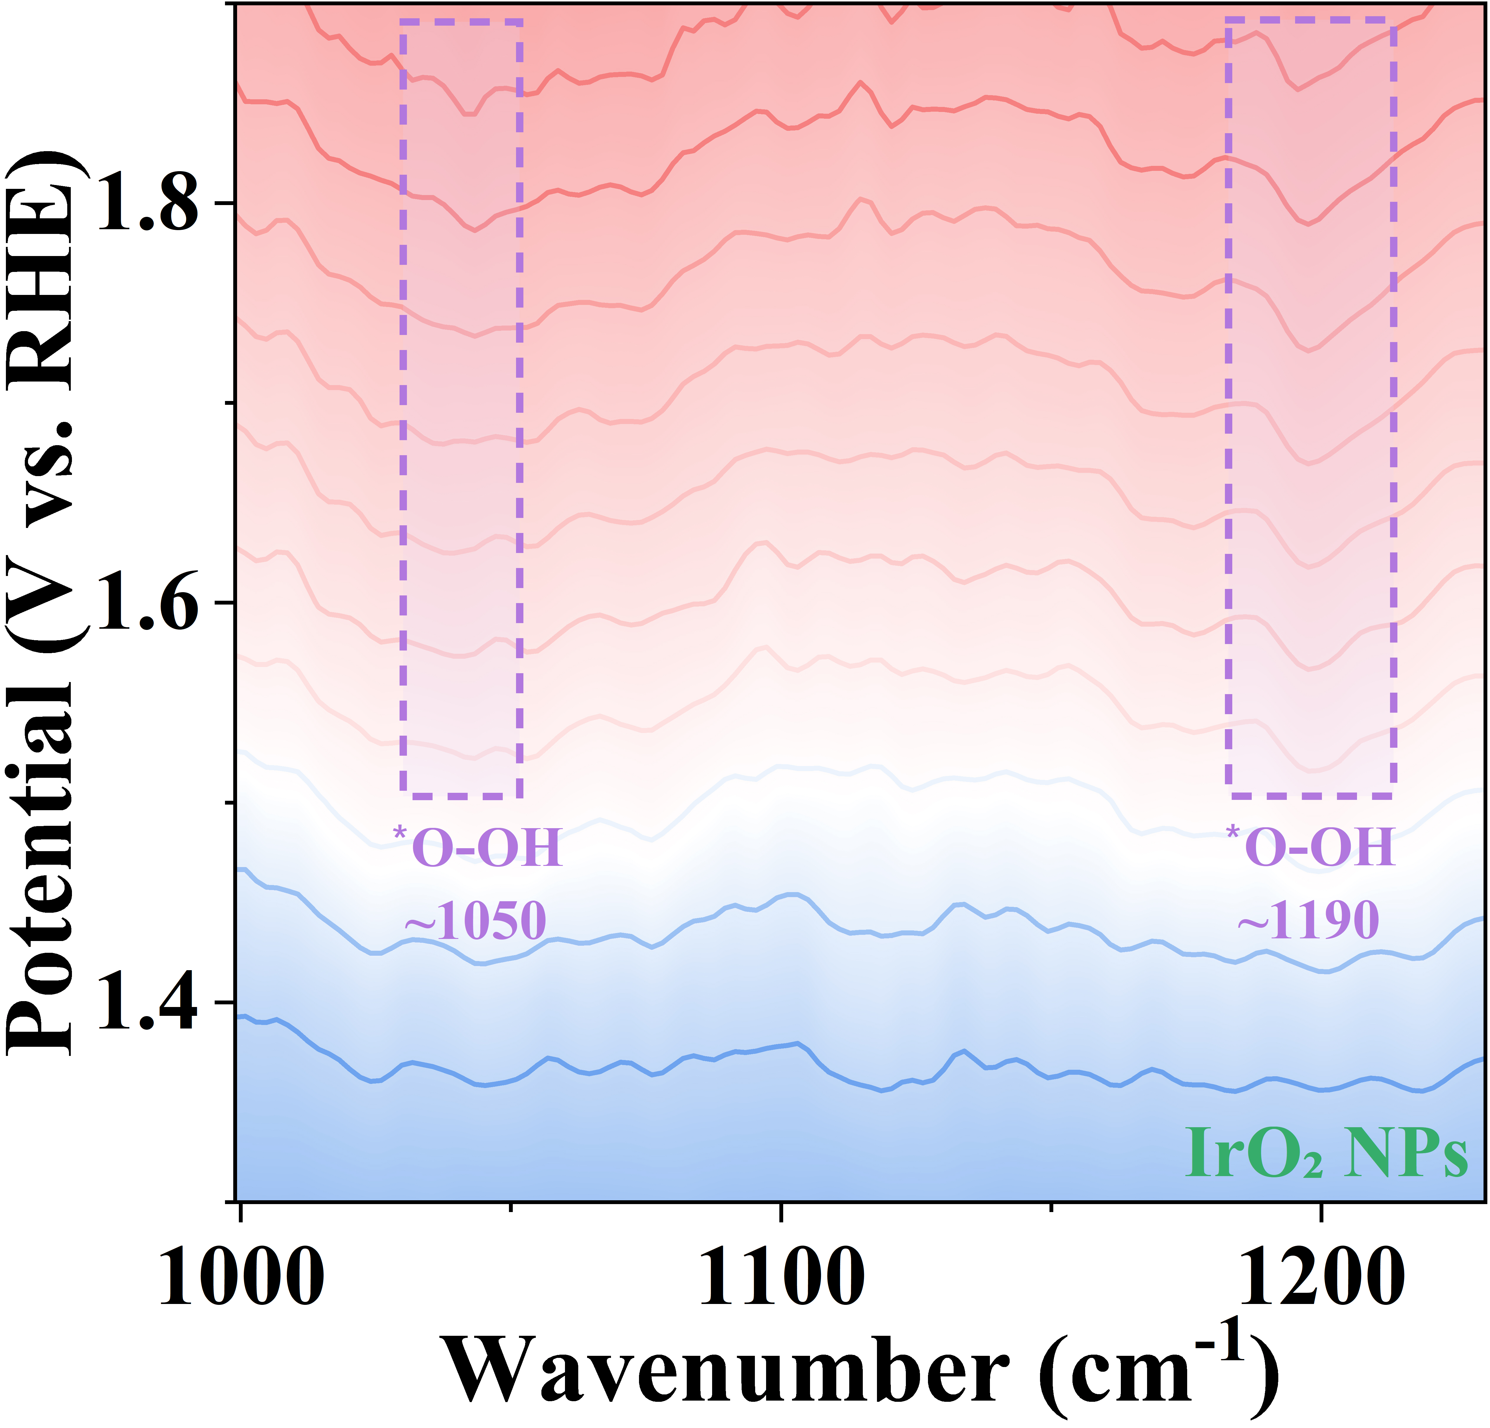
Supplementary Fig. S40. Operando ATR-SEIRAS IR spectra of IrO₂ NPs with potentials (versus RHE) applied from 1.3-1.9 V.
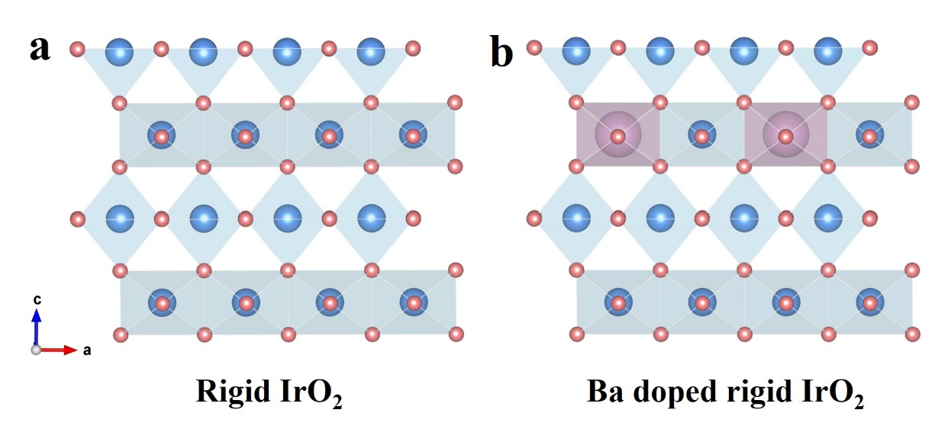
Supplementary Fig. S41. The optimized model structure of (a) rigid IrO₂ and (b) Ba doped rigid IrO₂.

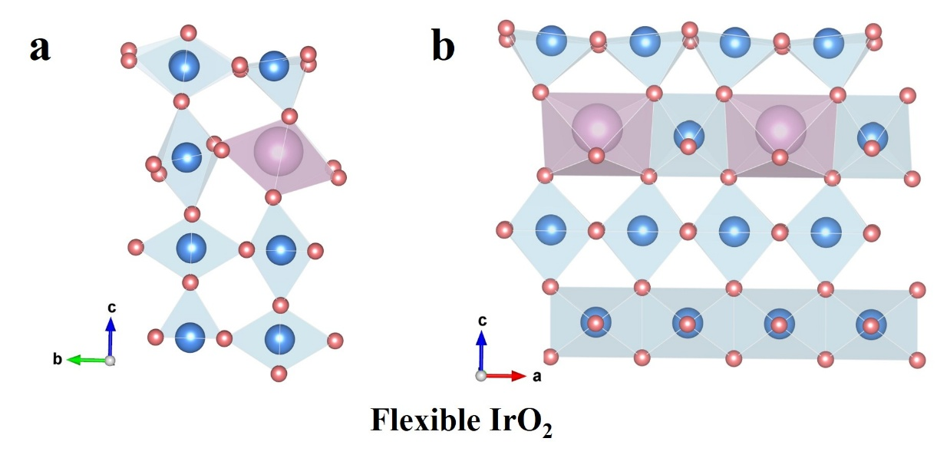
Supplementary Fig. S42. The optimized model structure of flexible IrO₂.
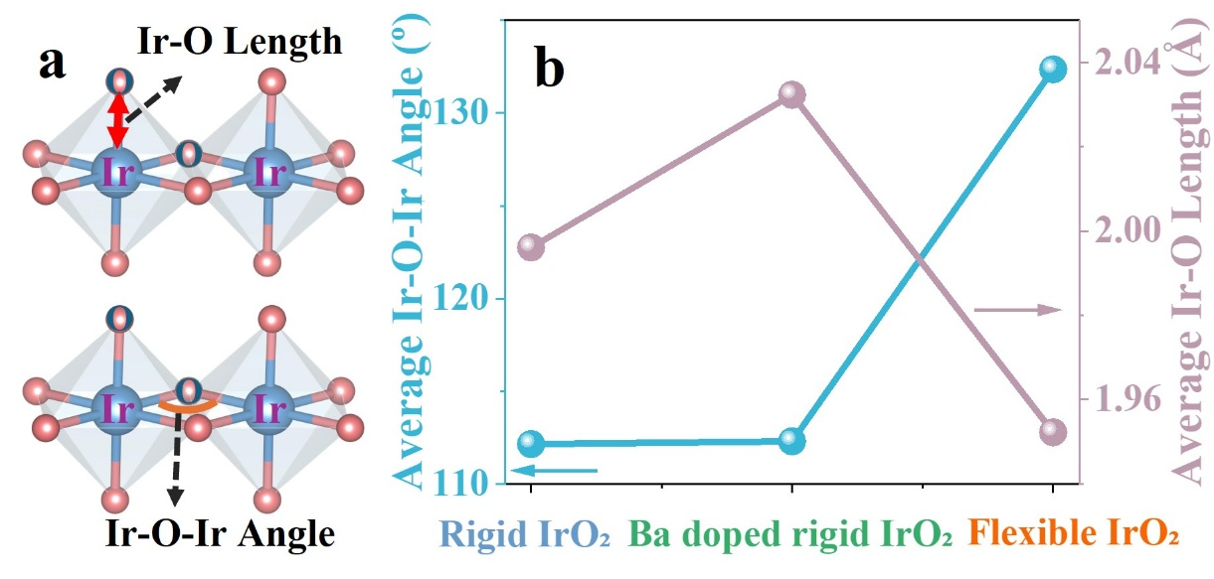
Supplementary Fig. S43. (a) Schematic diagram of the bond structure showing the measured average Ir-O bond lengths and Ir-O-Ir bond angles. (b) Trends in the average Ir-O bond lengths and Ir-O-Ir bond angles for flexible IrO₂, rigid IrO₂ and Ba doped rigid IrO₂.

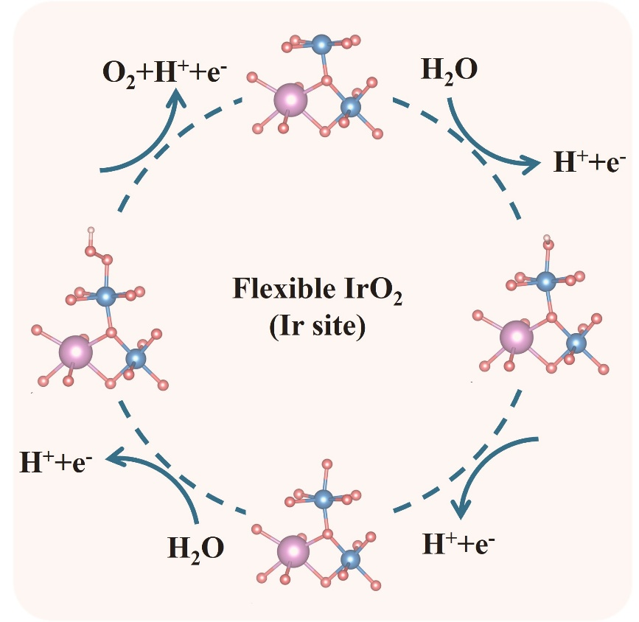
Supplementary Fig. S44. Adsorption models of the AEM pathway at the Ir site of flexible IrO₂ catalytic surfaces.
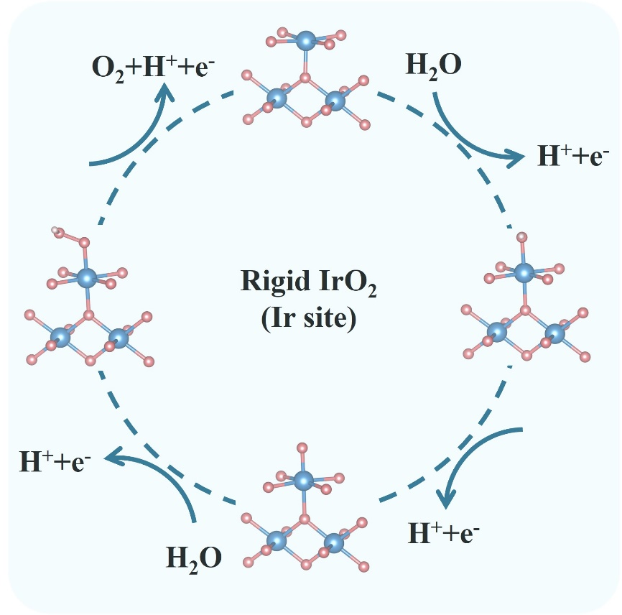
Supplementary Fig. S45. Adsorption models of the AEM pathway at the Ir site of rigid IrO₂ catalytic surfaces.

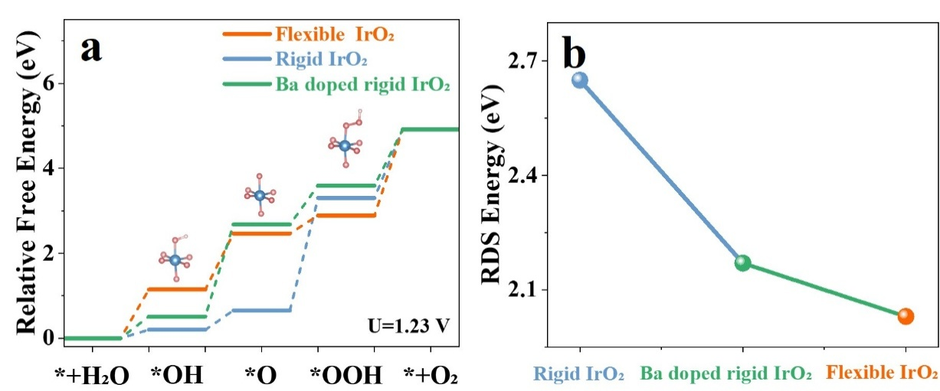
Supplementary Fig. S46. ΔG diagrams and rate-determining step (RDS) of flexible IrO₂, rigid IrO₂ and Ba doped rigid IrO₂.
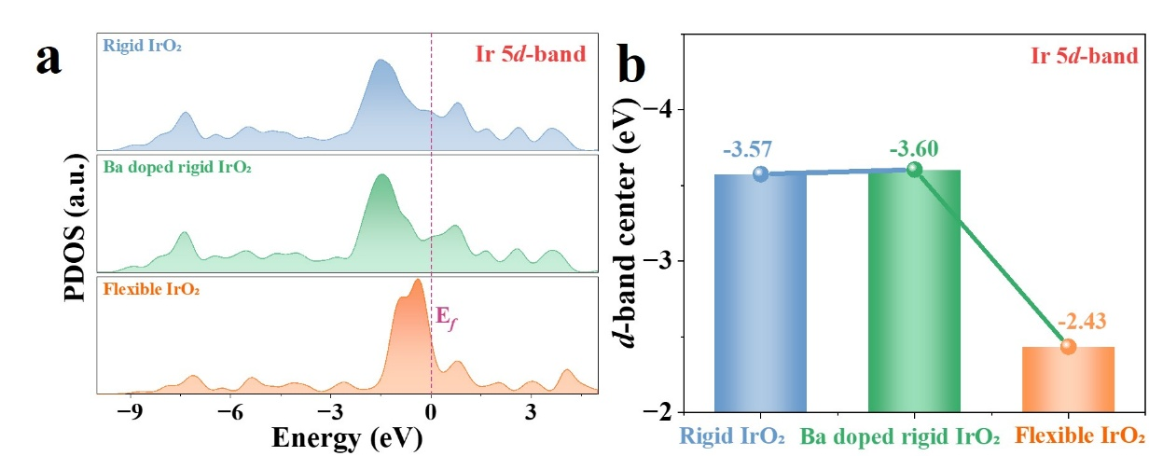
Supplementary Fig. S47. Calculated projected density of states (PDOS) of Ir 5d-band for flexible IrO₂, rigid IrO₂ and Ba doped rigid IrO₂.

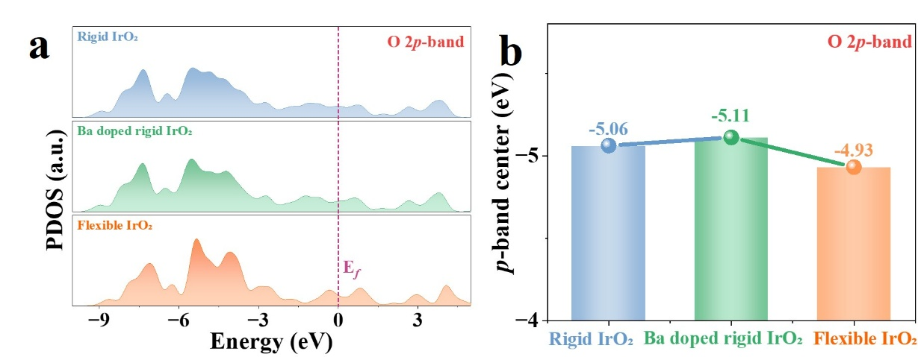
Supplementary Fig. S48. Calculated projected density of states (PDOS) of O 2p-band for flexible IrO₂, rigid IrO₂ and Ba doped rigid IrO₂.
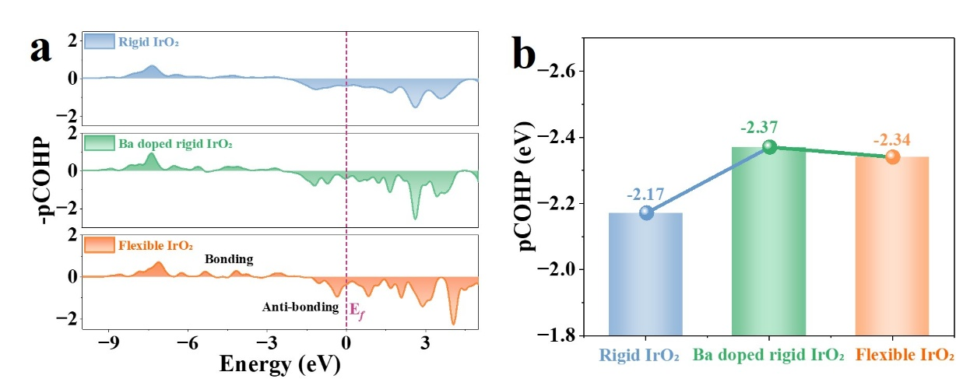
Supplementary Fig. S49. Calculated -pCOHP diagrams of flexible IrO₂, rigid IrO₂ and Ba doped rigid IrO₂.

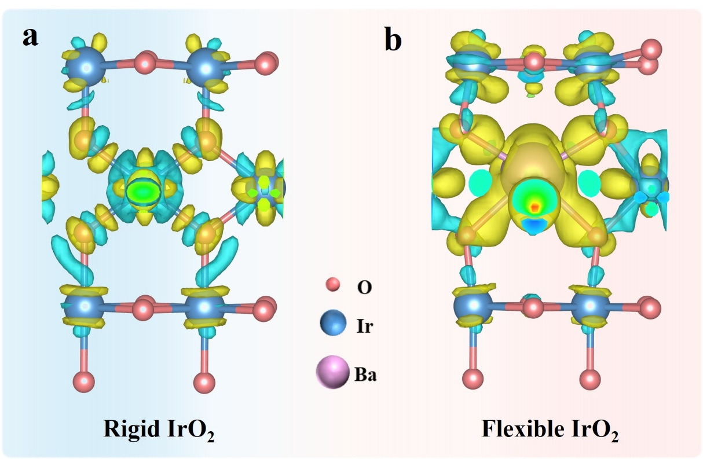
Supplementary Fig. S50. CDD plots of (a) flexible IrO₂ and (b) rigid IrO₂.
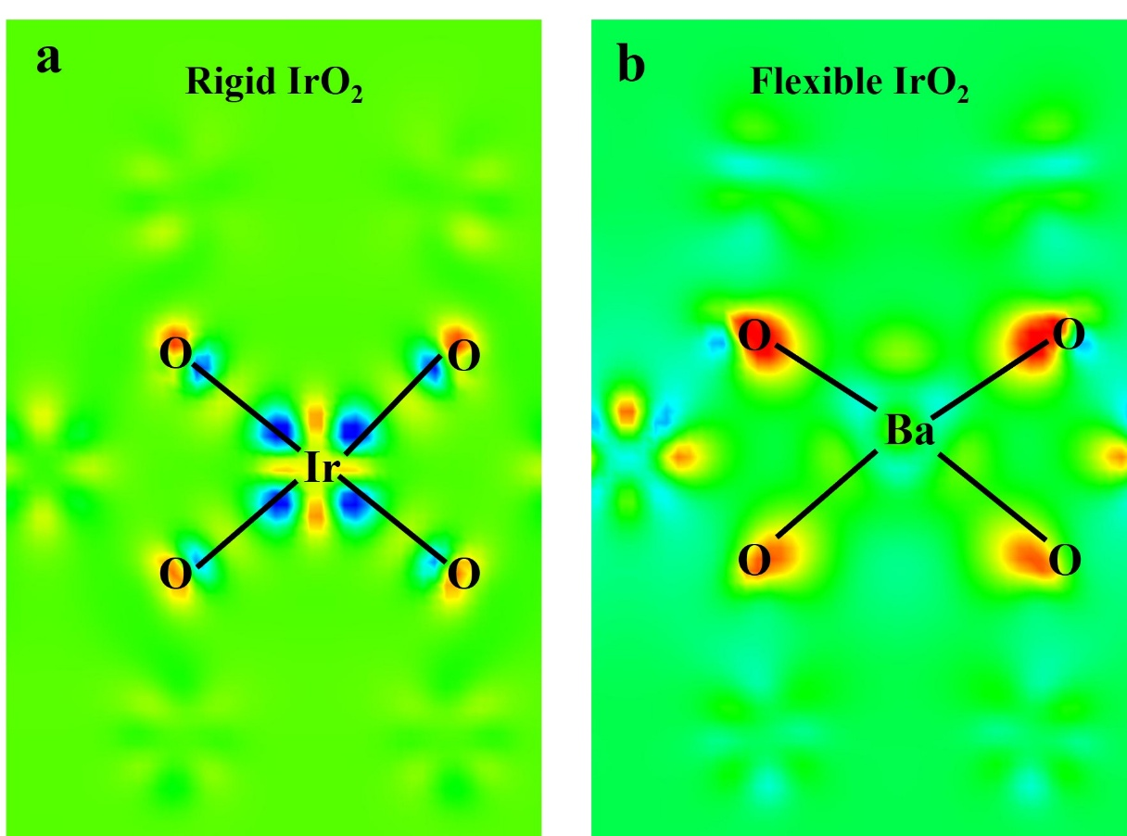
Supplementary Fig. S51. CDD plots of (a) flexible IrO₂ and (b) rigid IrO₂.
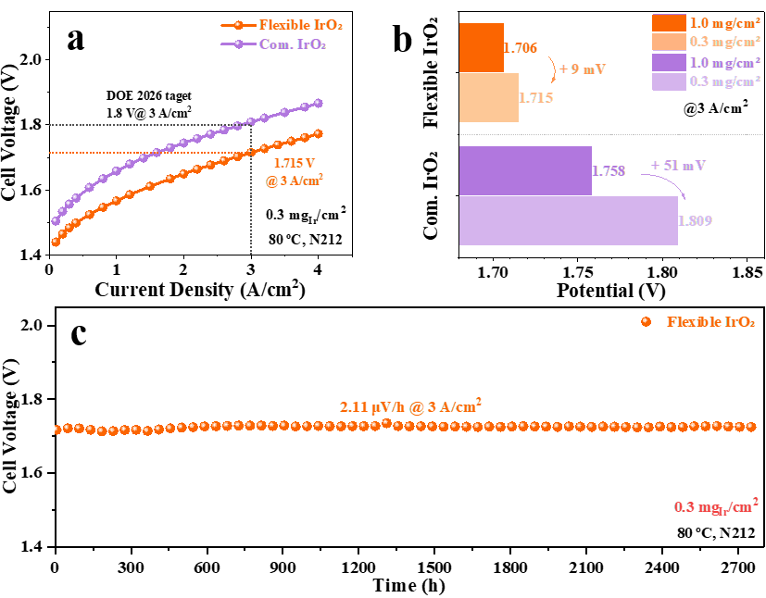
Supplementary Fig. S52. (a) Polarization curves and (b) OER potential with varied catalyst loadings of flexible IrO₂ and Com. IrO₂ (Umicore). (c) Electrolysis durability test of flexible IrO₂ with an anode loading of 0.3 mg_{Ir}/cm_{geo}².

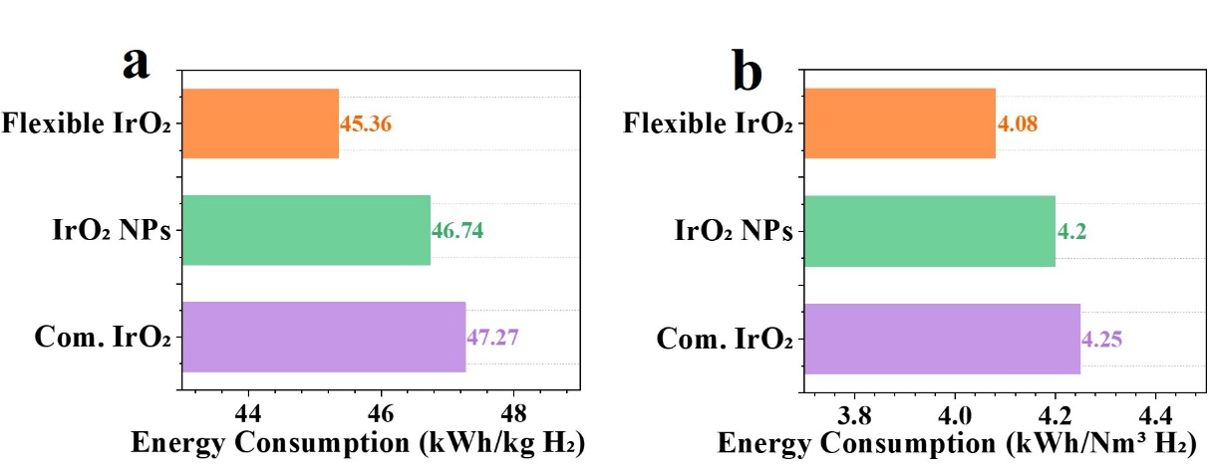
Supplementary Fig. S53. Energy consumption comparison of IrO₂, IrO₂ NPs and Com. IrO₂ (Umicore) for hydrogen production, expressed in kWh/kg H₂ (a) and kWh/Nm³ H₂ (b).
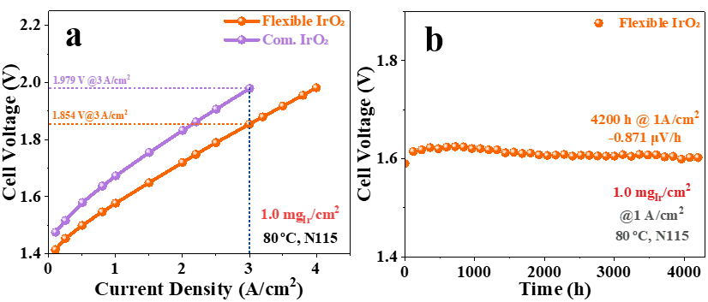
Supplementary Fig. S54. (a) Polarization curves of flexible IrO₂ and Com. IrO₂ (Umicore) with the anode loading of 1.0 mg_{Ir}/cm_{geo}² and the cathode loading of 0.4 mg_{Pt}/cm_{geo}². (b) Stability of the PEMWE with Nafion 115 measured at 1 A/cm².

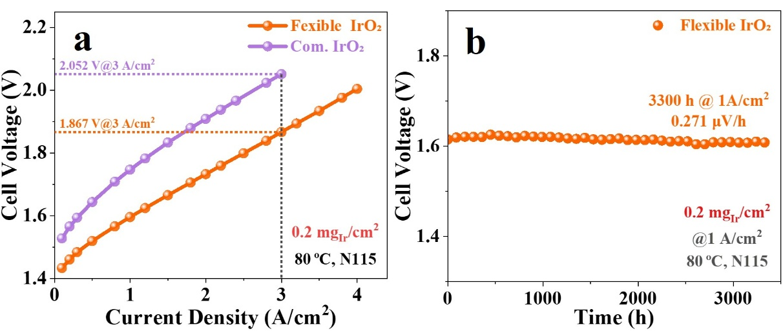
Supplementary Fig. S55. (a) Polarization curves of flexible IrO₂ and Com. IrO₂ (Umicore) with the anode loading of 0.2 mg_{Ir}/cm_{geo}² and the cathode loading of 0.2 mg_{Pt}/cm_{geo}². (b) Stability of the PEMWE with Nafion 115 measured at 1 A/cm².
Supplementary Fig. S56. Simulating solar PV fluctuation mode within a current density range of 0-4.5 A/cm².
Table S1. Frequency of signal peaks in Raman spectra.
Catalyst | E_{g} | B_{2g}
Flexible IrO₂ | 548.46 | 718.34
IrO₂ NPs | 542.06 | 708.74
Com. IrO₂ | 553.29 | 710.23

Table S2. Relative percentage comparison of different-valence Ir states in flexible IrO₂, IrO₂ NPs and Com. IrO₂ (Umicore).
Catalyst | Ir⁴⁺(%) | Ir³⁺(%) | Ir⁰(%)
Flexible IrO₂ | 27.34 | 72.66 | 0
IrO₂ NPs | 51.01 | 30.21 | 18.78
Com. IrO₂ | 56.28 | 25.52 | 18.20

Table S3. Proportion of O species obtained from XPS fitting in flexible IrO₂, IrO₂ NPs and Com. IrO₂ (Umicore).
Catalyst | Oxygen species | Binding energy  (eV) | Relative percentage  (%)
Flexible IrO₂ | Adsorbed oxygen (O₂)  Adsorbed hydroxyl (-OH)  Lattice oxygen (Ir-O) | 532.83  531.47  530.18 | 33.17  53.92  12.91
IrO₂ NPs | Adsorbed oxygen (O₂)  Adsorbed hydroxyl (-OH)  Lattice oxygen (Ir-O) | 532.83  531.47  530.39 | 45.99  27.92  26.09
Com. IrO₂ | Adsorbed oxygen (O₂)  Adsorbed hydroxyl (-OH)  Lattice oxygen (Ir-O) | 532.83  531.47  530.13 | 17.23  40.93  41.84

Table S4. EXAFS fitting parameters at the Ir L₃-edge for flexible IrO₂, Ir foil and IrO₂ standard.
Catalyst | Shell | N | σ² | R | R-factor (%)
Flexible IrO₂ | Ir-O | 5.93 | 0.006 | 2.01 | 0.14
IrO₂ standard | Ir-O | 6.00 | 0.002 | 1.97 | 0.07
Ir foil | Ir- Ir | 12.00 | 0.004 | 2.71 | 0.63
CN: coordination number; R: bond distance; σ²: Debye-Waller factor.

Table S5. Ohmic resistance (R_{s}) and Charge transfer resistance (R₁ and R₂) calculated by fitting EIS of flexible IrO₂, IrO₂ NPs and Com. IrO₂ (Umicore).
Catalyst | R_{s} (ohm) | R₁ (ohm) | R₂ (ohm)
Flexible IrO₂ | 3.88 | 4.08 | 9.63
IrO₂ NPs | 4.32 | 18.35 | 60.47
Com. IrO₂ | 4.68 | 20.29 | 76.53

Table S6. Comparison of activity and stability of various advanced Ir-based catalysts in the three-electrode system. (NA: not available)
Catalysts | Substrate | Ir loading  (mg/cm²) | Overpotential@10 mA/cm² (mV) | Stability (h@mA/cm²) | S-number | Refs
Flexible IrO₂ | GC/Carbon paper | 0.32 | 227 | 1000@10 | 6.97×10⁴ | This work
IrO₂ NPs | GC/Carbon paper | 0.32 | 279 | 204@10 | 3.92×10⁴ | This work
Com. IrO₂ | GC/Carbon paper | 0.32 | 399 | 83@10 | 1.50×10⁴ | This work
KIr₄O₈ | GC | 0.281 | 266 | 100@10 | NA | (1)
Ti-IrO_{x}/Ir | GC | 0.35 | 254 | 24@10 | 1.02×10⁵ | (2)
IrW-W₂B | NA | 0.0789 | 291 | 120@100 | 2.49×10⁵ | (3)
IrVMn/IrO_{x} | GC | 0.00934 | 279 | 45@10 | 4.55×10⁴ | (4)
IrRu-NBs | GC | NA | 204 | 71@10 | NA | (5)
IrO_{x}MoO₃ | Ti felt | 0.28 | 200 | 130@10 | NA | (6)
Ir-Co₃O₄ | GC | 0.018 | 236 | 30@10 | NA | (7)
H_{x}IrO₃ NSs | GC | 0.255 | 277 | 10@12 | NA | (8)
NiWIrO_{x} | Ti felt | 0.63 | 180 | 312@300 | 3.9×10⁵ | (9)
Li-IrO_{x} | GC | 0.0204 | 290 | 10@10 | NA | (10)
La₃IrO₇ | GC | 0.467 | 296 | 16.7@10 | NA | (11)
6H-SrIrO₃ | GC | 0.284 | 248 | 30@10 | NA | (12)
Ru₂IrO_{x} | GC | 0.285 | 245 | 250@10 | NA | (13)
Ir-Co₃O₄ | GC | 1.2 | 276 | 500@10 | 2.0×10⁵ | (14)

Table S7. Inductively coupled plasma test of Ir dissolved in 0.5M H₂SO₄ electrolyte after durability test at 10 mA/cm².
Catalyst | Label | 193 (KED) [ppb]
Flexible IrO₂ | 1 | 293.761
Flexible IrO₂ | 2 | 287.628
Flexible IrO₂ | 3 | 301.019
Flexible IrO₂ | Mean: | 294.136
IrO₂ NPs | 1 | 100.798
IrO₂ NPs | 2 | 104.721
IrO₂ NPs | 3 | 105.405
IrO₂ NPs | Mean: | 103.641
Com. IrO₂ | 1 | 109.329
Com. IrO₂ | 2 | 108.334
Com. IrO₂ | 3 | 112.147
Com. IrO₂ | Mean: | 109.937

Table S8. S-number of flexible IrO₂, IrO₂ NPs and Com. IrO₂ (Umicore).
Catalyst | $n_{O_{2}}$(mol) | $n_{Ir}$(mol) | S-number
Flexible IrO₂ | 1.338E-06 | 9.328E-02 | 6.97E+04
IrO₂ NPs | 4.858E-07 | 1.903E-02 | 3.92E+04
Com. IrO₂ | 5.153E-07 | 7.742E-03 | 1.50E+04

Table S9. Comparison of various PEMWE operation conditions and catalyst performances.
Catalyst | PGM loading (mg/cm²) | Cell activity (V@A/cm²) |  | Operation time (h) | Degradation rate (µV/h) | Refs
Flexible IrO₂ | 1.4 | 1.561@1 | 1.657@2 | 3000 | -0.2.74 | This work
IrO₂ NPs | 1.4 | 1.615@1 | 1.888@2 | -- | -- | This work
Com. IrO₂ | 1.4 | 1.610@1 | 1.692@2 | 1566 | 18.46 | This work
Ta_{0.1}Tm_{0.1}Ir_{0.8}O_{2-δ} | 0.6 | 1.766@1 | 1.923@2 | 100 | 500 | (15)
Ir/Nb₂O₅ | 2.8 | 1.650@1 | 1.800@2 | 2000 | 25.6 | (16)
CrO_{2-0.16}IrO₂ | 1.2 | 1.630@1 | 1.730@2 | 100 | 500 | (17)
IrRu | 0.9 | 1.650@1 | 1.810@2 | 240 | 25 | (18)
IrO₂/TaB₂ | 0.4 | 1.670@1 | 1.830@2 | 100 | 100 | (19)
IrO_{x}∙nH₂O | 2.5 | 1.770@1 | 2.000@2 | 600 | 6 | (20)
Ir^{VI-ado} (MnO₂/p-PTL) | 0.5 | 1.650@1 | 1.770@2 | 2700 | 1 | (21)
IrRuO_{x} | 1.6 | 1.600@1 | 1.830@2 | 1000 | 5 | (22)

Movie S1.
Evolution of oxygen bubble evolution on the surface of flexible IrO₂ catalyst on carbon paper with increasing applied voltage.
Movie S2.
Evolution of oxygen bubble evolution on the surface of IrO₂ NPs catalyst on carbon paper with increasing applied voltage.
Movie S3.
Evolution of oxygen bubble evolution on the surface of Com. IrO₂ (Umicore) catalyst on carbon paper with increasing applied voltage.

References
1. Z. Y. Li, X. Li, M. N. Wang, Q. Wang, P. F. Wei, S. J. Jana, Z. Q. Liao, J. C. Yu, F. Lu, T. F. Liu, G. X. Wang, KIr₄O₈ nanowires with rich hydroxyl promote oxygen evolution reaction in proton exchange membrane water electrolyzer. Advanced Materials 36, 2402643 (2024).
2. Y. B. Wang, R. P. Ma, Z. P. Shi, H. X. Wu, S. Hou, Y. Wang, C. P. Liu, J. J. Ge, W. Xing, Inverse doping IrO_{x}/Ti with weakened Ir-O interaction toward stable and efficient acidic oxygen evolution. Chem 9, 2931-2942 (2023).
3. R. Li, H. Wang, F. Hu, K. C. Chan, X. J. Liu, Z. P. Lu, J. Wang, Z. B. Li, L. J. Zeng, Y. Y. Li, X. J. Wu, Y. J. Xiong, IrW nanochannel support enabling ultrastable electrocatalytic oxygen evolution at 2A cm⁻² in acidic media. Nature Communications 12, 3540 (2021).
4. H. Luo, F. X. Lin, Q. H. Zhang, D. W. Wang, K. Wang, L. Gu, M. C. Luo, F. Lv, S. J. Guo, Atomic-layer IrO_{x} enabling ligand effect boosts water oxidation electrocatalysis. Journal of the American Chemical Society 146, 19327-19336 (2024).
5. L. M. Li, Z. F. Cheng, J. Q. Su, B. B. Song, H. Yu, Y. J. Ji, Q. Shao, J. M. Lu, One-dimensional amorphous porous iridium-ruthenium oxide for efficient acidic oxygen evolution reaction. Journal of Materials Chemistry A 11, 25268-25274 (2023).
6. Y. R. Chen, D. N. Liu, Q. Q. Zhao, X. Long, J. Wang, J. J. Zhang, X. Z. Fu, J. L. Luo, IrO_{x}-MoO₃ nano-heterostructure electrocatalysts for efficient acidic water oxidation. Chemical Engineering Journal 475, 146255 (2023).
7. Y. M. Zhu, J. A. Wang, T. Koketsu, M. Kroschel, J. M. Chen, S. Y. Hsu, G. Henkelman, Z. W. Hu, P. Strasser, J. W. Ma, Iridium single atoms incorporated in Co₃O₄ efficiently catalyze the oxygen evolution in acidic conditions. Nature Communications 13, 7754 (2022).
8. Z. F. Liu, J. Qi, H. Y. Zeng, Y. Q. Zeng, J. W. Wang, L. Gu, E. N. Hong, M. Z. Yang, Q. S. Fu, J. Chen, C. Z. Yang, Electrochemical preparation of iridium hydroxide nanosheets with ordered honeycomb structures for the oxygen evolution reaction in acid. Acs Applied Energy Materials 5, 6869-6877 (2022).
9. M. I. Abdullah, Y. S. Fang, X. B. Wu, M. Q. Hu, J. Shao, Y. K. Tao, H. J. Wang, Tackling activity-stability paradox of reconstructed NiIrO_{x} electrocatalysts by bridged W-O moiety. Nature Communications 15, 10587 (2024).
10. J. R. Esquius, D. J. Morgan, G. A. Siller, D. Gianolio, M. Aramini, L. Lahn, O. Kasian, S. A. Kondrat, R. Schlögl, G. J. Hutchings, R. Arrigo, S. J. Freakley, Lithium-directed transformation of amorphous iridium (Oxy)hydroxides to produce active water oxidation catalysts. Journal of the American Chemical Society 145, 6398-6409 (2023).
11. Q. Qin, H. Jang, Y. M. Wang, L. J. Zhang, Z. J. Li, M. G. Kim, S. G. Liu, X. E. Liu, J. Cho, Gettering La effect from La₃IrO₇ as a highly efficient electrocatalyst for oxygen evolution reaction in acid media. Advanced Energy Materials 11, 2003561 (2021).
12. L. Yang, G. T. Yu, X. Ai, W. S. Yan, H. L. Duan, W. Chen, X. T. Li, T. Wang, C. H. Zhang, X. R. Huang, J. S. Chen, X. X. Zou, Efficient oxygen evolution electrocatalysis in acid by a perovskite with face-sharing IrO₆ octahedral dimers. Nature Communications 9, 5236 (2018).
13. L. J. Zhao, W. J. Duan, C. Tang, Q. Zhang, Y. J. Hu, B. G. Mao, C. G. Hu, Wrinkle-induced strain activates a rapid deprotonation pathway in Ru₂IrO_{x} for efficient acidic water electrolysis. Advanced Functional Materials, e15512 (2025).
14. Z. M. Wei, Y. X. Ding, W. L. Shi, F. Y. Zhang, Y. X. Song, X. Cui, Y. Guo, L. C. Sun, Q. K. Jiang, B. B. Zhang, Lanthanum-assisted lattice anchoring of iridium in Co₃O₄ for efficient oxygen evolution reaction in low-iridium water electrolysis. Nature Communications 16, 8145 (2025).
15. S. Y. Hao, H. Y. Sheng, M. Liu, J. Z. Huang, G. K. Zheng, F. Zhang, X. N. Liu, Z. W. Su, J. J. Hu, Y. Qian, L. N. Zhou, Y. He, B. Song, L. C. Lei, X. W. Zhang, S. Jin, Torsion strained iridium oxide for efficient acidic water oxidation in proton exchange membrane electrolyzers. Nat Nanotechnol 16, 1371-1377 (2021).
16. Z. P. Shi, J. Li, J. D. Jiang, Y. B. Wang, X. Wang, Y. Li, L. T. Yang, Y. Y. Chu, J. S. Bai, J. H. Yang, J. Ni, Y. Wang, L. J. Zhang, Z. Jiang, C. P. Liu, J. J. Ge, W. Xing, Enhanced acidic water oxidation by dynamic migration of oxygen species at the Ir/Nb₂O_{5-x} catalyst/support interfaces. Angew Chem Int Edit 61, e202212341 (2022).
17. S. Y. Ge, R. K. Xie, B. Huang, Z. Y. Zhang, H. M. Liu, X. Kang, S. Q. Hu, S. H. Li, Y. T. Luo, Q. M. Yu, J. W. Wang, G. L. Chai, L. H. Guan, H. M. Cheng, B. L. Liu, A robust chromium-iridium oxide catalyst for high-current-density acidic oxygen evolution in proton exchange membrane electrolyzers. Energ Environ Sci 16, 3734–3742 (2023).
18. L. Tao, F. Lv, D. W. Wang, H. Luo, F. X. Lin, H. Y. Gong, H. T. Mi, S. G. Wang, Q. H. Zhang, L. Gu, M. C. Luo, S. J. Guo, Mass-efficient catalyst layer of hierarchical sub-nanosheets on nanowire for practical proton exchange membrane electrolyzer. Joule 8, 450–460 (2024).
19. Y. N. Wang, M. C. Zhang, Z. Y. Kang, L. Shi, Y. C. Shen, B. Y. Tian, Y. C. Zou, H. Chen, X. X. Zou, Nano-metal diborides-supported anode catalyst with strongly coupled TaO_{x}/IrO₂ catalytic layer for low-iridium-loading proton exchange membrane electrolyzer. Nature Communications 14, 5119 (2023).
20. J. Xu, H. Jin, T. Lu, J. Li, Y. Liu, K. Davey, Y. Zheng, S.-Z. Qiao, IrO_{x} nH₂O with lattice water-assisted oxygen exchange for high-performance proton exchange membrane water electrolyzers. Sci Adv 9, eadh1718 (2023).
21. A. L. Li, S. Kong, K. Adachi, H. Ooka, K. Fushimi, Q. K. Jiang, H. Ofuchi, S. Hamamoto, M. Oura, K. Higashi, T. Kaneko, T. Uruga, N. Kawamura, D. Hashizume, R. Nakamura, Atomically dispersed hexavalent iridium oxide from MnO₂ reduction for oxygen evolution catalysis. Science 384, 666-670 (2024).
22. S. Siracusano, V. Baglio, N. Van Dijk, L. Merlo, A. S. Aricò, Enhanced performance and durability of low catalyst loading PEM water electrolyser based on a short-side chain perfluorosulfonic ionomer. Applied Energy 192, 477-489 (2017).

