Recruitment information
Experiment 1 (2021–2022): We initially recruited 24 autistic and 21 typically developing (TD) children. Three autistic children and one TD child were excluded due to low accuracy (< 70%), and one additional autistic child was excluded for outlier reaction time (RT, exceeded 2.5 SD).
Experiment 2 (2022–2023): From an initial cohort of 22 autistic and 20 TD children, two autistic children were excluded due to low accuracy.
Experiment 3a (2023–2024): We recruited 20 autistic and 20 TD children, and one autistic child and one TD child were excluded due to outlier RT. Oculomotor data from five autistic and two TD children were excluded due to high proportional noise.
Experiment 3b (2024–2025): We recruited 14 autistic and 20 TD children. All behavioral data were retained; however, oculomotor data from three autistic and three TD children were excluded due to high proportional noise.
Experiment 4 (2023–2024): From an initial sample of 21 autistic and 20 TD children, one autistic child was excluded due to low accuracy.
Experiment 5 (2025–2026): We initially recruited 18 autistic and 17 TD children. Data from four autistic and three TD children were excluded due to high proportional physiological noise.

Accuracy information
For Experiment 1, a 2 (Group: ASD vs. TD) × 2 (Condition: Irrelevant-Change vs. No-Irrelevant-Change) × 2 (Stimulus Type: Social vs. Non-social) mixed-model ANOVA on response accuracy revealed no significant main effects of group (F(1, 38) = 0.589, p = .448, η_{p}² = .015, BF_{incl} = .240) or condition (F(1, 38) = 1.115, p = .298, η_{p}² = .029, BF_{incl} = .180). Furthermore, there were no significant interactions involving either group (all ps > .207, all BF_{incl}s < .278) or condition (all ps > .185, all BF_{incl}s < .247).
For Experiment 2, a 2 (Group: ASD vs. TD) × 2 (Condition: Irrelevant-Change vs. No-Irrelevant-Change) mixed-model ANOVA on response accuracy revealed no significant main effects of group (F(1, 38) = 0.327, p = .571, η_{p}² = .009, BF_{incl} = .280) or condition (F(1, 38) = 0.761, p = .389, η_{p}² = .020, BF_{incl} = .248). Furthermore, the interaction between group and condition did not reach the statistical significance (F(1, 38) = 1.484, p = .231, η_{p}² = .038, BF_{incl} = .150).
For Experiment 3a, a 2 (Group: ASD vs. TD) × 2 (Condition: Irrelevant-Change vs. No-Irrelevant-Change) mixed-model ANOVA on response accuracy revealed no significant main effects of group (F(1, 36) = 0.123, p = .728, η_{p}² = .003, BF_{incl} = .290) or condition (F(1, 36) = 0.044, p = .835, η_{p}² = .001, BF_{incl} = .186). Furthermore, the interaction between group and condition did not reach the statistical significance (F(1, 36) = 0.847, p = .363, η_{p}² = 0.023, BF_{incl} = .092).
For Experiment 3b, a 2 (Group: ASD vs. TD) × 2 (Condition: Irrelevant-Change vs. No-Irrelevant-Change) mixed-model ANOVA on response accuracy revealed no significant main effects of group (F(1, 32) = 0.632, p = .728, η_{p}² = .019, BF_{incl} = .458) or condition (F(1, 32) = 1.654, p = .208, η_{p}² = .049, BF_{incl} = .326). Furthermore, the interaction between group and condition did not reach the statistical significance (F(1, 32) = 1.654, p = .208, η_{p}² = .049, BF_{incl} = .246).
For Experiment 4, a 2 (Group: ASD vs. TD) × 2 (Condition: Irrelevant-Change vs. No-Irrelevant-Change) mixed-model ANOVA on response accuracy revealed no significant main effects of group (F(1, 38) = 0.327, p = .571, η_{p}² = .009, BF_{incl} = .263) or condition (F(1, 38) = 1.548, p = .221, η_{p}² = .039, BF_{incl} = .329). Furthermore, the interaction between group and condition did not reach the statistical significance (F(1, 38) = 6.339*10⁻³⁰, p = 1.000, η_{p}² = 1.668*10⁻³¹, BF_{incl} = .104).
Table 1 Accuracy across experiments
 | AS |  |  | TD
 | Change | No-Change | BF₁₀ | Change | No-Change | BF₁₀
Experiment 1 Social | 0.825 | 0.829 | 0.236 | 0.829 | 0.821 | 0.268
Experiment 1 NonSocial | 0.851 | 0.873 | 0.739 | 0.824 | 0.845 | 0.356
Experiment 2 | 0.934 | 0.949 | 0.597 | 0.949 | 0.946 | 0.239
Experiment 3a | 0.949 | 0.943 | 0.258 | 0.936 | 0.945 | 0.364
Experiment 3b | 0.938 | 0.957 | 0.785 | 0.931 | 0.931 | 0.232
Experiment 4 | 0.970 | 0.963 | 0.302 | 0.965 | 0.958 | 0.382

Cross-experiment comparison
To further investigate the temporal dynamics of social information processing, we conducted cross-experiment comparisons. For Experiment 1 Social condition (1000 ms, 3 items) and Experiment 2 (250 ms, 1 tiem), a 2 (Group: ASD vs. TD) × 2 (Condition: Irrelevant-Change vs. No-Irrelevant-Change) × 2 (Encoding time: long vs. short) mixed-model ANOVA on reaction time revealed a significant main effects of condition (F(1, 76) = 8.517, p = .005, η_{p}² = .101, M_{change} = 1393 ms, M_{nochange} = 1352 ms), group (F(1, 76) = 4.944, p = .029, η_{p}² = .061, M_{ASD} = 1467 ms, M_{TD} = 1278 ms) and time (F(1, 76) = 11.353, p = .001, η_{p}² = .130, M_{long} = 1516 ms, M_{short} = 1229 ms), and the three way interaction reached marginal significance as well (F(1, 76) = 3.193, p = .078, η_{p}² = .040). Specifically, for ASD group, a 2 (Condition: Irrelevant-Change vs. No-Irrelevant-Change) × 2 (Encoding time: long vs. short) mixed-model ANOVA on reaction time revealed a significant interaction (F(1, 38) = 4.773, p = .035, η_{p}² = .112), highlighting the dynamic temporal processing of social information in autistic children. However, this cross-experiment comparison must be interpreted with caution. The memory load varied between Experiment 1 (three items) and Experiment 2 (one item). Although Experiment 3a utilized a single item and yielded results similar to Experiment 1, which partially suggests that memory load is not the sole determining factor, the lack of identical experimental parameters necessitates conservative interpretation.
We also compared the result of Experiment 3a (1000 ms, gaze) and Experiment 2 (250 ms, face identity), a 2 (Group: ASD vs. TD) × 2 (Condition: Irrelevant-Change vs. No-Irrelevant-Change) × 2 (Encoding time: long vs. short) mixed-model ANOVA on reaction time revealed a significant main effects of condition (F(1, 74) = 14.128, p < .001, η_{p}² = .160, M_{change} = 1261 ms, M_{nochange} = 1210 ms), and the three way interaction reached marginal significance as well (F(1, 74) = 2.988, p = .088, η_{p}² = .039). Specifically, for ASD group, a 2 (Condition: Irrelevant-Change vs. No-Irrelevant-Change) × 2 (Encoding time: long vs. short) mixed-model ANOVA on reaction time revealed a marginally significant interaction (F(1, 37) = 3.879, p = .056, η_{p}² = .095). This finding is consistent with the comparison between Experiments 1 and 2, further supporting the dynamic temporal nature of social information processing in the ASD group. Similarly, these results should be interpreted cautiously, as the specific type of social feature (facial identity vs. gaze direction) varied across the two experiments.

Stimuli example
There are 6 male and 6 female faces used in Experiment 1 & 2, 12 faces in total:
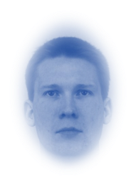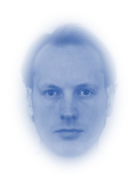
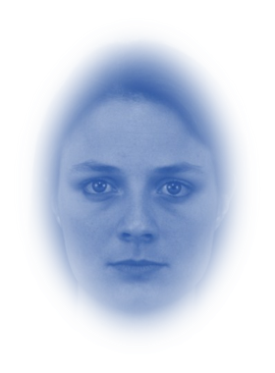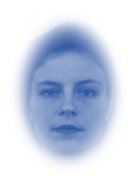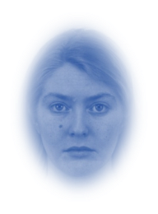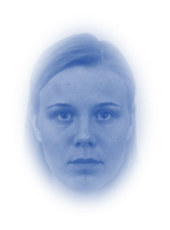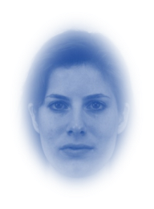
Each face has 5 colors:
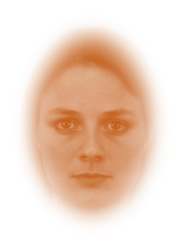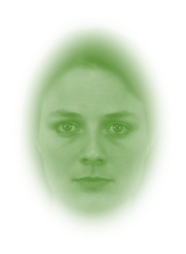
First 3 faces of each gender used in Experiment 1 & 2 are adopted in Experiment 4, and each face contain 6 emotional expressions:
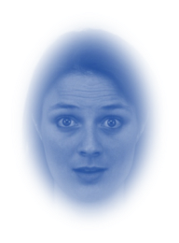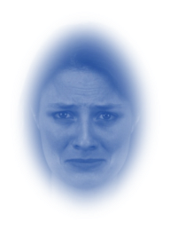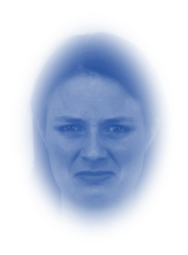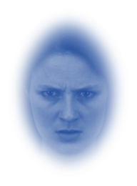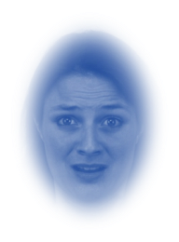
There are 3 gaze directions used in Experiment 3a:
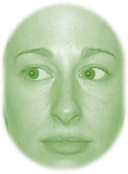
There are 5 topological shapes used in Experiment 3b:

Each shape contains 5 colors:


