Student preferences regarding re-opening universities in the Fall of 2020

Online appendix

Sample
Graduate students who had both attended in-person classes during the semester and online classes during the lockdown in the Spring of 2020 were identified by departmental administrators in Health Policy and Management in a convenience sample. 30 students were recruited to participate, with a target sample size of 22 students after attrition. All 30 students participated, and various students had recruited 16 other recent graduates from other departments within the School of Public Health to participate as well, yielding a total of 46 students. Each additional student recruited was done so with the permission of the authors under the assurance that the student who was recruited was a student in the School of Public Health. While we did not collect any personal information on the students, it is reasonable to assume that all were well-informed about the risks of Covid-19, the basic transmission dynamics of disease in the community, and the need to social distance in order to prevent its spread.

We used a combination of game theory-based questions and standard survey questions to assess their preferences for risk-taking in reference to Covid-19 in the university environment. We also asked about their willingness to leave campus to eat or to ride the subway, two potential sources of off-campus contagion.

Survey instrument
We used Survey Sparrow, Inc. (Palo Alto, CA) to administer the survey. Survey Sparrow deploys an interactive chat bot that implements skip logic and can accept conditional terms. Thus, it is possible to ask a subsequent question that is conditional on the response to the first question. Questions regarding risk offered ‘Yes’ and ‘No’ answer options when asking students whether they were willing to accept a certain risk to take classes in-person rather than online. (See Appendix Figure 1.)

Standard gamble trading risk of infection for in-person class attendance

Students were first presented with data on their age-specific risk of illness, hospitalization, and death as well as possible symptoms were they to become infected with Covid-19 as follows:

“As a 20-25 year old, you have a 0.06% daily chance of contracting Covid-19. For individuals your age, this means you will typically have a flu-like illness in which you are in bed with a fever and cough. You will be quarantined for 2-3 weeks depending on the duration of your illness. If you become infected, you have a 1.04% chance of being hospitalized and a chance of requiring ventilation or dying (0.031%).”

They were then presented with a “standard gamble” exercise, in which they were asked to trade between the risk of illness presented from in-person instruction and the safety of online instruction. The gamble began with a trade-off between a 10% chance of becoming infected while attending in-person classes versus a 0% chance of becoming infected taking online classes:

Appendix Figure 1. Screenshot from the standard gamble exercise.
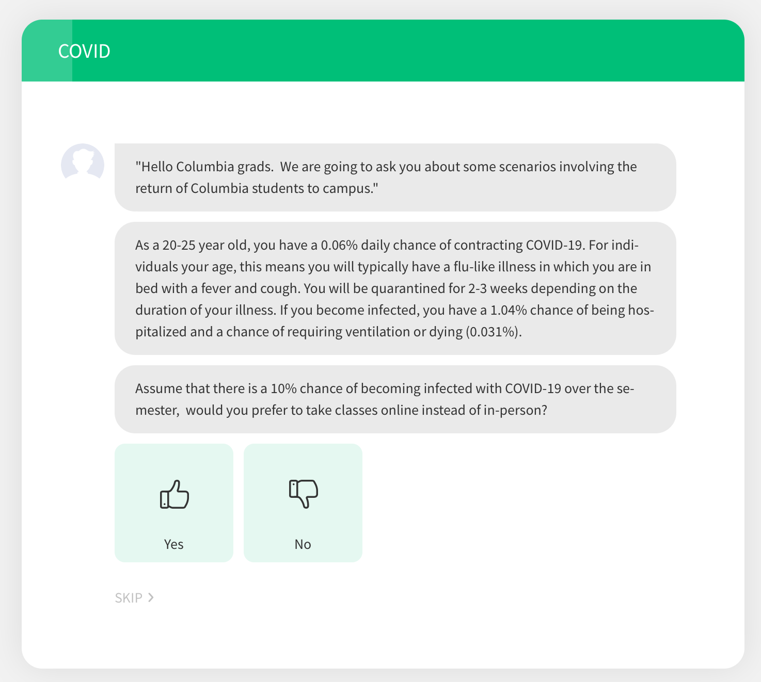

If students were willing to accept a 10% risk (answering ‘No’), they were presented with an incremental 5% increase in risk of infection until they felt that the trade-off was not worth the risk. The risk maxed out at 100%, indicating that students who accepted this risk, would prefer in-person classes over online classes despite a guarantee of infection. The gamble stopped as soon as the student’s level of risk tolerance was reached by selecting “Yes.” (See Appendix Figure 2.)

Conversely, if they rejected the 10% risk, the chance of infection was reduced to 5%, then 1%, 0.5%, 0.1%, 0.05%, and finally 0.001%. If they rejected all of the presented risks, their accepted risk was reported as 0%. Each student’s accepted risk was reported as the average of the highest percent risk they were willing to accept and the lowest percent risk they were unwilling to accept. (See Appendix Figure 3.)

Appendix Figure 2. Once the student reaches his or her level of risk tolerance, the exercise is stopped, and the next question is asked. Just as with the standard gamble technique deployed to ascertain risk tolerance for in-class exposure to Covid-19, students were asked to make trade-offs between community-level exposures and their willingness to attend parties (bottom of Appendix Figure 2.)

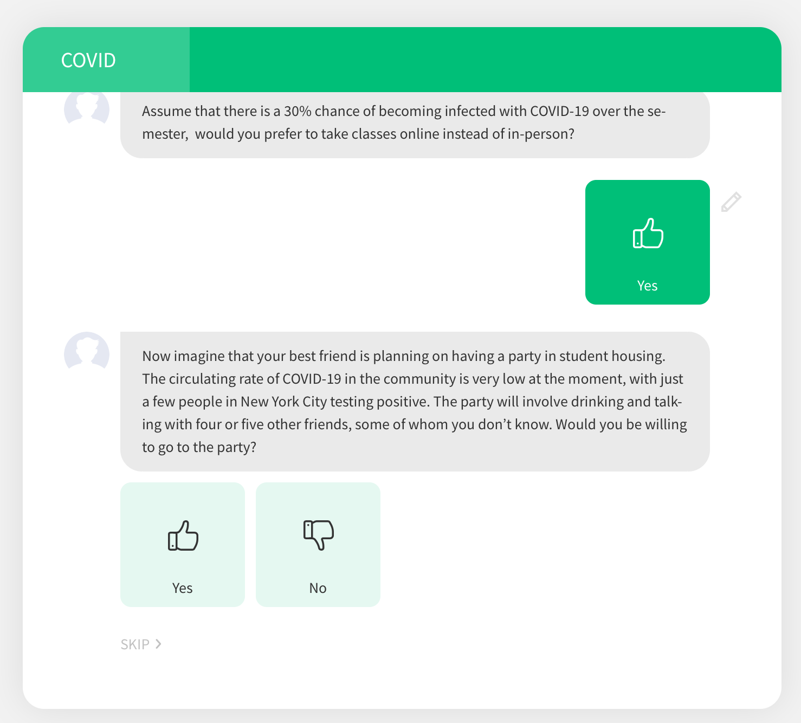

Appendix Figure 3. Told that they were to imagine that they faced a given prevalence of infection if they attended classes in person, students underwent a gamble in which their risk tolerance for in-person class time was assessed. Many students were willing to face a significant risk of infection in exchange of taking classes in-person.

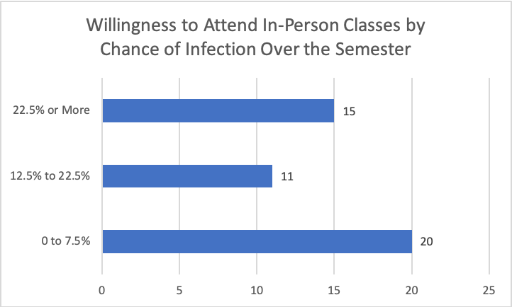

Willingness to attend a party at different incidence levels of Covid-19

Next, participants were presented with a scenario in which their best friend was planning a social gathering off-campus in an environment where the prevalence of circulating virus in the community was very low, with just a “few people” testing positive. The social gathering involved “drinking and talking” with 4-5 people whom they did not know.

They were first asked whether they would be willing to go to the social gathering under this low risk setting. If the student answered ‘Yes’, then the prevalence of Covid-19 was increased to medium but not negligible (a “few hundred people”) and then to high (a “few thousand people”). At that point, the exercise was stopped.

If the student was not willing to go to a social gathering under the low risk setting, they were reported to have no willingness to attend social gatherings. If they accepted only the low risk setting, rejecting the higher risk settings, they were reported to be willing to accept low risk of infection to attend a social gathering. If they also accepted the next risk (low but not negligible), they were reported to accept a medium risk of infection. If they accepted the risk in all scenarios, they were reported to accept high risk of infection. (See Appendix Figure 4.)

Appendix Figure 4. Out of 35 students reporting, only 27 graduate students in public health said that they would not attend any parties over the semester that involved 4-5 people drinking in a room. 7 indicated that they would be willing to attend a party even if the prevalence of Covid-19 in the community was very high.

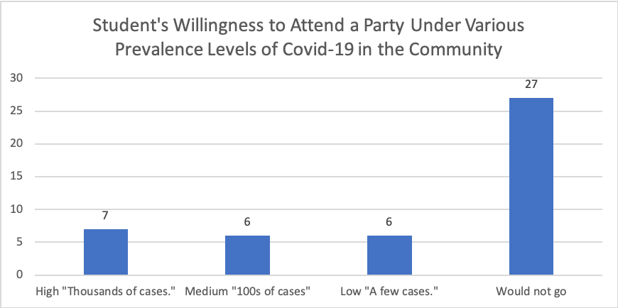

Next, the students were queried as to how many times per week that they were planning on leaving the campus by subway, dining in restaurants, and engaging in other activities that may put them in close contact with non-Columbia University affiliates. (See Appendix Figure 5.)

Appendix Figure 5. The number of times students plan to leave campus per week to take the subway or eat.

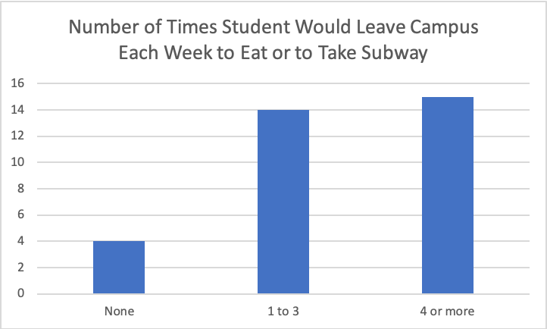

Finally, the students were presented with the average tuition paid per year at Columbia University ($20,000, a figure rounded down to the nearest $10,000 increment). They were then asked how much they would be willing to pay for classes per year given that they were online instead. (See Appendix Figure 6.)

Appendix Figure 6. Told that they were to imagine that they were paying $20,000 in tuition out-of-pocket, students were asked to simply report the value that they would be willing to pay in the event that all classes were held online.

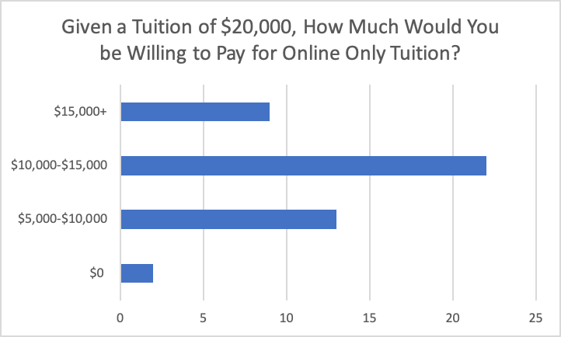

The raw data are presented in Appendix Table 1.

Appendix Table 1

Average Risk of Infection accepted until preference of Online Class | Students willing to attend social gatherings given Low/Moderate prevalence of Covid-19 in NYC | Average Annual Tuition willing to pay for Online Classes | Average Number of times per week going off-campus
23% | 28% | $9,818 | 3.6

Average Risk of Infection accepted until preference of Online Class | Willingness to attend social gatherings | Number of times per week going off campus | Average Annual Tuition willing to pay for Online Classes
0.125 | No | 0.5 | 9050
0.125 | Low | 5 | 10000
0.03 | No | 4 | 7000
0.003 | No | 2 | 10000
0.475 | Low | 6 | 10000
0.175 | Medium | 10 | 10000
0.0075 | No | 1 | 16000
0.275 | No | 2 | 5000
0.03 | No | 1 | 15000
0 | No | 10 | 17000
0.175 | No | 5 | 10000
0.175 | High | 3 | 10000
0.075 | High | 8 | 7500
0.225 | No | 2 | 15000
0.03 | Medium | 3 | 17000
0.003 | No | 1 | 5000
0.075 | No | 2 | 12000
0.375 | No | 2 | 8000
0.775 | Medium | 5 | 10000
0.175 | Medium | 10 | 10000
0.575 | No | 4 | NA
1 | No | 1 | 0
0.125 | No | 3 | 10000
0.075 | No | 0 | 15000
0.375 | Low | 1 | 10000
0.003 | No | 0 | 5000
0.125 | Low | 3 | 5000
0.175 | Medium | 2 | 10000
0.03 | Low | 2 | 10000
0.725 | No | 0 | 5000
1 | High | 4 | 10000
0.125 | Medium | 3 | 10000
0.0075 | No | 1 | 8000
0.175 | Low | 4 | 10000
0.003 | No | 0 | 10000
0.875 | High | 3 | 10000
0.03 | No | 1 | 10000
0.225 | No | 3 | 10000
0.0075 | High | 2 | 10200
0.03 | No | 2 | 15050
0.275 | High | 2 | 15000
0.225 | High | 7 | 15000
0.003 | No | 5 | 5000
1 | No | 21 | 10000
0.03 | No | NA | 5000
0.075 | No | 4 | 5000

Sample of Survey Questions
“Assume that there is a 10% chance of becoming infected with COVID-19 over the semester, would you prefer to take classes online instead of in-person?”
“Now imagine that your best friend is planning on having a party in student housing. The circulating rate of COVID-19 in the community is very low at the moment, with just a few people in New York City testing positive. The party will involve drinking and talking with four or five other friends, some of whom you don’t know. Would you be willing to go to the party?”
“Approximately, how many times a week do you plan to leave the Columbia campus and spend time in the general New York City area, possibly interacting with non-Columbia affiliates (riding the subway, eating at restaurants, etc.)?”
“Imagine that you are paying tuition out of pocket, and the annual tuition for online classes is $20,000. All things being equal (you remain in your New York housing and obtain a degree from Columbia University), how much would you be willing to pay if the courses were only available on Zoom as opposed to in-person?

Input value between 0 and 20,000”

Link to survey: https://katiakay.surveysparrow.com/s/COVID/tt-a89615

